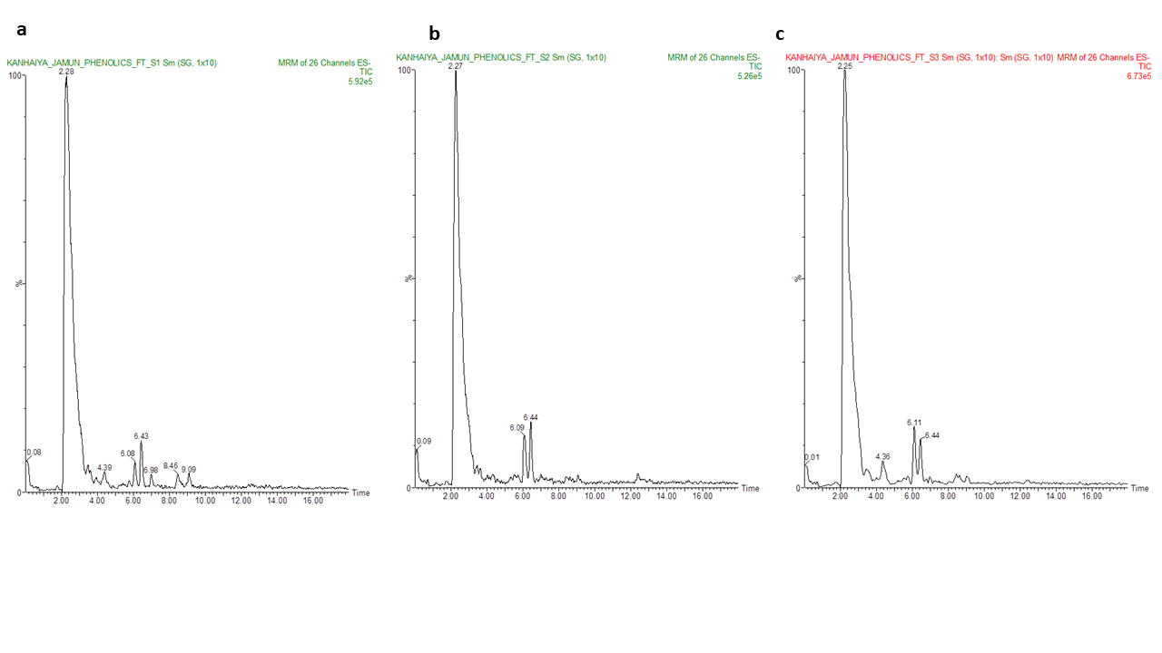Fig. S1. Representative MRM chromatograms of phenolic acids in pulp samples of Syzygium cumini genotypes.

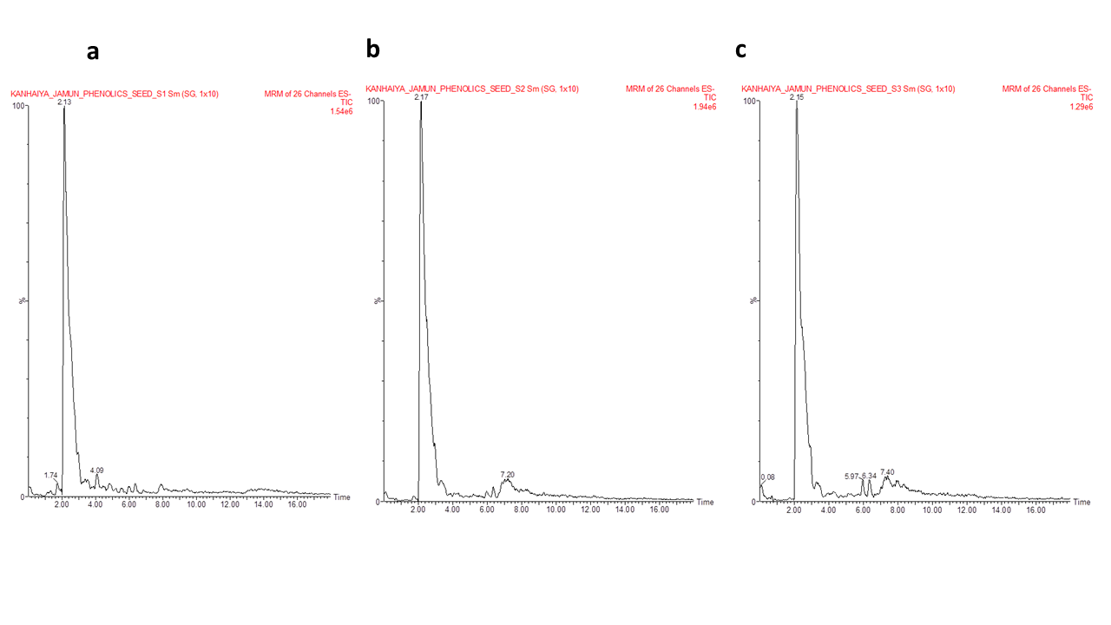
Fig. S2. Representative MRM chromatograms of phenolic acids in seed samples of Syzygium cumini genotypes.

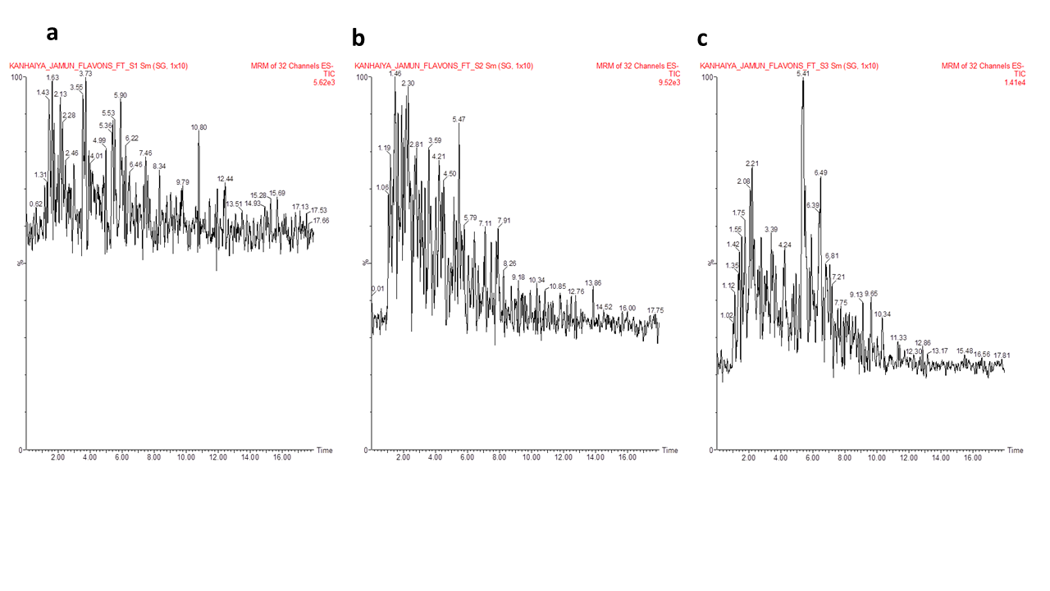
Fig. S3. Representative MRM chromatograms of flavonoids in pulp samples of Syzygium cumini genotypes.
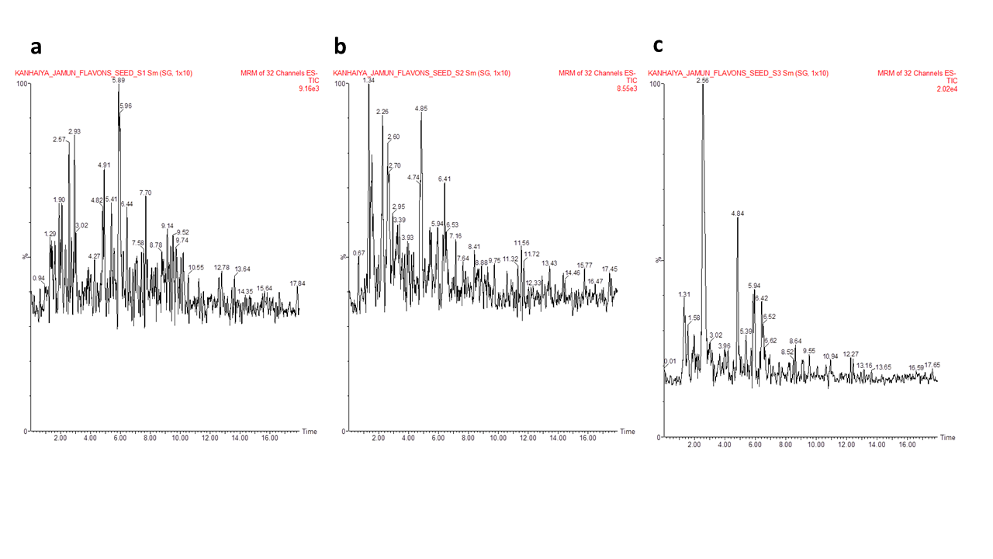

Fig. S4. Representative MRM chromatograms of flavonoids in seed samples of Syzygium cumini genotypes.

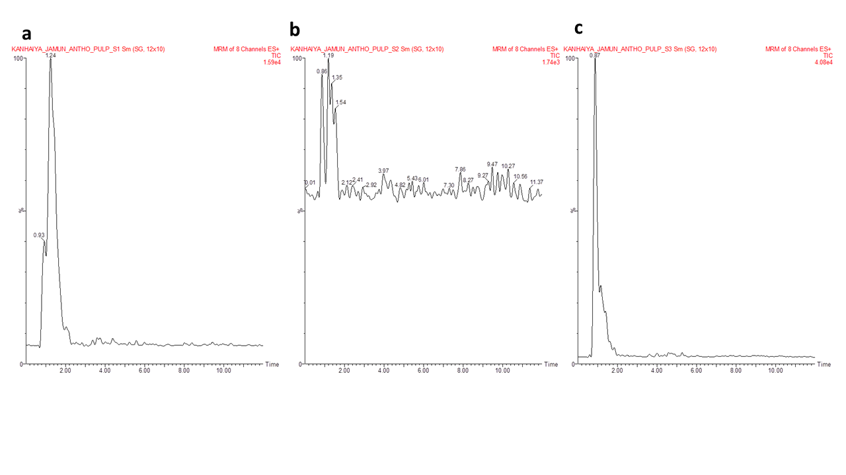Fig. S5. Representative MRM chromatograms of anthocyanins in pulp samples of Syzygium cumini genotypes.

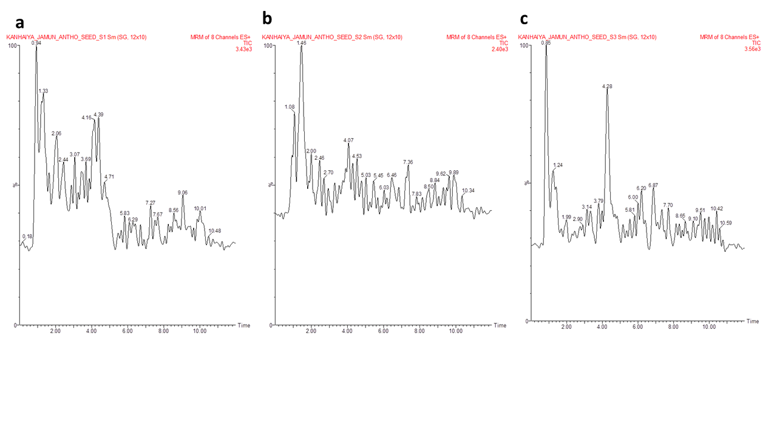
Fig. S6. Representative MRM chromatograms of anthocyanins in seed samples of Syzygium cumini genotypes.

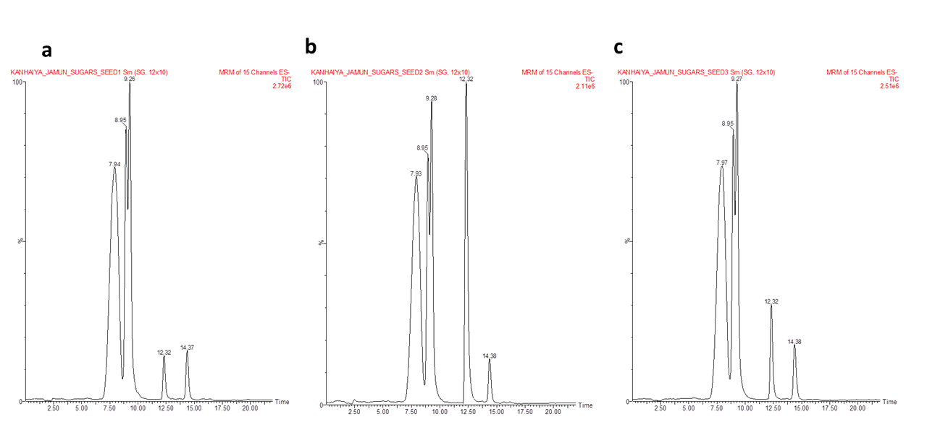
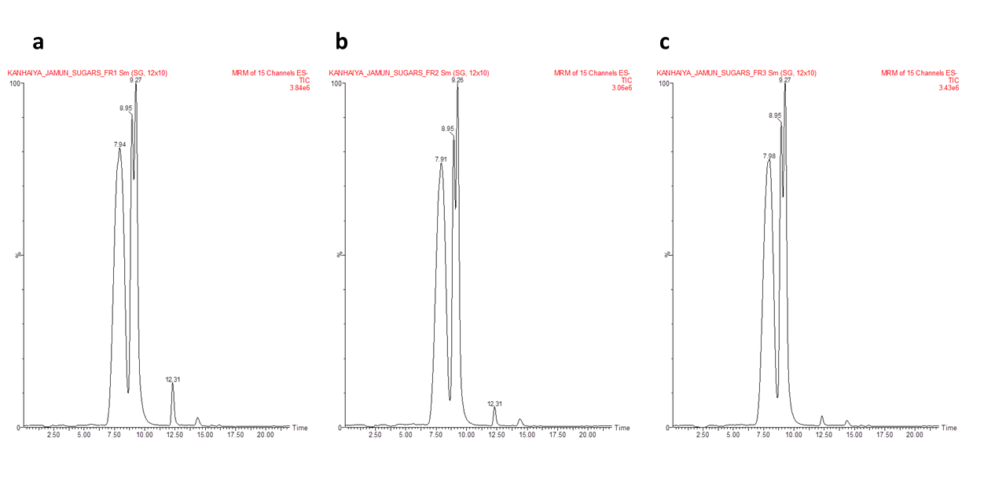
Fig. S7. Representative MRM chromatograms of sugars in pulp samples of Syzygium cumini genotypes.
Fig. S8. Representative MRM chromatograms of sugars in seed samples of Syzygium cumini genotypes.

Table S1. MRM parameters of phenolic acid standards used for LC–MS/MS analysis.

Sl. No. | Compounds | Formula/Mass | Parent  ion (m/z) [M+H]+ | Daughters | Cone  voltage  (V) | Collision  energy  (eV) | Ion  mode
1 | Caffeic acid | 180 | 178.90 | 135.05 | 30 | 16 | ES-
2 | 2,4- Dihydroxybenzoic acid | 154 | 152.90 | 65.02 | 28 | 18 | ES-
3 | Chlorogenic acid | 354 | 352.97 | 191.10 | 22 | 18 | ES-
4 | Ferulic acid | 194 | 192.90 | 134.02 | 26 | 14 | ES-
5 | Gallic acid | 170 | 168.90 | 125.03 | 28 | 12 | ES-
6 | Gentisic Acid | 154 | 152.90 | 108.98 | 24 | 12 | ES-
7 | o-Coumaric acid | 164 | 162.90 | 119.06 | 22 | 12 | ES-
8 | p-Coumaric acid | 164 | 162.90 | 119.05 | 24 | 14 | ES-
9 | p-Hydroxybenzoic acid | 138 | 136.90 | 93.01 | 26 | 12 | ES-
10 | Protocatecuic acid | 154 | 152.90 | 109.05 | 26 | 16 | ES-
11 | Salicylic acid | 138 | 136.90 | 93.10 | 28 | 14 | ES-
12 | Syringic acid | 198 | 196.97 | 182.07 | 26 | 10 | ES-
13 | t-Cinnamic Acid | 148 | 146.90 | 103.05 | 26 | 10 | ES-
14 | Vanillic Acid | 168 | 166.97 | 108.01 | 26 | 20 | ES-
15 | Benzoic acid | 122 | 120.96 | 77.02 | 26 | 10 | ES-
16 | 3-Hydroxy Benzoic acid | 138 | 137.02 | 93.8 | 28 | 10 | ES-
17 | Sinapic acid | 224 | 223.11 | 149.06 | 32 | 14 | ES-
18 | Ellagic acid | 302 | 301.09 | 144 | 70 | 38 | ES-

Table S2. MRM parameters of flavonoids standards used for LC–MS/MS analysis.

Sl.  No. | Compounds | Formula/Mass | Parent ion  (m/z) [M+H]+ | Daughters | Cone voltage  (V) | Collision  energy  (eV) | Ion  mode
1 | Apigenin | 270 | 268.97 | 107.04 | 46 | 30 | ES-
2 | Catechin | 290 | 289.03 | 245.15 | 38 | 12 | ES-
3 | Hesperetin | 302 | 300.97 | 286.15 | 42 | 16 | ES-
4 | Myricetin | 318 | 317.03 | 151.06 | 42 | 28 | ES-
5 | Quercetin | 302 | 301.03 | 151.12 | 36 | 20 | ES-
6 | Rutin | 610 | 609.10 | 300.20 | 60 | 42 | ES-
7 | Umbelliferone | 162 | 161.04 | 133.07 | 42 | 18 | ES-
8 | Luteolin | 286 | 284.97 | 93.05 | 52 | 32 | ES-
9 | Kaemepherol | 286 | 284.97 | 93.05 | 52 | 32 | ES-
10 | Naringenin | 272 | 271.13 | 119.05 | 34 | 22 | ES-
11 | Epicatechin | 290 | 289.05 | 109.08 | 36 | 22 | ES-
12 | Epigallocatechin | 306 | 305.05 | 125.10 | 34 | 20 | ES-
13 | Fisetin | 286 | 285.08 | 121.05 | 42 | 26 | ES-
14 | Galangin | 270 | 269.08 | 168.53 | 52 | 28 | ES-
15 | Eriodictyol | 288 | 287.09 | 135.12 | 32 | 20 | ES-

Table S3. MRM parameters of anthocyanins standards used for LC–MS/MS analysis.

Sl. No. | Compounds | Formula/Mass | Parent ion  (m/z) [M+H]+ | Daughters | Cone voltage (V) | Collision energy (eV) | Ion  mode
1 | Cyanidin | 286.00 | 287.10 | 137.07 | 56 | 34 | ES+
2 | Delphinidin | 301.98 | 303.08 | 229.06 | 66 | 32 | ES+
3 | Malvidin | 330.00 | 331.16 | 315.11 | 40 | 34 | ES+
4 | Pelargonidin | 270.00 | 271.10 | 121.05 | 56 | 34 | ES+

Table S4. MRM parameters of sugar standards used for LC–MS/MS analysis.

Sl.  No. | Compounds | Formula/Mass | Parent ion  (m/z) [M+H]+ | Daughters | Cone  voltage  (V) | Collision  energy  (eV) | Ion  mode
1 | Fructose | 180 | 178.97 | 89.09 | 18 | 16 | ES-
2 | Sucrose | 342 | 341.03 | 89 .08 | 32 | 22 | ES-
3 | Galactose | 180 | 178.97 | 89.09 | 18 | 16 | ES-
4 | Glucose | 180 | 178.97 | 59.08 | 18 | 16 | ES-
5 | Maltose | 342 | 341.03 | 161.05 | 12 | 8 | ES-
6 | Fucose | 164 | 162.97 | 89.06 | 18 | 6 | ES-
7 | Rhamnose | 164 | 162.97 | 103.06 | 18 | 6 | ES-
8 | Xylose | 150 | 148.9 | 89.09 | 18 | 8 | ES-
9 | Arabinose | 150 | 148.9 | 89.08 | 18 | 8 | ES-
10 | Mannose | 180 | 178.97 | 119.03 | 20 | 8 | ES-
11 | Sorbitol | 182 | 180.97 | 89.05 | 26 | 14 | ES-
12 | Inositol | 180 | 178.97 | 161.11 | 28 | 8 | ES-
13 | Lactose | 342 | 341.03 | 161.05 | 12 | 8 | ES-
14 | Ribose | 150 | 148.9 | 89.09 | 18 | 8 | ES-
15 | Trehalose | 342 | 341.03 | 89.08 | 32 | 22 | ES-

