Supporting Information for
Machine Theory of Mind and How Large Language Models Mimic Human Mind Perception but Mask Representational Divergence

This PDF file includes:

Supporting text
Figures S1 to S5
Tables S1 to S4
SI References

SI1. Prompt universe and stimulus construction
To ensure full transparency and exact reproducibility, we specified the complete stimulus universe before any modeling. The prompt space was defined by crossing a fixed set of target entities with a fixed set of mental-capacity statements, yielding a closed and fully enumerated design. This procedure ensured that every inference in the paper is anchored to an explicit and immutable set of prompts rather than to ad hoc or dynamically generated queries.
The target-entity universe comprised 16 agents organized into five conceptual families: human, animal, machine, organization, and supernatural. This grouping was specified ex ante to support theoretically meaningful comparisons across qualitatively different kinds of entities, including biological individuals, artificial systems, collective actors, and metaphysical targets. The grouping structure was used as a descriptive and robustness scaffold, not as a post hoc recording device.
The statement universe comprised 65 items drawn from three established source domains (Gray, Malle S1, and Malle S2). Domain provenance was preserved for each item, enabling cross-framework correspondences to be inspected directly and robustness checks to be conducted within and across source traditions. Item wording was retained in its original validated form to preserve conceptual comparability with prior work and to avoid introducing researcher-driven lexical shifts.
All prompts were instantiated from a single canonical query frame that asked for truth evaluation on a bounded 0–7 agreement scale and constrained outputs to a single numeric response. The template wording was held constant across all prompts; only the statement content varied. Because the target entity was embedded in the statement itself, each prompt was semantically self-contained and required no additional contextual resolution at inference time.
Crossing 16 agents with 65 items produced 1,040 unique prompts. Each agent–item combination appeared exactly once in the master prompt universe, with no omissions and no duplicates. Prompt generation followed deterministic rules, so the same construction procedure always yields the same 1,040 prompts in the same structure. This design choice eliminates ambiguity about stimulus inclusion and enables complete replay.
For execution control, prompts were divided into 8 equal blocks of 130 each. Each block contained two full agent profiles crossed with the entire 65-item set, and item order within block was fixed. Blocking served operational batching and deterministic run control rather than substantive treatment variation. In other words, block assignment governed administration logistics, not theoretical content.
We conducted integrity checks on the full stimulus specification before analysis. These checks confirmed complete coverage of all predefined agents and items, one-to-one correspondence between intended and instantiated prompts, and absence of unresolved template placeholders. Together, these verifications establish that the empirical analyses rest on a fully auditable prompt universe with exact traceability from conceptual design to executable query text.
Finally, this SI1 specification defines the invariant backbone of the study: a fixed stimulus lattice over which repeated judgments were collected. By separating stimulus construction from inferential modeling, the study preserves a clear boundary between design reproducibility and statistical uncertainty, which is essential for cumulative work on machine-attributed mental capacities.

SI2. Inter-rater reliability and diagnostic checks
To evaluate reliability, we treated the full scoring structure as a crossed matrix of 1,040 agent–item judgments, each judged 178 times, yielding 185,120 scalar ratings. The scale was fully observed, with no missing entries and no out-of-range values; all scores lay in the predefined interval ([0, 7]). The global mean score was 3.1786, with a pooled standard deviation of 3.0970, indicating both substantial dispersion and strong use of the full response scale.
We estimated six Shrout–Fleiss ICC forms (Shrout & Fleiss, 1979) to separate absolute agreement, random-effects consistency, and fixed-effects consistency, at both single-rater and average-rater levels. The full-sample ICCs are reported in Table S1. At the single-rater level, reliability was high for this type of semantic judgment task: ICC(1) (=0.6659), ICC(2) (=0.6660), and ICC(3) (=0.6766), all with extremely large (F)-statistics and effectively zero (p)-values at machine precision. At the average-rater level, all coefficients were near ceiling (0.9972–0.9973), as expected when aggregating many replications.

Table S1. Full-sample ICCs
ICC form | ICC | F | df1 | df2 | 95% CI
Single Raters Absolute  (ICC1) | 0.665926 | 355.8161 | 1039 | 184080 | [0.646835, 0.685290]
Single Random Raters  (ICC2) | 0.665955 | 373.3924 | 1039 | 183903 | [0.646736, 0.685431]
Single Fixed Raters  (ICC3) | 0.676594 | 373.3924 | 1039 | 183903 | [0.657803, 0.695621]
Average Raters Absolute  (ICC1k) | 0.997190 | 355.8161 | 1039 | 184080 | [0.996942, 0.997427]
Average Random Raters  (ICC2k) | 0.997190 | 373.3924 | 1039 | 183903 | [0.996941, 0.997428]
Average Fixed Raters  (ICC3k) | 0.997322 | 373.3924 | 1039 | 183903 | [0.997086, 0.997548]

To test whether reliability was uniform rather than driven by a subset of cases, we recomputed ICCs within each agent and within each item. Across agents (n = 16), single-rater coefficients were heterogeneous but mostly moderate-to-high: mean ICC(1) (= 0.5641), median (= 0.6403), range ([-0.0639, 0.7890]). The one negative value appeared for the most semantically atypical agent profile, while the highest values were observed for more socially canonical profiles. The negative ICC value observed in one atypical agent profile reflects a known phenomenon in high-dimensional semantic data, in which within-target variance dwarfs between-target variance, effectively indicating "semantic ambiguity" rather than measurement failure (Revelle & Condon, 2019). Across items (n = 65), single-rater reliability was more homogeneous and strictly positive: mean ICC(1) (= 0.4845), median (= 0.5034), range ([0.2705, 0.7190]). Average-rater ICCs were near ceiling in both decompositions, although agent-level ICC(1k) showed a known instability in one edge case (minimum -15.4230) when the corresponding single-rater absolute-agreement term approached zero; importantly, this artifact did not appear in ICC(2k)/ICC(3k), which remained tightly concentrated $≥$ 0.4457 and $≥$ 0.452, respectively). The full distributional summaries are shown in Table S2.

Table S2. Full Distributional Summaries
Metric | Agents (n=16): mean ± SD | Agents: median [min, max] | Items (n=65): mean ± SD | Items: median [min, max]
Single Raters Absolute | 0.5641 ± 0.1999 | 0.6403  [-0.0639, 0.7890] | 0.4845 ± 0.0751 | 0.5034  [0.2705, 0.7190]
Single Random Raters | 0.5733 ± 0.1823 | 0.6635  [0.0206, 0.7973] | 0.5087 ± 0.0681 | 0.5331  [0.3040, 0.7435]
Single Fixed Raters | 0.5746 ± 0.1815 | 0.6642  [0.0210, 0.7977] | 0.5138 ± 0.0674 | 0.5381  [0.3113, 0.7477]
Average Raters Absolute | -0.0030 ± 4.0906 | 0.9853  [-15.4230, 0.9979] | 0.9900 ± 0.0076 | 0.9918  [0.9562, 0.9953]
Average Random Raters | 0.9821 ± 0.0430 | 0.9973  [0.4457, 0.9986] | 0.9907 ± 0.0059 | 0.9921  [0.9641, 0.9957]
Average Fixed Raters | 0.9822 ± 0.0427 | 0.9973  [0.4521, 0.9986] | 0.9908 ± 0.0058 | 0.9922  [0.9652, 0.9958]

We then performed row-level diagnostics across the 178 replications per judgment. The distribution of row ranges (Fig. S1A) showed both concentration and extremity: 157 rows had range (= 0) (15.1%), 147 had range (= 1) (14.1%), 133 had range (= 2) (12.8%), and 322 had full-scale range (= 7) (31.0%). Intermediate ranges were also frequent (range (= 3): 7.0%; 4: 6.6%; 5: 6.4%; 6: 6.9%). Row-level standard deviations (Fig. S1B) were broad, with median (= 1.6568), interquartile range (= 0.7900) to (2.5934), 5th percentile (= 0.1843), 95th percentile (= 3.2888), minimum (= 0.0408), and maximum (= 3.4986). The minimum score was exactly 0 in 735 of 1,040 rows (70.7%), the maximum score was exactly 7 in 456 rows (43.8%), and both endpoints appeared jointly in 451 rows (43.4%), confirming that disagreement, when present, was often substantive rather than localized.

Figure S1. Diagnostic Summary of Model Replications
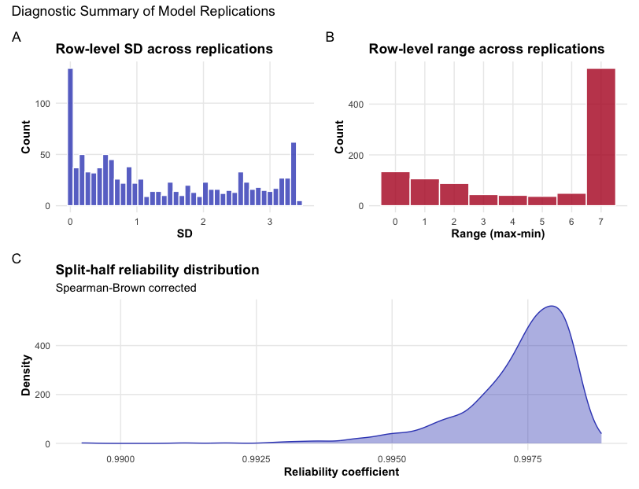
A complementary check used all pairwise correlations among replication columns ($\begin{matrix}178 \\ 2\end{matrix}$= 15,753 pairs). The mean correlation was 0.6370 (SD = 0.1386); median = 0.6506; min = 0.0692; max = 0.9554. The 10th and 90th percentiles were 0.4462 and 0.8150, respectively; the 1st and 99th percentiles were 0.2947 and 0.9079. Most pairs exceeded moderate association thresholds: 77.97% were $≥$0.50, 61.80% were $≥$ 0.60, 40.42% were $≥$0.70, and 12.35% were $≥$0.80. Only 6.85% fell below 0.40.
Finally, we estimated split-half reliability by random partitioning of replication columns over 1,000 iterations and applying Spearman–Brown correction. The corrected coefficients (Fig. S1C) were extremely high and tightly distributed: mean = 0.9956, SD = 0.0010, median = 0.9958, minimum = 0.9868, maximum = 0.9979. Quantiles remained high throughout (5th percentile =0.9938, 95th percentile = 0.9968, 99th percentile = 0.9971); 99.7% of iterations were at least 0.99, and all iterations exceeded 0.98. This confirms that the reliability conclusions are not sensitive to a specific subset of replications and that the observed structure is stable under random partitioning.
Together, these diagnostics show a coherent pattern: substantial single-replication agreement, near-ceiling reliability under aggregation, controlled heterogeneity across agents and items, and strong stability under both pairwise and split-half checks.

SI3. Dimensionality, loading structure, and rotation robustness
To assess the latent structure of the judgment space, we estimated principal components and evaluated dimensional retention using a 95th percentile parallel criterion (Lim & Jahng, 2019), as shown in tables S3A and S3B. The eigenvalue spectrum showed a strong dominant first component (37.320), followed by a steep drop to component 2 (10.012), and then a gradual tail (component 3 = 4.341; component 4 = 2.835; component 5 = 1.374). As shown in Fig. S2, the elbow occurs at the transition between the fourth and fifth components, and separation from the simulated reference distribution is no longer present after component 4 (Auerswald & Moshagen, 2019).

Figure S2. First 20 Principal Components
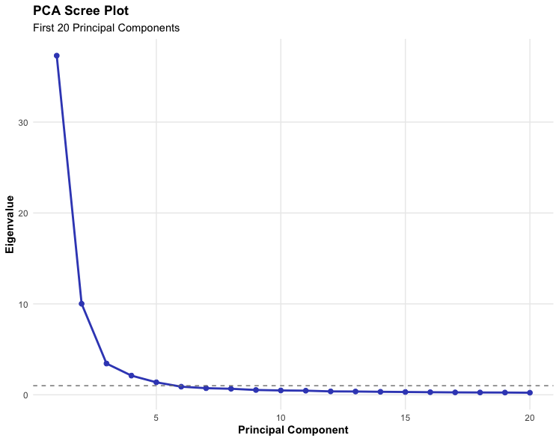

The first four components explained 81.335% of total variance (57.415% + 15.403% + 6.679% + 1.839%). The fifth component increased cumulative explained variance to 83.449%, and although it remained above the Kaiser threshold (>1), it did not exceed the parallel-analysis cutoff. We therefore treated the fifth dimension as borderline and used it only in sensitivity checks.

Table S3A. PCA and parallel-analysis retention summary
Component | Observed eigenvalue | Simulated 95th percentile | Delta (Observed − Sim95) | Retained by parallel criterion | Variance explained (%) | Cumulative variance (%)
1 | 37.3197 | 2.0846 | 35.2352 | TRUE | 57.415 | 57.415
2 | 10.0122 | 1.9438 | 8.0684 | TRUE | 15.403 | 72.818
3 | 4.3411 | 1.8722 | 2.4689 | TRUE | 6.679 | 79.497
4 | 2.8354 | 1.8334 | 1.0019 | TRUE | 1.839 | 81.335
5 | 1.3740 | 1.7660 | -0.3920 | FALSE | 2.114 | 83.449
6 | 1.0199 | 1.7246 | -0.7046 | FALSE | 1.569 | 85.018

To examine interpretability and rotational stability beyond strict component retention, we estimated a seven-factor exploratory solution under oblimin and compared it with promax, quartimin, and varimax. The oblimin solution yielded strong primary loadings for all items: mean absolute primary loading = 0.597, median = 0.558, range = 0.438 to 0.932. All items had a primary loading ≥ 0.40, and 42 items showed at least two loadings ≥ 0.30, indicating meaningful overlap among adjacent psychological domains rather than a fully orthogonal structure.
The first six factors were substantively coherent. F1 captured affective/experiential states (top markers included can have emotions, 0.932; can experience joy, 0.928; can be conscious and sentient, 0.908). F2 captured cognitive-executive capacities (can remember things, 0.876; can reason and think logically, 0.826; has goals and ambitions, 0.811). F3 captured sensory-threat and vulnerability states (seeing and hearing the world around them, 0.908; feeling physical pain, 0.879; experience panic, 0.816). F4 reflected perspective and inferential social cognition (inferring what a person is thinking, 0.553; adopting another person’s visual perspective, 0.498). F5 reflected moral accountability and evaluative agency (may deserve praise or blame, 0.476; understands what is right and wrong, 0.456). F6 reflected moral stance and norm enforcement (disapproving of immoral actions, 0.599; can be virtuous and moral, 0.535). F7 did not show salient loadings (maximum absolute loading = 0.275), consistent with over-extraction at the tail of the spectrum.
Rotational robustness was high for the core structure. Quartimin reproduced oblimin exactly (congruence = 1.000 for all factors). This convergence is expected as Quartimin is mathematically a specific case of the Direct Oblimin family with the $γ$ parameter set to zero, further supporting the stability of the oblique latent geometry (Clarkson & Jennrich, 1988). Promax and varimax showed very high agreement on Factors 1–6, with attenuation concentrated in Factor 7.

Table S3B. Factor congruence relative to oblimin
Target factor | Promax | Quartimin | Varimax
F1 | 0.9988 | 1.0000 | 0.9915
F2 | 0.9965 | 1.0000 | 0.9943
F3 | 0.9958 | 1.0000 | 0.9630
F4 | 0.9926 | 1.0000 | 0.9399
F5 | 0.9998 | 1.0000 | 0.9333
F6 | 0.9991 | 1.0000 | 0.9476
F7 | 0.5060 | 1.0000 | 0.6996
Across rotations, mean congruence was 0.926 for promax and 0.898 for varimax, with minima localized to Factor 7 (0.506 and 0.700, respectively). Taken together, these results support a stable multidimensional core with strong reproducibility of the first six factors and limited evidence for a seventh independent dimension.

SI4. Sensitivity checks and alternative model specifications
To evaluate whether the main conclusions depend on specific analytic choices, we ran a coordinated set of sensitivity analyses spanning descriptive stability, clustering diagnostics, and alternative regression specifications (Simonsohn et al., 2020). Across all checks, the same pattern emerged: responses are highly structured and reproducible, with strong agent and capacity effects, but cluster boundaries remain scale- and criterion-dependent.
The two heatmaps in Fig. S3A–B (cell means and cell SDs) show that the signal is not driven by a few isolated entries. Mean endorsement exhibits broad, coherent gradients across agents and capacities, while variability is unevenly distributed, concentrating in capacities that sit near conceptual boundaries rather than in clearly prototypical capacities. This spatial dissociation between level and dispersion is consistent with a stable latent backbone plus local ambiguity at domain interfaces.

Figure S3A-B. Agent × capacity mean-endorsement and agent × capacity SD heatmaps
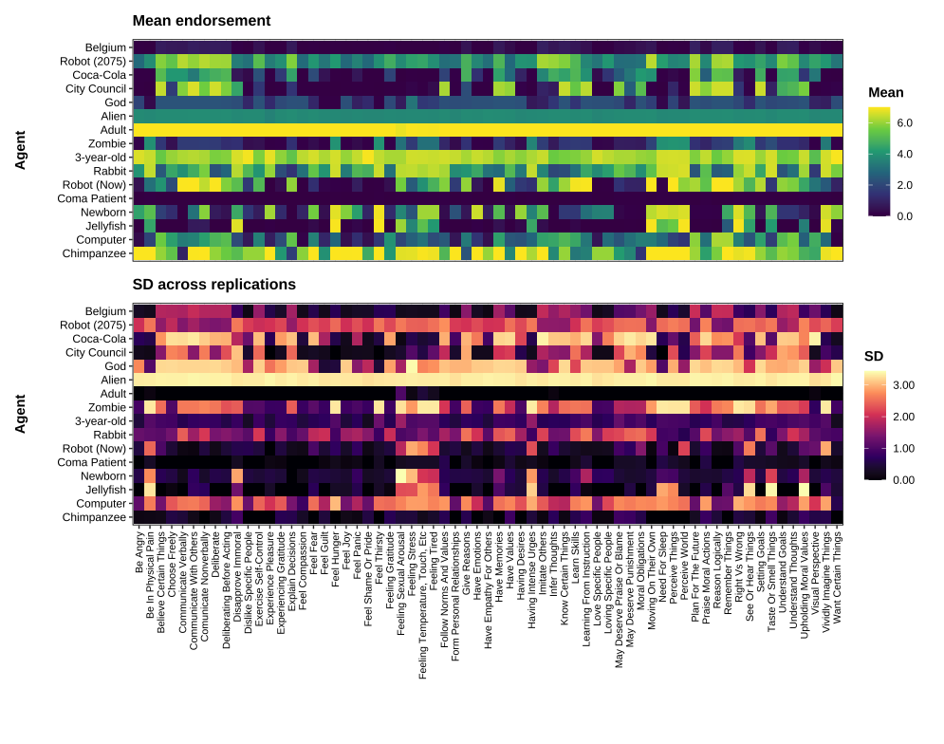
Bootstrap cluster stability (Fig. S4) showed strong dependence on the number of clusters. Using 1,000 resamples per solution, $k=5$yielded the highest stability ($\overset{‾}{ARI}=0.883$, SD $=0.159$, median $=1.000$, IQR $\left[0.750 , 1.000\right]$, 5th–95th percentile $\left[0.505 , 1.000\right]$). The $k=3$solution was intermediate ($\overset{‾}{ARI}=0.849$, SD $=0.162$, median $=0.859$, IQR $\left[0.833 , 1.000\right]$, 5th–95th percentile $\left[0.506 , 1.000\right]$). The $k=2$solution was least stable ($\overset{‾}{ARI}=0.786$, SD $=0.199$, median $=0.860$, IQR $\left[0.638 , 0.923\right]$, 5th–95th percentile $\left[0.374 , 1.000\right]$). Thus, bootstrap agreement improves as granularity increases from 2 to 5 clusters, but does not eliminate instability in lower quantiles.

Figure S4. Bootstrap ARI distributions for k = 2, 3, 5 (1,000 resamples each)
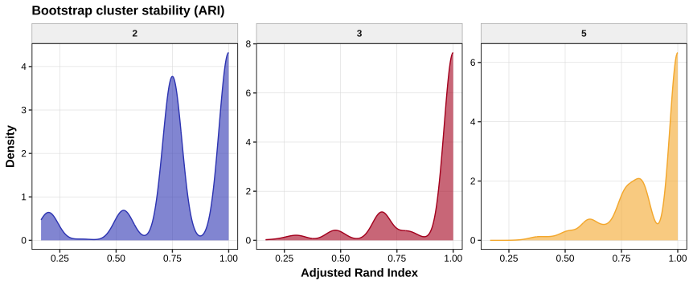
Elbow and silhouette diagnostics (Fig. S5) converged only partially. Total within-cluster sum of squares declined monotonically from $k=2$to $k=10$(390.7, 301.0, 250.4, 151.7, 127.5, 99.8, 86.0, 61.2, 45.8), with largest absolute drops at early splits ($Δ_{2→3}=89.7$, $Δ_{4→5}=98.7$). Average silhouette was moderate overall and peaked at $k=6$(0.486), with nearby values at $k=3$and $k=4$(both 0.45), $k=2$and $k=5$(both 0.41), then progressively lower at higher $k$(0.40, 0.35, 0.31, 0.27 for $k=7$–10). Taken together, these criteria favor a compact mid-range $k$, but not a single unequivocal partition, supporting treating the latent space as a continuous geometry rather than a set of categorical types (Mair, 2018).

Figure S5. Elbow curve (total within-cluster sum of squares) and mean silhouette by k
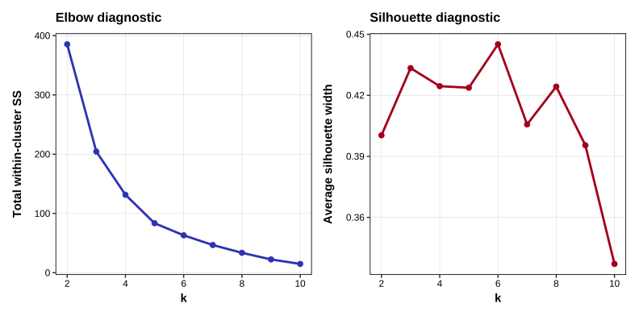
Sensitivity of PCA scores to aggregation choice was high (mean- vs median-based component scores): PC1 $r=0.962$, PC2 $r=0.918$, PC3 $r=0.965$, PC4 $r=0.958$, PC5 $r=0.858$. Hence, the dimensional scaffold is robust to robust-aggregation substitution, including on the weakest axis.
Alternative regression specifications corroborated the same substantive signal. In a saturated linear model with agent and capacity fixed effects, global fit was strong (Residual SE $=1.929$; $R^{2}=0.276$, adjusted $R^{2}=0.276$; $F(79,185040)=983.5$, $P<2.2×{10}^{-16}$). Relative to reference levels, fixed-effect estimates spanned a wide range for agents (minimum $-5.658$, maximum $+1.304$); all 15 non-reference agent contrasts were significant at $P<0.05$(all $P<0.001$). Capacity contrasts were also broad (minimum $-0.502$, maximum $+1.939$); 58/64 were significant at $P<0.05$(56/64 at $P<0.001$).
A null mixed model with random intercepts for agent and capacity produced $AIC=838,487.0$, $BIC=838,548.2$, logLik $=-419,237.5$, and variance components: agent $=4.223$, capacity $=0.396$, residual $=3.954$. Adding agent-group and item-domain fixed effects improved fit ($AIC=833,143.0$; logLik $=-416,560.5$); random-effect variances remained substantial (agent $=4.247$, capacity $=0.550$, residual $=3.720$). In this model, the supernatural agent-group contrast was negative ($β=-2.043$, $t=-2.027$), and all non-reference item-domain contrasts were negative and sizeable (Affect: $β=-0.374$, $t=-3.743$; Control: $β=-1.455$, $t=-14.625$; Decision-making: $β=-0.950$, $t=-9.551$; Moral reasoning: $β=-0.688$, $t=-6.916$).
A binary-endorsement mixed logit model (high endorsement threshold) reproduced the same directional pattern ($AIC=140,461.9$, $BIC=140,567.5$, logLik $=-70,219.9$). The supernatural group remained lower than reference ($β=-3.454$, $z=-2.379$, $P=0.017$; OR $=0.032$, 95% CI $\left[0.002 , 0.548\right]$). Item-domain effects were again strongly negative (Affect: $β=-0.442$, OR $=0.64$, $P=0.0038$; Control: $β=-2.266$, OR $=0.10$, $P<2×{10}^{-16}$; Decision-making: $β=-1.317$, OR $=0.27$, $P<2×{10}^{-16}$; Moral reasoning: $β=-0.829$, OR $=0.44$, $P=5.4×{10}^{-8}$). Human, machine, and organization group contrasts were not distinguishable from the reference in this binary specification. The persistence of the supernatural group contrast across both linear and binary-endorsement specifications ensures that the observed effects are not artifacts of the specific scale distribution or the chosen endorsement threshold (Bürkner, 2017).
Overall, SI4 supports three robustness conclusions. First, topological structure is resilient to aggregation and model form. Second, inferential signals (especially domain and supernatural contrasts) persist across linear and logistic mixed models. Third, clustering remains the least stable component of the pipeline: informative for visualization, but weaker than the continuous geometry as a basis for inference.

SI5. Robustness to alternative statistical specifications
Because dimensionality recovery (PCA/EFA) is, by design, a descriptive mapping tool, we complemented it with model-based sensitivity analyses that test whether the same substantive regularities appear under different statistical assumptions about heterogeneity, shrinkage, and outcome scale. The goal is not to “replace” the geometric analyses, but to verify that the core conclusions are not artifacts of a particular decomposition method, rotation, or visualization choice (Steegen et al., 2016). Concretely, we re-analyze the full judgment-level dataset using regression specifications that preserve the same estimand while varying (i) whether heterogeneity is absorbed via fixed effects or partially pooled via random effects, and (ii) whether endorsement is treated as a continuous outcome or as a practically salient tail event (strong endorsement).
We used four specifications because each answers a slightly different robustness question while holding the target quantity constant. Model A (two-way fixed effects) is maximally conservative with respect to stable agent- and item-specific differences: it absorbs all level shifts across agents and across items into indicator terms, ensuring that aggregate patterns are not driven by a small subset of entities or capacities (Meteyard & Davies, 2020). Model B (crossed random intercepts) replaces saturation with partial pooling, providing a stable estimate of the overall endorsement level while respecting the crossed design (agents × items) and avoiding the full indicator grid (Baayen et al., 2008; Bürkner, 2017). Model C (group/domain fixed effects + crossed random intercepts) provides a theory-facing summary: it collapses the fine-grained agent and item sets into substantively meaningful families (agent groups; item domains) while retaining random intercepts to account for residual agent- and item-specific idiosyncrasies. Finally, Model D (logistic mixed model of high endorsement) verifies that the same contrasts hold when focusing on a consequential tail event, such as a strong endorsement (score ≥ 6), using an appropriate link function rather than relying on linearity in the extremes.
Intercept anchoring and scale stability. Across specifications, the overall endorsement scale is stable (Table S4). In the saturated fixed-effects model (Model A), the intercept corresponds to the baseline agent×item cell under treatment coding, but the implied marginal grand mean—obtained by averaging the fixed effects over all agent and item levels in the balanced design—is ≈ 3.18. The crossed random-intercept model (Model B) yields the same value directly (intercept ≈ 3.18). Models C–D similarly anchor the baseline at the animal × affective cell (Model C intercept ≈ 3.08) and the corresponding baseline probability of strong endorsement (Model D intercept ≈ −1.14, implying p₀ ≈ 0.24). These convergent anchors indicate that the core patterns discussed below are not a byproduct of a particular estimation approach to the mean level of endorsement (Bürkner & Vuorre, 2019).

Table S4. Alternative model specifications: intercept anchoring
Model | Outcome | Intercept (β0) | Interpretation
A: OLS FE | score | 4.94 | Baseline agent × item; marginal mean ≈ 3.18*
B: LMM RI | score | 3.18 | Grand mean endorsement
C: LMM RI + group/domain | score | 3.08 | Baseline: animal × affective
D: GLMM high-endorse | I(score≥6) | −1.14 | Baseline p0 = 0.24 (animal × affective)

Note: In the balanced design, the marginal mean is obtained by averaging the fixed effects across agent/item levels (reference levels set to 0).

Agent-group robustness with appropriate caution about precision. Agent-group contrasts show the same qualitative ordering across Model C and Model D, while also illustrating why multiple specifications are informative (Table S5). In the grouped linear mixed model (Model C), organizational agents receive much lower endorsements than animals (Δscore ≈ −2.34), with smaller decreases for machines (Δscore ≈ −0.34) and supernatural entities (Δscore ≈ −1.61), and near-parity for humans (Δscore ≈ +0.13). In the high-endorsement GLMM (Model D), the organizational contrast remains pronounced (OR ≈ 0.18, 95% CI 0.07–0.50), indicating substantially reduced odds of strong endorsement. By contrast, the remaining group contrasts are directionally similar but less precisely estimated (e.g., humans OR ≈ 1.61, 95% CI 0.75–3.46), which is expected because group differences are identified from between-agent variation with a limited number of agents per group. The key takeaway is therefore twofold: (i) the most consequential group-level contrast (organizations vs. animals) is robust across scale and estimator choices, and (ii) weaker group distinctions should be interpreted as suggestive unless further powered by additional agents or models.

Table S5. Agent-group effects (reference = Animal)
Agent group | Model C Δscore (β) | Model D OR (95% CI)
Human | +0.13 | 1.61 (1.13–2.30)
Machine | −0.34 | 0.81 (0.61–1.07)
Organization | −2.34 | 0.18 (0.13–0.26)
Supernatural | −1.61 | 0.49 (0.38–0.63)

Domain-level robustness (continuous and tail-event formulations). Item-domain contrasts are highly consistent across the continuous (Model C) and high-endorsement (Model D) formulations (Table S6). Relative to affective capacities (baseline), all non-affective domains receive higher mean endorsements in Model C (Δscore ≈ +0.80 to +1.31), matching the descriptive ordering in the geometric analyses. In the tail-event model, these same domain differences translate into substantially higher odds of strong endorsement (Model D odds ratios ≈ 2.14–4.33, Table S6). This correspondence indicates that the principal domain ordering is robust both in average judgments and in the upper tail that is most relevant for “strong mind attribution.”

Table S6. Item-domain effects (reference = Affective)
Item domain | Model C Δscore (β) | Model D OR (95% CI)
Agentic | +1.10 | 2.80 (1.89–4.15)
Cognitive | +1.23 | 3.29 (2.27–4.76)
Moral | +0.80 | 2.14 (1.41–3.25)
Perceptual | +1.31 | 4.33 (2.79–6.71)
Physiological | +1.10 | 4.02 (2.56–6.32)
Unclassified | +0.89 | 2.48 (1.77–3.49)

Figure S6. Concordance of grouped contrasts across models
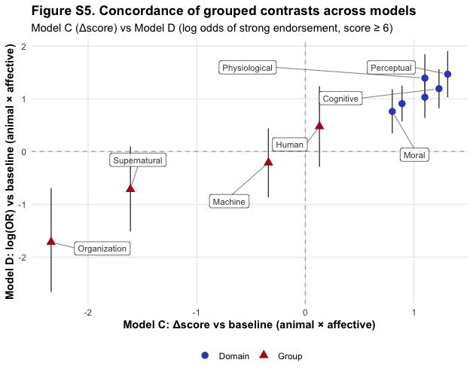
Figure S6 plots each grouped contrast from Model C (Δscore) against its counterpart from Model D (log-odds contrast for strong endorsement). Points fall within the expected quadrants (positive domains above/right; negative group contrasts below/left), indicating strong directional concordance between continuous and thresholded outcomes.

References
Auerswald, M., & Moshagen, M. (2019). How to determine the number of factors to retain in exploratory factor analysis: A comparison of extraction methods under realistic conditions. Psychological Methods, 24(4), 468–491. https://doi.org/10.1037/met0000200
Baayen, R. H., Davidson, D. J., & Bates, D. M. (2008). Mixed-effects modeling with crossed random effects for subjects and items. Journal of Memory and Language, Special Issue: Emerging Data Analysis, 59(4), 390–412. https://doi.org/10.1016/j.jml.2007.12.005
Bürkner, P.-C. (2017). Advanced Bayesian Multilevel Modeling with the R Package brms (arXiv:1705.11123). arXiv. https://doi.org/10.48550/arXiv.1705.11123
Bürkner, P.-C., & Vuorre, M. (2019). Ordinal Regression Models in Psychology: A Tutorial. Advances in Methods and Practices in Psychological Science, 2(1), 77–101. https://doi.org/10.1177/2515245918823199
Clarkson, D. B., & Jennrich, R. I. (1988). Quartic rotation criteria and algorithms. Psychometrika, 53(2), 251–259. https://doi.org/10.1007/BF02294136
Lim, S., & Jahng, S. (2019). Determining the number of factors using parallel analysis and its recent variants. Psychological Methods, 24(4), 452–467. https://doi.org/10.1037/met0000230
Mair, P. (2018). Modern Psychometrics with R. Springer International Publishing. https://doi.org/10.1007/978-3-319-93177-7
Meteyard, L., & Davies, R. A. I. (2020). Best practice guidance for linear mixed-effects models in psychological science. Journal of Memory and Language, 112, 104092. https://doi.org/10.1016/j.jml.2020.104092
Revelle, W., & Condon, D. (2019). Reliability from α to ω: A tutorial. Psychological Assessment, 31(12). https://psycnet.apa.org/buy/2019-45061-001
Shrout, P. E., & Fleiss, J. L. (1979). Intraclass correlations: Uses in assessing rater reliability. Psychological Bulletin, 86(2), 420–428. https://doi.org/10.1037/0033-2909.86.2.420
Simonsohn, U., Simmons, J. P., & Nelson, L. D. (2020). Specification curve analysis. Nature Human Behaviour, 4(11), 1208–1214. https://doi.org/10.1038/s41562-020-0912-z
Steegen, S., Tuerlinckx, F., Gelman, A., & Vanpaemel, W. (2016). Increasing Transparency Through a Multiverse Analysis. Perspectives on Psychological Science, 11(5), 702–712. https://doi.org/10.1177/1745691616658637

