Caputo et al. What value is provided by family forest land?: results from the National Woodland Owner Survey (NWOS)

Supplement 3: Estimating and mapping relative forest value
Relative forest value was calculated for the USDA Forest Inventory & Analysis (FIA) sample points in the CONUS. The true coordinates for all forested (i.e. COND_STATUS_CD=1), corporate and family-owned (i.e. OWNCD = 41 or 45) sample points were obtained from the FIA database (n=77,238). These points were intersected with a third-party, land parcel and landowner database (Parcelpoint by CoreLogic) in order to obtain estimates of assessed land value. Parcels less than 1 acre in size and those identified as likely to be tax-exempt were dropped from the dataset. In the final dataset, there were 45,447 qualifying points (58.8%). Assessed value was reported separately for the unimproved (i.e. the land itself) and the improved (i.e. buildings, development) aspects of the land, and we used the former exclusively. Raw data were current as of 2018 and all assessed values were transformed to 2018 dollars, using the Bureau of Labor (BLM) consumer price index (CPI). Because assessed value is only a coarse measure of market value, we chose to normalize the log of values on a relative [0,1] scale by dividing by the maximum value. In order to map these values across the CONUS, we then created a grid of regularly sized hexagons (50,000-m grid size) and determined the median relative forest value within each cell (Fig. S1).

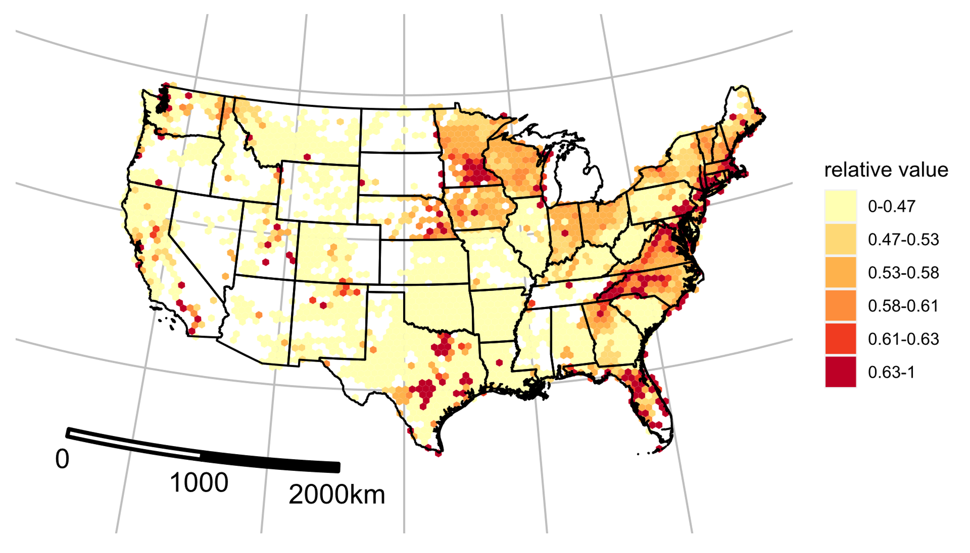
Figure S1: Median relative unimproved land value (log scale), private forest land. USA. 2018.

