Supplementary Materials to:

Comparative Effectiveness of Radical Surgery versus Concurrent Chemoradiotherapy in Stage IB3, IIA2, or IIICr Cervical Cancer: A Prospective, Multicenter, Propensity Score-Matched Cohort Study

Supplementary Treatment Plan……………………………………………………………………………………………………....2
Table S1. The recommended adjuvant therapy for patients with high-risk factors……………….…...3
Table S2. Sedlis’ criteria for external pelvic radiation after radical surgery in node-negative, margin-negative, parametria-negative cases………………………………………………………………………………….….…4
Table S3. The details of the chemotherapy schedule and radiotherapy technique………….……….5
Table S4. Postoperative follow-up schedule………………………………………………………………….……………….6
Table S5. Baseline characteristics and adverse effects before propensity score matching ……7-9
Table S6. Standardized mean difference (SMD) before and after propensity score matching…10
Supplementary Figure 1. Kaplan-Meier analysis of distant metastasis-free survival (DMFS) between the RS group and the definitive CCRT group after 1:3 PSM…………………………………………….11
Supplementary Figure 2. Kaplan-Meier analysis of OS and PFS between the RS subgroup with consistent preoperative and postoperative FIGO staging and the definitive CCRT group after 1:3 PSM……………………………………………………………….…………………………………………………………….………………12
Supplementary Figure 3. Kaplan-Meier analysis of distant metastasis-free survival (DMFS) between the tumor-free laparoscopic RS group and the open RS group after 1:1 PSM……………….13
Supplementary Figure 4. Kaplan–Meier analysis of PFS between the tumor-free laparoscopic RS subgroup with consistent preoperative and postoperative FIGO staging and the definitive CCRT group after 1:3 PSM.…………….……………………………………………………….…………………………………………14
Supplementary Figure 5. Subgroup Kaplan-Meier analysis of OS and PFS between the tumor-free laparoscopic RS group and the definitive CCRT group after 1:3 PSM…….……………………………15
Supplementary Figure 6. Subgroup Kaplan-Meier analysis of OS and PFS between the open RS group and the definitive CCRT group after 1:3 PSM…………….…………………………………………….…16
Supplementary Figure 7. Kaplan-Meier analysis of OS and PFS between the RS group and the definitive CCRT group after 1:2 PSM………………………………………………………………………………………….17
Supplementary Treatment Plan
Histopathological verification adheres to the WHO 2014 classification standards through dual independent review by board-certified gynecologic pathologists. Discordant cases undergo consensus review via multidisciplinary tumor board deliberation.
All histopathological diagnoses were confirmed according to the WHO 2014 classification criteria through independent dual review by board-certified gynecologic pathologists, with discordant cases resolved by multidisciplinary tumor board consensus.
Postoperative adjuvant therapy was administered based on standardized protocols: 1) For patients with high-risk features (lymph node metastasis, positive surgical margins, or parametrial involvement), treatment followed current NCCN guidelines (Tables S1-S2); 2) Intermediate-risk squamous cell carcinoma cases were managed according to Sedlis criteria incorporating tumor size, depth of stromal invasion, and LVSI status (Table S3); 3) For adenocarcinoma/adenosquamous carcinoma cases, adjuvant therapy was indicated when ≥2 of the following NCCN-defined risk factors were present: specific histology, LVSI positivity, deep stromal invasion (outer third), or tumor size >3 cm (Tables S1-S2).

Intensity-modulated external-beam radiotherapy (EBRT) was delivered at 45-50.4 Gy in 25-28 fractions (1.8 Gy/fraction, 5 fractions/week) with concurrent weekly cisplatin (40 mg/m²) starting on the first treatment day, while three-dimensional high-dose-rate brachytherapy (BT) was administered at week five using either 6 Gy×5 or 7 Gy×4 fractions (twice weekly) to the high-risk clinical target volume. Dose objectives required EQD2 ≥80 Gy for tumors <4 cm and ≥85 Gy for tumors ≥4 cm, with normal tissue constraints maintaining 2-mL doses of ≤65-75 Gy for rectum, ≤70-75 Gy for sigmoid, and ≤80-90 Gy for bladder, with treatment modifications implemented when necessary to stay within safe thresholds, though the combined intracavitary/interstitial approach typically achieved optimal dose distribution without exceeding organ limits. For cases with suspected lymph node metastases or parametrial invasion, boost radiation was delivered 60 Gy within normal tissue constraints, while common iliac/para-aortic nodal metastases received extended-field radiotherapy with simultaneous integrated boost (SIB) to 60-66 Gy, and parametrial invasion cases were treated with parametrial SIB to 60 Gy.
Table S1. The recommended adjuvant therapy for patients with high-risk factors
High-risk pathological factors | Recommended adjuvant therapy
Parametrial involvement | External-beam radiotherapy (EBRT) + platinum-containing concurrent chemotherapy
Vaginal resection margin involvement | EBRT + platinum-containing concurrent chemotherapy + vaginal brachytherapy
Pelvic lymph node metastasis | EBRT + platinum-containing concurrent chemotherapy

*Patients with para-aortic lymph node (PALN) metastasis by pathological confirmation or imaging evaluation should receive extended field radiotherapy.
*The recommended adjuvant therapy for squamous cell carcinoma patients who meet the Sedlis criteria is EBRT ± platinum-containing concurrent chemotherapy.
Table S2. Sedlis' criteria for external pelvic radiation after radical surgery in node-negative, margin-negative, parametria-negative cases
LVSI | Stromal Invasion | Tumor size (cm) (determined by clinical palpation)
+ | Deep 1/3 | Any
+ | Middle 1/3 | ≥ 2
+ | Superficial 1/3 | ≥ 5
- | Middle or Deep 1/3 | ≥ 4

*For adenocarcinoma and adenosquamous carcinoma, patients who meet the criteria of (1) +(2)/ (3)/ (4) need additional concurrent chemoradiotherapy (EBRT ± platinum-containing concurrent chemotherapy).
(1) histology (adenocarcinoma or adenosquamous carcinoma); (2) LVSI+; (3) stromal infiltration of the outer 1/3 of the uterine cervix; (4) tumor size larger than 3 cm

Table S3. The details of the chemotherapy schedule and radiotherapy technique
EBRT | Technology: IMRT  Treatment time: 4 weeks after surgery; < 8 weeks after surgery.  Therapeutic dose: EBRT is administered at a dose of 45-50.4 Gy in 25-28 fractions at a daily fraction of 1.8-2.0 Gy, 5 days per week.  Large unresectable metastatic lymph nodes require an additional simultaneous integrated boost (SIB) up to 2.1-2.4Gy.  In patients with parametrial invasion, SIB aiming for a total dose of 60 Gy is given.  In patients with pelvic lymph node, para-aortic lymph node, or retroperitoneal lymph node involvement, a SIB aiming for a total dose of 60-66 Gy is given.
Platinum-containing concurrent chemotherapy | Cisplatin (DDP) 40mg/m2/w starting on the first 2 days of the first week of EBRT for 5-6 cycles.
Vaginal brachytherapy | Technology: HDR, 3D  The total therapeutic dose depends on the residual condition.  The prescription is typically at 5mm below the vaginal surface.  Patients with close (R0) or positive (R1) vaginal mucosal surgical margins: equivalent dose at 2 Gy (EQD2) 70Gy.  Patients with imaging and visible lesions (R2): equivalent dose at 2 Gy (EQD2) 75-85Gy.

Table S4. Postoperative follow-up schedule
Postoperative time point (months) | Physical exam | LCT | HPV | Biomarkers | Imaging |  | Recurrence and survival | Quality of life | Side effects of adjuvant therapy
 |  |  |  | (SCCA, CA125, CA199, HE4, CEA | Ultrasound | CT, enhanced pelvic MRI, PET-CT | Recurrence and survival | Quality of life | Side effects of adjuvant therapy
1 | √ |  |  | √ | √ |  |  | √
3 | √ | √ |  | √ | √ |  | √ |  | √
6 | √ | √ | √ | √ | √ | √ | √ | √ | √
9 | √ | √ |  | √ | √ |  | √
12 | √ | √ | √ | √ | √ | √ | √ | √ | √
15 | √ | √ |  | √ | √ |  | √
18 | √ | √ | √ | √ | √ | √ | √ | √ | √
21 | √ | √ |  | √ | √ |  | √
24 | √ | √ | √ | √ | √ | √ | √ | √ | √
30 | √ | √ |  | √ | √ |  | √
36 | √ | √ | √ | √ | √ | √ | √ | √ | √
42 | √ | √ |  | √ | √ |  | √
48 | √ | √ | √ | √ | √ | √ | √ | √ | √
54 | √ | √ |  | √ | √ |  | √
60 | √ | √ | √ | √ | √ | √ | √ | √ | √

Table S5. Baseline characteristics and adverse effects before propensity score matching
Variables | Treatment strategy |  |  |  |  | Surgical approach
Variables | Radical surgery (RS) group  (n = 198) | Definitive CCRT † group (n = 48) | t/χ²/Z | p value |  | Tumor-free laparoscopic RS group (n = 119) | Open RS group (n = 79) | χ²/W | p value
Age (median [IQR]) | 53 [46, 58] | 53 [49, 61] | -1.644 ª | 0.104 |  | 54 [48, 58] | 52 [45, 58] | 1.439 ª | 0.152
Histological type |  |  | 2.254 ^{b} | 0.133 |  |  |  | 0.835 ^{b} | 0.361
Squamous cell carcinoma | 86.87% (172/198) | 95.83% (46/48) |  |  |  | 89.08% (106/119) | 83.54% (66/79)
Adenosquamous carcinoma/ Adenocarcinoma | 13.13% (26/198) | 4.17% (2/48) |  |  |  | 10.92% (13/119) | 16.46% (13/79)
Maximum tumor diameter, cm | 6.59 ± 1.77 | 5.67 ± 1.64 | 3.433 ª | 0.001 * |  | 6.40 ± 1.74 | 6.87 ± 1.78 | -1.837 ª | 0.068
FIGO stage |  |  | 1.911 ^{c} | 0.056 |  |  |  | 3.129 ^{b} | 0.372
I B3 | 17.68% (35/198) | 6.25% (3/48) |  |  |  | 19.33% (23/119) | 15.19% (12/79)
II A2 | 27.78% (55/198) | 18.75% (9/48) |  |  |  | 30.25% (36/119) | 24.05% (19/79)
III C1R | 47.47% (94/198) | 66.67% (32/48) |  |  |  | 45.38% (54/119) | 50.63% (40/79)
III C2R | 7.07% (14/198) | 8.33% (4/48) |  |  |  | 5.04% (6/119) | 10.13% (8/79)
FIGO stage III |  |  | 2.575 ^{b} | 0.109 |  |  |  | 0.185 ^{b} |  |  | 0.667
Maximum tumor diameter ≤4 cm | 12.04% (13/108) | 25.00% (9/36) |  |  |  | 10.00% (6/60) | 14.58% (7/48)
Maximum tumor diameter > 4 cm | 87.96% (95/108) | 75.00% (27/36) |  |  |  | 90.00% (54/60) | 85.42% (41/48)
Imaging-detected lymph node metastasis | 55.56% (110/198) | 75.00% (36/48) | 5.275 ^{b} | 0.022 * |  | 52.10% (62/119) | 60.76% (48/79) | 1.112 ^{b} |  |  | 0.291
Pelvic lymph nodes | 12.12% (24/198) | 20.83% (10/48) | 1.785 ^{b} | 0.182 |  | 11.76% (14/119) | 12.66% (10/79) | < 0.001 ^{b} |  |  | > 0.999
Parametrial nodes | 4.04% (8/198) | 8.33% (4/48) | 1.134 ^{c} | 0.257 |  | 5.88% (7/119) | 1.27% (1/79) | 1.447 ^{c} |  |  | 0.148
Iliac lymph nodes | 44.44% (88/198) | 56.25% (27/48) | 1.715 ^{b} | 0.190 |  | 42.86% (51/119) | 46.84% (37/79) | 0.165 ^{b} |  |  | 0.685
Inguinal nodes | 4.04% (8/198) | 10.42% (5/48) | 1.476 ^{c} | 0.140 |  | 5.04% (6/119) | 2.53% (2/79) | 0.705 ^{c} |  |  | 0.481
Retroperitoneal nodes | 4.55% (9/198) | 14.58% (7/48) | 2.326 ^{c} | 0.020 * |  | 2.52% (3/119) | 7.59% (6/79) | 1.405 ^{c} |  |  | 0.160
Paraaortic nodes | 7.58% (15/198) | 8.33% (4/48) | 0.291 ^{c} | 0.771 |  | 6.72% (8/119) | 8.86% (7/79) | 0.080 ^{b} |  |  | 0.778
Medically managed comorbidities
Hypertension | 16.16% (32/198) | 16.67% (8/48) | < 0.001 ^{b} | > 0.999 |  | 21.01% (25/119) | 8.86% (7/79) | 4.313 ^{b} |  |  | 0.038 *
Diabetes | 6.57% (13/198) | 14.58% (7/48) | 1.751 ^{c} | 0.080 |  | 6.72% (8/119) | 6.33% (5/79) | < 0.001 ^{b} |  |  | > 0.999
Anemia | 15.15% (30/198) | 14.08% (7/48) | < 0.001 ^{b} | > 0.999 |  | 11.76% (14/119) | 20.25% (16/79) | 2.042 ^{b} |  |  | 0.153
CCRT treatment strategy
CCRT + brachytherapy | — | 95.84% (46/48) |  |  |  | — | —
CCRT | — | 2.08% (1/48) |  |  |  | — | —
Unknown | — | 2.08% (1/48) |  |  |  | — | —
Department of surgery ‡ |  |  |  |  |  |  |  | 1.431 ^{b} |  |  | 0.232
Gynecologic oncology | 77.27% (153/198) | — |  |  |  | 73.95% (88/119) | 82.28% (65/79)
General gynecology | 22.73% (45/198) | — |  |  |  | 26.05% (31/119) | 17.72% (14/79)
Surgical procedure ‡
Open surgery | 40.00% (79/198) | — |  |  |  | — | —
Tumor-free laparoscopic surgery | 60.00% (119/198) | — |  |  |  | — | —
Adjuvant therapy ‡ |  |  |  |  |  |  |  | 0.156 ^{c} |  |  | 0.876
Chemoradiotherapy + brachytherapy | 19.19% (38/198) | — |  |  |  | 19.33% (23/119) | 18.99% (15/79)
Chemoradiotherapy | 77.27% (153/198) |  |  |  |  | 76.47% (91/119) | 78.48% (62/79)
Unknown | 3.54% (7/198) | — |  |  |  | 4.20% (5/119) | 2.53% (2/79)
Cervical stromal invasion ‡ |  |  |  |  |  |  |  | 1.645 ^{c} |  |  | 0.100
Superficial invasion | 2.53% (5/198) | — |  |  |  | 3.36% (4/119) | 1.27% (1/79)
Intermediate invasion | 6.06% (12/198) | — |  |  |  | 7.56% (9/119) | 3.80% (3/79)
Deep invasion | 37.37% (74/198) | — |  |  |  | 42.02% (50/119) | 30.38% (24/79)
Full-thickness invasion | 54.04% (107/198) | — |  |  |  | 47.06% (56/119) | 64.56% (51/79)
Positive surgical margins ‡ | 18.18% (36/198) | — |  |  |  | 17.65% (21/119) | 18.99% (15/79) | 0.003 ^{b} |  |  | 0.959
Perineural invasion | 15.15% (30/198) | — |  |  |  | 10.92% (13/119) | 21.52% (17/79) | 3.362 ^{b} |  |  | 0.067
Parametrial invasion ‡ |  |  |  |  |  |  |  | 2.738 ^{b} |  |  | 0.254
None | 70.20% (139/198) | — |  |  |  | 72.27% (86/119) | 67.09% (53/79)
Unilateral infiltration | 22.22% (44/198) | — |  |  |  | 22.69% (27/119) | 21.52% (17/79)
Bilateral infiltration | 7.58% (15/198) | — |  |  |  | 5.04% (6/119) | 11.39% (9/79)
Vaginal invasion ‡ |  |  |  |  |  |  |  | 1.347 ^{c} |  |  | 0.178
None | 41.92% (83/198) | — |  |  |  | 47.06% (56/119) | 34.18% (27/79)
Upper third | 55.05% (109/198) | — |  |  |  | 49.58% (59/119) | 63.29% (50/79)
Middle third | 3.03% (6/198) | — |  |  |  | 3.36% (4/119) | 2.53% (2/79)
Recurrence
Local recurrence^{d} | 3.03% (6/198) | — | — | — |  | 3.36% (4/119) | 2.53% (2/79) | < 0.001 ^{c} |  |  | > 0.999
Distant recurrence^{e} | 21.21% (42/198) | 22.92% (11/48) | 0.004 ^{b} | 0.951 |  | 20.17% (24/119) | 22.78% (18/79) | 0.069 ^{b} |  |  | 0.792
Unknown | 0.51% (1/198) | 2.08% (1/48) | 0.929 ^{c} | 0.353 |  | — | 1.27% (1/79) | — |  |  | —
Adverse events
Myelosuppression | 11.62% (23/198) | 62.50% (30/48) | 56.207 ^{b} | < 0.001 * |  | 4.20% (5/119) | 22.78% (18/79) | 14.211 ^{b} |  | < 0.001 *
Gastrointestinal symptoms | 12.12% (24/198) | 22.92% (11/48) | 2.858 ^{b} | 0.091 |  | 9.24% (11/119) | 16.46% (13/79) | 1.691 ^{b} |  |  | 0.194
Anemia | 1.01% (2/198) | 16.67% (8/48) | > 0.999 ^{c} | < 0.001 * |  | 0.84% (1/119) | 1.27% (1/79) | < 0.001 ^{c} |  |  | > 0.999
Edema | 34.85% (69/198) | 2.08% (1/48) | 18.795 ^{b} | < 0.001 * |  | 36.13% (43/119) | 32.91% (26/79) | 0.098 ^{b} |  |  | 0.754
Urinary system symptoms | 25.25% (50/198) | 2.08% (1/48) | 11.249 ^{b} | 0.001 * |  | 29.41% (35/119) | 18.99% (15/79) | 2.209 ^{b} |  |  | 0.137
Incisional pain | 16.16% (32/198) | 18.75% (9/48) | 0.047 ^{b} | 0.829 |  | 11.76% (14/119) | 22.78% (18/79) | 3.481 ^{b} |  |  | 0.062
Liver dysfunction | — | 8.33% (4/48) | — | — |  | — | — | — |  |  | —
Intestinal fistula | 0.51% (1/198) | 2.08% (1/48) | 0.929 ^{c} | 0.353 |  | — | 1.27% (1/79) | — |  |  | —
ª T-test ^{b} Chi-square test ^{c} Fisher's exact Test ^{d} Local recurrence included tumor and lymph metastasis located in the pelvic
^{e} Distant recurrence included distant metastasis beyond pelvic and lymph metastasis in the para-aortic area * p < 0.05
† Concurrent chemoradiotherapy ‡ Surgical approaches and postoperative parameters in radical surgery with adjuvant therapy group
Table S6. Standardized mean difference (SMD) before and after propensity score matching
PSM variable | Treatment strategy  Radical surgery (RS) vs Definitive CCRT |  | Surgical approach  Tumer-free laparoscopic RS vs Open RS
PSM variable | SMD before PSM | SMD after PSM | SMD before PSM | SMD after PSM
Age | 0.259 | 0.020 | 0.211 | 0.010
Histological type | 0.322 | 0.039 | 0.161 | 0.047
Maximum tumor diameter | 0.540 | 0.172 | 0.267 | 0.017
FIGO stage | 0.472 | 0.138 | 0.255 | 0.061
Lymph node metastasis | 0.415 | 0.115 | 0.174 | 0.058
SMD interpretation: 0-0.2, almost no difference; 0.2-0.5, little difference; 0.5-0.8, medium difference; 0.8-1.0, big difference. (Note: 1:3 PSM was used for radical surgery (RS) vs definitive CCRT, and 1:1 PSM for tumor-free laparoscopic RS vs open RS. After PSM, all SMDs < 0.2, indicating good baseline balance between groups.)

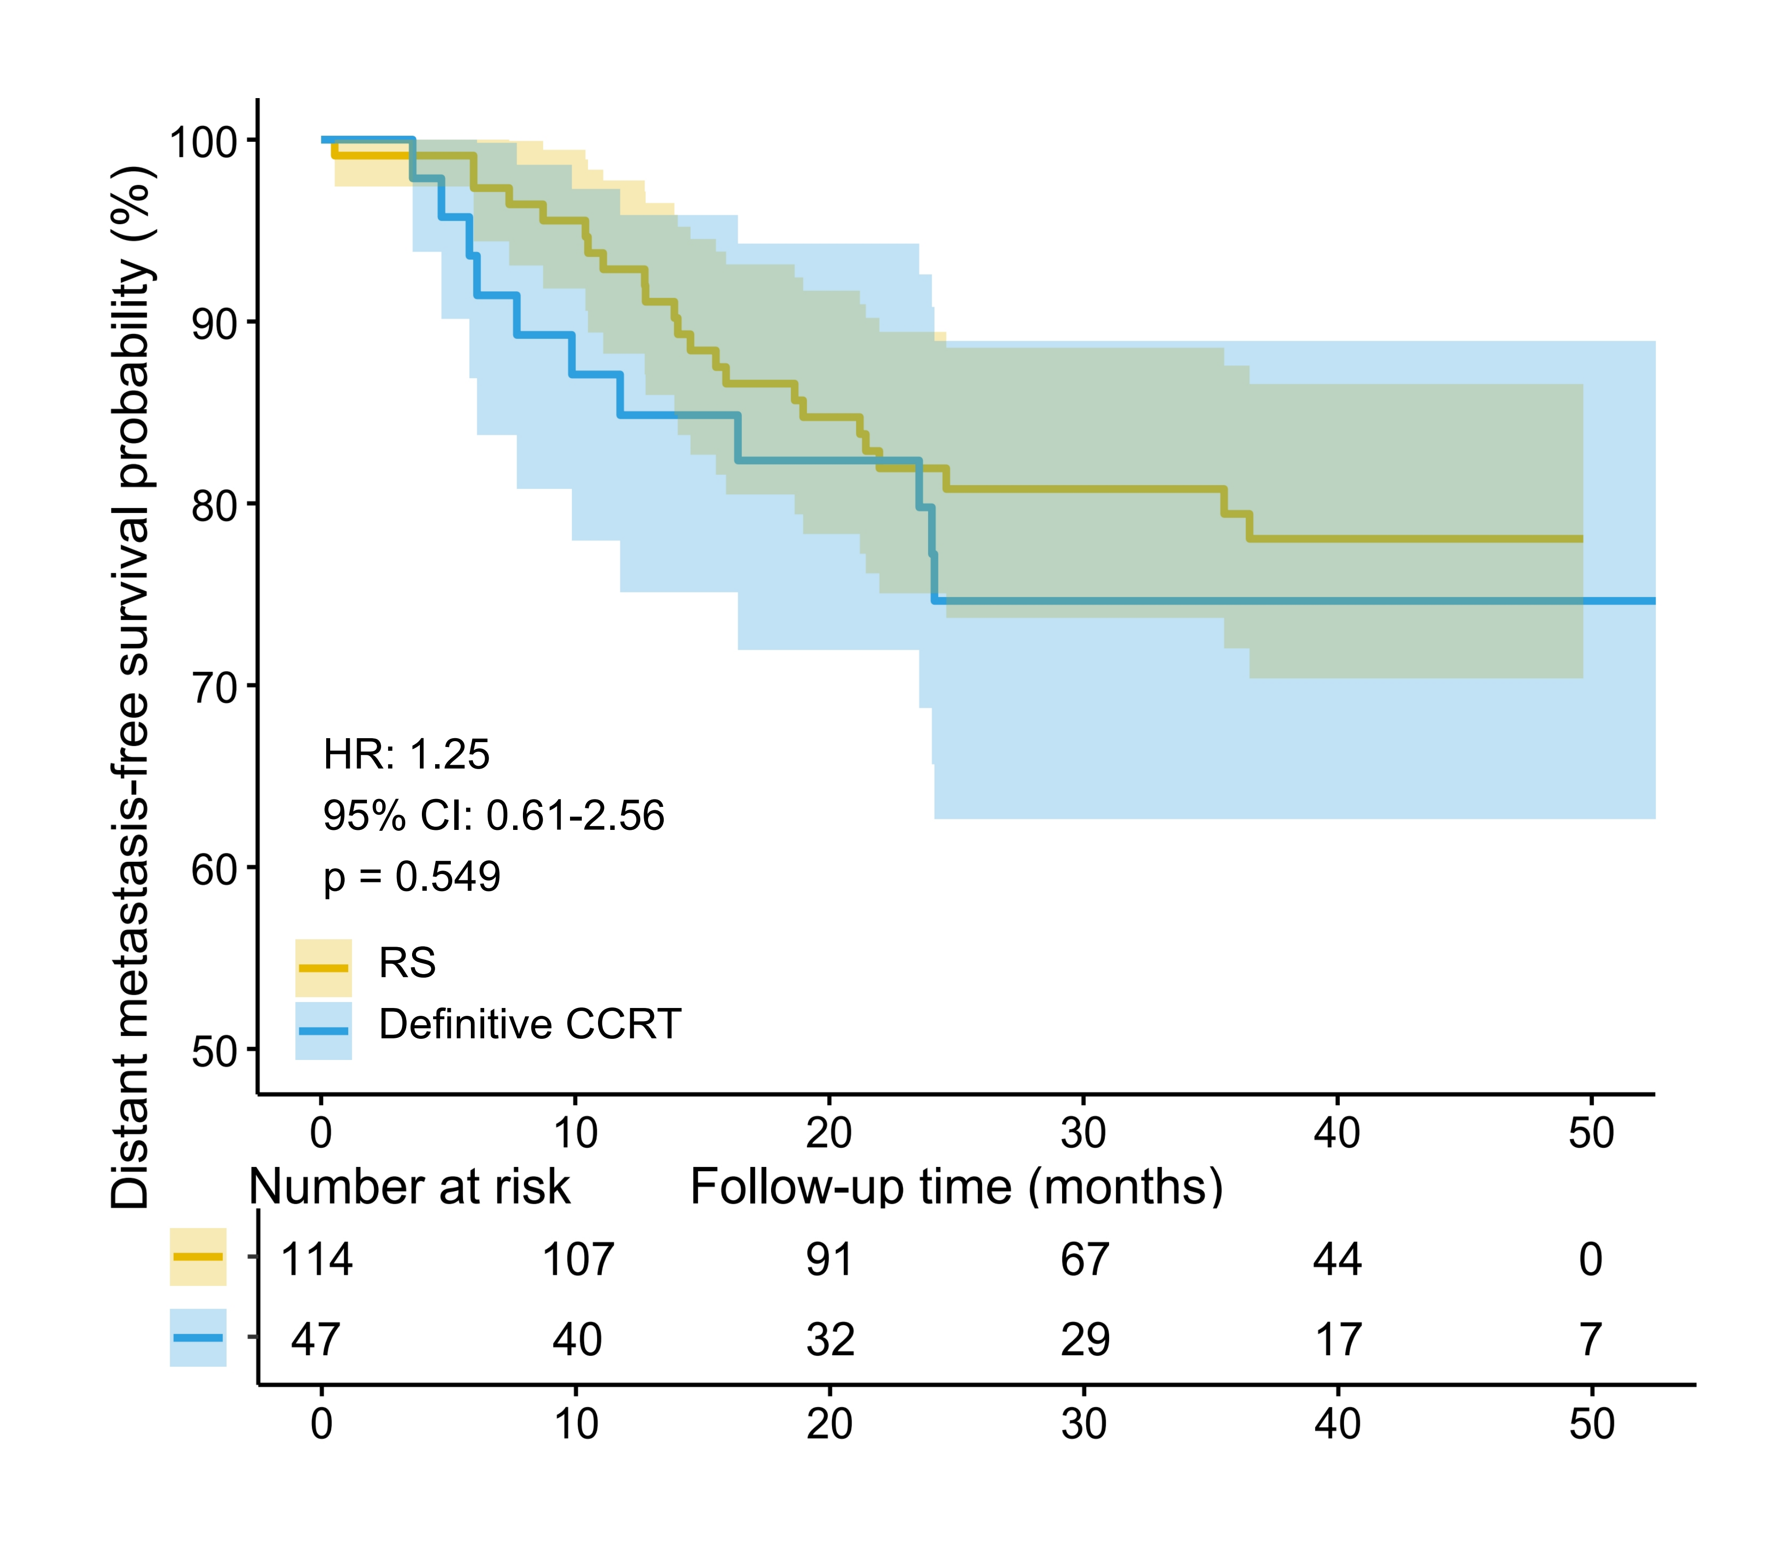

Supplementary Figure 1. Kaplan-Meier analysis of distant metastasis-free survival (DMFS) between the RS group and the definitive CCRT group after 1:3 PSM
The Kaplan-Meier analysis comparing the RS group and the definitive CCRT group after 1:3 PSM revealed no statistically significant differences in distant metastasis-free survival between the two groups.
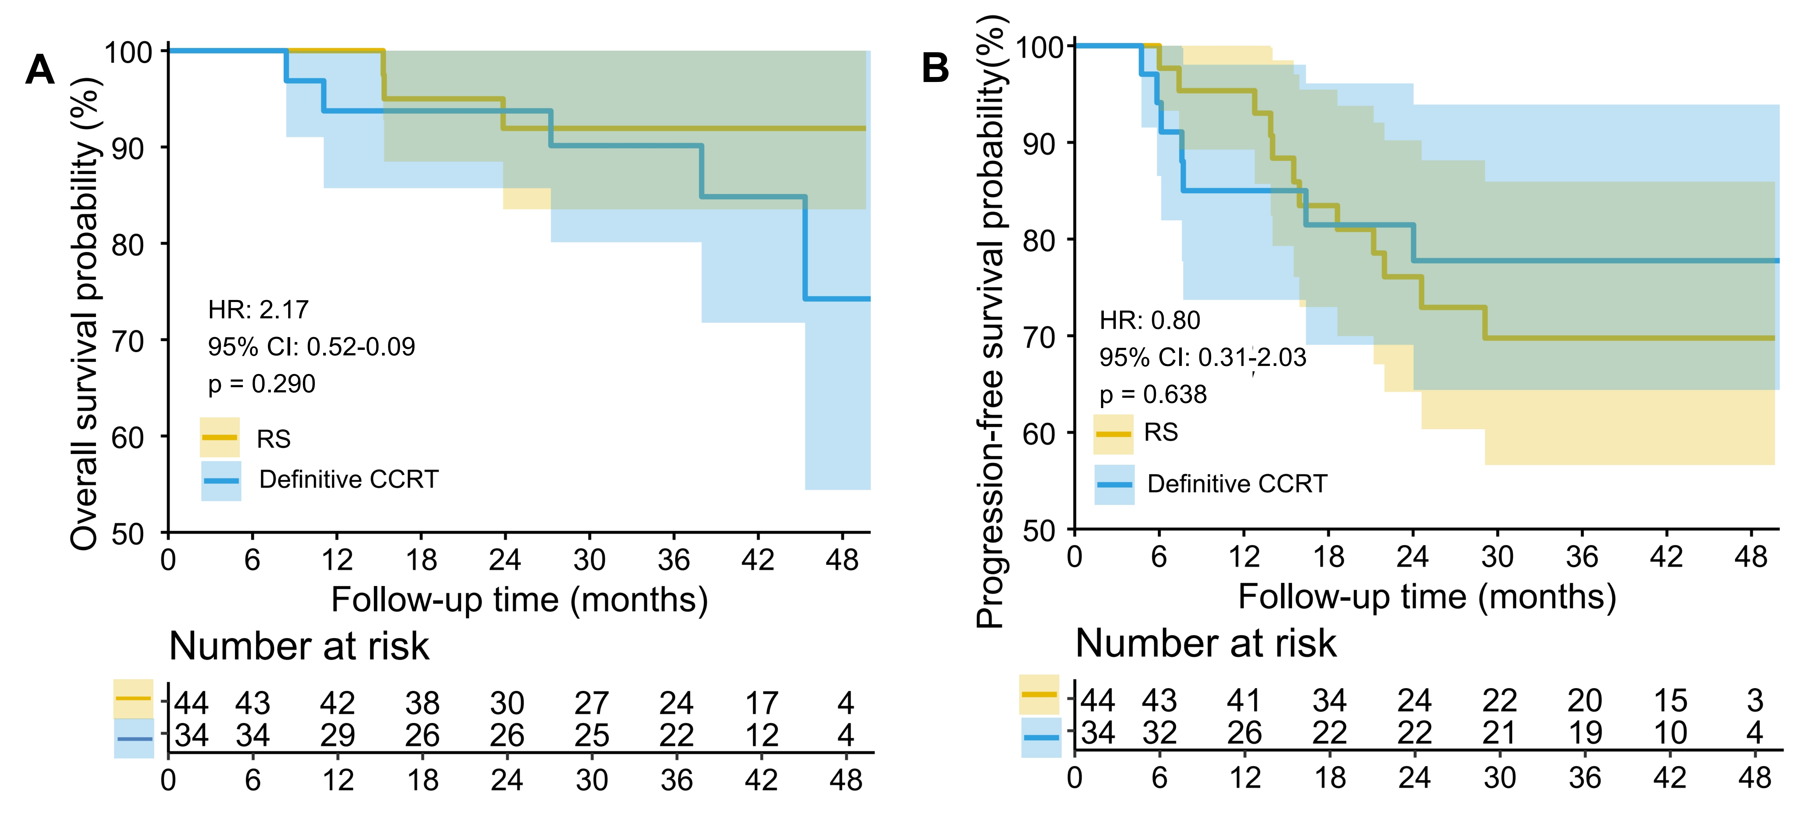
Supplementary Figure 2. Kaplan-Meier analysis of OS and PFS between the RS subgroup with consistent preoperative and postoperative FIGO staging and the definitive CCRT group after 1:3 PSM.
After 1:3 PSM between the RS group and definitive CCRT group, a subgroup of RS patients with consistent preoperative and postoperative FIGO staging and their matched counterparts in the definitive CCRT group were extracted. Kaplan-Meier analysis revealed no statistically significant differences in OS and PFS between the two groups.
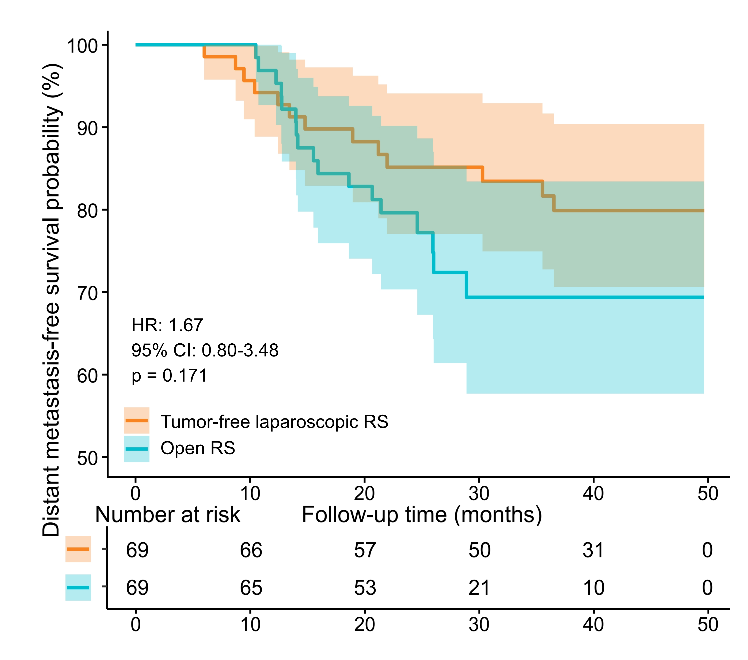

Supplementary Figure 3. Kaplan-Meier analysis of distant metastasis-free survival (DMFS) between the tumor-free laparoscopic RS group and the open RS group after 1:1 PSM
The Kaplan-Meier analysis comparing the tumor-free laparoscopic RS group and open RS group after 1:1 PSM showed no statistically significant differences in distant metastasis-free survival between the two groups.

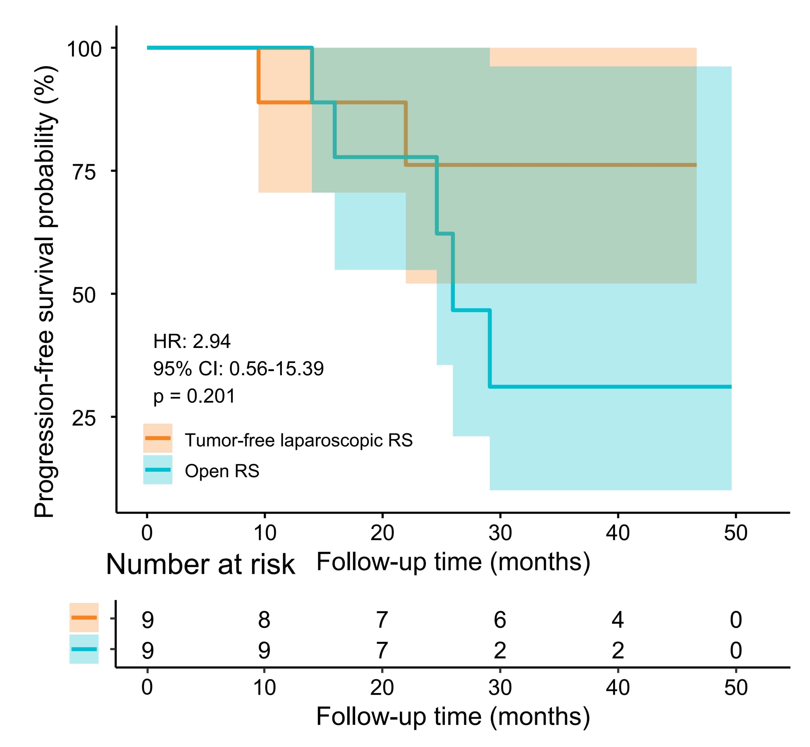
Supplementary Figure 4. Kaplan–Meier analysis of PFS between the tumor-free laparoscopic RS subgroup with consistent preoperative and postoperative FIGO staging and the definitive CCRT group after 1:3 PSM.
After 1:3 PSM between the RS group and definitive CCRT group, a subgroup of the tumor-free laparoscopic RS patients with consistent preoperative and postoperative FIGO staging and their matched counterparts in the definitive CCRT group were extracted. Kaplan-Meier analysis revealed no statistically significant differences in PFS between the two groups. (No death events occurred, making OS comparisons impossible.)
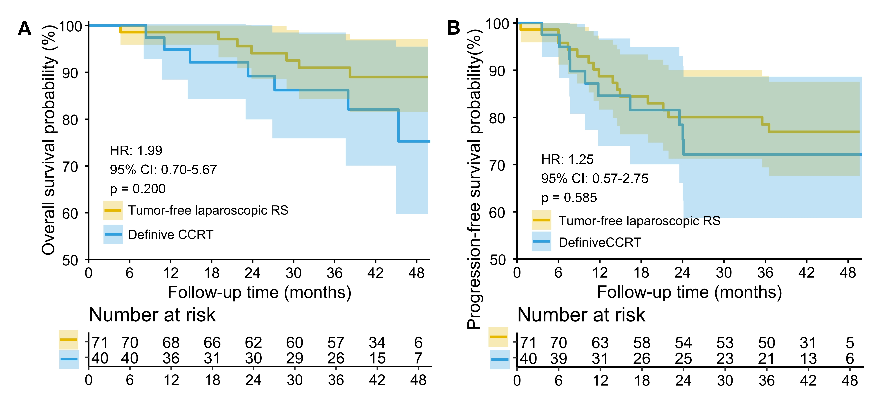
Supplementary Figure 5. Subgroup Kaplan-Meier analysis of OS and PFS between the tumor-free laparoscopic RS group and the definitive CCRT group after 1:3 PSM
After 1:3 PSM between the RS group and definitive CCRT group, a subgroup of patients who underwent tumor-free laparoscopy RS and their matched counterparts in the definitive CCRT group were extracted. Kaplan-Meier analysis revealed no statistically significant differences in OS and PFS between the two groups.

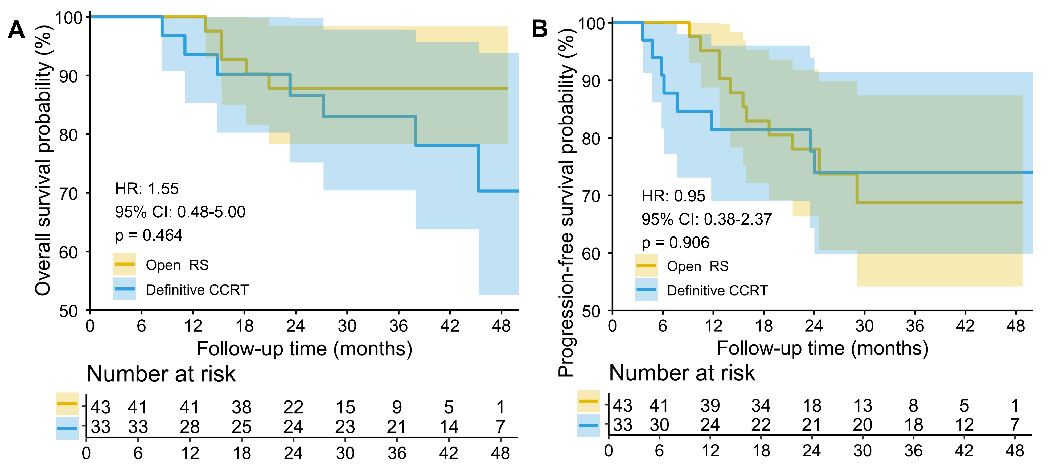
Supplementary Figure 6. Subgroup Kaplan-Meier analysis of OS and PFS between the open RS group and the definitive CCRT group after 1:3 PSM
After 1:3 PSM between the RS group and definitive CCRT group, a subgroup of patients who underwent open RS and their matched counterparts in the definitive CCRT group were extracted. Kaplan-Meier analysis revealed no statistically significant differences in OS and PFS between the two groups.

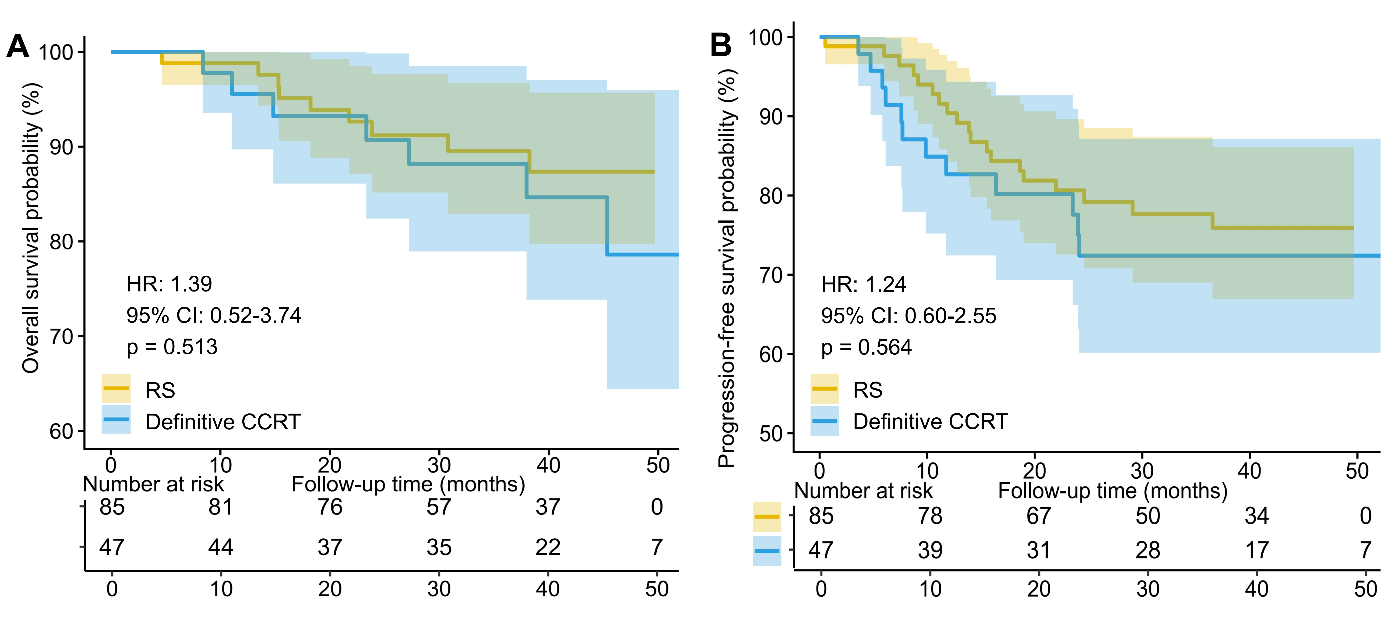
Supplementary Figure 7. Kaplan-Meier analysis of OS and PFS between the RS group and the definitive CCRT group after 1:2 PSM
After a 1:2 PSM between the RS group and definitive CCRT group, no significant differences in OS or PFS were observed.

