Supplementary materials
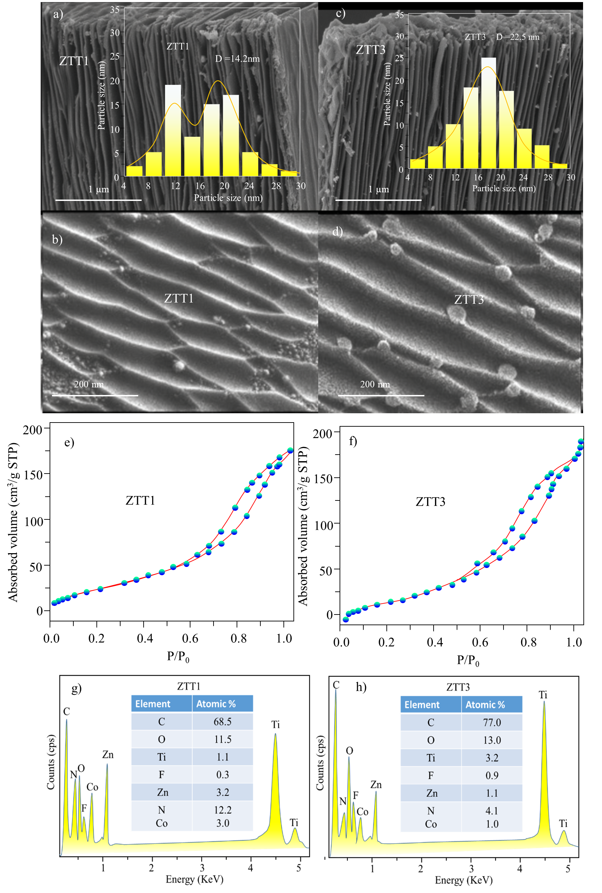
Fig.S1-SEM image of ZTT1 (a, b) and ZTT3 (c, d) and their N₂ adsorption-desorption isotherm curves (e, f) and EDX spectra (g, h). Insets: The particle distribution histograms

