Gonadal histology of adult western mosquitofish (Gambusia affinis) following early life exposure to 17α-ethynylestradiol, 17β- trenbolone, and/or atrazine

Caroline Matkin* 0000-0002-7701-8255, Bruce Felgenhauer, Paul Klerks 0000-0001-9895-5144
Department of Biology, University of Louisiana at Lafayette, 410 E. St. Mary Blvd, Lafayette, LA 70503
Corresponding author: carolinematkin1@gmail.com
In preparation for Archives of Environmental Contamination and Toxicology

Supplementary Information
Supplemental information is provided on (Fig. S1) experimental timeline; (Table S1) treatment groups; (Table S2) analytical chemistry; (Fig. S2) survival results; and (Table S3) sex ratio results.

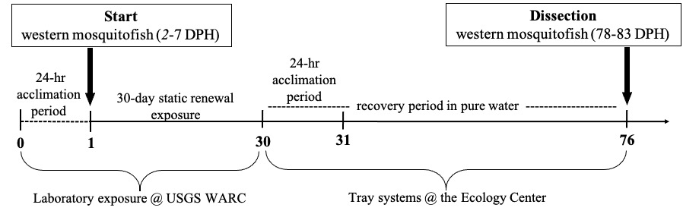

Fig. S1 Timeline of the 76-day experiment with western mosquitofish (Gambusia affinis), including two on site 24-hour acclimation periods (in moderately hard reconstituted fresh water and well water, respectively), early life 30-day static renewal exposure, and a 46-day recovery period.

Table S1: Treatment groups (n = 9) and compound concentrations used in 30-day static renewal exposure.
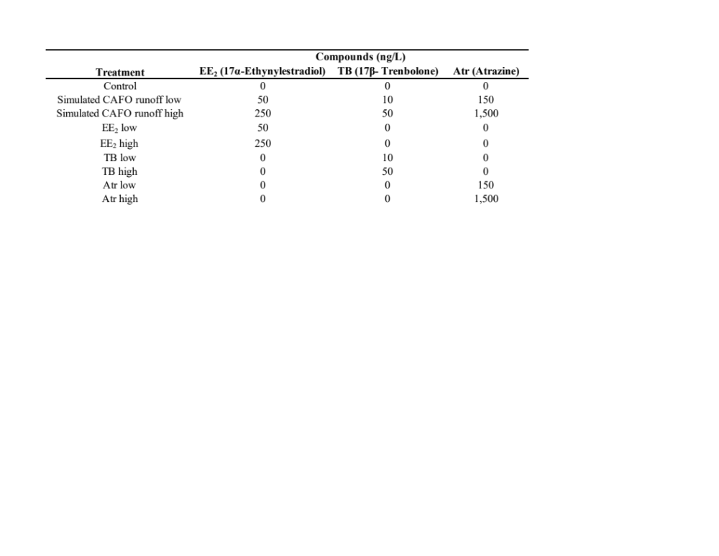

Chemical Analyses Overview:
SPE was necessary due to the low concentration of compounds present in solution, thus it was essential to concentrate the compounds in order to quantify. To begin, the starting volume was 400 mL (volume used in exposures) and then after SPE the volume was reduced to 2 mL (volume reduction, but not compound reduction). Next, the sample was brought to complete dryness to again reduce the amount of volume, and then rehydrated to a final volume of 50 µL. A volume of 50 µL supplies two injections into the HPLC. The concentration in each 25 µL must have a high enough concentration in order to be greater than the limit of detection (LOD) of the HPLC. In summation, this explains why an injection of 25 µL from the 400 mL exposure solution was not possible as the concentration would have been below the LOD.

Table S2: HPLC gradient for separation of EE₂, TB, and Atr using a Pinnacle DB Biphenyl column. Flow rate = 1 mL/min, Solvent A = DiH2O, Solvent B = Acetonitrile. EE₂, 17α -ethynylestradiol; TB, 17β- trenbolone; Atr, Atrazine.

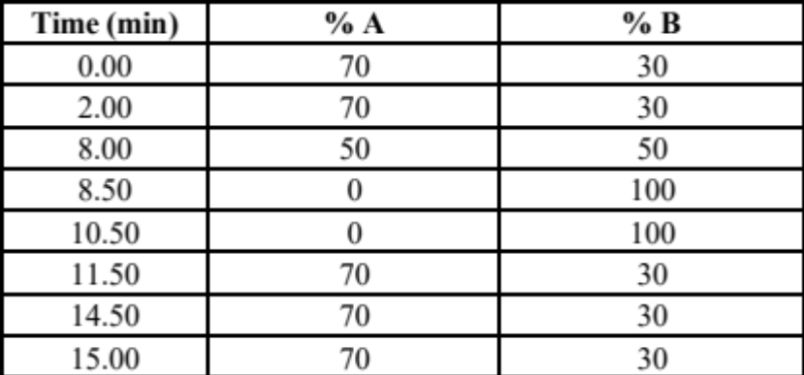

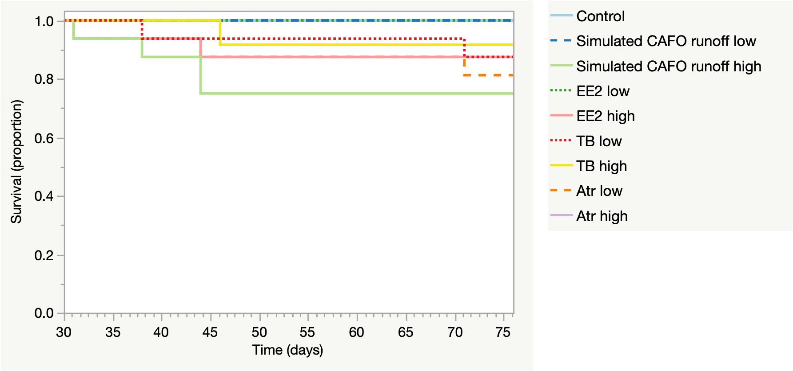
Fig. S2 Survival (proportion) of western mosquitofish (Gambusia affinis) during the 30–76-day recovery period following a 30-day exposure to the following treatments: Control; Simulated CAFO runoff low (50 ng/L EE₂, 10 ng/L TB, and 150 ng/L Atr; Simulated CAFO runoff high (250 ng/L EE₂, 50 ng/L TB, and 1,500 Atr); EE₂ low (50 ng/L); EE₂ high (250 ng/L); TB low (10 ng/L); TB high (50 ng/L); Atr low (150 ng/L); and Atr high (1,500 ng/L). Four individuals exposed to TB high escaped their containers and could not be recovered, therefore the data was censored in the survival analysis No deaths occurred during the 30-day exposure period. Data for males and females were combined in each treatment for analysis. Survival did not differ among treatments (P = 0.061 in Kaplan Meier survival analysis). EE₂, 17α -ethynylestradiol; TB, 17β- trenbolone; Atr, Atrazine

Table S3: Sex ratios (as percentages) and female sexual maturity (as percentages) of western mosquitofish (Gambusia affinis) determined on day 76 after exposure to treatments‡. Sex ratio and female sexual maturity were evaluated visually on the basis of external secondary sex characteristics. Fish with a modified anal fin (gonopodium) were designated as male, whereas those without a gonopodium were designated female. Female sexual maturity was determined based on the presence or absence of a gravid spot, where the gravid spot indicated sexual maturity while its absence indicated sexually immaturity. EE₂, 17α -ethynylestradiol; TB, 17β- trenbolone; Atr, Atrazine. n = number of individuals.
