Supplemental appendix
Human epithelial tooth organoids model disrupted amelogenesis following environmental and therapeutic exposures
Steffie Hasevoets^{1*}, Florian Hermans¹, Joeri Meyns^{2,3}, Hugo Vankelecom⁴, Heidi Declercq⁵, Esther Wolfs¹, Ivo Lambrichts¹, Annelies Bronckaers¹
¹Biomedical Research Institute (BIOMED), Faculty of Medicine and Life Sciences, Hasselt University, 3590 Diepenbeek, Belgium
²Department of Oral and Maxillofacial Surgery, General Hospital St-Jan, Synaps Park 1, 3600 Genk, Belgium
³LCRC, Faculty of Medicine and Life Sciences, Hasselt University, 3590 Diepenbeek, Belgium
⁴Laboratory of Tissue Plasticity in Health and Disease, Cluster of Stem Cell and Developmental Biology, Department of Development and Regeneration, KU Leuven, 3000 Leuven, Belgium.
⁵Tissue Engineering Lab, Department of Development and Regeneration, KU Leuven campus KULAK, 8500 Kortrijk, Belgium
*Corresponding author
- Supplemental Figures
- Supplemental Tables

- Supplemental Figures
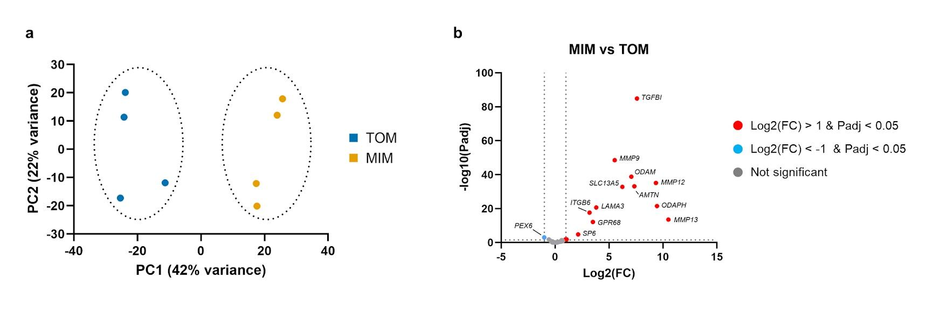Supplemental Figure 1: RNA-seq analysis of ETOs grown in TOM or MIM conditions demonstrates ameloblast-like differentiation. (a) PCA plot showing clear separation between TOM and MIM samples. (b) Volcano plot highlighting differentially expressed genes from the GSEA ‘amelogenesis’ and ‘amelogenesis imperfecta’ gene sets, indicates overall upregulation of amelogenesis-associated genes in MIM compared to TOM (n = 4 biological replicates).
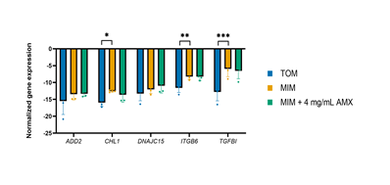
Supplemental Figure 2: Validation of candidate genes from RNA-seq analysis with qRT-PCR. (a) Normalized gene expression levels of ADD2, CHL1, DNAJC15, ITGB6, TGFBI. Data are presented as mean ± SEM. Statistical analyses were performed as described in Materials and Methods (P ≤ 0.05) (n = 4 biological replicates).
Supplemental Figure 3: Full-length western blots corresponding to AMX-treated samples. (a) Representative full western blot showing β-actin (~42 kDa) and DSG1 (~150 kDa). (b) Representative full western blots showing β-actin and HSPA5 (~78 kDa). Red boxes indicate the regions that were cropped and presented in the main figures.
Supplemental Figure 3: Full-length western blots corresponding to VB and VC-treated samples. (a) Representative full western blot showing β-actin (~42 kDa) and TUBA (~50 kDa). (b) Representative full western blots showing β-actin and HSPA5 (~78 kDa). Red boxes indicate the regions that were cropped and presented in the main figures.
- Supplemental Tables
Supplemental Table 1 – Patient list of produced organoid lines
Patient number | Age | Gender
P55 | 15 | Male
P56 | 16 | Male
P61 | 17 | Female
P62 | 19 | Male
P70 | 16 | Male
P72 | 13 | Male
P73 | 17 | Female
P77 | 15 | Female
P78 | 19 | Female
P79 | 16 | Male
P81 | 17 | Female
LP82 | 15 | Female
P84 | 15 | Female
P85 | 14 | Female
P87 | 15 | Male
P88 | 17 | Female
P111 | 18 | Male
LP135 | 16 | Female

Supplemental Table 2 – Composition of collection medium
Product | Concentration | Supplier | Catalogue Number
αMEM |  | Sigma-Aldrich | M4526
FCS | 10% | Sigma-Aldrich | F7524
Pen/Strep | 1% | Gibco | 15140-122
Amphotericin B | 0.5% | Gibco | 15290018

Supplemental Table 3 – Composition of dissociation medium
Product | Concentration | Supplier | Catalogue Number
PBS |  | Gibco | 10010-015
Collagenase IV | 3 mg/mL | Gibco | 17104-019
Dispase II | 4 mg/mL | Sigma-Aldrich | D4693

Supplemental Table 4 – Composition of medium A
Product | Concentration | Supplier | Catalogue Number
DMEM high glucose |  | Gibco | 52100039
HEPES | 1% | Sigma-Aldrich | H4034
Pen/Strep | 1% | Gibco | 15140-122
BSA | 3 g/L | PAN-Biotech | 47330.03
DNase | 0.4 mg/mL | Sigma-Aldrich | D5025-15KU

Supplemental Table 5 – Composition of SFDM, prepared with a pH of 7.3
Product | Concentration | Supplier | Catalogue Number
Water suitable for cell culture |  | Capricorn Scientific | WAT-1000ML
DMEM 1:1 F12 without FE | 16.8 g/L | Invitrogen | 074-90715A
Transferrin | 5 mg/L | Serva | 36760.01
Insulin from bovine pancreas | 5 mg/L | Sigma-Aldrich | I6634
Penicillin | 35 mg/L | Sigma-Aldrich | P3032
Streptomycin | 50 mg/L | Sigma-Aldrich | S6501
Ethanol absolute (≥ 99.8%) | 600 µl/L | Fisher chemical | E/0650DF/15
Catalase from bovine liver | 50 µl/L | Sigma-Aldrich | C100
NaHCO₃ | 1 g/L | Merck | 106329
BSA | 5 g/L | Serva | 47330.03

Supplemental Table 6 – Composition of TOM
Product | Concentration | Supplier | Catalogue Number
SFDM | See Supplemental Table 5
A83-01 | 0.5 µM | Sigma-Aldrich | SML0788
B27 (without vitamin A) | 2% | Gibco | 12587-010
Cholera Toxin | 100 ng/mL | Sigma-Aldrich | C8052
FGF2 | 20 ng/mL | Biotechne | 234-FSE
FGF8 | 200 ng/mL | PeproTech | AF-100-25
FGF10 | 100 ng/mL | PeproTech | 100-26
Glutamax | 2 mM | Gibco | 35050061
IGF-1 | 100 ng/mL | PeproTech | 100-11
N-acetyl-L-cysteine | 1.25 mM | Sigma-Aldrich | A7250
Nicotinamide | 10 mM | Sigma-Aldrich | N0636
Noggin | 100 ng/mL | PeproTech | 120-10C
RSPO1 | 200 ng/mL | PeproTech | 120-38
SB202190 | 10 µM | Biotechne | 1264/10
SHH | 100 ng/mL | Biotechne | 464-SH
WNT3A | 200 ng/mL | Biotechne | 5036-WN

Supplemental Table 7 – Composition of MIM
Product | Concentration | Supplier | Catalogue Number
KBM |  | Lonza | CC-3104
Calcium Chloride | 0.09 mM | Thermo Fisher Scientific | 349610250
EGF | 1 ng/mL | Biotechne | 236-EG
Bovine Pituitary Extract | 50 µg/mL | Thermo Fisher Scientific | 11568866
Tested supplements in MIM
Amoxicillin | 0.1 – 4 mg/mL | Sigma-Aldrich | A8523
Bisphenol A | 0.4 – 30 µg/mL | Merck | 239658
Vinblastine | 25 – 500 nM | Thermo Fisher Scientific | 203450050
Vincristine | 25 – 500 nM | Thermo Fisher Scientific | 203440050

Supplemental Table 8 – Sequences of forward and reverse primers used in quantitative qRT-PCR
Gene | Forward primer (5’-3’) | Reverse primer (5’-3)
AMTN | TGTCTTCTAGGATCAACTCGGT | TGGTTTGGTAGTGTTCCCTGA
CycA | AGACTGAGTGGTTGGATGGC | TCGAGTTGTCCACAGTCAGC
DSG1 | CTGCTGGCATTGGACTCCTCAT | CATTCGGGAACAGGCTCAAAGC
DSPP | TGGCGATGCAGGTCACAAT | CCATTCCCACTAGGACTCCCA
HSPA5 | CATCACGCCGTCCTATGTCG | CGTCAAAGACCGTGTTCTCG
OCLN | ACAAGCGGTTTTATCCAGAGTC | GTCATCCACAGGCGAAGTTAAT
ODAM | CAGGCCAAGTTGATCCCTTA | GAGGTTGTTCCCAGGGTAG
TUBA | CGGGCAGTGTTTGTAGACTTGG | CTCCTTGCCAATGGTGTAGTGC
VWDE | ACTGCTGTCTCTTTCAAATCCC | CCGCACAGTAGCCCATACAT

Supplemental Table 9 – Antibodies used for Western blot
Target | Host | Dilution | Supplier | Catalogue Number
Primary antibodies
AMELX | Mouse | 1:1000 | Santa-Cruz | sc-365284
ꞵ-actin | Mouse | 1:1000 | Santa-Cruz | sc-47778
DSG1 | Rabbit | 1:1000 | ProteinTech | 24587-1-AP
HSPA5 | Rabbit | 1:1000 | ProteinTech | 11587-1-AP
TUBA | Rat | 1:1000 | Novus Biologicals | NB600-506
Secondary antibodies
HRP-labeled anti-mouse | Rabbit | 1:2000 | Dako | P0260
HRP-labeled anti-rabbit | Goat | 1:2000 | Dako | P0448
HRP-labeled anti-rat | Rabbit | 1:5000 | Abcam | AB6734

