SUPPLEMENTARY
Supplementary Table 1 Socioeconomic status, behavioural factors and physical activity patterns stratified by glucose tolerance status
Socio-economic status and behavioral factors
 | All (n=65) | NGT (n=29) | IGT (n=24) | T2D (n=12) | p -value
Age (years) | 56 (50-60) | 56(50-56) | 56 (49-50) | 58(53-61) | 0.485
Sociodemographic factors
Marital status, n (%)
Unmarried | 33 (50.8) | 15 (51.7) | 12 (50.0) | 6 (50.0) | 0.990
Married | 32 (49.2) | 14(48.3) | 12 (50.0) | 6 (50.0) | 0.990
Highest level of education, n (%)
Primary/Some secondary education | 33 (60.0) | 19 (65.5) | 13 (54.2) | 7 (58.3) | 0.697
Completed Grade 12/ Tertiary education | 26 (40.0) | 10(34.5) | 11 (45.8) | 5(41.7) | 0.697
Employment, n (%)
Unemployed | 32 (49.2) | 15 (51.7) | 12 (50.0) | 5 (41.7) | 0.897
Employment | 33 (50.8) | 14 (48.3) | 12 (50.0) | 7 (58.3) | 0.897
Behavioral and lifestyle factors
Smoking status, n (%)
Never smoked | 64 (98.5) | 28 (96.6) | 24 (100%) |  | 1.00
Current smoker | 1 (1.5) | 1 (3.4) |  | 12 (100%) | 1.00
Alcohol intake, n (%)
No/Never | 57 (91.9) | 26 (92.9) | 21 (91.3) | 10 (90.90 | 1.00
Yes | 5 (8.1) | 2 (7.1) | 2 (8.7) | 1 (9.1) | 1.00
Actigraphy data (Physical activity)
Light (min/d) | 379.3 ± 94.9 | 378.1 ± 100.9 | 393.3 ± 101.3 | 354.2 ± 62.1 | 0.542
Total MVPA (min/d) | 38.0 (24.3 - 52.8) | 40.5 (27.3 - 57.9) | 41.8 (24.3 - 54.0) | 33.3 (7.7 - 44.0) | 0.356
MVPA (% per day) | 4.6 (3.1 - 5.8) | 4.9 (3.1 - 6.5) | 4.6 (3.2 - 6.0) | 4.0 (0.9 - 4.6) | 0.464
Total MVPA (mins/wk) | 266.0  (170.3 - 369.8) | 283.5  (191.1 - 405.4) | 292.6  (170.3 - 378.0) | 233.3  (53.7 - 308.0) | 0.356
ActivPal data (Sedentary behaviour)
Sedentary (min/d) | 501.0 ± 137.0 | 504.0 ± 151.0 | 495.0 ± 134.4 | 510.2 ± 114.1 | 0.948
Sedentary (% per day) | 50.6 ± 13.2 | 50.1 ± 13.4 | 49.8 ± 13.5 | 53.2 ± 12.7 | 0.751
Standing (% per day) | 37.2 ± 10.8 | 37.5 ± 10.8 | 37.4 ± 11.4 | 36.2 ± 10.4 | 0.939
Stepping (% per day) | 11.8 (9.4 - 14.0) | 11.9 (8.8 - 14.8) | 12.1 (10.2 - 13.6) | 10.0 (8.3 - 13.2) | 0.418
Steps per day | 8333.3  (7120.7 - 10661.7) | 8275.4  (7194.9 - 12579.7) | 8978.9  (7349.0 - 9789.1) | 7437.7  (5612.6 - 10317.0) | 0.419
Data are presented as means ± SD or median (25th-75th percentile) and n (%), as appropriate. P-value were calculated using one-way analysis of variance (ANOVA) or Kruskal-Wallis test for continuous variables, and Fishers or Chi-square tests for categorical variables. Abbreviations: NGT, normal glucose tolerance; IGT, impaired glucose tolerance; T2D, type 2 diabetes; MVPA, moderate-to-vigorous physical activity.

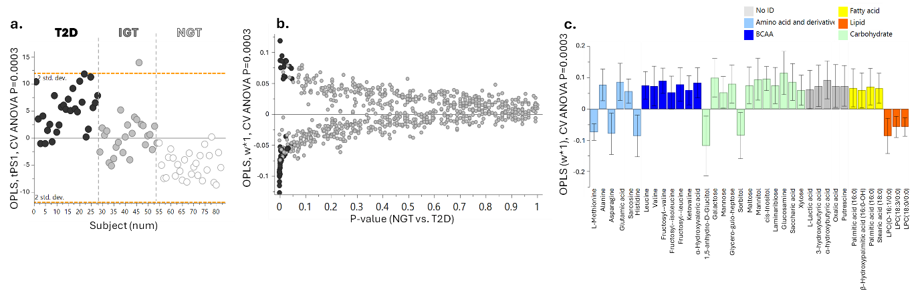
Supplementary Fig. 1 Differences in fasting metabolites by glycaemic group. a.) OPLS model illustrating differences in metabolite signatures between individuals with normal glucose tolerance (NGT) and type 2 diabetes (T2D), with individuals with impaired glucose tolerance (IGT) predicted into the model. b.) Glycaemic group-related differences in the fasting circulating metabolites. The Y-axis represents OPLS-derived differences across all metabolites, while the X-axis shows corresponding p-values. c.) OPLS weights (w*) of metabolites distinguishing NGT from T2D were determined through a combined univariate and multivariate analysis at a 95% confidence level. Positive w* values indicate higher levels in T2D, while negative w* values indicate higher levels in NGT. Metabolites are categorised by biochemical class, including amino acids, branched-chain amino acids (BCAA), carbohydrates, lipids, fatty acids and unclassified metabolites. Abbreviations: OPLS, Orthogonal Partial Least Squares; NGT, Normal Glucose Tolerance; T2D, Type 2 Diabetes; IGT, Impaired Glucose Tolerance

