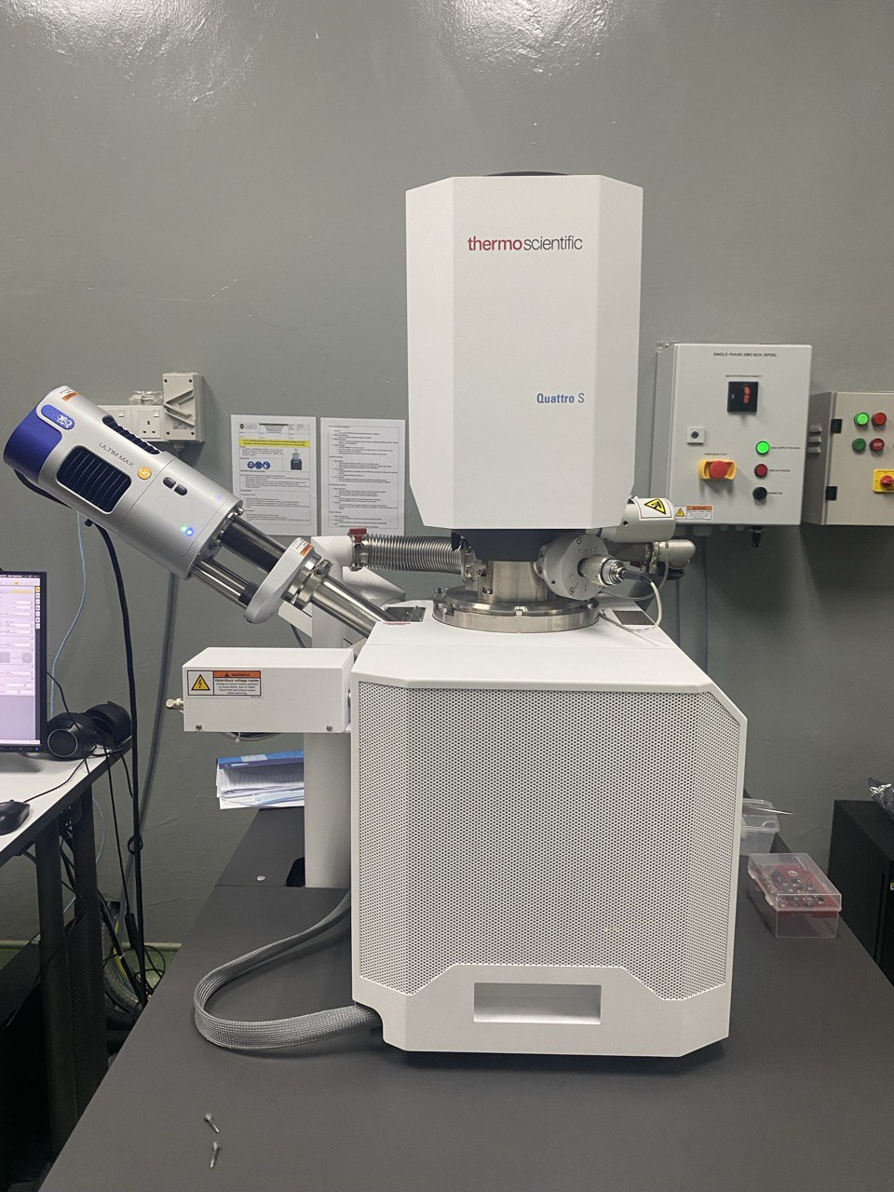
Figure 1. Field-Emission Scanning Electron Microscope (FESEM; Thermo Scientific Quattro S)

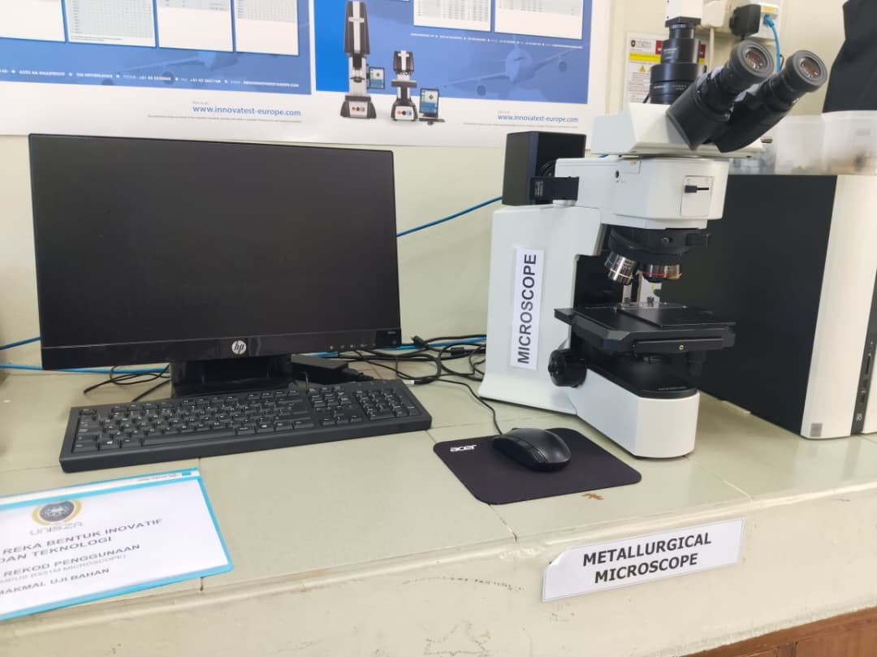
Figure 2. BX51M Optical Microscope (Olympus, Tokyo, Japan)
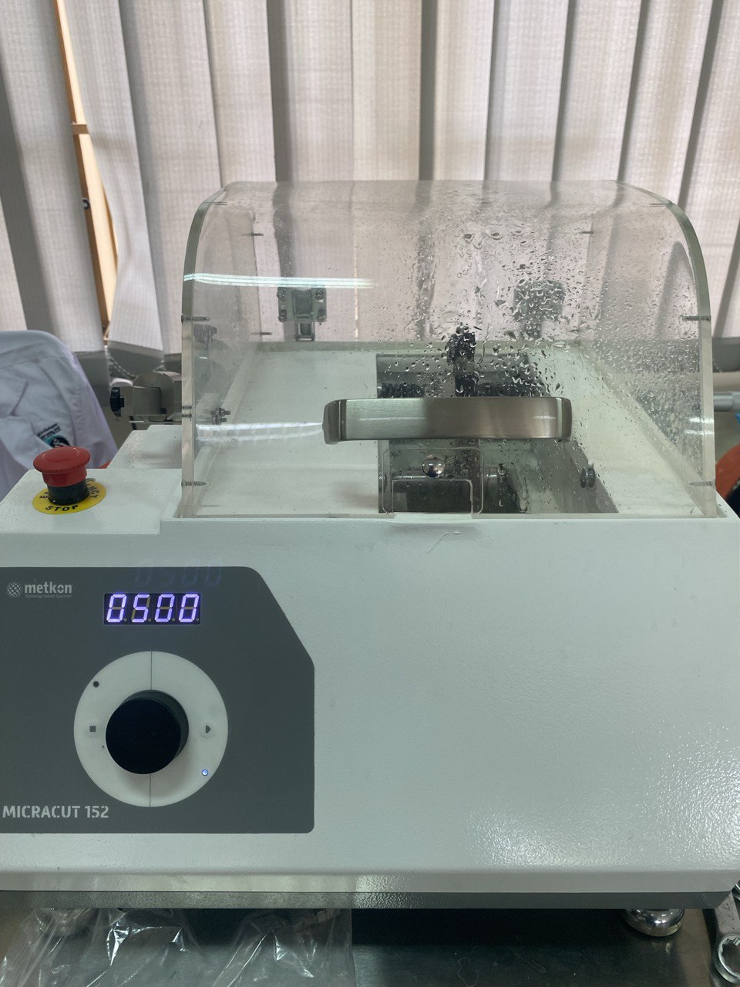
Figure 3. Precision Cutter
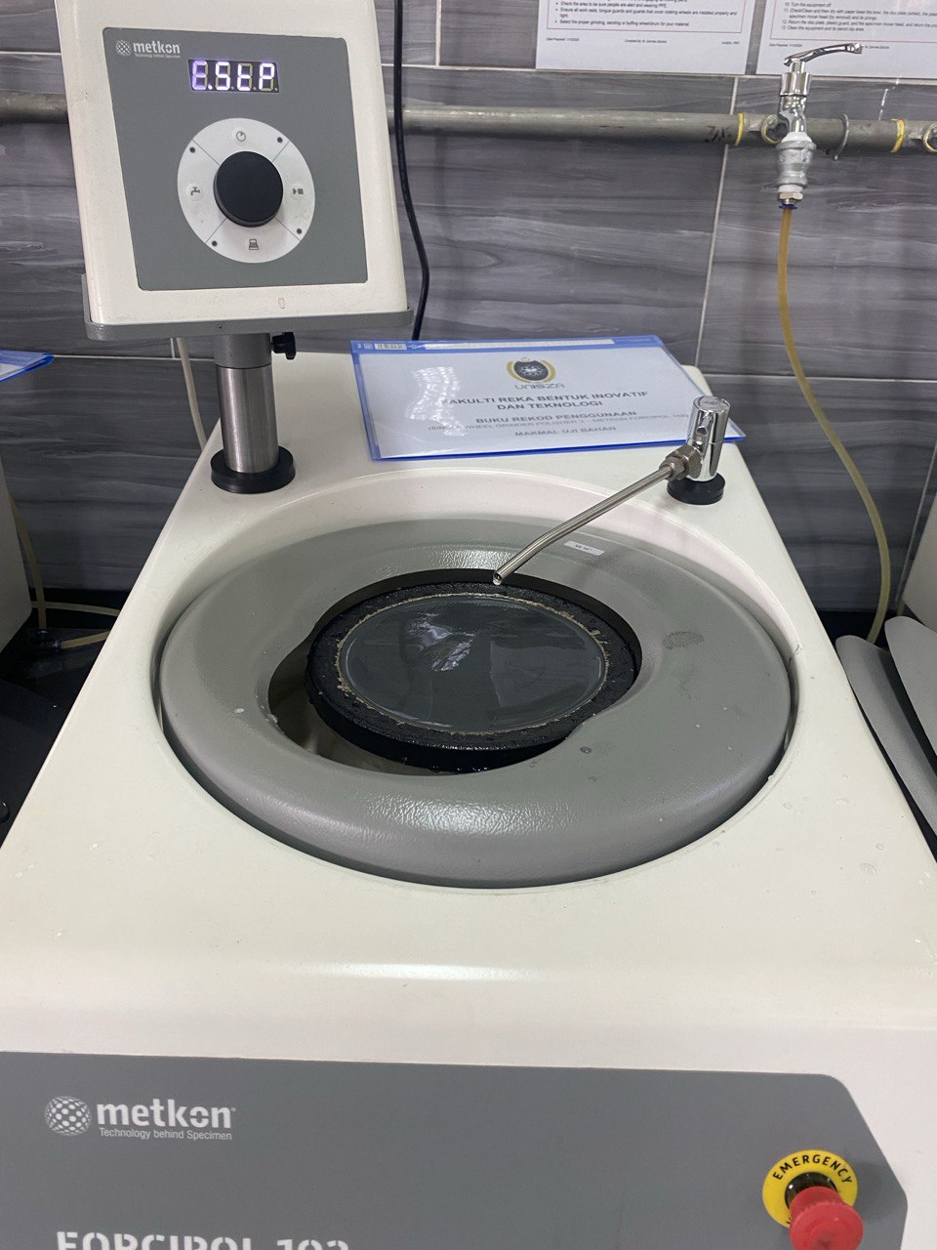
Figure 4. Single Wheel Grinder Polisher
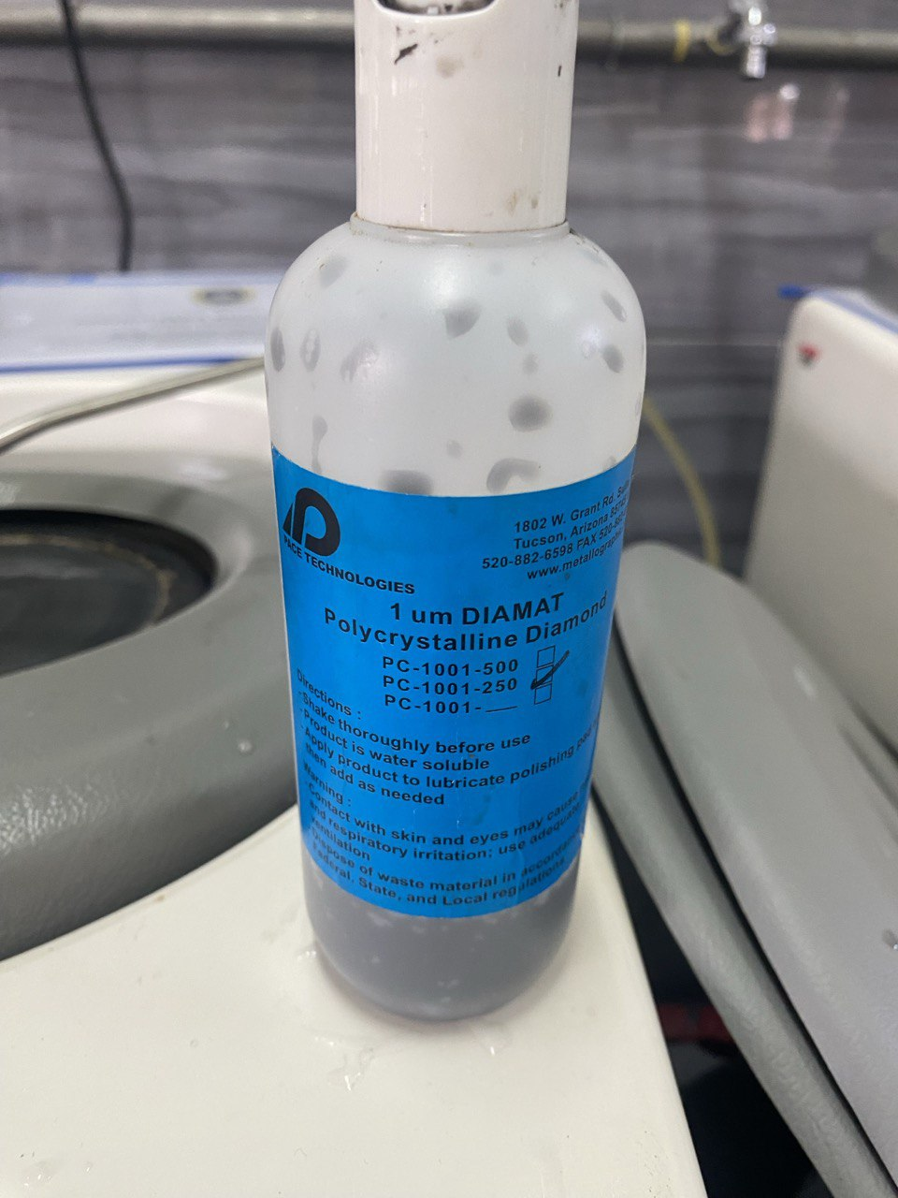
Figure 5. 1µm Polycrystalline Diamond
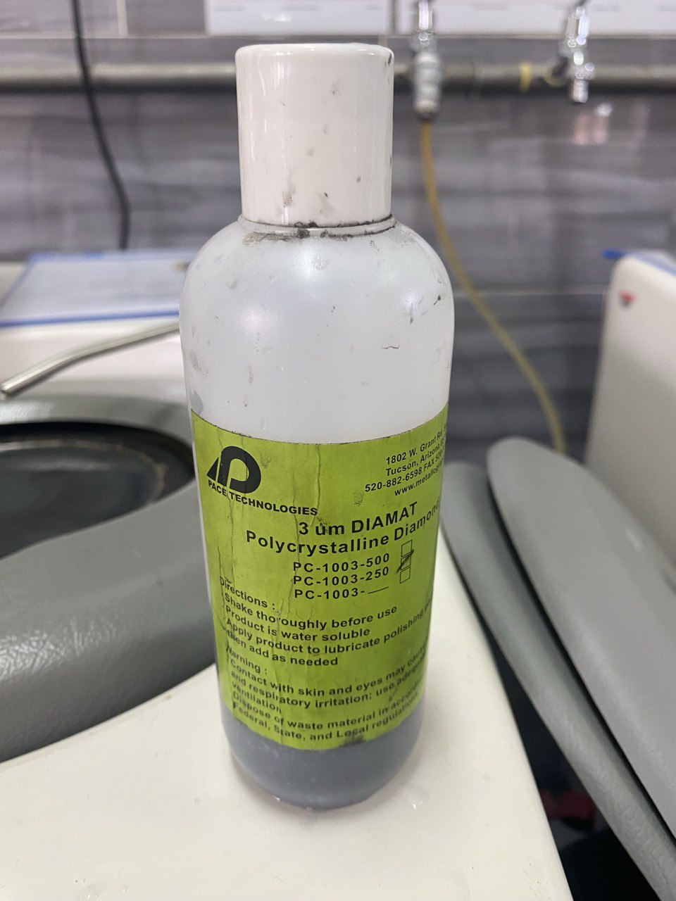
Figure 6. 3µm Polycrystalline Diamond
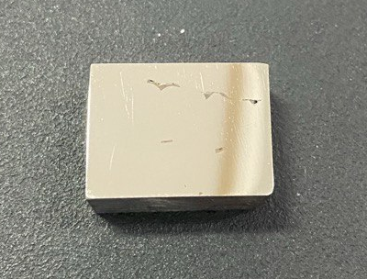
Figure 7: Surface of Sample after sample preparation was done using grinding machine and etching in a 2% Nital solution

