Supplementary Information (SI)
“Probabilistic assessment of uncertainty of carbon capture and storage for achieving Paris-Aligned goals”

This document presents additional information to support the results of the main article. This supplementary material includes a comparison of the model results with selected IPCC Sixth Assessment Report (AR6) ensembles (section 1); and the ensembles results compared with the parameters introduced (section 2).

1. IPCC Sixth Assessment Report ensembles comparison
In this article we utilize the IPCC Sixth Assessment Report (AR6) as a frame of reference for our 1.5ºC and 2.0ºC ensemble results. In the AR6, emissions scenarios are categorized by their probability of meeting specific temperature thresholds throughout the 21st century. Specifically, we focus on category 2 (C2) that represents pathways that return global warming to 1.5°C by 2100 with a median likelihood (>50%) after a high temporary overshoot, and category 3 (C3) that consists of pathways that are likely (>67%) to limit warming to below 2°C throughout the entire century.
An overview of the deployment scale of carbon sequestration in the C2 and C3 scenarios can be assessed in Table 1, which summarizes the cumulative sequestration of selected technologies or group of technologies.

Table 1 | Cumulative sequestration of selected technologies in C2 and C3 ensembles
Ensemble | Technology | Cumulative | Scenarios
C2 | CCS total | 708.03*  (550.56;1033.43) | 131
C2 | BECCS | 464.66  (292.10;624.08) | 122
C2 | A/R | 219.83  (207.32;311.83) | 64
C2 | Other CDR | 226.70  (83.35; 340.13) | 24
C2 | Combined | 957.24  (741.23;1148.34) | 133
C3 | CCS total | 591.90  (486.17;774.42) | 310
C3 | BECCS | 291.83  (244.88;412.39) | 294
C3 | A/R | 206.76  (75.55;214;51) | 120
C3 | Other CDR | 120.23  (14.50;199.05) | 91
C3 | Combined | 842.49  (611.04;981.21) | 310
Note: “CCS total” encompass carbon capture and storage from fossil and biomass sources; bioenergy with carbon capture and storage (BECCS); “Other CDR” encompass biochar, enhanced weathering, and direct air capture; “Combined” encompass all carbon sequestration technologies; “Cumulative” is the estimation of cumulative sequestration between 2026 - 2100 in GtCO₂; “Scenarios” column account for the frequency of the technology in the ensemble. Source: adapted from AR6 scenarios database³⁵.

Figure 1 presents a comparative assessment of selected carbon sequestration technologies across 1.5°C and 2.0°C ensembles derived from the C2 and C3 scenario categories³⁵.
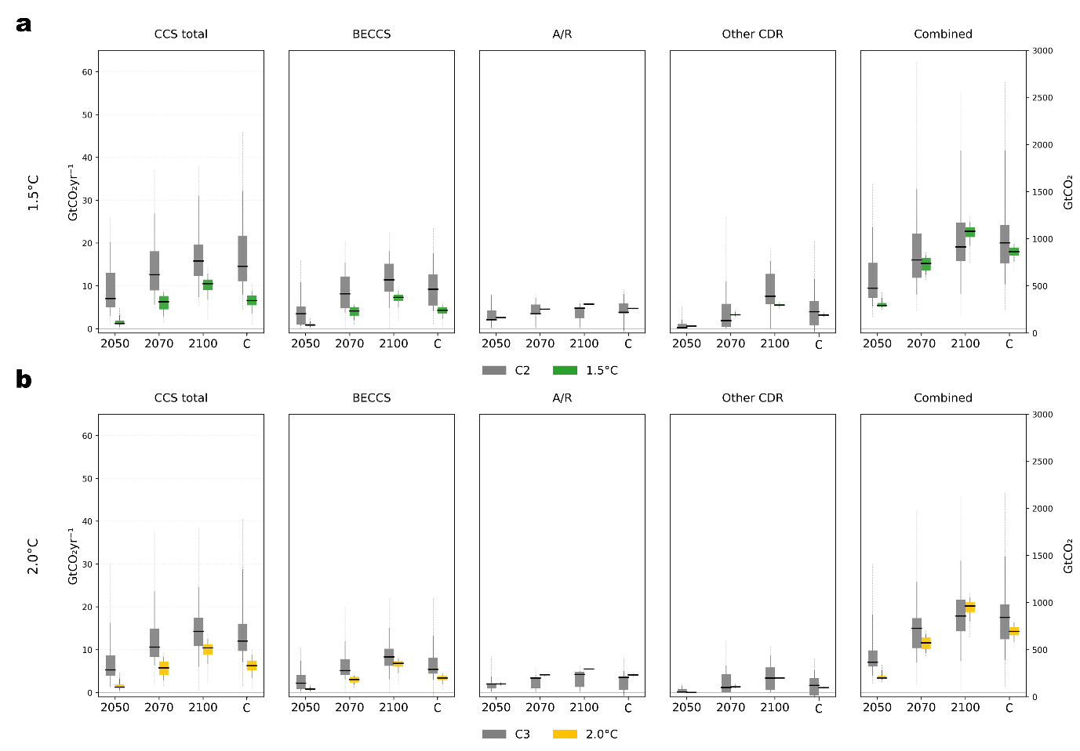
Figure 1 | Comparison of selected sequestration technologies. a, b, Boxplots (median, box P25-P75, whiskers P5-P95, and dashed lines with full range) of global selected carbon sequestration technologies in GtCO₂yr⁻¹ for the 1.5°C and 2.0°C (1,250 scenarios per ensemble), and C2 and C3 ensembles for the years 2050, 2070 and 2100 (left y-axis) and the respective cumulative (C) sequestration between 2026 and 2100 in GtCO₂ (right y-axis). Categories include CCS total (carbon capture and storage from fossil and biomass sources), bioenergy with carbon capture and storage (BECCS), afforestation/reforestation (A/R), other carbon dioxide removal (CDR) comprised of biochar, enhanced weathering, and direct air capture, and the “Combined” aggregate. Results are shown for (a) comparison between 1.5°C and C2 ensembles and (b) comparison between 2.0°C and C3 ensembles.
Figure 2 presents a comparative assessment of primary energy sources across 1.5°C and 2.0°C ensembles derived from the C2 and C3 scenario categories³⁵.
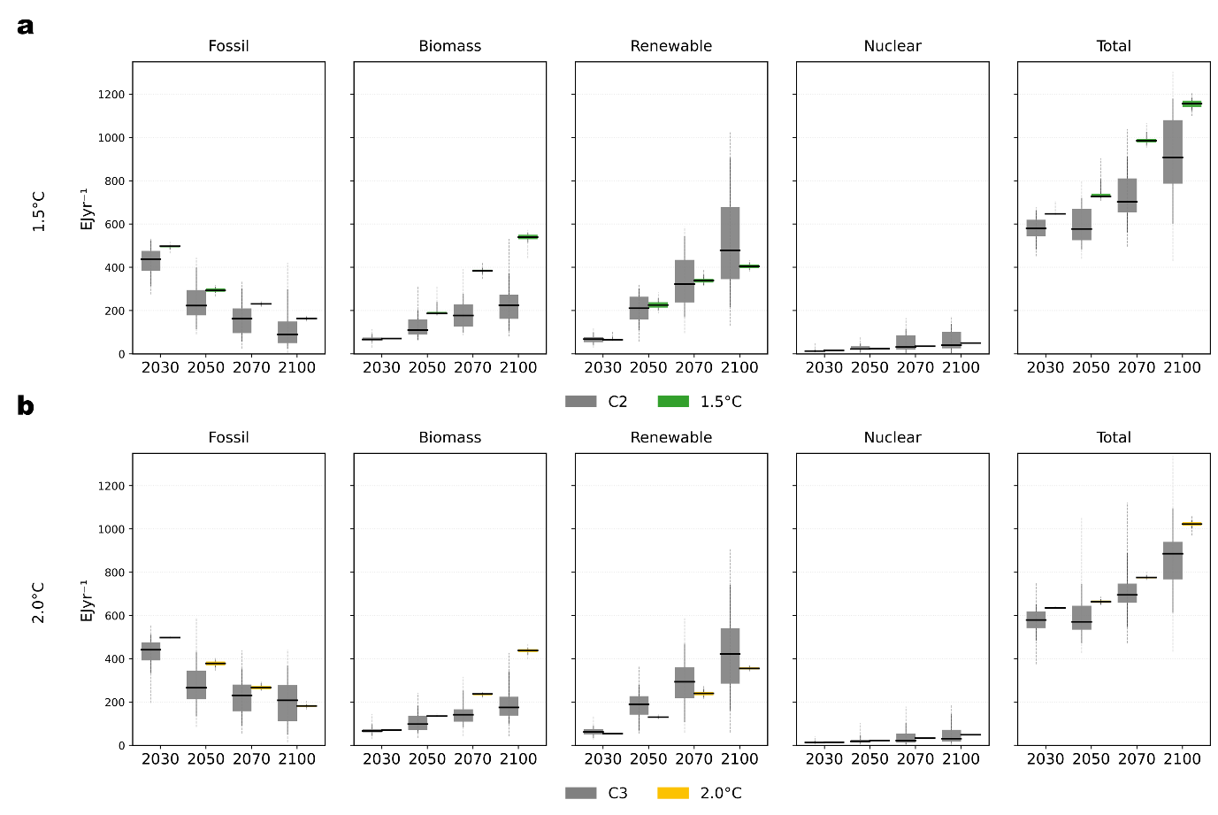
Figure 2 | Comparison of primary energy. a, b, Boxplots (median, box P25-P75, whiskers P5-P95, and dashed lines with full range) in EJy⁻¹ of global primary energy sources for the 1.5°C and 2.0°C (1,250 scenarios per ensemble), and C2 and C3 ensembles for the years 2030, 2050, 2070 and 2100. Primary energy categorized into fossil, biomass, renewables (representing non-biomass renewable sources), and nuclear. Results are shown for (a) comparison between 1.5°C and C2 ensembles and (b) comparison between 2.0°C and C3 ensembles.
2. Carbon injection and geological storage utilization
In this section we present the results of carbon injection and geological storage utilization compared to the limits defined by the parameters introduced in the ensembles. Figure 3 illustrates the distribution of global CCS limits and carbon injection for the 1.5°C and 2.0°C ensembles. The results illustrated how our model prefers others technologies creating an increasing gap between maximum CCS limit and maximum scenario utilization that start to be more noticeable after 2050, although the median difference remained less extreme.

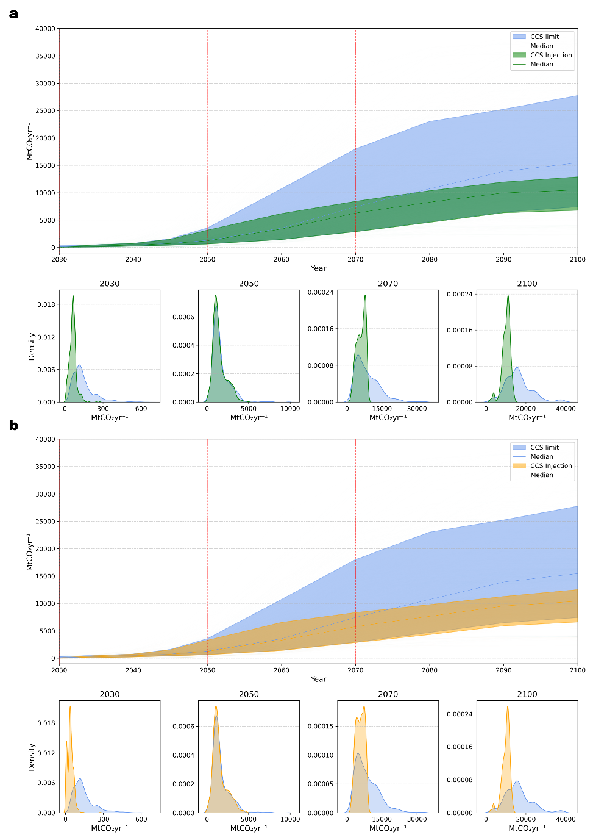
Figure 3 | Global CCS capacity limits and injection for 1.5°C and 2.0°C ensembles. a, b, Time-series of global CCS capacity limits (blue) and injections in MtCO₂yr⁻¹ for 1.5°C (green) and 2.0°C (yellow) ensembles (1,250 scenarios per ensemble). Solid central lines represent the ensemble median; shaded areas denote the central 90% quantile range (P5-P95); bottom subpanels display the kernel density estimation (KDE) for emissions at the 2030, 2050, 2070, and 2100 milestones with lines and shaded areas in density curves representing the 100% quantile. Results are shown for the (a) 1.5ºC and (b) 2.0ºC ensembles.

The geological carbon injection by region for the 1.5ºC and 2.0ºC ensembles shown in Figure 4 quantify the annual injection relative to the regional carbon sequestration limits assigned within the individual scenarios.

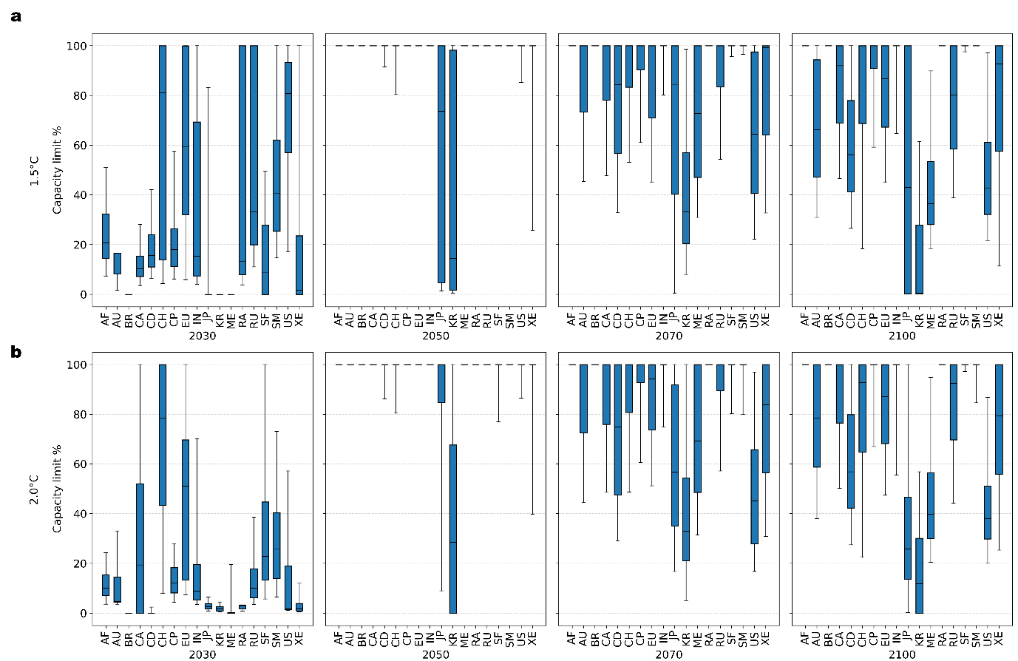
Figure 4 | Regional geological carbon injection rates. a, b, Boxplots (median, box P25-P75, and whiskers P5-P95) represent the distribution of the regional sequestration limit utilized in the years 2030, 2050, 2070, and 2100 per scenario. Results are shown for the (a) 1.5ºC and (b) 2.0ºC ensembles across all 18 regions.

Similarly, the geological carbon storage utilization in Figure 5 illustrates the total cumulative storage used between 2026 and 2100 as a percentage of the available geological capacity, within individual scenarios.
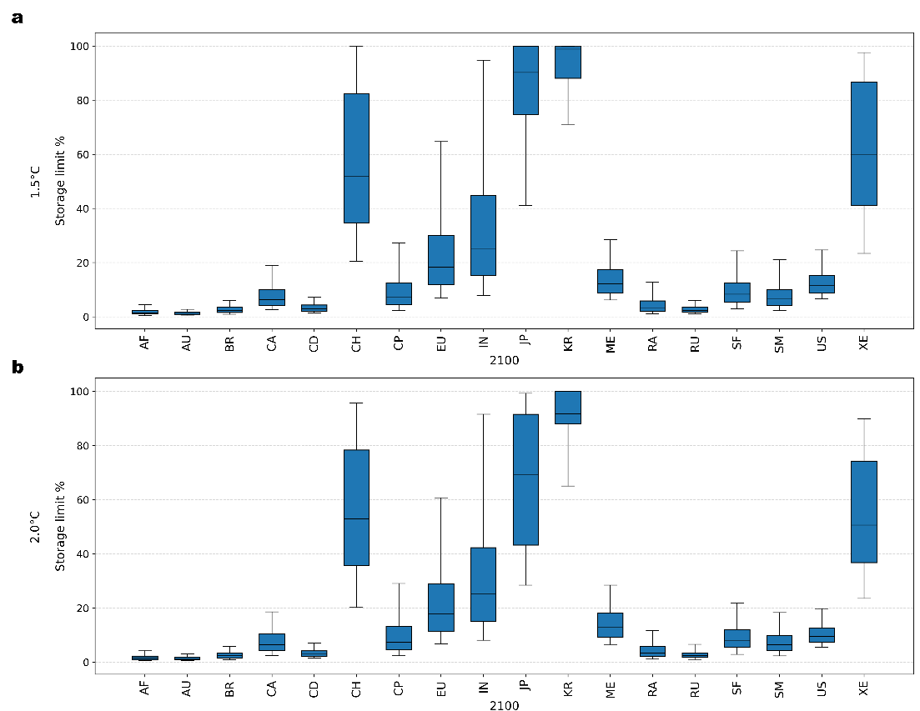
Figure 5 | Cumulative regional geological carbon storage utilization by 2100. a, b, Boxplots (median, box P25-P75, and whiskers P5-P95) represent regional distribution of cumulative carbon storage sequestered between 2026 to 2100 expressed as a percentage of total storage capacity per scenario. Results are shown for the (a) 1.5ºC and (b) 2.0ºC ensembles across all 18 regions.

References
1. Intergovernmental Panel on Climate Change. Climate Change 2022: Mitigation of Climate Change. (Cambridge University Press, 2022).
2. UNFCC. Conference of the Parties: Adoption of the Paris Agreement. (Paris, France, 2015).
3. Schleussner, C.-F. et al. Overconfidence in climate overshoot. Nature 634, 366–373 (2024).
4. Kazlou, Y. T., Cherp, A. & Jewell, J. Feasible deployment of carbon capture and storage and the requirements of climate targets. Nat. Clim. Chang. 14, 1047–1055 (2024).
5. Riahi, K. & et al. Cost and attainability of meeting stringent climate targets without overshoot. Nat. Clim. Chang. 11, 1063–1069 (2021).
6. Tavoni, M. et al. Implications of overshoot for climate mitigation strategies. Nature Climate Change Preprint at https://doi.org/10.1038/s41558-026-02563-7 (2026).
7. Warszawski, L. et al. All options, not silver bullets, needed to limit global warming to 1.5 ◦C: A scenario appraisal. Environmental Research Letters 16, (2021).
8. Chiquier, S., Fajardy, M. & Dowell, N. Mac. CO2 removal and 1.5 °C: what, when, where, and how? Energy Advances 524–561 (2022) doi:10.1039/d2ya00108j.
9. Fuhrman, J. & et al. Rate and growth limits for carbon capture and storage. Environmental Research Letters 20, 64034 (2025).
10. Lane, J., Greig, C. & Garnett, A. Uncertain storage prospects create a conundrum for carbon capture and storage ambitions. Nat. Clim. Chang. 11, 925–936 (2021).
11. Smith, P. et al. Biophysical and economic limits to negative CO2 emissions. Nature Climate Change vol. 6 42–50 Preprint at https://doi.org/10.1038/nclimate2870 (2016).
12. Strefler, J. & et al. Between Scylla and Charybdis: delayed mitigation narrows the passage between large-scale CDR and high costs. Environmental Research Letters 13, 44015 (2018).
13. Roe, S. et al. Land-based measures to mitigate climate change: Potential and feasibility by country. Glob. Chang. Biol. 27, 6025–6058 (2021).
14. Fuss, S. & et al. Betting on negative emissions. Nat. Clim. Chang. 4, 850–853 (2014).
15. Anderson, K. & et al. Controversies of carbon dioxide removal. Nat. Rev. Earth Environ. 4, 808–814 (2023).
16. Smith, E. et al. The cost of CO2 transport and storage in global integrated assessment modeling. International Journal of Greenhouse Gas Control 109, (2021).
17. Middleton, R. S. & Yaw, S. The cost of getting CCS wrong: uncertainty, infrastructure design and stranded CO_2. International Journal of Greenhouse Gas Control 70, 1–11 (2018).
18. Streck, C. & et al. Considering durability in carbon dioxide removal strategies for climate change mitigation. Climate Policy 25, 1–9 (2025).
19. Gidden, M. J. & et al. A prudent planetary limit for geologic carbon storage. Nature 645, 124–132 (2025).
20. Grant, N. & et al. The policy implications of an uncertain carbon dioxide removal potential. Joule 5, 2593–2605 (2021).
21. Weyant, J. Some contributions of integrated assessment models of global climate change. Rev. Environ. Econ. Policy 11, 115–137 (2017).
22. van Beek, L., Hajer, M., Pelzer, P., van Vuuren, D. & Cassen, C. Anticipating futures through models: the rise of Integrated Assessment Modelling in the climate science-policy interface since 1970. Global Environmental Change 65, (2020).
23. Cointe, B., Cassen, C. & Nadaï, A. Organising Policy-Relevant Knowledge for Climate Action: Integrated Assessment Modelling, the IPCC, and the Emergence of a Collective Expertise on Socioeconomic Emission Scenarios. Science and Technology Studies XX(X) 32, (2019).
24. Tavoni, M. & Valente, G. Uncertainty in Integrated Assessment Modeling of Climate Change. Perspectives on Science 30, 321–351 (2022).
25. Gambhir, A., Butnar, I., Li, P. H., Smith, P. & Strachan, N. A review of criticisms of integrated assessment models and proposed approaches to address these, through the lens of BECCs. Energies (Basel). 12, (2019).
26. Cooke, R. M. Uncertainty analysis comes to integrated assessment models for climate change...and conversely. Clim. Change 117, 467–479 (2013).
27. Bosetti, V. et al. Sensitivity to energy technology costs: A multi-model comparison analysis. Energy Policy 80, 244–263 (2015).
28. Huard, D., Fyke, J., Capellán-Pérez, I., Matthews, H. D. & Partanen, A. I. Estimating the Likelihood of GHG Concentration Scenarios From Probabilistic Integrated Assessment Model Simulations. Earths Future 10, (2022).
29. Marcucci, A., Panos, E., Kypreos, S. & Fragkos, P. Probabilistic assessment of realizing the 1.5 °C climate target. Appl. Energy 239, 239–251 (2019).
30. Lontzek, T. S., Cai, Y., Judd, K. L. & Lenton, T. M. Stochastic Integrated Assessment of Climate Tipping Points Calls for Strict Climate Policy.
31. Gillingham, K. et al. Modeling Uncertainty in Integrated Assessment of Climate Change: A Multi-Model Comparison. http://globalchange.mit.edu/sponsors/all.Bosettiacknowledges (2018).
32. Guivarch, C. et al. Using large ensembles of climate change mitigation scenarios for robust insights. Nature Climate Change vol. 12 428–435 Preprint at https://doi.org/10.1038/s41558-022-01349-x (2022).
33. Beath, H. et al. A weighting framework to improve the use of emissions scenario ensembles of opportunity. Nat. Clim. Chang. https://doi.org/10.1038/s41558-026-02565-5 (2026) doi:10.1038/s41558-026-02565-5.
34. Calvin, K. et al. IPCC, 2023: Climate Change 2023: Synthesis Report. Contribution of Working Groups I, II and III to the Sixth Assessment Report of the Intergovernmental Panel on Climate Change [Core Writing Team, H. Lee and J. Romero (Eds.)]. IPCC, Geneva, Switzerland. https://www.ipcc.ch/report/ar6/syr/ (2023) doi:10.59327/IPCC/AR6-9789291691647.
35. International Institute for Applied Systems Analysis. AR6 Scenarios Database hosted by IIASA. Preprint at https://data.ece.iiasa.ac.at/ar6/ (2021).
36. Bastin, J.-F. et al. The Global Tree Restoration Potential Downloaded From. Science vol. 365 http://science.sciencemag.org/ (2019).
37. Griscom, B. W. et al. Natural climate solutions. Proc. Natl. Acad. Sci. U. S. A. 114, 11645–11650 (2017).
38. Zanon-Zotin, M., Baptista, L. B., Rochedo, P. R. R., Szklo, A. & Schaeffer, R. Industrial sector pathways to a well-below 2 °C world: A global integrated assessment perspective. Appl. Energy 381, (2025).
39. Müller-Casseres, E. & et al. International shipping in a world below 2^C. Nat. Clim. Chang. 14, 600–607 (2024).
40. Kann, A. & Weyant, J. P. Approaches for Performing Uncertainty Analysis in Large-Scale Energy/Economic Policy Models. Environmental Modeling and Assessment vol. 5 (2000).
41. Kroese, D. P. Monte Carlo Methods. http://www.maths.uq.edu.au/ (2011).
42. Gentle, J. E., Hardle, Wolfgang. & Mori, Yuichi. Handbook of computational statistics : concepts and methods. in (2004).
43. Shields, M. D. & Zhang, J. The generalization of Latin hypercube sampling. Reliab. Eng. Syst. Saf. 148, 96–108 (2016).
44. Riahi, K. & et al. The shared socioeconomic pathways and their energy, land use, and greenhouse gas emissions implications: an overview. Global Environmental Change 42, 153–168 (2017).
45. Intergovernmental Panel on Climate Change (IPCC). Climate Change 2021 – The Physical Science Basis. Climate Change 2021 – The Physical Science Basis (Cambridge University Press, 2023). doi:10.1017/9781009157896.
46. Global Energy Monitor. Global Oil Infrastructure Tracker. Preprint at (2025).
47. World Bank. World Development Indicators (WDI) Database. Preprint at (2025).
48. International Energy Agency. IEA CCUS Database. Preprint at (2025).
49. Fuss, S. & et al. Negative emissions—Part 2: Costs, potentials and side effects. Environmental Research Letters 13, 63002 (2018).
50. Popp, A. et al. Land-use futures in the shared socio-economic pathways. Global Environmental Change 42, 331–345 (2017).

* Hereafter, values are reported as median (Q1; Q3), where Q1 and Q3 correspond to the 25th (P25) and 75th (P75) percentiles, respectively, defining the interquartile range (IQR), which encompasses the central 50% of the distribution.

