Figure S1. Heatmap of pairwise Spearman correlations between clinical endpoints TNST, TNT, PFS1, PFS2, and OS (all expressed in months). For each pair of variables, correlations were calculated only in patients for whom both corresponding status indicators (TNST_status, TNT_status, PFS1_status, PFS2_status, OS_status) were equal to 1 (event observed). Cell values represent Spearman correlation coefficients, with numbers in parentheses indicating the number of patients included in each calculation (ρ = 0.73–0.96).
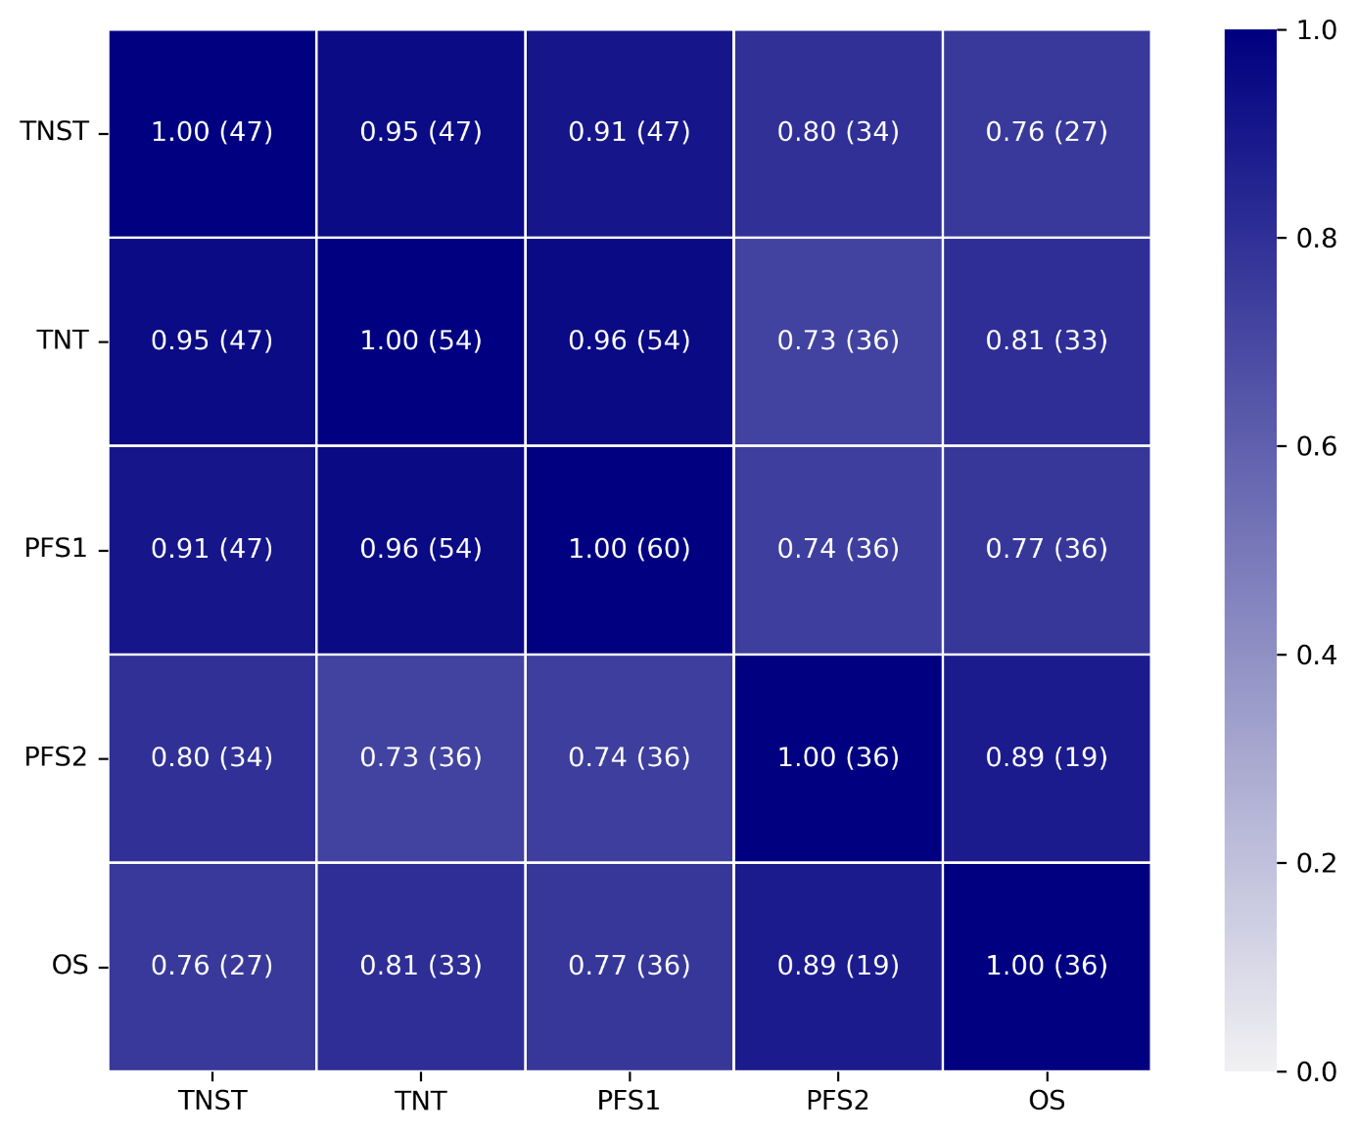

Figure S2. Time to next systemic treatment (TNST) (A) and progression-free survival 2 (PFS2) (B) according to brain versus other progression sites.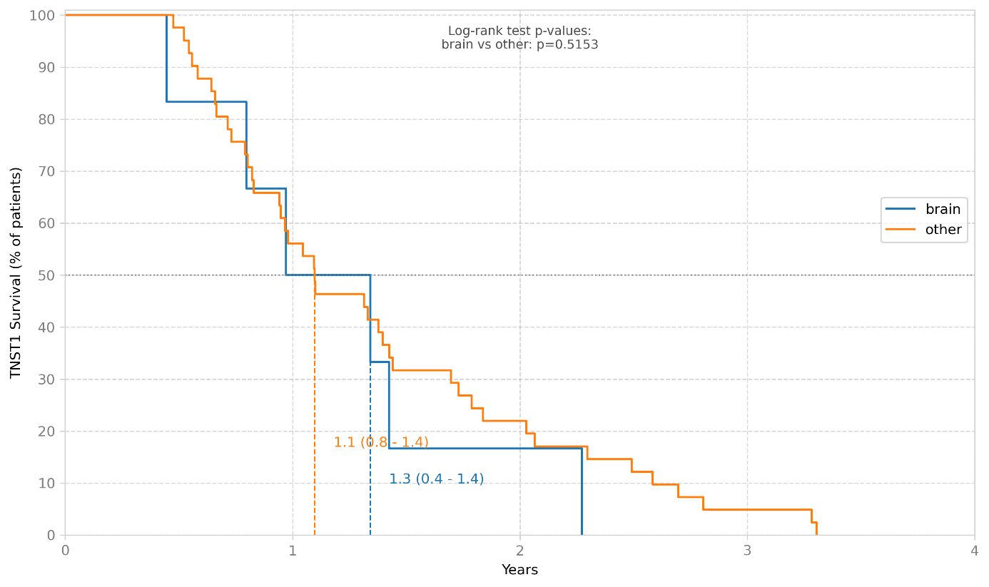
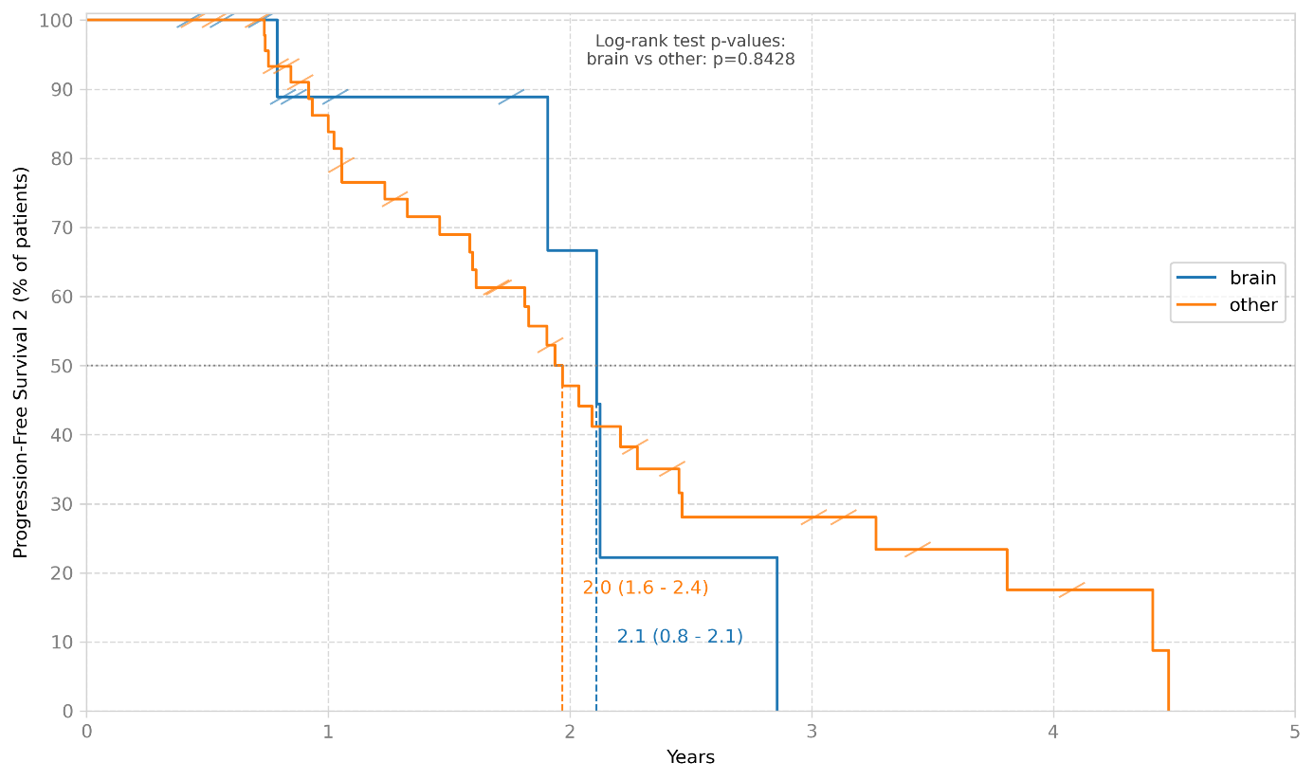

Figure S3. Time to next systemic treatment (TNST) (A) and progression-free survival 2 (PFS2) (B) according to the nature of progression (pre-existing, new, or combined).
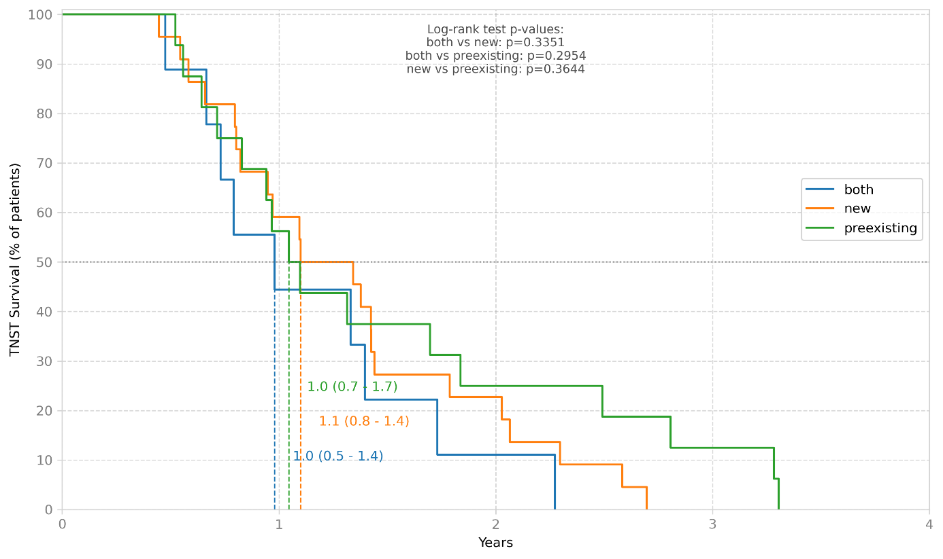
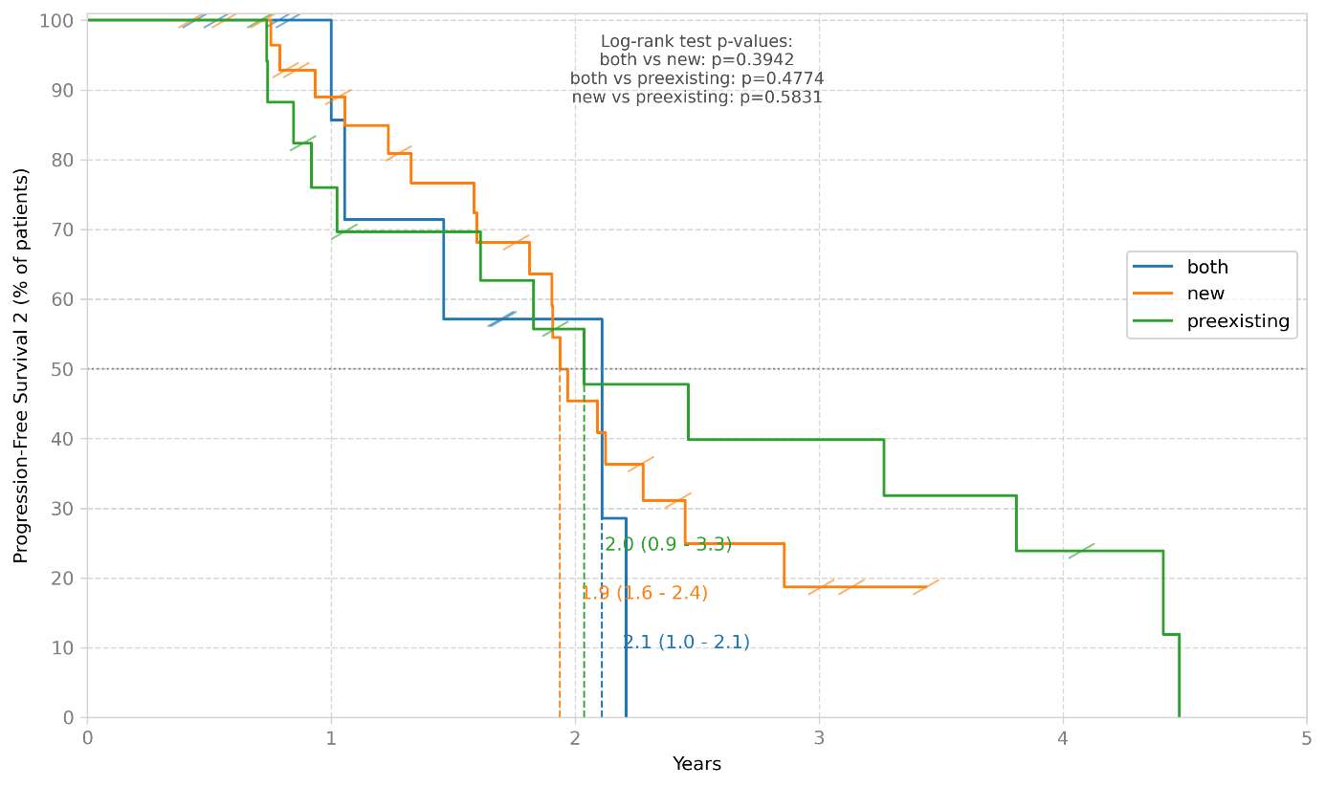
Figure S4. Progression-free survival 2 (PFS2) (A) and overall survival (OS) (B) stratified by post-progression systemic treatment, including docetaxel, platinum-based chemotherapy, other agents, and no systemic treatment.