Electrospun Fibers for Colorimetric Detection of Volatile Organic Compounds via Polyfluorene–Quinoxaline Copolymer Photoproperties Change

Jiyoung Boo^{1,†} · Jae Doo Nam^{2,†} · Seongwan Bae^{1,†} · Jae Yong Lee² · Jinho Choi^{3,*} · Dong Hyuk Park^{1,*} · · Jongho Kim^{2,*}

¹Department of Chemical Engineering, Inha University, Incheon 22212, Republic of Korea
²Department of Textile System Engineering, Kyungpook National University, Daegu 41566, Republic of Korea
³Department of Materials Science and Engineering, University of Michigan, Ann Arbor, Michigan 48109, USA

†These authors contributed equally to this work.
Supporting Information
Synthesis of PFO@QX Copolymer
1. Synthesis of PFO@QX 50:50 Copolymer
A 3-neck round-bottom flask was charged with M1 (0.192 g, 0.350 mmol), M2 (0.450 g, 0.700 mmol), and M3 (0.101 g, 0.350 mmol) and purged with argon gas. After sufficient degassing, toluene (10.0 mL) and a 2M aqueous K₂CO₃ solution (8.0 mL) were added to the reaction mixture, followed by the addition of Pd(PPh₃)₄ (0.040 g, 5.0 mol%) and Aliquat 336 as a phase-transfer catalyst. The reaction mixture was refluxed at 95°C under an argon atmosphere for 48 h. After completion of the polymerization, M4 (1.0 mL, 0.128 mmol) was added and the reaction mixture was further refluxed for 1.5 h. Subsequently, M5 (1.0 mL, 0.128 mmol) was added, and the reaction mixture was further refluxed for an additional 1.5 h. After cooling to room temperature, the reaction mixture was poured into methanol, and then the precipitated polymer was collected by filtration and washed with methanol, acetone, and distilled water. The crude polymer was purified by Soxhlet extraction with methanol and acetone, followed by collection using chloroform. After drying in a vacuum oven, the polymer was obtained (0.288 g, 47.11%). ¹H NMR (300 MHz, CDCl₃): δ 7.87–7.69 (m), 2.13 (s), 1.28–0.80 ppm (m). GPC (CHCl₃, polystyrene standards): M_{n} = 6255, M_{w} = 12148, PDI = 1.94.

2. Synthesis of PFO@QX 70:30 Copolymer
A 3-neck round-bottom flask was charged with M1 (0.269 g, 0.490 mmol), M2 (0.450 g, 0.700 mmol), and M3 (0.060 g, 0.210 mmol) and purged with argon gas. After sufficient degassing, toluene (10.0 mL) and a 2M aqueous K₂CO₃ solution (8.0 mL) were added to the reaction mixture, followed by the addition of Pd(PPh₃)₄ (0.040 g, 5.0 mol%) and Aliquat 336 as a phase-transfer catalyst. The reaction mixture was refluxed at 95°C under an argon atmosphere for 48 h. After completion of the polymerization, M4 (1.0 mL, 0.128 mmol) was added and the reaction mixture was further refluxed for 1.5 h. Subsequently, M5 (1.0 mL, 0.128 mmol) was added, and the reaction mixture was further refluxed for an additional 1.5 h. After cooling to room temperature, the reaction mixture was poured into methanol, and then the precipitated polymer was collected by filtration and washed with methanol, acetone, and distilled water. The crude polymer was purified by Soxhlet extraction with methanol and acetone, followed by collection using chloroform. After drying in a vacuum oven, the polymer was obtained (0.2421 g, 44.80%). ¹H NMR (300 MHz, CDCl₃): δ 7.87–7.69 (m), 2.13 (s), 1.28–0.80 ppm (m). GPC (CHCl₃, polystyrene standards): M_{n} = 19809, M_{w} = 53373, PDI = 2.69.

3. Synthesis of PFO@QX 85:15 Copolymer
A 3-neck round-bottom flask was charged with M1 (0.326 g, 0.595 mmol), M2 (0.450 g, 0.700 mmol), and M3 (0.030 g, 0.105 mmol) and purged with argon gas. After sufficient degassing, toluene (10.0 mL) and a 2M aqueous K₂CO₃ solution (8.0 mL) were added to the reaction mixture, followed by the addition of Pd(PPh₃)₄ (0.040 g, 5.0 mol%) and Aliquat 336 as a phase-transfer catalyst. The reaction mixture was refluxed at 95°C under an argon atmosphere for 48 h. After completion of the polymerization, M4 (1.0 mL, 0.128 mmol) was added and the reaction mixture was further refluxed for 1.5 h. Subsequently, M5 (1.0 mL, 0.128 mmol) was added, and the reaction mixture was further refluxed for an additional 1.5 h. After cooling to room temperature, the reaction mixture was poured into methanol, and then the precipitated polymer was collected by filtration and washed with methanol, acetone, and distilled water. The crude polymer was purified by Soxhlet extraction with methanol and acetone, followed by collection using chloroform. After drying in a vacuum oven, the polymer was obtained (0.433 g, 80.10%). ¹H NMR (300 MHz, CDCl₃): δ 7.87–7.69 (m), 2.13 (s), 1.28–0.80 ppm (m). GPC (CHCl₃, polystyrene standards): M_{n} = 31879, M_{w} = 74298, PDI = 2.33.

4. Synthesis of PFO@QX 90:10 Copolymer
A 3-neck round-bottom flask was charged with M1 (0.346 g, 0.630 mmol), M2 (0.450 g, 0.700 mmol), and M3 (0.020 g, 0.070 mmol) and purged with argon gas. After sufficient degassing, toluene (10.0 mL) and a 2M aqueous K₂CO₃ solution (8.0 mL) were added to the reaction mixture, followed by the addition of Pd(PPh₃)₄ (0.040 g, 5.0 mol%) and Aliquat 336 as a phase-transfer catalyst. The reaction mixture was refluxed at 95°C under an argon atmosphere for 48 h. After completion of the polymerization, M4 (1.0 mL, 0.128 mmol) was added and the reaction mixture was further refluxed for 1.5 h. Subsequently, M5 (1.0 mL, 0.128 mmol) was added, and the reaction mixture was further refluxed for an additional 1.5 h. After cooling to room temperature, the reaction mixture was poured into methanol, and then the precipitated polymer was collected by filtration and washed with methanol, acetone, and distilled water. The crude polymer was purified by Soxhlet extraction with methanol and acetone, followed by collection using chloroform. After drying in a vacuum oven, the polymer was obtained (0.310 g, 57.70%). ¹H NMR (300 MHz, CDCl₃): δ 7.87–7.69 (m), 2.13 (s), 1.28–0.80 ppm (m). GPC (CHCl₃, polystyrene standards): Mn = 11731, Mw = 20487, PDI = 1.74.

5. Synthesis of PFO@QX 95:5 Copolymer
A 3-neck round-bottom flask was charged with M1 (0.365 g, 0.665 mmol), M2 (0.450 g, 0.700 mmol), and M3 (0.010 g, 0.350 mmol) and purged with argon gas. After sufficient degassing, toluene (10.0 mL) and a 2M aqueous K₂CO₃ solution (8.0 mL) were added to the reaction mixture, followed by the addition of Pd(PPh₃)₄ (0.040 g, 5.0 mol%) and Aliquat 336 as a phase-transfer catalyst. The reaction mixture was refluxed at 95°C under an argon atmosphere for 48 h. After completion of the polymerization, M4 (1.0 mL, 0.128 mmol) was added and the reaction mixture was further refluxed for 1.5 h. Subsequently, M5 (1.0 mL, 0.128 mmol) was added, and the reaction mixture was further refluxed for an additional 1.5 h. After cooling to room temperature, the reaction mixture was poured into methanol, and then the precipitated polymer was collected by filtration and washed with methanol, acetone, and distilled water. The crude polymer was purified by Soxhlet extraction with methanol and acetone, followed by collection using chloroform. After drying in a vacuum oven, the polymer was obtained (0.454 g, 84.0%). ¹H NMR (300 MHz, CDCl₃): δ 7.87–7.69 (m), 2.13 (s), 1.28–0.80 ppm (m). GPC (CHCl₃, polystyrene standards): M_{n} = 17208, M_{w} = 33340, PDI = 1.94.

6. Synthesis of PFO@QX 98:2 Copolymer
A 3-neck round-bottom flask was charged with M1 (0.37 g, 0.686 mmol), M2 (0.450 g, 0.700 mmol), and M3 (0.004 g, 0.014 mmol) and purged with argon gas. After sufficient degassing, toluene (10.0 mL) and a 2M aqueous K₂CO₃ solution (8.0 mL) were added to the reaction mixture, followed by the addition of Pd(PPh₃)₄ (0.040 g, 5.0 mol%) and Aliquat 336 as a phase-transfer catalyst. The reaction mixture was refluxed at 95°C under an argon atmosphere for 48 h. After completion of the polymerization, M4 (1.0 mL, 0.128 mmol) was added and the reaction mixture was further refluxed for 1.5 h. Subsequently, M5 (1.0 mL, 0.128 mmol) was added, and the reaction mixture was further refluxed for an additional 1.5 h. After cooling to room temperature, the reaction mixture was poured into methanol, and then the precipitated polymer was collected by filtration and washed with methanol, acetone, and distilled water. The crude polymer was purified by Soxhlet extraction with methanol and acetone, followed by collection using chloroform. After drying in a vacuum oven, the polymer was obtained (0.2877 g, 53.3%). ¹H NMR (300 MHz, CDCl₃): δ 7.87–7.69 (m), 2.13 (s), 1.28–0.80 ppm (m). GPC (CHCl₃, polystyrene standards): M_{n} = 12488, M_{w} = 21097, PDI = 1.69.

 | 50:50 | 70:30 | 85:15 | 90:10 | 95:5 | 98:2
Solution | 0.14 ns | 0.15 ns | 0.16 ns | 0.59 ns | 0.85 ns | 0.81 ns
Spin-coated film | 0.40 ns | 0.40 ns | 0.30 ns | 0.22 ns | 0.16 ns | 0.15 ns
Table S1 PL Lifetimes of PFO@QX Polymers with Varying Component Ratios (λ_{ex}:370 nm, λ_{det}:405 nm)

Component ratio (m:n) | 50:50 | 70:30 | 85:15 | 90:10 | 95:5 | 98:2
Average Lifetime (ns) | 0.34 | 0.35 | 0.26 | 0.33 | 0.32 | 0.32
Concentration  (mg/mL) | 1 | 2 | 3 | 4
Average Lifetime (ns) | 0.31 | 0.35 | 0.27 | 0.32
Table S2 PL Lifetimes of PFO@QX Nanofibers with Varying Component Ratios and Concentrations (λ_{ex}:370 nm, λ_{det}:405 nm)
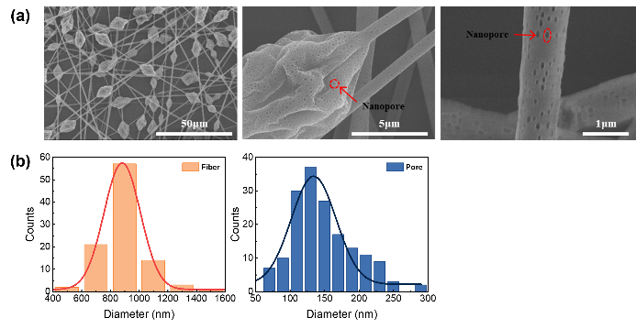
Fig. S1 SEM images and morphological analysis of electrospun PFO@QX nanofibers. (a) SEM images of electrospun PFO@QX (95:5) nanofibers at different magnifications, and (b) histograms of fiber diameter and nanopore size distributions

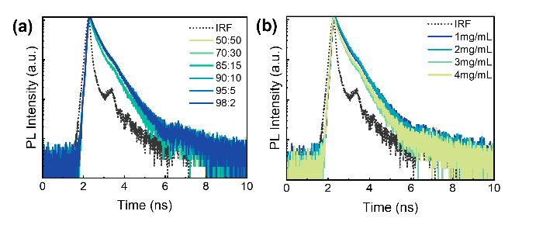
Fig. S2 Time-resolved photoluminescence decay curves of PFO@QX nanofibers as a function of donor-acceptor composition ratio and concentration. (λ_{ex}:370 nm, λ_{det}:405 nm), (a) composition-dependent decay curves, and (b) concentration-dependent decay curves

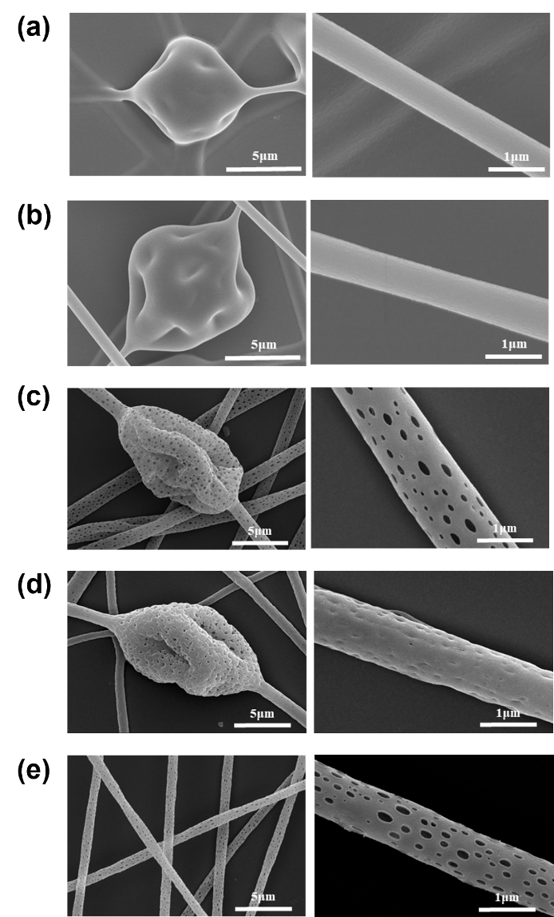
Fig. S3 SEM images of electrospun PFO@QX nanofibers after (a) chloroform, (b) THF, (c) methanol, (d) IPA, (e) hexane vapor exposure

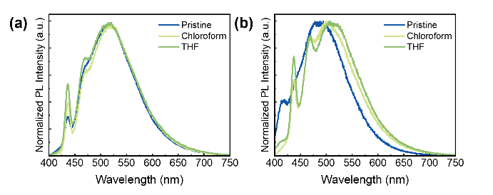
Fig. S4 Comparison of PL responses between spin-coated films and electrospun nanofibers upon various vapor exposures. PL spectra of (a) spin-coated films, (b) electrospun PFO@QX nanofibers, upon exposure to chloroform and THF

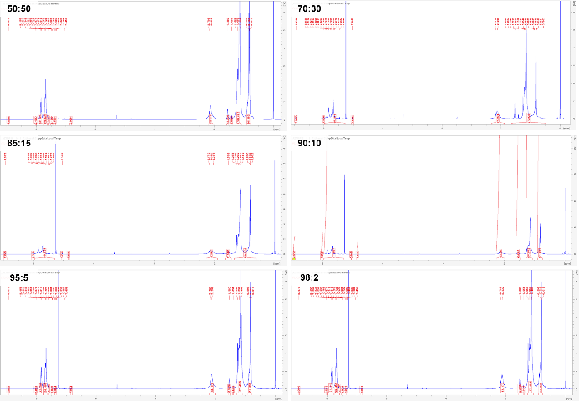
Fig. S5 ¹H NMR spectra of PFO@QX copolymers with varying donor–acceptor composition ratios (m:n)

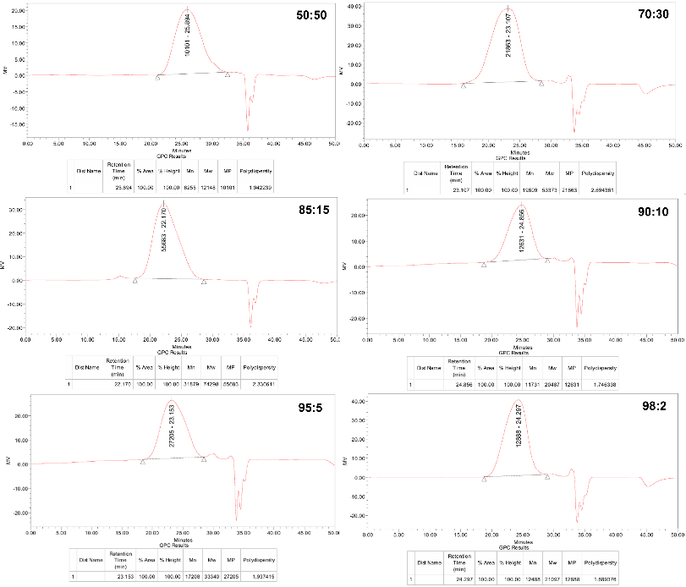
Fig. S6 Gel permeation chromatography (GPC) of the PFO@QX copolymers with varying donor–acceptor composition ratios (m:n)
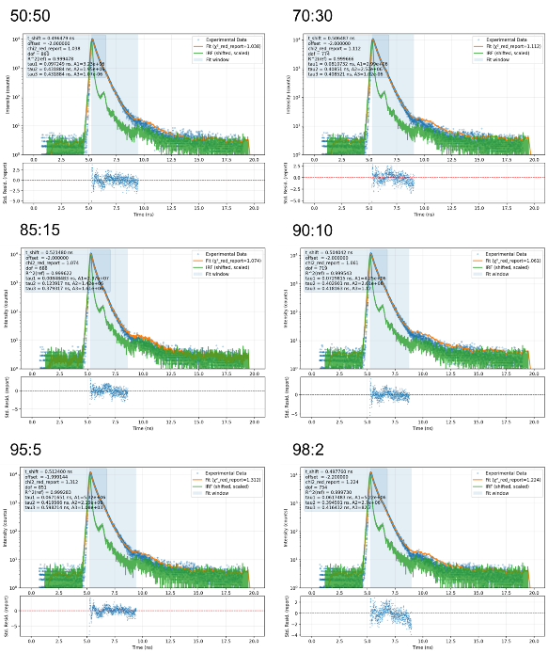
Fig. S7 Time-resolved photoluminescence decay profiles of PFO@QX nanofibers with varying donor–acceptor composition ratios (m:n). Representative decay curves (λ_{ex}:370 nm, λ_{det}:405 nm) for 50:50, 70:30, 85:15, 90:10, 95:5, and 98:2 samples are shown, including experimental data, fitted curves, and corresponding residual plots
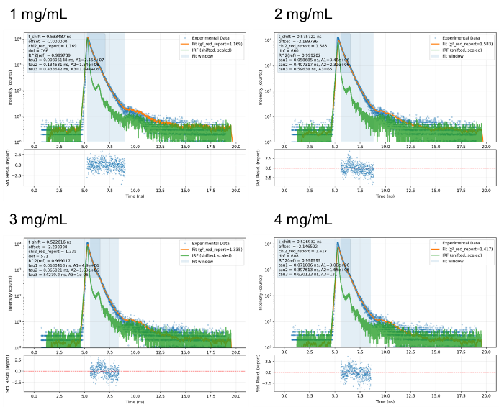
Fig. S8 Time-resolved photoluminescence decay profiles of PFO@QX nanofibers with varying polymer concentrations (1–4 mg/mL). Representative decay curves (λ_{ex}:370 nm, λ_{det}:405 nm) for 1, 2, 3, and 4 mg/mL samples are shown, including experimental data, fitted curves, and residual plots
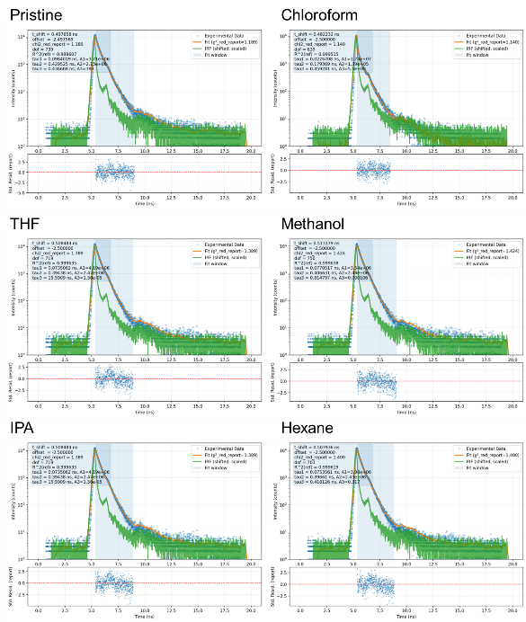
Fig. S9 Time-resolved photoluminescence decay profiles of PFO@QX nanofibers before and after exposure to various VOC vapors. Decay curves (λ_{ex}:370 nm, λ_{det}:405 nm) are shown for pristine, chloroform, THF, methanol, IPA, and hexane conditions, including experimental data, fitted curves, and residual plots

