Supplementary Information
Foliar application of flavonoids (rutin) regulates phytoremediation efficiency of Amaranthus hypochondriacus by altering the permeability of cell membranes and immobilizing excess Cd in the cell wall
Yuchen Kang ª, Jiaxin Liu ª, Li Yang ª, Na Li ª, Yuhao Wang ª, Tianqi Ao ^{b}, Wenqing Chen ^{a, *}
ª College of Architecture and Environment, Sichuan University, Chengdu 610065, China
^{b} State Key Laboratory of Hydraulics and Mountain River Engineering, Sichuan University, Chengdu 610065, China
*Corresponding author. Postal address: No. 24, South section 1, 1st Ring Rd., Chengdu, Sichuan Province, 610065, China. E-mail: kogami97@126.com (Wenqing Chen)

Tables and figures captions:
Table S1. Result of stepwise forward multiple regression model in whole plant.
Table S2. Result of stepwise forward multiple regression model in leaf.
Table S3. Result of stepwise forward multiple regression model in stem.
Table S4. Result of stepwise forward multiple regression model in root.
Figure S1. Changes in Cys, GSH, PC₂, PC₃, and PC₄ in roots of A. hypochondriacus under various Cd conditions and rutin treatments.
Figure S2. Changes in Cys, GSH, PC₂, PC₃, and PC₄ in stems of A. hypochondriacus under various Cd conditions and rutin treatments.
Figure S3. Correlation coefficient heat map of Pearson product-moment in Cd concentration, biomass, Cys, GSH, PC₂, PC₃, and PC₄ in leaf, stem, and root of A. hypochondriacus.

Table S1. Result of stepwise forward multiple regression model in whole plant
Parameters | Coef. | Std. Err. | Std. Coef. | t | P
Cons. | -288.584 | 60.616 |  | -4.769 | .000
Cd in soil | 3.652 | .250 | 1.117 | 14.618 | .000
Endogenous rutin | 2.067 | .437 | .224 | 4.728 | .000
PC₂ in root | -.047 | .011 | -.322 | -4.407 | .001

Table S2. Result of stepwise forward multiple regression model in leaf
Parameters | Coef. | Std. Err. | Std. Coef. | t | P
Cons. | -102.740 | 37.017 |  | -2.776 | .015
PC₃ in leaf | 17.347 | 2.044 | .915 | 8.489 | .000

Table S3. Result of stepwise forward multiple regression model in stem
Parameters | Coef. | Std. Err. | Std. Coef. | t | P
Cons.* | -5.428 | 6.270 |  | -.866 | .402
Cd in soil | 1.449 | .175 | .621 | 8.258 | .000
PC₂ in leaf | .049 | .049 | .420 | 5.579 | .000
* p > 0.05, not included in the model

Table S4. Result of stepwise forward multiple regression model in root
Parameters | Coef. | Std. Err. | Std. Coef. | t | P
Cons. | 50.449 | 14.972 |  | 3.370 | .005
PC₃ in leaf | 1.076 | .152 | .884 | 7.061 | .000

Figure S1. Changes in Cys, GSH, PC₂, PC₃, and PC₄ in roots of A. hypochondriacus under various Cd conditions and rutin treatments. Cys and GSH represent cysteine and glutathione, PC₂, PC₃, and PC₄ are phytochelatins of PCn which are oligomers of glutathione. Each value represents the mean ± S.D. of three independent experiments.

Figure S2. Changes in Cys, GSH, PC₂, PC₃, and PC₄ in stems of A. hypochondriacus under various Cd conditions and rutin treatments. Cys and GSH represent cysteine and glutathione, PC₂, PC₃, and PC₄ are phytochelatins of PCn which are oligomers of glutathione. Each value represents the mean ± S.D. of three independent experiments.

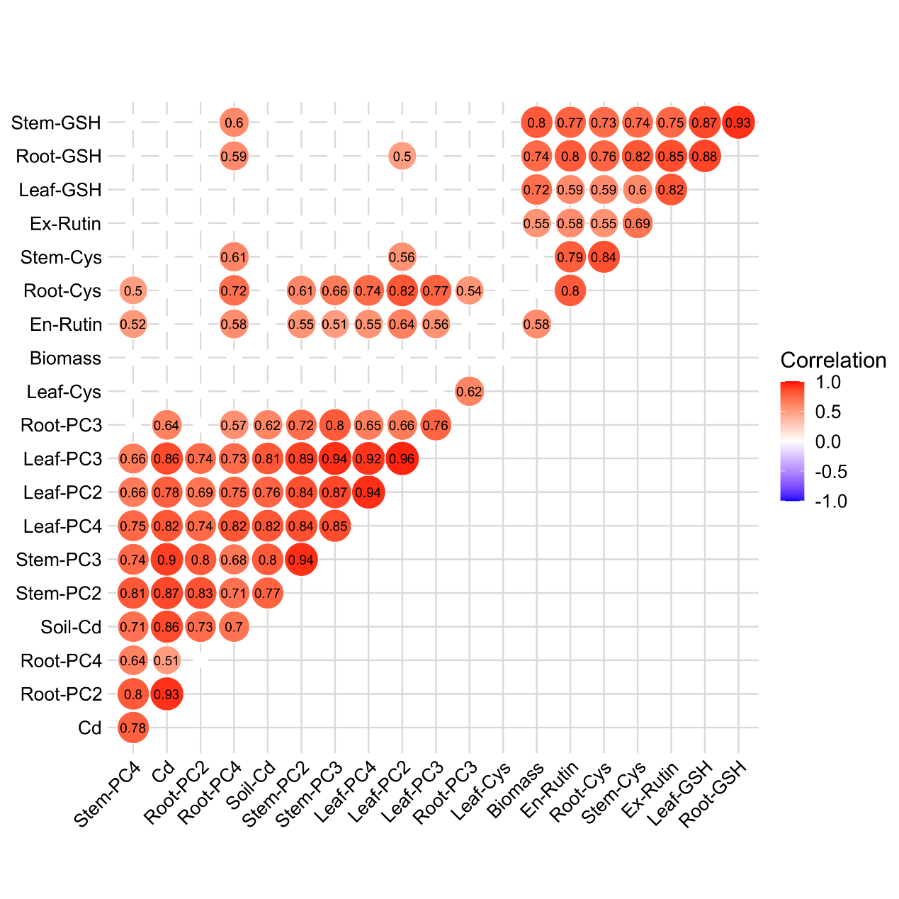
Figure S3. Correlation coefficient heat map of Pearson product-moment in Cd concentration, biomass, Cys, GSH, PC₂, PC₃, and PC₄ in leaf, stem, and root of A. hypochondriacus. Red indicates a positive correlation. The darker the color, the stronger the correlation. Values without significant correlation (p < 0.05) were not shown in figure.

