Characterizing mobility patterns of forest goers
in southern Lao PDR using GPS loggers.

Author Block: Francois Rerolle^{1,2*}, Emily Dantzer¹, Toula Phimmakong³, Andrew Lover⁴, Bouasy Hongvanthong³, Rattanaxay Phetsouvanh⁵, John Marshall⁶, Hugh Sturrock^{1,2}, Adam Bennett^{1,2}

¹Malaria Elimination Initiative, The Global Health Group, University of California, San Francisco, CA, USA, ²Department of Epidemiology and Biostatistics, University of California, San Francisco, CA, USA, ³Center for Malariology, Parasitology and Entomology, Ministry of Health, Vientiane, Lao People's Democratic Republic, ⁴Department of Biostatistics and Epidemiology, School of Public Health and Health Sciences, University of Massachusetts-Amherst, MA, USA, ⁵Department of Communicable Disease Control, Ministry of Health, Vientiane, Lao PDR, ⁶Divisions of Epidemiology and Biostatistics, School of Public Health, University of California, Berkeley, CA, USA

*For correspondence: francois.rerolle@ucsf.edu

Supplemental Materials S2: Additional figures

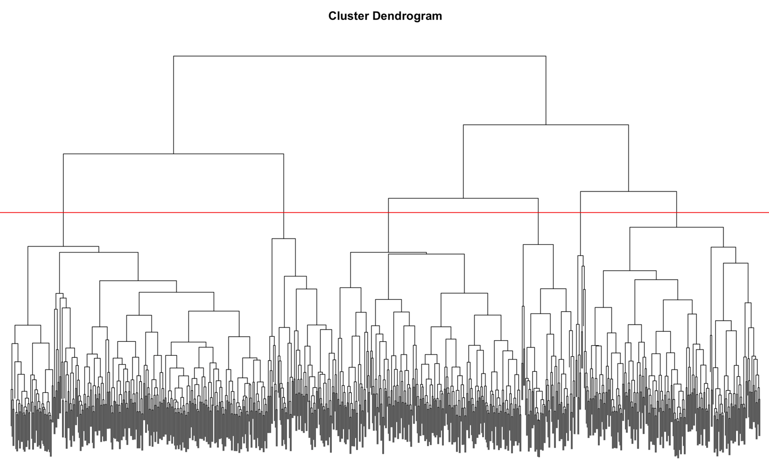

Figure 9 – Dendogram from the hierarchical clustering algorithm. Starting from the bottom, every data point, i.e outdoor trip, is regrouped one a time into “leaves” (=cluster) until they are all in one big and uninformative cluster. The length of the “branches” quantifies the dissimilarity between the leaves. The red horizontal line represents our subjective decision to cut the tree in 6 clusters. We felt selecting 5 clusters would have failed to cut lengthy branches whereas selecting 7 clusters would have started to cut short branches.

