Pre-course Knowledge Test
◎A. Scope of Practice for Emergency Medical Technicians
1.Select an item that is not currently designated as an emergency lifesaving procedure by EMTs.
a. Intravenous infusion using lactated Ringer’s solution
b. Airway management using an esophageal obturator airway, laryngeal mask, or endotracheal tube
c. FAST examination using an ultrasound device
d. Administration of glucose solution

2.In telemedicine-based information sharing inside an ambulance, select the incorrect statement.
a. Before initiating telemedicine, provide sufficient explanation to the patient and family, and obtain their understanding.
b. To conduct telemedicine, only the benefits are explained; potential disadvantages do not need to be explained in advance.
c. When transmitting a patient’s video images, privacy protection is handled with great care.
d. Telemedicine may be conducted when long travel distances make early diagnosis difficult before hospital arrival.

◎Fundamental Knowledge of Ultrasound
1. In FAST examinations, which probe is used? Select one.
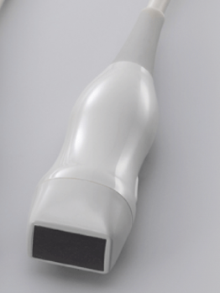
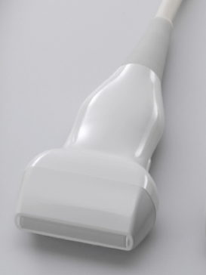
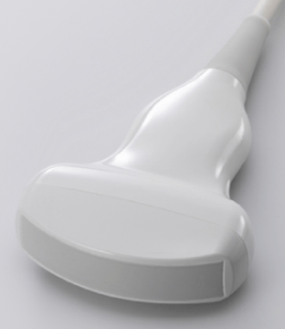
a. Linear b. Convex c. Sector
(Images cited from reference 1.)

2. How should the probe marker (arrow in Figure 1) be oriented in Figures 2 and 3? Select one.

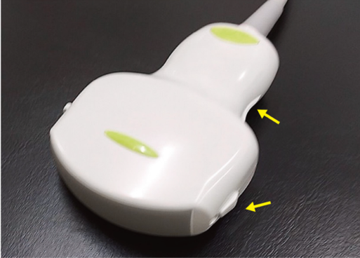
Figure 1 (cited from reference 2) / Figures 2–3

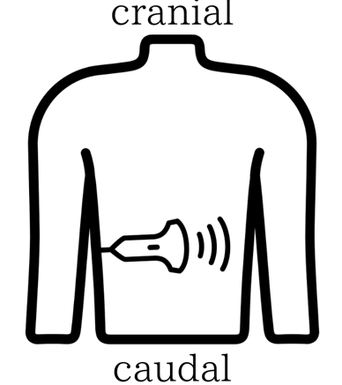
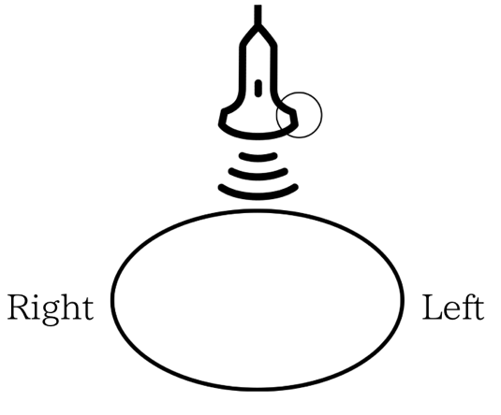
Figure2 Figure3

a. Patient’s right/cranial b. Patient’s right/caudal
c. Patient’s left/cranial d. Patient’s left/caudal

3. For FAST, which combination of anatomical windows (①–⑥) is correct? Select one.
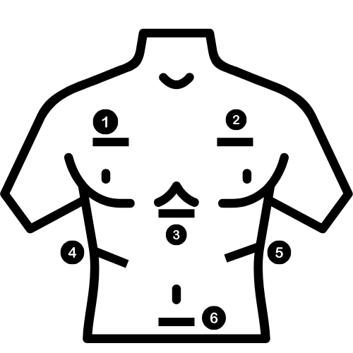
a.①,②,③,⑥ b.①②④⑤ c.①,②,④,⑤,⑥ d.③,④,⑤,⑥

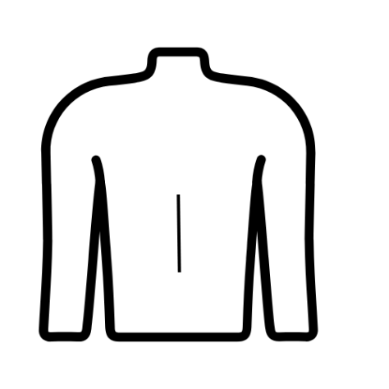
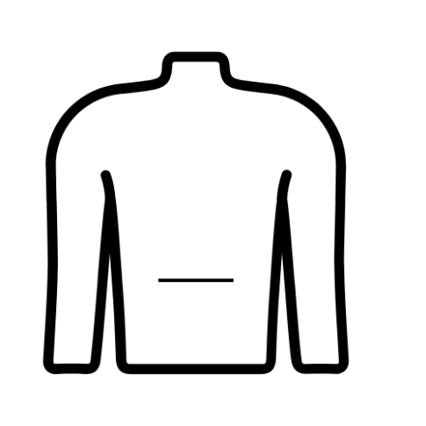
4. Figure 1 shows the probe applied longitudinally; Figure 2 shows it applied transversely. Select the correct pairing of image planes.
Figure 1 Figure 2
a. Fig.1: axial, Fig.2: sagittal b. Fig.1: sagittal, Fig.2: axial

◎ Questions on Ultrasound Images
●The following image is an epigastric view.
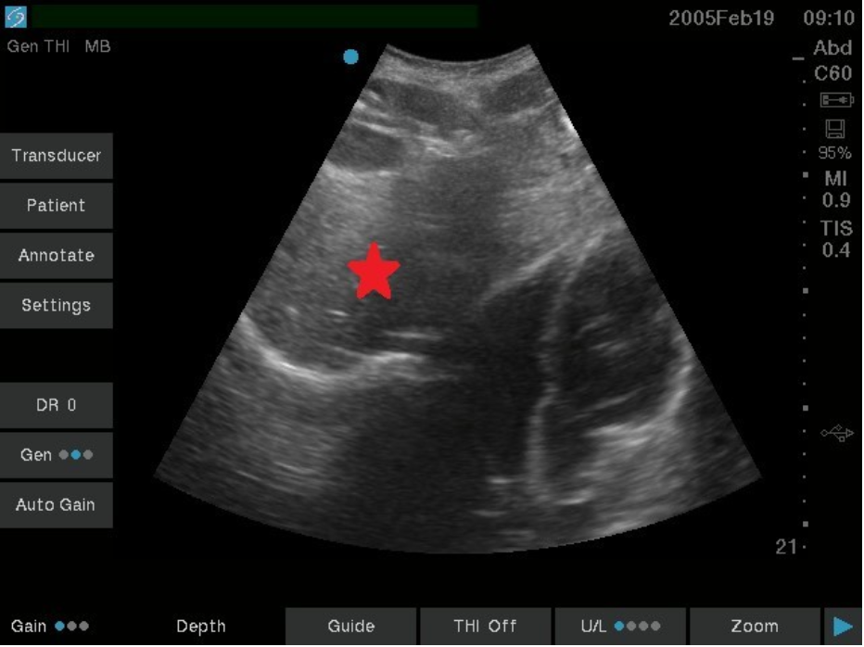
Source: (3)
1. Which organ is marked by the red star? Select one.
a. Stomach b. Liver c. Kidney d. Kidney

●The following image is a left upper quadrant view.
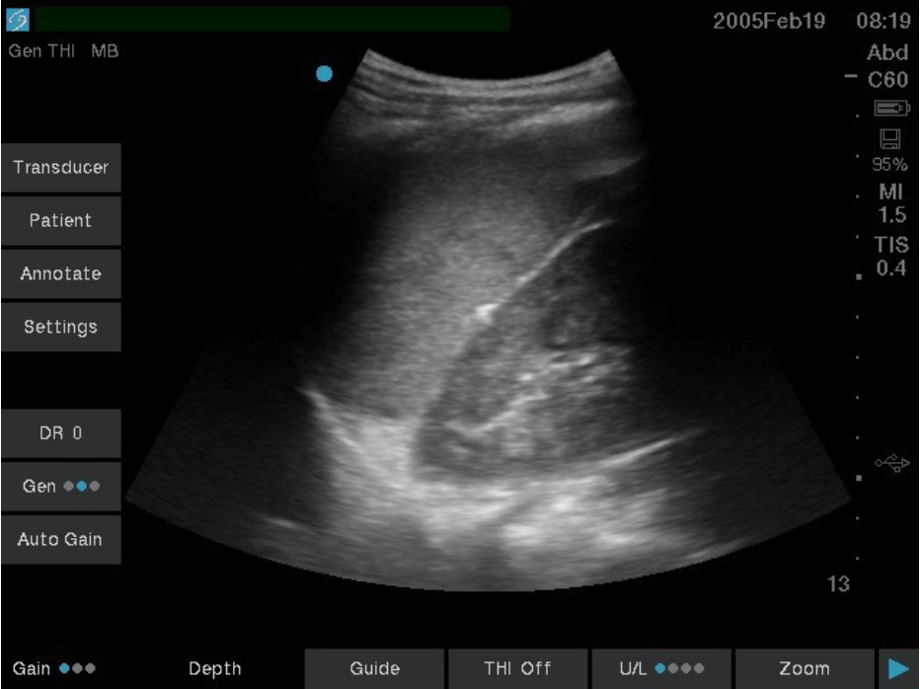
Source: (3)
2. Which organs are primarily shown? Select one.
a. Heart and liver b. Spleen and kidney c. Liver and spleen d. Liver and kidney

●The following image is a right upper quadrant view.
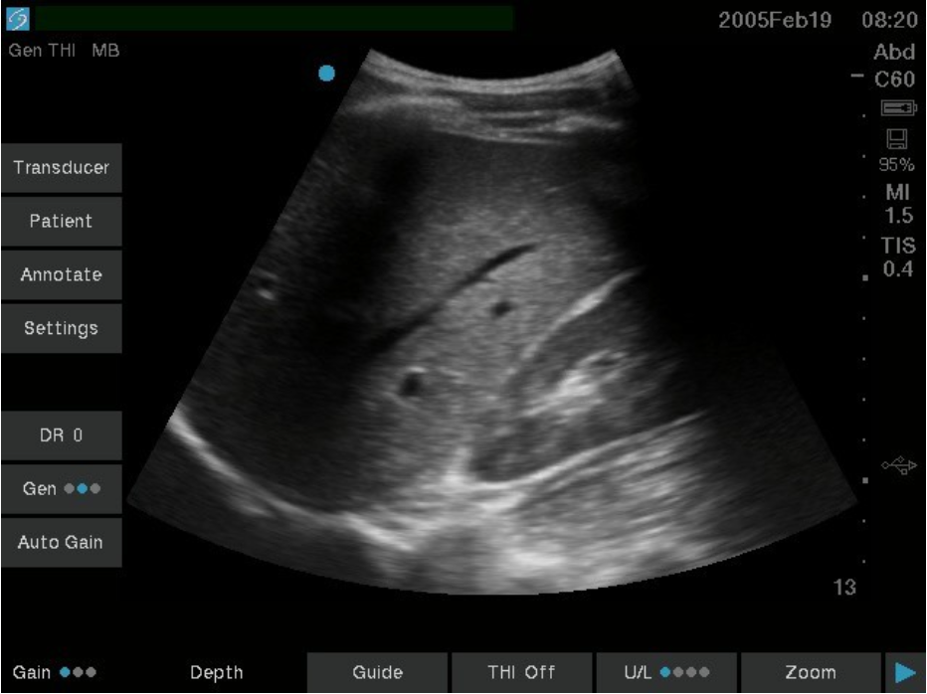
Source: (3)
3-1. Which organs are primarily shown? Select one.
a. Heart and liver b. Spleen and kidney c. Liver and spleen d. Liver and kidney

3-2. In the same view, where does fluid accumulate when FAST is positive? Select one.
a. Splenorenal recess b. Hepatorenal recess (Morison pouch)
c. Rectouterine/rectovesical pouch (Douglas pouch) d. Pericardial space

●The following image is a midline suprapubic view.
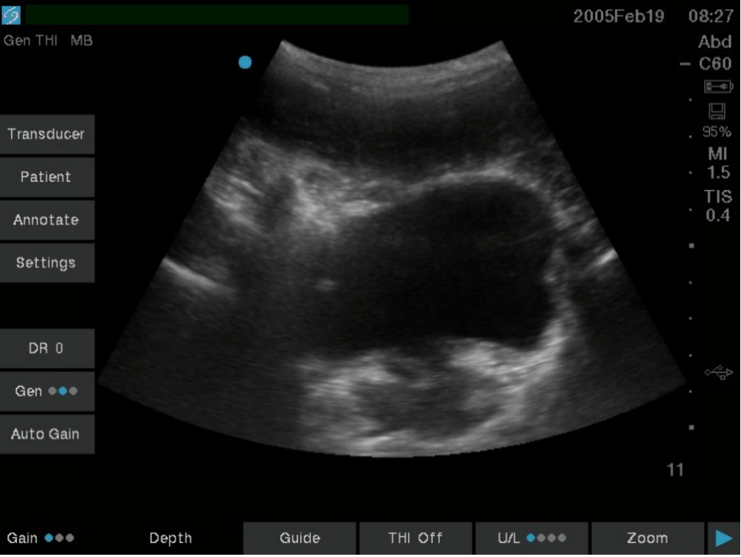
Source: (3)
4. How does the bladder content appear on ultrasound? Select one.
a. Hypoechoic b. Hyperechoic c. Anechoic (echo-free space)

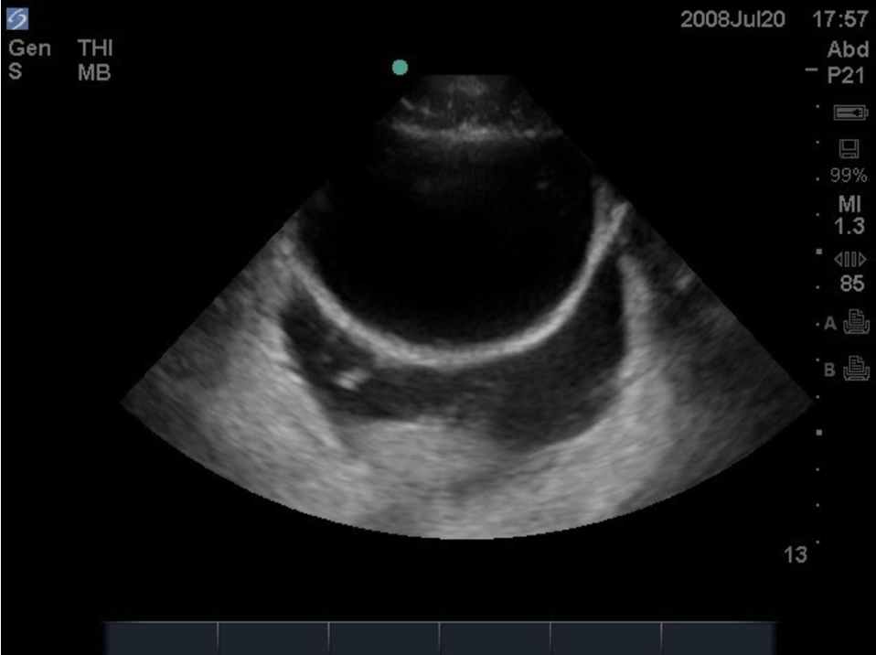
●The following image is a midline suprapubic view.

Source: (3)

5. Is fluid accumulation present? Select one.
a. Yes, an anechoic (echo-free) area is present in the Douglas pouch.
b. Yes, a hyperechoic area is present in Morison pouch.
c. No fluid is present in this image.
d. Further detailed assessment is required.

●The following image is an epigastric view.
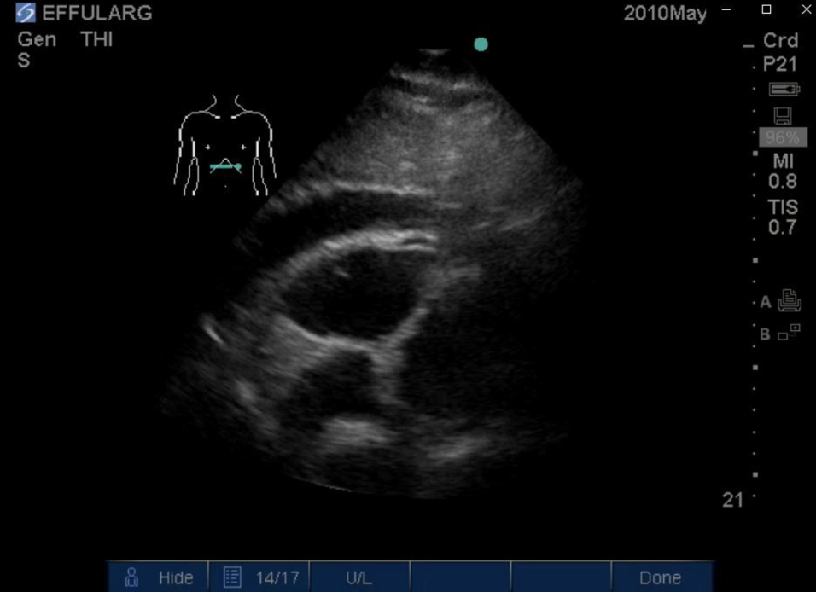
Source: (3)
6. Is fluid accumulation present? Select one.
a. Yes, an anechoic (echo-free) area is present in Morison pouch.
b. Yes, an anechoic (echo-free) area is present in the pericardial space.
c. No fluid is present in this image.
d. Further detailed assessment is required.

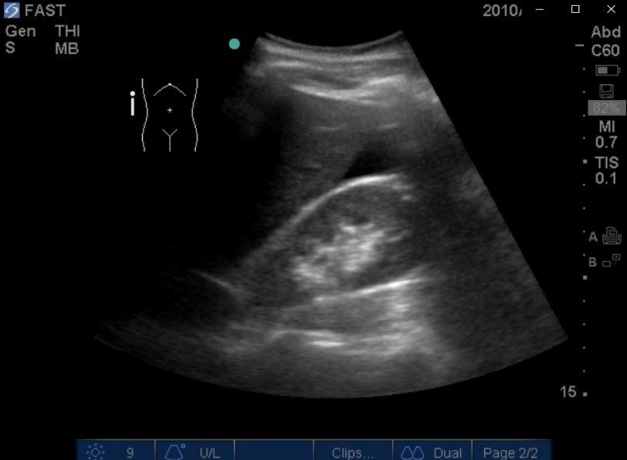
●The following image is a right upper quadrant view.
Source: (3)
7. Is fluid accumulation present? Select one.
a. Yes, an anechoic (echo-free) area is present in Morison pouch.
b. Yes, a hyperechoic area is present in Morison pouch.
c. No fluid accumulation is present.
d. Further detailed assessment is required.

●The following image is a right upper quadrant view.
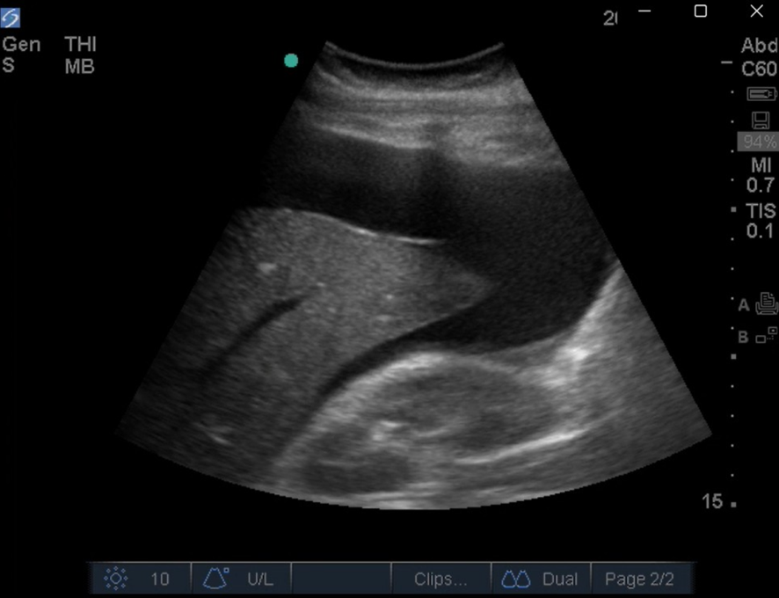
Source: (3)
8. If the depicted finding is present, what is the most likely diagnosis? Select one.
a. Cardiac tamponade b. Liver injury c. Splenic injury d. Ectopic pregnancy

Answers
◎A. Scope of Practice for Emergency Medical Technicians
1.c
2.b
◎Fundamental Knowledge of Ultrasound
1.b
2.d
3.d
4.b
◎ Questions on Ultrasound Images
1.b
2.b
3-1.d. 3-2.b
4.c
5.a
6.b
7.a
8.b

References

1. Nihon Dempa Kogyo Co., Ltd. 3D imaging linear type probe sample data. NDK Website. https://www.ndk.com/en/products/ultrasound/probe/3glinear/. Accessed September 2, 2025.
2. Kameda T. Ultrasound anatomy and scanning technique—Gallbladder and extrahepatic bile duct. Igaku-Shoin medical news plus; published October 20, 2023. https://www.igaku-shoin.co.jp/paperplus/archive/y2023/hukubueco_01. Accessed September 2, 2025.
Further reading
3. Nguyen CM, Hartmann K, Goodmurphy C, Flamm A. E-FAST ultrasound training curriculum for prehospital emergency medical service (EMS) clinicians. J Educ Teach Emerg Med 2024;9:C41–C97. doi: 10.21980/J8S060.

1. Nihon Dempa Kogyo Co., Ltd. 3D imaging linear type probe sample data. NDK Website. https://www.ndk.com/en/products/ultrasound/probe/3glinear/. Accessed September 2, 2025.
2. Kameda T. Ultrasound anatomy and scanning technique—Gallbladder and extrahepatic bile duct. Igaku-Shoin medical news plus; published October 20, 2023. https://www.igaku-shoin.co.jp/paperplus/archive/y2023/hukubueco_01. Accessed September 2, 2025.
Further reading
3.Nguyen CM, Hartmann K, Goodmurphy C, Flamm A. E-FAST ultrasound training curriculum for prehospital emergency medical service (EMS) clinicians. J Educ Teach Emerg Med. 2024;9(1):C41-C97. doi: 10.21980/J8S060.

