Supplementary figures

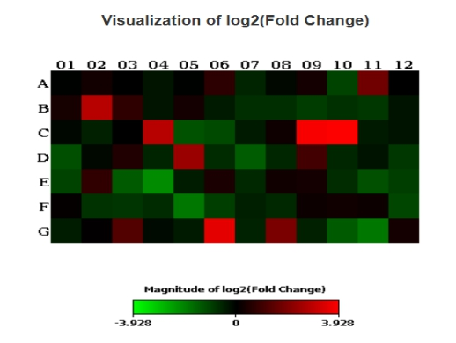
Figure. S1 Heat map of NSCLC group and COPD group.

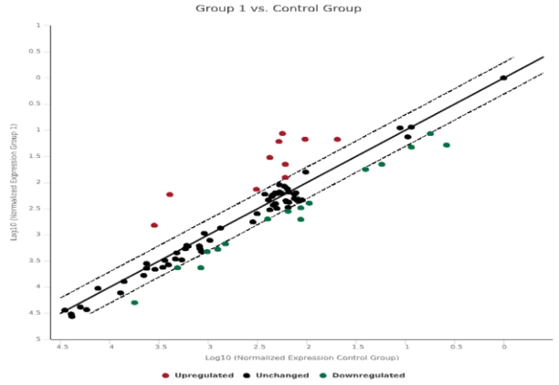
Figure. S2 Scatter diagram of NSCLC group and COPD group

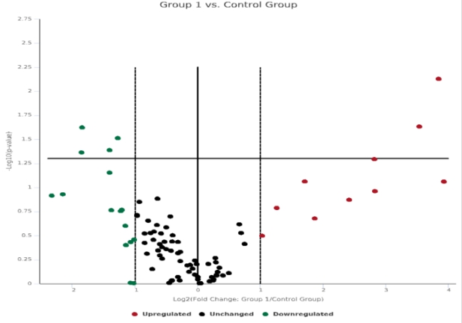
Figure. S3 Volcano plot of NSCLC group and COPD group
Note: Control group is the COPD group, Group 1 is the NSCLC group, and Group 2 is the complication group of NSCLC and COPD.

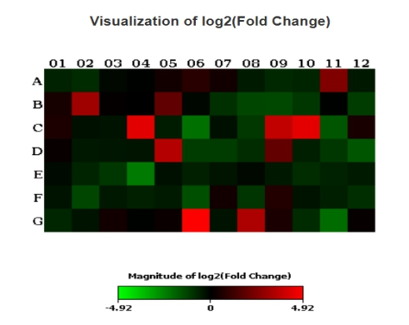
Figure. S4 Heat map of the complication group and COPD group

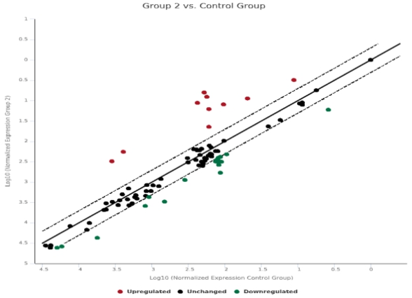
Figure. S5 Scatter diagram of the complication group and COPD group

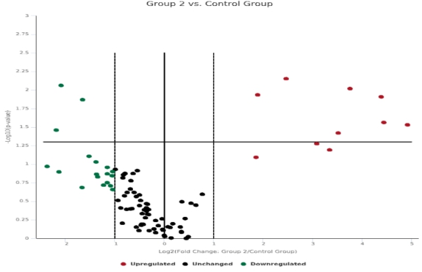
Figure. S6 Volcano plot of the complication group and COPD group

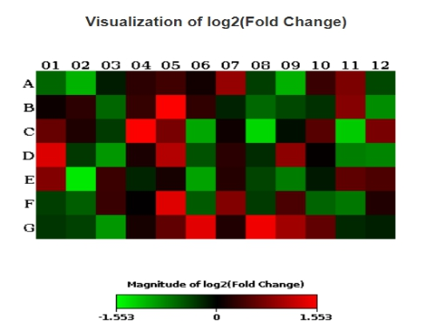
Figure. S7 Heat map of the complication group andNSCC group

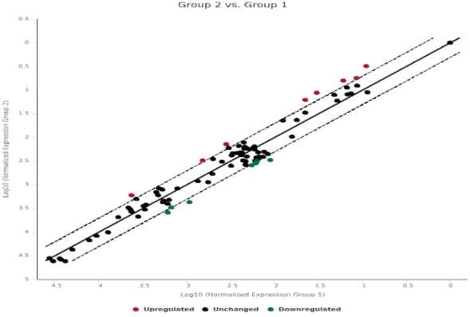
Figure. S8 Scatter diagram of the complication group and NSCLC group

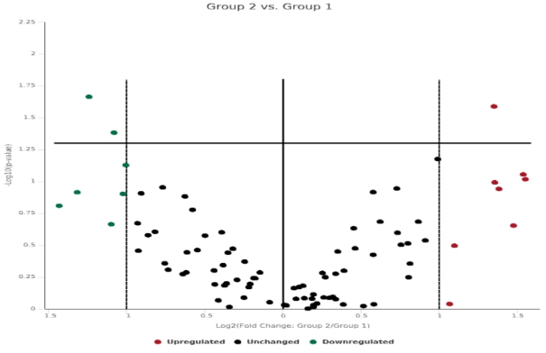

Figure. S9 Volcano plot of the complication group and NSCLC group
Note: Control group is the COPD group, Group 1 is the NSCLC group, and Group 2 is the complication group of NSCLC and COPD.

