Supplementary Materials for

Electron-buffered Substoichiometric Overlayers Enable Tunable Active Sites and Exceptional Stability in Oxidative and Humid Catalytic Conditions
Li Xiang, Yumin Mao, Kexin Cao, Wenbo Li, Xueqing Luo, Feng Bi, Bowen Han, Junqi Zhang, Liang Wang*, Sheng Dai*, Zhongbiao Wu*, Xiaole Weng*

Corresponding author: Liang Wang, E-mail: liangwang@zju.edu.cn; Sheng Dai, E-mail: shengdai@ecust.edu.cn; Zhongbiao Wu, E-mail: zbwu@zju.edu.cn; Xiaole Weng, E-mail: xlweng@zju.edu.cn

The PDF file includes:

Supplementary Text
Figs. S1 to S57
Tables S1 to S2
SI References

Supplementary Text

S1. Materials
Titanium (IV) bis (ammonium lactate) dihydroxide (TiBALD, 50 wt% in water, Aladdin); Ce(NO₃)₃·6H₂O (98%, Sinopharm Chemical Reagent Co., Ltd.); (NH₄)₂PdCl₆ (99.9% metals basis，Pd 29%, Sinopharm Chemical Reagent Co., Ltd.); NaOH ( > 96%, Sinopharm Chemical Reagent Co., Ltd.); CO/N₂ (2 vol%), O₂ (99.999%), H₂/N₂ (5 vol%), and SO₂/N₂ (3000 ppm) supplied by Hangzhou Jingong special gas Co. Ltd.

S2. Catalyst Preparation
Preparation of Pd/CeTiO_{x}-H, Pd/CeO₂-H, and Pd/TiO₂-H
The Pd/CeTiO_{x}-H precursor was synthesized using a continuous hydrothermal flow synthesis (CHFS) system (Fig. S1) using supercritical water (sc-H₂O) in our laboratory. The detailed synthesis procedure was as follows: deionized (DI) water delivered by pump P1 (20 mL/min) was heated in flow to 450 ºC. Simultaneously, a mixture of TiBALD (0.05 M, 250 mL), Ce(NO₃)₃·6H₂O (0.05 M, 250 mL), and (NH₄)₂PdCl₆ (0.055 g Pd) from pump P2 (10 mL/min) was pre-mixed with a NaOH solution (1.0 M, 10 mL/min) at room temperature in a T-piece. This combined stream then merged with the sc-H₂O flow under turbulent conditions within the current confined jet mixer, resulting in rapid co-precipitation of the Pd/CeTiO_{x}-H precursor at a mixing temperature of approximately 374.3 ºC. The resulting nanoparticulate slurry was cooled to approximately 40 ºC using a 1.5 m pipe-in-pipe heat exchanger before exiting the reactor via a back-pressure regulator, which maintained a constant system pressure of 22.1 MPa. The collected Pd/CeTiO_{x}-H precursor was washed, collected by centrifugation, frozen at -50 °C, and then freeze-dried for 24 hours at 50 Pa. Subsequently, the dried precursor was reduced under a 5 vol% H₂/N₂ atmosphere at 400 °C for 4 hours to obtain the final Pd/CeTiO_{x}-H catalyst. The preparation methods for Pd/CeO₂-H and Pd/TiO₂-H were similar to that of Pd/CeTiO_{x}-H, differing only in the composition of the metal precursor mixture delivered by pump P2 (10 mL/min), for which Ce(NO₃)₃·6H₂O (0.1 M, 500 mL) and (NH₄)₂PdCl₆ (0.055 g Pd) were used for Pd/CeO₂ precursor, and TiBALD (0.1 M, 500 mL) and (NH₄)₂PdCl₆ (0.055 g Pd) for Pd/TiO₂-H precursor. The dried precursors were subsequently reduced under a 5 vol% H₂/N₂ atmosphere for 4 hours to obtain the final catalysts. For the Pd/CeO₂ precursor, a reduction temperature of 500 °C was applied to obtain Pd/CeO₂-H. As for the Pd/TiO₂ precursor, it was reduced at both 400 ºC and 500 ºC, with the resulting catalysts denoted as Pd/TiO₂-400H and Pd/TiO₂-H, respectively.
Preparation of Pd/CeTiO_{x}-IM
The CeTiO_{x} support was first synthesized using the continuous CHFS system and followed a procedure analogous to that of the Pd/CeTiO_{x}-H precursor, differing only in the composition of the metal precursor mixture delivered by pump P2 (10 mL/min). Specifically, a mixture of Ce(NO₃)₃·6H₂O (0.05 M, 250 mL) and TiBALD (0.05 M, 250 mL) was used, without the addition of (NH₄)₂PdCl₆. Subsequently, the impregnation method was employed to load 1 wt% Pd onto the CeTiO_{x} support, forming Pd/CeTiO_{x}-IM. The resulting solid was dried overnight at 100 ºC and reduced in 5 vol% H₂/N₂ at 400 ºC for 4 h, forming Pd/CeTiO_{x}-IM.
Preparation of Au/CeTiO_{x}-H, Pt/CeTiO_{x}-H, Pd/SnTiO_{x}-H, and Pd/ZrTiO_{x}-H
The synthesis procedures for Au/CeTiO_{x} and Pt/CeTiO_{x} precursors were similar to that of Pd/CeTiO_{x}, except that (NH₄)₂PdCl₆ (0.055 g Pd) in the metal precursor mixture delivered by pump P2 (10 mL/min) was replaced with HAuCl₄·3H₂O (0.055 g Au) and (NH₄)₂PtCl₆ (0.055 g Pt), respectively. The resulting Au/CeTiO_{x} and Pt/CeTiO_{x} precursors were subsequently reduced under 5 vol% H₂/N₂ at 500 ºC and 600 ºC for 4 h to yield Au/CeTiO_{x}-H and Pt/CeTiO_{x}-H, respectively. The synthesis procedures for the Pd/SnTiO_{x} and Pd/ZrTiO_{x} precursors were similar to that of Pd/CeTiO_{x}, except that Ce(NO₃)₃·6H₂O (0.05 M, 250 mL) in the metal precursor mixture delivered by pump P2 (10 mL/min) was replaced with SnCl₄ (0.05 M, 250 mL) and Zr(NO₃)₂·6H₂O (0.05 M, 250 mL), respectively. The resulting Pd/SnTiO_{x} and Pd/ZrTiO_{x} precursors were then reduced under 5 vol% H₂/N₂ at 400 ºC for 4 h to yield Pd/SnTiO_{x}-H and Pd/ZrTiO_{x}-H, respectively.

S3. Catalyst Characterization
Inductively coupled plasma emission spectrometry (ICP-OES)
ICP-OES was conducted using an Agilent 5110 to determine the actual Pd content of catalysts.
X-ray diffraction (XRD)
XRD patterns were recorded on a Rigaku D/Max-RA powder diffractometer using Cu Kα radiation (λ = 1.5418 Å, 40 kV and 150 mA). The data were collected at the scattering angles (2θ) ranging from 10 to 80° with a scan rate of 5°/min.
The Brunauer–Emmett–Teller (BET) specific surface area
The BET specific surface area of the support was measured using a static volumetric adsorption analyzer (JW-BK132F). Before measurement, all samples were degassed at 150 °C for 1-2 hours under vacuum. The pore size distribution was measured from the N₂ desorption isotherm using the cylindrical pore model (BJH method).
Aberration-corrected transmission electron microscopy (AC-TEM)
AC-TEM were performed on a ThermoFisher Themis Z microscope with two aberration correctors under 300 kV. Energy dispersive X-ray spectroscopy (EDS) was carried out using 4 in-column Super-X detectors. Electron energy loss spectroscopy (EELS) was acquired using a Gatan Enfinium ER (model 977) EELS.
In situ environmental TEM
In situ environmental TEM was performed using an ThermoFisher Themis ETEM transmission electron microscope equipped with a Cs corrector on the objective lens and a K2 electron direct detection camera (Gatan). In situ experiments were conducted under 5 vol% H₂/Ar (gas pressure 5 kPa) at 400 ºC. Low-dose HRTEM images were carried out at 300 kV under a very low electron dose (~5 e/Å²s). Images were acquired as a series of 20 frames with a 0.1s/frame rate and the image stack was processed by post-acquisition drift correction.
X-ray absorption spectroscopy (XAS)
The XAS including X-ray absorption near-edge structure (XANES) and extended X-ray absorption fine structure (EXAFS) at Pd K-edge of the samples were measured at the beamline 14 W of Shanghai Synchrotron Radiation Facility (SSRF) in China. The output beam was selected by Si(111) monochromator, and the energy was calibrated by Pd foil. Before measurement, the samples were diluted by boron nitride and tableted in a glovebox to avoid air exposure. The acquired EXAFS data was processed via Athena module implemented in the Demeter software. The k² weighted EXAFS were obtained by subtracting the pre-edge and post-edge background from the overall absorption and then normalized with respect to the edge jump step in 1st derivative line. EXAFS of the Pd foil is fitted and the obtained amplitude reduction factor S₀² value was set in the EXAFS analysis to determine the coordination numbers (CNs) in scattering path in sample. Subsequently, the χ(k) data was then Fourier transformed to R space, using a hanning window (dk=1 Å⁻¹) to separate EXAFS conditions from different coordination shells. XAFS fitting was proceeded using ARTEMS software. The EXAFS equation was listed:
$$χ\left(k\right)=\sum_{j}{\frac{N_{j}S_{0}^{2}F_{j}(k)}{kR_{j}^{2}}exp⁡[-2k^{2}σ_{j}^{2}]e^{-2R_{j}/λ_{j}(k)}\sin{[2kR_{j}+ϕ_{j}(k)]}}$$
S₀² is the amplitude reduction factor, F_{j}(k) is the effective curved-wave backscattering amplitude, N_{j} is the number of neighbors in the jth atomic shell, R_{j} is the distance between the X-ray absorbing central atom and the atoms in the jth atomic shell, λ_{i} is the mean free path in Å, Ф_{j}(k) is the phase shift (including the phase shift for each shell and the total central atom phase shift), σ_{j}² is the Debye-Waller parameter of the jth atomic shell (variation of distances around the average Rj). The relevant parameters were calculated with the ab initio code FEFF.
The k² weighting, k-range of 3-13.6 Å⁻¹ and R range of 1-3 Å were used for the fitting of Pd foil; k-range of 3-11 Å⁻¹ and R range of 1-3 Å were used for the fitting of Pd samples. The parameters, coordination number, bond length, and E₀ shift (CN, R, ΔE₀) were fixed, while the Debye-Waller factor (σ²) was set.
The Wavelet transformed (WT) of EXAFS was performed via Wtexafs software. The parameters were listed as follows: R range of 1-4 Å, k range of 0-12 Å⁻¹, k-weight of 2, and a Morlet function (κ = 10, σ = 1) as the mother wavelet.
In situ near-ambient pressure X-ray photoelectron spectroscopy (In situ NAP-XPS)
The experiments were performed using the laboratory NAP-XPS system (SPECS Surface Nano Analysis, GmbH Germany). All spectra were obtained using monochromatized Al Kα irradiation (1486.6 eV) generated by an Al anode (SPECS XR-50) and an excitation source power fixed at 50 W. The reaction pressure was maintained at 0.6 mbar. The heating of the sample during the measurement is achieved by contact with a hot sample table heated by electron bombardment from the backside (vacuum).
CO-temperature-programmed reduction (CO-TPR) experiments
CO-TPR experiments were performed using TP-5079 (Tianjin Xianquan Industry and Trade Development Co.). For each experiment, 50 mg of sample was pretreated in flowing He (30 mL min⁻¹) at 200 °C for 1 h and then cooled to -50 ºC. The pretreated sample was then exposed to 5 vol% CO/He (30 mL/min) and heated from -50 °C to 200 °C at 10 °C/min. The signals of CO and CO₂ were recorded by a quadrupole mass spectrometer (Hiden Analytical).
O₂-chemisorption experiments
O₂-chemisorption experiments were performed using TP-5079. The O₂ chemisorption were conducted with the O₂ pulse at 150 ºC. The catalysts were exposed into 10 vol% O₂/He with at least 20 pulses till no O₂ adsorptions were observed. Each injection supplied 60 μL of 10 vol% O₂ to 0.1 g of catalyst.
SO₂/CO+SO₂ temperature-programmed desorption (TPD) experiments
SO₂/CO+SO₂ TPD tests were conducted on a Huasi chemisorption analyzer. Prior to TPD experiment, 50 mg sample was pretreated at 120 ºC in Ar for 30 min, followed by cooling to 30 ºC and purging with 1000 ppm SO₂/N₂ and 2500 ppm CO/N₂ (when needed) for 1 h. Subsequently, the temperature was heated to 500 ºC at a rate of 10 ºC·min⁻¹ and the desorption signals for m/z = 64 were monitored using an online mass spectrometer (MS), which was connected to the outlet of the chemisorption instrument.
CO-adsorption/SO₂-oxidation diffuse reflectance infrared Fourier transform infrared spectroscopy (CO/SO₂-DRIFTS)
CO/SO₂-DRIFTS were conducted using an FT-IR spectrometer (Nicolet 6700) with a mercury cadmium telluride detector. The DRIFTS cell with CaF₂ windows was fitted into a heating cartridge. The spectra were measured by accumulating 32 scans at a resolution of 4 cm⁻¹. For CO-DRIFTS tests, the catalyst was pretreated in a He flow (99.99 %, 30 mL/min) at 200 °C for one hour and naturally cooled to 30 °C, whose spectra were taken as the background spectra. After that, a 2 vol% CO/N₂ gas mixture (30 mL/min) was introduced at atmospheric pressure (ca. 1 atm) to attain adsorption near saturation, corresponding to a CO partial pressure of approximately 2 kPa, and the spectra were collected. The gas flow was then switched to pure He to mitigate the effect of gaseous CO efficiently, and the spectra were recorded after it reached the steady state. For SO₂-DRIFTS tests, the catalyst was pretreated in a He flow (99.99 %, 30 mL/min) at 200 °C for 1 hour and naturally cooled to 175 °C, whose spectra were taken as the background spectra. After that, a 1000 ppm SO₂/N₂ gas mixture and 10 vol% O₂ (total flow rate = 30 mL/min) were introduced at atmospheric pressure and the spectra were collected.

S4. Catalytic tests
The catalytic activity was evaluated by CO oxidation using a conventional fixed-bed quartz tubular flow reactor (i.d. 4 mm) at atmospheric pressure. 0.50 g catalyst powder was sieved into 40-60 mesh and placed in an electrically heated furnace. The gaseous mixture of 0.25 vol% CO, 10 vol% O_{2,} and N₂ balance (or 0.4 vol% CO, 10 vol% O_{2,} and N₂ balance) was passed through the catalysts to maintain a weight hourly space velocity of 20000 mL·g⁻¹·h⁻¹ (or 200000 mL·g⁻¹·h⁻¹). SO₂ was introduced when needed. Liquid-phase water was injected into a vaporizer with a syringe pump, followed by electrically heated pipelines to ensure complete evaporation. The effluent gas was analyzed online by a gas chromatograph (GC, Agilent 6890) equipped with two flame ionization detectors (FID) and nickel-converting equipment. The error of each measurement was controlled to lower than 3%. The CO conversion was calculated based on the following equation:
CO conversion = ([CO]_{in} − [CO]_{out}) / [CO]_{in} × 100%
where [CO]_{in} and [CO]_{out} represent the inlet and outlet CO concentrations, respectively.
The apparent activation energy for CO conversion below 15% was determined, with the corresponding Arrhenius plot described by the following equation:
ln r = − E_{a} / RT + C
where r represents reaction rate (mmol/(g·s)), T represents reaction temperature (K), R represents the gas constant, E_{a} represents reaction activation energy (kJ/mol).

S5. Density Functional Theory (DFT) modeling approach
The DFT calculations in this study were performed using the Vienna ab initio simulation package (VASP5.4.4) with a Perdew-Burke-Ernzerhof functional^{1,2}. The project augmented wave (PAW) method was used to describe the core-valence electron interaction with an energy cutoff of 520 eV³. For the work-function calculations, the self-consistent-field (SCF) energy convergence criterion was set to 1E-05 eV, and the forces on each atom were converged to less than 0.03 eV Å⁻¹. A 1×1×1 k-point mesh was used, with the top 3 layers relaxed. The vacuum between slabs was 25 Å to avoid interactions between the neighboring slabs. The brookite TiO₂ model was constructed as a TiO₂ (211) surface consisting of 12 Ti atoms and 28 O atoms with a cell size of 11.85350 Å × 7.49270 Å. The CeO₂ model was constructed as a CeO₂ (111) surface consisting of 4 Ce atoms and 8 O atoms with a cell size of 3.82520 Å × 3.82520 Å. The CeTiO_{x} model was constructed based on the metal ratios and crystal structure determined by XRD analysis. Two approximate bulk structures were obtained and, for each of them, the ground-state energies of three common low-index facets (100), (110), and (111) as well as the truncated surfaces were calculated, followed by the calculation of their respective work functions. The DFT+U method was employed to accurately describe the electronic states of Ce and Ti. A Hubbard U correction of 3.5 eV was applied to the d band of Ti. In the CeO₂ model, where Ce adopts the +4 oxidation state and the outermost p band is fully occupied, no U correction was applied. For the CeTiO_{x} model, in which Ce exhibits a +3 oxidation state, a Hubbard U correction of 5.0 eV was applied to its f band.
For the construction of the working models and the calculation of adsorption configurations, the electronic and ionic convergence criteria were kept consistent with those described above. Because of the structural complexity and asymmetry of the supported slab models, dipole correction was applied. However, the Ce-containing supported structures were difficult to converge to the above criteria when dipole correction and the Ce 4f Hubbard correction were simultaneously included during structural relaxation. Therefore, a commonly adopted two-step strategy was employed to balance surface-dipole correction and microscopic electron localization: the geometries were first optimized using the PBE functional with dipole correction, and the energies and electronic properties associated with localized Ce³⁺ states were subsequently evaluated through single-point DFT+U calculations. In these models, the bottom four atomic layers were fixed, whereas all other atoms were allowed to relax. The Pd@Ti₁₈O₃₆ model consisted of a bilayer TiO₂ (3×3 supercell)-Pd (8×4×2 supercell) surface with dimensions of 16.00060 Å × 11.31410 Å, containing 64 Pd atoms, 18 Ti atoms, and 36 O atoms. Following a similar construction method, a monolayer TiO₂-Pd surface (16.00060 Å × 11.31410 Å) consisting of 64 Pd, 9 Ti and 18 O atoms, and a bilayer TiO₂-Pd surface (16.00060 Å × 11.31410 Å) consisting of 64 Pd, 18 Ti and 36 O atoms were generated. Substituting four surface Ti atoms with Ce atoms in the monolayer surface gave the Pd@Ce₄Ti₅O₁₈ model, while replacing five Ti atoms with Ce atoms in the bilayer surface afforded the Pd@Ce₅Ti₁₃O₃₆ model. Following the same cation-substitution procedure used for the Ce-containing models, nine of the eighteen Ti atoms in the bilayer overlayer were replaced by Sn atoms. The resulting Pd@Sn₉Ti₉O₃₆ model contained 64 Pd atoms, 9 Sn atoms, 9 Ti atoms, and 36 O atoms. A Hubbard U correction of 4.0 eV was applied to the Sn 4d states.
It should be noted that we attempted to construct amorphous CeTiO_{x}@Pd interface models using large supercells and ab initio molecular dynamics (AIMD) melt-quench protocols in the initial stage of this study. However, statistically representative amorphous interfaces require extensive dynamical sampling, and the localized Ce 4f electrons prevented stable SCF convergence in CP2K. The computational cost of long-duration AIMD sampling on large interfacial supercells was also very unfeasible. We therefore adopted periodic structures as a unified framework to compare different overlayer compositions and thicknesses. Previously, periodic ultrathin oxide/metal models have been employed to investigate local interfacial structures and charge transfer in amorphous SMSI systems (e.g., TiO_{x}/Ni and BO_{x}/Ru)^{4,5}. We fully acknowledge the inherent limitations of using periodic crystalline models to simulate experimentally observed amorphous structures. Accordingly, the DFT simulations in this work serve mainly to elucidate qualitative trends in electronic structure modulation and interfacial charge redistribution.
Adsorption energy of molecules on slab models was determined by E_{ads} = E_{ads/sub} - E_{ads} - E_{sub}, whereas E_{ads/sub} represents the total energy of slab model with molecule adsorbed on surface; E_{ads} represents the total energy of slab model clean surface; E_{sub} represents the total energy of molecule in its gas phase. The adsorbate-substrate interaction was characterized by evaluating the moments of the projected density of states (PDOS). Crystal Orbital Hamilton Populations (COHP) was calculated by Local-Orbital Basis Suite Towards Electronic-Structure Reconstruction (LOBSTER) program⁶. Both PDOS and COHP calculations employed the DFT+U method, with U values of 5.0 eV for Ce 4f and 3.5 eV for Ti 3d orbitals.
For the calculations of CO oxidation and the subsequent oxygen-replenishment pathways, the Ce³⁺ 4f states exerted a more pronounced influence on the optimized structures than in the molecular-adsorption calculations. Therefore, both dipole correction and the Ce 4f Hubbard correction were included during geometry optimization, and the force-convergence criterion was relaxed to 0.05 eV Å⁻¹. For the examination of candidate sites for local oxygen-vacancy redistribution, the oxygen-vacancy formation energy was calculated according to E_{vo} = E_{vac} + 1/2E_{O2} - E_{tot}, whereas E_{vac} represents the total energy of slab model with oxygen vacancy; E_{tot} represents the total energy of slab model with lattice oxygen; 1/2E_{O2} represents half of the total energy of oxygen molecule in its gas phase. The minimum-energy reaction pathways were calculated using the climbing-image nudged elastic band (CINEB) method. The transition states were verified by vibrational-frequency analysis. Because the Ce-containing systems may exhibit multiple closely competing electronic states and relatively flat potential-energy surfaces, low-frequency modes associated only with small displacements of peripheral surface atoms were separately examined. A valid transition state was confirmed by the presence of one significant imaginary frequency corresponding to the intended reaction coordinate.
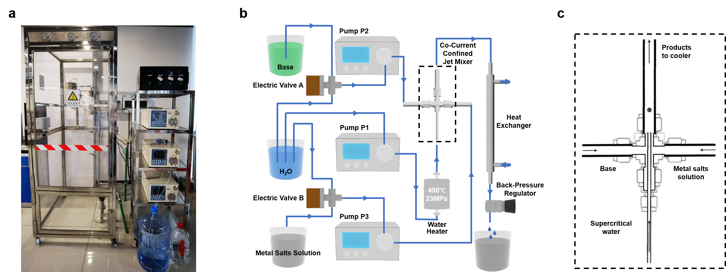
Figure S1. Physical (a) and schematic (b) diagram of continuous hydrothermal flow synthesis system diagram, and schematic diagram of jet mixer (c).

Note: The continuous hydrothermal flow synthesis (CHFS) system diagram employed in this work comprises five main components: a high-pressure liquid delivery system, water heater, co-current confined jet mixer, heat exchanger, and back-pressure system. The high-pressure delivery system consists of three semi-preparative high performance liquid chromatography (HPLC) pumps, which supply deionized water, salt solution, and alkaline solution (for pH adjustment) into the reaction system at flow rates ranging from 0 to 50 ml/min, with a maximum pressure tolerance of 25 MPa. The water heater employs a dual-zone design to rapidly heat the deionized water to supercritical conditions, with a rated power of 2 kW. The salt solution contacts the supercritical/subcritical water in a co-current confined jet mixer. In the jet mixer (Fig. S1c), the sc-H₂O is rapidly ejected through a 1/16-inch inner diameter tube, while the salt and alkaline solutions enter from the two sides of a 1/4-inch four-way cross fitting, mixing with the sc-H₂O at the upper end of the cross. Due to the high linear velocity of the ejected sc-H₂O, it possesses strong scouring ability, thereby preventing particle deposition and clogging. The heat exchanger utilizes a counter-current water-cooled jacket to rapidly quench the effluent to ambient temperature for subsequent collection. The back-pressure system includes a filter (7 μm frit) to prevent particle clogging and a back-pressure regulator capable of maintaining pressures up to 25 MPa. All tubing is made of 316L stainless steel (Swagelok) to resist corrosion under high-temperature acidic or alkaline conditions.
The core principle of supercritical hydrothermal approach lies in exploiting the unique physicochemical properties of water under supercritical conditions (typically T_{c} = 374.3 ºC, P = 22.1 MPa). Upon surpassing the critical point, the partial rupture of hydrogen bonds leads to a drastic reduction in the dielectric constant of water (from ~80 under ambient conditions to <10 in the supercritical regime), causing a transition from a polar to a non-polar solvent. This fundamental change markedly diminishes the solubility of metal salts compared to conventional hydrothermal conditions, generating an exceptionally high supersaturation upon precursor mixing. According to classical nucleation theory, this extreme supersaturation substantially lowers the critical free energy for nucleation and dramatically accelerates the nucleation rate. The system thus favors the formation of a large number of stable nuclei, with rapid quenching immediately suppressing Ostwald ripening and coalescence, thereby kinetically trapping the particles in the nanometer regime. Nanosized metal oxides are obtained through rapid hydrolysis-dehydration reactions⁷:
Hydrolysis reaction : | M(NO₃)_{x} (aq) + x H₂O → M(OH)_{x} (s) + x HNO₃
Dehydration reaction: | M(OH)_{x} (s) → MO_{x/2} (s) + x/2 H₂O
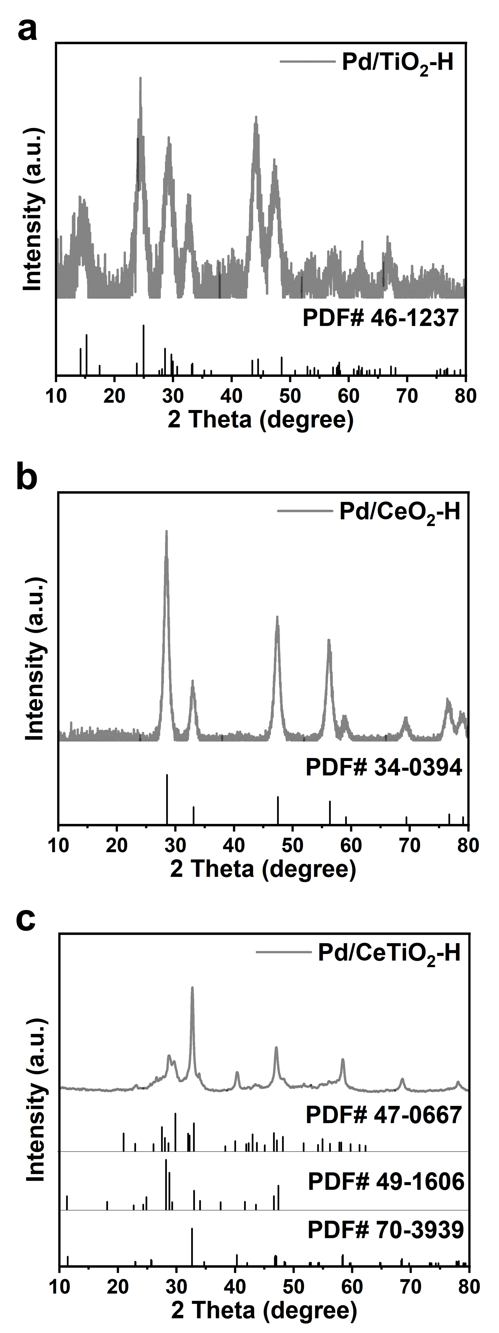
Figure S2. XRD patterns of Pd/TiO₂-H (a), Pd/CeO₂-H (b), and Pd/CeTiO_{x}-H (c).

Note: The diffraction pattern of Pd/CeTiO_{x}-H was consistent with Ce_{0.4}Ti_{0.6}O₂ (JCPDS pattern number 70-3939), Ce₂TiO₂ (JCPDS pattern number 49-1606), and Ce₂Ti₂O₇ (JCPDS pattern number 47-0667).

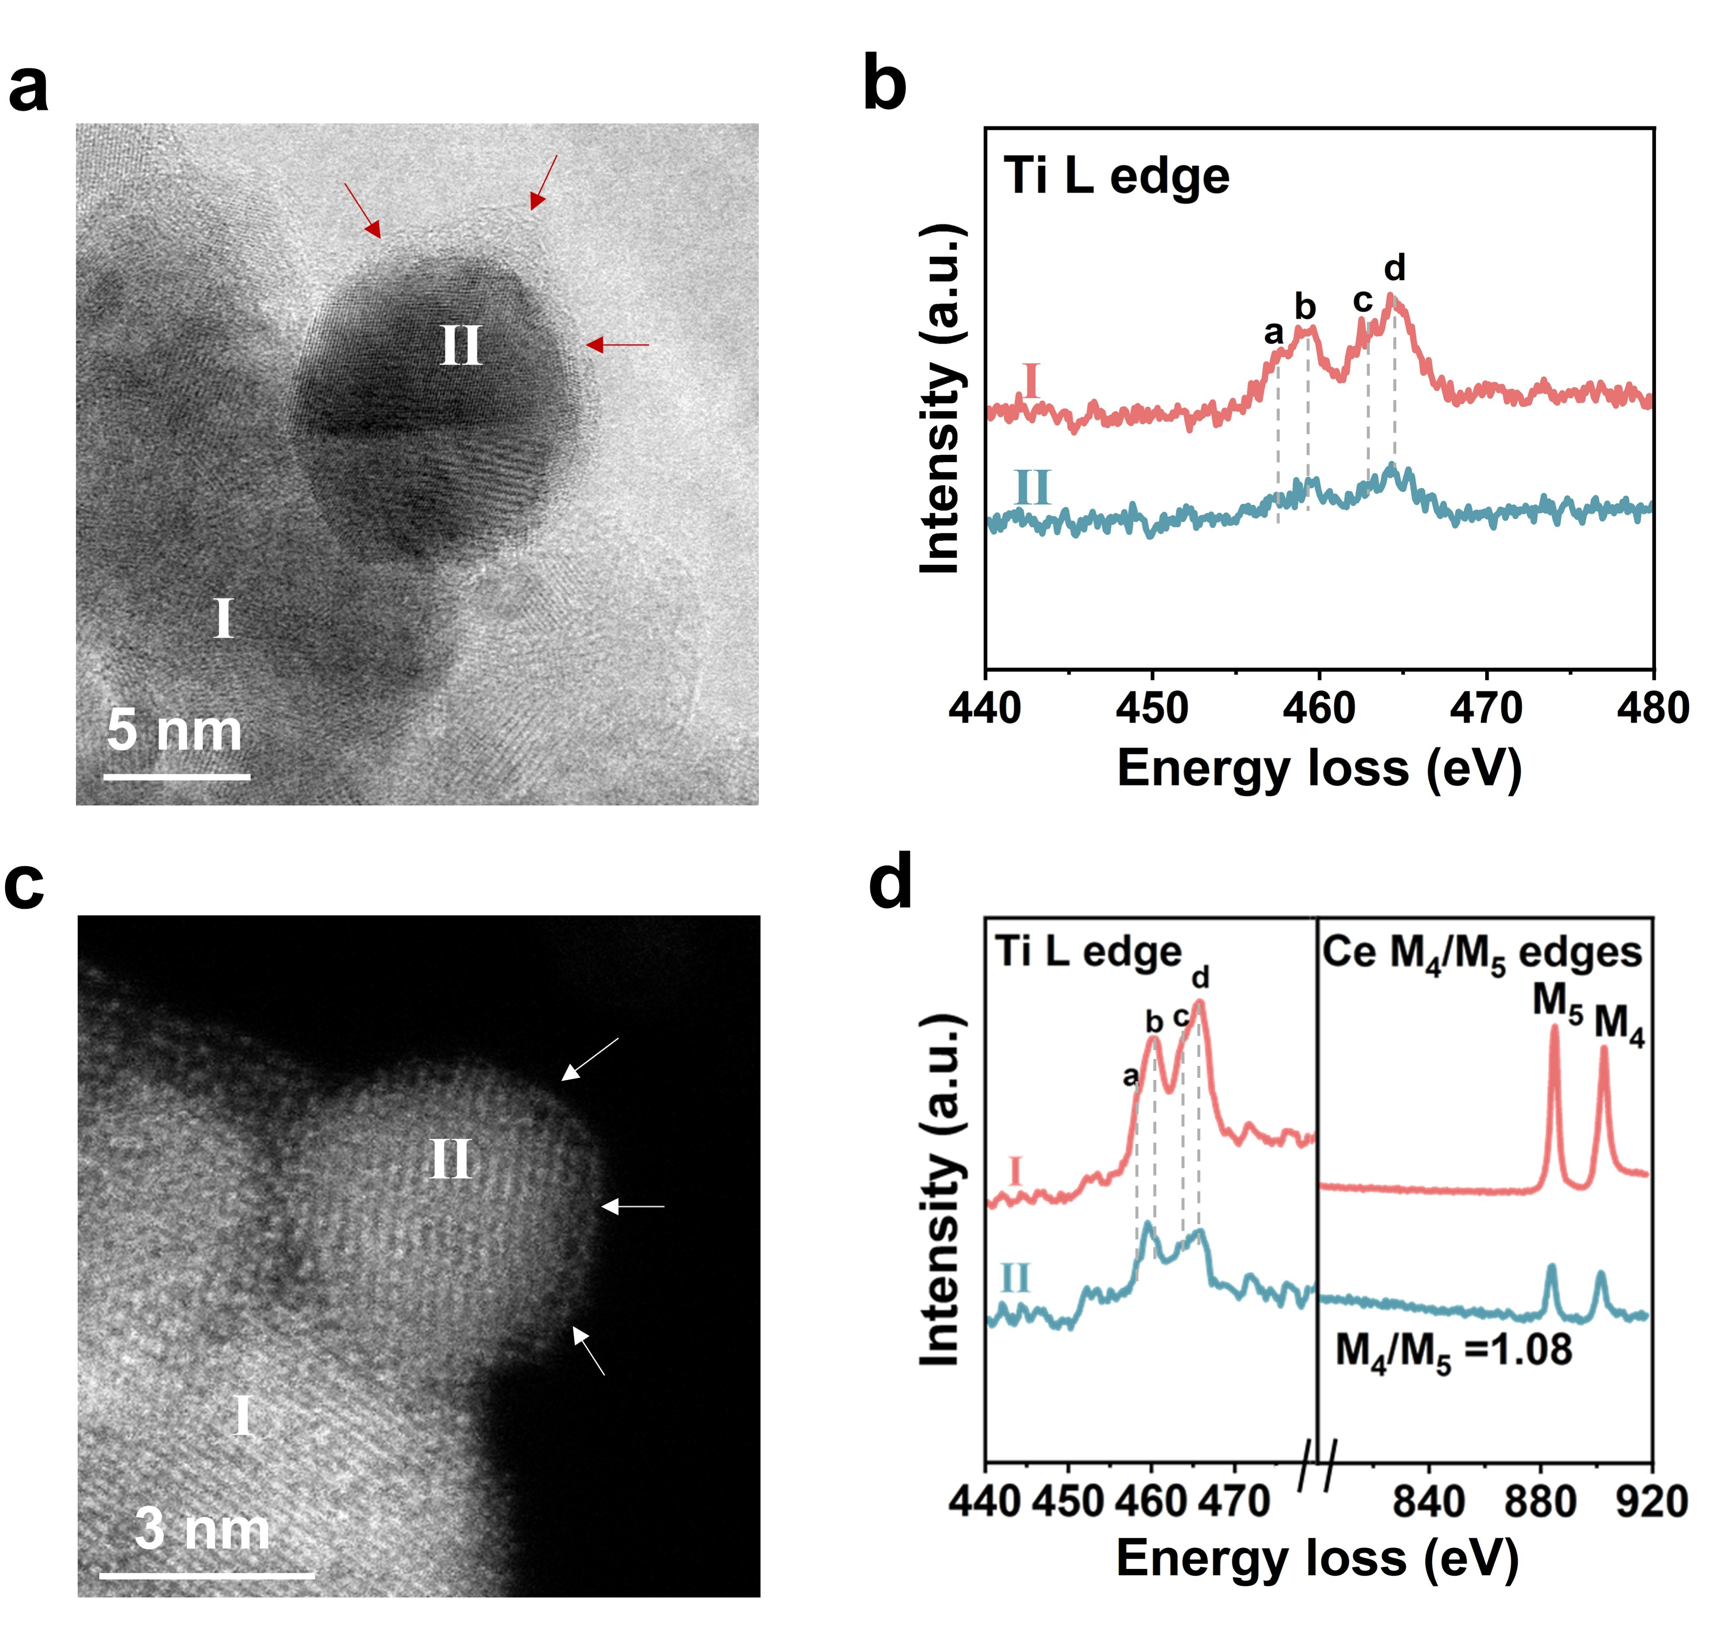
Figure S3. AC-TEM and EELS results of Pd/TiO₂-H (a, b) and Pd/CeTiO_{x}-H (c, d).

Note: Ti L-edge EELS spectrum of supports (measuring point Ⅰ) over Pd/TiO₂-H and Pd/CeTiO_{x}-H showed feature typical of Ti⁴⁺ due to the observation of four distinct peaks (labeled a, b, c, and d). For Ti L-edge EELS spectrum of overlayer (measuring point Ⅱ) over Pd/TiO₂-H, the absence of a and c peaks revealed the overlayer existed mainly as Ti³⁺ species⁸. For Ti L-edge EELS spectrum of overlayer (measuring point Ⅱ) over Pd/CeTiO_{x}-H, the shift in the b peak relative to that in support indicated the coexistence of Ti³⁺ and Ti⁴⁺ species in the overlayer⁹.
The atomic ratio of Ce and Ti is given by¹⁰:
$$\frac{N_{Ce}}{N_{Ti}}=\frac{I_{Ce}(β, ∆)/σ_{Ce}(β, ∆)}{I_{Ti}(β, ∆)/σ_{Ti}(β, ∆)}$$
where N_{Ce} and N_{Ti} are density of Ce and Ti atoms, respectively, I(β,Δ) is the core-loss intensity integrated in an energy range Δ from the threshold (after background subtraction based on a power-law model), and σ(β,Δ) is the partial cross section for the ionization with the energy-loss range Δ and collection semiangle β. Partial cross sections were calculated using the Hartree−Slater model. In this study, Δ was fixed at 50 eV. Based on the built-in Image Calculator function in Gatan DigitalMicrograph software (Version 3.5), the Ce-to-Ti ratio in the Pd/CeTiO_{x}-H was measured at about 3:7.

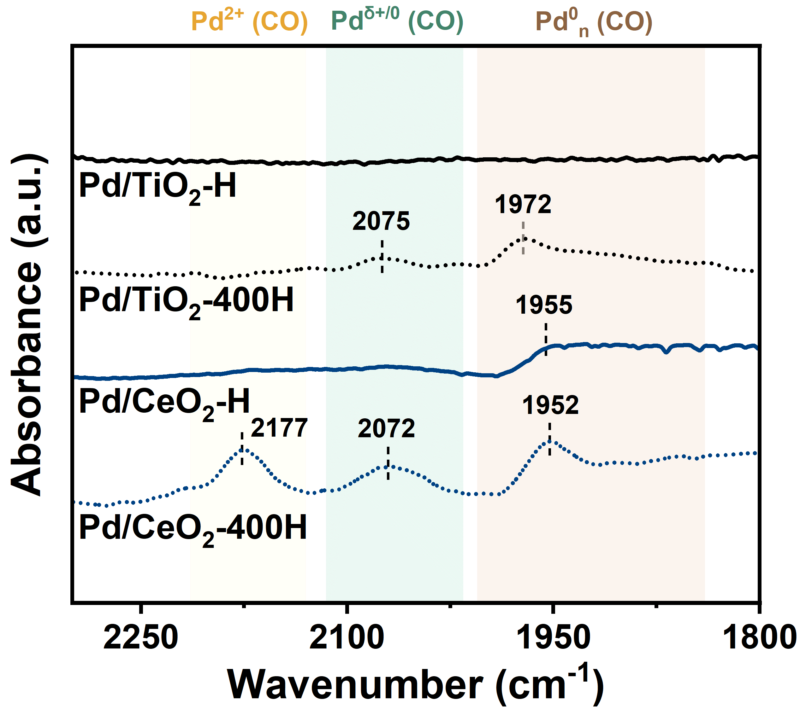
Figure S4. In-situ CO-adsorption infrared spectra of Pd/TiO₂-H, Pd/TiO₂-400H, Pd/CeO₂-H, and Pd/CeO₂-400H.

Note: The Fourier Transform Infrared (FTIR) spectra of Pd/CeO₂ and Pd/TiO₂ treated at 400 ºC (denoted as Pd/CeO₂-400H and Pd/TiO₂-400H, respectively) showed CO-FTIR peaks at 1800-2250 cm⁻¹, indicating exposed state of Pd. However, further elevating the temperature of calcination to 500 ºC (denoted as Pd/CeO₂-H and Pd/TiO₂-H, respectively), the CO adsorption significantly suppressed. Specifically, Pd/CeO₂-H only showed CO-FTIR peak at 1955 cm⁻¹ and CO-FTIR peak was absent over Pd/TiO₂-H. This indicated that a fully overlayer structure emerged in Pd/TiO₂-H whereas only a partly overlayer structure emerged in Pd/CeO₂-H.

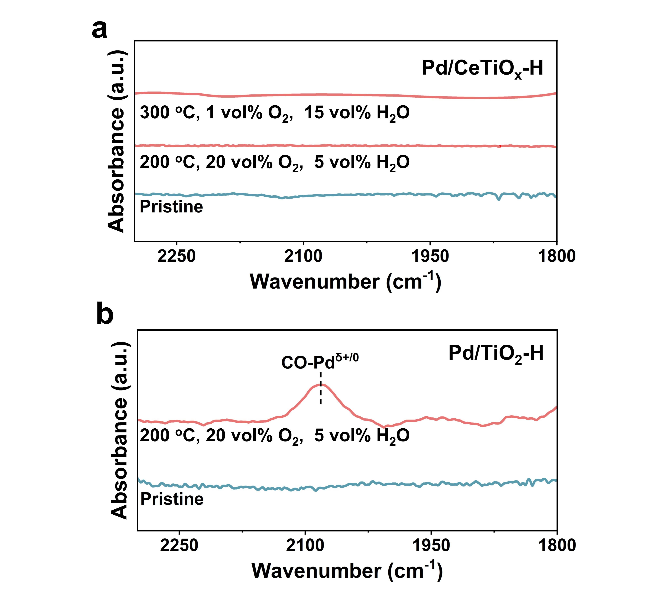
Figure S5. In-situ CO-adsorption infrared spectra of pristine/treated Pd/CeTiO_{x}-H (a) and Pd/TiO₂-H (b).

Note: Treated samples were obtained by treating 0.1 g of Pd/CeTiO_{x}-H or Pd/TiO₂-H for 2 hours in a gas mixture containing 20 vol% O₂ and 5 vol% H₂O at 200 °C or 1 vol% O₂ and 15 vol% H₂O at 300 °C.

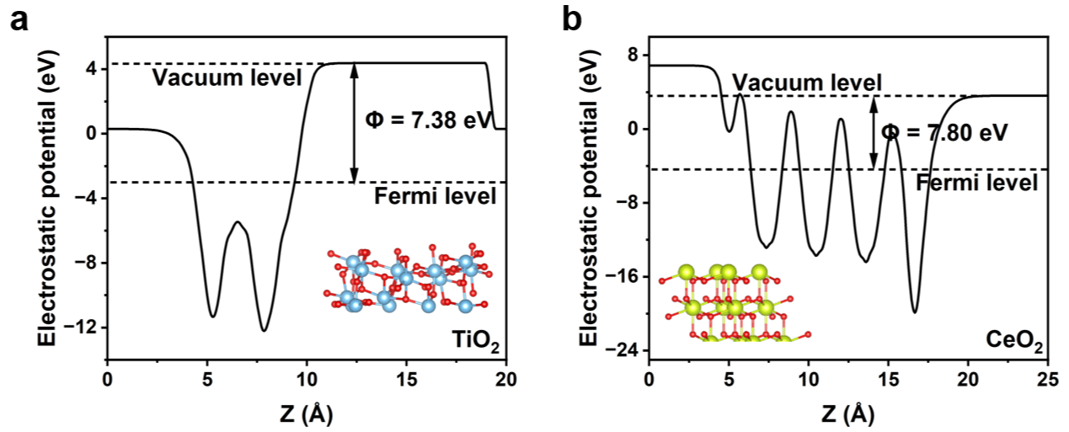
Figure S6. Electrostatic potentials of TiO₂ (a) and CeO₂ (b) surface.

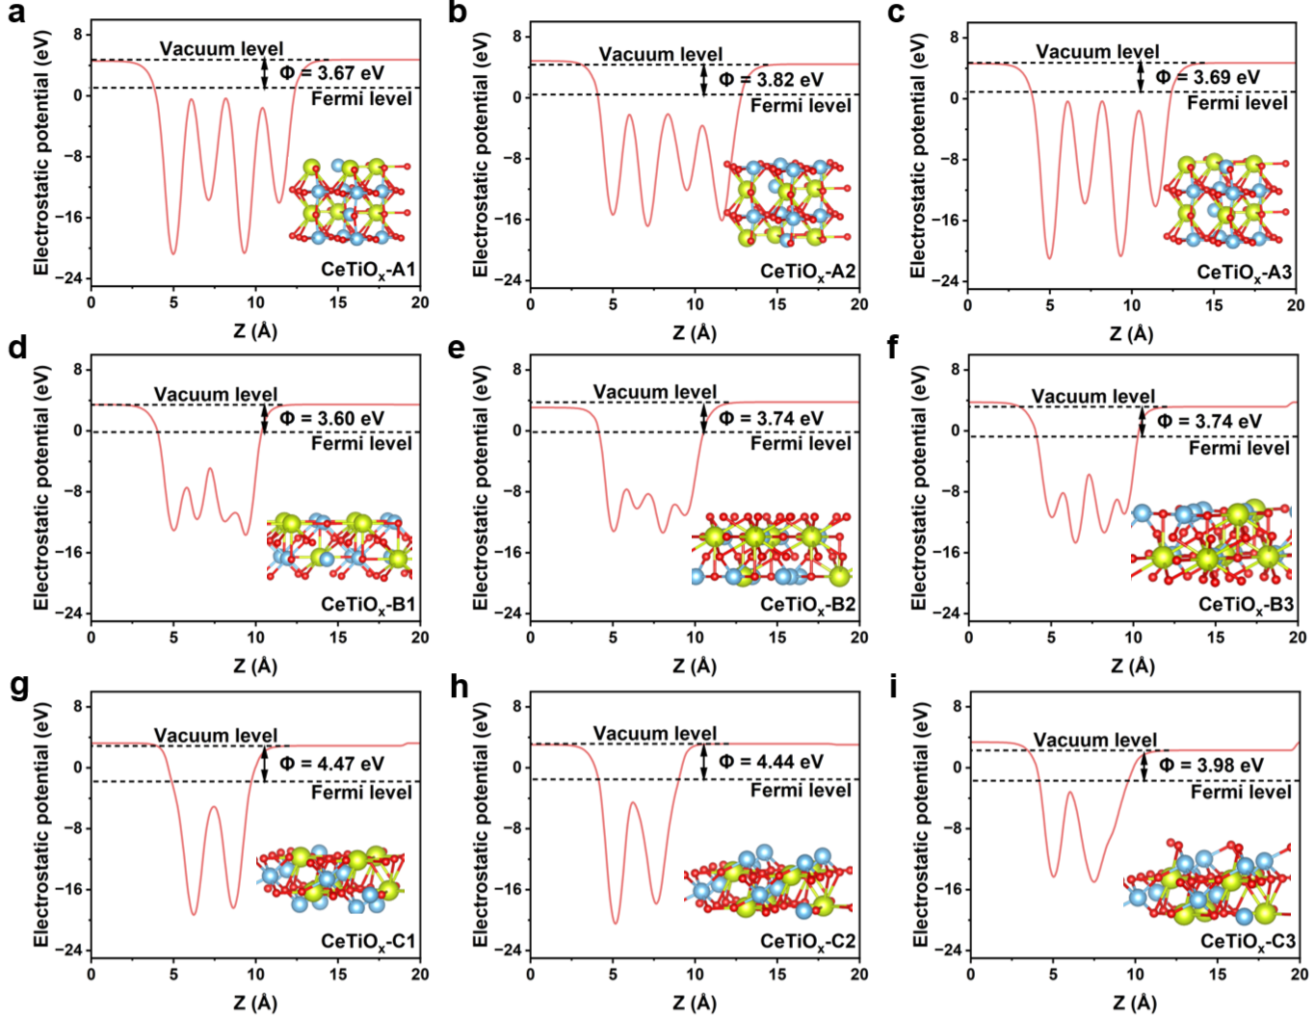 Figure S7. Electrostatic potentials of different types of Ce₆Ti₁₀O₂₄ surface with (100) facets (a-c), (110) facets (d-f), and (111) facets (g-i).

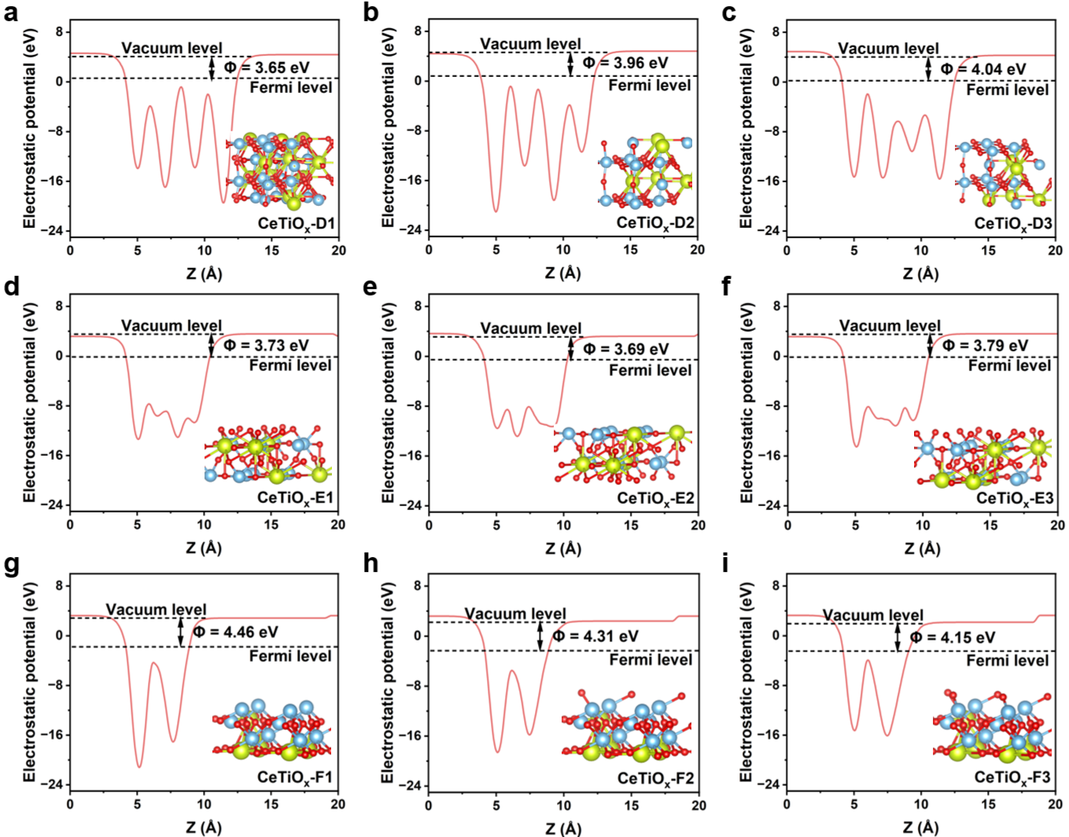
Figure S8. Electrostatic potentials of different types of Ce₅Ti₁₁O₂₄ surface with (100) facets (a-c), (110) facets (d-f), and (111) facets (g-i).

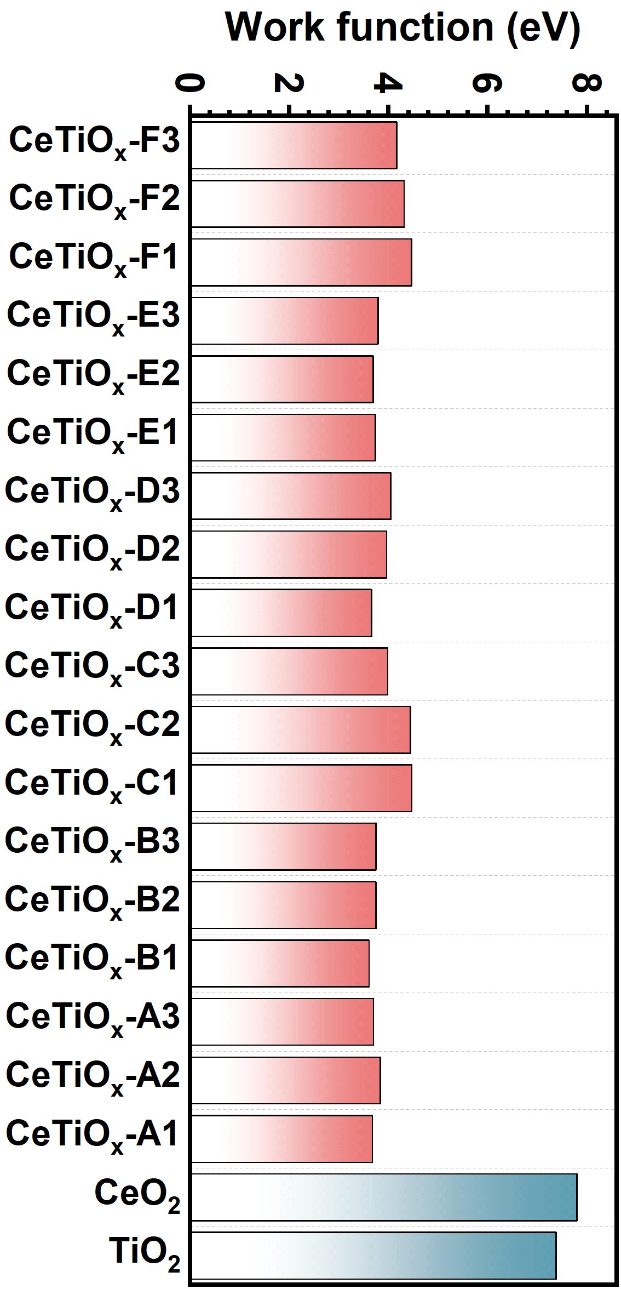
Figure S9. Comparison of work function for TiO₂, CeO₂, and series of CeTiO_{x} models.

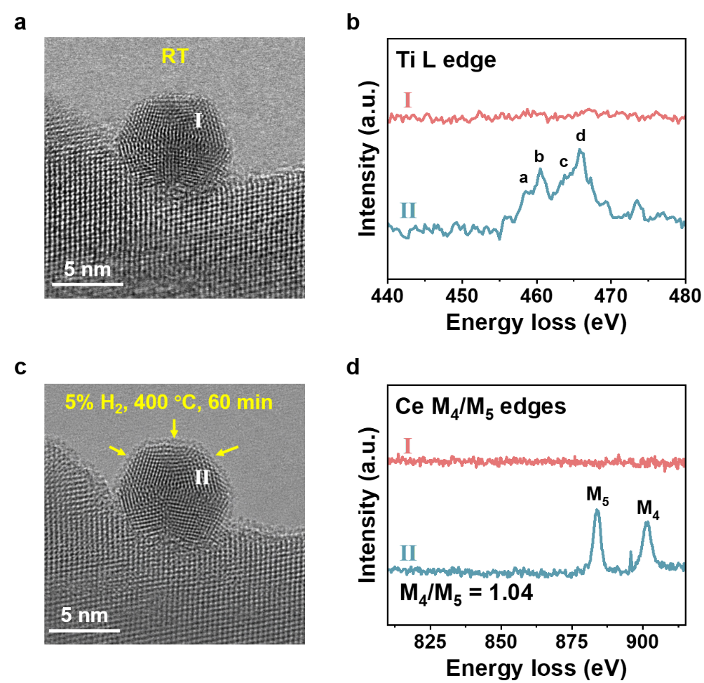
Figure S10. In situ TEM images and EELS results of Pd/CeTiO_{x}-H in 5 vol% H₂ (gas pressure 5 kPa, balanced with Ar) at 400 °C.

Note: To further monitor the in situ formation of the overlayer, in situ TEM and EELS analysis were performed on the surface sites of Pd nanoparticles before and after H₂ treatment. As shown in Fig. S10, after treatment in 5 vol% H₂ at 400 °C for 60 min, an amorphous encapsulation appeared on the Pd surface, accompanied by the emergence of Ti L-edge and Ce M₄/M₅-edge EELS signals, confirming the dynamic formation of a Ce–Ti binary-metal-oxide overlayer. The Ti L-edge EELS spectrum exhibited four distinct splitting peaks, indicating that Ti was predominantly in the Ti⁴⁺ state. The M₄/M₅ ratio derived from the Ce M₄/M₅-edge EELS spectrum was 1.04, suggesting a dominant Ce⁴⁺ state in the overlayer. Based on the built-in Image Calculator function of the Gatan DigitalMicrograph software (Version 3.5), the Ce-to-Ti ratio in Pd/CeTiO_{x}-H was determined to be approximately 3:7.

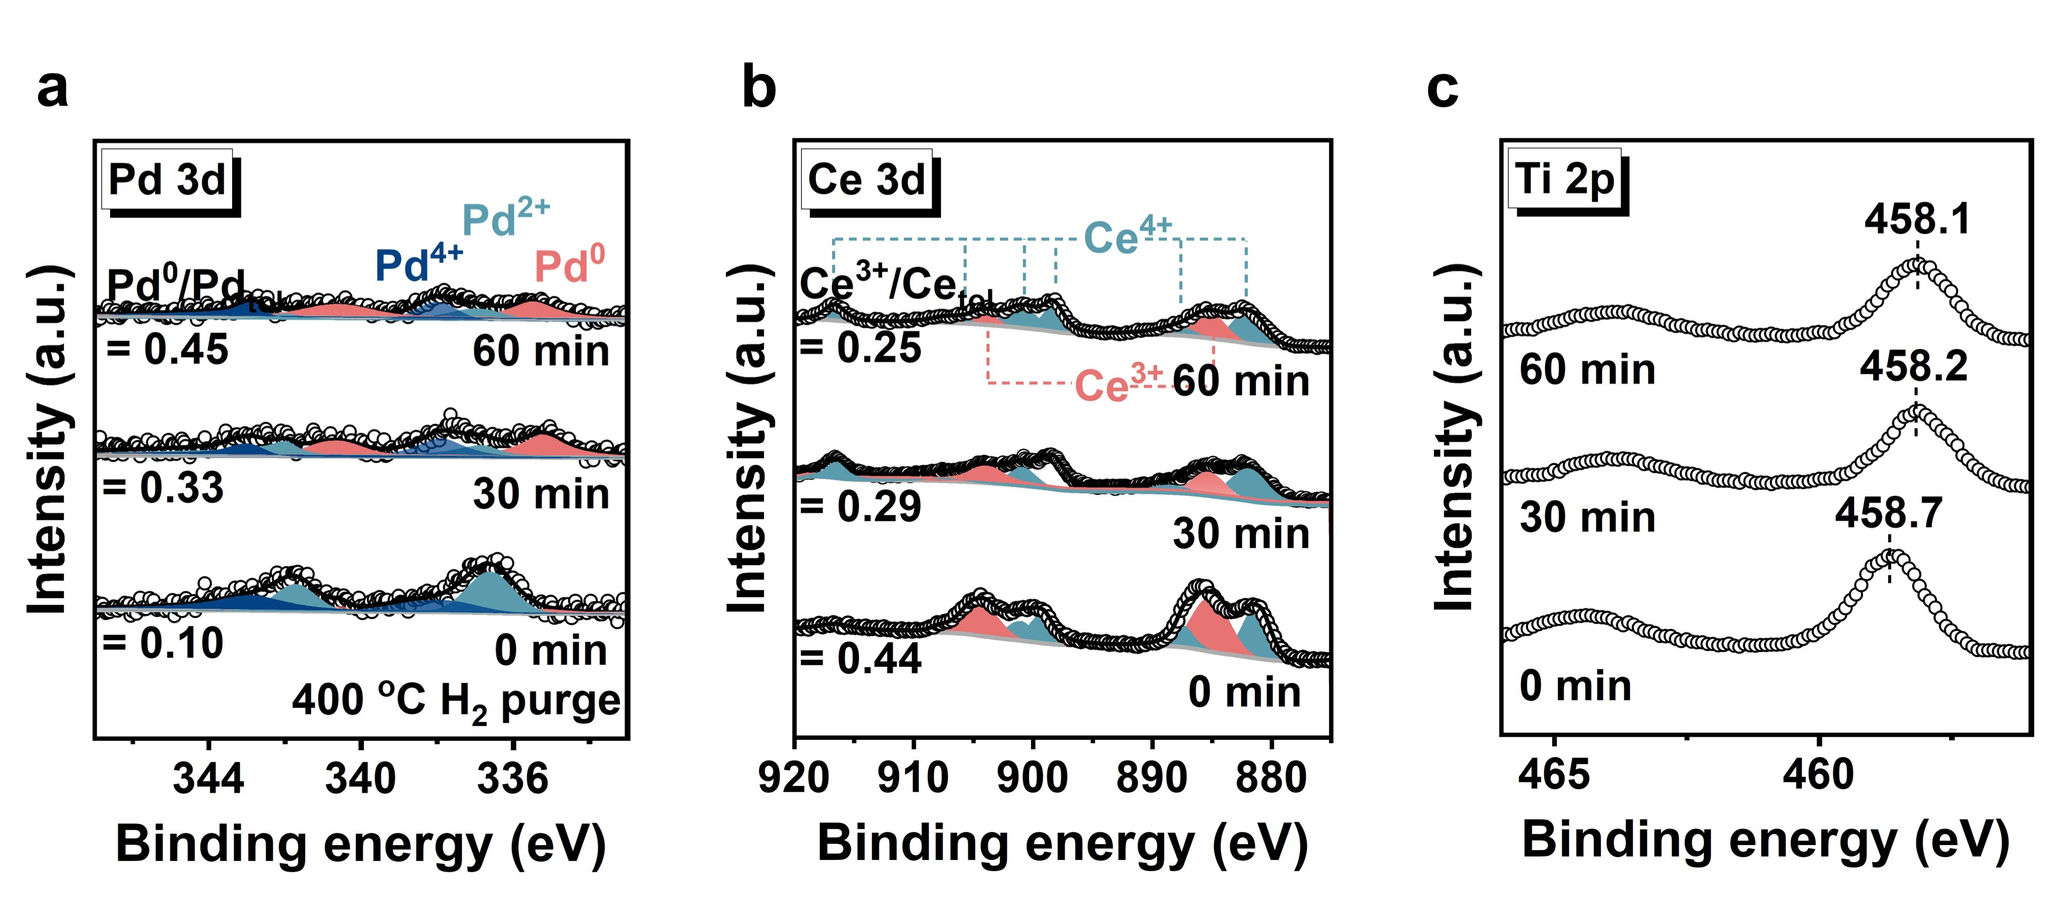
Figure S11. In situ NAP-XPS spectra of Pd 3d (a), Ce 3d (b), and Ti 2p (c) for Pd/CeTiO_{x}-H in H₂ at 400 °C as a function of time.

Note: The Pd 3d peaks at 335.2, 336.7, and 338.1 eV are assigned to Pd⁰, Pd²⁺, and Pd⁴⁺, respectively¹¹. The Ce 3d spectra exhibit characteristic features of Ce³⁺ (885.0 and 903.8 eV) and Ce⁴⁺ (882.1, 887.6, 898.5, 900.8, 907.5, and 916.7 eV)¹².

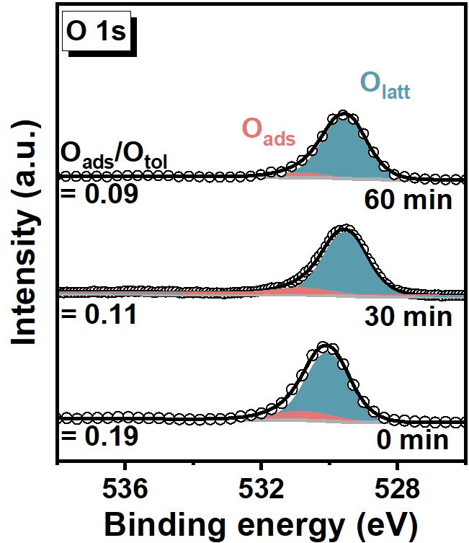
Figure S12. In situ NAP-XPS spectra for O 1s of Pd/CeTiO_{x}-H in H₂ at 400 ºC as a function of time.

Note: The O 1s peaks at 529.7, and 530.9 eV are assigned to lattice oxygen (O_{latt}) and chemisorbed oxygen (O_{ads}), respectively¹³.

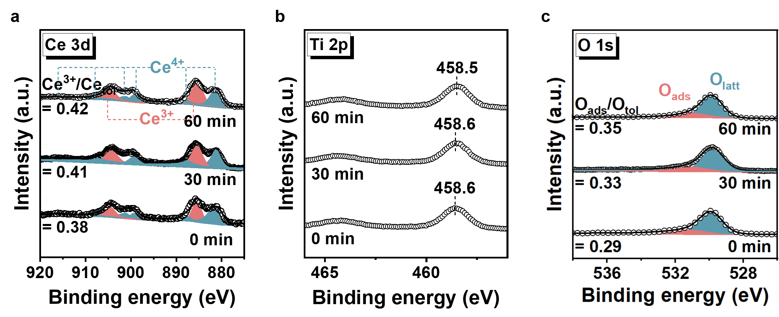
Figure S13. In situ NAP-XPS spectra of Ce 3d (a), Ti 2p (b), and O 1s (c) for CeTiO_{x} in H₂ at 400 °C as a function of time.

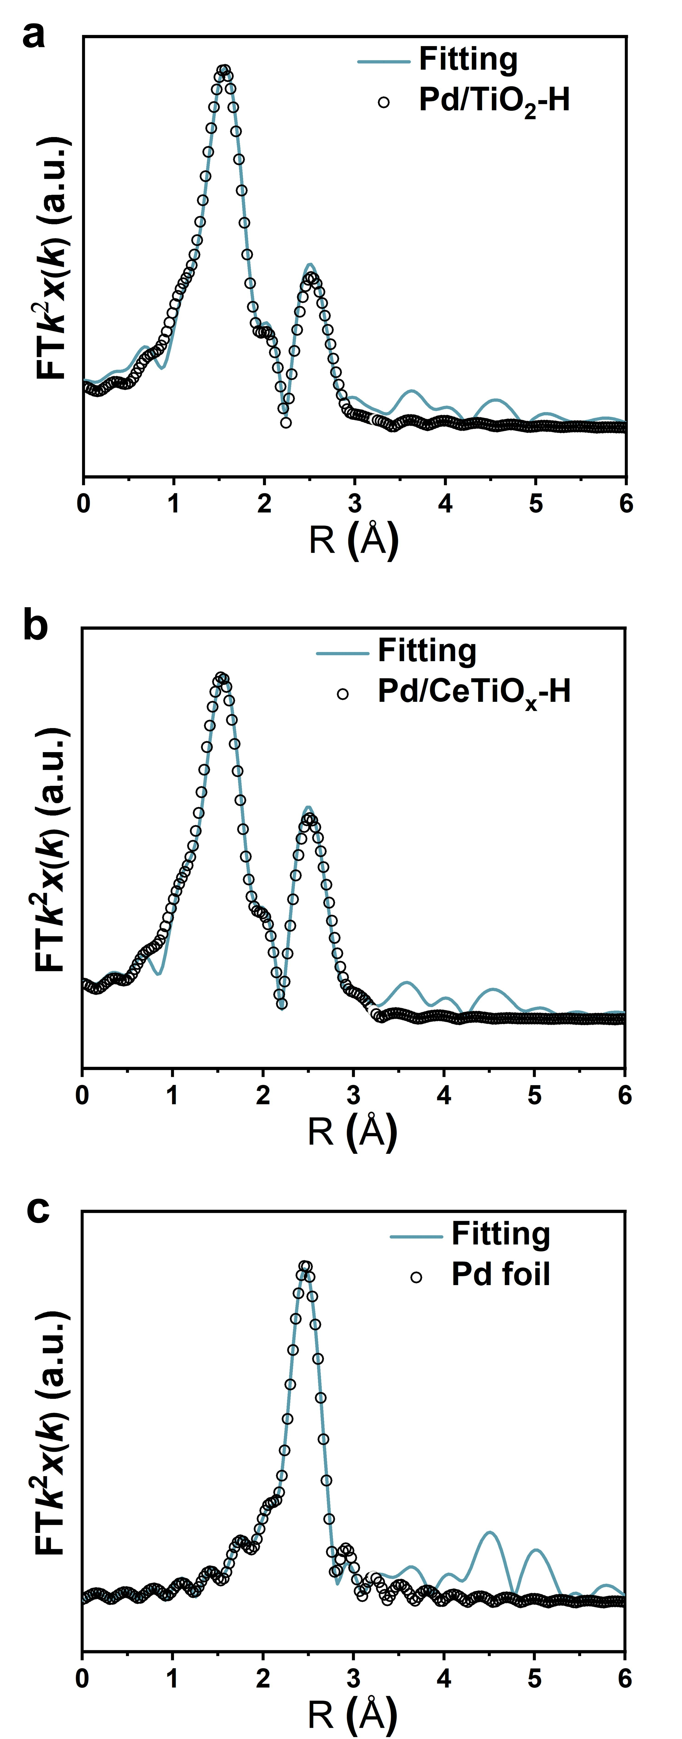
Figure S14. EXAFS fitting curves of Pd/TiO₂-H, Pd/CeTiO_{x}-H, and Pd foil in R space.

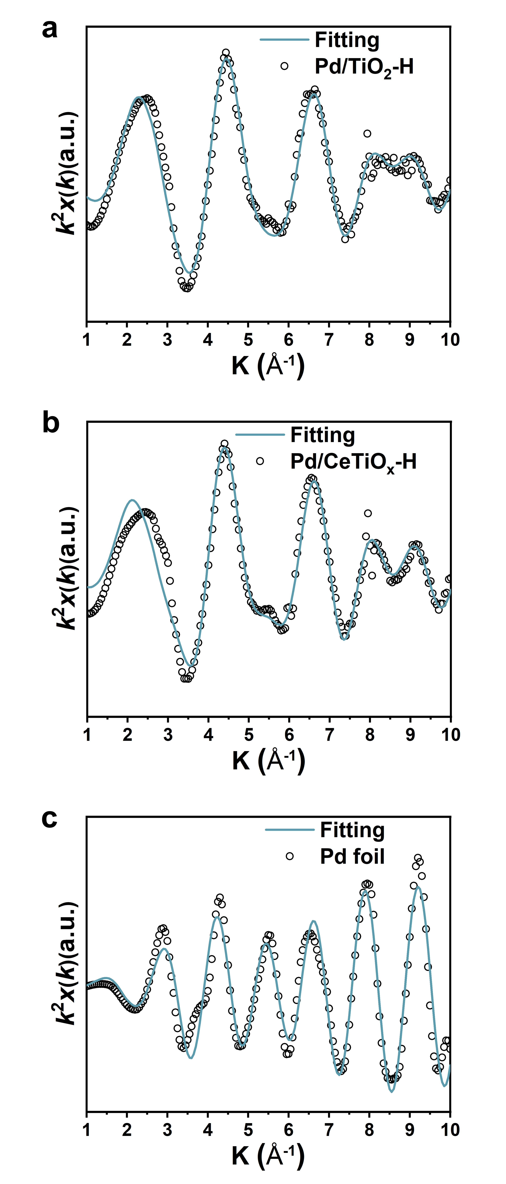
Figure S15. EXAFS fitting curves of Pd/TiO₂-H, Pd/CeTiO_{x}-H, and Pd foil in K space.

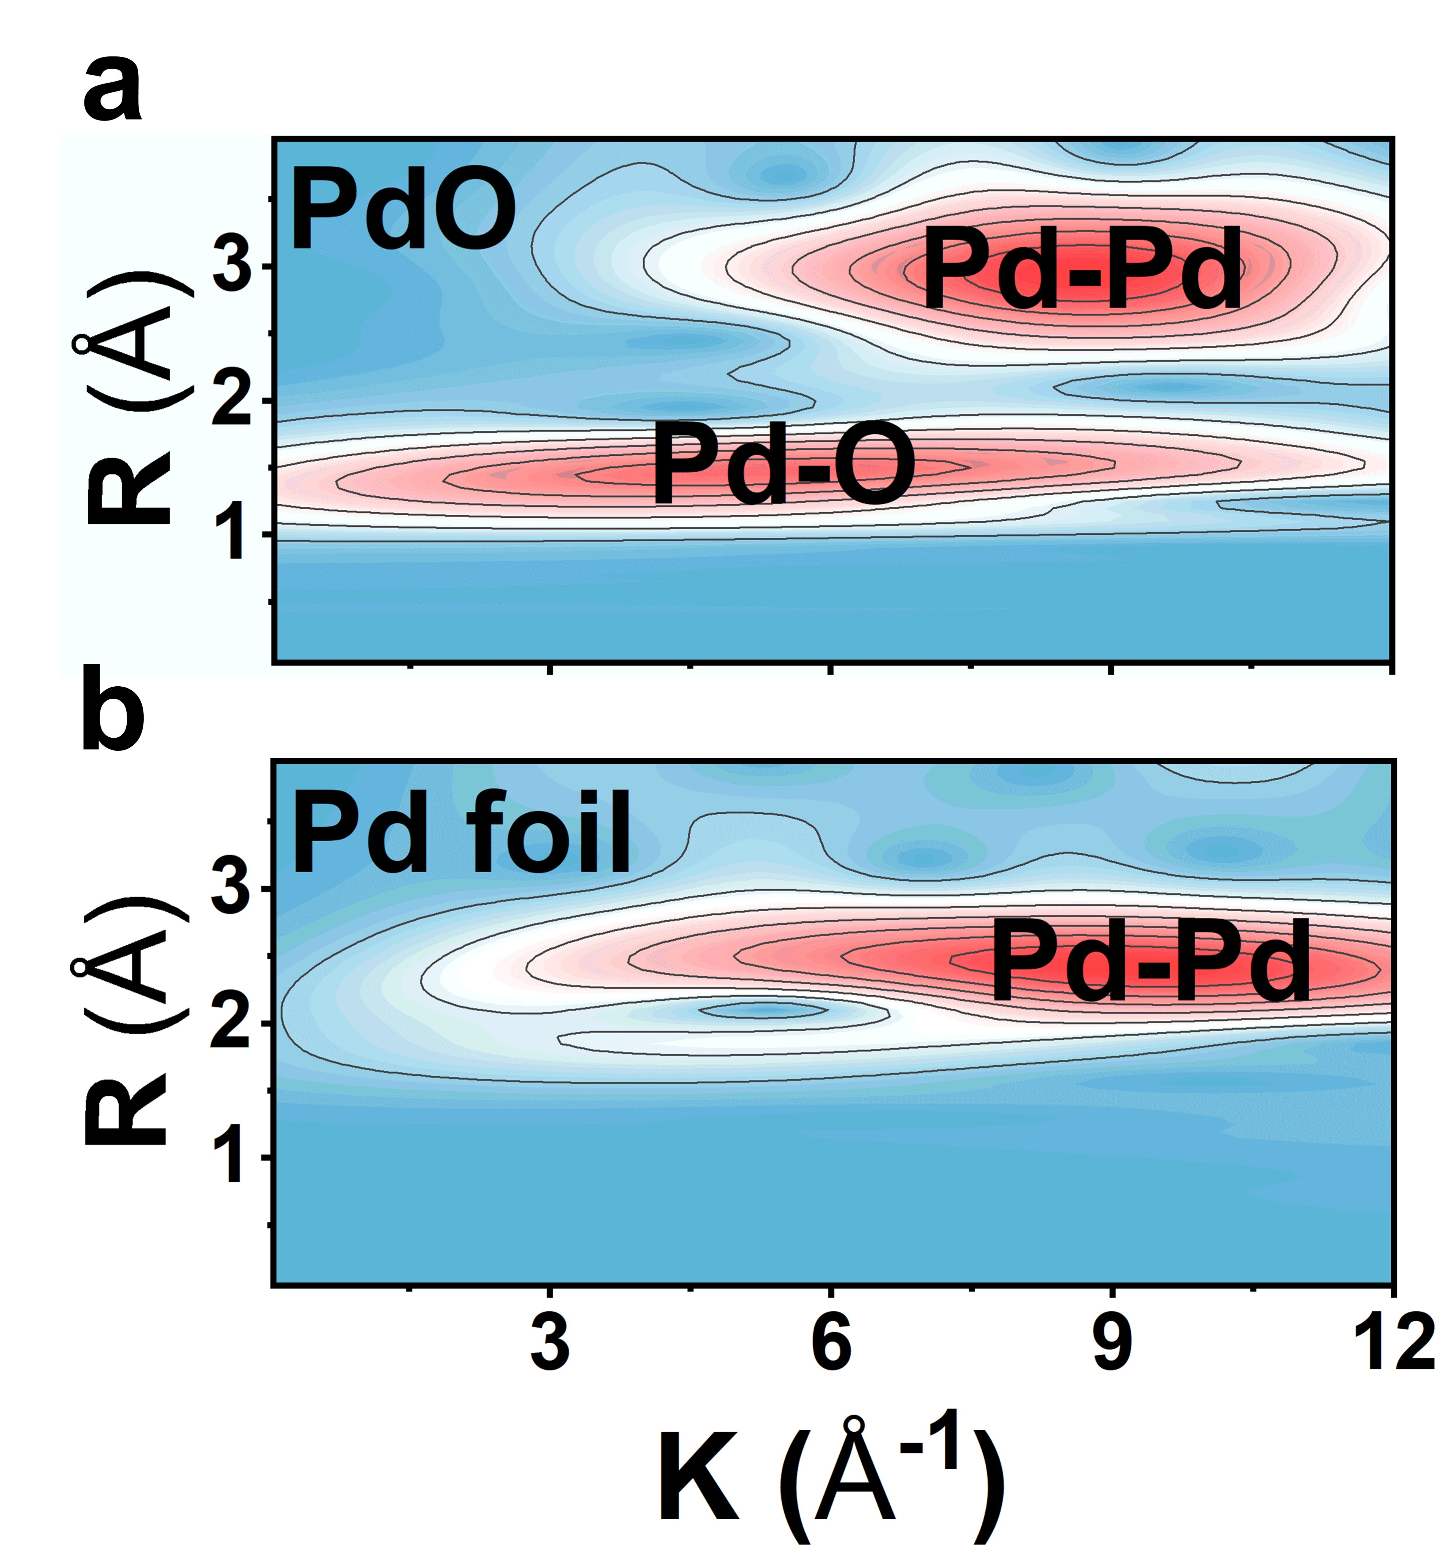
Figure S16. Wavelet transform (WT) of EXAFS spectra of PdO and Pd foil.

Figure S17. Oxygen storage capacity (OSC) of Pd/TiO₂-H, Pd/CeTiO_{x}-IM, and Pd/CeTiO_{x}-H. Reaction condition: 10 vol% O₂, 60 µL per injection.

Note: During the OSC test, each injection supplied 60 μL of 10 vol% O₂ to 0.1 g of catalyst. As shown in Fig. S17, Pd/TiO₂-H, Pd/CeTiO_{x}-IM, and Pd/CeTiO_{x}-H reached equilibrium after 13, 18, and 29 oxygen pulses, respectively, demonstrating that Pd/CeTiO_{x}-H possesses the best oxygen storage capacity.

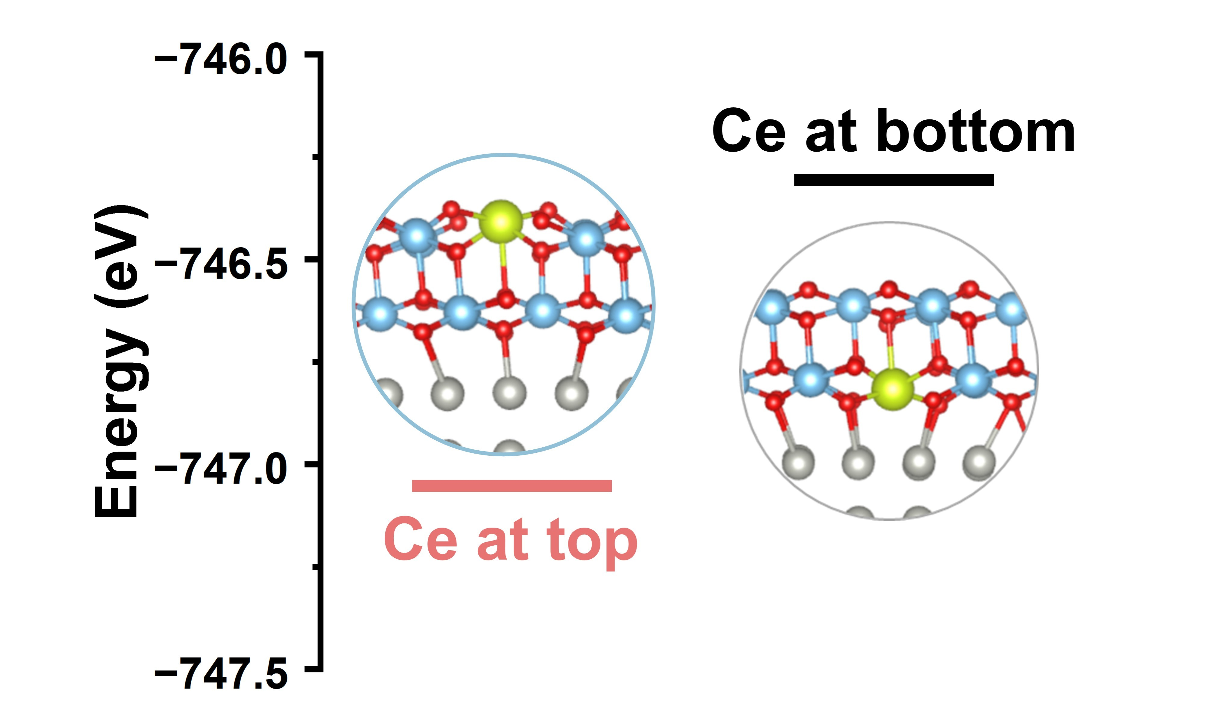
Figure S18. Structural energy of encapsulated-Pd models with different CeTiO_{x} overlayers.

Note: In the Pd@Ti₁₈O₃₆ model, substituting one Ti atom with Ce in the upper and lower layers of the overlayer, respectively, and comparing their ground-state energies revealed that the configuration with Ce in the upper layer is more stable.

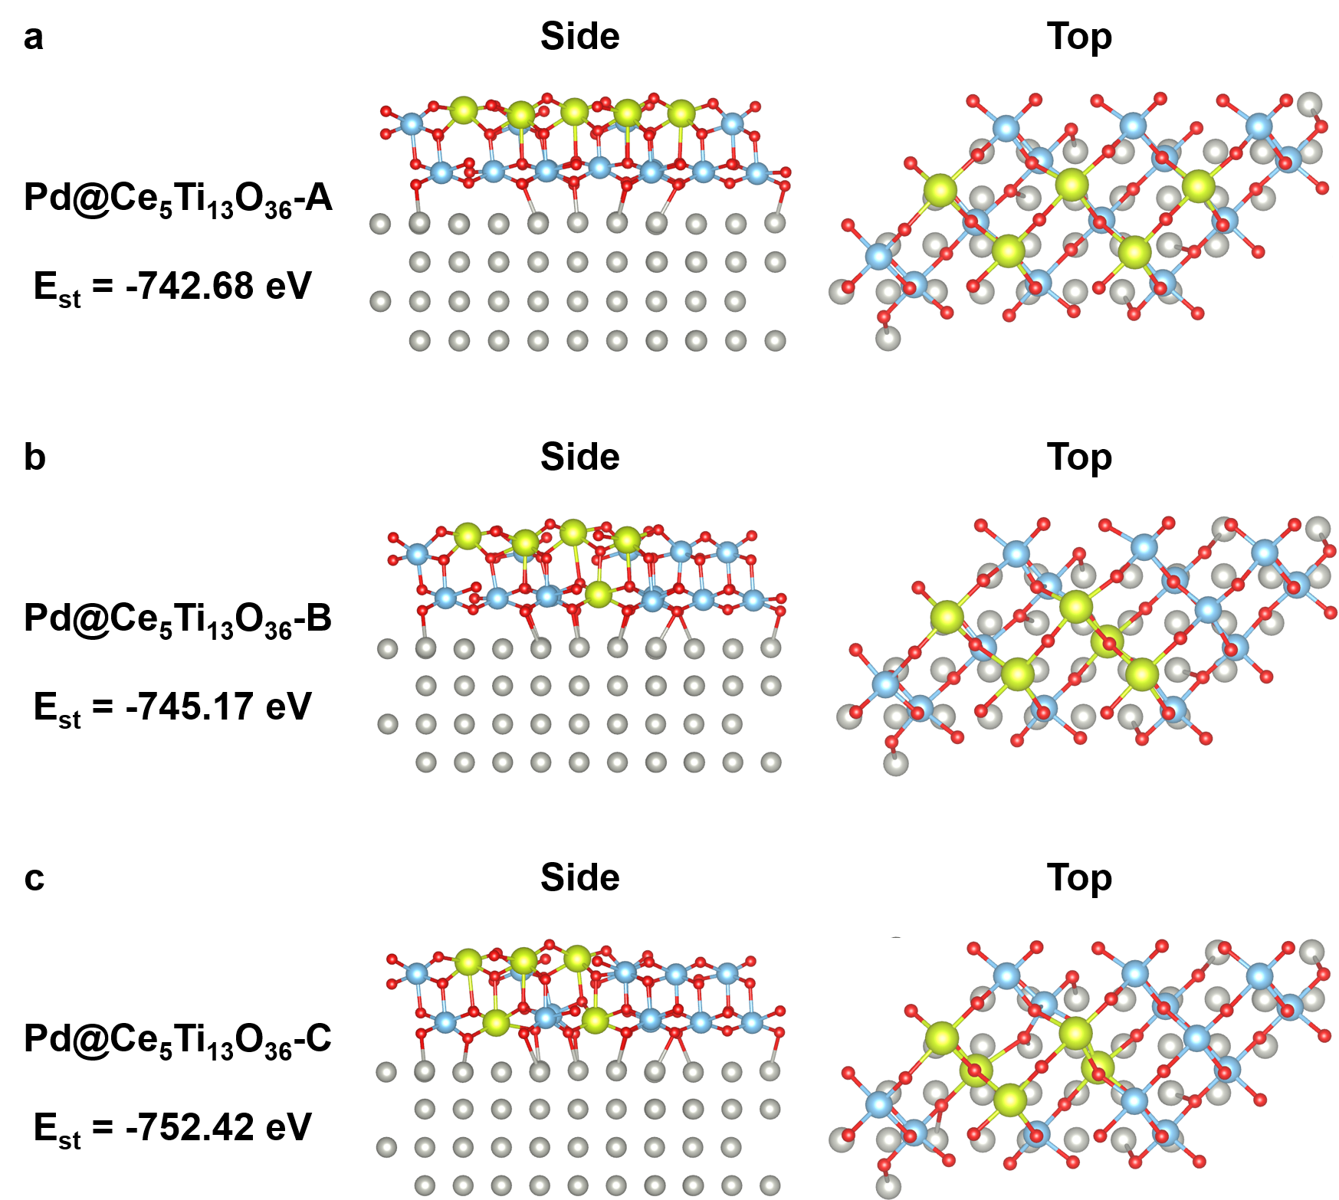
Figure S19. The slab models and calculated structural energy of different configurations of Pd@Ce₅Ti₁₃O₃₆. Atoms are color-coded as Pd (gray), Ce (yellow), Ti (blue), and O (red).

Note: During the structural optimization of the Pd@Ce₅Ti₁₃O₃₆ models, three configurations with preferential Ce enrichment at the surface were examined. The optimization results revealed that the structure with three Ce atoms located on the outer side of the overlayer was more stable

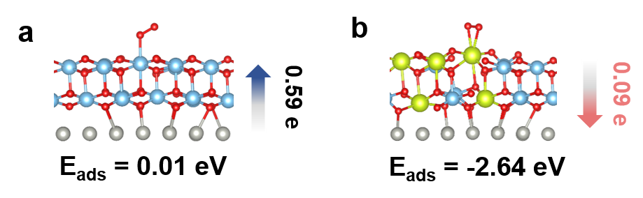
Figure S20. Adsorption of O₂ over encapsulated-Pd models with Ti₁₈O₃₆ (two layers) (a) and Ce₅Ti₁₃O₃₆ (two layers) overlayers (b).

Note: The O₂ molecular adsorbed over the Ti site and Ce site of encapsulated-Pd models with Ti₁₈O₃₆ (two layers) and Ce₅Ti₁₃O₃₆ (two layers) overlayers with the adsorption energy of 0.01 and -2.64 eV, respectively.

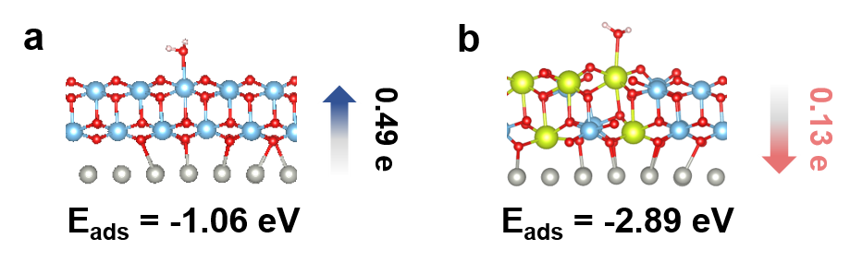
Figure S21. Adsorption of H₂O over encapsulated-Pd models with Ti₁₈O₃₆ (two layers) (a) and Ce₅Ti₁₃O₃₆ (two layers) overlayers (b).

Note: The H₂O molecular adsorbed over the Ti site and Ce site of encapsulated-Pd models with Ti₁₈O₃₆ (two layers) and Ce₅Ti₁₃O₃₆ (two layers) overlayers with adsorption energy of -1.06 and -2.89 eV, respectively.

Figure S22. PDOS of encapsulated-Pd models with Ce₅Ti₁₃O₃₆ (two layers) overlayer (a) after adsorption of O₂ (b) and H₂O (c).

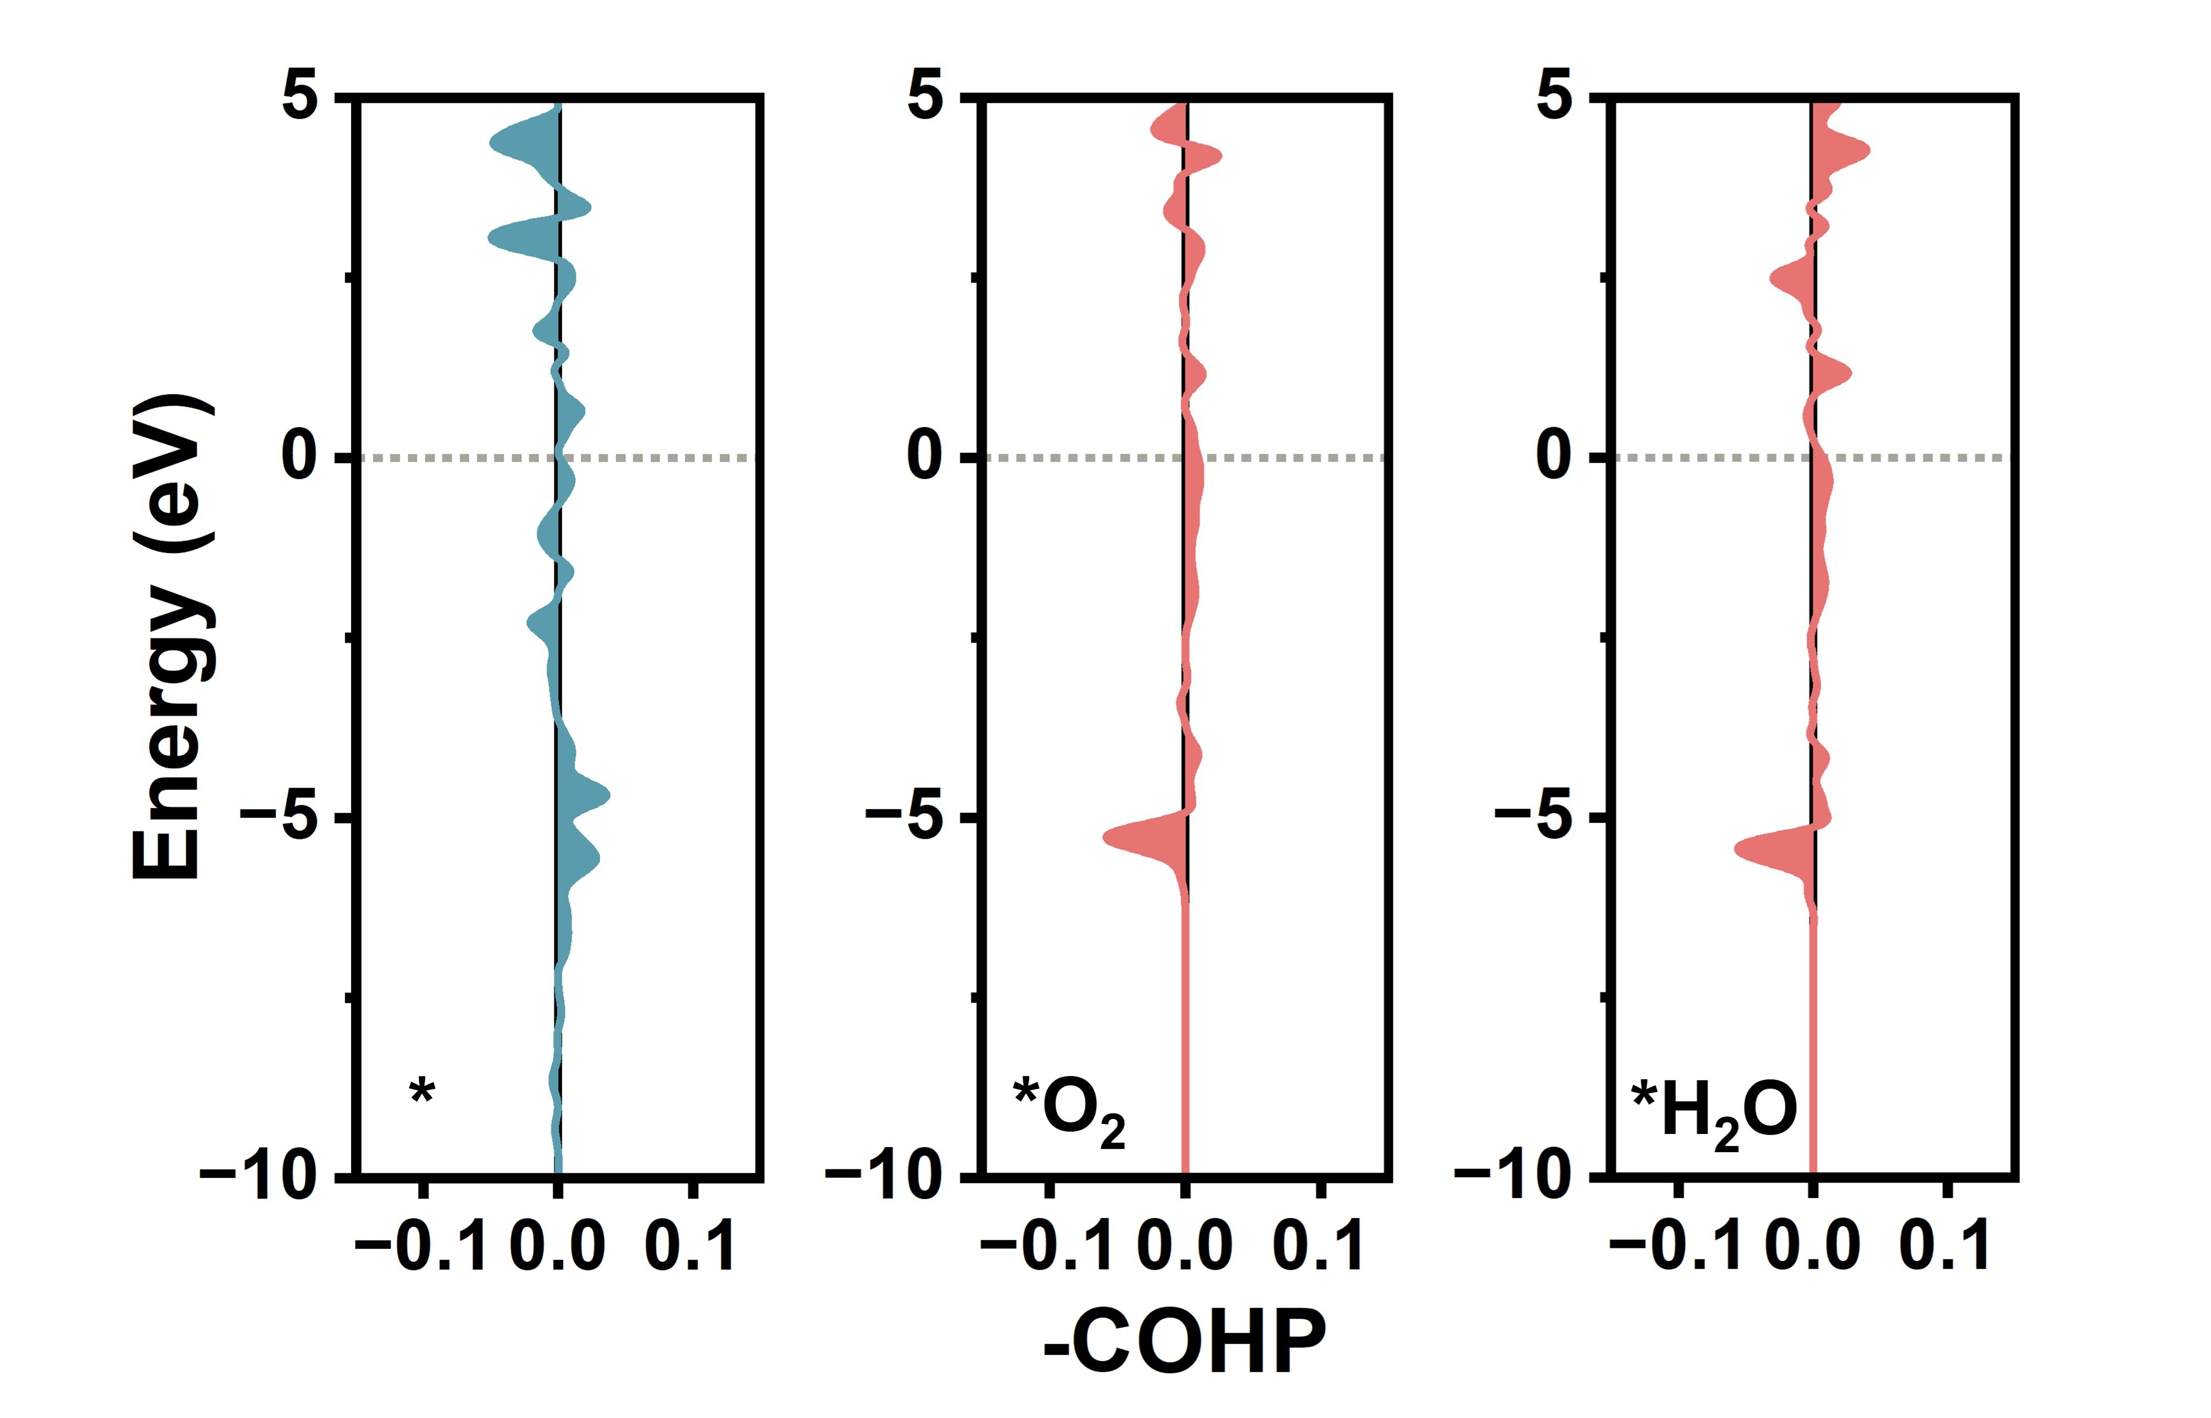
Figure S23. -COHP of Pd-Ti in encapsulated-Pd models with Ce₅Ti₁₃O₃₆ (two layers) overlayers after adsorption of O₂ and H₂O.

Note: The COHP results indicated that after the adsorption of H₂O and O₂, the bonding between Pd and Ti below the Fermi level showed little change, suggesting that the electron transfer between Pd and Ti was not significantly affected by the adsorption of H₂O and O₂.

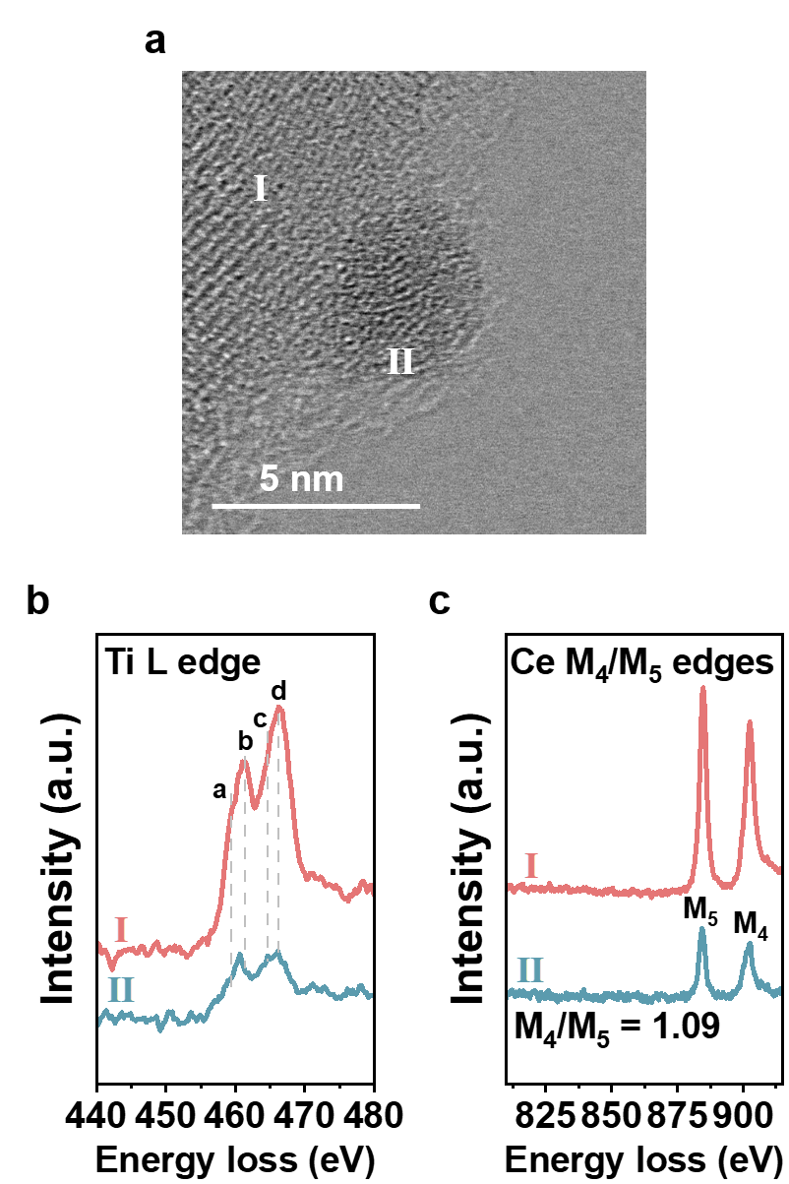
Figure S24. AC-TEM and EELS results of treated Pd/CeTiO_{x}-H. Treatment condition: 200 ºC, 20 vol% O₂, 5 vol% H₂O, and 2 h.

Note: The Ti L-edge EELS spectrum (Fig. S24b) from measuring point Ⅱ on the overlayer of the treated Pd/CeTiO_{x}-H revealed a b-peak shift relative to the support, evidencing the coexistence of Ti³⁺ and Ti⁴⁺ species in the overlayer. The M₄/M₅ ratio derived from the Ce M₄/M₅-edge EELS spectrum of the treated Pd/CeTiO_{x}-H was determined to be 1.09 (Fig. S24c), which was higher than those of the pristine samples (1.08). This increase indicated that the Ce valence state in the overlayer was elevated after humid-air treatment.

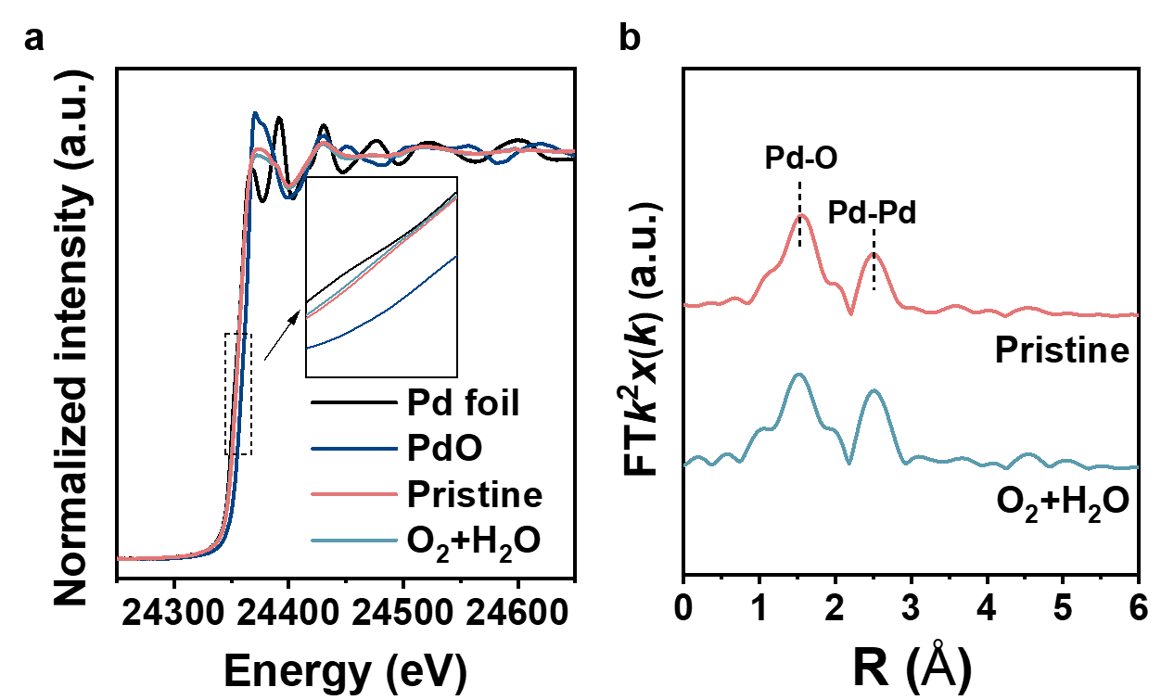
Figure S25. Normalized Pd K-edge X-ray absorption near-edge structure (XANES) spectra (a), Fourier transform of extended X-ray absorption fine structure (FT-EXAFS) spectra (b) of pristine and treated Pd/CeTiO_{x}-H. Treatment condition: 200 ºC, 20 vol% O₂, 5 vol% H₂O, and 2 h.

Note: From the normalized XANES spectra (Fig. S25a), it can be observed that the absorption edge position of Pd/CeTiO_{x}-H shifted further toward that of Pd foil after humid-air treatment. The corresponding R-space EXAFS spectra presented in Fig. S25b showed two prominent peaks at ~1.5 Å and ~2.5 Å, which are attributable to Pd−O and metallic Pd−Pd bonding, respectively. The calculated Pd−O coordination number for the treated Pd/CeTiO_{x}-H decreased from 2.3 to 2.1 (Table S2), indicating a slight reduction in the Pd valence state upon humid-air treatment.

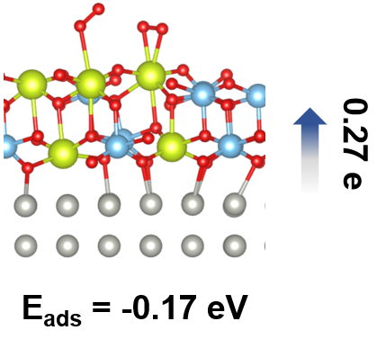
Figure S26. Adsorption of two O₂ over encapsulated-Pd models with Ce₅Ti₁₃O₃₆ (two layers) overlayer.

Note: The second O₂ molecular adsorbed over the Ce site of encapsulated-Pd models with adsorption energy of -0.17 eV, which resulted in a reversal of electron transfer from Pd to Ce₅Ti₁₃O₃₆ overlayer, indicative of the retreat-off of oxide overlayer.

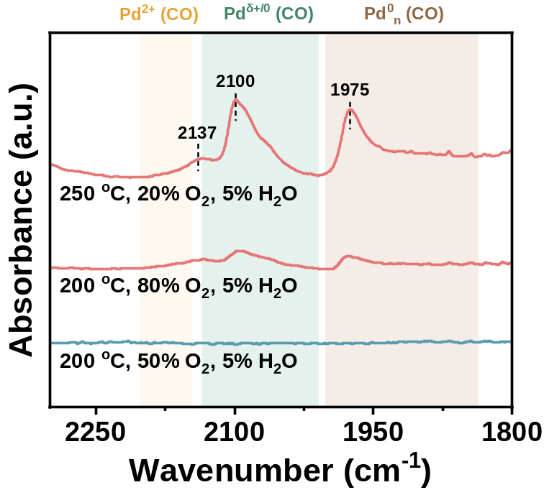
Figure S27. In-situ CO-adsorption infrared spectra of Pd/CeTiO_{x}-H treated by humid air.

Note: The FTIR spectra of Pd/CeTiO_{x}-H treated by 80 vol% O₂ and 5 vol% H₂O at 200 ºC and 20 vol% O₂ and 5 vol% H₂O at 250 ºC showed CO-FTIR peaks at 1800-2250 cm⁻¹, indicating exposed state of Pd.

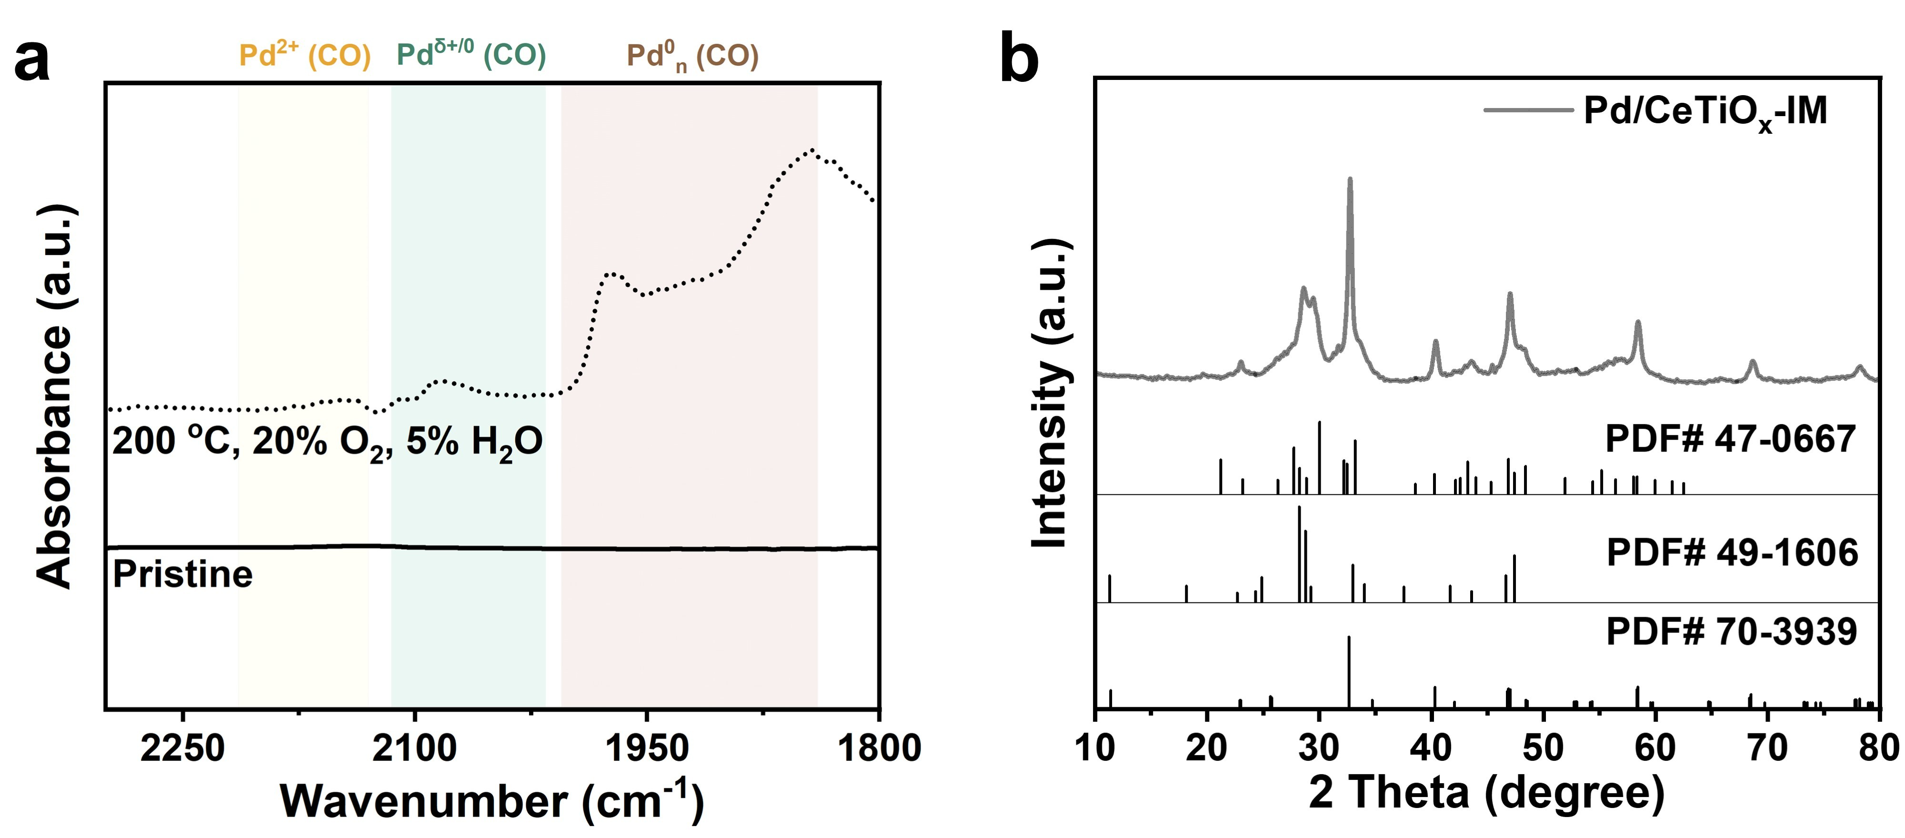
Figure S28. In-situ CO-adsorption infrared spectra of fresh and treated Pd/CeTiO_{x}-IM (a), XRD pattern of Pd/CeTiO_{x}-IM (b).

Note: The presence of overlayer was confirmed by CO-DRIFTS analysis, showing the absence of CO adsorption peaks at 2071 cm⁻¹ and 1954 cm⁻¹ in Pd/CeTiO_{x}-IM (Fig. S28a). The FTIR spectra of Pd/CeTiO_{x}-IM treated by 20 vol% O₂ and 5 vol% H₂O at 200 ºC showed CO-FTIR peaks at 1800-2250 cm⁻¹, indicating exposed state of Pd. XRD analyse was endowed this sample with similar crystal phases to Pd/CeTiO_{x}-H (Fig. S28b).

Figure S29. AC-TEM (a) and EELS results of Pd/CeTiO_{x}-IM (b-d).

Note: Ti L-edge EELS spectra of the overlayer consisted mainly of four white lines: a, b, c, and d. The first doublet at lower energy loss comprises the Ti L₃ edge, and the second at a higher energy loss comprises the Ti L₂ edge. The two doublets can be further split, depending on the valence state, coordination, and site symmetry of the Ti atoms. The shift in the b peak of overlayer (measuring point Ⅱ) relative to that in support (measuring point Ⅰ) indicated the coexistence of Ti³⁺ and Ti⁴⁺ species in the overlayer⁹. Ce EELS spectra are characterized by sharp white lines of 3d_{3/2}→4f_{5/2} (M₄) at 901 eV and 3d_{5/2}→4f_{7/2} (M₅) at 883 eV associated with the spin-orbit split. Generally, Ce³⁺ exhibits the M₄/M₅ value at 0.78 in orthophosphate, and Ce⁴⁺ is at 1.10 in CeO₂ ¹⁴⁻¹⁶. While for the overlayer in Pd/CeTiO_{x}-IM, the M₄/M₅ value was 0.86, suggesting a dominant Ce³⁺ state in the overlayer. Moreover, the Ce-to-Ti ratio was calculated to about 45:55 based on the built-in Image Calculator function in Gatan DigitalMicrograph software (Version 3.5)¹⁰.

Figure S30. In situ NAP-XPS spectra of Pd 3d (a), Ce 3d (b), and Ti 2p (c) for Pd/CeTiO_{x}-IM catalyst.

Note: The Pd XPS peaks showed declined content in Pd²⁺ and increased content in Pd⁰ and the Ti XPS peaks exhibited a shift towards lower energy, which was similar to the Pd/CeTiO_{x}-H (Fig. S30a and c). Further Ce 3d XPS (Fig. S30b) confirmed that a much higher Ce³⁺ (0.43) was obtained in the Pd/CeTiO_{x}-IM compared to Pd/CeTiO_{x}-H (0.25).

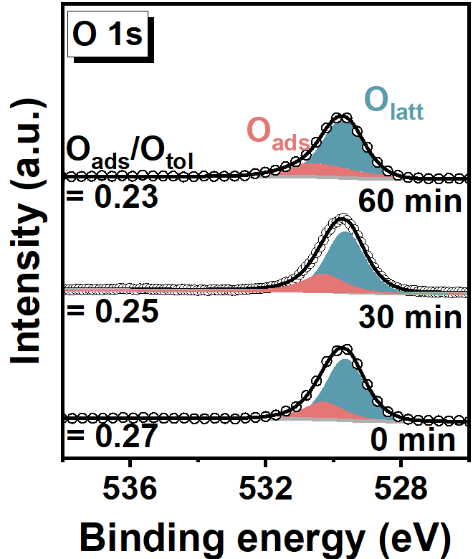
Figure S31. In situ NAP-XPS spectra for O 1s of Pd/CeTiO_{x}-IM in H₂ at 400 ºC as a function of time.

Note: The O XPS peaks showed slight declined content in O_{ads} during the formation of the overlayer. Compared to Pd/CeTiO_{x}-H, the Pd/CeTiO_{x}-IM displayed more oxygen vacancies, correlating to the much higher Ce³⁺ (0.43) in the Pd/CeTiO_{x}-IM compared to Pd/CeTiO_{x}-H (0.25).

Figure S32. The slab models and calculated structural energy of different configurations of Pd@Ce₄Ti₅O₁₈. Atoms are color-coded as Pd (gray), Ce (yellow), Ti (blue), and O (red).

Note: Five possible configurations of the Pd@Ce₄Ti₅O₁₈ model were examined. The calculated results showed that the Pd@Ce₄Ti₅O₁₈-A configuration was the most stable. Therefore, subsequent charge-transfer and adsorption-energy calculations were performed on this model.

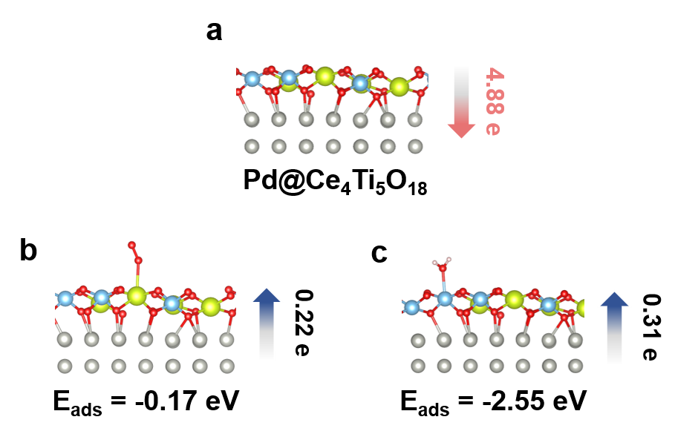
Figure S33. Bader charge of Pd@Ce₄Ti₅O₁₈ with/without adsorption of O₂ and H₂O.

Note: For pristine Pd@Ce₄Ti₅O₁₈ model, electron transfer from the overlayer to Pd metal. Following the adsorption of O₂ and H₂O, electron transfer exhibited reverse direction. The O₂ and H₂O molecular adsorbed over the Ce site and Ti site of Pd@Ce₄Ti₅O₁₈ with adsorption energy of -0.17 and -2.55 eV, respectively.

Figure S34. The slab models and calculated structural energy of different configurations of Pd@Ce₃Ti₆O₁₈. Atoms are color-coded as Pd (gray), Ce (yellow), Ti (blue), and O (red).

Note: Three possible configurations of the Pd@Ce₃Ti₆O₁₈ model were examined. The calculated results showed that the Pd@Ce₃Ti₆O₁₈-C configuration was the most stable. Therefore, subsequent charge-transfer and adsorption-energy calculations were performed on this model.

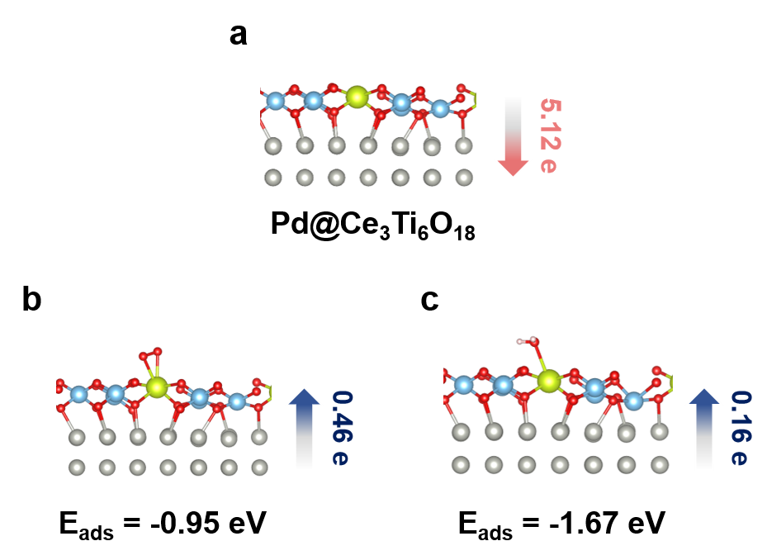
Figure S35. Bader charge of Pd@Ce₃Ti₆O₁₈ with/without adsorption of O₂ and H₂O.

Note: For pristine Pd@Ce₃Ti₆O₁₈ model, electron transfer from the overlayer to Pd metal. Following the adsorption of O₂ and H₂O, electron transfer exhibited reverse direction. The O₂ and H₂O molecular adsorbed over the Ce site of Pd@Ce₃Ti₆O₁₈ with adsorption energy of -0.95 and -1.67 eV, respectively.

Figure S36. CO conversions (a) and Arrhenius plots (b) over Pd/CeTiO_{x}-H, Pd/TiO₂-H and Pd/CeTiO_{x}-IM.

Note: Pd/CeTiO_{x}–IM and Pd/TiO₂-H achieved complete CO conversion at a temperature of ~60 °C and ~100 ºC, with an apparent activation energy (E_{a}) of 43.1 and 45.3 kJ/mol, respectively.

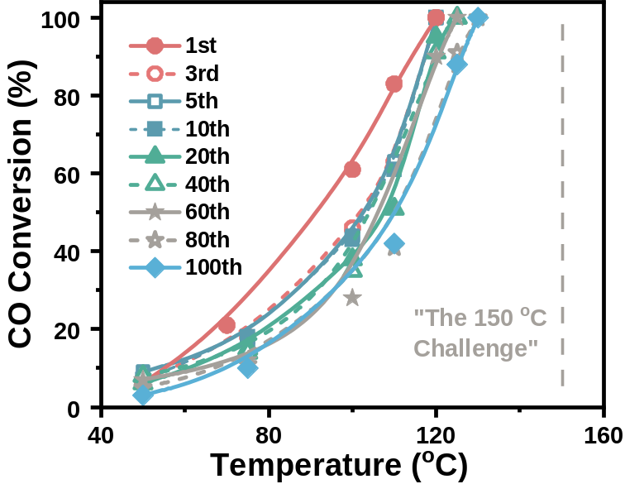
Figure S37. CO oxidation light-off cycles over Pd/CeTiO_{x}-H. Conditions: 4000 ppm CO, 10 vol% O₂, 200000 mL·g⁻¹·h⁻¹.

Note: The light-off cycles for the on-stream stability test showed that Pd/CeTiO_{x}-H retained its ability to meet the "150 ºC Challenge" even after 100 cycles, with the T₁₀₀ increased from 120 ºC to 130 ºC. It should be noted that the light-off curves no longer shifted to higher temperature after 80 cycles, indicating that the catalyst reached a stable catalytic state.

Figure S38. In-situ CO-adsorption infrared spectra of Pd/CeTiO_{x}-H after 100 CO oxidation cycles.

Note: CO-DRIFTS analysis confirmed that the overlayer persisted even after 100 cycles, as evidenced by the absence of CO adsorption peaks.

Figure S39. AC-TEM and EELS results of Pd/CeTiO_{x}-H after 100 CO oxidation cycles.

Note: The TEM and EDS mapping images (Fig. S39a) further confirmed the presence of the encapsulated structure after 100 CO oxidation cycles. The Ti L-edge EELS spectrum (Fig. S39b) from measuring point Ⅱ on the overlayer of Pd/CeTiO_{x}-H after 100 CO oxidation cycles revealed a b-peak shift relative to the support, evidencing the coexistence of Ti³⁺ and Ti⁴⁺ species in the overlayer. The M₄/M₅ ratio derived from the Ce M₄/M₅-edge EELS spectrum of Pd/CeTiO_{x}-H after 100 CO oxidation cycles (Fig. S39c) was determined to be 1.05, lower that of pristine Pd/CeTiO_{x}-H (1.08), suggesting a slight reduction of the overlayer during CO oxidation cycles. Moreover, the Ce-to-Ti ratio was calculated remaining at 3:7 based on the built-in Image Calculator function in Gatan DigitalMicrograph software (Version 3.5).

Figure S40. The oxygen vacancy formation energy of encapsulated-Pd models with Ce₅Ti₁₃O₃₆ (two layers) at different positions.

Note: To determine whether the oxygen vacancy formed after CO oxidation underwent redistribution to the surrounding environment, the oxygen vacancy formation energies at four representative oxygen sites were further calculated. The formation energy of the in situ generated vacancy after CO oxidation was 3.01 eV (Fig. S40a), which was lower than that of the interfacial oxygen vacancy (5.42 eV, Fig. S40b), and also lower than those of the near-surface adjacent Ti–O_{v}–Ti site (3.23 eV, Fig. S40c) and the subsurface adjacent Ti–O_{v}–Ti site (3.27 eV, Fig. S40d). These results demonstrated that, within the examined local structural range, the oxygen vacancy was thermodynamically more favourable to remain at the original Ce–O_{v}–Ti site that participated in CO oxidation. This finding indicated that subsequent vacancy regeneration did not rely on long-range oxygen migration, but rather on oxygen dissociation in the vicinity of the original reaction site.
Figure S41. In-situ CO-adsorption infrared spectra of Pd/CeTiO_{x}-A (a), and CO-TPR spectra of Pd/TiO₂-H, Pd/CeTiO_{x}-A, and CeTiO_{x} (b).

Note: In the synthesis of unencapsulated Pd/CeTiO_{x}-A, titanium (IV) bis (ammonium lactate) dihydroxide (TiBALD) (0.05M), Ce(NO₃)₃·6H₂O (0.05M), and (NH₄)₂PdCl₆ (0.055g_{Pd}) were mixed with supercritical H₂O (Tc = 371 °C, Pc = 24.1 MPa) in a confined jet mixer, leading to the rapid precipitation of Pd/CeTiO_{x}. The resulting Pd/CeTiO_{x} was then calcinated in air at 400 °C to obtain Pd/CeTiO_{x}-A. The unencapsulated structure was confirmed by CO-DRIFTS analysis, showing the presence of CO adsorption peaks in the range from 1800-2250 cm⁻¹. In the CO-TPR profiles, the CO₂ desorption peaks at 0-50 and 50-140 ºC were ascribed to the reduction of the oxygen species of Ce–O–Pd/Ti and PdO/Ce–O–Ti, respectively^{17,18}.

Figure S42. CO conversion with time on stream with presence of SO₂

Figure S43. CO conversion of Pd/CeTiO_{x}-H with time on stream under SO₂+H₂O feed.

Figure S44. Long term tests of SO₂ resistance over Pd/CeTiO_{x}-H.

Figure S45. SO₂-FTIR tests of pristine Pd/CeTiO_{x}-H and Pd/CeTiO_{x}-H (After SO₂-resistance test) (a), SO₂-TPD and SO₂+CO-TPD profiles over Pd/CeTiO_{x}-H (b).

Note: In the SO₂-FTIR spectrum (Fig. S45a) of pristine Pd/CeTiO_{x}, peaks attributable to Ce-related asymmetric stretching of S=O (1280 cm⁻¹) and symmetric stretching of S–O (1000-1200 cm⁻¹) in tridentate sulfate were observed. However, these peaks were not detectable in the SO₂-FTIR spectrum of Pd/CeTiO_{x} (After SO₂-resistance test). The adsorption behavior of CO and SO₂ molecules on Pd/CeTiO_{x} was analyzed by comparing the CO-TPD and CO+SO₂-TPD profiles (Fig. S45b). The results showed that upon the introduction of a certain amount of CO, the desorption peak area of SO₂ species in the range of 50–250 °C significantly decreased, which was attributed to the competitive adsorption effect.

Figure S46. TEM images of reacted Pd/CeTiO_{x}-H (a) and Pd/CeTiO_{x}-IM (b).

Figure S47. In-situ CO-adsorption infrared spectra of reacted Pd/CeTiO_{x}-H and Pd/CeTiO_{x}-IM.

Note: Reacted samples were obtained by treating 0.5 g of Pd/CeTiO_{x}-IM or Pd/CeTiO_{x}-H at 200 °C for 10 hours in a gas mixture containing 10 vol% O₂, 2500 ppm CO, and 50 ppm SO₂.

Figure S48. XRD pattern (a), in-situ CO-adsorption infrared spectra (b), and TEM image (inset: EDS mapping image) (c) of Au/CeTiO_{x}-H.

Note: XRD indicated this sample with similar crystal phases to Pd/CeTiO_{x}-H but with weaker crystallinity (Fig. S48a). The presence of overlayer was confirmed by CO-DRIFTS analysis, showing the absence of CO adsorption peaks. After the treatment of 200 ºC, 20 vol% O₂, and 5 vol% H₂O, the CO adsorption peaks were not observed, demonstrating the stability of the overlayer under oxidative and humid condition (Fig. S48b). The TEM and EDS mapping images further confirmed the preserve of the encapsulated structure (Fig. S48c).

Figure S49. XRD pattern (a), in-situ CO-adsorption infrared spectra (b), and TEM image (inset: EDS mapping image) (c) of Pt/CeTiO_{x}-H.

Note: XRD analyse was endowed this sample with similar crystal phases to Pd/CeTiO_{x}-H but with weaker crystallinity (Fig. S49a). The presence of overlayer was confirmed by CO-DRIFTS analysis, showing the absence of CO adsorption peaks. After the treatment of 200 ºC, 20 vol% O₂, and 5 vol% H₂O, the CO adsorption peaks were not observed, demonstrating the stability of the overlayer under oxidative and humid condition (Fig. S49b). The TEM and EDS mapping images further confirmed the preserve of the encapsulated structure (Fig. S49c).

Figure S50. XRD pattern (a), in-situ CO-adsorption infrared spectra (b) of Pd/SnTiO_{x}-H.

Note: SnO₂ is a classic material capable of storing and releasing electrons¹⁹, and its atomic radius conforms to the Hume-Rothery requirements for SnTiO_{x} solid solution formation (<15%). Thus, it can be another electron buffer similar to Ce. To verify this, we have synthesized Pd/SnTiO_{x}-H sample. XRD pattern of Pd/SnTiO_{x}-H closely matched the standard JCPDS reference for Sn_{0.7}Ti_{0.3}O₂ (JCPDS pattern number 70-4409), with no detectable diffraction peaks corresponding to Pd species (Fig. S50a). The presence of overlayer was confirmed by CO-DRIFTS analysis, showing the absence of CO adsorption peaks. After the treatment of 200 ºC, 20 vol% O₂, and 5 vol% H₂O, the CO adsorption peaks were not observed, demonstrating the stability of the overlayer under oxidative and humid condition (Fig. S50b). The TEM and EDS mapping images further confirmed the preserve of the encapsulated structure (Fig. S50c).

Figure S51. AC-TEM and EELS results of Pd/SnTiO_{x}-H (a-c) and treated Pd/SnTiO_{x}-H (d-f). Treatment condition: 200 ºC, 20 vol% O₂, 5 vol% H₂O, and 2 h.

Note: AC-TEM images demonstrated the encapsulated structure of Pd/SnTiO_{x}-H remained intact after treatment in humid air (Fig. S51a and d). The Ti L-edge EELS spectrum (Fig. S51b and e) from measuring point Ⅱ on the overlayer of both Pd/SnTiO_{x}-H and treated Pd/SnTiO_{x} revealed a b-peak shift relative to the support, evidencing the coexistence of Ti³⁺ and Ti⁴⁺ species in the overlayer. Since the Sn M-edge and O K-edge contributions overlap, the O K-edge lineshape is commonly used to identify the phase state of Sn species²⁰. For O K-edge EELS spectrum of overlayer (Fig. S51c and f), all measured spots exhibited a three-peak feature characteristic of coexisting Sn²⁺ and Sn⁴⁺ species. After humid-air treatment, the characteristic signal at ~560 eV, assigned to the contribution of Sn⁴⁺, was enhanced. This indicated that, similar to the Pd/CeTiO_{x}-H sample, electron transfer from Sn to Pd occurred upon exposure to humid air. Moreover, the Sn-to-Ti ratio was calculated to about 1:1 based on the built-in Image Calculator function in Gatan DigitalMicrograph software (Version 3.5).

Figure S52. The slab models and calculated structural energy of different configurations of Pd@Sn₉Ti₉O₃₆. Atoms are color-coded as Pd (gray), Sn (purple), Ti (blue), and O (red).

Note: The Pd@Sn₉Ti₉O₃₆ model consisted of a bilayer TiO₂ (3×3 supercell)-Pd (8×4×2 supercell) surface with dimensions of 16.00060 Å × 11.31410 Å, containing 64 Pd atoms, 9 Ti atoms, 9 Sn atoms, and 36 O atoms. Five possible configurations of the Pd@Sn₉Ti₉O₃₆ model were examined. The optimization results revealed that the structure with four Sn atoms located on the outer side of the overlayer (Pd@Sn₉Ti₉O₃₆-D) was more stable. Therefore, subsequent charge-transfer and adsorption-energy calculations were performed on this model.

Figure S53. Bader charge of Pd@Sn₉Ti₉O₃₆ with/without adsorption of O₂ and H₂O.

Note: For pristine Pd@Sn₉Ti₉O₃₆ model, electron transfer from the overlayer to Pd metal. Following the adsorption of O₂ and H₂O, electron transfer exhibited same direction. The O₂ and H₂O molecular adsorbed over the Ti site and Sn site of Pd@Sn₉Ti₉O₃₆ with adsorption energy of -1.41 and -0.64 eV, respectively.

Figure S54. XRD pattern (a) and in-situ CO-adsorption infrared spectra (b) of Pd/ZrTiO_{x}-H.

Note: ZrO₂ does not have sufficient electron storage-release capability, although its atomic radius conforms to the Hume-Rothery requirements for ZrTiO_{x} solid solution formation (<15%)²¹. To further confirm the critical role of an electron-buffering overlayer in maintaining structural stability, we also synthesized Pd/ZrTiO_{x}-H sample. XRD pattern of Pd/ZrTiO_{x}-H closely matched the standard JCPDS reference for Zr_{1.34}Ti_{2.66}O₈ (JCPDS pattern number 901-0855), with no detectable diffraction peaks corresponding to Pd species (Fig. S54a). The presence of overlayer was confirmed by CO-DRIFTS analysis, showing the absence of CO adsorption peaks. After the treatment of 200 ºC, 20 vol% O₂, and 5 vol% H₂O, the CO adsorption peaks can be observed at 1981 and 2082 cm⁻¹, demonstrating the retreat-off of the overlayer under oxidative and humid condition (Fig. S54b).
Figure S55. HAADF-STEM images of Pd/CeTiO_{x}-HT (a) and Pd/CeTiO_{x}-H (b) (Inset: particle sizes distribution of Pd clusters).

Note: Pd/CeTiO_{x}-HT was synthesized using a conventional hydrothermal route, in which 3.6 g Ce(NO₃)₃·6H₂O, 4.9 g TiBALD, and (NH₄)₂PdCl₆ (0.018 g Pd) were dissolved in 140 mL deionized water with vigorous stirring at room temperature. The resulting solution was subsequently transferred to a 200 mL Teflon-lined stainless-steel autoclave and maintained at 180 ºC for 20 h. After cooling down to room temperature, the precipitate was collected by filtration, washed extensively with deionized water and ethanol, and then dried overnight at 100 ºC. Finally, the sample was reduced at 400 ºC in 5 vol% H₂/N₂ for 4 h. As shown in Fig. S55, STEM imaging revealed that the Pd nanoparticles over Pd/CeTiO_{x}-HT and Pd/CeTiO_{x}-H exhibited average size of 63.45 nm and 3.57 nm, respectively.

Figure S56. AC-TEM and EELS results of Pd/CeTiO_{x}-HT.

Note: The TEM and EDS mapping images (Fig. S56a) confirmed the presence of the encapsulated structure with a binary-metal-oxide overlayer of about 0.8–2.0 nm in thickness. The Ti L-edge EELS spectrum (Fig. S56b) of the overlayer (measuring point Ⅱ) showed the absence of a and c peaks, indicating that Ti³⁺ species dominated in the overlayer. For Ce M₄/M₅-edge EELS spectrum of overlayer (Fig. S56c), the M₄/M₅ value was 1.04, suggesting a dominant Ce⁴⁺ state in the overlayer. Moreover, the Ce-to-Ti ratio was calculated to about 6:4 based on the built-in Image Calculator function in Gatan DigitalMicrograph software (Version 3.5).

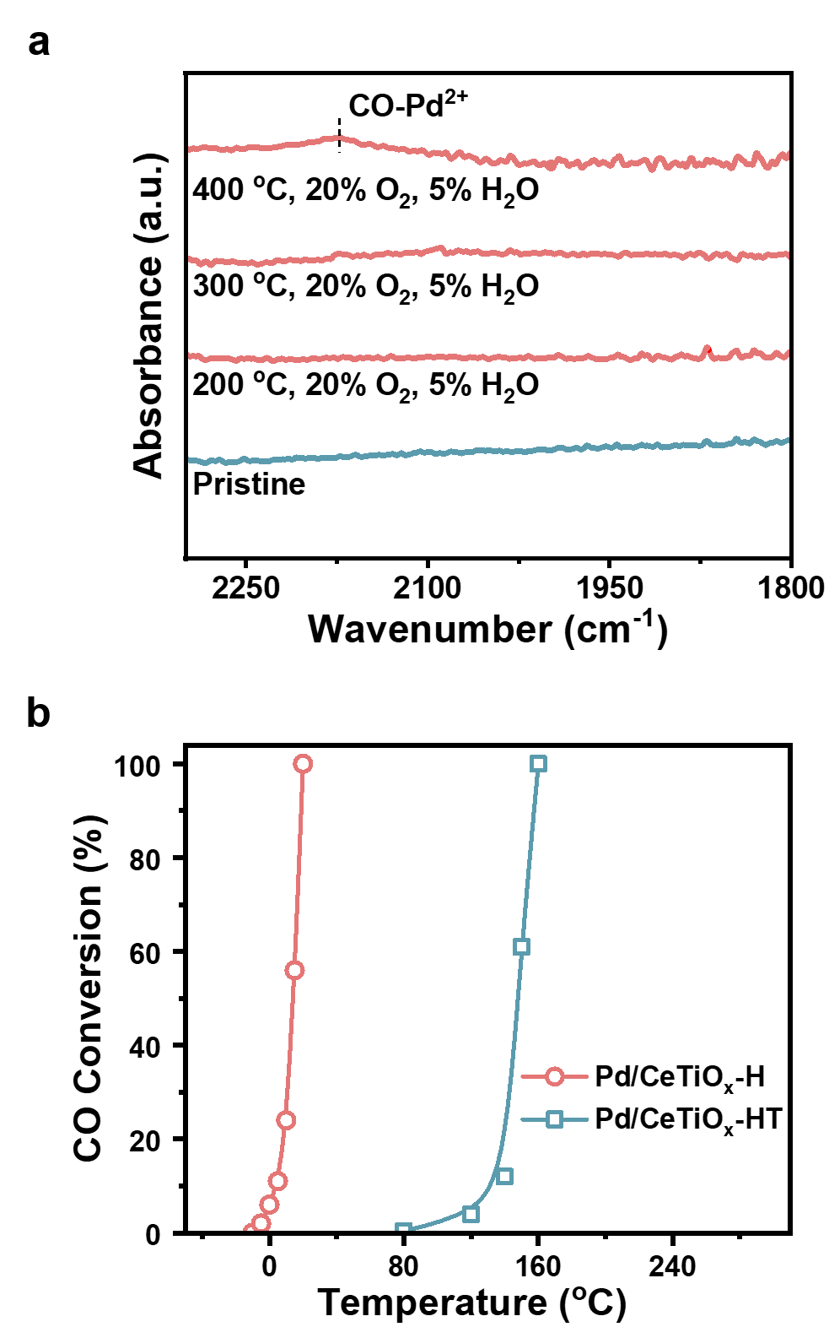
Figure S57. In-situ CO-adsorption infrared spectra of pristine/treated Pd/CeTiO_{x}-HT (a) and CO conversions over Pd/CeTiO_{x}-H and Pd/CeTiO_{x}-HT (b).

Note: The encapsulated structure of Pd/CeTiO_{x}-HT remained intact after treatment in an oxidative and humid atmosphere at 200 and 300 ºC, as demonstrated by the in-situ CO-adsorption infrared spectroscopy (Fig. S57a). After calcination in humid air at 400 ºC, the binary-metal-oxide overlayer in the Pd/CeTiO_{x}-HT disintegrated, as evidenced by the appearance of linear CO adsorption bands on Pd²⁺ site. In comparison with Pd/CeTiO_{x}-IM and Pd/CeTiO_{x}-H, Pd/CeTiO_{x}-HT demonstrated a superior tolerance temperature under oxidative and humid conditions, underscoring the critical role of overlayer structure (e.g, thickness) in stabilizing the encapsulated layer. Nevertheless, the enhanced structural stability came at the expense of catalytic activity. As presented in Fig. S57b, the temperature for 100% CO conversion (T₁₀₀) over Pd/CeTiO_{x}-HT increased by 140 °C relative to that of Pd/CeTiO_{x}-H, unequivocally demonstrating the superiority of supercritical hydrothermal approach.

Table S1
Elemental analyses and BET surface areas of the as-prepared Pd/CeO₂-H, Pd/TiO₂-H, Pd/CeTiO_{x}-H and Pd/CeTiO_{x}-IM catalysts.
Catalyst | Pd (wt%) | Ce-to-Ti molar ratio | S_{BET} (m²/g)
Pd/CeO₂-H | 0.89 | / | 100.55
Pd/TiO₂-H | 0.85 | / | 102.39
Pd/CeTiO_{x}-H | 0.93 | 1.03 | 107.65
Pd/CeTiO_{x}-IM | 0.82 | 1.10 | 79.81

Table S2
EXAFS fitting parameters at the Pd K-edge for various samples
Sample | Shell | Nª | R(Å)^{b} | σ²(Å²)^{c} | ΔE₀ (eV)^{d} | R factor
Pd foil | Pd-Pd | 12 | 2.74±0.01 | 0.0056 | -5.7±0.4 | 0.0030
Pd/TiO₂-H | Pd-O | 2.5±0.1 | 2.00±0.01 | 0.0038 | 3.3±1.0 | 0.0059
Pd/TiO₂-H | Pd-Pd | 1.7±0.2 | 2.79±0.01 | 0.0096 | 3.3±1.0 | 0.0059
Pd/CeTiO_{x}-H | Pd-O | 2.3±0.1 | 2.04±0.01 | 0.0044 | 0.7±1.0 | 0.0065
Pd/CeTiO_{x}-H | Pd-Pd | 2.7±0.3 | 2.78±0.01 | 0.0105 | 0.7±1.0 | 0.0065
Pd/CeTiO_{x}-H  (treated by O₂+H₂O) | Pd-O | 2.1±0.2 | 2.00±0.01 | 0.0043 | -1.3±1.2 | 0.0165
Pd/CeTiO_{x}-H  (treated by O₂+H₂O) | Pd-Pd | 3.9±0.3 | 2.76±0.01 | 0.0098 | -1.3±1.2 | 0.0165
ªN: coordination numbers;
^{b}R: bond distance;
^{c}σ²: Debye-Waller factors;
^{d}ΔE₀: the inner potential correction.

References
1. Kresse, G. & Hafner, J. Ab initio molecular dynamics for liquid metals. Physical Review B 47, 558-561 (1993).
2. Perdew, J. P., Burke, K. & Ernzerhof, M. Generalized gradient approximation made simple. Physical Review Letters 77, 3865-3868 (1996).
3. Kresse, G. & Furthmüller, J. Efficiency of ab-initio total energy calculations for metals and semiconductors using a plane-wave basis set. Computational Materials Science 6, 15-50 (1996).
4. Gao, L. et al. Facet-dependent adsorbate-mediated strong metal-support interaction in Ni/TiO₂. Nature Communications 17, 990 (2025).
5. Zhang, H. et al. Unveiling thickness-dependent interfacial synergy in inverse M@BO_{x} catalysts for highly efficient oxidative dehydrogenation of propane. ACS Catalysis (2026).
6. Nelson, R. et al. LOBSTER: Local orbital projections, atomic charges, and chemical-bonding analysis from projector-augmented-wave-based density-functional theory. Journal of Computational Chemistry 41, 1931-1940 (2020).
7. Darr, J. A. & Poliakoff, M. New directions in inorganic and metal-organic coordination chemistry in supercritical fluids. Chemical Reviews 99, 495-542 (1999).
8. Zhang, S. et al. Dynamical observation and detailed description of catalysts under strong metal–support interaction. Nano Letters 16, 4528-4534 (2016).
9. Stoyanov, E., Langenhorst, F. & Steinle-Neumann, G. The effect of valence state and site geometry on Ti L_{3,2} and O K electron energy-loss spectra of Ti_{x}O_{y} phases. American Mineralogist 92, 577-586 (2007).
10. Haruta, M. et al. Determination of elemental ratio in an atomic column by electron energy loss spectroscopy. ACS Nano 10, 6680-6684 (2016).
11. Tan, H., Wang, J., Yu, S. & Zhou, K. Support morphology-dependent catalytic activity of Pd/CeO₂ for formaldehyde oxidation. Environmental Science & Technology 49, 8675-8682 (2015).
12. Bêche, E., Charvin, P., Perarnau, D., Abanades, S. & Flamant, G. Ce 3d XPS investigation of cerium oxides and mixed cerium oxide (Ce_{x}Ti_{y}O_{z}). Surface and Interface Analysis 40, 264-267 (2008).
13. Zhang, T. et al. Simultaneously activating molecular oxygen and surface lattice oxygen on Pt/TiO₂ for low-temperature CO oxidation. Nature Communications 15, 6827 (2024).
14. Xu, J., Li, X., Liu, X. & Liu, J. EELS analysis of Ce valence state of SiO₂ supported CeO₂ nanoparticles, CeO_{x} nanoclusters and Ce single atoms. Microscopy and Microanalysis 26, 728-730 (2020).
15. Xu, F. F. & Bando, Y. Valence evaluation of cerium ions in Ce-doped α-sialon by electron energy loss spectra. Journal of Applied Physics 89, 5469-5472 (2001).
16. Borja-Urby, R., González-Vargas, O. A., Suárez-Toriello, V. A. & Herrera-Pérez, G. EELS post-processing and multiplet calculation for Ce⁴⁺, Ce³⁺ valency determination in nanomaterials. MRS Advances 7, 1032-1037 (2022).
17. Zhu, H., Qin, Z., Shan, W., Shen, W. & Wang, J. Pd/CeO₂–TiO₂ catalyst for CO oxidation at low temperature: a TPR study with H₂ and CO as reducing agents. Journal of Catalysis 225, 267-277 (2004).
18. Hu, Z. et al. Effect of ceria crystal plane on the physicochemical and catalytic properties of Pd/ceria for CO and propane oxidation. ACS Catalysis 6, 2265-2279 (2016).
19. Chen, M. et al. Novel and facile method, dynamic self-assemble, to prepare SnO₂/rGO droplet aerogel with complex morphologies and their application in supercapacitors. ACS Applied Materials & Interfaces 6, 14327-14337 (2014).
20. Moreno, M. S., Egerton, R. F., Rehr, J. J. & Midgley, P. A. Electronic structure of tin oxides by electron energy loss spectroscopy and real-space multiple scattering calculations. Physical Review B 71, 035103 (2005).
21. Zhang, X. et al. Low-temperature NH₃-SCR catalytic study of Mn_{x}Ce_{1-x}/ZrTiO₄ catalysts: Effect of MnCeO_{x} solid solution. Fuel 407, 137260 (2026).

