Supplementary material

The Creation of Sono-Fenton System via trace Fe²⁺ addition in Sono-Degradation Dimethoate: Mechanism and Optimization
Juanjuan Yao^{1,*}, Shiyi Liu¹, Yanjuan Fang¹, Naiyun Gao², Wenchao Jiang^{1,*}, Zhi Zhang¹ , Xiangyu Chen¹

- Key Laboratory of Three Gorges Reservoir Region’s Eco-Environment, Ministry of Education, Chongqing University, Chongqing 40045, China;
- State Key Laboratory of Pollution Control and Resources Reuse, Tongji University, Shanghai, 200092, China.

Fig. S1 was used to point to Section 3.4.
Fig. S1 was used to point to Section 3.5.
Table. S1 was used to point to Section 3.5.
Table. S2 was used to point to Section 3.6.

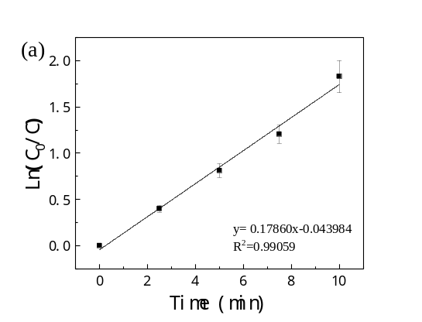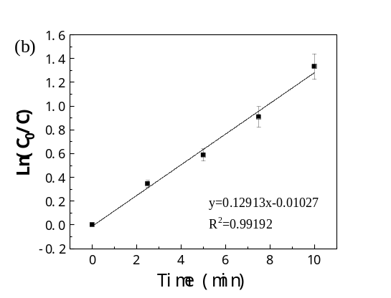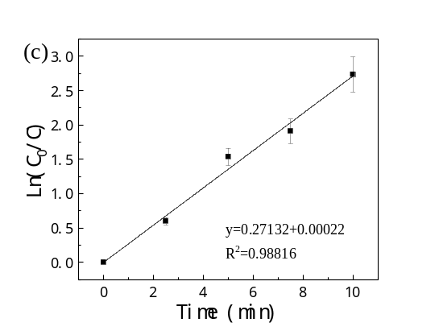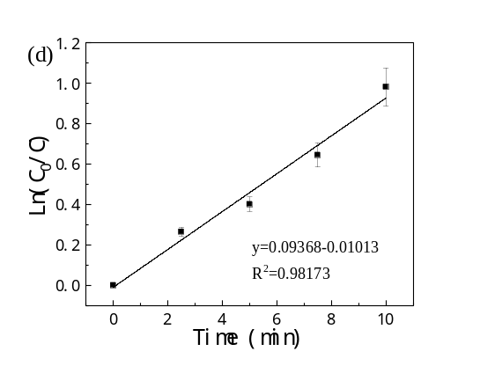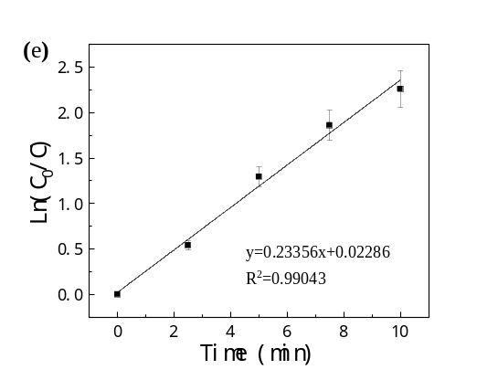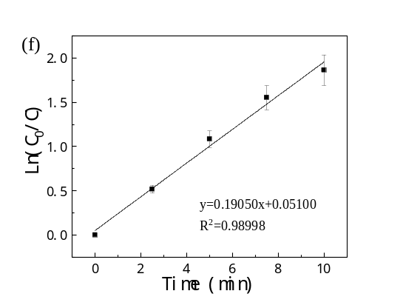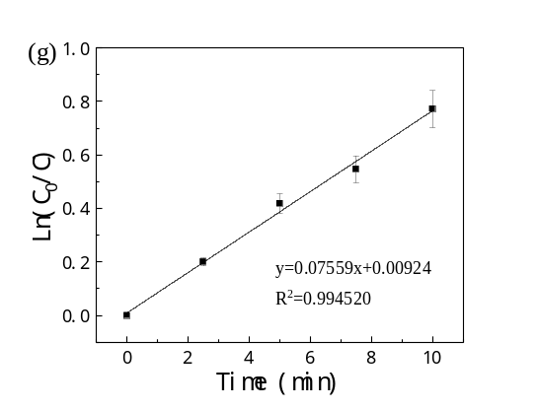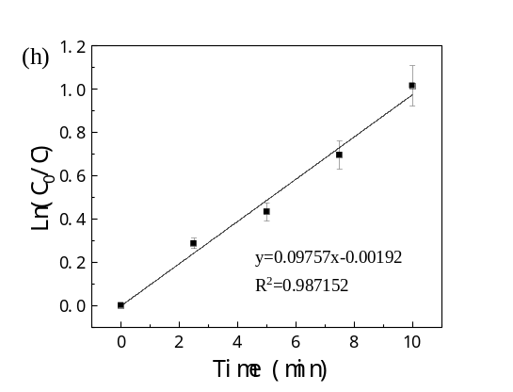
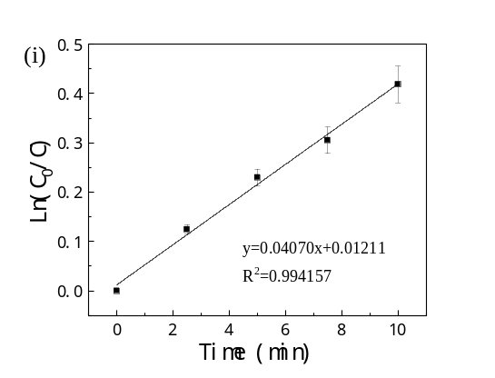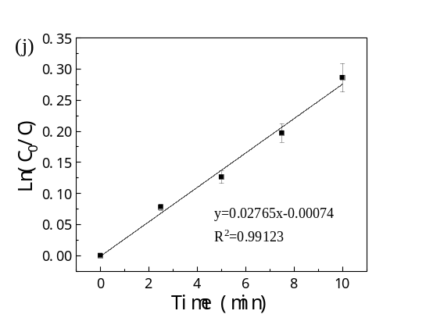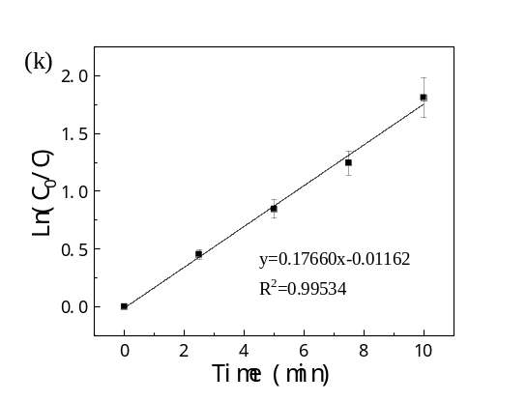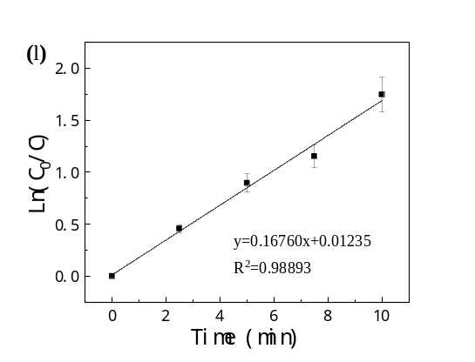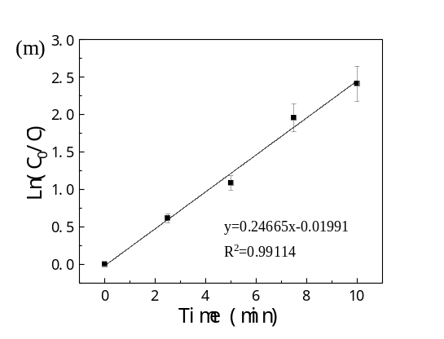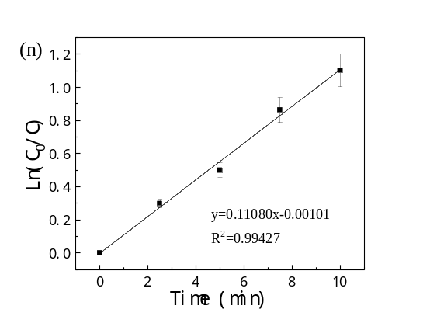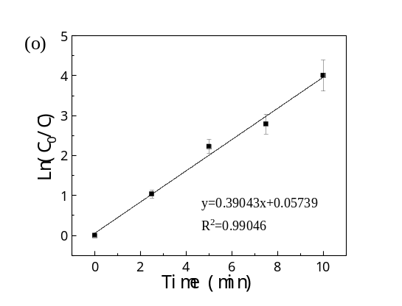
Fig. S1 Degradation curves of dimethoate ((a)–(o)) under 15 working conditions (Run order 1 to 15) corresponding to Table.2
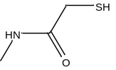
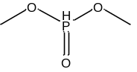
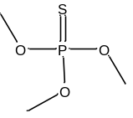
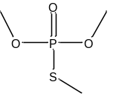
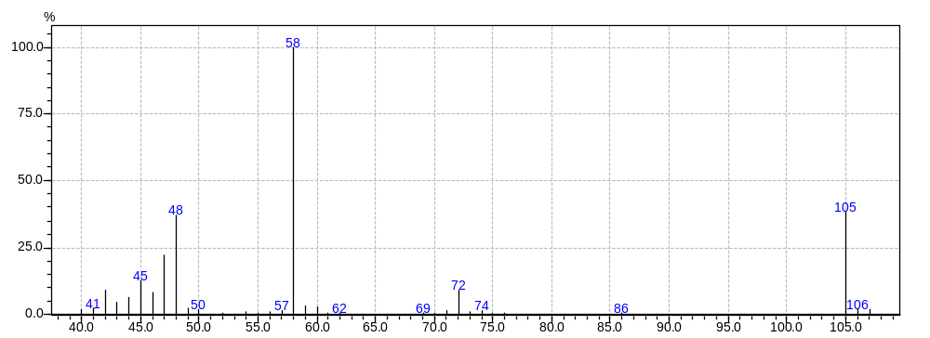
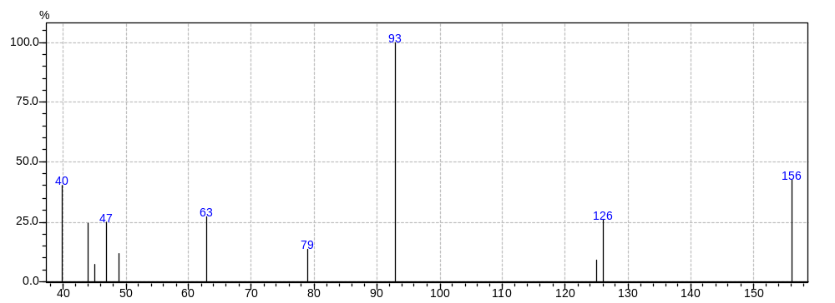
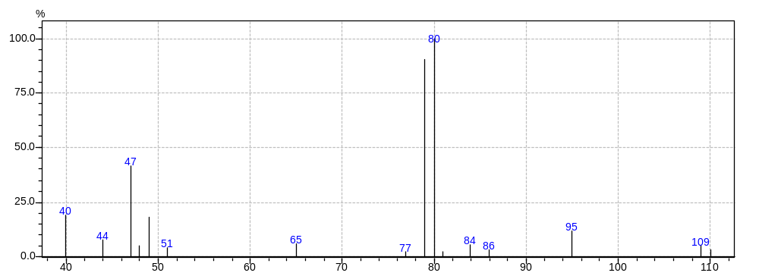
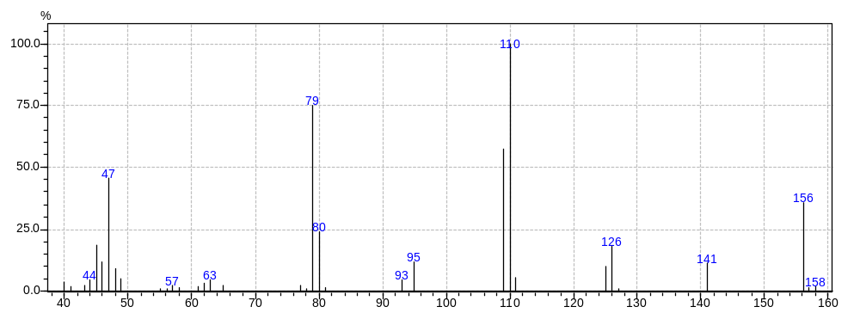
No.4
No.3
No.2
No.1
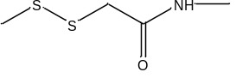
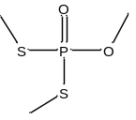
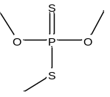
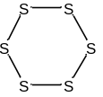
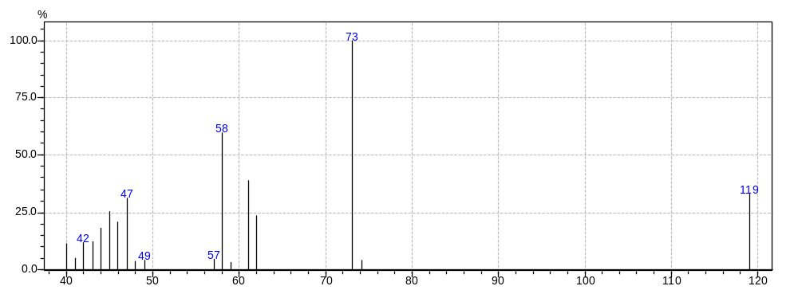
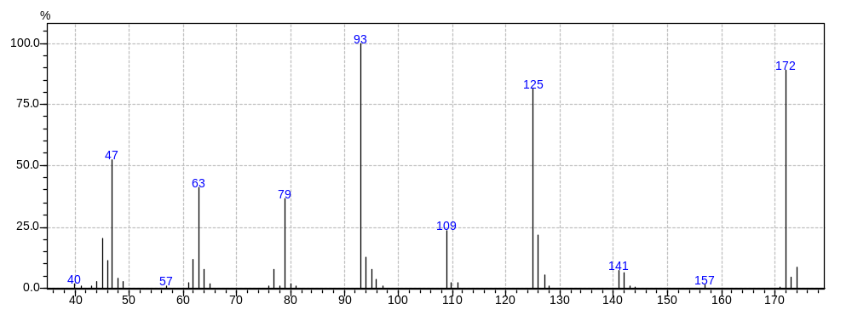
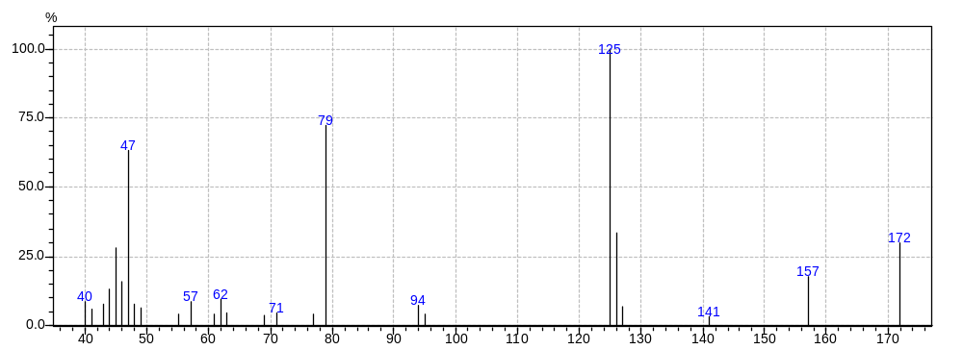
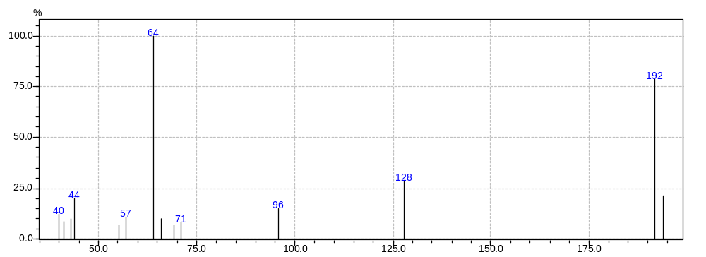
No.8
No.7
No.6
No.5

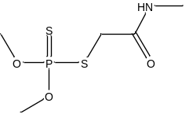
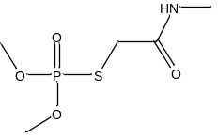
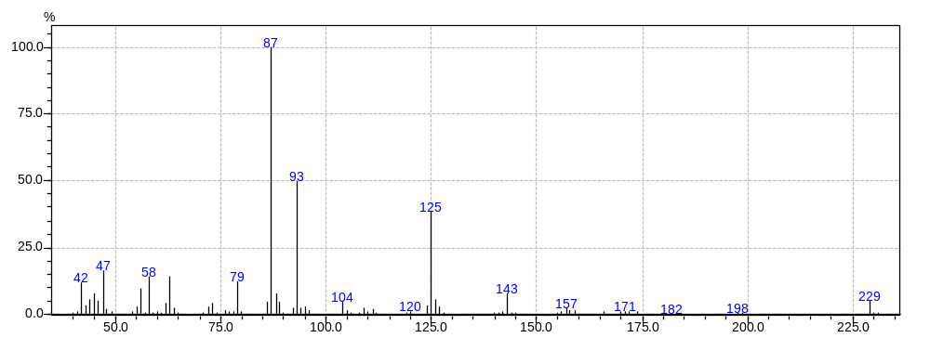
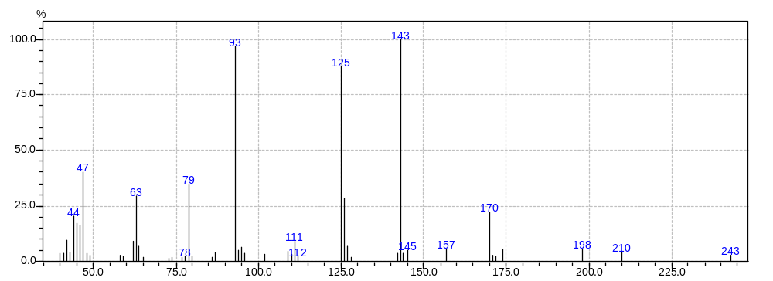 Fig. S2 Mass spectra and chemical formulasof degradation intermediates (No.1–No.9) and dimethoate (DIM)formed during the sono-degradation in the presence of Fe²⁺(200µM)
No.9
DIM

Table. S1
The reference value of hydrophobic parameter calculation(XLogP3-AA) of degradation intermediates
No. | Intermediate compound | XLogP3-AA
1 | Dimethyl phosphite | 0
2 | O, O, O-trimethyl thiophosphate | 1.2
3 | N-(methyl) mercaptoacetamide | -0.1
4 | O, O, S-trimethyl phosphorothioate | -0.1
5 | 2-(methyldisulfanyl) acetamide | -0.1
6 | O, O, S-trimethyl phosphorodithioate | 1.6
7 | O, S, S-trimethyl phosphorodithioate | 0.3
8 | Cyclic hexatomic sulfur | 2.6
9 | Omethoate | -0.9
Computed by XLogP3 3.0 (PubChem release 2019.06.18).

Table. S2
Water quality of three real water samples
 | pH | TOC(mg/L) | Conductivity(µs/cm) | Turbidity(NTU)
pure water | 7.05 | 0.0589 | 0.8 | 0.04
lake water | 6.57 | 19.8202 | 400 | 4.30
tap water | 6.48 | 2.1367 | 401 | 0.86

