Supplementary Materials
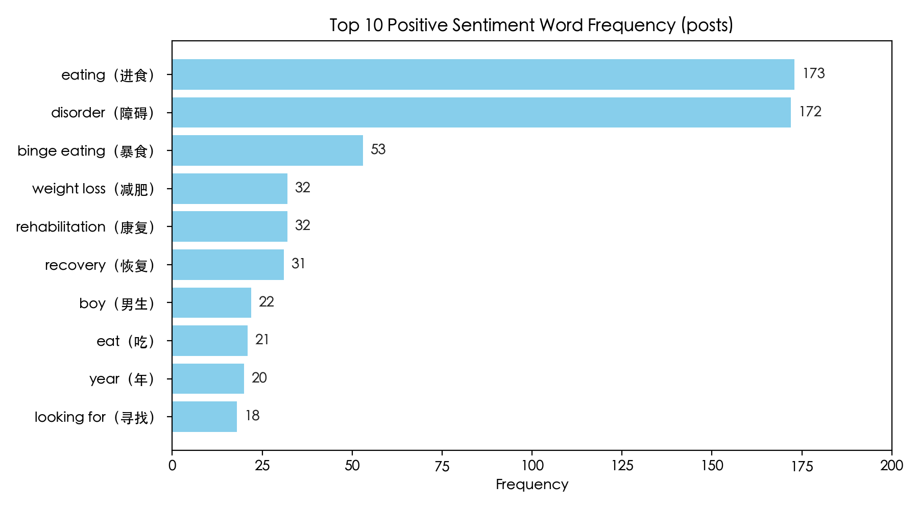
Figure S1: Top 10 positive sentiment word frequency (posts)
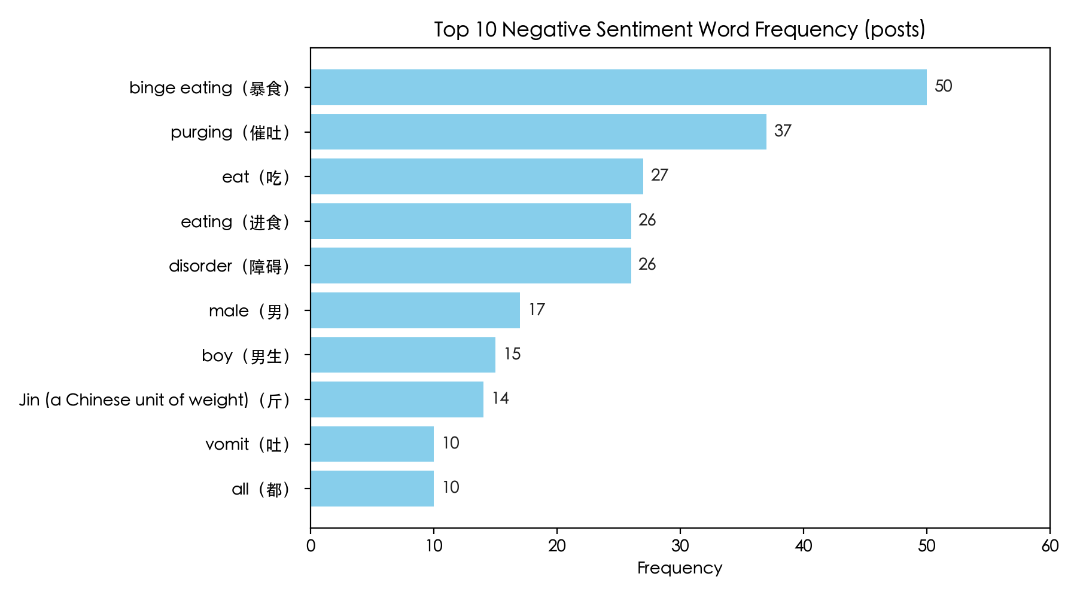

Figure S2: Top 10 negative sentiment word frequency (posts)

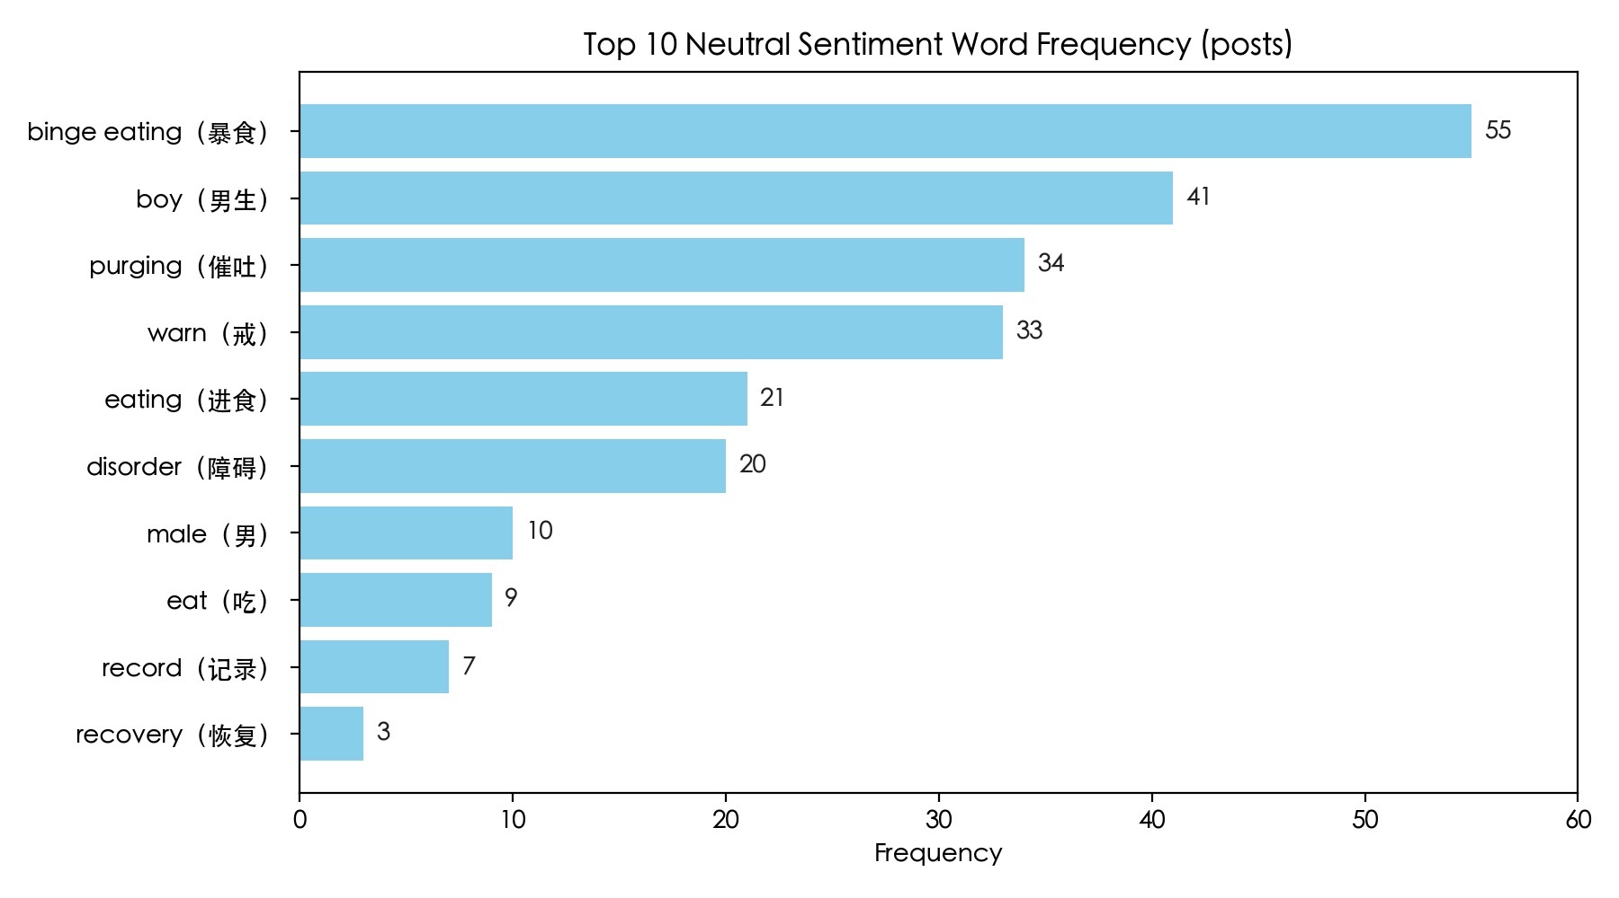
Figure S3: Top 10 neutral sentiment word frequency (posts)
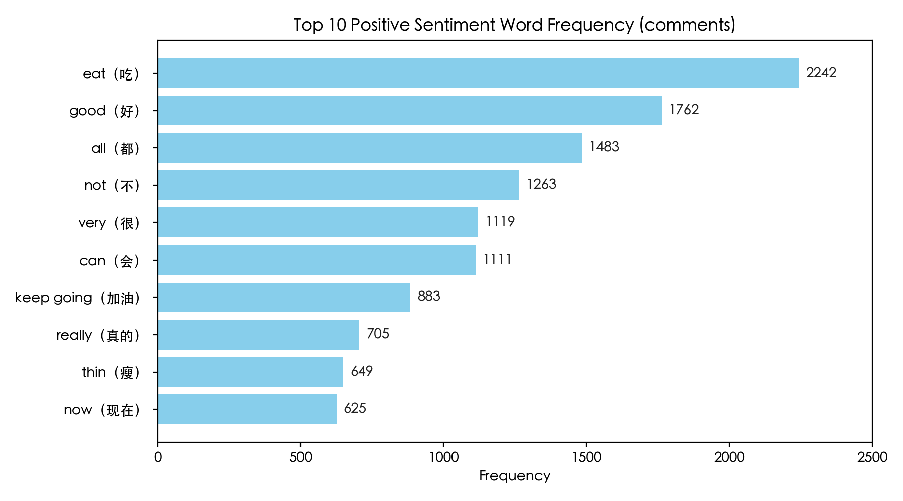
Figure S4: Top 10 positive sentiment word frequency (comments)
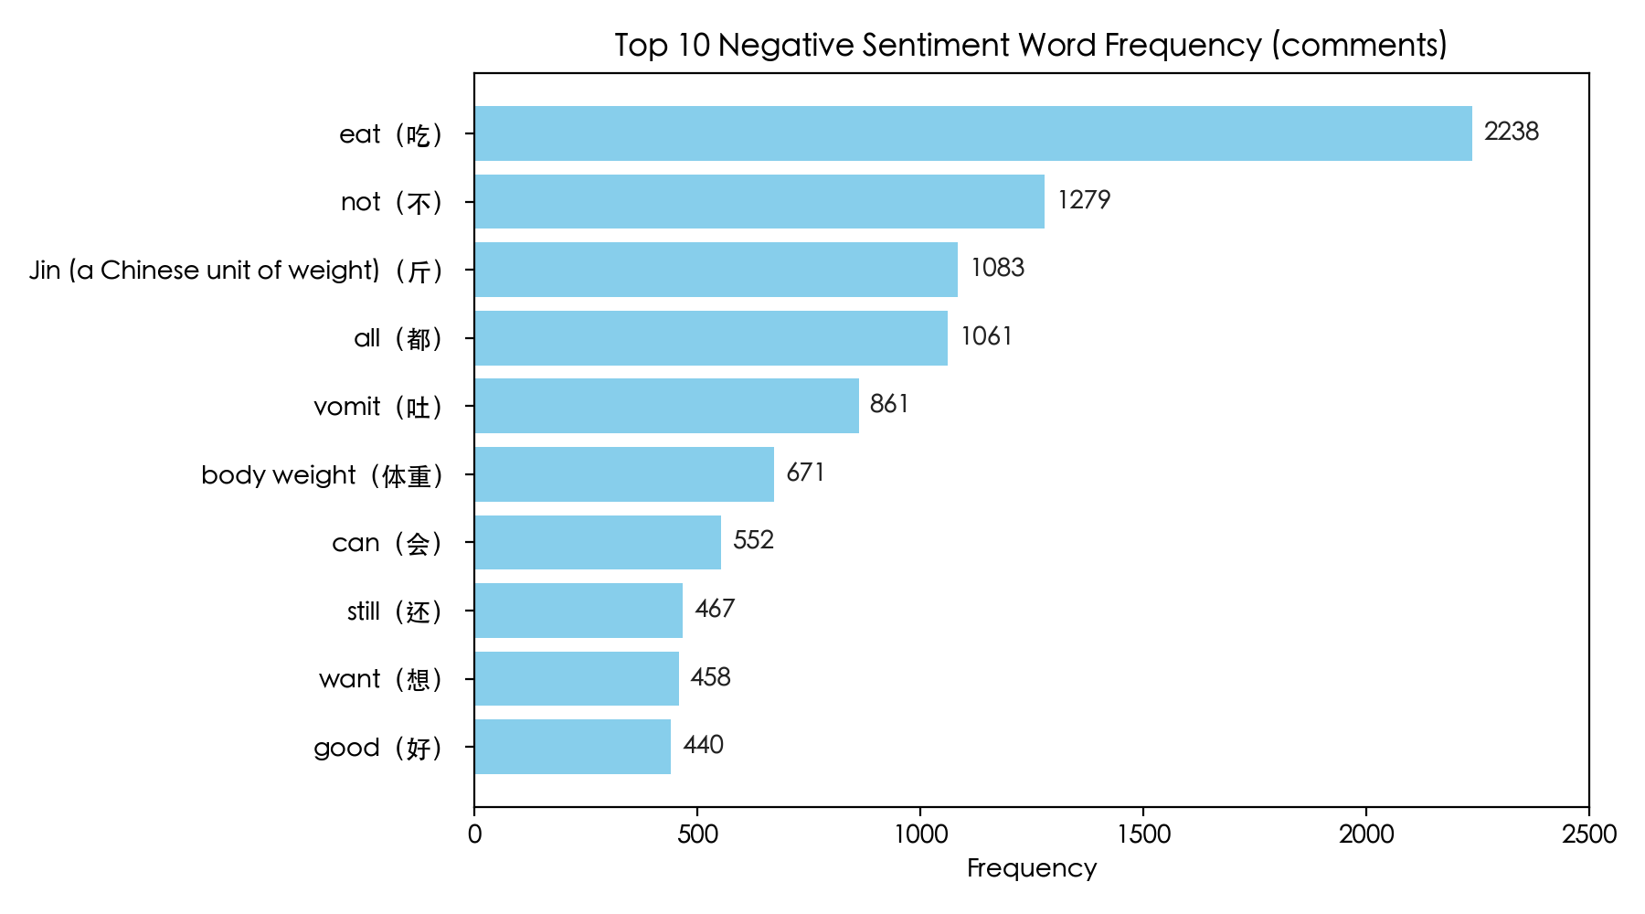
Figure S5: Top 10 negative sentiment word frequency (comments)

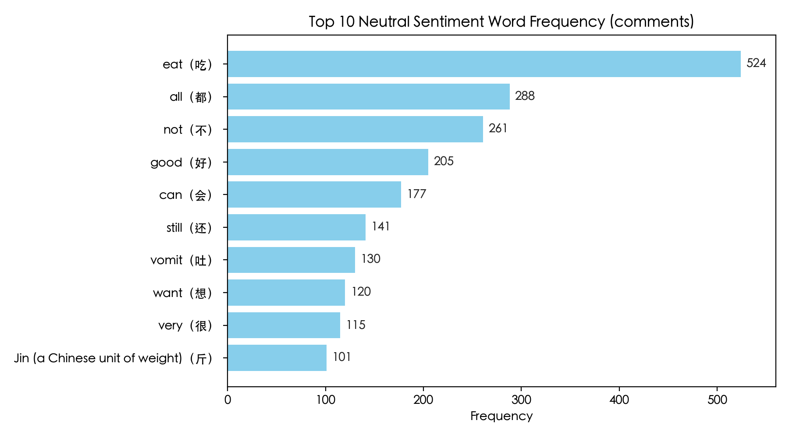
Figure S6: Top 10 neutral sentiment word frequency (comments)

Table S1. LDA Model Selection Metrics —Posts Corpus (K = 2–10; Optimal K = 3)
K | c_v | c_npmi | u_mass | perplexity | diversity | balance | combined_score
2 | 0.582 | -0.420 | -16.865 | 4.882 | 0.933 | 0.958 | 0.671
3 | 0.604 | -0.433 | -17.385 | 4.919 | 0.811 | 0.812 | 0.645
4 | 0.586 | -0.414 | -17.111 | 5.005 | 0.767 | 0.826 | 0.534
5 | 0.565 | -0.410 | -17.595 | 5.104 | 0.847 | 0.747 | 0.478
6 | 0.556 | -0.406 | -17.929 | 5.132 | 0.850 | 0.714 | 0.455
7 | 0.564 | -0.415 | -17.838 | 5.164 | 0.795 | 0.699 | 0.408
8 | 0.547 | -0.405 | -17.895 | 5.144 | 0.763 | 0.797 | 0.374
9 | 0.531 | -0.387 | -17.325 | 5.237 | 0.737 | 0.786 | 0.241
10 | 0.549 | -0.401 | -17.659 | 5.251 | 0.723 | 0.870 | 0.345

Table S2. LDA Model Selection Metrics — Comments Corpus (K = 2–10; Optimal K = 3)
K | c_v | c_npmi | u_mass | perplexity | diversity | balance | combined_score
2 | 0.598 | -0.001 | -2.776 | 7.910 | 0.967 | 0.969 | 0.892
3 | 0.572 | 0.009 | -3.442 | 7.959 | 0.922 | 0.900 | 0.737
4 | 0.555 | -0.017 | -3.736 | 8.021 | 0.867 | 0.890 | 0.585
5 | 0.451 | -0.076 | -5.514 | 8.055 | 0.880 | 0.850 | 0.298
6 | 0.441 | -0.134 | -7.199 | 8.080 | 0.889 | 0.831 | 0.255
7 | 0.451 | -0.160 | -8.421 | 8.088 | 0.914 | 0.790 | 0.290
8 | 0.442 | -0.172 | -8.466 | 8.162 | 0.883 | 0.852 | 0.241
9 | 0.448 | -0.188 | -8.904 | 8.367 | 0.922 | 0.809 | 0.254
10 | 0.458 | -0.158 | -7.781 | 8.663 | 0.860 | 0.896 | 0.207

