Supporting Information
Ductile Mg-Te-Pb Thermoelectric Materials with Ultralow Lattice Thermal Conductivity Predicted by a Deep Learning Potential Model
Xin-Xuan Wang,¹ Zhen-Shuai Lei,¹ Wen-Juan Li,¹ Xiao-Bin Feng,¹ Gang Chen,¹ Peng-Cheng Zhai,^{1, 2} Bo Duan,¹ Guo-Dong Li,^{1, 2} Qing-Jie Zhang ²
¹ Hubei Key Laboratory of Theory and Application of Advanced Materials Mechanics, School of Physics and Mechanics, Wuhan University of Technology, Wuhan 430070, China
² State Key Laboratory of Advanced Technology for Materials Synthesis and Processing, Wuhan University of Technology, Wuhan 430070, China

This Supporting Information presents all structural data used for training the first-generation Mg-Te-Pb-Bi quaternary general-purpose potential model in this work (Table S1), the Lattice parameters of Mg-Te-Pb ternary thermoelectric (TE) materials (Table S2), analysis of the intralayer slip mechanisms for II-Mg₂Te₃Pb and MgTe₂Pb (Figures S1-S2 and corresponding descriptions), and the experimental synthesis and characterization that have been attempted (Figures S3-S5, Tables S3-S4), all provided to support the research conclusions in the main text.

Crystal | Space group |  | Crystal | Space group
Mg | P6₃mc |  | Mg₂Bi | C2-m
Te | P3₁-21 / C2-m |  | Mg₃Bi | Pm-3m
Pb | Fm-3m / P6₃-mmc |  | Mg₃Bi₂ | P-3m1
Bi | R-3m / C2-m / Im-3m |  | Mg₄Bi | Cmmm
BiTe | P3m1 |  | MgTe | P6₃mc
Bi₂Te₃ | R-3m |  | MgTe₂ | Pa-3
Bi₄Te₃ | R-3m |  | Mg₂Pb | Fm-3m
MgBi | Cmmm / Pmmm |  | PbTe | Fm-3m / Pm-3m / Pnma
MgBi₂ | C2-m |  | Bi₂Te₄Pb | R-3m
MgBi₃ | C2-m |  | Bi₄Te₇Pb | P-3m1
Table S1. Crystal structures selected for fitting the Deep Potential (DP) model.

Table S2. Lattice parameters of I-Mg₂Te₃Pb, II-Mg₂Te₃Pb, and MgTe₂Pb.
Phase | Lattice Parameters（Å） | Atomic coordinates（fractional）
Phase | Lattice Parameters（Å） | Atoms | X | Y | Z
I-Mg₂Te₃Pb  P-3m1 | a= 4.35050  b= 4.35050  c= 10.75790  α=β= 90.0000°  γ = 120.0000° | Mg(2d) | 0.33333 | 0.66667 | 0.15751
I-Mg₂Te₃Pb  P-3m1 |  | Te(2d) | 0.33333 | 0.66667 | 0.69162
I-Mg₂Te₃Pb  P-3m1 |  | Te(1a) | 0.00000 | 0.00000 | 0.00000
I-Mg₂Te₃Pb  P-3m1 |  | Pb(1b) | 0.00000 | 0.00000 | 0.50000
II-Mg₂Te₃Pb  P-6m2 | a= 4.31220  b= 4.31220  c= 11.06090  α=β= 90.0000°  γ = 120.0000° | Mg(2g) | 0.00000 | 0.00000 | 0.84560
II-Mg₂Te₃Pb  P-6m2 |  | Te(2h) | 0.33333 | 0.66667 | 0.69549
II-Mg₂Te₃Pb  P-6m2 |  | Te(1e) | 0.66667 | 0.33333 | 0.00000
II-Mg₂Te₃Pb  P-6m2 |  | Pb(1b) | 0.00000 | 0.00000 | 0.50000
MgTe₂Pb  P-6m2 | a= 4.35260  b= 4.35260  c= 15.16190  α=β= 90.0000°  γ = 120.0000° | Mg(2i) | 0.66667 | 0.33333 | 0.25182
MgTe₂Pb  P-6m2 |  | Te(2h) | 0.33333 | 0.66667 | 0.14234
MgTe₂Pb  P-6m2 |  | Te(2g) | 0.00000 | 0.00000 | 0.63994
MgTe₂Pb  P-6m2 |  | Pb(1e) | 0.66667 | 0.33333 | 0.00000
MgTe₂Pb  P-6m2 |  | Pb(1d) | 0.33333 | 0.66667 | 0.50000

In the crystal structures of II-Mg₂Te₃Pb and MgTe₂Pb, single-layer Te slip occurs within the Pb-Te layers, whereas double-layer Te slip is exclusively observed in the Mg-Te polyhedral layers. Schematic illustrations of the corresponding slip mechanisms for the two materials are provided here. Figures S1(a)-(c) show the slip process of single-layer Te within the Pb-Te polyhedra and the associated evolution of bond lengths. The Pb(1) and Te(1) atoms, highlighted in red, belong to the same structural unit, while the Te(2) atom, marked in pink, belongs to an adjacent unit. As the shear strain increases from 0.330 to 0.360, the Pb(1)-Te(1) bond stretches and ruptures, and simultaneously, the Pb(1) atom forms a new bond with the Te(2) atom from the neighboring unit. Figures S1(d)-(g) illustrate the slip process of double-layer Te within the Mg-Te polyhedra along with the corresponding bond-length responses. The Mg(1) and Te(1) atoms, highlighted in green, reside in the same structural unit, whereas the Te(2) and Te(3) atoms, marked in pink, belong to two distinct neighboring units. When the shear strain increases from 0.550 to 0.555, the Mg(1) atom forms a new bond with the broken Te(2) atom from an adjacent unit, while the Mg(1)-Te(1) bond elongates. Upon further increasing the strain to 0.565, the Mg(1)-Te(1) bond breaks, and concurrently, the Mg(1) atom establishes a new bond with the Te(3) atom.

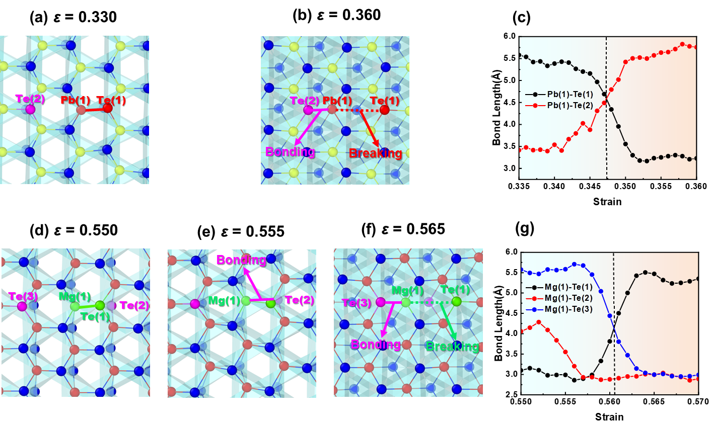
Figure S1. (a)-(b) Schematic illustrations of the slip process of single-layer Te within the Pb-Te polyhedral layers in the II-Mg₂Te₃Pb system, and (c) the corresponding bond-length evolution. (d)-(f) Schematic illustrations of the slip process of double-layer Te within the Mg-Te polyhedral layers in the II-Mg₂Te₃Pb system, and (g) the corresponding bond-length evolution.

Figures S2(a)-(c) illustrate the slip process of single-layer Te within the Pb-Te polyhedra and the corresponding evolution of bond lengths. As the shear strain increases from 0.128 to 0.136, the Pb(1)-Te(1) bond stretches and ruptures, and simultaneously, the Pb(1) atom forms a new bond with the Te(2) atom from an adjacent unit. Figures S2(d)-(i) depict the slip process of double-layer Te within the Mg-Te polyhedra along with the associated bond-length responses. When the shear strain increases from 0.480 to 0.490, the Mg(1)-Te(1) bond stretches and breaks, while the Mg(1)-Te(2) bond elongates. Upon further increasing the strain to 0.495, the Mg(1)-Te(2) bond ruptures, and concurrently, the Mg(1) atom forms a new bond with the Te(3) atom from a neighboring unit. At a strain of 0.498, the Mg(1) atom establishes an additional new bond with the Te(4) atom.
Notably, the slip process of single-layer Te in the II-Mg₂Te₃Pb and MgTe₂Pb systems differs slightly from that in the I-Mg₂Te₃Pb system. This difference arises because the Pb-Te polyhedra in the II-Mg₂Te₃Pb and MgTe₂Pb structures are twisted. During the slip of the Te layer, only one set of Pb-Te bonds needs to break and reform to achieve a stable state. Additionally, the slip process of double-layer Te in the II-Mg₂Te₃Pb structure also exhibits slight differences compared to that in the I-Mg₂Te₃Pb structure. Specifically, during the initial stages of slip in the II-Mg₂Te₃Pb structure, one bond within the Mg-Te polyhedra breaks, transforming the [MgTe₆] unit into the [MgTe₅] unit. Consequently, when the Te layer slips, only one set of Pb-Te bonds needs to break, while two sets of Pb–Te bonds need to reform to reach a stable state.
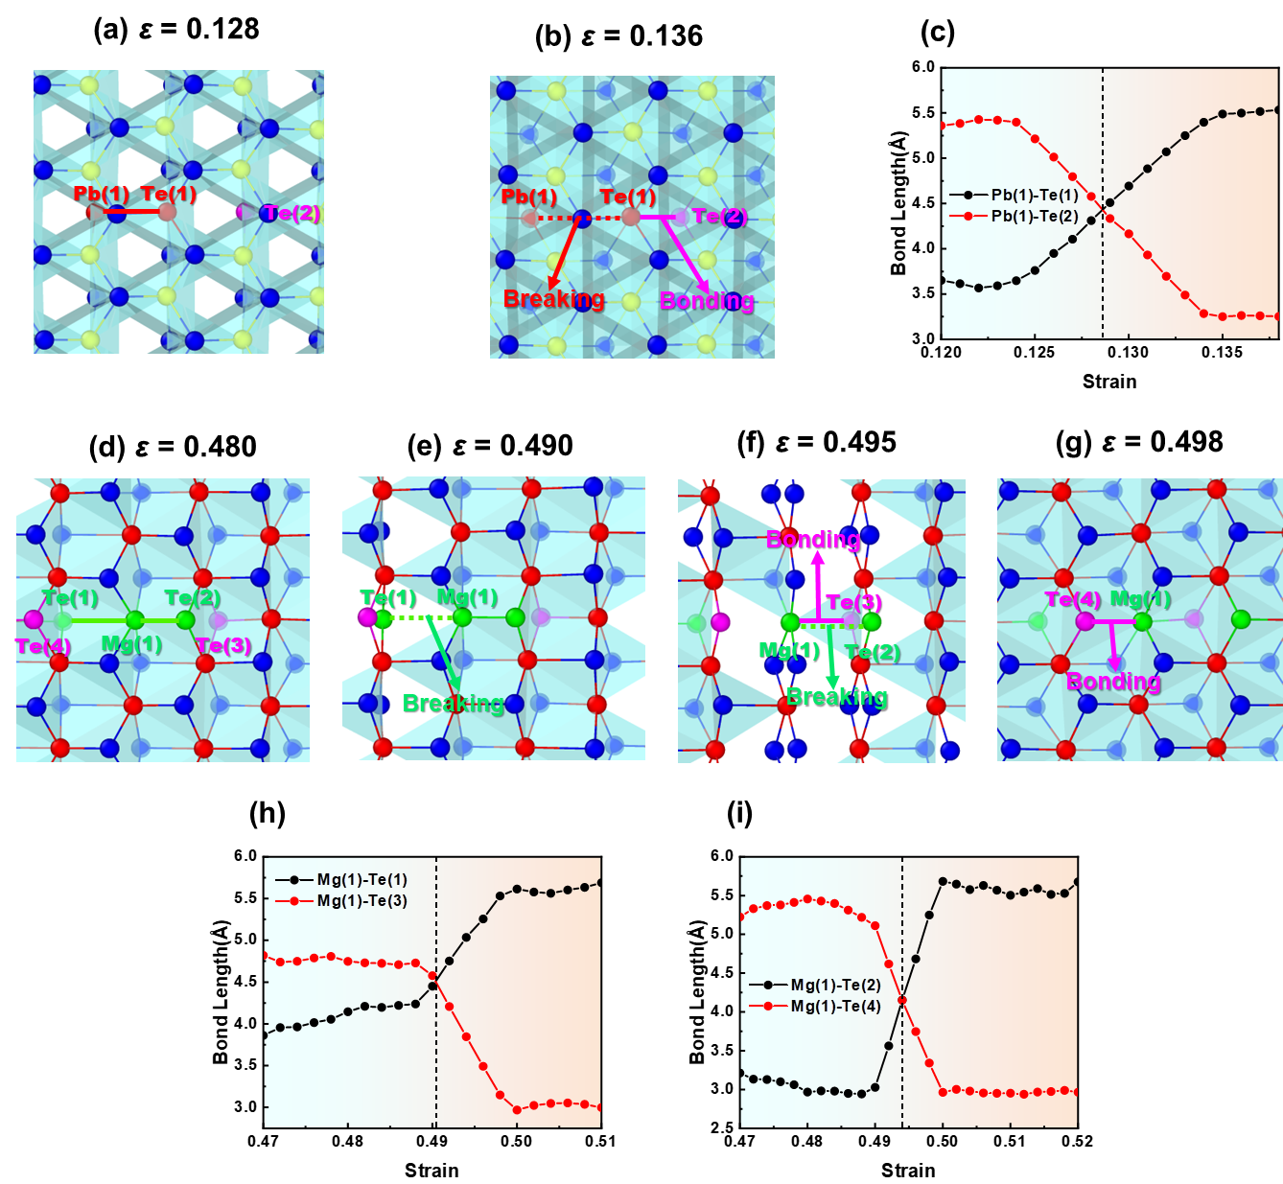
Figure S2. (a)-(b) Schematic illustrations of the slip process of single-layer Te within the Pb-Te polyhedral layers in the MgTe₂Pb system, and (c) the corresponding bond-length evolution. (d)-(g) Schematic illustrations of the slip process of double-layer Te within the Mg-Te polyhedral layers in the MgTe₂Pb system, and (h)-(i) the corresponding bond-length evolution.

We attempt to synthesize the three target materials using melting, magnetron sputtering, and high-pressure methods, respectively. Detailed experimental procedures and corresponding results for each method are provided below. First, synthesis is performed via the melting route. Mg (99.5% purity), Te (99.99% purity), and Pb (99.95% purity) powders are used as starting materials. For each compound, 5 g of powder is weighed according to the stoichiometric ratios of Mg₂Te₃Pb and MgTe₂Pb and thoroughly mixed. The mixture is sealed in a carbon tube, which is then vacuum-encapsulated in a quartz tube under a pressure of 10⁻³ Pa and placed in a furnace. A stepwise heating profile is designed based on the melting points of the constituent elements and relevant intermediates (Mg: 650 °C, Pb: 327.5 °C, Te: 449.5 °C, PbTe: 924 °C, MgTe: 1258 °C). The temperature is first raised to 600 °C and held for 10 h to facilitate solid-state reactions and form intermediate phases. It is then increased to 950 °C and maintained for 10 h to promote melting and enhance reaction kinetics. Thereafter, the sample is cooled to 600 °C, held for 48 h, and finally furnace-cooled to room temperature. During the grinding of the resulting ingots, both samples exhibit noticeable volatilization and decomposition, accompanied by a pungent odor. This is likely attributable to the reaction of MgTe with atmospheric moisture, which yields Mg(OH)₂ and H₂Te. Hence, strict protection from moisture is essential during the processing of these materials. The as-synthesized samples are characterized by powder X-ray diffraction (XRD, Bruker D8 Advance, Cu Kα). The measured patterns are compared with the simulated XRD profiles of I-Mg₂Te₃Pb, II-Mg₂Te₃Pb, and MgTe₂Pb generated using VESTA software, as shown in Figure S3. The results reveal that although the main diffraction peaks of Sample 1 align closely with those of I-Mg₂Te₃Pb and II-Mg₂Te₃Pb, a systematic minor shift is observed. Moreover, the remaining peaks exhibit significant mismatches in position or intensity. A similar trend is noted for Sample 2. These observations suggest that the synthesized samples are not single-phase compounds with ideal stoichiometry. Instead, their phase constitution is multiphase mixtures, predominantly comprising off-stoichiometric solid solutions along with minor impurity phases.

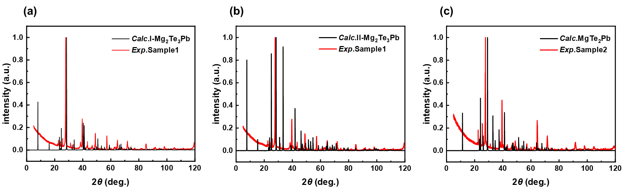
Figure S3 (a) XRD patterns of Sample 1 and I-Mg₂Te₃Pb; (b) XRD patterns of Sample 1 and II-Mg₂Te₃Pb; (c) XRD patterns of Sample 2 and MgTe₂Pb

Subsequently, we explore the fabrication of thin films of I-Mg₂Te₃Pb, II-Mg₂Te₃Pb, and MgTe₂Pb using magnetron sputtering. A stepwise approach is adopted: first, sputtering conditions for Mg and Te targets are determined to attempt the deposition of Mg₂Te₃ or MgTe₂ films; then, a Pb target is introduced for co-sputtering to obtain Mg₂PbTe₃ and MgTe₂Pb films. In the initial stage, single-crystal Si (100) is used as the substrate. The Mg and Te targets have a purity of 99.99%. The process is carried out at 25 °C with high-purity Ar as the working gas, an Ar flow rate of 50 sccm, and a N₂ flow rate of 20-50 sccm. The working pressure is maintained at 1 Pa, and the sputtering duration is 1 h. After deposition, the elemental composition of the films is analyzed by Energy Dispersive Spectroscopy (EDS, XFlash Detector 760, Bruker). The sputtering powers and corresponding elemental ratios are listed in Table S3. When the Mg: Te sputtering power ratio is set to 80:10, the film shows an atomic ratio of Mg: Te = 59.03:40.97. To approach the target stoichiometries (Mg: Te = 2:3 or 1:2), the sputtering power of the Te target is gradually increased. However, the Te content does not continue to rise with increasing power; instead, it drops abruptly when the composition approaches Mg: Te ≈ 1:1 (i.e., MgTe). More notably, within two minutes of exposure to air after removal from the chamber—on both single-crystal Si and polyimide (PI) substrates—the films exhibit decomposition and volatilization of MgTe, as shown in Figure S4, accompanied by a pungent odor. This observation is consistent with results from the melting synthesis of similar materials, further confirming the instability of MgTe in ambient air.

Table S3. Sputtering powers and elemental ratios of the samples.
Mg:Te sputtering power (W) | 80:10 | 80:15 | 80:20 | 80:30 | 80:40
Mg:Te elemental (%) | 59.03:40.97 | 94.09:5.91 | 87.59:12.41 | 68.44:31.56 | 70.15:29.85

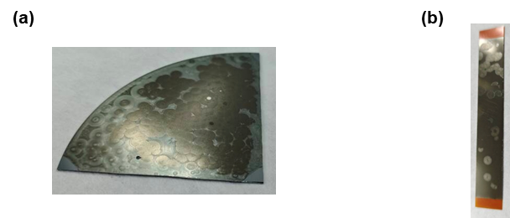
Figure S4. Decomposition and volatilization of MgTe observed on (a) single-crystal Si substrate and (b) polyimide (PI) substrate.

Finally, this work also attempts to synthesize the three target compounds using high-pressure methods. Elemental powders of Mg (99.5% purity), Te (99.99% purity), and Pb (99.95% purity) are weighed according to the target stoichiometries, thoroughly mixed, and then cold-pressed into cylindrical pellets in stainless steel dies. The pellets are encapsulated in molybdenum cups and assembled into high-pressure sample assemblies for synthesis. The synthesis is performed under the following conditions: pressure of 4 GPa; pressurization and decompression time of 10 min each; temperature of 1300 °C; heating time of 20 min; soaking time of 30 min; cooling time of 3 min; and pressure-holding duration of 60 min. After synthesis, two samples are obtained, and their elemental compositions at different positions are analyzed using Energy Dispersive Spectroscopy (EDS, XFlash Detector 760, Bruker). The results are listed in Table S4. The analysis shows that in Sample 1, the Mg and Te contents corresponding to the Mg₂Te₃Pb stoichiometry are systematically lower than expected across all measurement points. Similarly, in Sample 2, the Mg and Pb ratios corresponding to the MgTe₂Pb stoichiometry are also consistently lower than the target values. Further phase identification is carried out by powder X-ray diffraction (XRD, Bruker D8 Advance, Cu Kα), and the experimental patterns are compared with the theoretical XRD profiles of I-Mg₂Te₃Pb, II-Mg₂Te₃Pb, and MgTe₂Pb, as shown in Figure S5. The results indicate that, similar to those obtained by melt-based synthesis, both high-pressure samples are multiphase mixtures containing minor secondary phases, and single-phase, high-purity target compounds are not achieved.
Table S4. Elemental ratios of the two samples at different positions.
Experimental sample | Element | Mg | Te | Pb
Sample 1 | Position 1 | 0.2% | 36.3% | 49.4%
Sample 1 | Position 2 | 0.4% | 37.7% | 48.0%
Sample 2 | Position 1 | 11.0% | 59.4% | 5.2%
Sample 2 | Position 2 | 9.0% | 63.8% | 7.4%

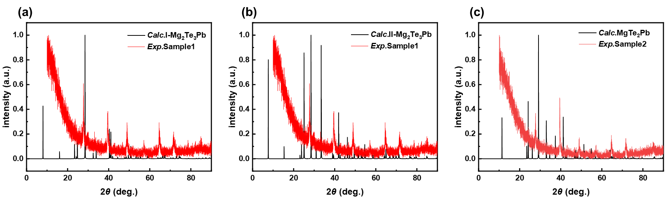
Figure S5. (a) XRD patterns of Sample 1 and I-Mg₂Te₃Pb; (b) XRD patterns of Sample 1 and II-Mg₂Te₃Pb; (c) XRD patterns of Sample 2 and MgTe₂Pb.

Electronic mail: guodonglee@whut.edu.cn

