Supplementary Information

Scalable Ultrathin Anodes via Band-Engineered Gradient Interlayers for Ultrafast All-Climate Aluminum Battery

Long Yao ^{1,2}, Manzhou Li ¹, Shunlong Ju ², Xiang-Long Huang ¹, Kunjie Zhu ¹, Shi-Xue Dou ^{1,3}*, Hua-Kun Liu ^{1,3}, Xuebin Yu ²*
1 Institute of Energy Materials Science, University of Shanghai for Science and Technology, Shanghai 200093, China
2 College of Smart Materials and Future Energy, Fudan University, Shanghai 200433, China
3 Institute for Superconducting & Electronic Materials (ISEM), Australian Institute of Innovative Materials, University of Wollongong, Wollongong, NSW, Australia.
* Corresponding author. E-mail: shi@uow.edu.au; yuxuebin@fudan.edu.cn

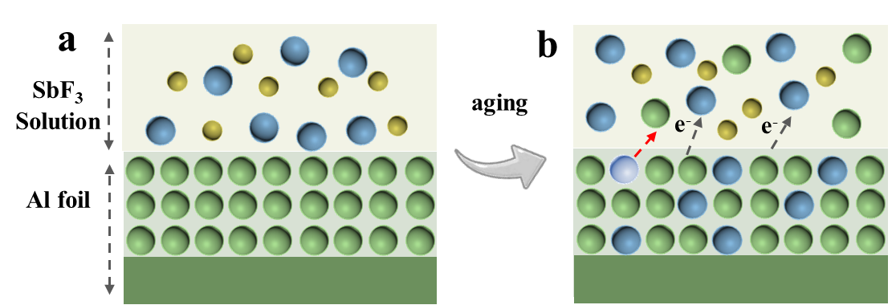

Supplementary Fig. 1 (a) Illustration of the initial state to observe the interface between Al foil and SbF₃ solution. (b) Once being immersed and aged, there will be electron exchange (shown by the gray arrow) and ion exchange (shown by the red arrow) on the surface of the Al foil.
The Al-ions would be replaced by Sb here and diffuse into the solution. Due to the low solubility of SbF₃, Al -ions will preferentially combine with fluoride ions and become fluoride precipitates in the outermost layer of the PGI-layer.



Supplementary Fig. 2 (a)-(d) The optical images of initial state of zinc foil, and the different samples after aging durations, that is, PGI-0, PGI-2, and PGI-10 samples, respectively. Aluminum substrates were aged in an antimony trifluoride (SbF₃) solution for varying durations (2 min, 5 min, and 10 min), with the resulting coated electrodes designated as PGI-2, PGI-5, and PGI-10, respectively. Macroscopic examination revealed that the surface color of the bare Al progressively darkened from bright silver to gray with increasing treatment time (Fig. S2).
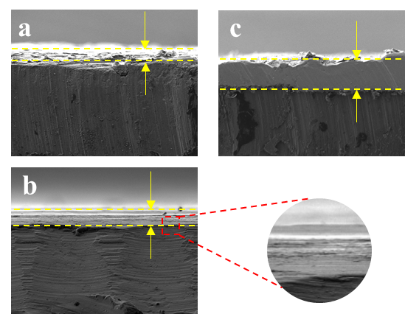

Supplementary Fig. 3 SEM images of GPE/Al-metal interface for in-situ-formed GFA-2 (a), GFA-5 (b), GFA-10 (c). Cross-sectional SEM analysis indicated that the thicknesses of the PGI-2, PGI-5, and PGI-10 coatings increased progressively, measuring approximately 8 μm, 15 μm, and 20 μm, respectively.

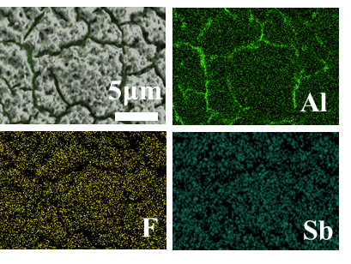

Supplementary Fig. 4 SEM and (d) corresponding elemental mapping image of PGI layer.

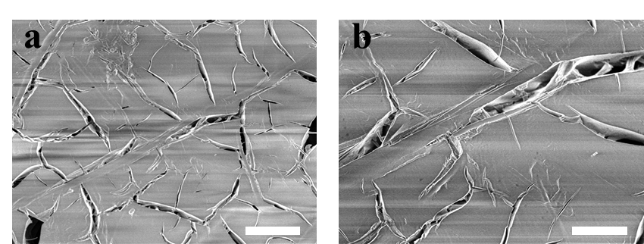

Supplementary Fig. 5 SEM images of Sb-coated Al. The scale bar is (a) 10 μm and (b) 5 μm.

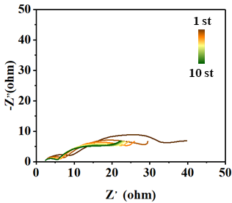

Supplementary Fig. 6 In situ impedance spectroscopy of Sb-Al electrode during the stripping and deposition processes in the first twenty cycles.

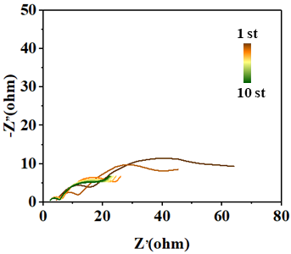

Supplementary Fig. 7 In situ impedance spectroscopy of PGE-Al electrode during the stripping and deposition processes in the first twenty cycles.

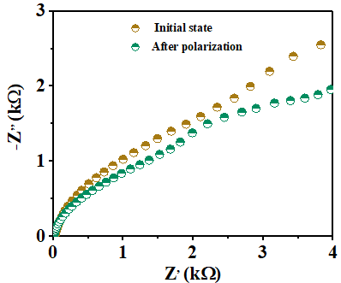

Supplementary Fig. 8 Impedance response of Sb-Al in symmetric cells before and after the potentiostatic hold.

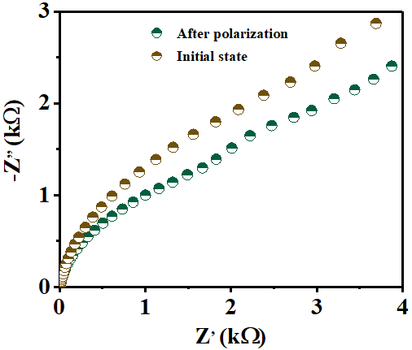

Supplementary Fig. 9 Impedance response of GFA-coated Al in symmetric cells before and after the potentiostatic hold.

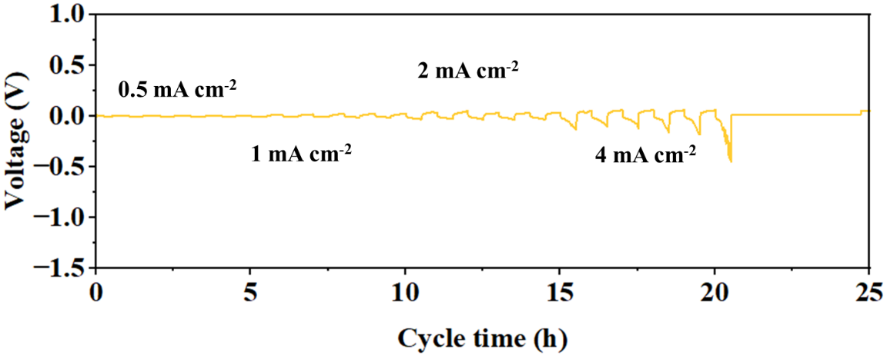

Supplementary Fig. 10 Galvanostatic charge and discharge curves of the Sb-Al symmetrical cells under the increasing current density.

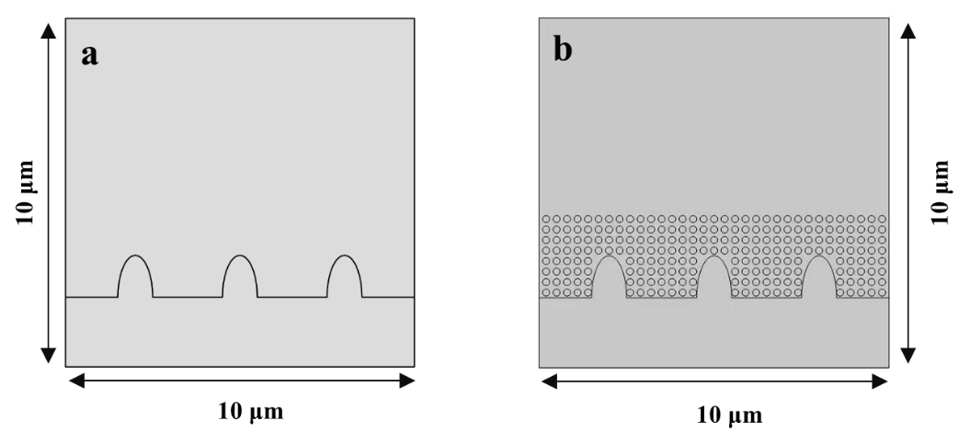

Supplementary Fig. 11 Models for (a) Sb- Al electrode, and (b) PGI-Al electrode.

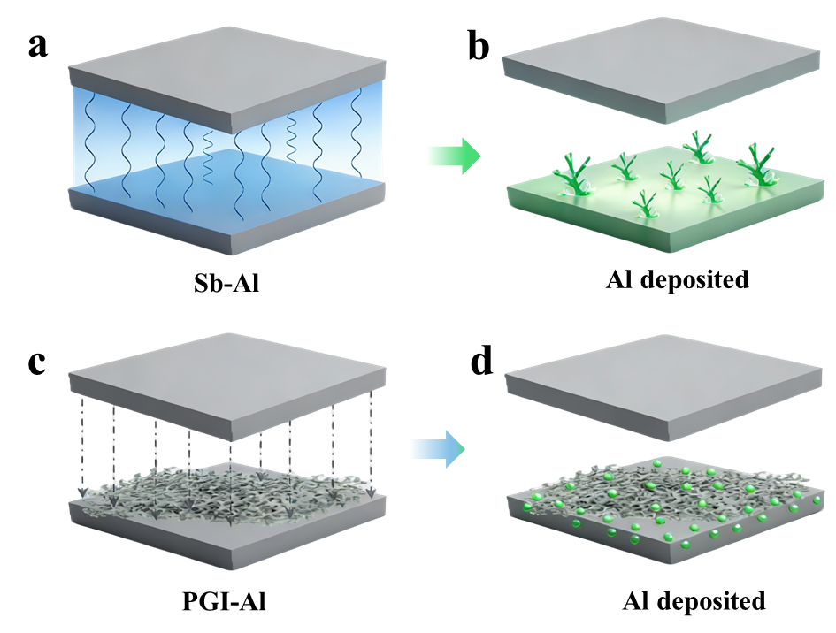

Supplementary Fig. 12 Distribution of the electric field and the different morphologies after Al deposition in Sb-Al and PGI-Al cells, respectively. (a) The electrical field is unevenly distributed by concentrating at microscopically uneven spots, resulting in the dendritic morphology after Al plating on Sb-Al (b). (c) homogenizing the distributions of electrical fields for PGI-Al electrode, and (d) the void-filling morphology as dendrite-free morphology after Al plating.

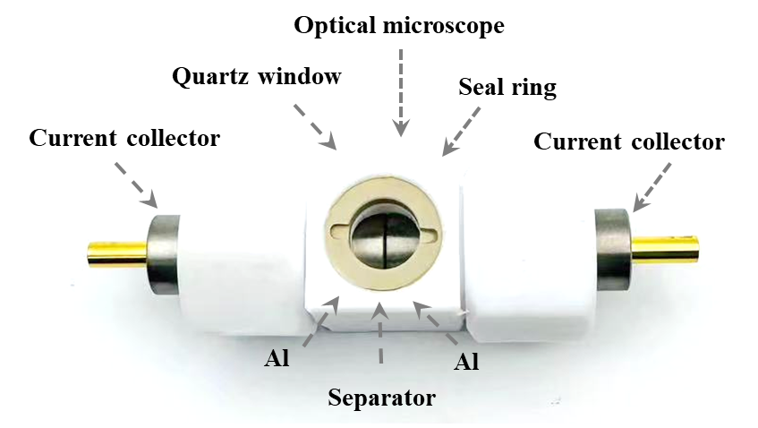

Supplementary Fig. 13 In situ optical observation device images of aluminum anodes in plating process.

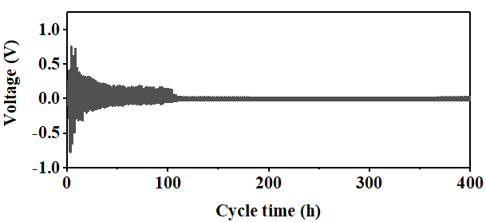

Supplementary Fig. 14 The cycling performance of PGI-2 coated Al at a current density of 10 mA cm⁻² and a plating capacity of 10 mA cm⁻².

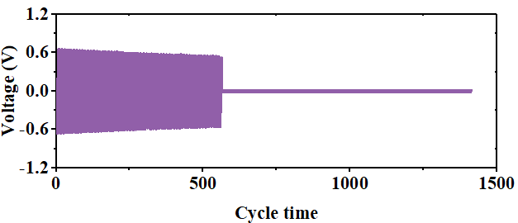

Supplementary Fig. 15 The cycling performance of PGI-10 coated Al at a current density of 10 mA cm⁻² and a plating capacity of 10 mA cm⁻².

Among the PGI-x series, PGI-5 demonstrates a more stable voltage profile, with a reduced voltage hysteresis of 45 mV throughout 5000 hours of operation. In contrast, PGI-2 also shows enhanced cycling stability and lower voltage hysteresis compared to bare Al. However, PGI-2 displays more pronounced voltage fluctuations after 660 hours (Supplementary Fig. 13), which can be attributed to its relatively thin PGI layer being less mechanically robust against volume changes during aluminum plating and stripping. Additionally, PGI-10 exhibits greater voltage variations and higher polarization, as illustrated in Supplementary Fig. 14. This is caused by the excessive thickness of its PGI coating, which hinders ion transport between the Al metal and the electrolyte. Together, these findings highlight PGI-5 as the optimal protective layer among the series. Unless otherwise specified, the term “PGI” in the text refer to “PGI-5”.
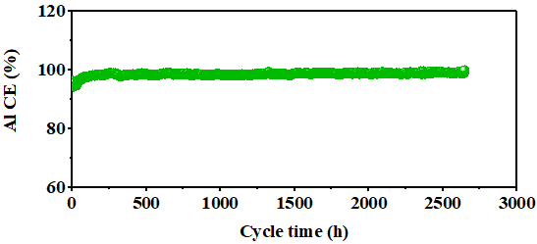

Supplementary Fig. 16 Coulombic efficiency profiles of PGI-Al asymmetric cells under a 3 mAh cm^{–2} capacity at a current density of 3 mA cm^{–2}.

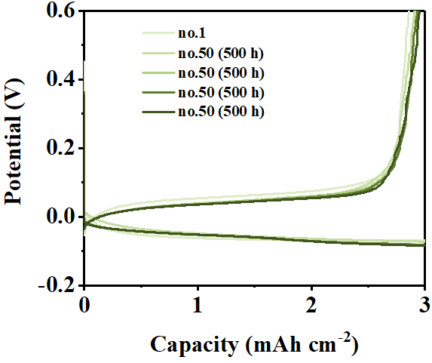

Supplementary Fig. 17 Voltage profiles of PGI-Al measured during Al plating/stripping at an areal capacity of 3 mAh cm^{–2} at a current density of 3 mA cm^{–2}.

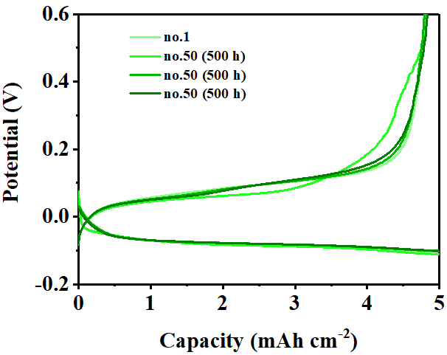

Supplementary Fig. 18 Voltage profiles measured during Al plating/stripping at an areal capacity of 5 mAh cm^{–2} at a current density of 5 mA cm^{–2}.

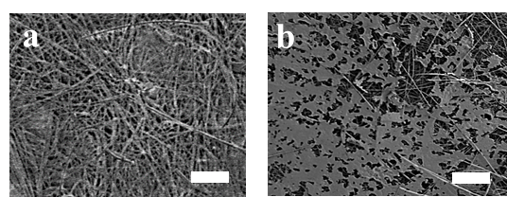

Supplementary Fig. 19 SEM of Al growth in the presence of glass fiber separator when PGI-Al is used as anode. Deposition capacity: 5 mAh cm². Scale bars:50 μm.. SEM of Al growth in the presence of glass fiber separator when Sb-Al is used as anode. Deposition capacity: 5 mAh cm². Scale bars:50 μm.

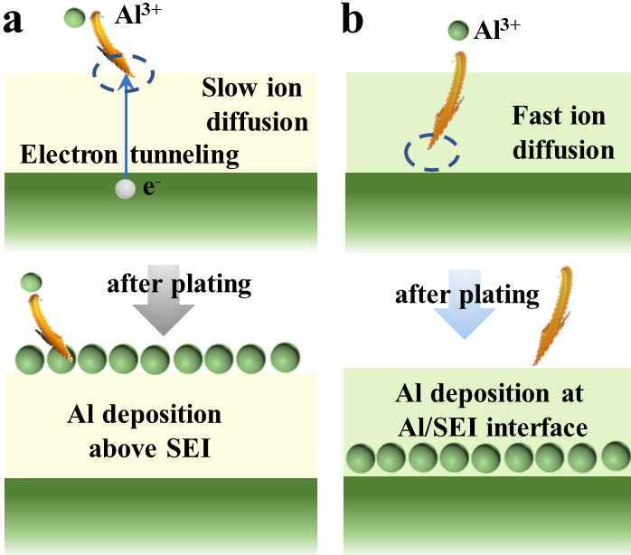

Supplementary Fig. 20 (a) Sb-based narrow-band interface and (b) Sb-AlF₃ wide-band interface exhibit substantial differences in the modulation of ion/electron transport pathways and the sites for aluminum nucleation.

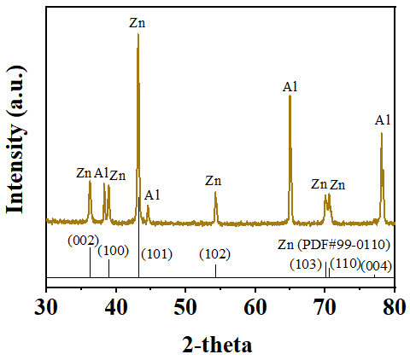
Supplementary Fig. 21 XRD pattern of PGI-Zn coated Al.

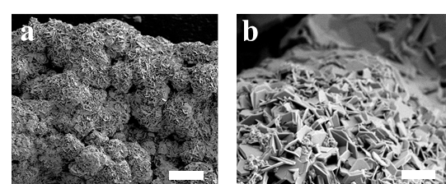

Supplementary Fig. 22 SEM images of PGI-Zn coated Al. The scale bar is (a) 100 μm and (b)10 μm.

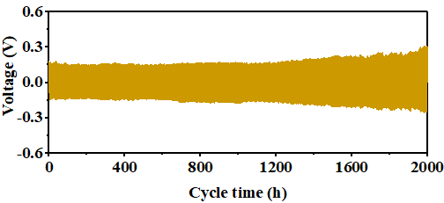

Supplementary Fig. 23 The cycling performance of PGI-Zn coated Al at a current density of 10 mA cm⁻² and a plating capacity of 10 mA cm⁻².

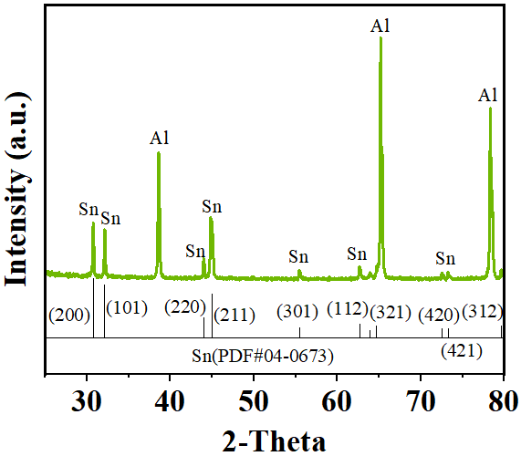

Supplementary Fig. 24 XRD pattern of PGI-Sn coated Al.

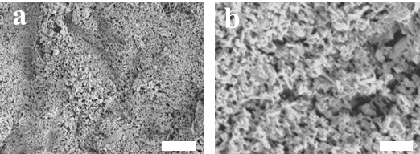

Supplementary Fig. 25 SEM images of PGI-Sn coated Al. The scale bar is (a) 100 μm and (b)10 μm.

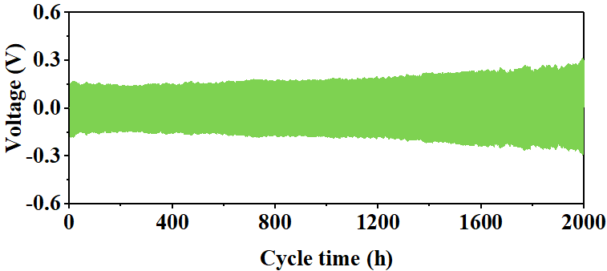

Supplementary Fig. 26 The cycling performance of PGI-Sn coated Al at a current density of 10 mA cm⁻² and a plating capacity of 10 mA cm⁻².

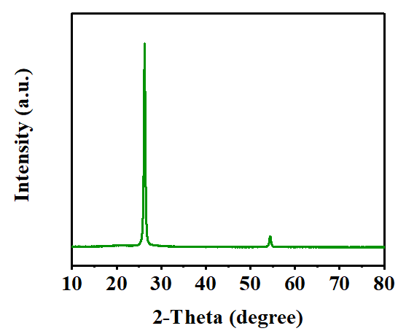

Supplementary Fig. 27 XRD results of three-dimensional graphite

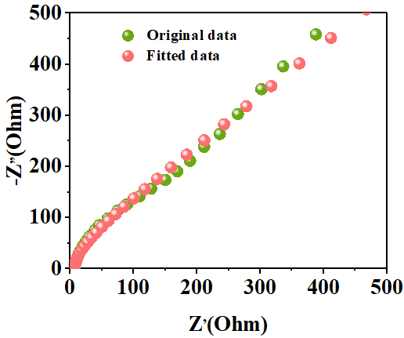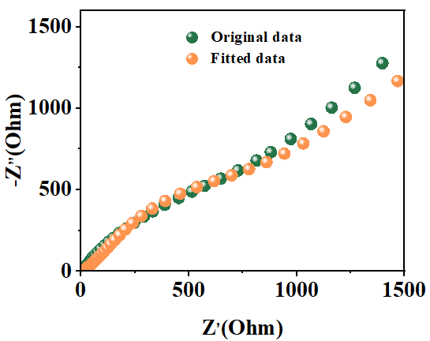

Supplementary Fig. 28 Nyquist plots of Al-graphite full cells using Sb-Al as anode. Nyquist plots of Al-graphite full cells using PGI-Zn as anode.

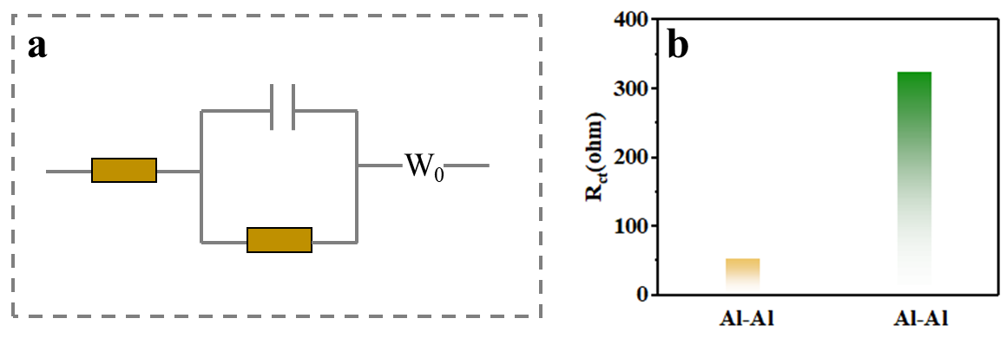

Supplementary Fig. 29 (a) Equivalent circuit model of Al||graphite full cells. (b) Rct of PGI coating Al||graphite battery and Sb-coated Al||graphite battery.

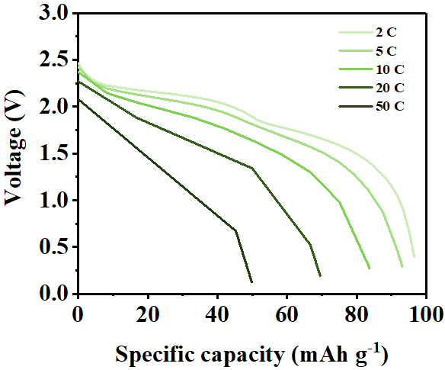

Supplementary Fig. 30 Galvanostatic discharge/charge curve of PGI-Al||graphite battery at 2 C to 50 C under 25℃.

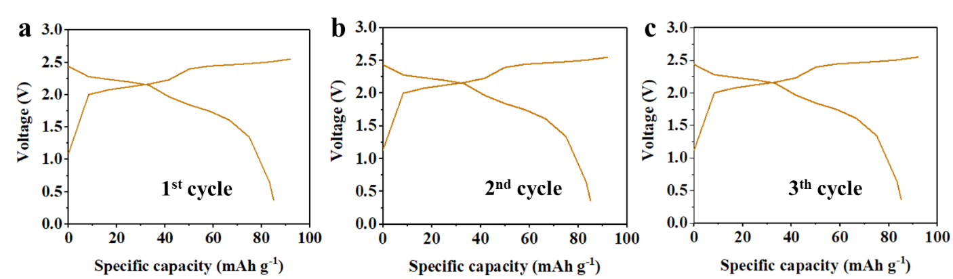

Supplementary Fig. 31 Galvanostatic discharge/charge curve of PGI-Al||graphite battery at 10 C under 25℃.

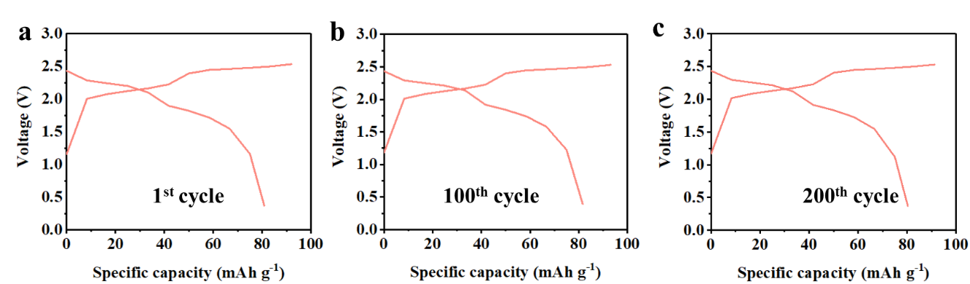

Supplementary Fig. 32 Galvanostatic discharge/charge curve of PGI-Al||graphite battery at 20 C under 80℃.

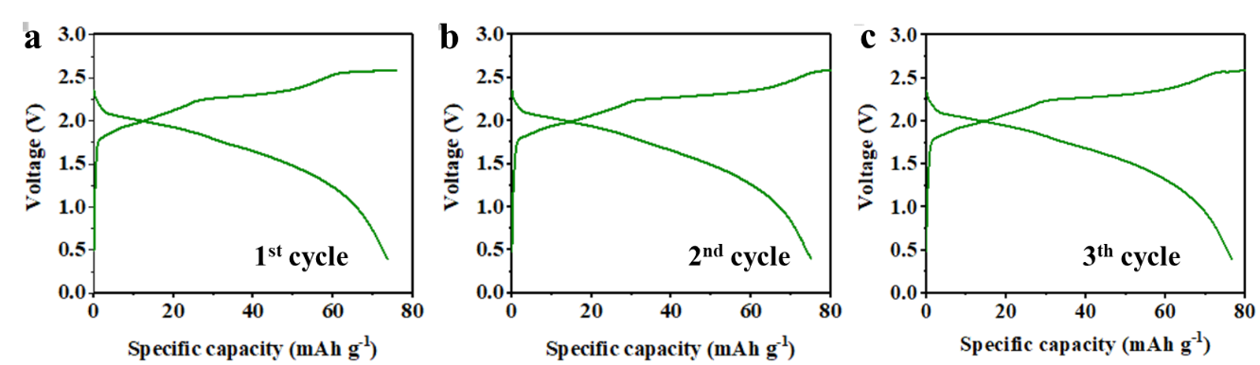

Supplementary Fig. 33 Galvanostatic discharge/charge curve of PGI-Al||graphite battery at 0.2 C under -20℃.

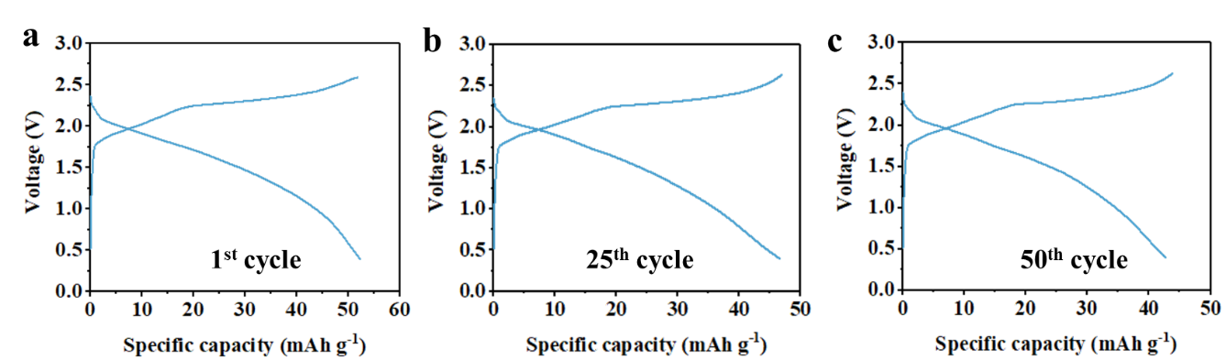

Supplementary Fig. 34 Galvanostatic discharge/ charge curve of PGI-Al||graphite battery at 0.2 C under -30℃.

Table S1. Comparison of electrochemical performance of 3D porous gradient interlayer with some previously reported Al metal anodes in non-aqueous electrolyte.
Optimization Strategy | Composition | Current density  (mA cm⁻²) | Areal capacity  (mAh cm⁻²) | Cycle Time  (h) | Ref.
Electrolyte Optimization | AlCl₃/DPE | 0.1 | 0.2 | 2000 | 1
Electrolyte Optimization | AlCl₃/acetamide | 0.1 | 0.1 | 225 | 2
Electrolyte Optimization | 1,2-difluorobenzene additive | 0.054 | 0.27 | 1000 | 3
Electrolyte Optimization | CTAC additive | 3 | 1 | 1200 | 4
Electrolyte Optimization | Molten salt | 2 | 2 | 500 | 5
Electrolyte Optimization | Fluorobenzene additive | 8 | 8 | 7600 | 6
Multifunctional Host | (111) Al | 1 | 5 | 2000 | 7
Multifunctional Host | Carbon cloth | 1.6 | 8 | 3600 | 8
Multifunctional Host | SA-Co/NPCS | 1 | 2 | 5000 | 9
Separator Design | Cellulose | 0.5 | 1 | 800 | 10
SEI Protective Layer | MXene | 2 | 12 | 5000 | 11
SEI Protective Layer | Bi | 10 | 10 | 550 | 12
SEI Protective Layer | Diatomite | 3 | 1 | 2000 | 13
SEI Protective Layer | PDMS | 5 | 5 | 2800 | 14
SEI Protective Layer | MOF-C | 1 | 1 | 11000 | 15
SEI Protective Layer | 3D Porous Gradient Interlayer | 10 | 10 | 5000 | This work

Reference
- B. Zhang, Z. Li, D. Han, Z. Min, C. Cui, L. Wang, Q. Li, X. Mao, Y. Sun, Z. Weng, Q. H. Yang. Non-corrosive organodichloro electrolyte for reversible aluminium metal batteries. Nat. Sustain.2025, 10.1038/s41893-025-01706-6.
- W. Chu, X. Zhang, S. Zhao, M. Tang, S. Li, S. Liu, H. Yu. High-Voltage Deep Eutectic Solvent Electrolyte with Fluorine-Substituted Acetamide Additive for Aluminum-ion Battery. Adv. Funct. Mater. 2024, 34, 2305194.
- C. Xu, T. Diemant, A. Mariani, M. E. D. Pietro, A. Mele, X. Liu, S. Passerini. Locally Concentrated Ionic Liquid Electrolytes for Wide-Temperature-Range Aluminum-Sulfur Batteries. Angew. Chem. 2024, 136, e202318204.
- Y. Xie, X. Du, Y. Meng, Y. Liu, S. Wang, W. You, M. Liu, Y. Guo, Z. Liang, D. Li. Dynamic molecular adsorption interface strategy for stable aluminum batteries. Energy Storage Mater. 2024,70,103545.
- J. Meng, X. Hong, Z. Xiao, L. Xu, L. Zhu, Y. Jia, F. Liu, L. Mai, Q. Pang. Rapid-charging aluminium-sulfur batteries operated at 85 °C with a quaternary molten salt electrolyte. Nat. Commun. 2024, 15, 596.
- J. Guo, S. Gu, W. Nie, B. Long, S. Ryazantsev, S. Malyshev, J. Li, S. Guo, C. Wu. Mixed Electrolyte Enabling Ultrafast Mass Transport and Compatibility with Polypropylene Separator for Stable and Low-Cost Aluminum Ion Battery. Adv. Mater. 2025, 37, 2419865.
- S. Wang, Y. Guo, X. Du, L. Xiong, Z. Liang, M. Ma, Y. Xie, W. You, Y. Meng, Y. Liu, M. Liu. Preferred crystal plane electrodeposition of aluminum anode with high lattice-matching for long-life aluminum batteries. Nat. Commun. 2024, 15, 6476.
- J. Zheng, D. C. Bock, T. Tang, Q. Zhao, J. Yin, K. R. Tallman, G. Wheeler, X. Liu, Y. Deng, S. Jin, A. C. Marschilok, E. S. Takeuchi, K. J. Takeuchi, L. A. Archer. Regulating electrodeposition morphology in high-capacity aluminium and zinc battery anodes using interfacial metal–substrate bonding. Nat. Energy 2021, 6, 398-406.
- L. Yao, S. Ju, G. Xia, D. Sun, X. Yu. Dynamic Al−O Interactions Enable Uniform Al Deposition toward High Energy-Density and Practical Al Metal Batteries. ACS Energy Lett. 2024, 9, 253−261.
- Y. Liu, Y. Xie, X. Wang, L. Xiong, D. Li, S. Wang, X. Li, W. You, L. Cheng, L. Li, A. zheng. Anti-dissolving cellulose-based separator for dendrite-free rechargeable aluminum batteries. Nano Energy 2024,130, 110140.
- L. Yao, S. Ju, T. Xu, W. Wang, X. Yu. MXene-Based Mixed Conductor Interphase for Dendrite-Free Flexible Al Organic Battery. ACS Nano 2023, 17, 25027−25036.
- Y. Zhu, S. Ju, L. Yao, G. Xia, X. Yu. A Bismuth Surface Layer Enables Uniform Aluminum Electrodeposition for Reversible Aluminum Metal Anodes. Small 2025, e09150.
- S. Hu, D. Yan, M. Fan, Z. Qiu, R. Ma, S. Yi, Y. Zeng, T. Yang, K. Luo, Q. Liu, Y. Xia. Interface Engineering of Spatial Confinement-Induced Ion-Channel for Stabilizing Rechargeable Aluminum Batteries. Adv. Funct. Mater. 2025, e21397.
- S. Gu, W. Nie, Q. Meng, X. Chen, J. Zhang, Y. Cao, W. Lv. Stabilizing the aluminum metal anode through polymer coating-enabled regulation of exchange current. Energy Environ. Sci., 2025,18, 1477-1488.
- B. Long, Fe. Wu, Y. Li, H. Wang, W. Liu, Y. Li, Q. Li, Q. Zhou, Y. Bai, C. Wu. Decoding interfacial evolution of aluminum anode and constructing multifunctional layers toward ultra-Long cycle stability. J. Am. Chem. Soc. 2026, 148, 9, 9990–10001.

