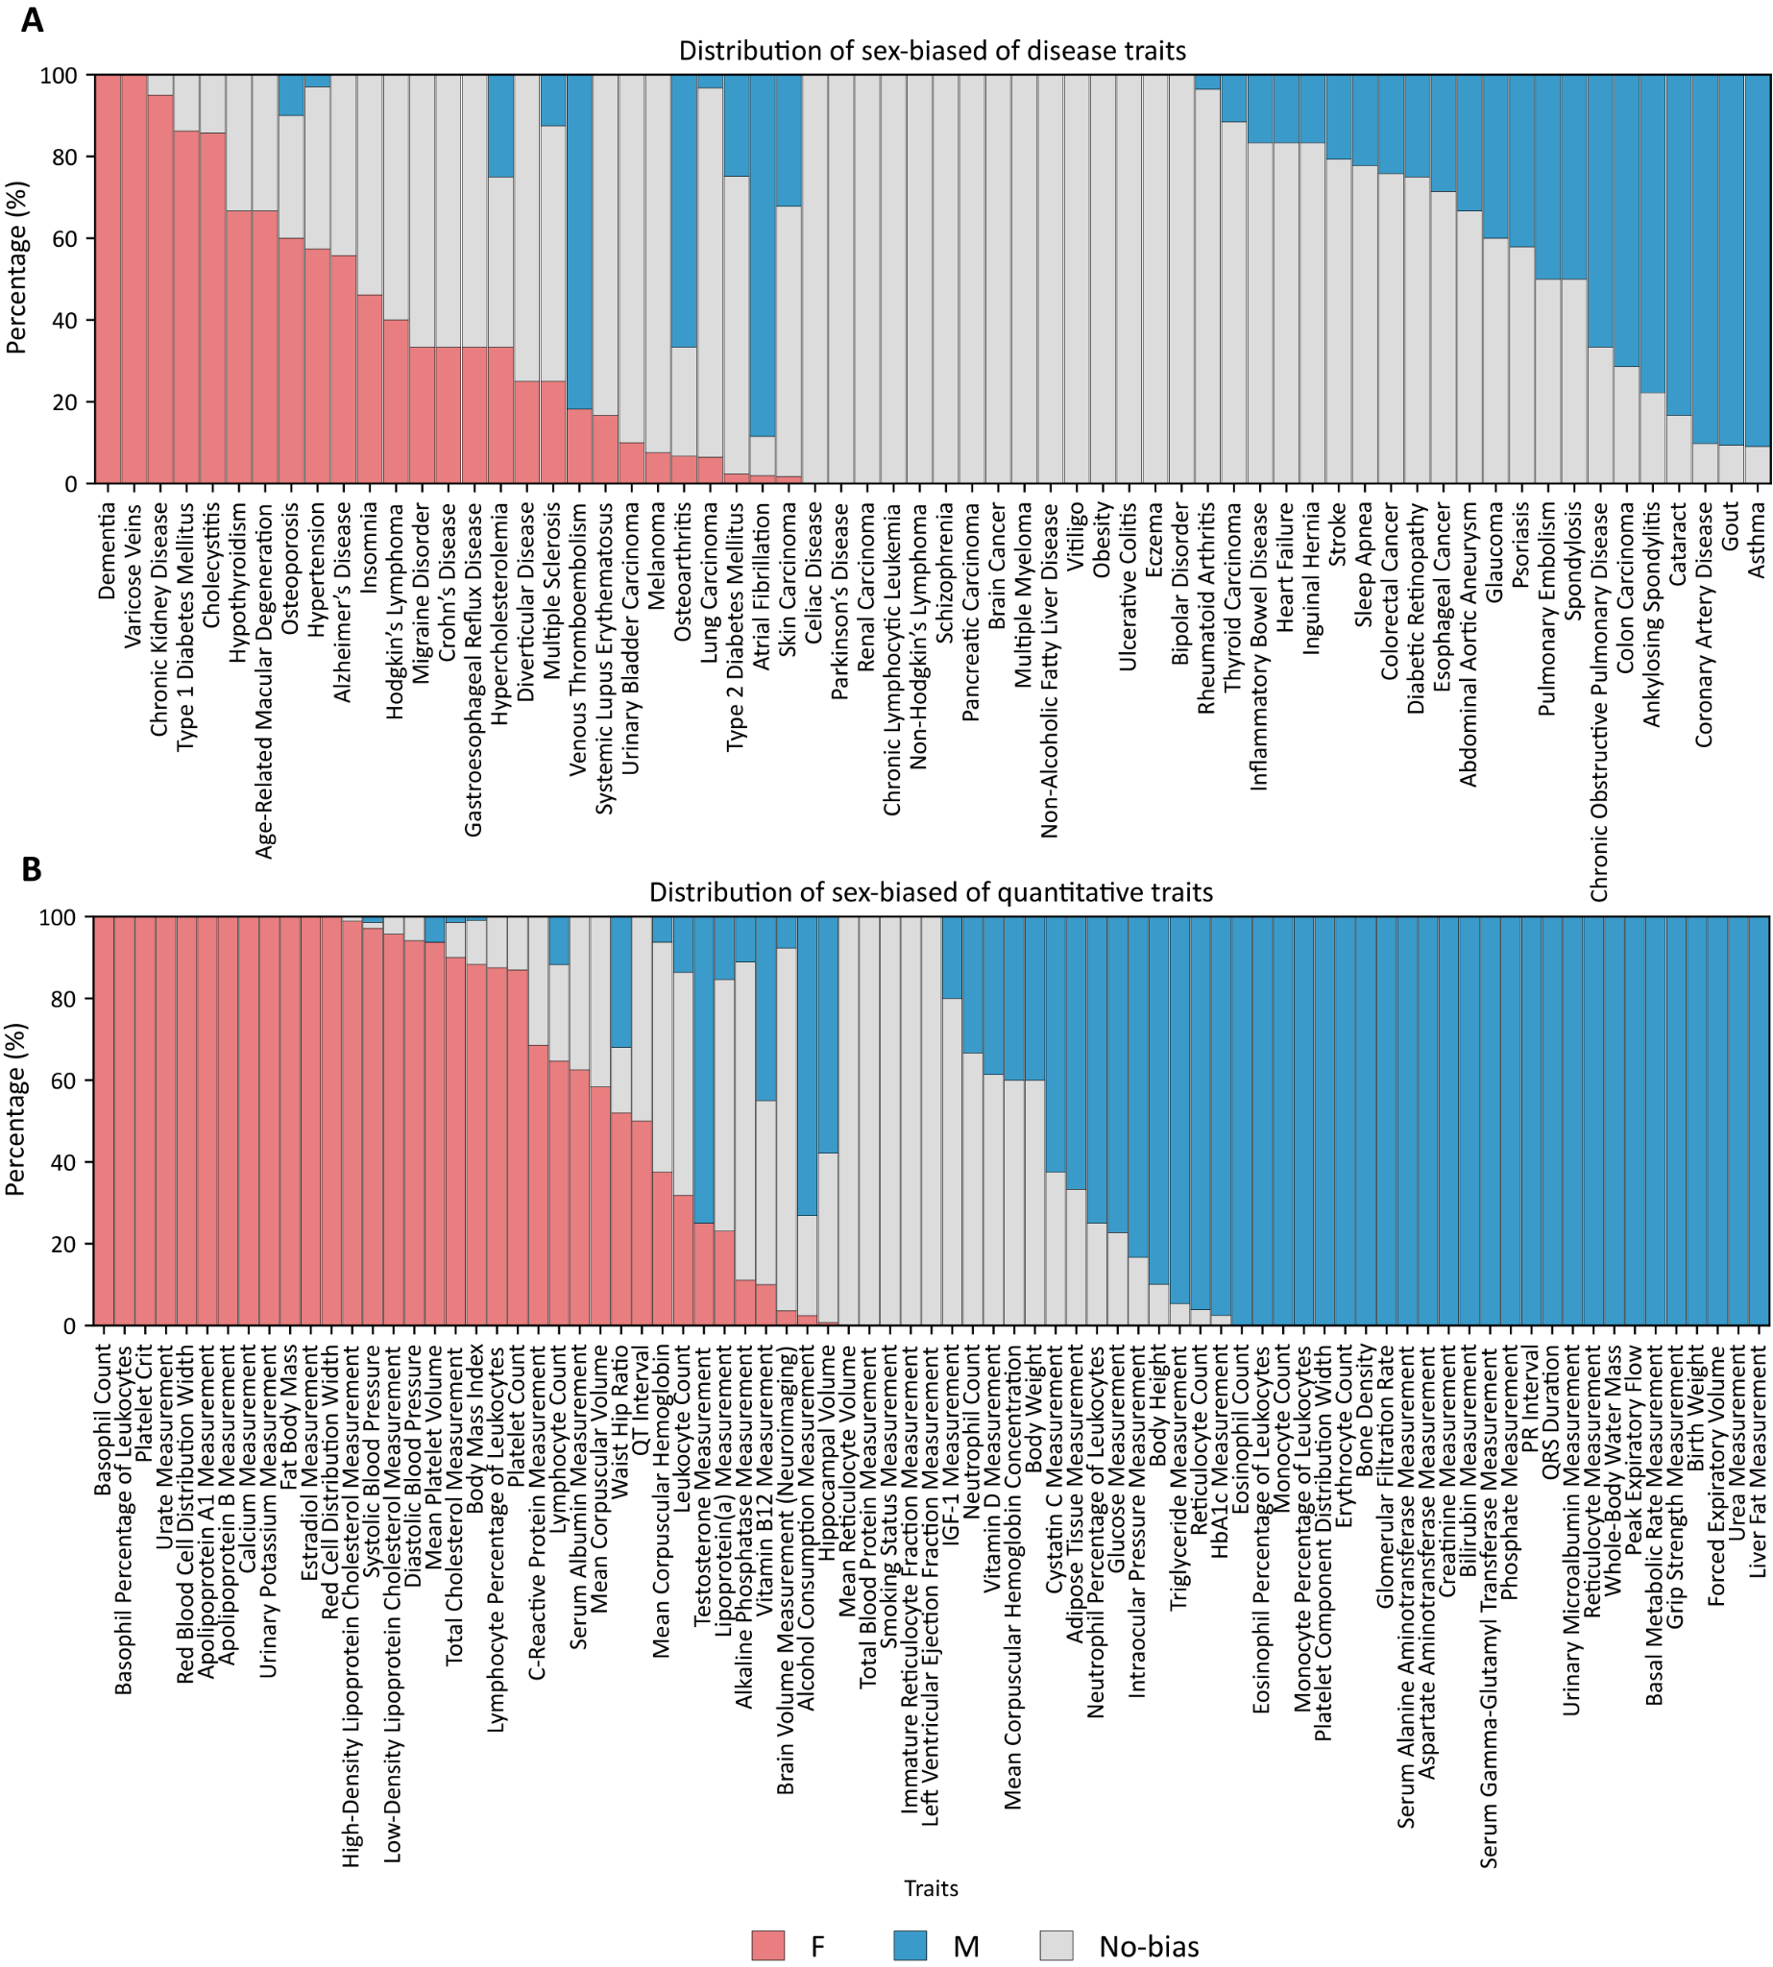

Supplementary Figure 1. Distribution of Sex Bias in Predictive Performance Across All Polygenic Scores in the PGS Catalog
Stacked bars summarize the proportion of polygenic scores (PRSs) showing significant sex bias in predictive performance for each trait in the PGS Catalog when applied to the UK Biobank cohort (N = 409,440; European ancestry). The upper panel displays disease traits and the lower panel quantitative traits, with bars colored by bias direction (female-biased = red; male-biased = blue; no bias = gray). Sex differences were assessed using a 2-sided Z test comparing sex-stratified regression coefficients, with FDR < 0.05 considered significant. Each bar represents one phenotype, ordered from predominantly female-biased to predominantly male-biased. PRS values were standardized to a mean of 0 and a standard deviation of 1; regression covariates included age, sex, genotyping array and top 10 genetic principal component.

