Supplementary material
C₃N₄/C₃N₅ homojunction induced peroxymonsulfate activation for efficient oxidation of sulfamethoxazole

Chi Zhou^{a1}, Xuwei Deng^{b1}, Hanmei Zhao^{c}, Hongyan Song^{d}, Dongqin Wang^{e}, Laiyan Wu^{d*}
a Hubei Water Resources Research Institute, Hubei Water Resources and Hydropower Science and Technology Promotion Center Wuhan, 430070, China
b Institute of Hydrobiology, Chinese Academy of Sciences, Wuhan, 430072, China
c HuBei Water Conservancy Technical College, Wuhan, 430072, China
d College of Resources and Environmental Science, South-Central Minzu University, Wuhan 430074, China
e Wuhan Second Ship Design and Research Institute, Wuhan China 430205
*Corresponding author: wulaiyan@scuec.edu.cn

1. Characterization. The Fourier transform infrared (FTIR) spectra were measured on a NEXUIS-470 infrared spectrometer with a wavenumber range of 400–4000 cm⁻¹. The crystal structure (XRD) of the samples were recorded on a Bruker D8 Advance diffractometer with Cu Kα radiation (1.54178 Å) in the 2θ range of 10–80° at a scan rate of 0.02° min⁻¹. The X-ray photoelectron spectra (XPS) were performed on a PerkinElmer PHI-5000C spectrometer with a monochromic Al Kα X-ray source (1486.7 eV), calibrated using the adventitious C 1s peak at 284.8 eV. The Brunauer-Emmett-Teller (BET) surface area were determined via N₂ adsorption-desorption isotherms on a surface area and porosimetry system (JW-BK132F) at 77 K. The UV–vis diffuse reflection spectra (DRS) were measured on a Shimadzu UV-3600 spectrometer with BaSO₄ as reference. The photoluminescence (PL) spectra recorded on a Hitachi F-7000 fluorescence spectrophotometer with an excitation wavelength of 365 nm. The Electrochemical impedance spectroscopy (EIS, 1.6 V), Transient photocurrent response (TPR), linear scanning voltammetry (LSV) curves and Mott-Schottky curves were conducted on a CHI760e workstation (Chenhua Instruments, China) using a three-electrode system (working electrode: catalyst-coated FTO glass; counter electrode: Pt wire; reference electrode: Ag/AgCl). The electrolyte was 0.1 M Na₂SO₄ (pH = 5.95). Electron paramagnetic resonance (EPR) signals were measured at ambient temperature on a Bruker ESR A300 spectrometer using DMPO (for ${SO}_{4}∙^{-}, ∙OH$, $∙O_{2}^{-}$) and TEMP (for ¹O₂ ) as spin traps.

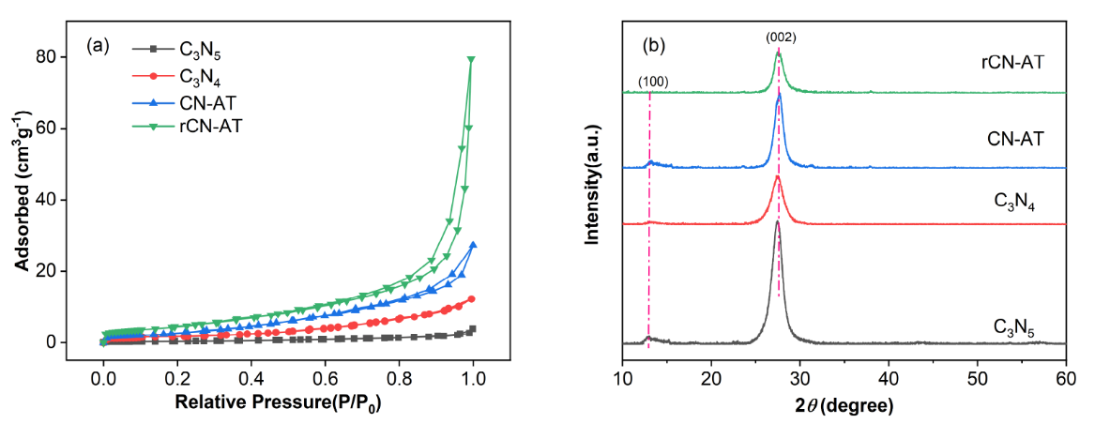
Fig. S1 nitrogen adsorption-desorption curves (a) and XRD pattern (b) of the as-prepared catalysts.

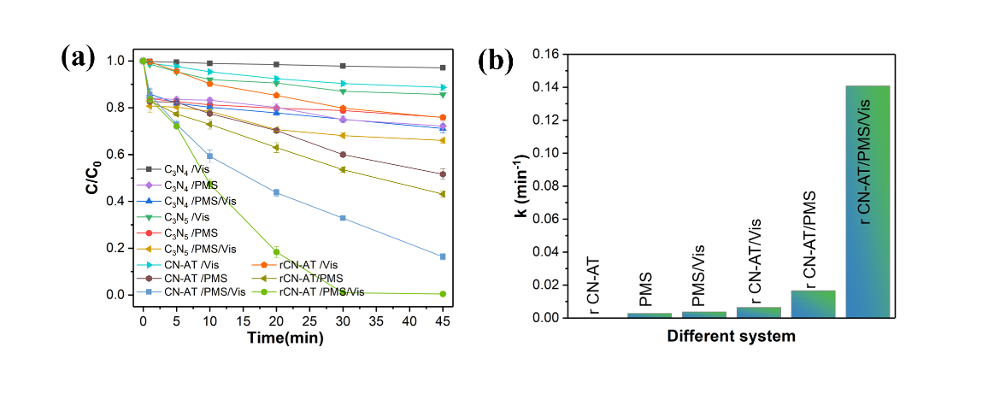
Fig. S2 Degradation curves of sulfamethoxazole in the presence of different photocatalyst (a) and comparison of the corresponding rate constants (b)

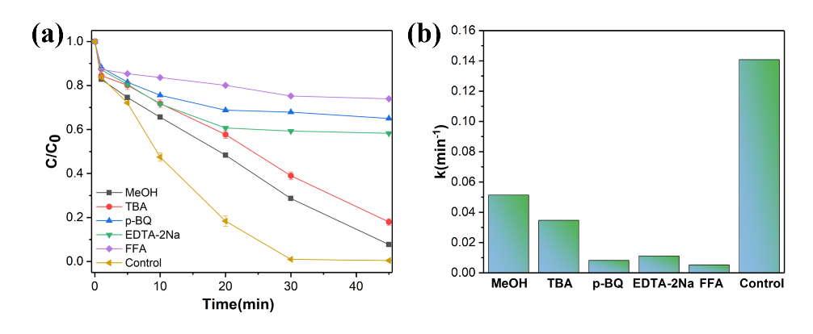
Fig. S3 Effect of quenchers on SMX degradation in rCN-AT/PMS/Vis system.

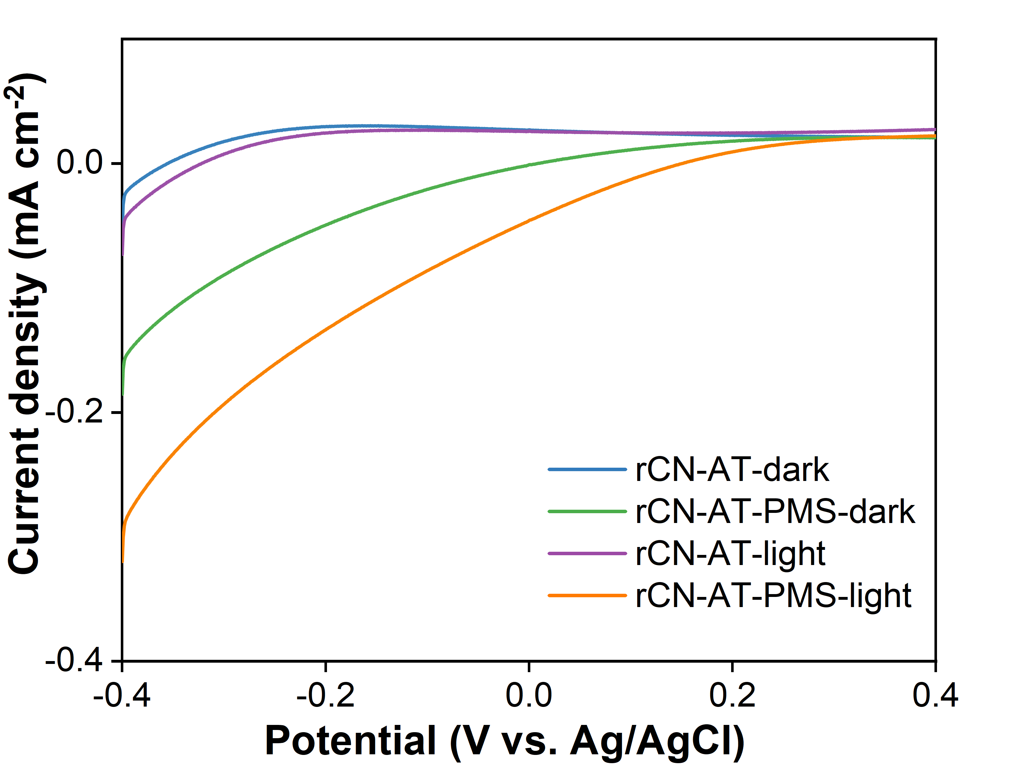
Fig.S4 LSV curve of rCN-AT with or without visible light irradiation and PMS

