Supplementary Information for

Winter sediment resuspension in a submarine canyon drives the offshore export of toxigenic Alexandrium catenella cysts

Authors: Florian Jacques^{1,2,*}, Audrey Limoges^{3,*}, Michel Gosselin¹, André Rochon ^{1,2}, El Mahdi Bendif¹, Jean-Carlos Montero-Serrano^{1,2}, Alexandre Normandeau⁴, Guillaume St-Onge^{1,2}, Urs Neumeier¹, Catherine Lalande⁵, Charles Logan Tilney⁶, Aouregan Terre-Terrillon⁷, Kenneth Neil Mertens⁷

Affiliations:
¹ Institut des sciences de la mer (ISMER), Université du Québec à Rimouski (UQAR), Québec-Océan, 310 allée des Ursulines, Rimouski, QC, Canada, G5L 3A1.
² Geotop Research Center, 201 Av. du Président-Kennedy, Montréal, QC, Canada, H2X 3Y7.
³ Department of Earth Sciences, University of New Brunswick, 15 Dineen Dr, Fredericton, NB, Canada, E3B 5A3.
⁴ Geological Survey of Canada (Atlantic), 1 Challenger Dr, Dartmouth, NS, Canada, B3B 1A6.
⁵ Division of Ocean and Atmosphere Sciences, Korea Polar Research Institute, 26 Songdomirae-ro, Yeonsu-gu, Incheon, Republic of Korea, 21990.
⁶ Maurice Lamontagne Institute, Fisheries and Oceans Canada (DFO), 850 Route de la Mer, Mont-Joli, Québec, Canada, G5H 3Z4.
⁷ Ifremer, COAST, Place de la Croix – BP 40537 Cedex, Concarneau, France, 29185

*Corresponding authors at: florian.jacques@uqar.ca (F. Jacques) and alimoges@unb.ca (A. Limoges).

Supplementary Note 1
Regional setting
Surface circulation in the LSLE and the GSL is predominantly west-to-east (Supplementary Fig.1). In the LSLE, the main current is the Gaspé Current, a jet formed by the outflow of the St. Lawrence and Saguenay Rivers, which flows along the southern shore. In the GSL, east of PDM, the Anticosti Gyre dominates the circulation¹. West of PDM, two additional eddies form seasonally: one between PDM and Rimouski, and another between PDM and Baie-Comeau, largely in response to variable discharges from the St. Lawrence, the Saguenay, and the Manicouagan rivers, particularly in early summer² (Supplementary Fig.1). At the convergence zone of the Anticosti and LSLE gyres, a transverse current forms between PDM and the southern shore^{3,4}.
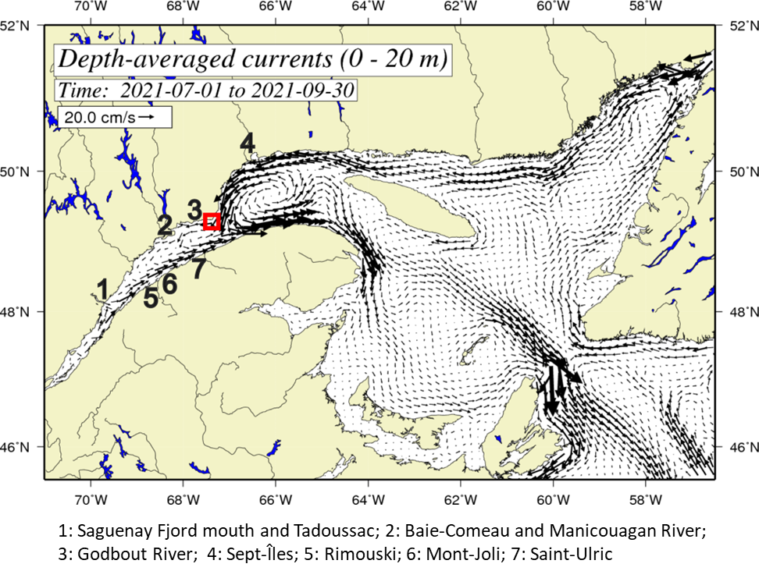
Supplementary Fig. 1: Mean surface currents in the LSLE and the GSL from 1 July to 30 September 2021 (adapted with permission from Galbraith et al.⁵).

In summer, the LSLE is typically stratified into three main water masses (Fig. 9): a surface layer (0 – 50 m, salinity ≈ 25 psu, temperature: 2–10 °C), a cold intermediate layer (50–150 m, salinity ≈ 32 psu, temperature: -1 to 2 °C), and a bottom layer (150 – bottom, salinity ≈ 33–35 psu, temperature: 2–6 °C)^{6–8}. In winter, the sea-ice period, which spans, on average, 2–3 months from mid-January to mid-April⁹, alters water column structure, typically reducing it to a two-layer system with an upper and a bottom layer¹⁰. However, sea-ice extent and duration have varied considerably in the last decade^{5,9,11}.
The dominant physiographic characteristic of the LSLE is its U-shaped Laurentian Channel¹², a glacially incised valley formed during the Quaternary (e.g., ^{13,14}). This channel connects to the coast via lateral flanks and submarine channels^{15–17}.
At PDM, hydrodynamics and seafloor morphology promote upwelling¹⁸. In addition, internal waves are consistently observed during nearly every tidal cycle, impacting the seafloor at ~180 m depth, as shown by a year-long dataset¹⁹. These interactions can resuspend fine sediments^{20,21}. The PDM region also features salinity fronts and water inflows. A cold salinity front, driven by differences in salinity between waters of the GSL and the LSLE, spreads southward from PDM (e.g., ³). Furthermore, inflow from the GSL can penetrate through PDM following extratropical storm events, which may trigger the seasonal shift from the winter-spring to summer-autumn circulation regime²².
Supplementary Table 1: Information on surface sediment samples collected with a Van Veen grab (VV) or a box corer (BC). Each sample was assigned a number to facilitate the comparison of samples with similar original names. Locations are shown in Fig. 2.

Expedition | Name | Sample  number  (this paper) | Water depth (m) | Sampling date | Coordinates
COR2001 | COR2001-03VV | 3 | 177 | 9 July, 2020 | 49°18'15.84"N  67°23'25.08"W
COR2001 | COR2001-04VV | 11 | 254 | 9 July, 2020 | 49°17'38.40"N 67°22'36.84"W
COR2001 | COR2001-05VV | 15 | 291 | 9 July, 2020 | 49°17'7.80"N 67°22'6.24"W
COR2001 | COR2001-06VV | 16 | 291 | 9 July, 2020 | 49°17'6.72"N 67°22'9.48"W
COR2001 | COR2001-07VV | 19 | 278 | 9 July, 2020 | 49°17'7.08"N 67°22'47.28"W
COR2001 | COR2001-08VV | 4 | 142 | 11 July, 2020 | 49°18'36.36"N 67°25'33.96"W
COR2001 | COR2001-08BC | 14 | 290 | 9 July, 2020 | 49°17'8.52"N  67°22'10.20"W
COR2001 | COR2001-09BC | 12 | 266 | 10 July, 2020 | 49°17'25.44"N  67°22'54.48"W
COR2001 | COR2001-10BC | 18 | 277 | 10 July, 2020 | 49°17'4.92"N  67°22'46.56"W
COR2001 | COR2001-11BC | 22 | 291 | 10 July, 2020 | 49°17'2.76"N 67°23'17.88"W
COR2001 | COR2001-12BC | 9 | 263 | 10 July, 2020 | 49°17'34.08"N 67°23'33.72"W
COR2001 | COR2001-13BC | 2 | 152 | 10 July, 2020 | 49°18'24.84"N  67°23'47.40"W
COR2001 | COR2001-14BC | 6 | 175 | 11 July, 2020 | 49°18'13.68"N 67°24'50.40"W
COR2001 | COR2001-15BC | 8 | 215 | 11 July, 2020 | 49°17'47.76"N 67°24'45.00"W
COR2001 | COR2001-16BC | 25 | 295 | 11 July, 2020 | 49°16'40.80"N 67°24'35.64"W
COR2001 | COR2001-17BC | 7 | 218 | 11 July, 2020 | 49°17'42.36"N 67°25'35.76"W
COR2001 | COR2001-18BC | 5 | 170 | 11 July, 2020 | 49°18'15.48"N 67°25'24.24"W
COR2001 | COR2001-19BC | 24 | 200 | 11 July, 2020 | 49°17'3.12"N 67°25'20.64"W
COR2212 | COR2212-01BC | 1 | 159 | 9 October, 2022 | 49°18'36.47"N  67°23'43.30"W
COR2212 | COR2212-03BC | 10 | 251 | 9 October, 2022 | 49°17'46.41"N 67°22'56.56"W
COR2212 | COR2212-04BC | 13 | 266 | 10 October, 2022 | 49°17'25.12"N  67°22'47.56"W
COR2212 | COR2212-05BC | 20 | 280 | 10 October, 2022 | 49°17'5.24"N  67°22'52.48"W
COR2212 | COR2212-06BC | 17 | 282 | 10 October, 2022 | 49°17'1.40"N 67°22'8.08"W
COR2212 | COR2212-07BC | 21 | 284 | 10 October, 2022 | 49°17'0.36"N 67°22'49.12"W
COR2212 | COR2212-08BC | 26 | 301 | 10 October, 2022 | 49°16'37.12"N  67°22'50.13"W
COR2212 | COR2212-09BC | 23 | 287 | 10 October, 2022 | 49°16'59.20"N 67°23'41.13"W

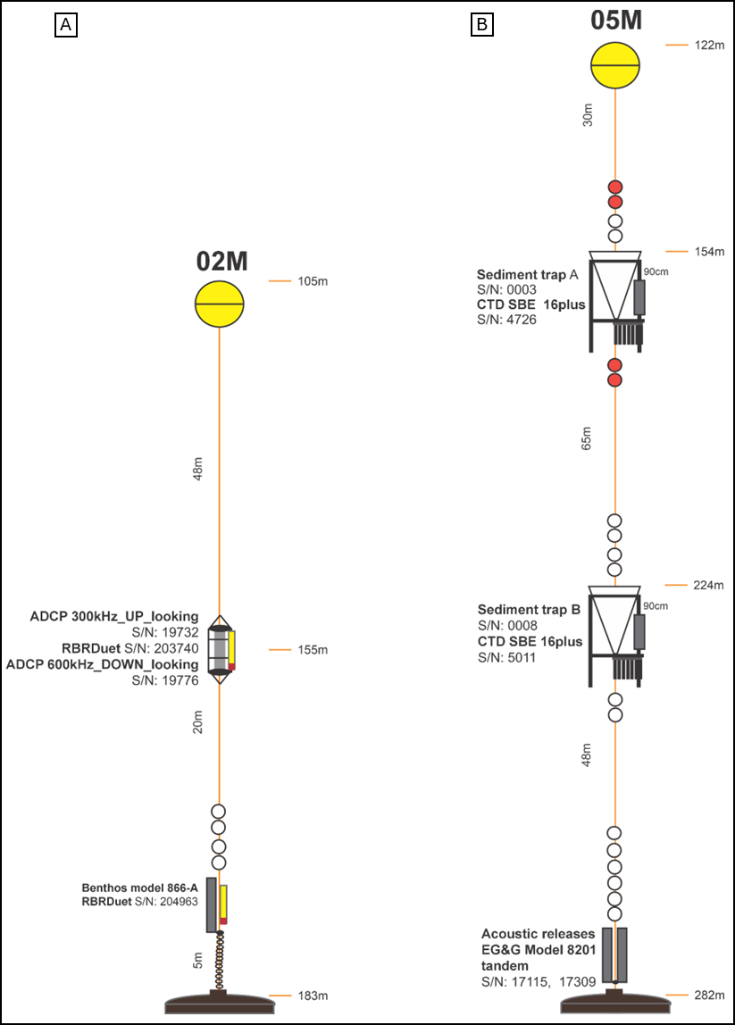
Supplementary Fig. 2: Illustration of (A) the 02M ADCP-CTD mooring and (B) the 05M sediment traps-CTD mooring structure.
Supplementary Table 2: Information on oceanographic moorings (see also Supplementary Fig. 1). Locations are shown in Fig. 2 (modified from Jacques et al.²³).

Instrument | Collection interval | Coordinates | Mooring depth | Instrument depth
ADCP | 14 Oct 2020 – 11 Oct 2021 | 49°18'23.54"N  67°23'32.67"W | 183 m | 155 m
ADCP | 13 Oct 2021 – 09 Oct 2022 | 49°18’23.34"N  67°23’25.98"W | 195 m | 167 m
Trap A  Trap B | 1 Nov 2020 – 30 Sept 2021 | 49°17'2.63"N  67°22'53.72"W | 282 m | 154 m  224 m
Trap A  Trap B | 1 Nov 2021 – 30 Sept 2022 | 49°17'2.28"N  67°22'50.70"W | 288 m | 160 m  230 m
AWAC | 04 Oct 2020 – 11 Oct 2021 | 49°18' 49.74" N 67°21' 0.96" W | 45 m | -
AWAC | 11 Oct 2020 – 09 Oct 2021 | 49°18'50.34"N  67°21'11.40"W | 38 m | -

Supplementary Table 3: Analytical precision of particulate organic carbon, particulate nitrogen, and carbon isotope ratio of sinking particles based on the blind standard C-55, a L-glutamic acid, on 5 batches of trap samples from the second cycle (November 2021–October 2022).
Batch number | Analysis | Result | n, standard deviation | Coefficient of variation | Expected value
Batch n°1 | %C | 40.90 | n = 5, std dev = 0.62 | 1.52 | 40.82
Batch n°1 | %N | 9.52 | n = 6, std dev = 0.07 | 0.74 | 9.52
Batch n°1 | δ¹³C_{vpdb} | -28.6 | n = 6, std dev = 0.1 | 0.35 | -28.5
Batch n°2 | %C | 40.82 | n = 6, std dev = 0.15 | 0.37 | 40.82
Batch n°2 | %N | 9.50 | n = 6, std dev = 0.03 | 0.32 | 9.52
Batch n°2 | δ¹³C_{vpdb} | -28.6 | n = 6, std dev = 0.1 | 0.35 | -28.5
Batch n°3 | %C | 40.53 | n = 6, std dev = 0.65 | 1.60 | 40.82
Batch n°3 | %N | 9.48 | n = 6, std dev = 0.08 | 0.84 | 9.52
Batch n°3 | δ¹³C_{vpdb} | -28.6 | n = 6, std dev = 0.1 | 0.35 | -28.5
Batch n°4 | %C | 40.82 | n = 6, std dev = 0.25 | 0.61 | 40.82
Batch n°4 | %N | 9.48 | n = 6, std dev = 0.04 | 0.42 | 9.52
Batch n°4 | δ¹³C_{vpdb} | -28.5 | n = 6, std dev = 0.1 | 0.35 | -28.5
Batch n°5 | %C | 40.94 | n = 7, std dev = 0.39 | 0.95 | 40.82
Batch n°5 | %N | 9.55 | n = 7, std dev = 0.15 | 1.57 | 9.52
Batch n°5 | δ¹³C_{vpdb} | -28.5 | n = 7, std dev = 0.1 | 0.35 | -28.5
Supplementary Method 1: DNA extraction and amplification protocol

DNA extraction. For DNA extraction of surface and core sediment samples, 240–250 mg of wet sediment was weighed directly into a crystal bead tube containing rough and heterogeneous corundum grains (type C tube, Macherey-Nagel). DNA was then extracted using the DNeasy PowerLyser PowerSoil kit (Qiagen). Bead beating for surface and core sediments samples consisted of shaking for 10 minutes at 30 Hz on a Retch Mixer Mill MM 400 (Retch GmbH, Haan, Germany). For sediment trap samples, 25 or 50 mL of material was subsampled with a serological pipette after gentle manual homogenization (100 s). The subsamples were transferred into conical tubes and centrifuged at 3000 rpm (= 1550 g) for 16 min. The supernatant was then discarded, and 250 ± 5 mg of homogenized sediment was transferred into a type C bead tube (Macherey-Nagel) for extraction using DNeasy PowerLyser PowerSoil kit (Qiagen). Bead beating for sediment trap samples consisted of 10 minutes of shaking in an adapter on a vortex mixer. For one sample (sample 17, see Supplementary Table 1), 264 mg was processed (+5.6% relative to the others), which may slightly overestimate DNA yield.
The qPCR mix consisted of 5 μL of PowerTrack Sybr Green Master Mix (Applied Biosystems), 0.5 μL of each primer (AlexGp1Fw: GAT-AAG-TCT-CCT-GTG-GGG-GG; AlexGp1Rv: AAG-CAC-AGG-AAC-ACA-CAC-ATA; amplicon length = 90 bp) at a concentration of 8 µM, 3 μL PCR-grade water, and 1 μL DNA extract. Primers targeting the 28S rRNA gene D1–D2 domain were selected following Vandersea et al.²⁴.
DNA amplification. Amplification was carried out on a QuantStudio 5 thermocycler (Applied Biosystems) using the following program: initial activation at 95 °C for 2 min (1.6 °C s⁻¹), followed by 40 cycles of 95 °C for 15 s (1.6 °C s⁻¹) and 60 °C for 1 min (1.6 °C s⁻¹). A final dissociation curve was generated to verify specificity and obtain melt curves: 95 °C for 15 s (1.6 °C s⁻¹), 60 °C for 1 min (1.6 °C s⁻¹), and 95 °C for 15 s (0.15 °C s⁻¹).
DNA extracts in dilution series of two reference cultures were used to calibrate the analyses using the same protocol as used on samples. These reference cultures were used to generate standard curves that served as PCR positive controls, and to confirm qPCR assay linearity (R²) within the range of our samples and qPCR efficiency (E). For each four qPCR assays on surface sediments and sediment core samples (R² = 0.998, 0.995, 0.979, 0.994; E = 100.2, 92.7, 86.5, 112.1; respectively), the reference culture was an A. catenella strain originating from Casco Bay (Maine, USA), provided by Dr. Donald M. Anderson and prepared by Nate Spada (Woods Hole Oceanographic Institution, Woods Hole, MA, USA). For each 3 qPCR assays on sediment trap samples (R² = 0.985, 0.999, 0.995; E = 93.5, 67.2, 61.6; respectively), the reference culture was an A. catenella strain isolated from the LSLE. The latter two low efficiency curves were potentially due to a loss of template DNA, since in the second and third runs the more diluted standards showed more delayed Ct values than the more concentrated standards (as compared with the first run). This potential loss of template DNA in standards could have plausibly occurred via adsorption to the tubes or by hydrolysis since the standards were prepared with molecular grade water (rather than a buffered solution), and without low retention plastics or carrier nucleic acids (e.g. yeast tRNA) Ellison et al. 2006. Consequently, these low values are unlikely to be representative of the assay’s actual qPCR efficiency, which is reported to be near to 100% (Vandersea et al. 2017), and which we also estimated on average to be 97% (excluding the two outliers). Moreover, since we did not employ these curves for direct quantification, no biases were introduced.
Although qPCR efficiency can be affected by inhibitors^{25,26} and formalin preservation (e.g., ^{27–30}), several measures were implemented to minimize these effects, since the sediment trap samples were preserved in alkaline formaldehyde (see Data and Methods). Samples were stored at 4 °C, and short amplicons (90 bp) were targeted to enhance amplification success from formalin-fixed material^{31,32}. Additionally, the relatively short preservation period and the large genome size of A. catenella likely facilitate DNA recovery^{25,33}, supporting the use of qPCR results as a reliable proxy for relative abundance of cysts of A. catenella. Finally, the presence of cysts of cf. A. catenella was visually confirmed in some surface sediment samples using a volumetric method with a Sedgewick-Rafter chamber³⁴ and observation under an inverted microscope (Nikon Eclipse TE-2000-U).
Supplementary Note 2: List of known Harmful Algal Blooms and resulting Paralytic Shellfish Poisoning.

Supplementary Table 4: Documented Harmful Algal Bloom (HAB) events, paralytic shellfish poisoning (PSP), Paralytic Shellfish Toxin (PST) exceeding harmful limits, and fisheries closures associated with Alexandrium spp. in the Lower St. Lawrence Estuary (LSLE), the Gulf of St. Lawrence (GSL), and Newfoundland from ca. 1600 to 2009. Sources are Stafford³⁵, Tennant et al.³⁶, Medcof et al.³⁷, Caddy and Chandler³⁸, Prakash et al.³⁹, Medcof⁴⁰, Therriault et al.⁴¹, White and White⁴², Schwinghamer et al.⁴³, Blasco et al.⁴⁴, Weise et al.⁴⁵, Fauchot et al.⁴⁶, Gracia et al.⁴⁷, Starr et al.⁴⁸, and GBIF⁴⁹. Red blocks correspond to HAB events near the Pointe-des-Monts (PDM) area and may correspond to the A. catenella DNA peaks detected by qPCR (Fig. 9). The gray block represents the only event recorded near the winter season (10 December 1991). Ministère de l’Industrie et du Commerce du Québec (MIC).

Data are fragmentary because surveys were conducted at specific stations and dates, limiting the ability to monitor all local blooms or their full extent. For example, PSP events may have gone unrecorded, particularly if they did not result in hospitalization or documented shellfish toxicity. For example, PST exceeded harmful limits in most years between 1961 and 1984 in the Manicouagan and Aux-Outardes region, particularly in 1968⁴¹. Many events before 1989 may be missing. Data are more complete between 1989 and 2009, thanks to the Harmful Algal Monitoring Program (HAMP, DFO). No data after 2010 are available on GBIF⁴⁹. Note that shellfish harvesting in the PDM area has been prohibited since 10 June 2010 due to toxicity risk⁵⁰ (decree numbers 2010Q-T-168 and 2010Q-T-169).

Year | Season or month | Confirmed location | Human sickness and mortality | Event type | Reference
At least since 1600 | Summer | LSLE and GSL | No record | PSP | Indigenous knowledge reported by Tennant et al.³⁶ and Prakash et al.³⁹
1880 | July | Douglastown | 1 and 1 | PSP | ^{35,37}
1884 | July | Douglastown | 1 and 1 | PSP | ^{35,37}
1902 | July | Baie-des-Capucins | 7 and 1 | PSP | ³⁷
1906-1910 | Summer | Les Escoumins | 5 and 4 | PSP | ³⁷
1914 | July | Baie-Comeau and Barachois | 2 and 0 | PSP | ³⁷
1924-1925 | August | Sainte-Flavie | 2 and 0 | PSP | ³⁷
1928 | August | Sainte-Flavie | 1 and 0 | PSP | ³⁷
1929-1930 | - | Baie des Anglais | 2 and 2 | PSP | ³⁷
1935 | July | Havre-Saint-Nicolas | 1 and 0 | PSP | ³⁷
1936-1937 | - | Godbout | 12 and 0 | PSP | ³⁷
1945 | July | Sainte-Luce | 2 and 0 | PSP | ³⁷
1945 | July | Bic | 1 and 1 | PSP | ³⁷
1948 | August | Baie-des-Capucins and Les Boules | 5 and 3 | PSP | ^{37,40}
1951 | April | Grand-Métis | 3 and 0 | PSP | ³⁷
1954 | July | Métis-sur-Mer | 9 and 2 | PSP | ^{36,37}
1960 | Spring | Latour | 1 and 0 | PSP | ³⁷
1962 | August | Anse Saint-Pancrace | 1 and 0 | PSP | ³⁷
1962 | September | Franquelin, Mistassini, and Havre St-Nicolas | 16 and 1 | PSP | ³⁷
1963 | April | Latour | 1 and 0 | PSP | ³⁷
1966 | Summer | Godbout | 12 and 0 | PSP | Medcof et al.³⁷ cited in Caddy and Chandler³⁸
1966 | September | Cap-Chat, Les Méchins, Sainte-Anne-des- Monts, and Sainte-Marthe | 7 and 0 | PSP | Ministère de l’Industrie et du Commerce du Québec (MIC, unpublished reports) cited in Prakash et al.³⁹
1966 | November | Les Méchins | 6 and 0 | PSP | MIC (unpublished reports) cited in Prakash et al.³⁹
1967 | March | Les Méchins | 1 and 0 | PSP | MIC (unpublished reports) cited in Prakash et al.³⁹
1969 | August | Godbout, Métis-sur-Mer, and Ste-Anne-des-Monts | 13 and 3 | PSP | MIC (unpublished reports) cited in Prakash et al.³⁹
1969 | September | Petite-Vallée | 1 and 1 | PSP | MIC (unpublished reports) cited in Prakash et al.³⁹
1970 | March | Cap-Chat | 4 and 1 | PSP | A. Litalien, personal communication to Prakash et al.³⁹
1982 | Late September | Harbour Grace (Newfoundland) | 4 and 0 | PSP, PST were also detected at harmful levels near Hermitage Bay from late September to December | ⁴²
1983 | October – November | Hermitage Bay (Newfoundland) | Not reported | PST | ⁴²
1980 | August | Mostly around Manicouagan and Aux-Outardes rivers plumes, various locations along the North and South Coast of LSLE | Not reported | PST, Bloom | ⁴¹
1987 | June – September | South coast of LSLE and GSL | - | Fisheries closure | ⁴⁹
1988 | Late June – early July | South coast of LSLE and GSL (Gaspé Current, Gaspé, and Baie des Chaleurs) | - | PSP | ⁴⁹
1989 | Late June – early July | LSLE and GSL | - | - | ^{44,49}
1990 | Late June – early July | LSLE and southwest coast of GSL | - | Exceeded toxicity limit | ^{44,49}
1991 | Late July - early August | North coast of LSLE and south coast of GSL | Not reported | Exceeded toxicity limit | ^{44,49}
1991 | 10 December | Various locations in Notre-Dame Bay (Newfoundland) | - | Exceeded toxicity limit, cysts | ^{43,49}
1992 | Early June – mid September | LSLE and north coast of GSL | Not reported | Exceeded toxicity limit | ^{44,45,49}
1993 | June – late July, September | LSLE and GSL | - | exceeded toxicity limit | ⁴⁴
1994 | June – late September | LSLE and GSL | - | - | ^{44,45}
1995 | Early June – late August | LSLE and GSL | - | PSP exceeded toxicity limit | ^{45,49}
1995 | Late October | Various locations in Newfoundland, specifically Hermitage Bay | Not reported | No toxins in Shellfish | ⁴⁹
1996 | Late July | North of the Anticosti Gyre and Sept-Îles | - | Exceeded toxicity limit | ^{45,49}
1996 | Mid-August | South shore of LSLE and Sainte-Flavie | - | Exceeded toxicity limit | ⁴⁹
1997 | Early July | Gaspé and Penouille | - | - | ⁴⁹
1997 | Mid – late July | North of the Anticosti Gyre and Sept-Îles | - | - | ^{45,49}
1998 | Early July – mid August | South coast of LSLE, north of the Anticosti Gyre, and Sept-Îles | 2 and Not reported | PSP | ^{45,46,49}
2000 | Mid-July - October | LSLE, GSL, and various locations in Notre-Dame Bay (Newfoundland) | - | Fisheries closure in Newfoundland | ⁴⁹
2001 | Early June – early August | LSLE, south coast of GSL, and Îles-de-la- Madeleine | - | Fisheries closure 16/06/01 – 11/08/01 | ⁴⁹
2002 | June – late October | LSLE, south coast of GSL, and Îles-de-la- Madeleine | - | Exceeded toxicity limit | ⁴⁹
2003 | Early July – mid August | LSLE and south coast of GSL | - | 3-week bloom periods at various locations | ⁴⁹
2004 | Early July – late July | LSLE and GSL | - | Exceeded toxicity limit | ⁴⁹
2005 | Early June – late September | LSLE and GSL | - | Exceeded toxicity limit | ⁴⁹
2008 | June, August | LSLE and GSL | - | Marine fauna mass mortality | ^{47–49}
2009 | Mid June – mid August | LSLE and GSL | - | Fisheries closure | ⁴⁹

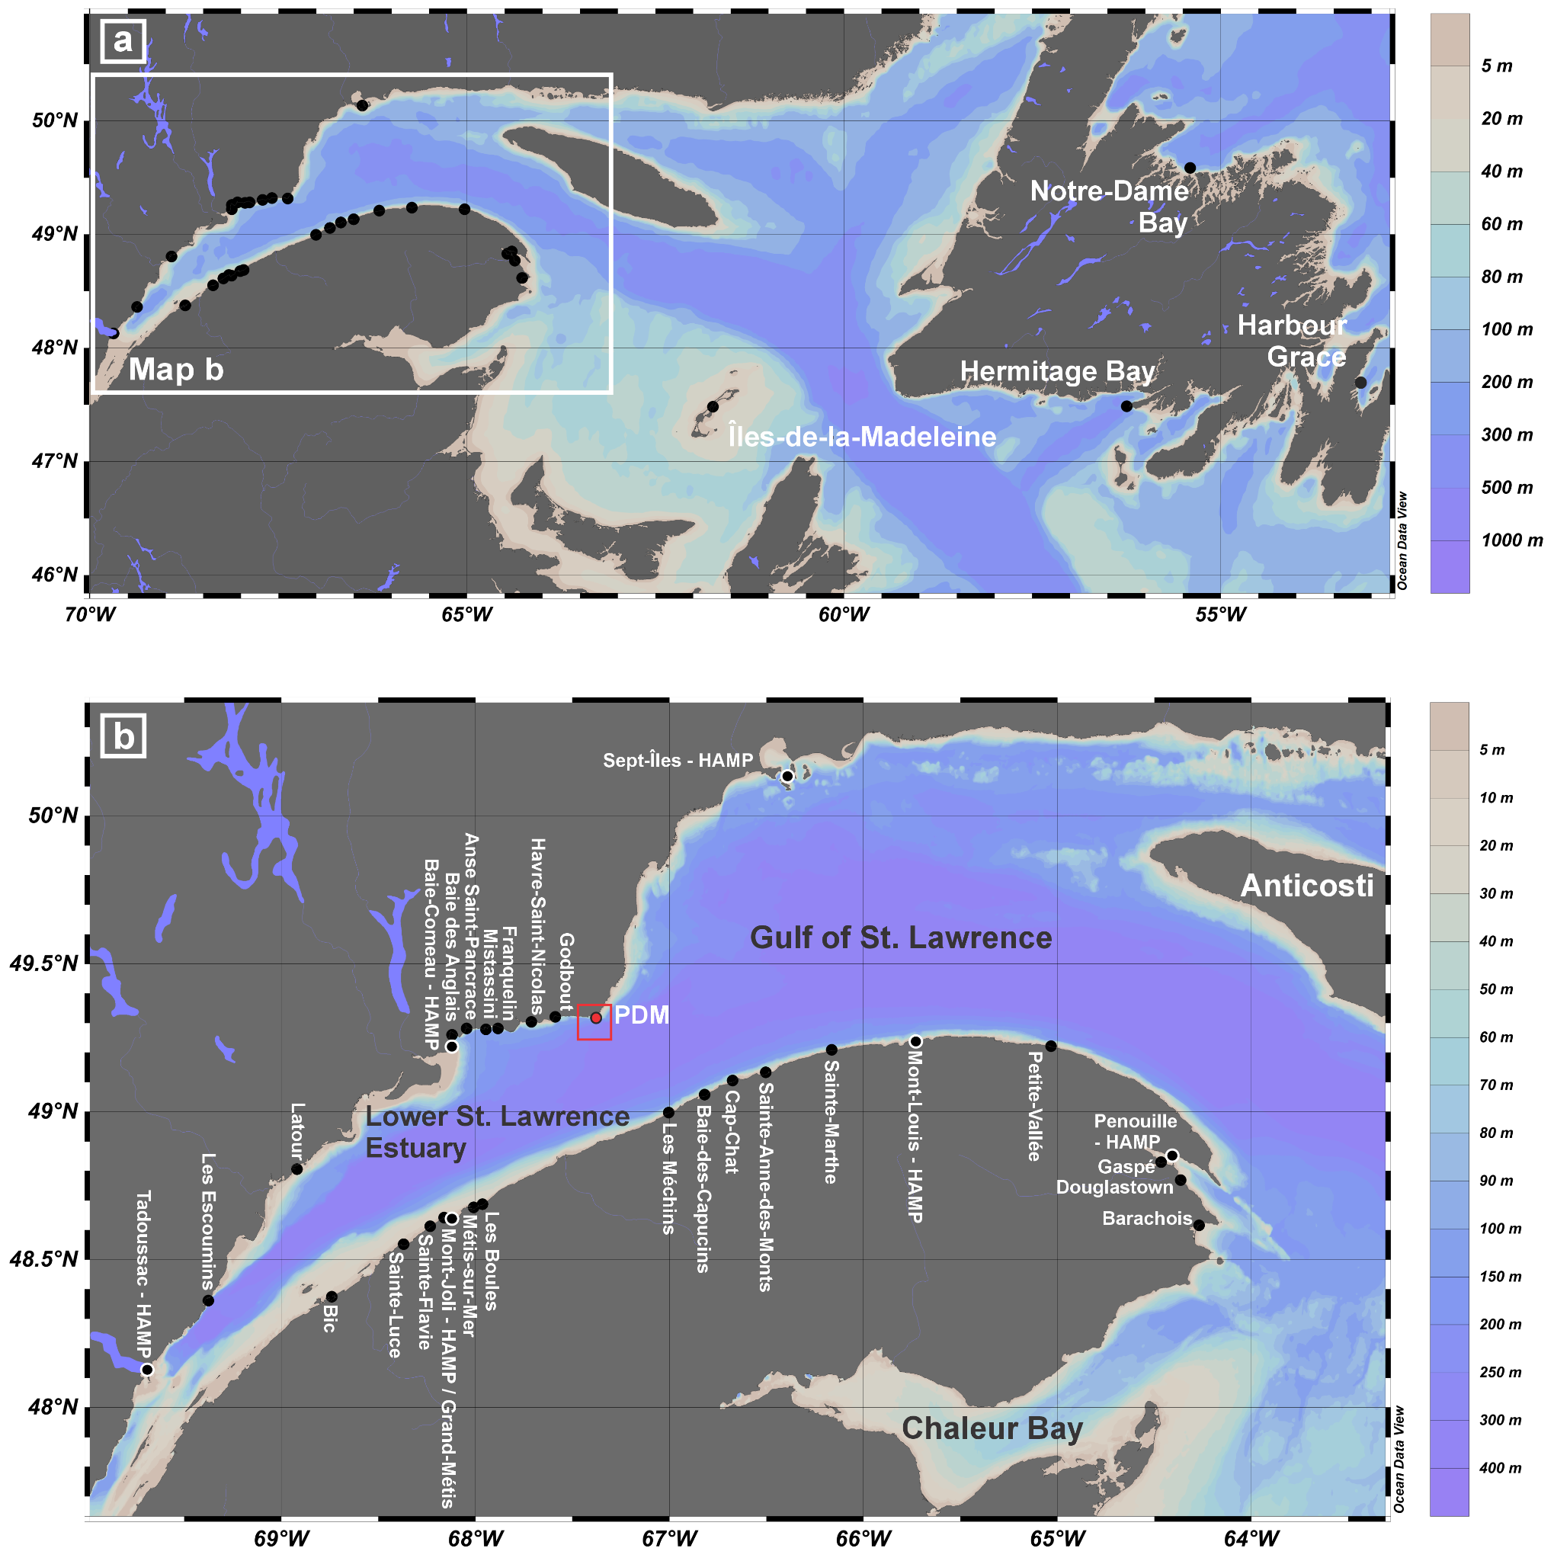
Supplementary Fig. 3: Maps showing the locations of confirmed cases of paralytic shellfish poisoning (PSP) in (a) the entire study area and (b) the Lower Estuary and western Gulf of St. Lawrence. For details on areas where PSP was confirmed before 1971, see Prakash et al.³⁹. For cases confirmed after 1971, refer to ^{41,42,44–49}. HAMP: Stations of the Harmful Algal Monitoring Program (DFO). PDM: Pointe-des-Monts. The basic map is from the Ocean Data View software⁵¹.

Supplementary References

1. El-Sabh, M. I. Surface Circulation Pattern in the Gulf of St. Lawrence. J. Fish. Res. Board Can. 33, 124–138 (1976).
2. Koutitonsky, V. G., Wilson, R. E. & El-Sabh, M. I. On the seasonal response of the Lower St Lawrence Estuary to buoyancy forcing by regulated river runoff. Estuar. Coast. Shelf Sci. 31, 359–379 (1990).
3. Tang, C. L. Mixing and circulation in the northwestern Gulf of St. Lawrence: A study of a buoyancy-driven current system. J. Geophys. Res. Oceans 85, 2787–2796 (1980).
4. El-Sabh, M. I., Lie, H.-J. & Koutitonsky, V. G. Variability of the near-surface residual current in the lower St. Lawrence estuary. J. Geophys. Res. Oceans 87, 9589–9600 (1982).
5. Galbraith, P. S. et al. Physical Oceanographic Conditions in the Gulf of St. Lawrence during 2021. DFO Can. Sci. Advis. Sec. Res. Doc. 2022/034. iv + 83 (2022).
6. Dickie, L. & Trites, R. W. The Gulf of St. Lawrence. in Estuaries and Semi-Enclosed Seas (Elsevier Scientific Publication, Amsterdam, The Netherlands, 1983).
7. Koutitonsky, V. G. & Bugden, G. L. The physical oceanography of the Gulf of St. Lawrence : a review with emphasis on the synoptic variability of the motion. Gulf St Lawrence Small Ocean Big Estuary 57–90 (1991).
8. Galbraith, P. S. Winter water masses in the Gulf of St. Lawrence. J. Geophys. Res. Oceans 111, (2006).
9. Galbraith, P. S. et al. Physical Oceanographic Conditions in the Gulf of St. Lawrence during 2020. DFO Can. Sci. Advis. Sec. Res. Doc. 2021/045. iv + 81 (2021).
10. Drinkwater, K. F. & Gilbert, D. Hydrographic Variability in the Waters of the Gulf of St. Lawrence, the Scotian Shelf and the Eastern Gulf of Maine (NAFO Subarea 4) During 1991-2000. J. Northwest Atl. Fish. Sci. 34, 85–101 (2004).
11. Galbraith, P. S. et al. Physical Oceanographic Conditions in the Gulf of St. Lawrence during 2022. Can. Tech. Rep. Hydrogr. Ocean Sci. 354 : v + 88 p (2023).
12. d’Anglejan, B. Recent Sediments and Sediment Transport Processes in the St. Lawrence Estuary. in Oceanography of a Large-Scale Estuarine System 109–129 (American Geophysical Union (AGU), 1990). doi:10.1002/9781118663783.ch6.
13. d’Anglejan, B. F. & Smith, E. C. Distribution, Transport, and Composition of Suspended Matter in the St. Lawrence Estuary. Can. J. Earth Sci. 10, 1380–1396 (1973).
14. St-Onge, G., Duchesne, M. J. & Lajeunesse, P. Marine geology of the St. Lawrence Estuary. IOP Conf. Ser. Earth Environ. Sci. 14, 012003 (2011).
15. Gagné, H., Lajeunesse, P., St-Onge, G. & Bolduc, A. Recent transfer of coastal sediments to the Laurentian Channel, Lower St. Lawrence Estuary (Eastern Canada), through submarine canyon and fan systems. Geo-Mar. Lett. 29, 191–200 (2009).
16. Pinet, N., Brake, V., Campbell, C. & Duchesne, M. Seafloor and Shallow Subsurface of the St. Lawrence River Estuary. Geosci. Can. 38, 31–40 (2011).
17. Normandeau, A., Lajeunesse, P. & St-Onge, G. Submarine canyons and channels in the Lower St. Lawrence Estuary (Eastern Canada): Morphology, classification and recent sediment dynamics. Geomorphology 241, 1–18 (2015).
18. Forrester, W. D. Internal tides in St. Lawrence Estuary. J. Mar. Res. 32, 55–66 (1974).
19. Baccara, K. Conditions océanographiques dans les canyons sous-marins de Pointe-des-Monts. (Université du Québec à Rimouski, 2023).
20. Bourgault, D., Morsilli, M., Richards, C., Neumeier, U. & Kelley, D. E. Sediment resuspension and nepheloid layers induced by long internal solitary waves shoaling orthogonally on uniform slopes. Cont. Shelf Res. 72, 21–33 (2014).
21. Boegman, L. & Stastna, M. Sediment Resuspension and Transport by Internal Solitary Waves. Annu. Rev. Fluid Mech. 51, 129–154 (2019).
22. Lavoie, D. et al. Large-Scale Atmospheric and Oceanic Control on Krill Transport into the St. Lawrence Estuary Evidenced with Three-Dimensional Numerical Modelling. Atmosphere-Ocean 54, 299–325 (2016).
23. Jacques, F. et al. The incompleteness of turbidite records: Comparing direct monitoring of turbidity currents to deposits preserved in submarine fans (Pointe-des-Monts, eastern Canada). Mar. Geol. 491, 107660 (2026).
24. Vandersea, M. W. et al. qPCR assays for Alexandrium fundyense and A. ostenfeldii (Dinophyceae) identified from Alaskan waters and a review of species-specific Alexandrium molecular assays. Phycologia 56, 303–320 (2017).
25. Erdner, D. L., Percy, L., Keafer, B., Lewis, J. & Anderson, D. M. A quantitative real-time PCR assay for the identification and enumeration of Alexandrium cysts in marine sediments. Deep Sea Res. Part II Top. Stud. Oceanogr. 57, 279–287 (2010).
26. Dumoulin, L.-A., Chevrinais, M., St-Louis, R. & Parent, G. J. Metal ions limit or enhance environmental DNA detectability in marine sediments. Environ. DNA 6, e568 (2024).
27. Godhe, A., Anderson, D. M. & Rehnstam-Holm, A.-S. PCR amplification of microalgal DNA for sequencing and species identification: studies on fixatives and algal growth stages. Harmful Algae 1, 375–382 (2002).
28. Eckford-Soper, L. K. & Daugbjerg, N. Examination of six commonly used laboratory fixatives in HAB monitoring programs for their use in quantitative PCR based on Taqman probe technology. Harmful Algae 42, 52–59 (2015).
29. Totoiu, C. A. et al. Vortex fluidics-mediated DNA rescue from formalin-fixed museum specimens. PLOS ONE 15, e0225807 (2020).
30. Hahn, E. E. et al. Unlocking inaccessible historical genomes preserved in formalin. Mol. Ecol. Resour. 22, 2130–2147 (2022).
31. Srinivasan, M., Sedmak, D. & Jewell, S. Effect of Fixatives and Tissue Processing on the Content and Integrity of Nucleic Acids. Am. J. Pathol. 161, 1961–1971 (2002).
32. Bucklin, A. & Allen, L. D. MtDNA sequencing from zooplankton after long-term preservation in buffered formalin. Mol. Phylogenet. Evol. 30, 879–882 (2004).
33. Wisecaver, J. H. & Hackett, J. D. Dinoflagellate Genome Evolution. Annu. Rev. Microbiol. 65, 369–387 (2011).
34. Utermöhl, H. Zur Vervollkommnung der quantitativen Phytoplankton-Methodik: Mit 1 Tabelle und 15 abbildungen im Text und auf 1 Tafel. Int. Ver. Für Theor. Angew. Limnol. Mitteilungen 9, 1–38 (1958).
35. Stafford, J. On the fauna of the Atlantic Coast of Canada. Third report — Gaspé, 1905-1906. Contrib. Can. Biol. 1906-1910., 45–68 (1912).
36. Tennant, A. D., Naubert, J. & Corbeil, H. E. An Outbreak of Paralytic Shellfish Poisoning. Can. Med. Assoc. J. 72, 436–439 (1955).
37. Medcof, J. C., Morin, N., Nadeau, A. & Lachance, A. Survey of Incidence and Risks of Paralytic Shellfish Poisoning in the Province of Quebec. 131 (1966).
38. Caddy, J. F. & Chandler, R. A. Accumulation of Paralytic Shellfish Poison by the Rough Whelk (Buccinurn Undatum L.). 46–50 (1968).
39. Prakash, A., Medcof, J. C. & Tennant, A. D. Paralytic Shellfish Poisoning in Eastern Canada. 87 (1971).
40. Mecdof, J.-C. Life and death with Gonyaulax, an historical perspective. in Toxic dinoflagellates 1–8 (Elsevier, 1985).
41. Therriault, J.-C., Painchaud, J. & Levasseur, M. Factors controlling the occurrence of Protogonyaulax tamarensis and shellfish toxicity in the St. Lawrence Estuary: Freshwater runoff and the stability of the water column. in Toxic dinoflagellates 141–146 (Elsevier, 1985).
42. White, D. R. L. & White, A. W. First report of Paralytic Shellfish Poisoning in Newfoundland. in Toxic dinoflagellates 511–516 (Elsevier, 1985).
43. Schwinghamer, P., Hawryluk, M., Powell, C. & MacKenzie, C. H. Resuspended hypnozygotes of Alexandrium fundyense associated with winter occurrence of PSP in inshore Newfoundland waters. Aquaculture 122, 171–179 (1994).
44. Blasco, D. et al. Monitorage du phytoplancton toxique et des toxines de type IPM dans les mollusques du Saint-Laurent : 1989 à 1994. Rapp. stat. can. hydrogr. sci. océan. 15, x + 117 p (1998).
45. Weise, A. M. et al. The link between precipitation, river runoff, and blooms of the toxic dinoflagellate Alexandrium tamarense in the St. Lawrence. Can. J. Fish. Aquat. Sci. 59, 464–473 (2002).
46. Fauchot, J., Levasseur, M., Roy, S., Gagnon, R. & Weise, A. M. Environmental Factors Controlling Alexandrium Tamarense (Dinophyceae) Growth Rate During a Red Tide Event in the St. Lawrence Estuary (canada). J. Phycol. 41, 263–272 (2005).
47. Gracia, S., Roy, S. & Starr, M. Spatial distribution and viability of Alexandrium tamarense resting cysts in surface sediments from the St. Lawrence Estuary, Eastern Canada. Estuar. Coast. Shelf Sci. 121–122, 20–32 (2013).
48. Starr, M. et al. Multispecies mass mortality of marine fauna linked to a toxic dinoflagellate bloom. PLOS ONE 12, e0176299 (2017).
49. GBIF.org User. Occurrence Download (29 December 2025). The Global Biodiversity Information Facility https://doi.org/10.15468/DL.3C5274 (2025).
50. IRMELL FR. https://egisp.dfo-mpo.gc.ca/vertigisstudio/web/?app=d29ff20b8e6d4421815174fc2fbb0e07&locale=fr-CA (2026).
51. Schlitzer, R. Ocean Data View, https://odv.awi.de, V5.8.3. (2025).

