Supplementary Material for:

Dynamics of sulphur-cycling microbiomes and potential role of viruses in cadmium-contaminated rice paddy soil during remediation
Zhongyi Cheng^{1,2}, Yan He^{1,3}, Christina Hazard⁴, Graeme Nicol⁴, Xueling Yang¹, Tianyu Wang¹, Laosheng Wu⁵, Jianming Xu^{1,3} and Jiachun Shi^{1,3*}

¹ Zhejiang Provincial Key Laboratory of Agricultural Resources and Environment, College of Environmental and Resource Sciences, Zhejiang University, Hangzhou 310058, China.

² Institute of Agricultural Resources and Environment, Jiangsu Academy of Agricultural Sciences, Nanjing 210014, China.

³ Key Laboratory of Environment Remediation and Ecological Health, Ministry of Education, Hangzhou 310058, China.

⁴ Université Claude Bernard Lyon 1, CNRS, INRAE, VetAgro Sup, Laboratoire d'Ecologie Microbienne, Villeurbanne 69622, France.

⁵ Department of Environmental Sciences, University of California, Riverside, CA 92521, USA

Corresponding author:
Jiachun Shi (jcshi@zju.edu.cn)
Supplementary figures
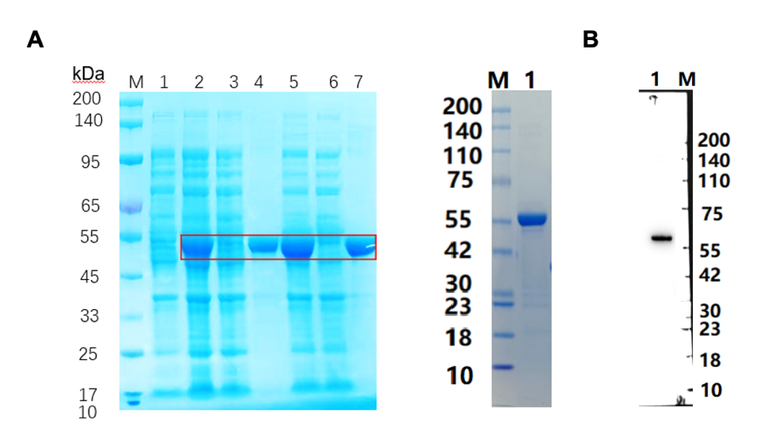
Fig. S1. SDS-PAGE and Western blot analysis of the expressed virus-encoded ABC transporter. In panel A, 1, blank control; 2, total cell lysate induced at 20 °C; 3, soluble fraction (supernatant) at 20 °C; 4, insoluble fraction (pellet) at 20 °C; 5, total cell lysate induced at 37 °C; 6, soluble fraction at 37 °C; 7, insoluble fraction at 37 °C. The results indicated that the recombinant protein was mainly expressed under both 20 °C and 37 °C induction conditions, and the observed molecular weight was consistent with the predicted size. In panel B, Western Blot analysis of the purified protein using an anti-His-tag antibody detected a single distinct band at approximately 55 kDa, confirming the successful expression of the His-tagged viral-encoded ABC transporter.

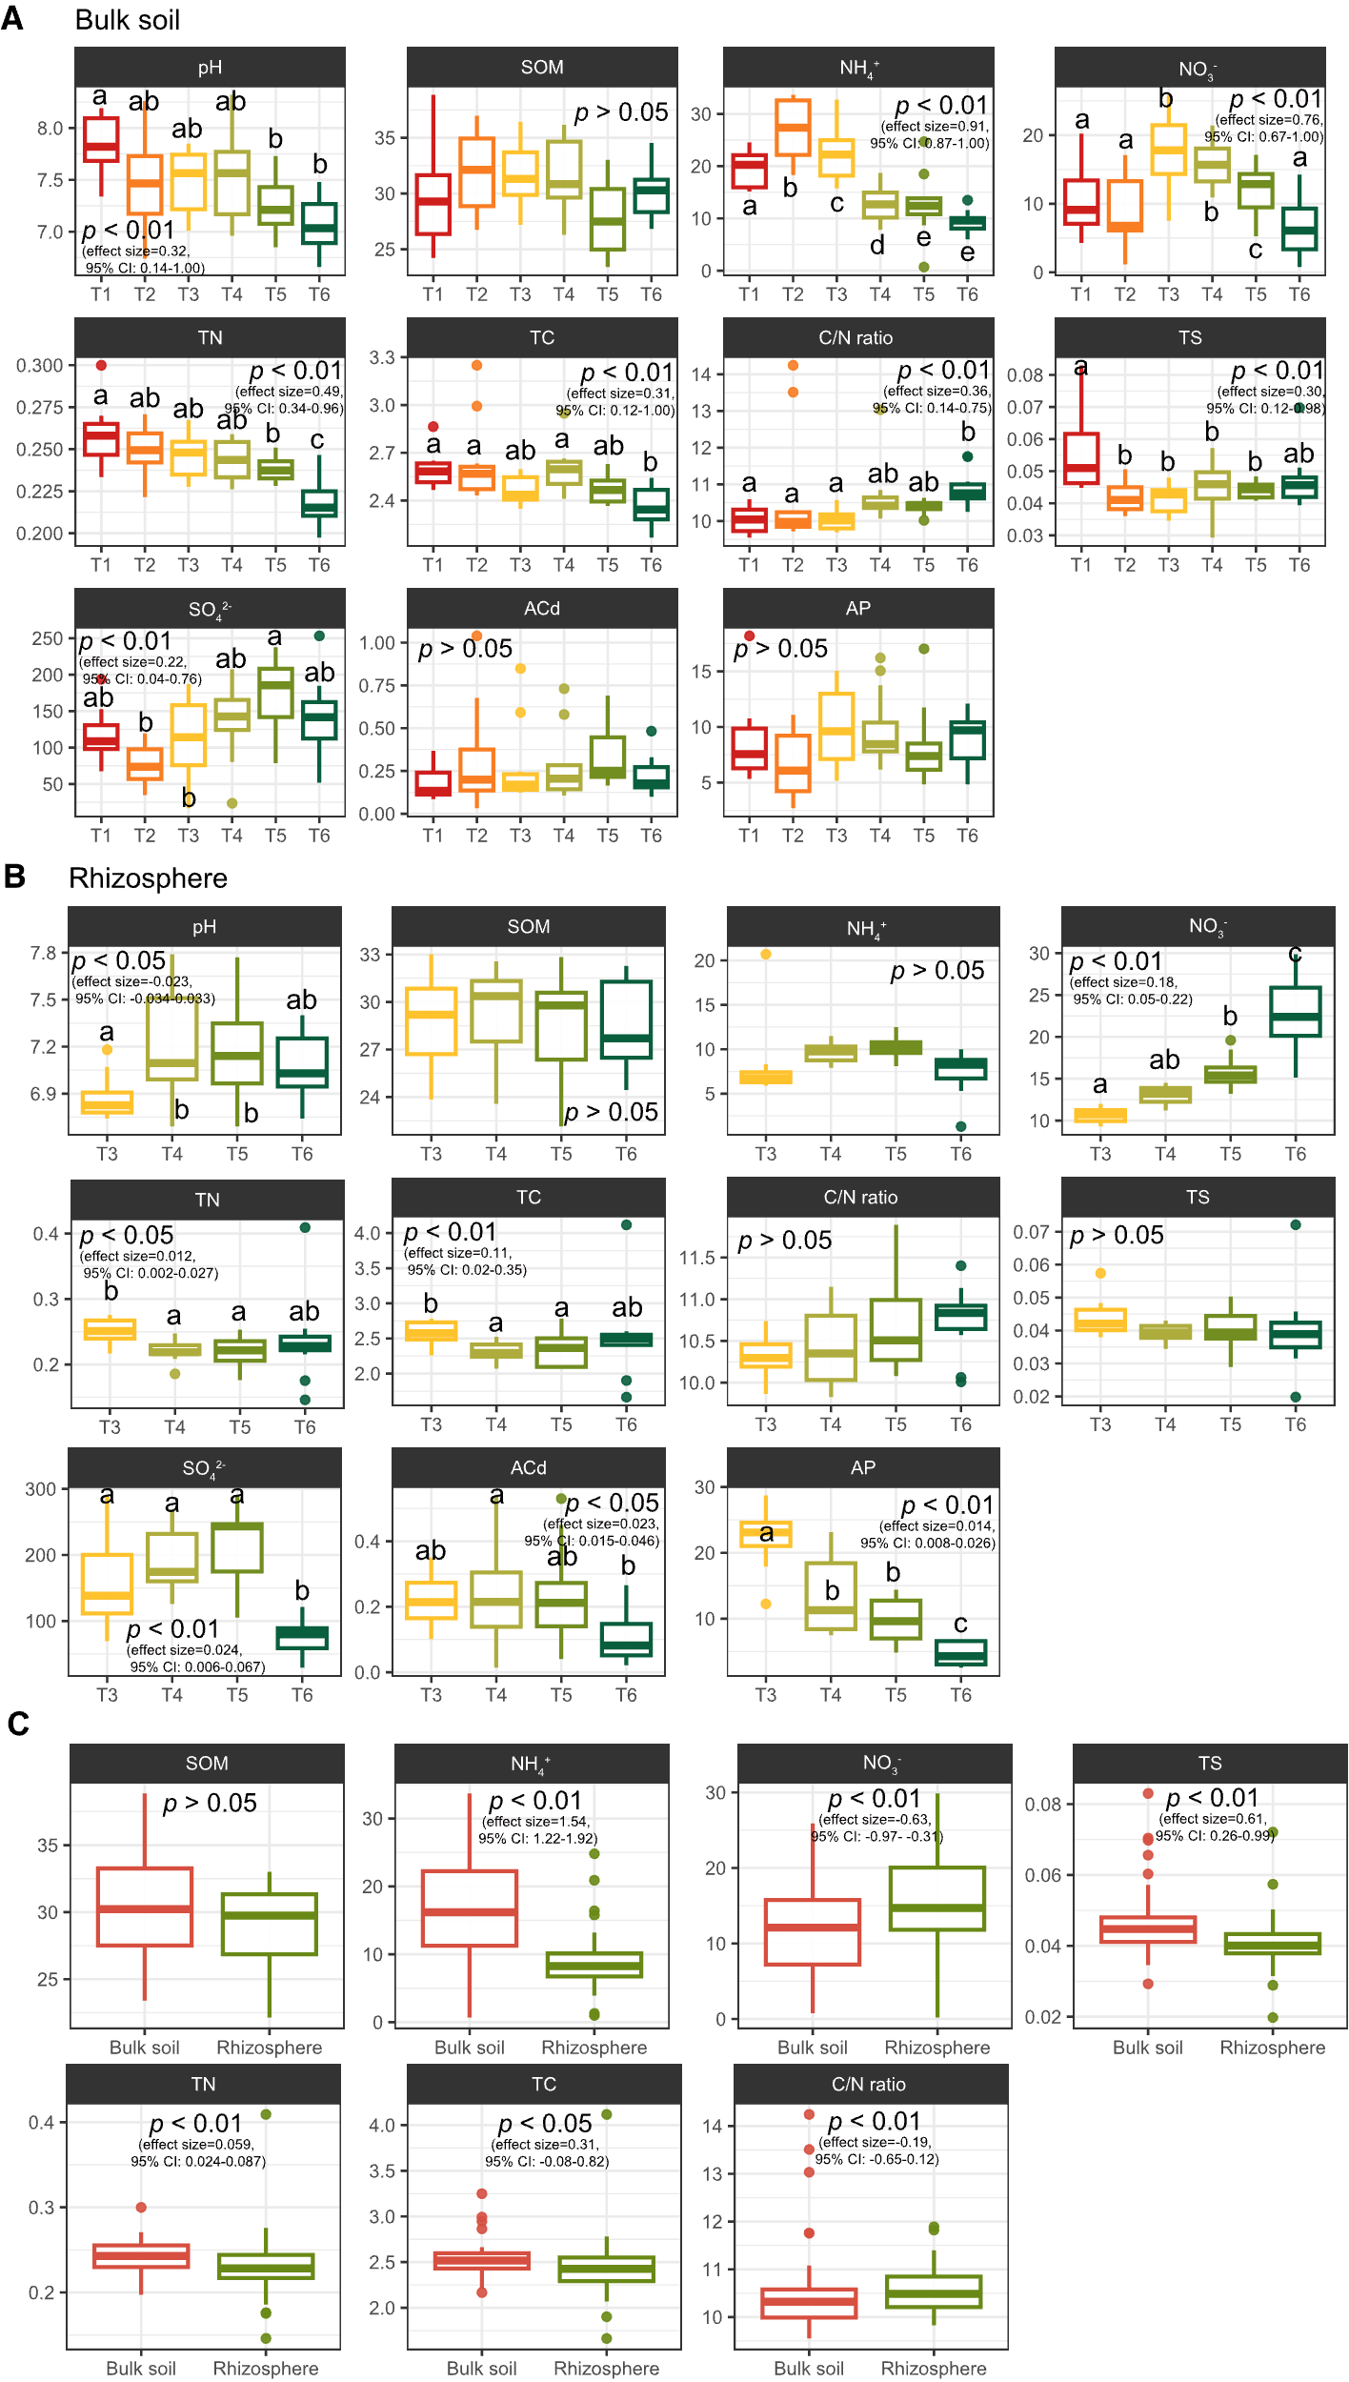
Fig. S2. Changes in soil properties during rice growth. Differences in soil properties of bulk soil (A) and rhizosphere (B) during rice growth. C Differences in soil properties between bulk and rhizosphere soil. The significance of difference (p < 0.05) was determined by Tukey’s HSD test. Effect sizes and confidence intervals were also indicated. Different letters represent significant differences. T1 pre-transplant, T2 sowing, T3 tillering, T4 heading, T5 filling, T6 ripening.

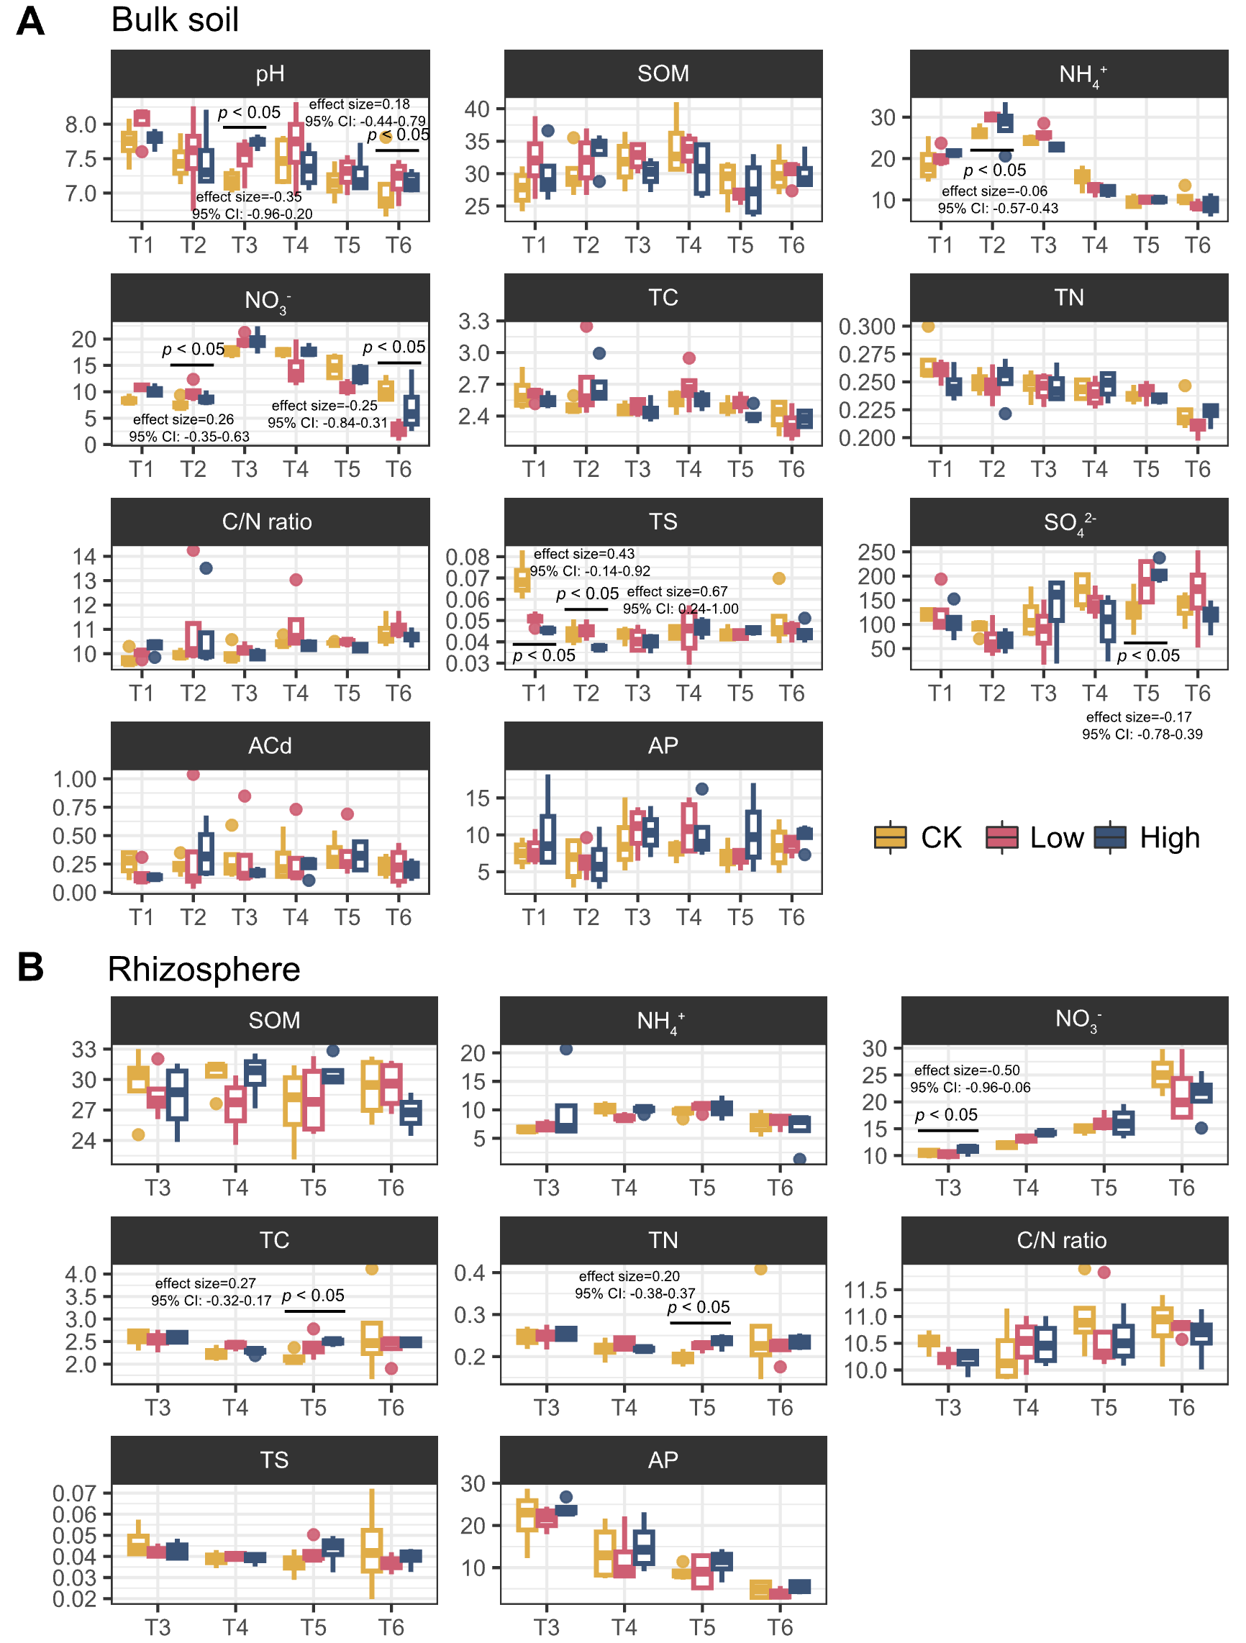
Fig. S3. Changes in soil properties across three soil amendment treatments. Differences in soil properties of bulk (A) and rhizosphere soil (B) across three treatments during rice growth. The significance of difference (p < 0.05) was determined by Tukey’s HSD test. Effect sizes and confidence intervals were also indicated. T1 pre-transplant, T2 sowing, T3 tillering, T4 heading, T5 filling, T6 ripening.
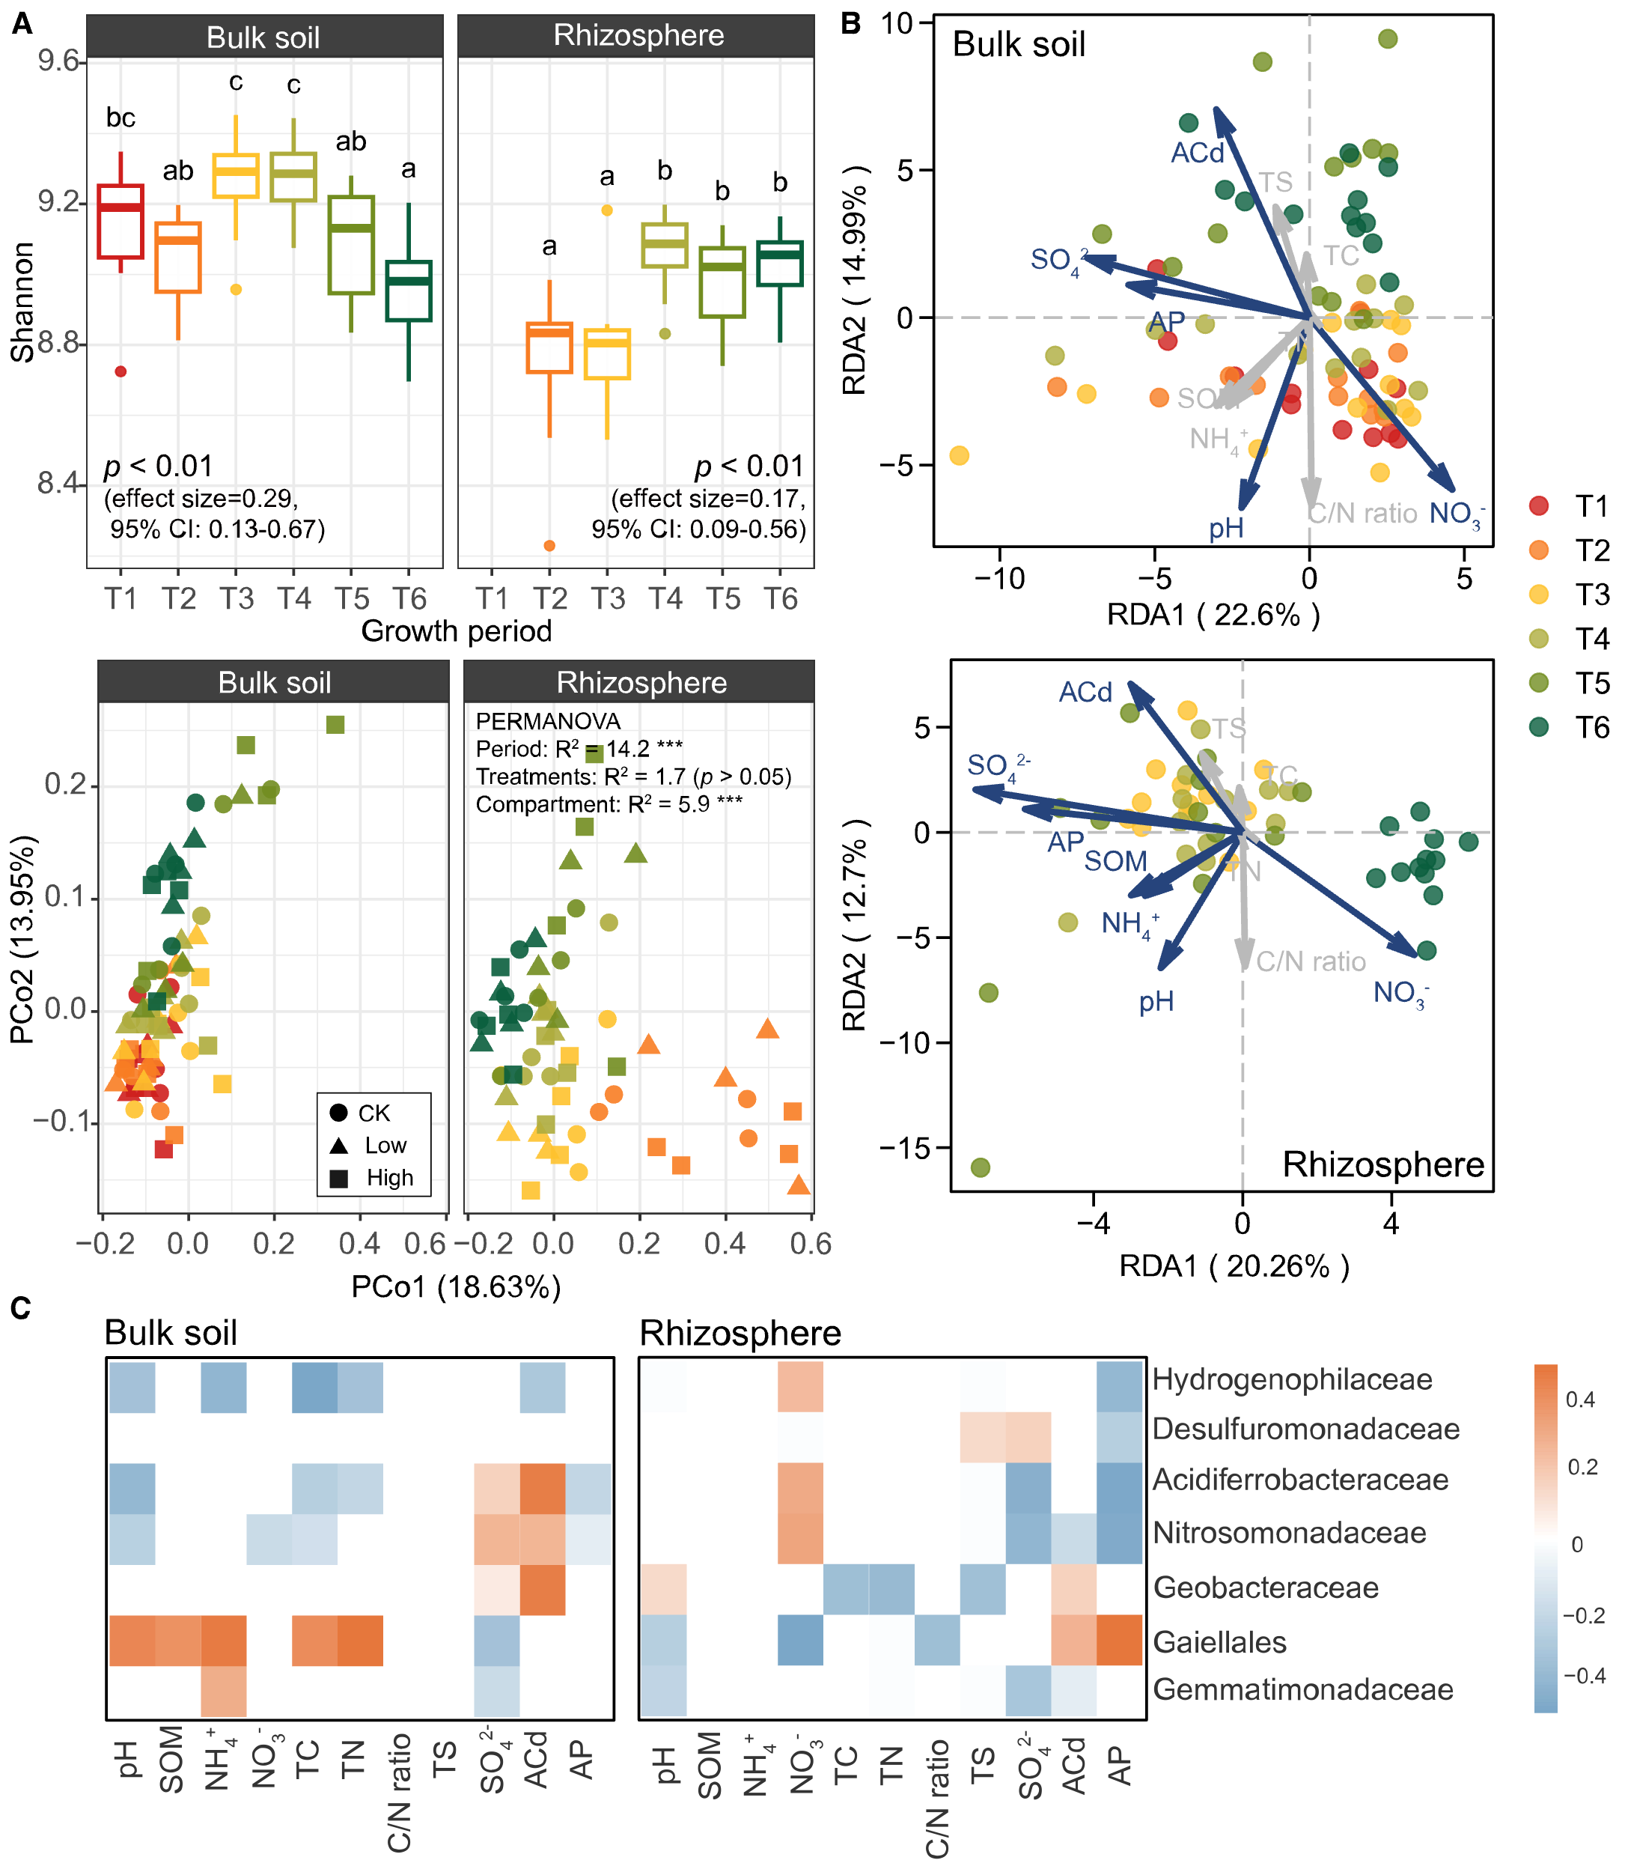
Fig. S4. Temporal variation in microbial community diversity during rice growth and relationship with environmental factors. A Shannon diversity and principal coordinate analysis (PCoA) based on Bray-Curtis distance matrices of the microbial community in bulk and rhizosphere soil. Letters depict significant differences (p < 0.05) determined by Tukey’s HSD test. B Redundancy analysis (RDA) of soil properties for microbial communities in bulk and rhizosphere soil. Dark blue labels indicate significant environmental factors (permutation, p < 0.05). C Pearson’s correlations between soil properties and the relative abundances of the 7 most abundant bacterial families. Only significant (p < 0.05) correlations are shown. T1 pre-transplant, T2 sowing, T3 tillering, T4 heading, T5 filling, T6 ripening.

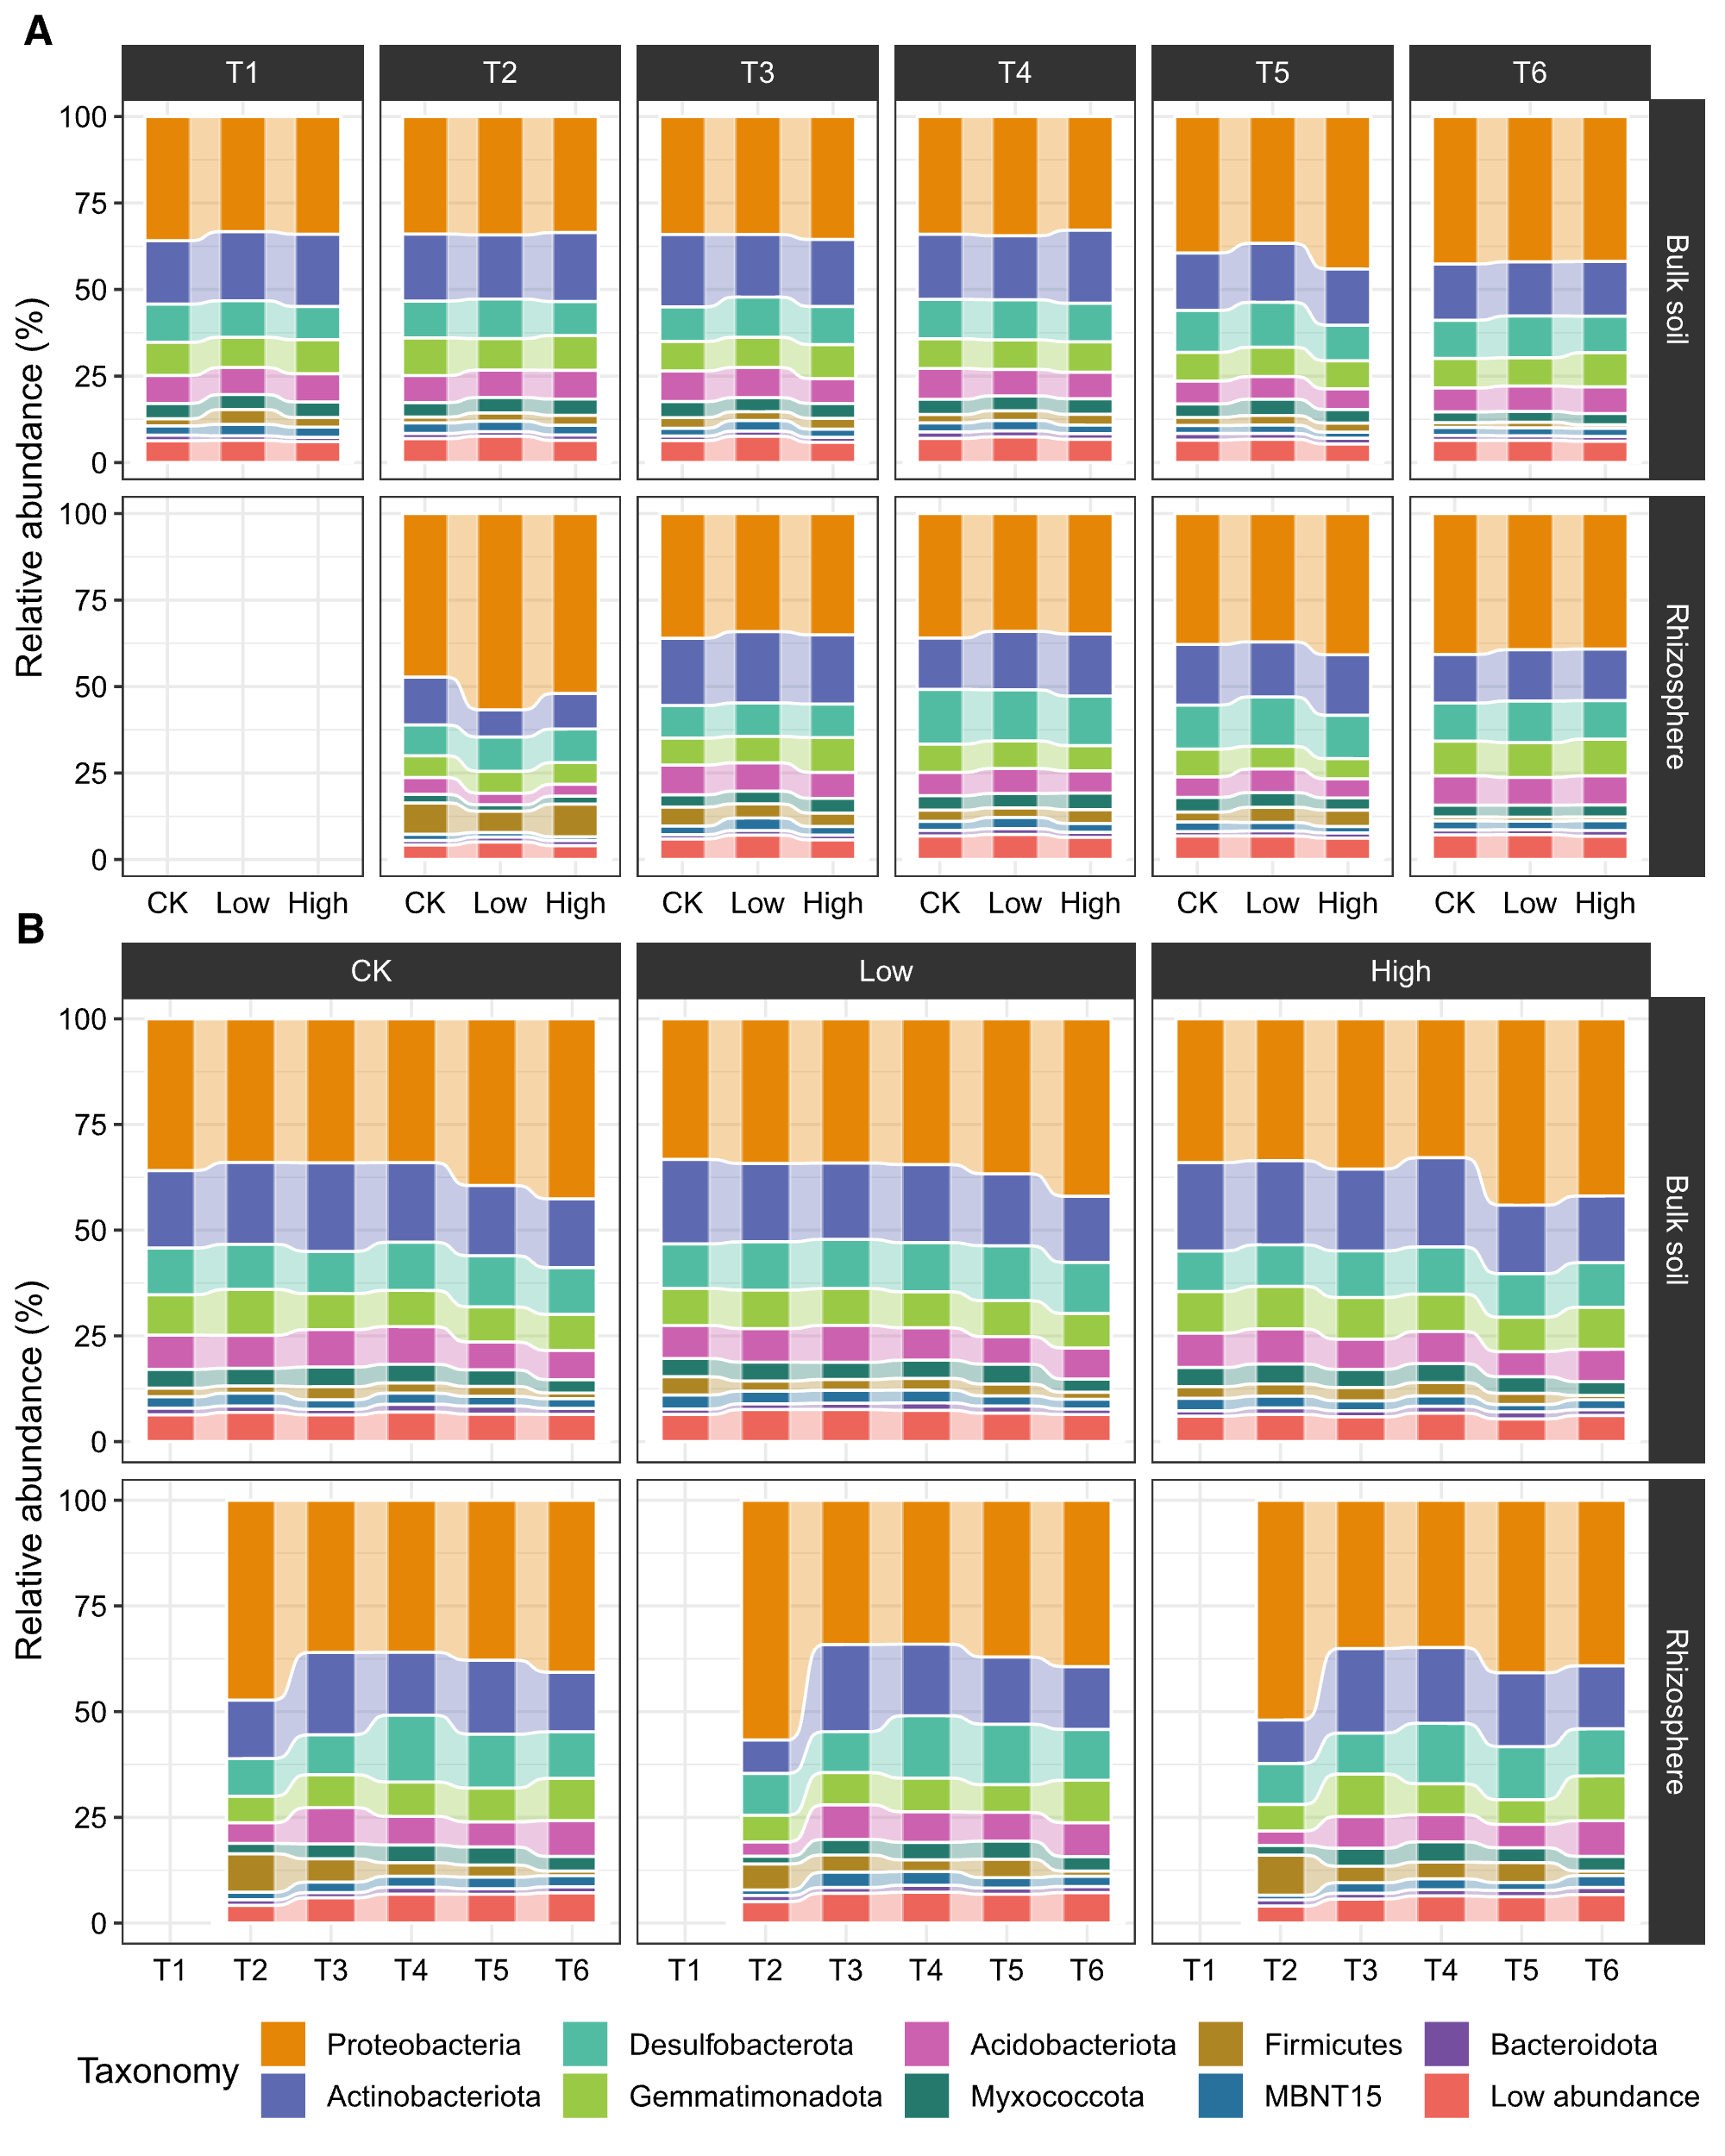
Fig. S5. Relative abundances of the microbial community at the phylum level across rice growth stages (A) and soil amendment treatments (B). T1 pre-transplant, T2 sowing, T3 tillering, T4 heading, T5 filling, T6 ripening.

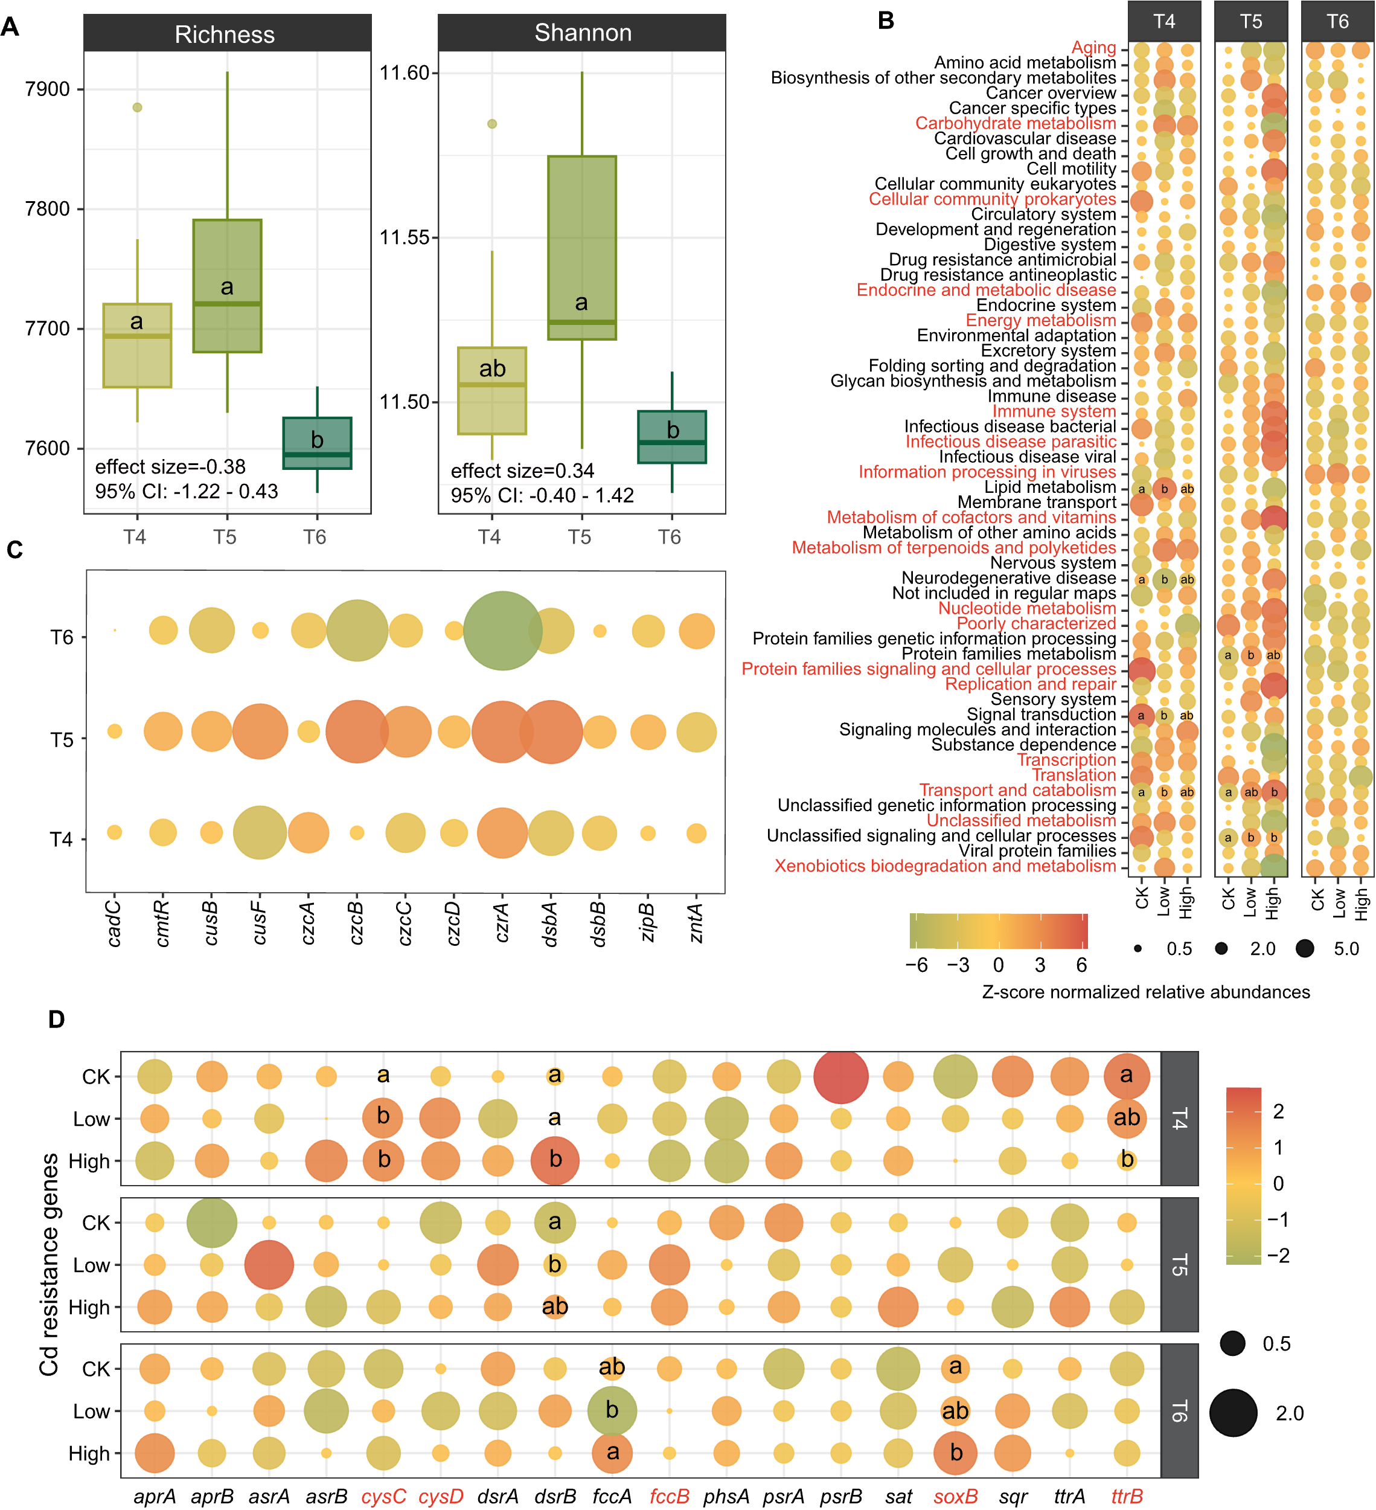
Fig. S6. Functional variability in the rhizosphere soil microbiome from rice filling to ripening stage. A Functional alpha diversity (Richness and Shannon index) based on KO profiles among three growth stages. Different letters indicate significant differences. B Relative abundances of KEGG pathway of rice rhizosphere soil microbiome. Abundance is normalized among different treatments based on Z-score. C Relative abundances of Cd resistance genes across three rice growth stages. D Relative abundances of S-cycling genes across rice growth stage and soil amendment treatment. The genes marked in red indicate their relative abundances were significantly (p < 0.05) differed between the three rice growth stages, and different letters on the circle indicate significant (p < 0.05) differences in relative abundances among the three amendment treatments. T3 tillering, T4 heading, T5 filling, T6 ripening.

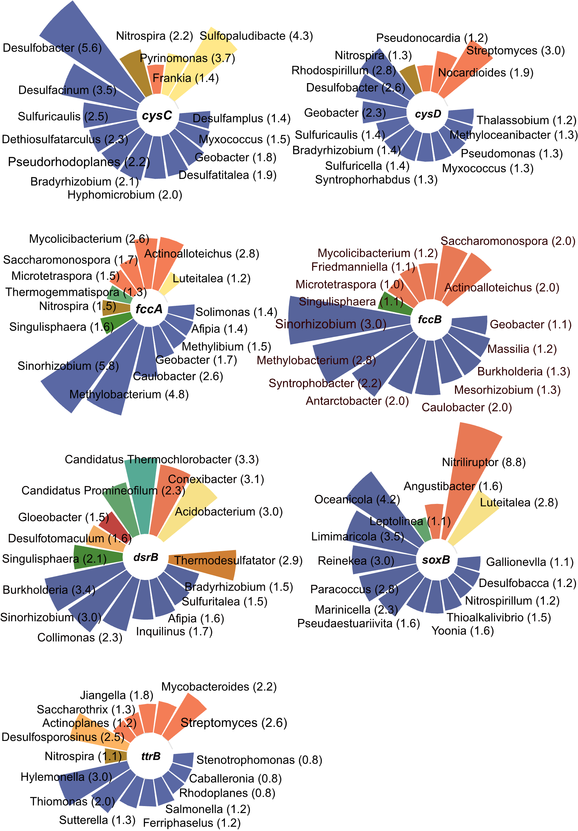
Fig. S7. A summary of key microbial taxa at the genera level involved in S cycling. The percentage of relative abundances for the top 15 abundant microbes involved in each gene family is shown in the wind rose diagrams. Numbers indicate relative abundances (%).
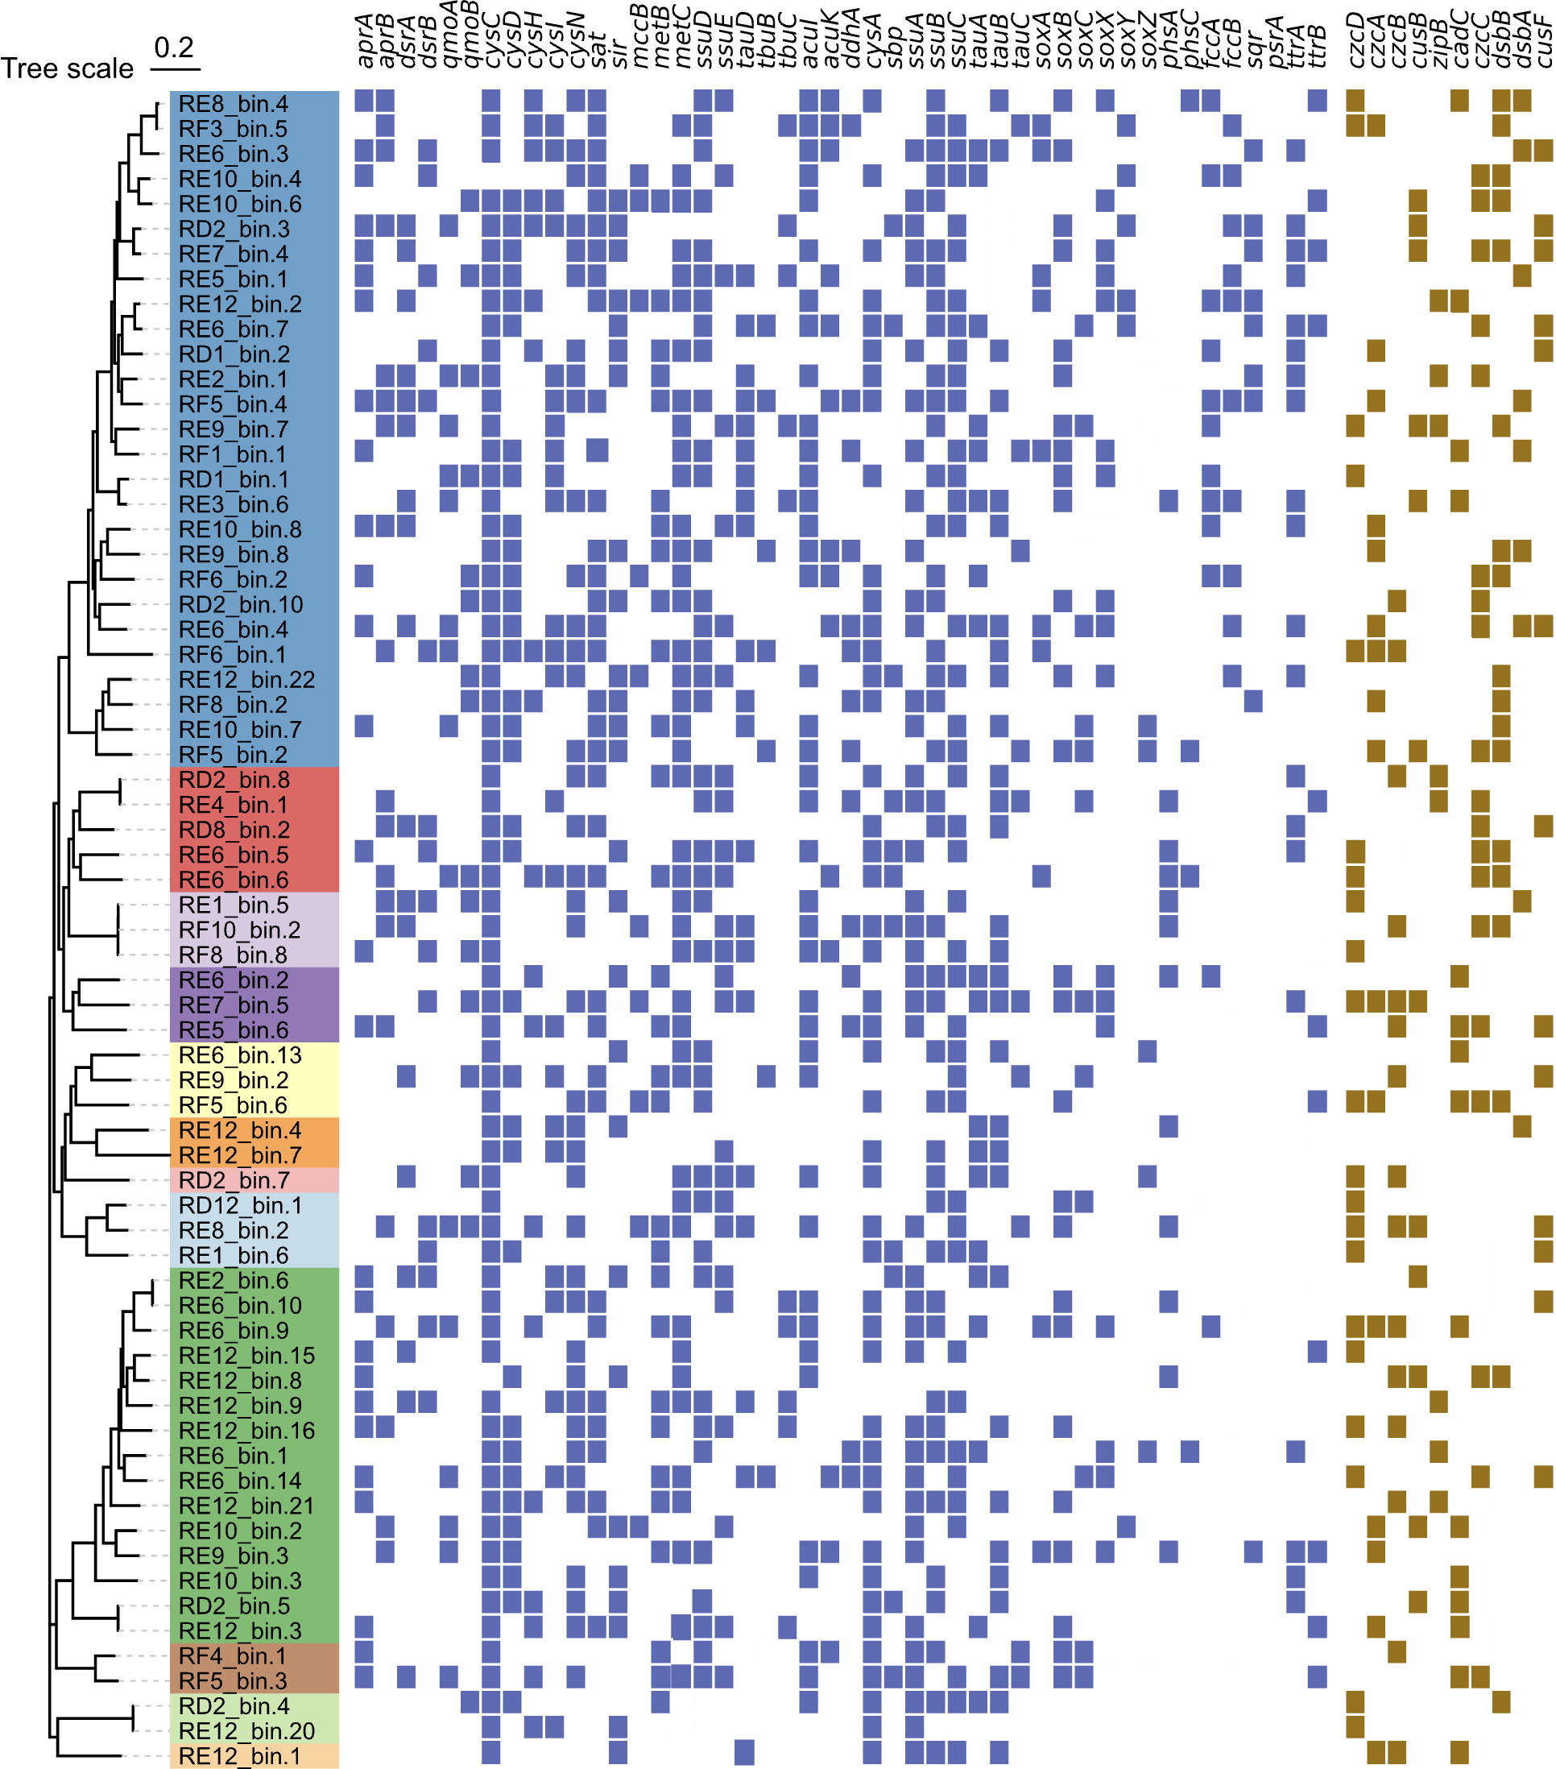
Fig. S8. Phylogenetic tree and functional characterization of the 67 high-quality bacteria MAGs. The left panel shows the construction of the maximum likelihood tree of MAGs based on the conserved marker genes from GTDB-Tk. The heatmap denotes the presence (colored) and absence (blank) of genes responsible for S-cycling (blue) and heavy metal resistance (yellow).

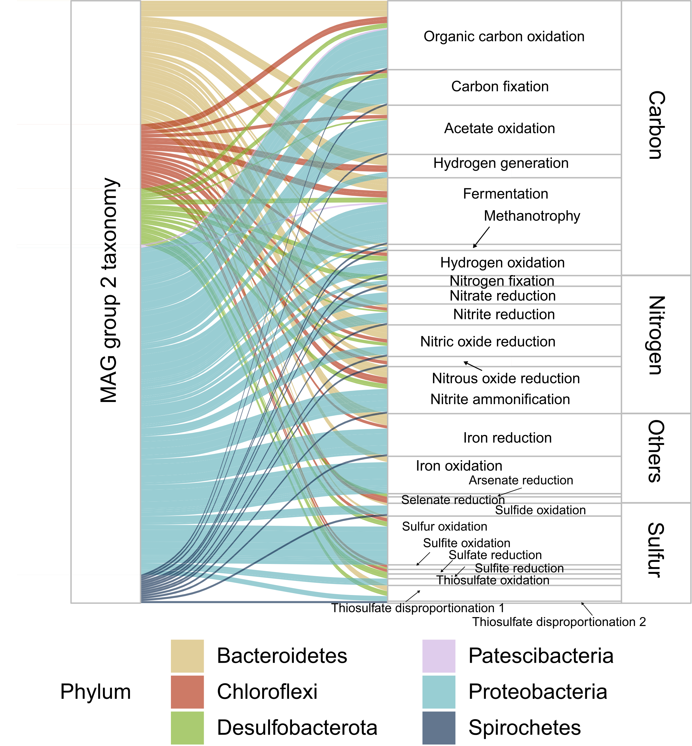
Fig. S9. Sankey plot showing the metabolic functions associated with MAGs within group 2. Width of curved lines represents the relative contribution of MAGs (left) to a given metabolic reaction (right).

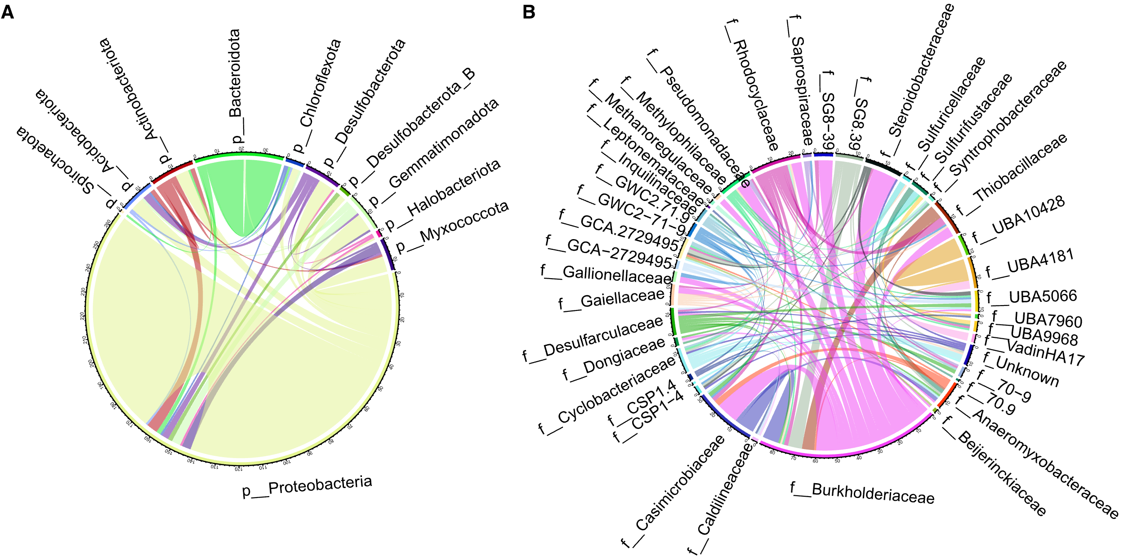
Fig. S10. Predicted HGTs within the obtained MAGs at the phylum (A) and family (B) levels. Bands connect donors and recipients, with the width of the band correlating to the number of HGTs and the color corresponding to the donors.

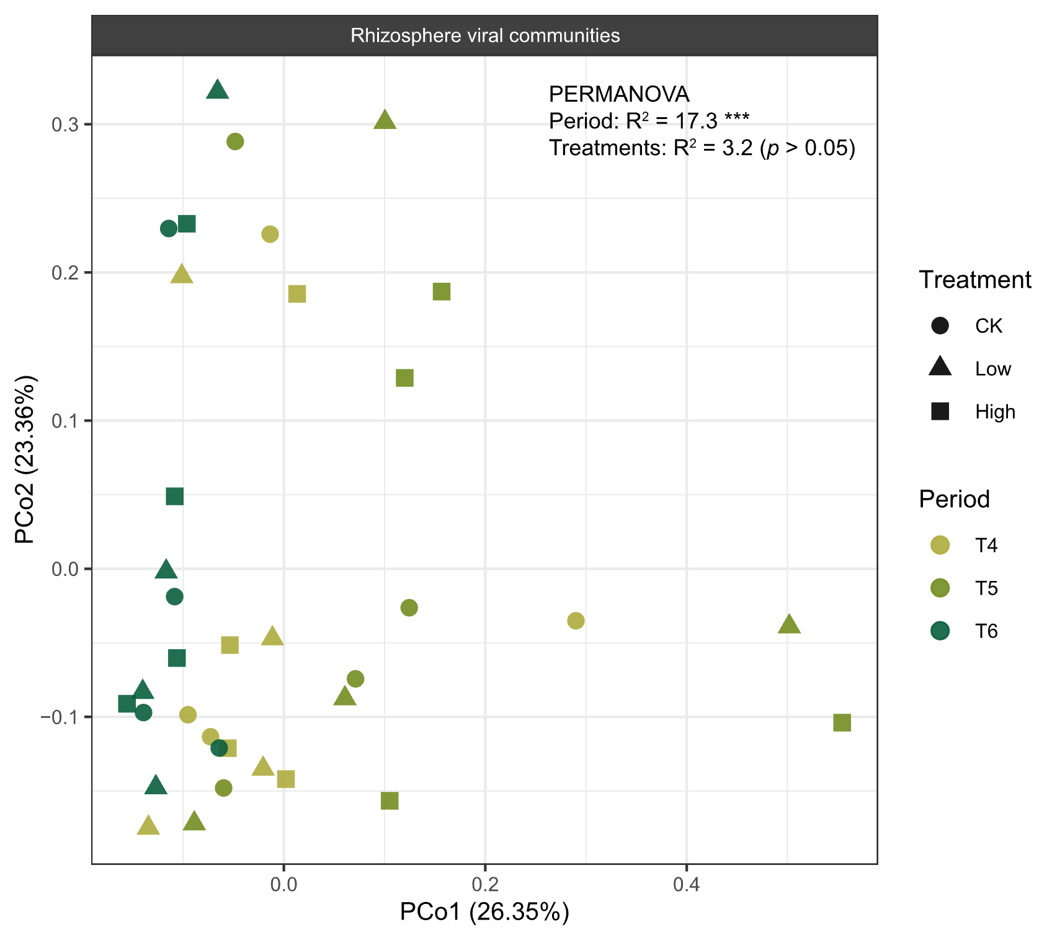
Fig. S11. Principal coordinate analysis (PCoA) based on Bray-Curtis distance matrices of viral communities in the rhizosphere soil.
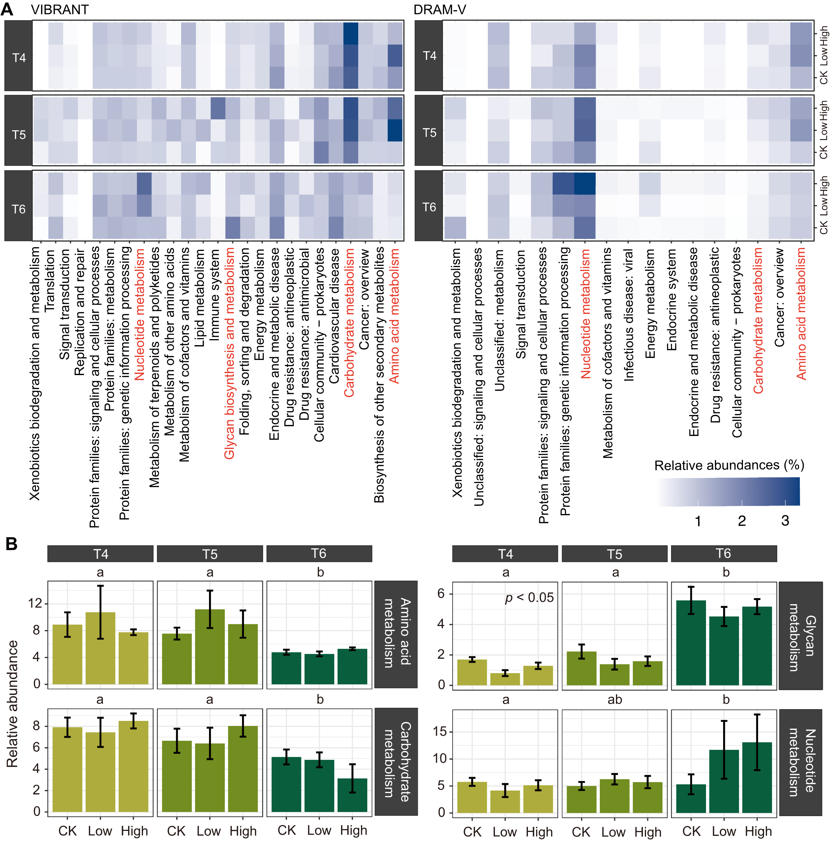
Fig. S12. Predicted virus-encoded AMG profiles. A Relative abundance of virus-encoded auxiliary metabolic genes based on KEGG level 2 according to VIBRANT and DRAM-V results. The pathways marked in red indicate their relative abundances were significantly (p < 0.05) differed between three growth stages of rice. B The bar plot indicates the cumulative relative abundances of four specific functional pathways across rice growth stages and soil amendment treatments. Different letters on the top of the plots indicate significant differences between three growth stages of rice. The p value in the plots indicate significant differences between all three treatments.

