Supplementary survey questionnaire

Participant Information Sheet

Remote Primary Healthcare Staff Survey on Workforce Retention Strategies in Remote Australia

[Information on Participant information removed]

Eligibility for participation in this research

Q1. Do you consent to participate in the survey?
- Yes
- No

Q2. Are you aged 18 years or older?
- Yes
- No

Q3. Do you have recent or current experience working for a remote health service?
- Yes
- No

Section 1: Professional Background

Q1. Instructions: Please answer the following questions to the best of your ability.
Please select your main work location (ie. where you are physically located most of the time when you are working for the remote health services).
- Small, remote or very remote community
- Larger remote community (population over 1,000)
- Other (please specify)

Q2. In what type of remote health service are you currently (or most recently) working (Select all that apply)?
- Aboriginal Community Controlled Health Services (ACCHSs)
- Government (Northern Territory Health, Queensland Health etc.)
- Private health service (Such as private allied health service, private medical practice etc.)
- Other (Please specify)

Q3. Please Indicate your profession (category)

- Remote Area Nurse or Midwife
- Aboriginal Health Practitioner or Aboriginal Health Worker
- Allied Health Professional (including pharmacy, dental)
- Administrative or support staff (eg. Receptionist, Driver, Cleaner)
- General Practitioner
- Other (please specify)

Q4. Please Indicate your profession (category)

- Remote Area Nurse or Midwife
- Aboriginal Health Practitioner or Aboriginal Health Worker
- Allied Health Professional (including pharmacy, dental)
- Administrative or support staff (eg. Receptionist, Driver, Cleaner)
- General Practitioner
- Other (please specify)

Q5. How many years and months have you been working for your current (or most recent) remote health service?

Years

Months

Q6. How safe overall do you feel in the remote community where you work (including physical, psychological and cultural safety)?
- Very unsafe
- Unsafe
- Somewhat safe
- Moderately safe
- Very safe

Q7. Does safety influence whether you keep working in your current remote health service?
- Not at all important
- Slightly important
- Moderately important
- Very important
- Extremely important

Q8. Is your current housing provided by your health service?
- Yes
- No
- Other

Q9. Does your current housing influence whether you keep working in your current remote health service?
- Not at all important
- Slightly important
- Moderately important
- Very important
- Extremely important

Section 2: Best-Worst Scale (BWS) Survey

This section of the survey aims to identify the most important features that you feel affect your decisions to remain working for the health service.

In the next ten questions, you will be shown a list of four statements about health workforce retention strategies that could be used in remote Australia.

Your views about these statements will be used to help inform health services about what are the most important things that could improve how long their staff stay.
In each question, please select an option that you most prefer (check boxes on the left side) and the one you least prefer (check boxes on the right side) for maximizing how long you work in a remote health service. There are no right or wrong answers; we just want to know what you prefer.

While questions might look the same, no set of four options are exactly the same. By answering all the questions, we will be able to figure out the overall importance of each item compared to all the other items for people like you.

The final question in this section provides an opportunity for you to tell us about any other things that you think are important for retaining staff in remote health services.
At the end of the 10 questions, there will be a chance to tell us about other things that you think are important that you did not see on the lists of statements. We have deliberately left out housing and safety in the options that you will be presented with, but you can write about them and other things that are important for your retention in the open text box at
question 11.

An example of a completed question is shown below.

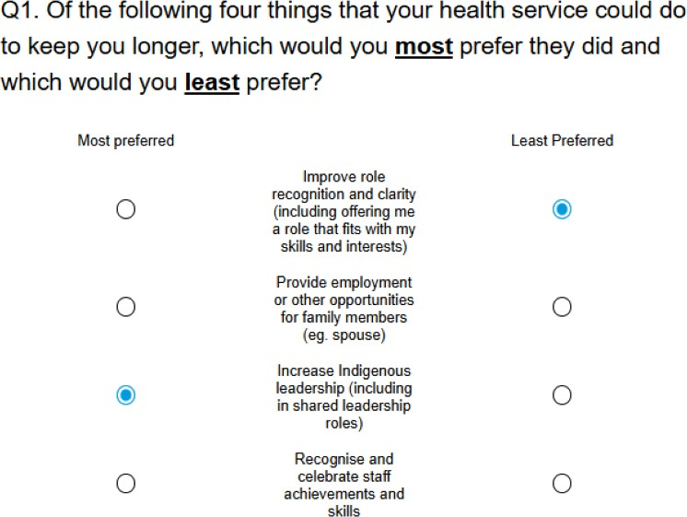
In this example, the respondent thought that Option 3 on the left; "Increase Indigenous leadership (including in shared leadership roles)" was most preferred option for their retention. They also thought Option 1 on the right "Improve role recognition and clarity (including offering me a role that fits with my skills and interests)" was the least preferred option for their retention.

Block 1

Q1 Of the following four things that your health service could do to keep you longer, which would you most prefer they did and which would you least prefer?

Most preferred |  | Least Preferred
 | Improve role recognition and clarity (including offering me a role that fits with my skills and interests)
 | Provide employment or other opportunities for family members (eg. spouse)
 | Increase Indigenous leadership (including in shared leadership roles)
 | Recognise and celebrate staff achievements and skills

Q2 Of the following four things that your health service could do to keep you longer, which would you most prefer they did and which would you least prefer?

Most preferred |  | Least Preferred
 | Provide a better rostering model and supports (eg. transport) to allow staff rotations in and out of community
 | Increase retention bonus for every 12 months of fulltime service completed (eg. by $10,000 after 12 months work)
 | Increase coordination support for personal logistics (eg. online grocery orders)
 | Increase support networks, including embedded emotional wellbeing and debriefing, and engagement with the local community

Q3 Of the following four things that your health service could do to keep you longer, which would you most prefer they did and which would you least prefer?

Most preferred |  | Least Preferred
 | Improve role recognition and clarity (including offering me a role that fits with my skills and interests)
 | Improve human resources support, including having policies and processes in place to support ongoing employment arrangements
 | Provide employment or other opportunities for family members (eg. spouse)
 | Increase retention bonus for every 12 months of fulltime service completed (eg. by $10,000 after 12 months work)

Q4 Of the following four things that your health service could do to keep you longer, which would you most prefer they did and which would you least prefer?

Most preferred |  | Least Preferred
 | Provide employment to a sufficient number of local community members.
 | Increase Indigenous leadership (including in shared leadership roles)
 | Increase capabilities of onsite manager (eg. communicates well, knowledge of, and respect for, remote Indigenous context)
 | Increase access and support for training courses and higher education or engagement in research (eg. paid courses, quarantined time)

Q5 Of the following four things that your health service could do to keep you longer, which would you most prefer they did and which would you least prefer?

Most preferred |  | Least Preferred
 | Improve role recognition and clarity (including offering me a role that fits with my skills and interests)
 | Increase Indigenous leadership (including in shared leadership roles)
 | Increase coordination support for personal logistics (eg. online grocery orders)
 | Increase support networks, including embedded emotional wellbeing and debriefing, and engagement with the local community

Q6 Of the following four things that your health service could do to keep you longer, which would you most prefer they did and which would you least prefer?

Most preferred |  | Least Preferred
 | Increase training and mentoring by local Indigenous people
 | Increase Indigenous leadership (including in shared leadership roles)
 | Increase access and support for training courses and higher education or engagement in research (eg. paid courses, quarantined time)
 | Increase support networks, including embedded emotional wellbeing and debriefing, and engagement with the local community

Q7 Of the following four things that your health service could do to keep you longer, which would you most prefer they did and which would you least prefer?

Most preferred |  | Least Preferred
 | Increase training and mentoring by local Indigenous people
 | Provide more professional mentoring appropriate to my needs
 | Improve role recognition and clarity (including offering me a role that fits with my skills and interests)
 | Offer additional annual leave and flexible time-off if needed (eg. family emergencies)

Q8 Of the following four things that your health service could do to keep you longer, which would you most prefer they did and which would you least prefer?

Most preferred |  | Least Preferred
 | Recognise and celebrate staff achievements and skills
 | Increase access and support for training courses and higher education or engagement in research (eg. paid courses, quarantined time)
 | Increase subsidies for costs of living (eg. extra $2,500 per year for housing, electricity, child care fees, school fees, airfares etc.)
 | Increase coordination support for personal logistics (eg. online grocery orders)

Q9 Of the following four things that your health service could do to keep you longer, which would you most prefer they did and which would you least prefer?

Most preferred |  | Least Preferred
 | Ensure more on-Country training (no travelling) for Indigenous staff tailored to their training needs
 | Provide employment to a sufficient number of local community members
 | Offer additional annual leave and flexible time-off if needed (eg. family emergencies)
 | Increase subsidies for costs of living (eg. extra $2,500 per year for housing, electricity, childcare fees, school fees, airfares etc.)

Q10 Of the following four things that your health service could do to keep you longer, which would you most prefer they did and which would you least prefer?

Most preferred |  | Least Preferred
 | Increase training and mentoring by local Indigenous people
 | Provide employment to a sufficient number of local community members
 | Provide employment or other opportunities for family members (eg. spouse)
 | Increase coordination support for personal logistics (eg. online grocery orders)

Q11. Are there other things your remote health service should consider doing that will support you to stay longer? If so, please explain below.
________________________________________________________________
________________________________________________________________

Section 3: Demographic Questions

Q1. Which of the following best describes the stage you are at in your working life (in remote primary health care)?
- Close to the start of my working life
- In the middle of my working life
- Towards the end of my working life

Q2. What is your gender?

- Male
- Female
- Non-binary or prefer not to choose

Q3. What is your age group?

- 18-24 years
- 25-44 years
- 45-64 years
- 65 years or above

Q4. Do you currently have a partner/spouse?

- Yes
- No

Q5. Do you have any dependents (children under 18 years) who live with you?

- Yes
- No

Q6. What is the highest level of education you have completed?
- Primary school (up to year 6)
- High school (up to year 12)
- Vocational education and training (Certificate II to IV, Diploma)
- Bachelors degree
- Masters degree, Graduate Diploma, Graduate Certificate
- Doctoral degree (PhD, DrPH, DSc)
Q7. Approximately how much do you earn per year (before tax)?
- Under $25,999
- $26,000 –$51,999
- $52,000 – $64,999
- $65,000 - $90,999
- $91,000 - $103,999
- $104,000 – $155,99
- $156,000- $181,999
- $182,000 and above
- I would rather not say

Q8. Are you of Aboriginal and/or Torres Strait Islander origin?
- Yes
- No

Q9. I have a strong sense of belonging in the community where I work.
- Strongly disagree
- Disagree
- Do not agree or disagree
- Agree
- Strongly agree

Q10. We offer every participant in this survey the opportunity to enter a prize draw to win a $500 gift voucher (one of two available). The draw will take place in late September 2025, after the survey has closed. The two winners will be contacted within two weeks of the draw.
Would you like to enter the prize draw to have a chance of winning the prize? If you would like to enter the prize draw, please select 'Yes' below and you will be directed to a separate form where you can enter your contact details.
Note that this email address and contact number will only be used to contact winners of the prize draw and will not be used to identify your responses to this survey.

Would you like to participate in the prize draw?

- Yes
- No

