Table 5. Correlation matrix between agronomic, fruit proximate, nutrient and quality parameters of fresh fruit and okra meal

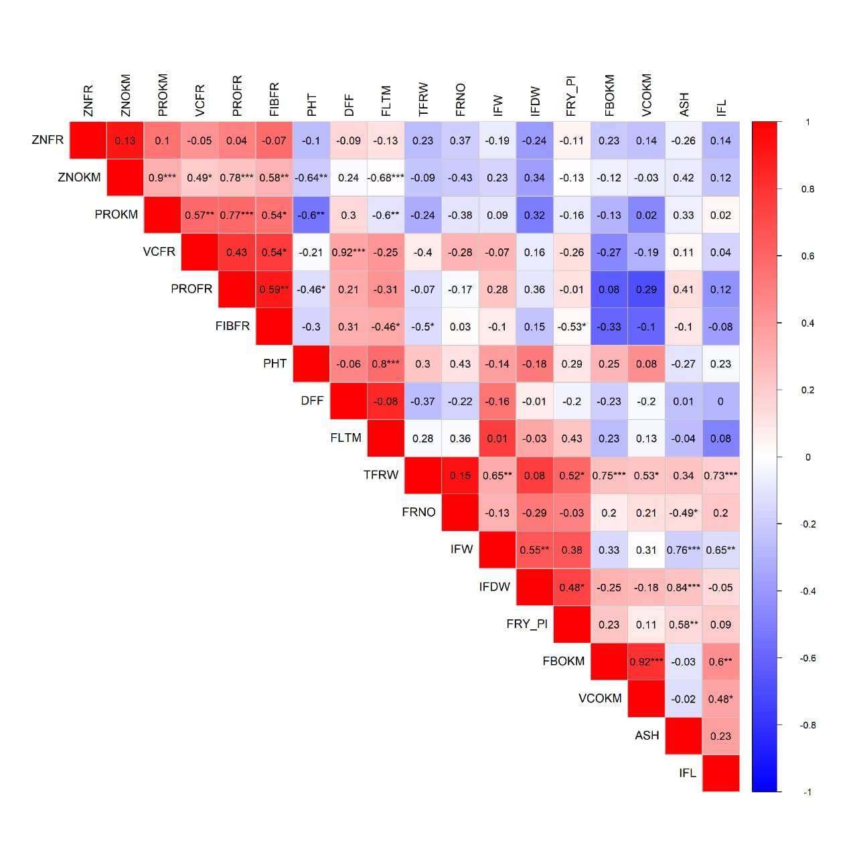
ZNFR = Zinc content in fresh fruit, ZNOM = Zinc content in okra meal, PROKM = Protein content in okra meal, VCFR = Viscosity in fresh fruit, PROFR = Protein in fresh fruit, FIBFR = Fiber in fresh fruit, PHT = Plant height, DFF = Day to anthesis, FLTM= Fruit length at maturity, TFRW= Total fruit weight, FRNO = Fruit number, IFW= Individual fruit width, IFDW = Individual fruit dry weight, FYPL = Fruit yield/plot, FBOKM = Fiber in Okra meal, VCOKM= Viscosity in okra meal, ASH = Ash in fresh fruit, IFL = Individual fruit length

