Supplementary Figures

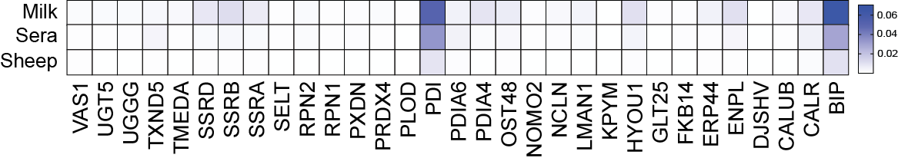
Figure S1: Endoplasmic reticulum proteins in the PM of differently fed larvae. Proteins associated with “endoplasmic reticulum” like GO terms. Normalized protein abundance is relative to total and values show mean.

