High Concentrations of Illicit Stimulants and Cutting Agents Cause False Positives on Fentanyl Test Strips

Authors: Tracy-Lynn E. Lockwood*, Alexandra Vervoordt, Marya Lieberman

Table of Contents
1. Alprazolam, Gabapentin, and Naloxone Buprenorphine Fentanyl Test Strip Reactivity 2
2. Fentanyl Test Strips in Cold (4ºC), Room Temperature (25ºC), and Warm (40^{c}C) Conditions 2

Alprazolam, Gabapentin, and Naloxone Buprenorphine Fentanyl Test Strip Reactivity
- Solutions were prepared following the procedure listed in the main text.
- FTS were dipped into solution for 12-15 seconds, set flat to dry, and photographed after 5 minutes following the manufacturer’s instructions.

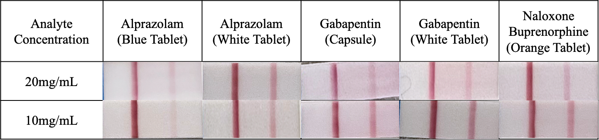

Fentanyl Test Strips in Cold (4ºC), Room Temperature (25ºC), and Warm (40^{c}C) Conditions
- Solutions were prepared following the procedure listed in the main text.
- FTS were dipped into solution for 12-15 seconds in the specified temperature condition, set flat to dry, and allowed 5 minutes to process in specific temperature condition.

