Significance codes:
p < 0.001 = *** 0.001 ≤ p < 0.01 = ** 0.01 ≤ p < 0.05 = * 0.05 ≤ p < 0.1 = . p ≥ 0.1 = ns

Following analysis of variance testing, appropriate post hoc analyses were performed using Welch’s two-sample t-tests to compare groups within each region (cortex, hippocampus, thalamus), injury (sham, traumatic brain injury), and treatment (saline, buprenorphine) condition while accounting for differences in group variance.

Abbreviations used:
GFAP – glial fibrillary acidic protein; SWELL1 (LRRC8A) – swelling-activated chloride channel protein 1; (leucine-rich repeat–containing 8A ); TRPM4 – transient receptor potential melastatin 4; AQP4 – aquaporin 4; TBI – traumatic brain injury; ctx – cortex; hippo – hippocampus; thal – thalamus

GFAP
Supplemental Table S1. Post hoc regional comparisons for GFAP expression 1 day post injury
Comparison | t(df) | p-value | Significance | 95% CI | Interpretation
TBI saline ctx vs. TBI saline hippo | -4.09(6.12) | 0.006 | ** | [-5.48, -1.39] | hippo > ctx
TBI saline ctx vs. TBI saline thal | -3.05(4.17) | 0.036 | * | [-10.85, -0.59] | thal > ctx
TBI saline hippo vs. TBI saline thal | -1.13(5.45) | 0.306 | ns | [-7.35, 2.79] | hippo = thal
TBI bup ctx vs. TBI bup hippo | -4.64(5.10) | 0.005 | ** | [-5.78, -1.67] | hippo > ctx
TBI bup ctx vs. TBI bup thal | -2.78(4.14) | 0.048 | * | [-12.05, -0.09] | thal > ctx
TBI bup hippo vs. TBI bup thal | -1.02(4.95) | 0.353 | ns | [-8.25, 3.56] | hippo = thal

Supplemental Table S2. Post hoc injury comparisons for GFAP expression 4 weeks post injury
Comparison | t(df) | p-value | Significance | 95% CI | Interpretation
TBI saline (overall) vs. sham saline (overall) | 2.91(32.62) | 0.006 | ** | [0.18, 1.00] | TBI > sham
TBI saline ctx vs. sham saline ctx | 1.94(10.70) | 0.079 | . | [-0.04, 0.59] | TBI > sham (trend)
TBI saline hippo vs. sham saline hippo | 1.81(10.16) | 0.100 | . | [-0.15, 1.47] | TBI > sham (trend)
TBI saline thal vs. sham saline thal | 2.16(5.89) | 0.074 | . | [-0.12, 1.84] | TBI > sham (trend)
TBI bup (overall) vs. sham bup (overall) | -0.15(31.04) | 0.884 | ns | [-0.39, 0.34] | TBI = sham
TBI bup ctx vs. sham bup ctx | -0.71(7.00) | 0.501 | ns | [-0.32, 0.17] | TBI = sham
TBI bup hippo vs. sham bup hippo | -1.82(6.58) | 0.115 | ns | [-1.11, 0.15] | TBI = sham
TBI bup thal vs. sham bup thal | 1.43(8.37) | 0.190 | ns | [-0.30, 1.29] | TBI = sham

Supplemental Table S3. Post hoc regional comparisons for GFAP expression 4 weeks post injury
Comparison | t(df) | p-value | Significance | 95% CI | Interpretation
sham saline ctx vs. sham saline hippo | -1.83(5.93) | 0.118 | ns | [-1.26, 0.18] | ctx = hippo
sham saline ctx vs. sham saline thal | -1.59(9.32) | 0.146 | ns | [-0.55, 0.09] | ctx = thal
sham saline hippo vs. sham saline thal | 1.03(6.60) | 0.341 | ns | [-0.42, 1.04] | hippo = thal
TBI saline ctx vs. TBI saline hippo | -3.59(8.70) | 0.006 | ** | [-1.50, -0.34] | hippo > ctx
TBI saline ctx vs. TBI saline thal | -2.04(5.87) | 0.088 | . | [-1.79, 0.16] | thal > ctx (trend)
TBI saline hippo vs. TBI saline thal | 0.25(8.40) | 0.811 | ns | [-0.91, 1.13] | hippo = thal
sham bup ctx vs. sham bup hippo | -7.59(8.18) | <0.001 | *** | [-1.06, -0.56] | hippo > ctx
sham bup ctx vs. sham bup thal | -1.12(5.54) | 0.309 | ns | [-0.68, 0.26] | ctx = thal
sham bup hippo vs. sham bup thal | 2.89(7.74) | 0.021 | * | [0.12, 1.08] | hippo > thal
TBI bup ctx vs. TBI bup hippo | -1.53(6.43) | 0.173 | ns | [-1.04, 0.23] | hippo > ctx (trend)
TBI bup ctx vs. TBI bup thal | -2.52(6.01) | 0.045 | * | [-1.53, -0.02] | thal > ctx
TBI bup hippo vs. TBI bup thal | -0.98(9.69) | 0.351 | ns | [-1.23, 0.48] | hippo = thal

Supplemental Table S4. Post hoc treatment comparisons for GFAP expression 4 weeks post injury
Comparison | t(df) | p-value | Significance | 95% CI | Interpretation
sham saline (overall) vs. sham bup (overall) | -1.13(35.17) | 0.264 | ns | [-0.48, 0.14] | saline = bup
sham saline ctx vs. sham bup ctx | -0.84(7.35) | 0.430 | ns | [-0.31, 0.14] | saline = bup
sham saline hippo vs. sham bup hippo | -1.18(6.21) | 0.280 | ns | [-1.07, 0.37] | saline = bup
sham saline thal vs. sham bup thal | -0.30(8.37) | 0.774 | ns | [-0.56, 0.43] | saline = bup
TBI saline (overall) vs. TBI bup (overall) | 1.99(35.77) | 0.055 | . | [-0.01, 0.89] | saline > bup (trend)
TBI saline ctx vs. TBI bup ctx | 1.83(10.92) | 0.095 | . | [-0.05, 0.59] | saline > bup (trend)
TBI saline hippo vs. TBI bup hippo | 2.34(10.74) | 0.040 | * | [0.04, 1.53] | saline > bup
TBI saline thal vs. TBI bup thal | 0.63(9.41) | 0.546 | ns | [-0.78, 1.38] | saline = bup

SWELL1
Supplemental Table S5. Post hoc injury comparisons for SWELL1 expression 4 weeks post injury
Comparison | t(df) | p-value | Significance | 95% CI | Interpretation
TBI saline (overall) vs. sham saline (overall) | 1.76(33.26) | 0.087 | . | [-0.02, 0.30] | TBI > sham (trend)
TBI saline ctx vs. sham saline ctx | 2.91(9.23) | 0.017 | * | [0.06, 0.46] | TBI > sham
TBI saline hippo vs. sham saline ctx | 0.70(6.90) | 0.507 | ns | [-0.21, 0.39] | TBI = sham
TBI saline thal vs. sham saline thal | 0.41(8.09) | 0.694 | ns | [-0.14, 0.21] | TBI = sham

Supplemental Table S6. Post hoc regional comparisons for SWELL1 expression 4w post injury
Comparison | t(df) | p-value | Significance | 95% CI | Interpretation
sham saline ctx vs. sham saline hippo | -2.14(8.39) | 0.063 | . | [-0.61, 0.02] | hippo > ctx (trend)
sham saline ctx vs. sham saline thal | 0.86(9.88) | 0.411 | ns | [-0.14, 0.30] | ctx = thal
sham saline hippo vs. sham saline thal | 2.83(7.84) | 0.023 | * | [0.07, 0.69] | hippo > thal
TBI saline ctx vs. TBI saline hippo | -1.73(12.00) | 0.109 | ns | [-0.28, 0.03] | ctx = hippo
TBI saline ctx vs. TBI saline thal | 4.90(10.63) | 0.001 | ** | [0.17, 0.46] | ctx > thal
TBI saline hippo vs. TBI saline thal | 6.83(10.60) | <0.001 | *** | [0.30, 0.58] | hippo > thal
sham bup ctx vs. sham bup hippo | -2.04(11.00) | 0.066 | . | [-0.55, 0.02] | hippo > ctx (trend)
sham bup ctx vs. sham bup thal | 0.38(9.28) | 0.715 | ns | [-0.34, 0.48] | ctx = thal
sham bup hippo vs. sham bup thal | 1.99(7.57) | 0.083 | . | [-0.06, 0.72] | hippo > thal (trend)
TBI bup ctx vs. TBI bup hippo | -0.82(5.73) | 0.443 | ns | [-0.32, 0.16] | ctx = hippo
TBI bup ctx vs. TBI bup thal | -1.58(5.58) | 0.170 | ns | [-0.44, 0.10] | ctx = thal
TBI bup hippo vs. TBI bup thal | -0.66(9.87) | 0.533 | ns | [-0.41, 0.22] | hippo = thal

Supplemental Table S7. Post hoc treatment comparisons for SWELL1 expression 4w post injury
Comparison | t(df) | p-value | Significance | 95% CI | Interpretation
sham saline (overall) vs. sham bup (overall) | -1.47(35.95) | 0.150 | ns | [-0.32, 0.05] | saline = bup
sham saline ctx vs. sham bup ctx | -1.05(10.36) | 0.315 | ns | [-0.42, 0.15] | saline = bup
sham saline hippo vs. sham bup hippo | -0.73(8.82) | 0.484 | ns | [-0.42, 0.22] | saline = bup
sham saline thal vs. sham bup thal | -0.93(6.88) | 0.383 | ns | [-0.54, 0.23] | saline = bup
TBI saline (overall) vs. TBI bup (overall) | 0.79(35.95) | 0.433 | ns | [-0.08, 0.19] | saline = bup
TBI saline ctx vs. TBI bup ctx | 3.31(8.71) | 0.010 | ** | [0.06, 0.32] | saline > bup
TBI saline hippo vs. TBI bup hippo | 2.18(7.85) | 0.062 | . | [-0.01, 0.48] | saline > bup (trend)
TBI saline thal vs. TBI bup thal | -2.64(6.30) | 0.037 | * | [-0.57, -0.02] | bup > saline

TRPM4
Supplemental Table S8. Post hoc regional comparisons for TRPM4 expression 1 day post injury
Comparison | t(df) | p-value | Significance | 95% CI | Interpretation
TBI saline ctx vs. TBI saline hippo | 3.20(5.04) | 0.024 | * | [0.35, 3.12] | ctx > hippo
TBI saline ctx vs. TBI saline thal | 1.94(7.95) | 0.089 | . | [-0.28, 3.18] | ctx > thal (trend)
TBI saline hippo vs. TBI saline thal | -0.48(4.89) | 0.654 | ns | [-1.78, 1.23] | hippo = thal
TBI bup ctx vs. TBI bup hippo | 7.17(7.77) | <0.001 | *** | [1.51, 2.96] | ctx > hippo
TBI bup ctx vs. TBI bup thal | 3.04(5.27) | 0.027 | * | [0.32, 3.55] | ctx > thal
TBI bup hippo vs. TBI bup thal | -0.48(4.91) | 0.650 | ns | [-1.92, 1.31] | hippo = thal

Supplemental Table S9. Post hoc injury comparisons for TRPM4 expression 4 weeks post injury
Comparison | t(df) | p-value | Significance | 95% CI | Interpretation
TBI saline (overall) vs. sham saline (overall) | 2.18(35.82) | 0.036 | * | [0.09, 2.52] | TBI > sham
TBI saline ctx vs. sham saline ctx | 4.01(10.31) | 0.002 | ** | [1.27, 4.41] | TBI > sham
TBI saline hippo vs. sham saline hippo | 2.19(8.33) | 0.059 | . | [-0.09, 3.88] | TBI > sham (trend)
TBI saline thal vs. sham saline thal | -1.23(7.38) | 0.258 | ns | [-3.36, 1.05] | TBI = sham
TBI bup (overall) vs. sham bup (overall) | 0.60(23.39) | 0.551 | ns | [-1.27, 2.33] | TBI = sham
TBI bup ctx vs. sham bup ctx | -1.44(8.93) | 0.184 | ns | [-2.48, 0.55] | TBI = sham
TBI bup hippo vs. sham bup hippo | 0.65(5.79) | 0.542 | ns | [-1.74, 2.99] | TBI = sham
TBI bup thal vs. sham bup thal | 0.90(6.87) | 0.397 | ns | [-3.32, 7.40] | TBI = sham

Supplemental Table S10. Post hoc regional comparisons for TRPM4 expression 4 weeks post injury
Comparison | t(df) | p-value | Significance | 95% CI | Interpretation
sham saline ctx vs. sham saline hippo | -1.53(7.72) | 0.167 | ns | [-3.26, 0.67] | ctx = hippo
sham saline ctx vs. sham saline thal | -0.83(7.20) | 0.431 | ns | [-2.97, 1.42] | ctx = thal
sham saline hippo vs. sham saline thal | 0.46(9.86) | 0.657 | ns | [-1.99, 3.02] | hippo = thal
TBI saline ctx vs. TBI saline hippo | -0.48(11.23) | 0.643 | ns | [-1.96, 1.26] | ctx = hippo
TBI saline ctx vs. TBI saline thal | 4.47(10.50) | 0.001 | ** | [1.62, 4.81] | ctx > thal
TBI saline hippo vs. TBI saline thal | 5.80(10.98) | <0.001 | *** | [2.21, 4.92] | hippo > thal
sham bup ctx vs. sham bup hippo | -3.21(10.76) | 0.009 | ** | [-2.45, -0.45] | hippo > ctx
sham bup ctx vs. sham bup thal | 0.45(6.64) | 0.669 | ns | [-1.91, 2.79] | ctx = thal
sham bup hippo vs. sham bup thal | 2.00(5.82) | 0.094 | . | [-0.44, 4.23] | hippo > thal (trend)
TBI bup ctx vs. TBI bup hippo | -2.82(8.22) | 0.022 | * | [-5.51, -0.56] | hippo > ctx
TBI bup ctx vs. TBI bup thal | -1.20(5.72) | 0.278 | ns | [-7.87, 2.74] | ctx = thal
TBI bup hippo vs. TBI bup thal | 0.21(6.92) | 0.841 | ns | [-4.89, 5.84] | hippo = thal

Supplemental Table S11. Post hoc treatment comparisons for TRPM4 expression 4 weeks post injury
Comparison | t(df) | p-value | Significance | 95% CI | Interpretation
sham saline (overall) vs. sham bup (overall) | 1.02(28.33) | 0.317 | ns | [-0.06, 0.18] | saline = bup
sham saline ctx vs. sham bup ctx | 0.24(10.79) | 0.818 | ns | [-0.10, 0.13] | saline = bup
sham saline hippo vs. sham bup hippo | 0.41(6.09) | 0.699 | ns | [-0.24, 0.34] | saline = bup
sham saline thal vs. sham bup thal | 1.86(9.57) | 0.095 | . | [-0.02, 0.23] | saline > bup (trend)
TBI saline (overall) vs. TBI bup (overall) | 2.82(29.53) | 0.009 | ** | [0.03, 0.18] | saline > bup
TBI saline ctx vs. TBI bup ctx | -0.45(8.63) | 0.664 | ns | [-0.17, 0.11] | saline = bup
TBI saline hippo vs. TBI bup hippo | 5.82(9.86) | <0.001 | *** | [0.16, 0.35] | saline > bup
TBI saline thal vs. TBI bup thal | 2.71(6.81) | 0.031 | * | [0.01, 0.17] | saline > bup

AQP4
Supplemental Table S12. Post hoc regional comparisons for AQP4 expression 1 day post injury
Comparison | t(df) | p-value | Significance | 95% CI | Interpretation
TBI saline ctx vs. TBI saline hippo | -0.87(4.84) | 0.427 | ns | [-0.39, 0.19] | ctx = hippo
TBI saline ctx vs. TBI saline thal | 3.34(6.59) | 0.014 | * | [0.12, 0.71] | ctx > thal
TBI saline hippo vs. TBI saline thal | 7.00(6.13) | <0.001 | *** | [0.33, 0.69] | hippo > thal
TBI bup ctx vs. TBI bup hippo | -3.23(4.85) | 0.024 | * | [-0.41, -0.04] | hippo > ctx
TBI bup ctx vs. TBI bup thal | 3.61(7.03) | 0.009 | ** | [0.15, 0.71] | ctx > thal
TBI bup hippo vs. TBI bup thal | 6.51(4.39) | 0.002 | ** | [0.38, 0.92] | hippo > thal

Supplemental Table S13. Post hoc injury comparisons for AQP4 expression 4 weeks post injury
Comparison | t(df) | p-value | Significance | 95% CI | Interpretation
TBI saline (overall) vs. sham saline (overall) | 0.59(23.10) | 0.561 | ns | [-0.08, 0.15] | TBI = sham
TBI saline ctx vs. sham saline ctx | 2.64(10.40) | 0.024 | * | [0.02, 0.24] | TBI > sham
TBI saline hippo vs. sham saline hippo | 0.16(6.04) | 0.878 | ns | [-0.27, 0.31] | TBI = sham
TBI saline thal vs. sham saline thal | -1.13(7.17) | 0.296 | ns | [-0.14, 0.05] | TBI = sham
TBI bup (overall) vs. sham bup (overall) | -0.31(34.67) | 0.755 | ns | [-0.10, 0.07] | TBI = sham
TBI bup ctx vs. sham bup ctx | 2.73(9.24) | 0.023 | * | [0.03, 0.31] | TBI > sham
TBI bup hippo vs. sham bup hippo | -4.19(9.75) | 0.002 | ** | [-0.28, -0.09] | sham > TBI
TBI bup thal vs. sham bup thal | -0.52(8.13) | 0.614 | ns | [-0.15, 0.09] | TBI = sham

Supplemental Table S14. Post hoc regional comparisons for AQP4 expression 4 weeks post injury
Comparison | t (df) | p-value | Significance | 95% CI | Interpretation
sham saline ctx vs. sham saline hippo | -1.74(6.09) | 0.131 | ns | [-0.50, 0.08] | ctx = hippo
sham saline ctx vs. sham saline thal | -6.07(9.97) | <0.001 | *** | [-0.43, -0.20] | thal > ctx
sham saline hippo vs. sham saline thal | -0.90(5.98) | 0.405 | ns | [-0.40, 0.19] | hippo = thal
TBI saline ctx vs. TBI saline hippo | -1.96(11.83) | 0.073 | . | [-0.20, 0.01] | hippo > ctx (trend)
TBI saline ctx vs. TBI saline thal | -3.80(8.95) | 0.004 | ** | [-0.22, -0.06] | thal > ctx
TBI saline hippo vs. TBI saline thal | -1.06(8.41) | 0.317 | ns | [-0.14, 0.05] | hippo = thal
sham bup ctx vs. sham bup hippo | -3.32(11.98) | 0.006 | ** | [-0.29, -0.06] | hippo > ctx
sham bup ctx vs. sham bup thal | -3.89(10.10) | 0.003 | ** | [-0.35, -0.10] | thal > ctx
sham bup hippo vs. sham bup thal | -0.86(10.31) | 0.411 | ns | [-0.18, 0.08] | hippo = thal
TBI bup ctx vs. TBI bup hippo | 3.25(6.95) | 0.014 | * | [0.05, 0.32] | ctx > hippo
TBI bup ctx vs. TBI bup thal | -0.40(7.54) | 0.699 | ns | [-0.16, 0.11] | ctx = thal
TBI bup hippo vs. TBI bup thal | -5.72(8.29) | <0.001 | *** | [-0.29, -0.12] | thal > hippo

Supplemental Table S15. Post hoc treatment comparisons for AQP4 expression 4 weeks post injury
Comparison | t (df) | p-value | Significance | 95% CI | Interpretation
sham saline (overall) vs. sham bup (overall) | -1.01(34.91) | 0.321 | ns | [-1.60, 0.54] | saline = bup
sham saline ctx vs. sham bup ctx | -1.54(10.65) | 0.152 | ns | [-2.06, 0.37] | saline = bup
sham saline hippo vs. sham bup hippo | -1.27(6.22) | 0.248 | ns | [-2.92, 0.91] | saline = bup
sham saline thal vs. sham bup thal | 0.30(9.94) | 0.770 | ns | [-2.39, 3.14] | saline = bup
TBI saline (overall) vs. TBI bup (overall) | 0.27(27.03) | 0.789 | ns | [-1.63, 2.13] | saline = bup
TBI saline ctx vs. TBI bup ctx | 3.67(10.98) | 0.004 | ** | [1.18, 4.73] | saline > bup
TBI saline hippo vs. TBI bup hippo | 0.27(7.27) | 0.800 | ns | [-2.14, 2.67] | saline = bup
TBI saline thal vs. TBI bup thal | -1.34(5.42) | 0.235 | ns | [-8.12, 2.48] | saline = bup

Supplemental Table S16. AQP4/GFAP overlap
Comparison | t(df) | p-value | Significance | 95% CI | Interpretation
GFAP signal overlapping with AQP4 (saline vs. bup) | 1.76(8) | 0.117 | ns | [-0.10, 0.72] | Trend toward reduced AQP4 localization within GFAP-positive astrocytic processes in bup-treated animals
AQP4 signal overlapping with GFAP (saline vs. bup) | -0.08(8) | 0.940 | ns | [-0.26, 0.25] | No difference in the fraction of AQP4 signal overlapping with GFAP between groups

Supplemental Table S17. Dextran clearance two-way ANOVA results
Factor | df | Sum sq | Mean sq | F-value | p-value | Significance | Interpretation
injury | 1 | 32 | 31.9 | 0.177 | 0.678 | ns | No effect of sham vs. TBI on clearance
treatment | 1 | 135 | 135.4 | 0.753 | 0.396 | ns | No effect of saline vs. bup on clearance
injury:treatment | 1 | 1247 | 1247.0 | 6.939 | 0.016 | * | Effect of combination of injury & treatment taken together on clearance
Residuals | 20 | 3594 | 179.7 | -- | -- | -- | --

Supplemental Table S18. Post-hoc dextran clearance analysis
Comparison (factor being assessed) | t(df) | p-value | Significance | 95% CI | Interpretation
TBI-saline vs. TBI-bup (treatment with TBI) | -2.93(10) | 0.015 | * | [-33.72, -4.61] | Effect of bup in TBI
sham-saline vs. sham-bup (treatment in sham) | 1.10(10) | 0.297 | ns | [-9.90, 29.23] | No effect of bup in sham
TBI-saline vs. sham-saline (injury with saline) | 1.54(10) | 0.154 | ns | [-5.37, 29.59] | No effect of injury with saline
TBI-bup vs. sham-bup (injury with bup) | -2.19(10) | 0.053 | . | [-33.73, 0.283] | Trend effect of injury with bup

Supplemental Table S19. Post hoc BH-adjusted dextran clearance t-test with pooled SD
 | sham-saline | sham-bup | TBI-saline
sham-bup | 0.34 | -- | --
TBI-saline | 0.27 | 0.76 | --
TBI-bup | 0.45 | 0.13 | 0.13

Supplemental Figure 1. Representative western blot for GFAP with corresponding total protein
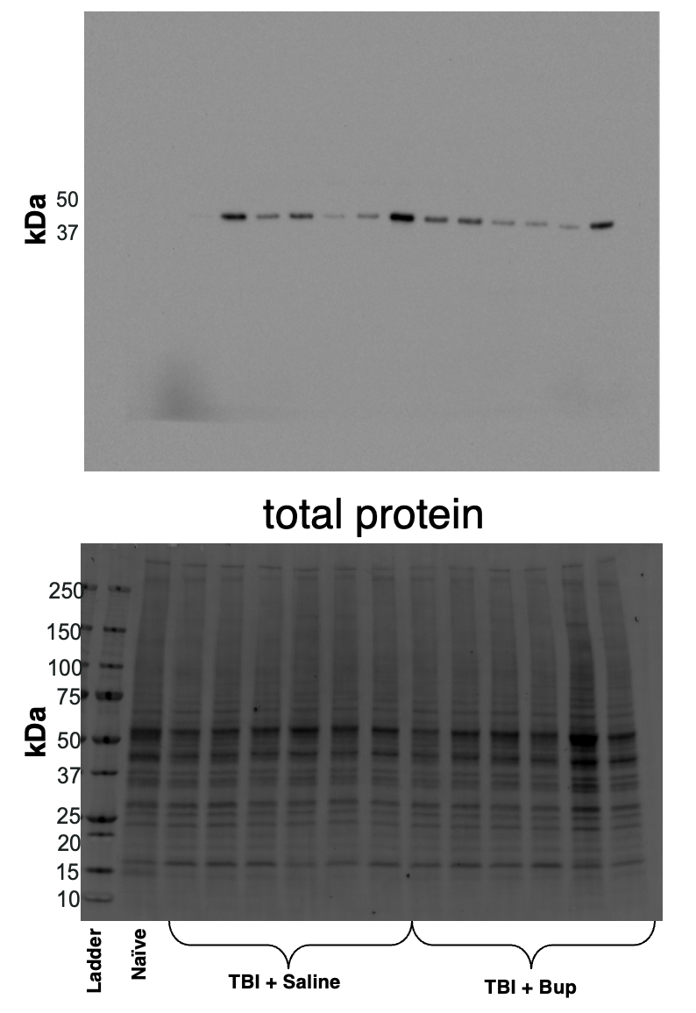

Supplemental Figure 2. Representative western blot for SWELL1 with corresponding total protein
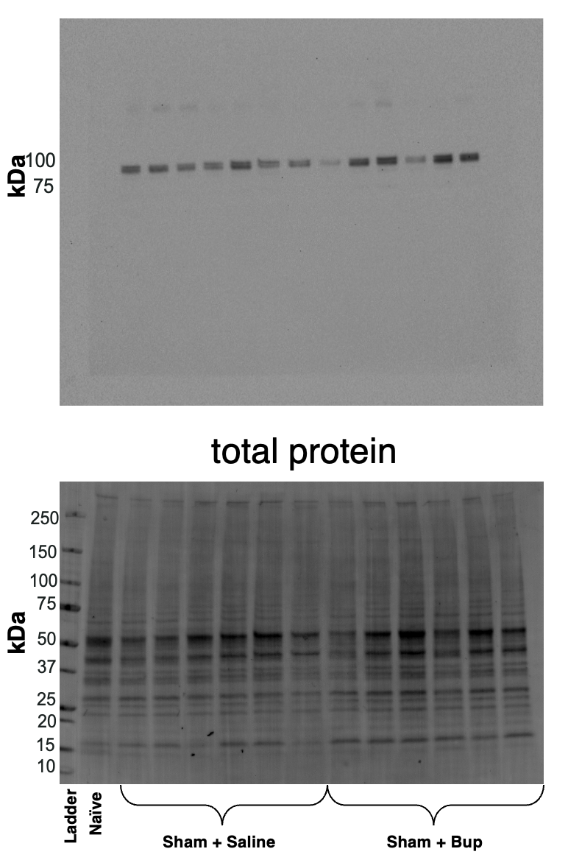

Supplemental Figure 3. Representative western blot for TRPM4 with corresponding total protein
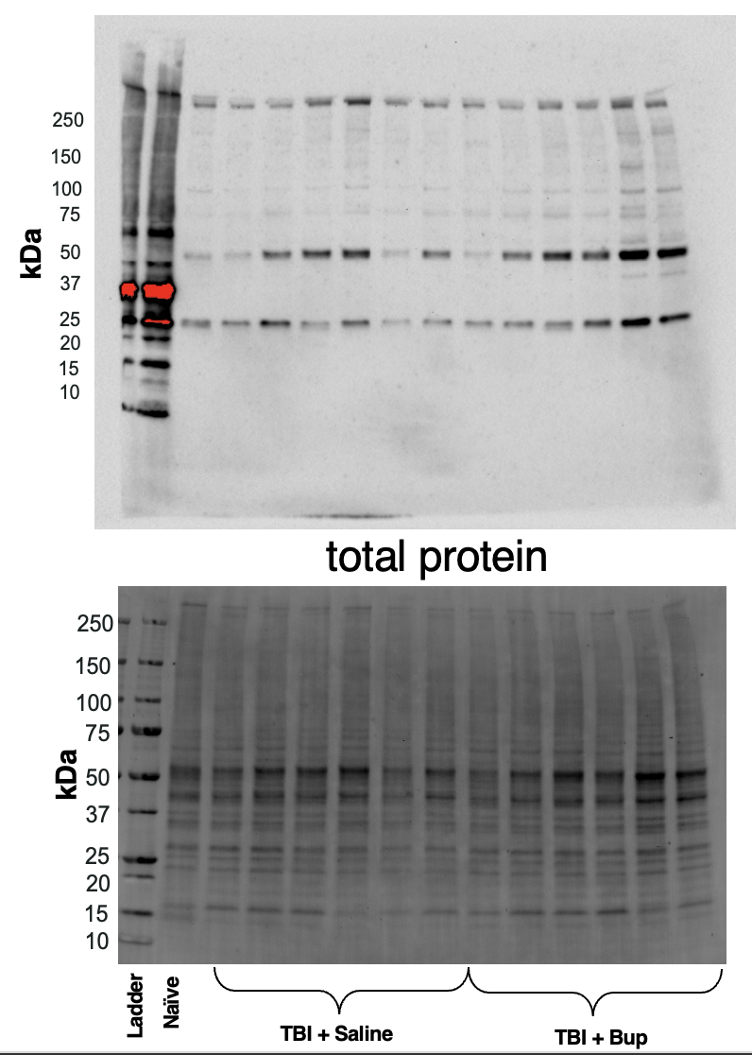

Supplemental Figure 4. Representative western blot for AQP4 with corresponding total protein
