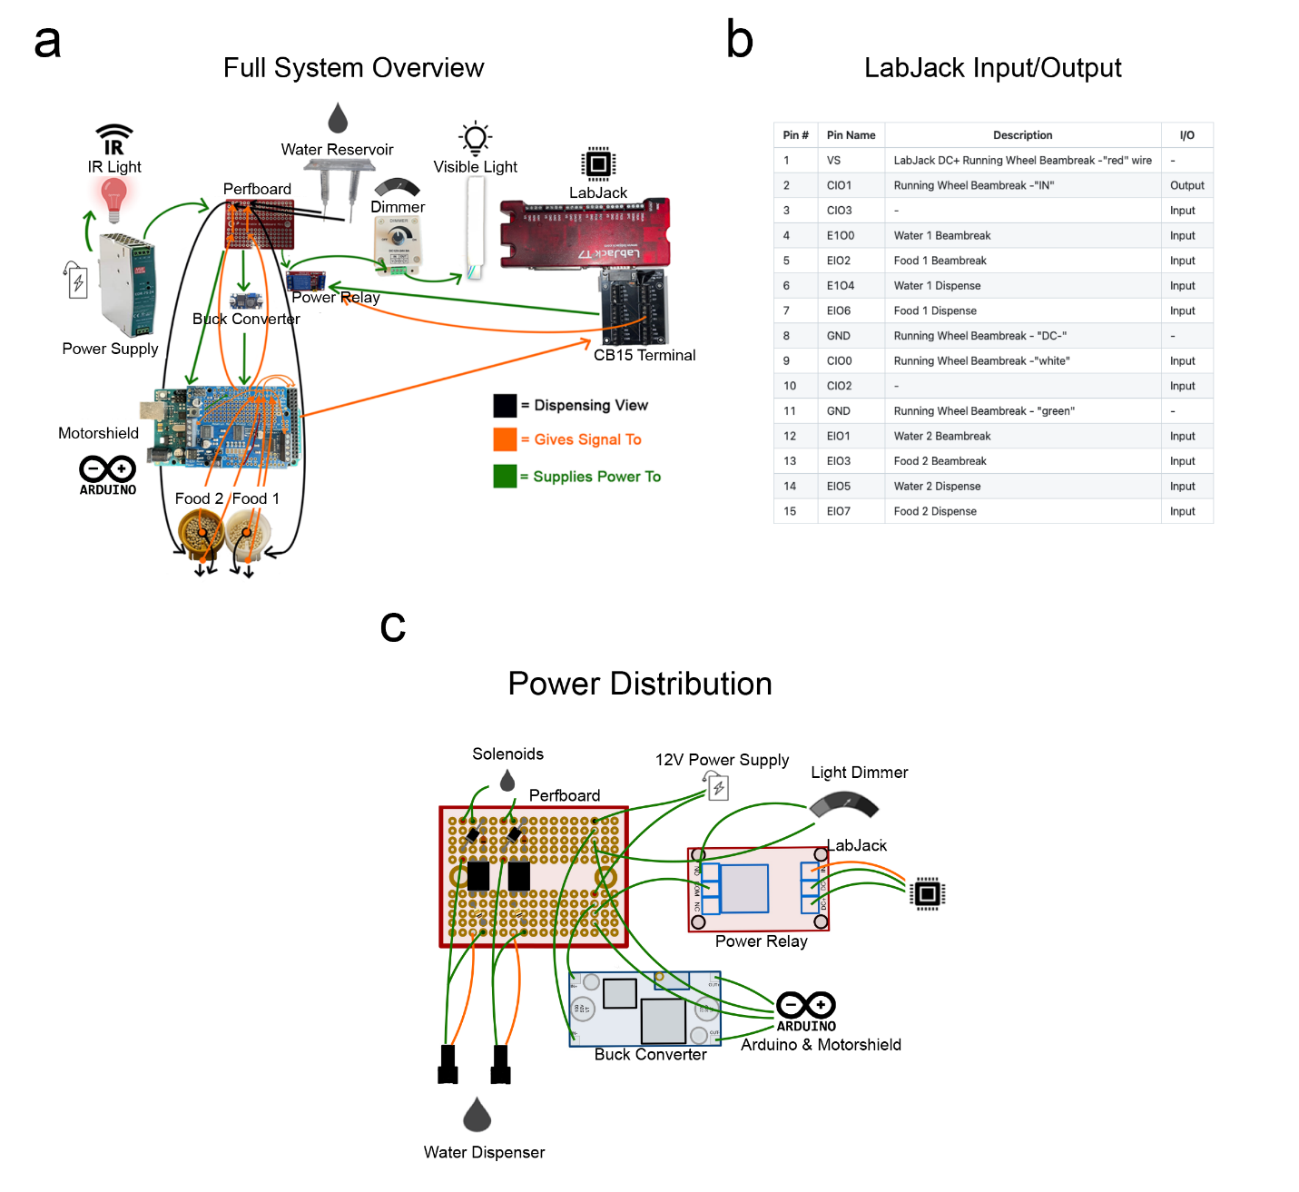Supplemental figure 1. Electrical Components and flow of information and power in the DHC. (a) Overview diagram of voltage signals across the power, control (Arduino and Motor shield), recording systems (Arduino to LabJack), and light control. The three main flows of voltage in the DHC are shown: dispensing outputs (black), animal recording signals (orange), and power (green). These are consistent across the rest of the figure. (b) Ports used on the LabJack CB15 Terminal Board for recording data inputs as .csv files. (c) Front view of the power distribution circuit panel made of a red-solderable power distribution perfboard, a buck converter set to 9V which supplies power to the motorshield to turn pellet dispensers, and a power relay board (set to high level trigger) which uses conditional input from a LabJack T7 to differentially distribute power to key components of the system. The left half of the power distribution perfboard houses two solenoid valve driving circuits and a 12V rail from which power is distributed to an Arduino Mega 2560, a buck converter, and a power relay board which controls the visible LED.

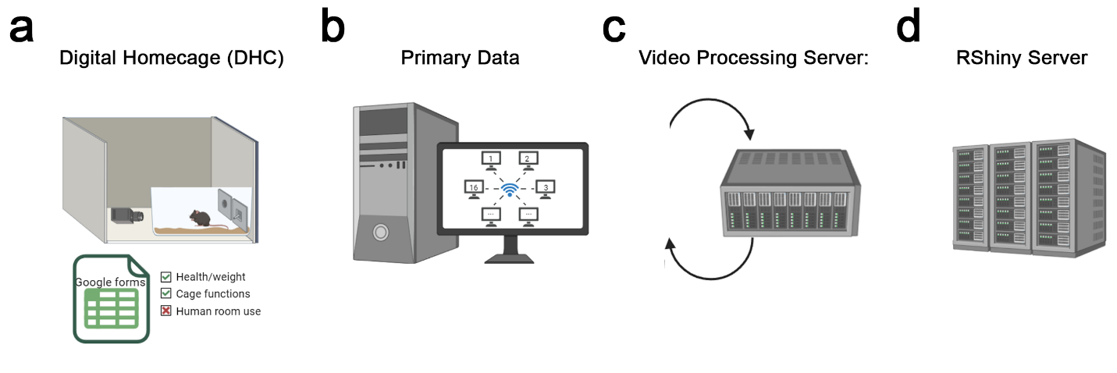
Supplemental figure 2. Data transfer, backup, and storage for processing. (a) The DHC stores food/water beambreaks, dispenses, running wheel positions, and video data and integrates with a Google sheet generated for entries during researcher daily checks. (b) Food, water and wheel data is saved to .csv with POSIX timestamps with auto-backup to both warm and cold storage servers. Computer control allows LabJack-encoded data (food, water and running wheel) as .csv in real time on local drives and automatically backed up to nearby RAID arrays and then university cold storage. (c) Video data are processed post-hoc by HomeCageScan on a dedicated server, and output files are .csv, with behaviors demarcated as having started in particular frames. An additional column is added to the .csv denoting the POSIX time of each behavioral start/end frame. (d) RShiny Server uploads data from warm storage server for daily and offline processing.
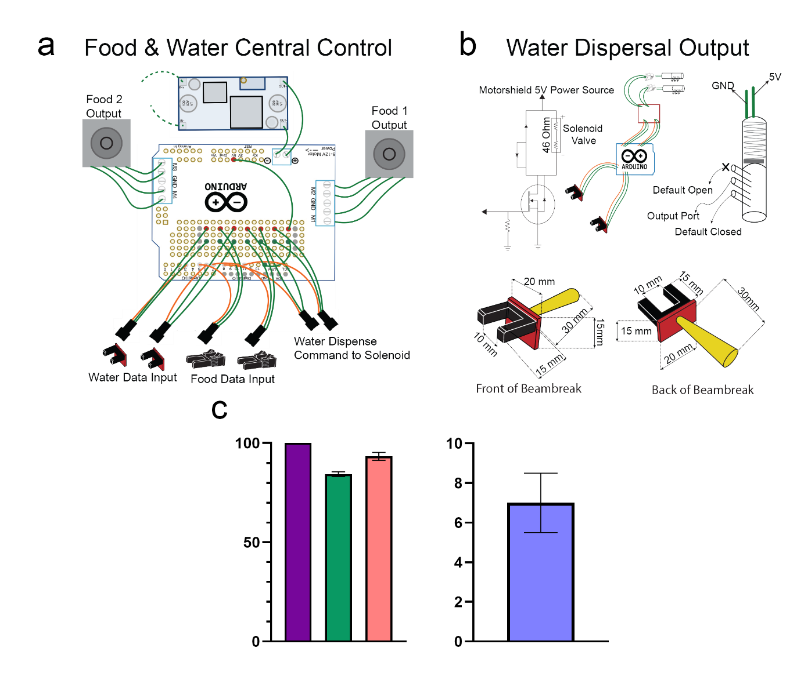
Supplemental figure 3. Food and Water control in the DHC. (a) To control food and water dispensing, an Adafruit Motor Shield v2 is mounted onto an Arduino Mega 2564. The Motor Shield distributes stepped down voltage (from 12V to 9V) from the Buck converter to mechanical elements. Six male 3-pin connectors are soldered onto the Motor Shield. Two of these connectors provide constant 5V of Power and a conditional logical output to the Solenoid Valve Driving Circuit, the latter only in the event of a beam break at one of the water ports. The other four 3-pin connectors interface with the Beambreak Assemblies located at each dispensing port. Colors of wires as in Figure S1. (b) Solenoid Valve Driving Circuit mediates water dispensing via control of the conditional opening of the appropriate solenoid valve. The 5 V solenoid valves (right) can be opened and closed to control the flow of water through the connected tubes. Additionally, each dispensing port is fitted with a Beambreak Assembly made of a photointerruptor, a female 3-pin connector providing power, and a 220 Ω current-limiter resistor. A digital signal is sent to the Motor Shield whenever the beam of the photointerruptor is broken (water-port assembly shown here). Colors of wires as in Fig. S1. (c) The purple bar represents the number of beambreak events (n = 100), green represents the dispense events (84.3 ± 1.2), and salmon represents the pellets dispensed (93.3 ± 2.0). The periwinkle bar represents the dispensing events with multiple pellets (7 ± 1.5). All beambreaks resulted in a motor turn.

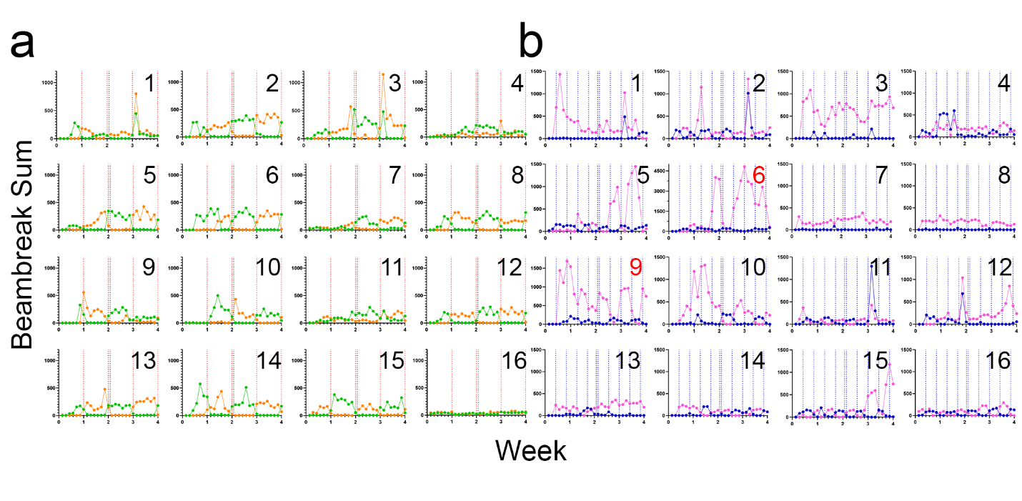
Supplemental figure 4: Individual eating and drinking habits. Each graph illustrates the total beambreak sum for each day of the experiment for every individual animal. Eating habits are shown with orange lines to represent the fatty food and green lines for normal food (a), and drinking habits are shown with pink lines to represent sucrose water and blue lines for normal water (b). The vertical red dotted lines represent the food swap days, and the vertical blue dotted lines represent the water swap days. Mouse ID numbers are found in the top right corner of each graph, and those marked in red have different scales on the y-axis to account for increased consumption.

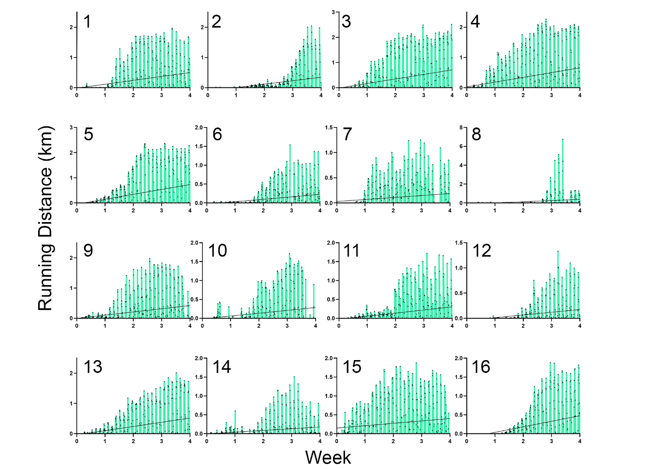
Supplemental figure 5: Individual actigraphy habits. Each graph illustrates the distance ran in kilometers for each day of the experiment for every individual animal. Mouse ID numbers are found in the top left corner of each graph. Each black dot represents the distance run during one hour of the day, so each teal bar includes 24 dots to represent one day. The line on each graph is a regression line to illustrate the trend of increased wheel running as the experiment progresses.
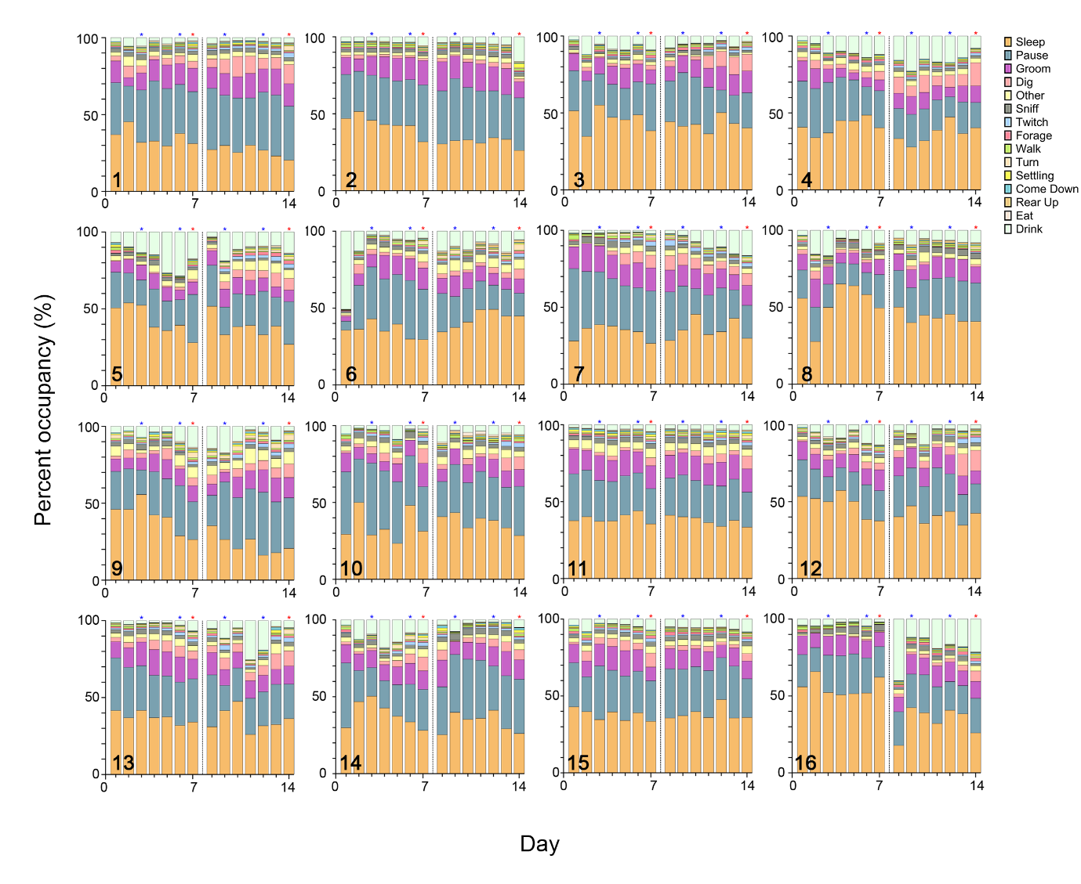
Supplemental figure 6. Daily behavioral breakdown of HCS video behavior. Graphs are shown for each animal individually housed in the DHC as annotated by number in bottom left of each plot. Plots show the percentage of daily time spent doing each of the behaviors listed at right (colors in graph correspond to each behavior). Data is plotted across the first 14 days of DHC housing- the ‘Acclimation period’.

Supplemental Table 1. DHC Cost Breakdown

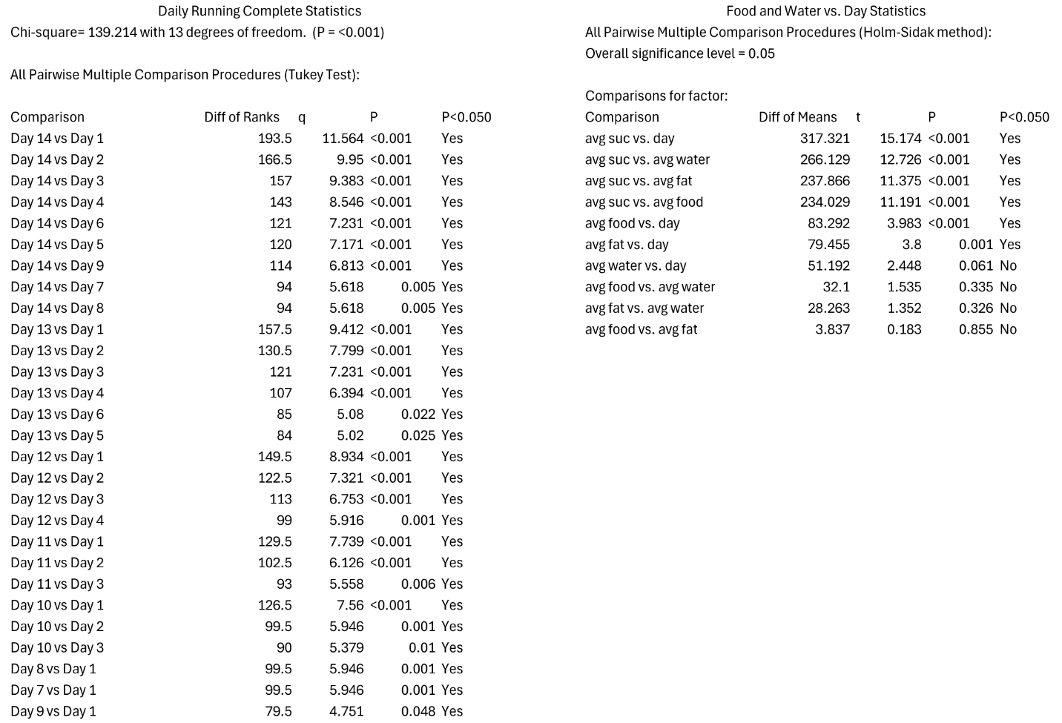

Supplemental Table 2. Complete Statistics

