Supplementary Figure 1. Flow Chart

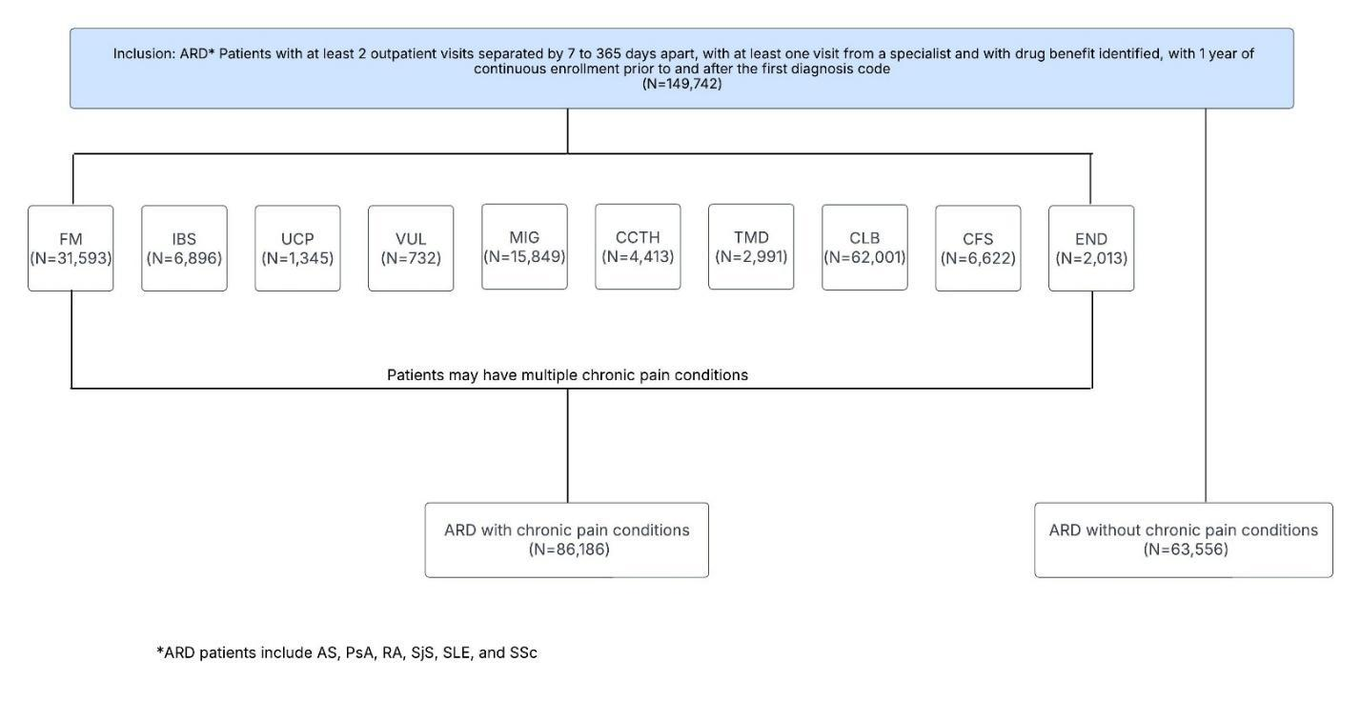

Supplementary Table. Statistical Testing
 | Statistic | Period Prior to 2015  (2008–2014) | Period After 2015  (2015–2024) | Difference | Z-Score for Difference | P-value for Difference
Prescriptions | Mean | 9.31 | 8.53 | -0.79 | -11.56 | < 0.0001
Categories | Mean | 2.16 | 2.06 | -0.10 | -9.96 | < 0.0001
MQS | Mean | 3.93 | 3.67 | -0.26 | -8.71 | < 0.0001
≥5 medications | Proportion | 0.49 | 0.46 | -0.03 | -12.38 | < 0.0001
≥10 prescriptions | Proportion | 0.31 | 0.29 | -0.02 | -10.22 | < 0.0001

Supplementary Figure 2. Number of Prescriptions by COPC in Ankylosing Spondylitis
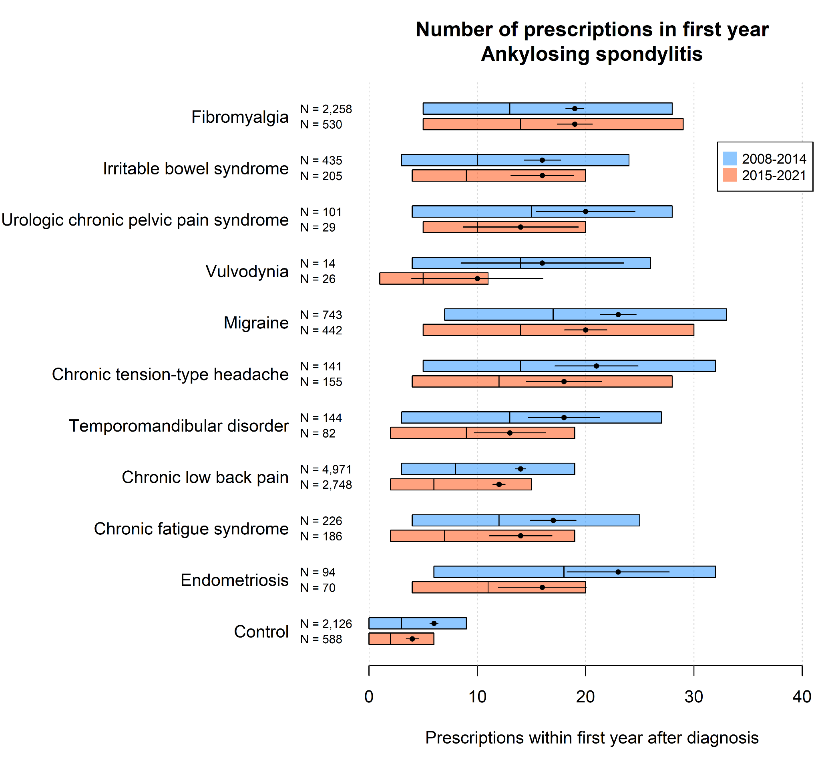
Supplementary Figure 3. Number of Prescriptions by COPC in Psoriatic Arthritis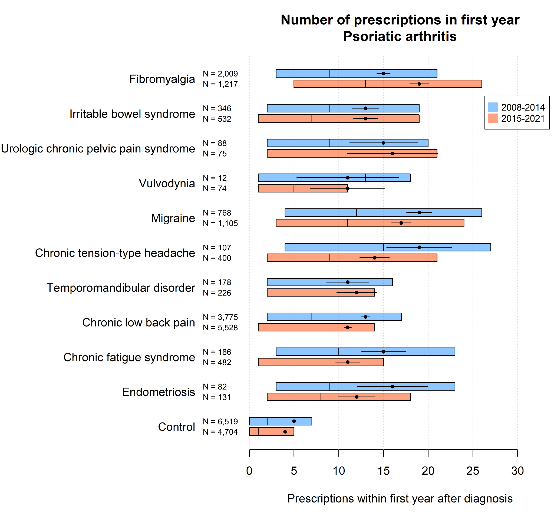
Supplementary Figure 4. Number of Prescriptions by COPC in Rheumatoid Arthritis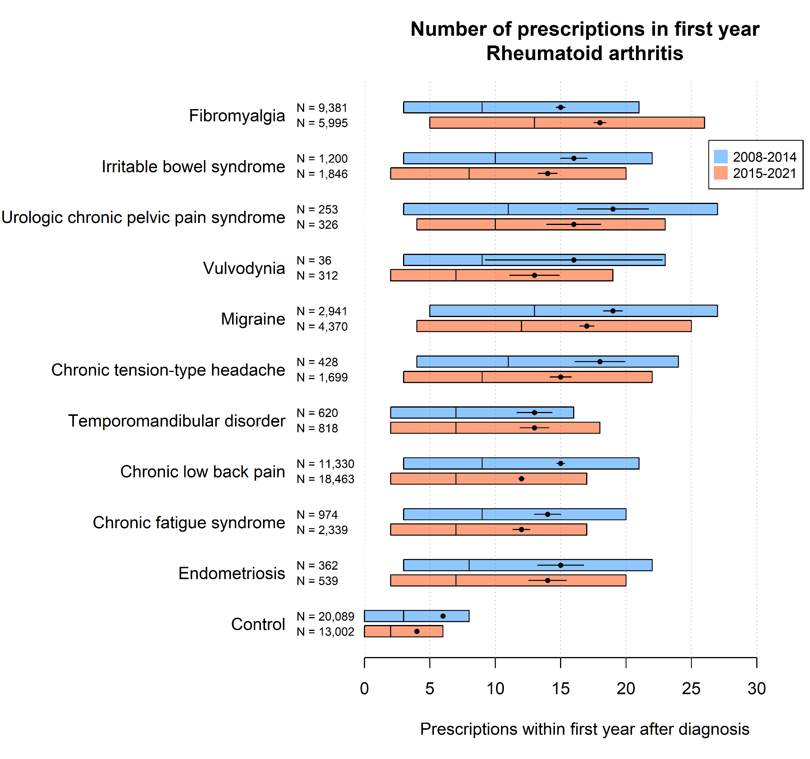
Supplementary Figure 5. Number of Prescriptions by COPC in Sjogren’s disease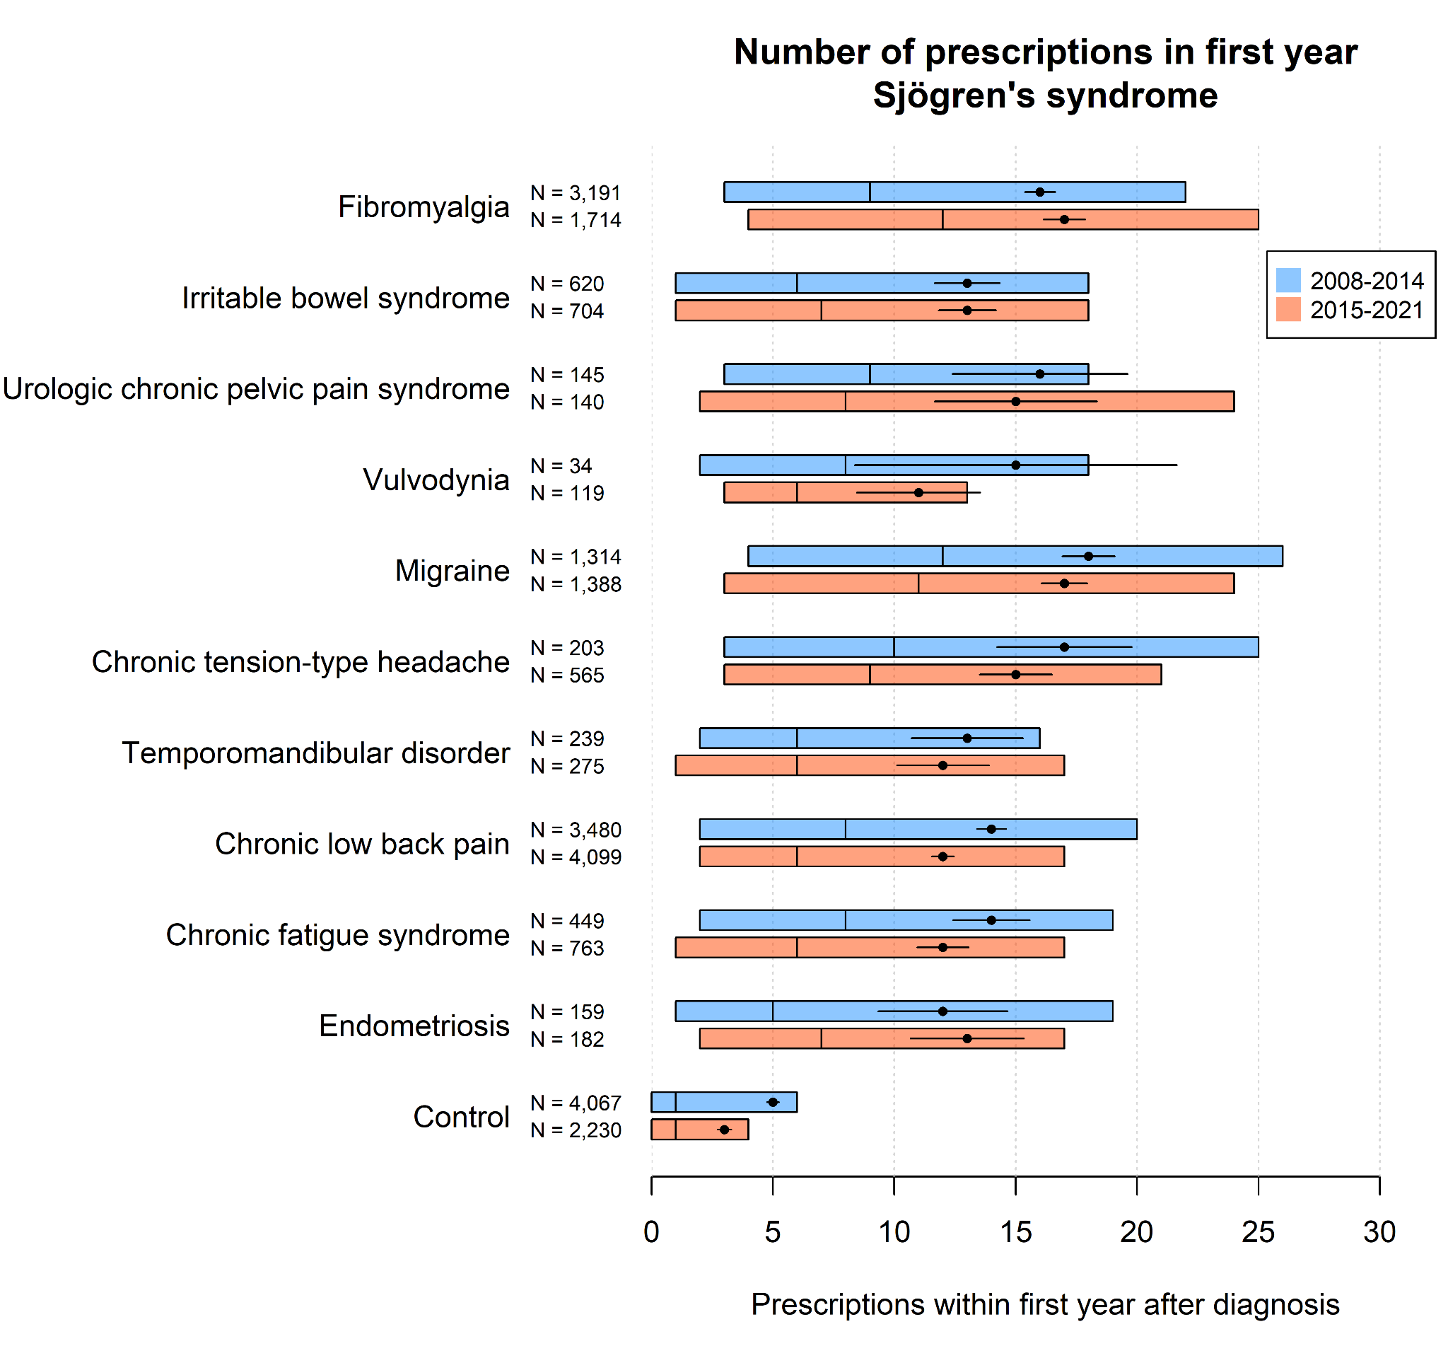
Supplementary Figure 6. Number of Prescriptions by COPC in Systemic Lupus Erythematosus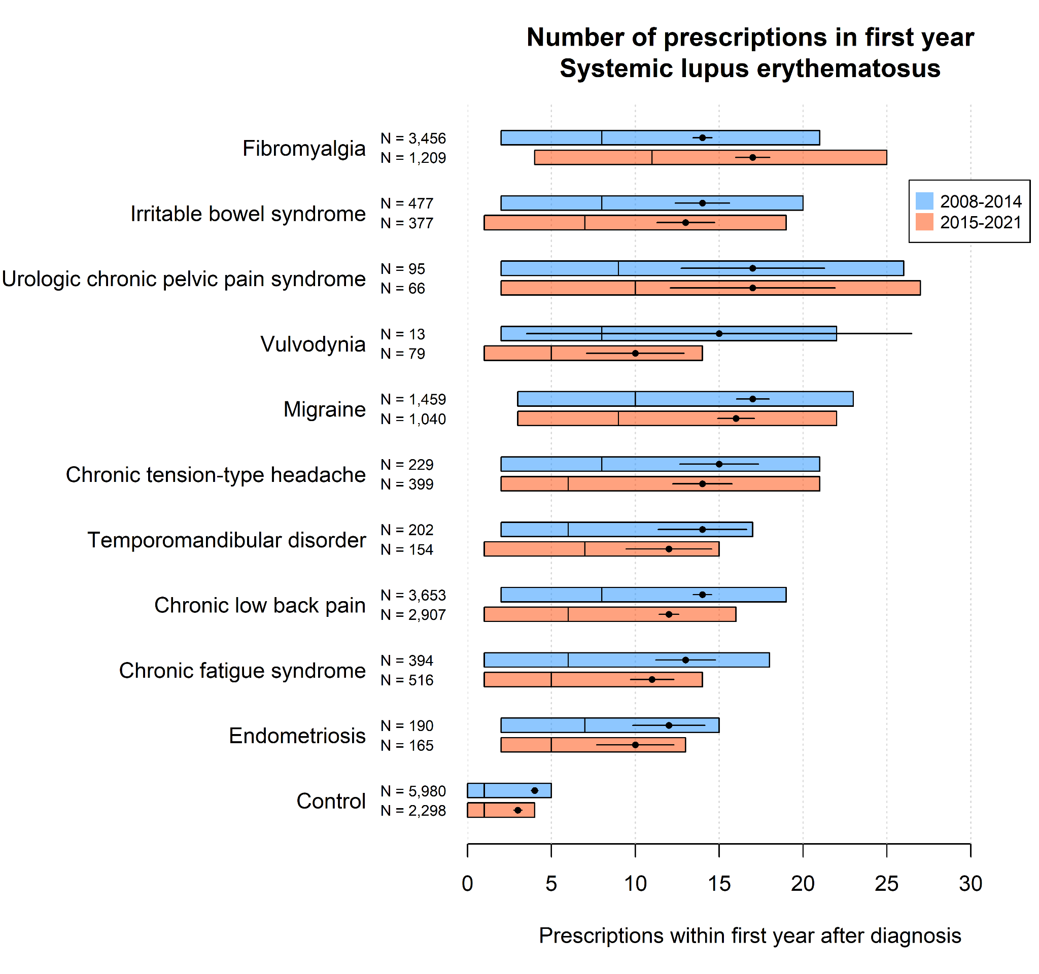
Supplementary Figure 7. Number of Prescriptions by COPC in Systemic Sclerosis 