Supplementary information for
Sustainable development trade-offs shape the acceptability of climate mitigation scenarios

This file includes:
Supplementary Notes
Supplementary Figures
References

Other Supplementary Material for this manuscript includes:
Original data used to create the figures

Supplementary Notes

Supplementary Note 1. Narratives, scenarios and paths
Scenarios essentially offer a structured exploration of potential future developments, built upon a defined set of assumptions. By envisioning diverse futures and evaluating their consequences under different actions, scenarios provide insights into strategic decision-making^{1,2}. Although scenarios typically use quantitative methods to assess future trajectories, they are often preceded by qualitative narratives that capture these numeric projections in words. Narrative elements are essential to provide a general context to paths³.

The workflow of the scenario creation is summarized in the steps shown in figure S1. We conceptualized and quantified four climate mitigation pathways with a common target of 1.83 ºC by 2050 (SD = 0.001 ºC). This shared climate target is obtained in the paths with the moderate levels of population and minimum EROI for solar and wind, and without activating the climate change impacts (see table S2). Three pathways assume exponential carbon tax growth, reaching 300 $2015/tCO₂eq by 2050, consistent with historical trends and estimates for a 1.5 ºC trajectory. Additional international efforts beyond 2050 remain necessary according to WILIAM. The 1.83 ºC outcome is delivered by the most limiting mitigation scenario (S1-TLD) when testing policies in the model. This exercise is intended to illustrate how SDG interactions are affected by the general context rather than to propose a definitive 1.5 ºC pathway. Such a scenario requires closer alignment with empirical political and technological data, and refined projection methodologies.

Figure S2 shows a conceptual position of these scenarios based on their dependence on demand-side social and supply-side technological solutions. Three are based on existing literature on three topics: technological changes in the supply side of systems, reductions in the demand side due to lifestyle changes, and the promotion of measures aiming to restore natural carbon sinks. The four is a middle-of-the-road scenario combining lower intense policies of the previous three. Three scenarios are grounded in existing literature, focusing respectively on technological changes on the supply side, demand reductions driven by lifestyle changes, and measures to restore natural carbon sinks. A fourth, middle-of-the-road scenario, combines the less stringent policies of the preceding three. The attributes defining the level of change are summarized in table S1. The specific policies applied in WILIAM to reproduce these attributes is shown in table S2. Finally, the final numeric values that WILIAM assume can be found in the scenario_parameters.xlsx of the Zenodo repository (https://doi.org/10.5281/zenodo.19066849). The scenarios reflect the following characteristics:
- Provide a range of potential futures addressing socio-economic challenges.
- Incorporate various scenario assumptions related to key systems: energy (both demand and supply), technological advancements, land-use changes^{3,4}, and behavioural shifts (e.g., lifestyle).
- Demonstrate significance in terms of mitigation, sharing a common goal of decarbonisation scenarios.
- Consider a sustainable perspective aligned with global sustainable development in the narrative, offering “more truly” sustainable goals beyond the reference scenario.
- Promotion of an energy transition towards energy efficiency and dominant presence of renewable energies.
- Consider a sustainable perspective aligned with global sustainable development in the narrative, offering “more truly” sustainable paths beyond the reference scenario.

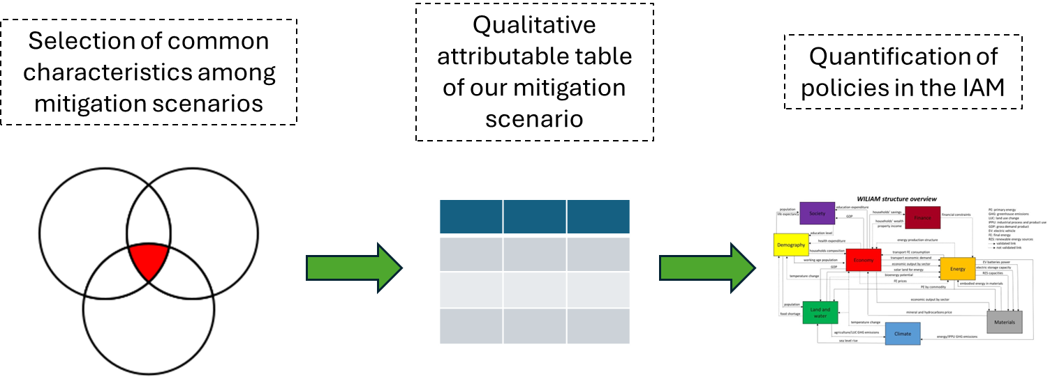
Figure S 1. Steps to build a mitigation scenario, according to Van Vuuren et al.³ .

Narrative 1: Technology-led decarbonization (TLD). Decarbonization of society relies primarily on technological solutions such as the vast expansion of renewable energy, the electrification of transport, alternative production processes in carbon-intense sectors such as steel and cement, a deep retrofitting of the building stock, and a general technology-driven decarbonization across all value chains, including agriculture. This is achieved through massive public and private technology and infrastructure investments and deregulation to speed up technology deployment. By mid-century, fossil fuels are phased out of the power system through explicit bans, accelerating renewable deployment and integration as the backbone of decarbonization. Revenues from carbon pricing are recycled primarily to finance the energy transition, with public policy placing strong emphasis on retrofitting existing infrastructure and advancing large-scale electrification. Emerging technologies—including electrolysers, carbon capture and storage, and floating offshore wind—reach technological maturity and assume a central role in system transformation. On the land side, energy crops and forest biomass are prioritized alongside improved mineral recycling, linking land-use strategies with energy and material transitions. Agriculture will be further industrialized globally. Private and public consumption follow current trends.

Narrative 2: Demand-side reduction (DSR). Decarbonization of society relies primarily on lowering consumption by scaling back demand and adopting low-carbon ways of living. This change is motivated by increasing health and environmental concerns, and incentivized through a combination of soft (e.g. educational campaigns) and hard (e.g. fiscal measures and pricing, restrictive regulatory measures) policies but also through public investments into the necessary infrastructure and investment to facilitate people’s choice for the sustainable substitutes/options (e.g., public transport networks and services, repurposing of public spaces). By mid-century, growing demand in consumer goods, transport, meat consumption, floor space etc. will have either slowed significantly or will have started to decline. With declining production and risks of rising unemployment, governments expand their role in redistributing expenditures, directing increased resources toward public services, education, and social protection. Revenues from carbon pricing are re-invested in social welfare and debt reduction. Collective ownership and the sharing economy proliferate in all spheres of life such as housing, consumer goods, community energy, mobility. Mobility systems undergo substantial change, witnessing a shift towards non-motorized travel and public transport and, effectively, a ban of short-haul flights. Per-capita transport demand declines across all modes. The relocalization of agriculture fosters short supply-chains and local economic development. Food waste on the producer and consumer side will drop drastically.

Narrative 3: Promotion of natural carbon sinks (NCS). Decarbonization of society relies primarily on potentiating the use of natural carbon sinks through afforestation and forest protection and the widespread adoption of regenerative agricultural practices. By mid-century, forested areas have expanded globally and agriculture has incorporated mature agroecological management across cropland, grassland and manure systems. These approaches are framed not only as carbon sequestration measures, but also as strategies to enhance the adaptive capacity and resilience of agricultural production under changing climatic conditions, increased soil health, biodiversity preservation, and long-term productivity, thereby reinforcing both mitigation and adaptation objectives. Revenues from carbon pricing mechanisms are increasingly ring-fenced for supporting land-use transformation, financing incentives for farmers, and scaling agroecological innovations. At the same time, public investment in environmental protection expands steadily, signalling a broader societal commitment to sustainability. Together, these measures create a policy landscape where natural carbon sinks are strengthened, agricultural resilience is enhanced, and environmental stewardship becomes embedded in economic and political systems.

Narrative 4: Mixed strategy scenario (MSS). The world follows a middle way, with decarbonization relying on a blend of all the aforementioned policies (scenarios 1-3) to balance efforts across social agents and sectors. This mixed strategy is inherently adaptive and context-specific, seeking to harness the strengths of each approach while mitigating their individual social, economic, and technical risks. By mid-century, this mixed strategy has crystallized into a multi-faceted framework. Public-private investments have diversified the renewable energy grid to provide relative decarbonization of the industry and power system. This includes a more modest penetration of the strategic green hydrogen for hard-to-abate industries, a moderate electrification of transport and heating proceeds supported by smart grids and energy storage solutions. Recognizing that efficiency gains can be offset by rising consumption, demand-side reduction in transport, housing, consumer goods and a moderate dietary change is a second important pillar of the transition. Policy does not outright ban consumption but actively shapes it through "choice editing". Concurrently, the promotion of natural carbon sinks is elevated from a niche agricultural practice to a relevant national security strategy. Governments fund large-scale afforestation restoration projects and incentivize farmers to adopt regenerative agroecological practices. A moderately increased carbon price offers additional revenues to governments, which are reinvested across all areas of public expenditures.

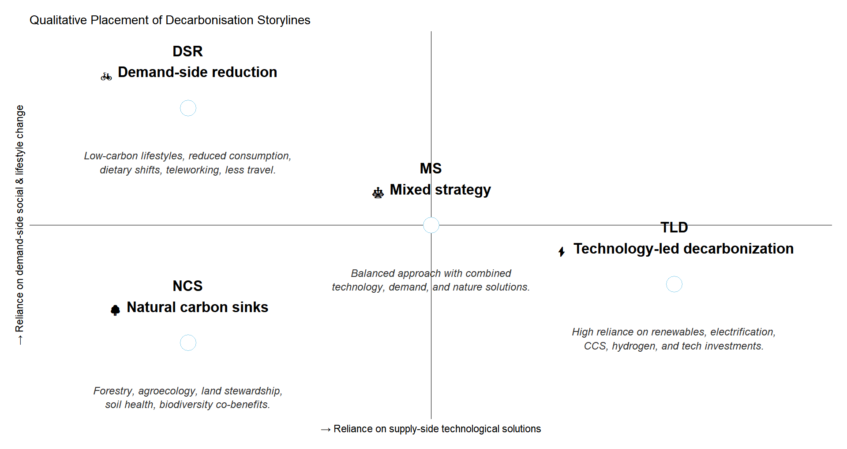
Figure S2. Conceptual map of scenarios according to the reliance on demand-side social policies and reliance on supply-side technological solutions.

For the stochastic multicriteria acceptability analysis (SMAA) sensitivity ranges need to be produced for mapping decisions to outcomes. The next hypotheses have been used to generate these sensitivities in the three mitigation scenarios:
- Energy Returned on Energy Invested (EROI). The minimum EROI (EROImin) is the minimum ratio of the energy delivered from a process divided by the energy required to get it over its lifetime, indicating the net energy available for the society. The sensitivities around the estimation of the EROImin is large, as the reduced availability of discretionary energy, as intermediary operations become less efficient, is a gradual non-linear process with increasing and cascade consequences over time. The values used are based on different works^{5,6} which have suggested a minimum static EROI of the system of 10-15:1. Brandt et al.⁷ found that if the EROI is considered less than 5:1, the social system starts to face serious problems. We have included three values, i.e., 5, 8 and 12, to cover this sensitivity variable in the critical renewable technologies of an energy transition.
- Population. Given the United Nations statistics⁸ from 2005 to 2020, the minimum and maximum population size is determined by the minimum and maximum fertility rates and life expectancies at birth by region, respectively. We include it to vary the load in consumption of goods and services to the system, which extract and process materials and energy according to the required levels that population and the economy demand.
- Climate change impacts. Since climate change impacts is a relatively novelty in the field of IAMs, we impose two levels of climate change impacts, including or not negative damage to mortality rates, capital stock (heatwaves, wildfires, droughts) and labour productivity (heat stress and vector-borne diseases).
Table S1. Qualitative attribute table for the narratives implemented in this study.
Attributes | Narrative 1 - technology-led decarbonisation | Narrative 2 - reduction in consumption | Narrative 3 - increase in carbon sinks | Narrative 4 - mixed strategy
Climate target by 2050 | Common global temperature change
Demography
Population | Continuation of past trends in fertility, mortality and migration (8865 million people worldwide in 2050)
Economy
Carbon tax in 2050 | High | High | High | Moderate
Carbon revenues recycling | Finance energy transition plans | Social benefits & Debt reduction | Purchase of private land protection and afforestation | A balanced blend of the other narratives
Government expenditures | High investments | High social benefits | High consumption | A balanced blend of the other narratives
Government consumption & investments | High for economic affairs | High for general public services, education, social protection | High for environmental protection | A balanced blend of the other narratives
Energy/Technology
Share of renewables | High | Low | Low | Moderate
Energy Efficiency Improvement in all production sectors | High | Low | Low | Moderate
Technology improvement in passenger transport | High | Low | Low | Moderate
Electrification | High | Low | Low | Moderate
Hydrogen | High | Low | Low | Moderate
Use of immature technologies | Electrolysers, CCS, oceanic, wind offshore floating | Only electrolysers | Only electrolysers | Only electrolysers
Ban fossil fuels in the power system | Yes | No | No | Yes
Innvestment costs for newly installed energy capacities | High | Low | Low | Moderate
Improvement recycling rates | High | Low | Low | Moderate
Land use/agriculture/forestry
Afforestation/New plantations | No | No | High | Moderate
Protection of natural lands incl. primary forests | No | No | High | Moderate
Agricultural management | Highly industrial | Moderate industrial | Highly regenerative | Moderate regenerative
Grassland management | Highly industrial | Moderate industrial | Highly regenerative | Moderate regenerative
Manure management | No | No | Yes | No
Society/Lifestyle changes
Consumption of durable goods | High | Low | High | Moderate
Diet | Current | High | Current | Moderate
Food waste | High | Low | High | Moderate
Passenger transport demand | High | Low | High | Moderate
Promotion of public transport and non-motorized means | Low | High | Low | Moderate
Hypothesis for the sensitivity analysis (SMAA exercise)
Population | Low
Population | Medium
Population | High
Minimum EROI solar and wind technologies | Low
Minimum EROI solar and wind technologies | Medium
Minimum EROI solar and wind technologies | High
Climate change impacts | No
Climate change impacts | Yes

Table S2. Description of policies behind attributes of scenarios.
Attributes | Narrative 1 - technology-led decarbonisation | Narrative 2 - reduction in consumption | Narrative 3 - increase in carbon sinks | Narrative 4 - mixed strategy
Climate target by 2050 | 1.83 ºC by 2050 (standard deviation equal to 0.001 ºC)
Demography
Mortality | Continuation of past trends in fertility, mortality and migration (8865 million people worldwide in 2050)
Economy
Carbon tax in 2050 | 300 $2015/ton CO2eq by 2050 for CO2, CH4 and NO2 | 300 $2015/ton CO2eq by 2050 for CO2, CH4 and NO2 | 300 $2015/ton CO2eq by 2050 for CO2, CH4 and NO2 | 196.5 $2015/ton CO2eq by 2050 for CO2, Ch4 and NO2
Carbon revenues recycling | 100% to finance energy infraestructure | 50% for social benefits & 50% for public debt reduction | 100% to purchase private land for afforestation and natural land protection | 25% for debt reduction, 25% for social benefits, 25% for energy infraestructure and 25% for afforestation and natural land protection
Government expenditures | Related to the historical data, increase 50% of investments at the expense of consumption and social benefits | Related to the historical data, increase 50% social benefits at the expense of investment, transferences and other expenditures | Related to the historical data, increase 50% consumption at the expense of social benefits, investments, transferences and other expenditures | Current levels and patterns, regional specific
Government consumption & investments | 50% higher for economic affairs at the expense of defense, public services, public order, health and social protection | 30% higher for general public services, education, social protection at the expense of economic affairs, health, public order and defense | 500% higher for environmental protection at the expense of health, economic affairs, defense and public order | Current levels and patterns, regional specific
Energy/Technology
Share of renewables | Highest priority by 2030 | Highest priority by 2050 | Highest priority by 2050 | Highest priority by 2040
Energy Efficiency Improvement in all production sectors | 54% energy intensity average reduction (different across sectors, regions and final energies) by 2050, related to 2015 | Continuation of historical trends. 31% energy intensity average reduction (different across sectors, regions and final energies) by 2050, related to 2015 | Continuation of historical trends. 31% energy intensity average reduction (different across sectors, regions and final energies) by 2050, related to 2015 | 42% energy intensity average reduction (different across sectors, regions and final energies) by 2050, related to 2015
Technology improvement in passenger transport | 15% savings in fuel consumption, 50% of gasoline and diesel engines are substituted by electric vehicles by 2040 | No improvement in efficiency | No improvement in efficiency | 7.5% savings in fuel consumption, 50% of gasoline and diesel engines are substituted by electric vehicles by 2045
Electrification | 59% average increase of electricity (different across sectors and regions) | 4% average increase of electricity (different across sectors and regions) | 4% average increase of electricity (different across sectors and regions) | 26% average increase of electricity across regions
Hydrogen | 100% substitution of fossil fuels by hydrogen of non-energy uses, steel manufacturing processes, subsitution of 15% liquid and 4% gas by synthetic fuels by 2050 | 10% substitution of fossil fuels by hydrogen of non-energy uses, steel manufacturing processes, and substitution of 5% liquid by synthetic fuels by 2050 | 10% substitution of fossil fuels by hydrogen of non-energy uses, steel manufacturing processes, and substitution of 5% liquid by synthetic fuels by 2050 | 55% substitution of fossil fuels by hydrogen of non-energy uses, steel manufacturing processes, subsitution of 7.5% liquid and 2% gas by synthetic fuels by 2050
Use of immature technologies (CCS, offshore floating wind) | Electrolysers, wind offshore floating, CCS | Electrolysers | Electrolysers | Electrolysers
Ban fossil fuels in the power system | Ban plants fueled by fossil fuels (liquids, solids, and gases) by 2030, except CCS plants | No | No | Ban plants fueled by solid fossil fuels by 2040
Energy capacity investment costs | Investment costs of energy infrastructure is 35% lower, related to 2015 | Investment costs of energy infrastructure is 20% higher, related to 2015 | Investment costs of energy infrastructure is 20% higher, related to 2015 | Investment costs of energy infrastructure is 8% lower, related to 2015
Improvement recycling rates | Minimum of 30% recycling rate. For the rest, 30% higher recycling rate | Minimum of 5% recycling rate. For the rest, 5% higher recycling rate | Minimum of 5% recycling rate. For the rest, 5% higher recycling rate | Minimum of 15% recycling rate. For the rest, 15% higher recycling rate
Land use/agriculture/forestry
Afforestation/New plantations | No | No | 27% afforestation, new plantations by 2050. | 11% afforestation, new plantations by 2050
Protection of natural lands incl. primary forests | No | No | 27% protection of primary forests and other natural land by 2030 | 11% protection of primary forests by 2050
Agricultural management | 100% industrial agriculture by 2040 | 50% industrial agriculture by 2050 | 100% regenerative agriculture by 2050 | 50% regenerative agriculture by 2050
Grassland management | 100% grassland management with high inputs by 2050 | 100% grassland management with medium inputs by 2050. | 100% regenerative grazing by 2050 | 50% regenerative grazing by 2050
Manure management | Current levels and patterns | Current levels and patterns | Application of a manure management system based on lagoon, liquid/slurry, solid storage, dry lot, pasture/range, daily spread, digester, burned for fuel, PIT, other | Current levels and patterns
Society/Lifestyle changes
Consumption of durable goods | Limit growth consumption of durable goods to 4% | Limit growth consumption of durable goods to 1.25% | Limit growth consumption of durable goods to 4% | Limit growth consumption of durable goods to 2%
Diet | Current dietary patterns | 70% transition to 50% plant-based diet by 2050. Crops for food are prioritized | Current dietary patterns | 35% transition to 50% plant-based diet by 2050
Food waste | Current levels and patterns | 40% reduction of food waste before intake by 2050 | Current levels and patterns | 20% reduction of food waste before intake by 2050
Passenger transport demand | 10% of reduction of light duty vehicles, maritime and air transport by 2035 | 60% of reduction of light duty vehicles, maritime and air domestic and intra-EU transport, 100% reduction of domestic air transport by 2035 | 10% of reduction of light duty vehicles, maritime and air transport by 2035 | 30% of reduction of light duty vehicles, maritime and air domestic and intra-EU transport, 55% reduction of domestic air transport by 2035
Promotion of public transport and non-motorized means | Current levels and patterns | 40% reduction of light duty vehicles and increase bus, train and non-motorized transport by 2050 | Current levels and patterns | 20% reduction of light duty vehicles and increase bus, train and non-motorized transport by 2050
Hypothesis for the sensitivity analysis (SMAA exercise)
Population | Minimum historical (2005-2020) fertility rates and life expectancy at birth (8459 million people worldwide in 2050, without climate change impacts)
Population | Mean historical (2005-2020) fertility rates and life expectancy at birth (8865 million people worldwide in 2050, without climate change impacts)
Population | Maximum historical (2005-2020) fertility rates and life expectancy at birth (9497 million people worldwide in 2050, without climate change impacts)
Minimum EROI solar and wind technologies | 5
Minimum EROI solar and wind technologies | 8
Minimum EROI solar and wind technologies | 12
Climate change impacts | No
Climate change impacts | Damage to mortality rates, capital stock (heatwaves, wildfires, droughts) and labour productivity (heat stress and vector-borne diseases)

Supplementary Note 2. State-of-the art. Our SDG framework for WILIAM
The final indicator space we used in the study is shown in table S4. This work has required a quantitative analysis of narratives with SDGs as decision indicators. Here we present a narrative literature review carried out to understand the state-of-the-art in modelling SDGs in IAMs, including our contribution. A comparative summary of representative percentage of SDG indicators approached in the models covered in the review is shown in figure S3 (accessible figure in the Zenodo repository https://doi.org/10.5281/zenodo.19066849. Folder “Results”, Excel file “LitReview_SDG_indicators_representation.xlsx”), which is detailed in table S3.
The review identifies three types of SDG proxy: exogenous scenario assumption, endogenous variable, and post-processing extension⁹. However, here we state that the assessment of interactions should only require the presence of endogenous calculations across indicators to show possible feedback loops or rebound effects.
Two studies^{10,11} have recently discussed the quantification of SDGs in simulations and numerical approaches to correlate SDGs with proxy variables in IAMs. Although the harmonization of SDG implementation in IAMs is still under development, most of the studies have proposed a similar solution based on the establishment of a target The objective of a target space is to help the scientific community in evaluating the achievement of SDGs in future scenarios, thus helping to identify potential synergies and trade-offs among policies. As a result, they could cover 36 proxy variables for targets covering the 17 SDGs. The authors selected articles where the SSP2 was exogenously assumed in order to identify proxies for the target space (except Riahi et al. (2017)⁴, the reference where the modellers of the IPCC’s IAMs explain the SSPs). Although all referenced studies used the same scenario data (MESSAGE-GLOBIOM, developed by IIASA), the methodological extensions applied to estimate inequality, hunger risk, population dynamics, impact indicators, and water stress were developed independently. This implies an underlying assumption that these extensions are not interdependent; otherwise, the results would not be directly comparable, and the scenario would need to be re-run with all methods fully integrated within the IAM framework. As a result, potential cross-model interactions – such as the influence of hunger risk in the population dynamics – may be missing from the IPCC scenario context.
Soergel et al. (2021b)⁹ was the only study reporting results for all SDGs through 56 indicators. However, the authors faced similar limitations in the IAM (REMIND-MAgPIE). First, 12 indicators were exogenously assumed via scenario (SSPs) such as educational attainment, GDP, population and end-use energy demands in buildings and mobility. Similarly, 15 indicators were post-processed to extend the analysis with other tools. Specifically, SDG 3 (Good Health and Well-Being), SDG 4 (Quality Education), SDG 5 (Gender Equality), SDG 8 (Decent Work and Economic Growth), SDG 10 (Reduced Inequalities), SDG 11 (Sustainable Cities and Communities), SDG 14 (Life Below Water), SDG 16 (Peace, Justice and Strong Institutions), and SDG 17 (Partnerships for the Goals) were calculated out from the IAM. Later on, Soergel et al. (2024)¹² proposed three sustainable development paths based on 36 proxies to cover all the Goals, from which 22 were endogenous, 13 were scenario assumptions, and 3 post-processing assumptions.
Moreno et al. (2023)¹³ analyzed the implications of long-term mitigation strategies on SDG Agenda. The authors combined the IAM GCAM with two tools to extend the SDG coverage. On the side of the IAM, seven endogenous indicators were captured to assess on SDG 2, 6, 7, 11, 13, 14, and 15. In China, SDGs have been integrated in two models to assess on mitigation paths.
He et al. (2025)¹⁴ used variables of the IPAC model as proxies of 32 indicators, also requiring simplification hypothesis to quantify the indicators. For example, SDG 6.3.1 (Proportion of wastewater safely treated) was proxied by the industrial water demand, and material footprint (8.4.1) by GDP and population. Among them, 10 were directly quantified focusing on SDGs 7, 8, 9 and 12, while the rest were determined with the help of post-processing, independent analysis. However, we cannot clearly conclude which variables are exogenously assumed (scenario) and which others are endogenously calculated.
Finally, Wang et al. (2025)¹⁵ employed GCAM 6.0 to evaluate the effects of coal phase-down in SDGs. In this case, 16 indicators covered 9 SDGs. The level of detail remains similar than previous works, for example, GPD per capita to proxy SDG 1 (No Poverty), and municipal water per capita, water use efficiency and water consumption per GDP as proxies of SDG 6 (Clean Water and Sanitation). Furthermore, some proxies were exogenously assumed via scenario parametrization (SSPs).
The review reveals an expansion of SDGs in literature since 2015. After 10 years of data, historical analyses have aimed to cover more and more dimensions to better capture synergies and trade-offs across Goals. Given the historical framework, these studies faced the limitation of capturing major future changes behind the indicators. Consequently, we see here a clear multidisciplinary collaboration with integrated models to join efforts in bringing sustainable and fair scenarios to the IPCC and UN official reports.
We can highlight two main limitations in the field of IAMs. First, complexity for modelling social indicators such as education and gender equality. Second, difficulty to model interlinkages across modules. All together could radically change the holistic policy assessment about future scenarios. For example, the effects of material and food scarcity on the population dynamics and economic growth, fertility shifts driven by education, inequality and migration, or the impacts of SDG 16 and 17 on global economies. The indicators exogenously assumed via scenario assumptions and post-processing lack uncertainty. Consequently, they would not be valid as part of a multicriteria assessment exercises.

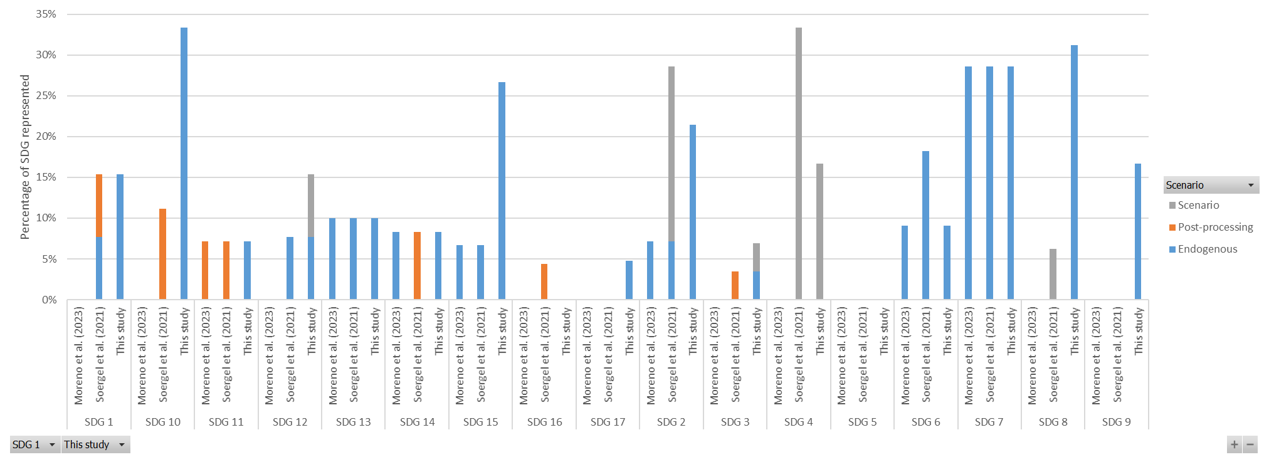
Figure S3. Percentage of the SDG represented (number of indicators) in the integrated assessment models studying SDG interactions in global climate mitigation scenarios.

Table S3. Gaps, contributions and novelties from the literature review on SDG frameworks applied in integrated assessment models.
 | Novelty | Contribution | Gaps
Soergel et al. (2021)⁹ | A new sustainable development pathway for climate action within the UN 2030 Agenda and some planetary boundaries.  First time that all SDGs are covered in studying global pathways. | They show how SSP1 and SSP2 + National Determined Contributions + lifestyle change is insufficient to reach SDG targets and some Planetary Boundaries.  SDG space in the IAM with 56 indicators or proxies across all 17 SDGs. IAM: REMIND-MAgPIE.  They identify policy interventions within two scenarios.  They analyse regional outcomes. | No uncertainty analysis in scenarios. No climate change impacts.  Interventions are applied incrementally, loosing possible combined or side effects.  Several indicators and targets were ex-ante assumed as scenario assumptions. They highlight this limitation in the conclusions.  Missing feedbacks from post-processing findings back to the IAM over time. Three years were simulated, i.e., 2015, 2030 and 2050.  Detrimental effects of the COVID-19 pandemic are not yet captured in our modelling framework.  No feedback that could present re-bound effects.
Moreno et al (2023)¹³ | Application of mitigation strategies (technology, natural solutions, behavioural changes) in the context of the SSP2 scenario.  Novelty is that the authors adopt both a global and a regional framework to capture dynamic transboundary effects of CLEW-related long-term SDGs derived from regional climate policies. | Linking Paris Agreement and SDGs to analyze the interactions between both agendas together. | Limited set of SDG indicators.  Method to identify synergies and trade-offs.  No feedback that could present re-bound effects.
Forouli et al. (2020)¹⁶ | Selection of optimal portfolios of actions through a multi–objective approach based on SDGs. Integration of methods for policy portfolio selection (AUCMECON 2) with IAMs (GCAM). | Uncertainty is considered with three scenarios (SSP 2, 3 and 5).  Technological subsidisation has implications for multiple SDGs.  Constraint of budget is available for cost-effectiveness decision in installations.  Biogas emerged as the technology with the higher participation in the robust portfolios, across all SSPs and timescales, while fuelwood is the least attractive technology. | Scope is limited to three SDG indicators, i.e., air pollution-related mortality (SDG3), access to clean energy (SDG7) and greenhouse gas emissions (SDG13).  Regional scope is limited to twelve Eastern African countries.  Scope of the policy assessment is limited to six technologies.  Analysis of SDG interactions.  A limitation of their proposed methodology related to the “SSP robustness” scenario lies on the initial choice of the mid-point between the range of SSP results in terms of the impact of each technology on SDG progress, for identifying the Pareto front of the optimal portfolio.  No feedback that could present re-bound effects.
Wang et al. (2025a)¹⁷ | SDG index for China  Spearman correlation coefficients were calculated based on the SDG data of each province under different scenarios to assess the synergies or trade-offs between SDG targets | Analysis at province level.  Identification of SDG objectives for prioritization at national and regional levels based on the HITS algorithm, for policymaking. | Limited regional scope to China and the power sector.  No feedback that could present re-bound effects.
Chen-Min He et al. (2025)¹⁴ | Linkages between climate change mitigation pathways and SDGs in China | Simulation of the currently implemented national Chinese climate mitigation policies. | Limited regional scope to China.  No feedback that could present re-bound effects.
This study | Novelty: all our four scenarios share the same climate target to introduce competitiveness in decision making.  Novelty: consideration of biophysical constraints. | Contribution: three sensitivity hypotheses. Climate change impacts is one of them.  Contribution: all WILIAM variables building the SDG indicator space are endogenous.  Contribution: feedbacks in WILIAM are time-dependent, they could be reinforcing or balancing. Mathematics of system dynamics represent a continuous inertia based on differential equations, rather than optimization of single years.  Contribution: our scope is broader in terms of SDG indicators covered, regions (9 world regions), and policy portfolio.  Contribution: the use of SMAA to study the acceptability of a scenario under sensitivity.
Table S4. Endogenous variables to represent indicators of the sustainable development goals in the WILIAM integrated assessment model.
 | OUTPUTS
SDG  name | SDG indicator | Variable in WILIAM | Description of the variable. Source & Comment | Units | Polarity
No Poverty | 1.A.2 | global_share_government_expenditure_in_social_benefits | Share of global government expenditure allocated to social benefits. This indicator is derived from the official SDG Target 1.A and reflects efforts to eradicate poverty. | Dmnl | 1
Zero Hunger | 2.4.1 | global_ratio_of_sustainable_agriculture_area | Proportion of global agricultural land managed under sustainable practices. This indicator corresponds to SDG Target 2.4 and captures the environmental dimension of agricultural sustainability, as defined by the official UN framework. | Dmnl | 1
Zero Hunger | 2.4.1 | global_ratio_of_productive_agriculture_area | Proportion of global agricultural land engaged in high-input production. This complements the sustainable agriculture indicator by representing the productivity aspect of SDG Target 2.4. | Dmnl | 1
Zero Hunger | 2.c.1 | global_availability_of_crops_for_food | Availability of crops for food consumption at the global level. This proxy indicator addresses the accessibility component of SDG Target 2.1 and, to a lesser extent, SDG Target 2.c on price volatility, acknowledging that limited availability can exacerbate market instability, according to Soergel et al. (2021)⁹ and Moreno et al. (2023)¹³. | Dmnl | 1
Zero Hunger | 2.c.1 | global_daily_nutritional_energy_intake | Average daily energy intake per capita from nutrition at the global level. This indicator supports SDG Target 2.1 by serving as a broad proxy for food security and the performance of the food system. It has been previously used in modelling exercises to approximate undernourishment, such as in van Vuuren et al. (2022)¹⁸. | kcal/(person*day) | 1
Good Health and Well-being | 3.2.1 | global_under_5_mortality_rate | Average global under-five mortality rate, expressed as the number of deaths of children under five per 1,000 live births. This official indicator directly tracks SDG Target 3.2, which aims to reduce child mortality. | person/kpeople | -1
Clean Water and Sanitation | 6 | global_effective_blue_water_demanded_for_agriculture | Effective global blue water demand for agricultural use. This variable proxies SDG Target 6.4, focusing on sustainable freshwater withdrawals, as presented by Soergel et al. (2021)⁹. | hm3 | -1
Clean Water and Sanitation | 6 | global_fertilizers_demanded | Global demand for industrial fertilizers, primarily nitrogen-based. It serves as a proxy for nutrient-related water pollution, relevant to SDG Target 6.3 on improving water quality. It is derived from Soergel et al. (2021)⁹. | tonnes | -1
Clean Water and Sanitation | 6.4.2 | global_water_stress | Global water stress level, defined as the ratio of total freshwater withdrawn to available renewable water resources. This is a direct official indicator under SDG Target 6.4 addressing sustainable water use. | % | -1
Affordable and Clean Energy | 7.2.1 | global_share_RES_in_FE | Global share of renewable energy in total final consumption. This directly reflects progress towards SDG Target 7.2, which seeks to increase the share of renewables in the energy mix. | Dmnl | 1
Affordable and Clean Energy | 7.3.1 | global_PE_GDP_intensity | Primary energy consumption per unit of GDP (PPP-adjusted, 2015 dollars). This is the official indicator for SDG Target 7.3, aiming to improve global energy efficiency. | TJ/Mdollars_2015 | -1
Affordable and Clean Energy | 7 | global_PROTRA_RES_capacity_stock_per_capita | Per capita installed renewable energy capacity worldwide. This indicator serves as a proxy for energy access and infrastructure readiness, aligning with SDG 7's overarching goal. It covers all countries, developed and developing. | w/person | 1
Decent Work and Economic Growth | 8.1.1 | global_annual_growth_rate_GDPpc_real | Annual growth rate of global real GDP per capita. Although SDG Target 8.1 explicitly mentions least developed countries, this broader indicator allows for assessment across all global regions. | Dmnl | 1
Decent Work and Economic Growth | 8.2.1 | global_annual_growth_rate_GDPpw_real | Annual growth rate of real GDP per worker. This indicator tracks labour productivity growth, in line with SDG Target 8.2 on increasing economic productivity. | Dmnl | 1
Decent Work and Economic Growth | 8.4.1 | global_material_footprint_per_capita | Material footprint per capita. This indicator approximates SDG Target 8.4, which promotes efficient resource use and sustainable consumption and production patterns. | Mt/(Year*person) | -1
Decent Work and Economic Growth | 8.4.1 | global_material_footprint_per_GDP | Material footprint per gross domestic product. This indicator approximates SDG Target 8.4, which promotes efficient resource use and sustainable consumption and production patterns. | Mt/Mdollars_2015 | -1
Decent Work and Economic Growth | 8.5.1 | global_average_wage_hour | Average hourly wage at the global level. While aligned with SDG Target 8.5 on promoting decent work and equal pay, this indicator does not disaggregate by sex or occupation. | $/h | 1
Decent Work and Economic Growth | 8.5.2 | global_unemployment_rate | Global average unemployment rate. This proxy contributes to monitoring SDG Target 8.5, although it lacks detailed breakdowns by sex, age, etc. | Dmnl | -1
Decent Work and Economic Growth | 8.9.1 | global_GDP_pc_vs_GDP_pc_OECD | Ratio between per capita GDP in a region and the OECD average. Suggested by Soergel et al. (2021)⁹ and van Vuuren et al. (2022)¹⁸, this indicator serves as a proxy for economic convergence under SDG Target 8.1. | % | 1
Industry, Innovation and Infrastructure | 9.2.1 | global_share_manufacturing_value_added_per_GDP | Global share of manufacturing value added in GDP. This is the official indicator for SDG Target 9.2, promoting inclusive and sustainable industrial development. | Dmnl | 1
Industry, Innovation and Infrastructure | 9.2.1 | global_manufacturing_value_added_per_capita | Manufacturing value added per capita, in constant 2015 international dollars. This complements the previous indicator under SDG Target 9.2 by providing an income-based per person perspective. | Mdollars_2015/  (Year*person) | 1
Industry, Innovation and Infrastructure | 9.2.2 | global_manufacturing_employment_ratio | Proportion of global employment in the manufacturing sector. This is another official UN indicator associated with SDG Target 9.2. | Dmnl | 1
Industry, Innovation and Infrastructure | 9 | global_CO2_industry_direct_emissions | Total direct CO₂ emissions from industrial activities globally. This proxy supports SDG Target 9.4 on sustainable industrial practices and is aligned with the approach in Soergel et al. (2021)⁹. | Gt/Year | -1
Reduced Inequalities | 10.4.1 | global_labour_compensation_share | Share of labour compensation in global GDP. This indicator reflects the distributive dimension of SDG Target 10.4, which aims to reduce inequality through fiscal and labour policy. | Mdollars/  Mdollars_2015 | 1
Reduced Inequalities | 10 | global_GINI_GDPpc_regions | GINI coefficient of per capita GDP across WILIAM regions. A value of 0 implies perfect equality and 1 indicates maximal inequality. This intrinsic WILIAM indicator serves as a proxy for SDG Target 10.2, although focused solely on economic disparities. | Dmnl | -1
Sustainable Cities and Communities | 11.3.1 | global_ratio_land_consumption_rate_to_population_growth_rate | Ratio between the rate of land consumption and the rate of population growth globally. This official indicator monitors urban sprawl in the context of SDG Target 11.3, which promotes sustainable urban development. | km² | -1
Responsible Consumption and Production | 12.a.1 | global_capacity_renewables_installations_pc_developing_regions | Per capita renewable energy infrastructure capacity in developing regions. This aligns with SDG Target 12.A, focusing on technology and capacity-building support for renewable energy in developing countries. Developing regions are defined here as EASOC (East of Asia and Oceania), LATAM (Latin America), and LROW (Rest of the World). | w/person | 1
Responsible Consumption and Production | 12.2.1 | global_material_footprint_per_capita | Material footprint per capita. This indicator approximates SDG Target 12.1 and 12.2, which promotes efficient resource use and sustainable consumption and production patterns. | Mt/(Year*person) | -1
Responsible Consumption and Production | 12.2.1 | global_material_footprint_per_GDP | Material footprint per gross domestic product. This indicator approximates SDG Target 12.1 and 12.2, which promotes efficient resource use and sustainable consumption and production patterns. | Mt/Mdollars_2015 | -1
Climate Action | 13.2.2 | global_total_CO2e_emissions_per_capita | Per capita total greenhouse gas emissions, expressed in CO₂-equivalent using global warming potentials. While SDG Target 13.2 addresses national policies, this variable offers a per capita perspective on climate impact. | t/(Year*person) | -1
Climate Action | 13 | global_temperature_change | Global average temperature anomaly (atmosphere and upper ocean) relative to the pre-industrial baseline (1850). This proxy is consistent with the objectives of the Paris Agreement and has been adopted in Soergel et al. (2021)⁹ and van Vuuren et al. (2022)¹⁸. | °C | -1
Climate Action | 13 | global_total_CO2_emissions_from_2020 | Total CO₂ emissions from simulation since 2023 to calculate remaining carbon budget. Historical emissions in 2020, 2021, 2022 comes from Global Carbon Budget (GCB) data¹⁹. | Gt | -1
Climate Action | 13 | global_C_emissions_LUC_and_cropland_management | Annual CO₂ emissions from land-use change and cropland management. This variable serves as a proxy for land-based mitigation challenges, in line with Soergel et al. (2021)⁹. | Gt/Year | -1
Life Below Water | 14.3.1 | global_pH_ocean | Ocean surface pH level, indicating acidification trends. This official indicator under SDG Target 14.3 tracks progress in minimising the impacts of ocean acidification. | pH | 1
Life on Land | 15.1.1 | global_forest_area_vs_total_area | Forest area as a proportion of total land surface. This indicator directly corresponds to SDG Target 15.1, promoting sustainable terrestrial management with a focus on forest coverage. | Dmnl | 1
Life on Land | 15.2.1 | global_index_of_forest_stock_per_area | Index of forest stock per unit area. Derived from WILIAM model outputs, this proxy assesses forest productivity and management sustainability under SDG Target 15.2. | Dmnl | 1
Life on Land | 15.2.2 | global_index_of_forest_area | Global index of forest area relative to its initial value. This WILIAM-based proxy tracks trends in forest expansion or loss and is relevant to SDG Target 15.2 on halting deforestation. | Dmnl | 1
Life on Land | 15.3.1 | global_degraded_land_over_total_land | Proportion of total land considered degraded. This proxy is based on land classified as 'other' (e.g., deserts, ice, waterbodies) and areas with primary forest loss. It contributes to SDG Target 15.3, though degradation requires further specification. | Dmnl | -1
Partnerships for the Goals | 17.1.1 | global_governmental_revenue_by_GDP | Total government revenue by gross domestic product at the global scale. This indicator aligns with SDG Target 17.1, which seeks to enhance domestic resource mobilization, although it does not distinguish revenue sources. | Mdollars/Year | 1

Supplementary Note 3. Stochastic Multicriteria Acceptability Assessment (SMAA)

Table S5. The equations used to calculate the criteria for SDGs in the SMAA methods.
SDG Variable in WILIAM | Indicator | Sub-criterion | Criterion
$${Var}_{1.A.2}$$ | $$I_{1.A.2}=\sum_{t=2024}^{2050}{{{Var}_{1.A.2}}_{t}}$$ | $${{SC}_{1.A.2}}_{s}=\frac{{I_{1.A.2}}_{s}-\min_{s∈S}{{I_{1.A.2}}_{s}}}{\max_{s∈S}{{I_{1.A.2}}_{s}}-\min_{s∈S}{{I_{1.A.2}}_{s}}}$$ | $$C_{1}={SC}_{1.A.2}$$
$${Var}_{2.4.1-1}$$ | $$I_{2.4.1-1}=\sum_{t=2024}^{2050}{{{Var}_{2.4.1-1}}_{t}}$$ | $${{SC}_{2.4.1-1}}_{s}=\frac{{I_{2.4.1-1}}_{s}-\min_{s∈S}{{I_{2.4.1-1}}_{s}}}{\max_{s∈S}{{I_{2.4.1-1}}_{s}}-\min_{s∈S}{{I_{2.4.1-1}}_{s}}}$$ | $$C_{2}={Average(SC}_{2.4.1-1},{SC}_{2.4.1-2},{SC}_{2.c.1-1}, {SC}_{2.c.1-2})$$
$${Var}_{2.4.1-2}$$ | $$I_{2.4.1-2}=\sum_{t=2024}^{2050}{{{Var}_{2.4.1-2}}_{t}}$$ | $${{SC}_{2.4.1-2}}_{s}=\frac{{I_{2.4.1-2}}_{s}-\min_{s∈S}{{I_{2.4.1-2}}_{s}}}{\max_{s∈S}{{I_{2.4.1-2}}_{s}}-\min_{s∈S}{{I_{2.4.1-2}}_{s}}}$$
$${Var}_{2.c.1-1}$$ | $$I_{2.c.1-1}=\sum_{t=2024}^{2050}{{{Var}_{2.c.1-1}}_{t}}$$ | $${{SC}_{2.c.1-1}}_{s}=\frac{{I_{2.c.1-1}}_{s}-\min_{s∈S}{{I_{2.c.1-1}}_{s}}}{\max_{s∈S}{{I_{2.c.1-1}}_{s}}-\min_{s∈S}{{I_{2.c.1-1}}_{s}}}$$
$${Var}_{2.c.1-2}$$ | $$I_{2.c.1-2}=\sum_{t=2024}^{2050}{{{Var}_{2.c.1-2}}_{t}}$$ | $${{SC}_{2.c.1-2}}_{s}=\frac{{I_{2.c.1-2}}_{s}-\min_{s∈S}{{I_{2.c.1-2}}_{s}}}{\max_{s∈S}{{I_{2.c.1-2}}_{s}}-\min_{s∈S}{{I_{2.c.1-2}}_{s}}}$$
$${Var}_{3.2.1}$$ | $$I_{3.2.1}=\sum_{t=2024}^{2050}{{{Var}_{3.2.1}}_{t}}$$ | $${{SC}_{3.2.1}}_{s}=1-\frac{{I_{3.2.1}}_{s}-\min_{s∈S}{{I_{3.2.1}}_{s}}}{\max_{s∈S}{{I_{3.2.1}}_{s}}-\min_{s∈S}{{I_{3.2.1}}_{s}}}$$ | $$C_{3}={SC}_{3.2.1}$$
$${Var}_{6-1}$$ | $$I_{6-1}=\sum_{t=2024}^{2050}{{{Var}_{6-1}}_{t}}$$ | $${{SC}_{6-1}}_{s}=1-\frac{{I_{6-1}}_{s}-\min_{s∈S}{{I_{6-1}}_{s}}}{\max_{s∈S}{{I_{6-1}}_{s}}-\min_{s∈S}{{I_{6-1}}_{s}}}$$ | $$C_{6}={Average(SC}_{6-1},{SC}_{6-2},{SC}_{6-3})$$
$${Var}_{6-2}$$ | $$I_{6-2}=\sum_{t=2024}^{2050}{{{Var}_{6-2}}_{t}}$$ | $${{SC}_{6-2}}_{s}=1-\frac{{I_{6-2}}_{s}-\min_{s∈S}{{I_{6-2}}_{s}}}{\max_{s∈S}{{I_{6-2}}_{s}}-\min_{s∈S}{{I_{6-2}}_{s}}}$$ | $$C_{6}={Average(SC}_{6-1},{SC}_{6-2},{SC}_{6-3})$$
$${Var}_{6-3}$$ | $$I_{6-3}=\sum_{t=2024}^{2050}{{{Var}_{6-3}}_{t}}$$ | $${{SC}_{6-3}}_{s}=1-\frac{{I_{6-3}}_{s}-\min_{s∈S}{{I_{6-3}}_{s}}}{\max_{s∈S}{{I_{6-3}}_{s}}-\min_{s∈S}{{I_{6-3}}_{s}}}$$ | $$C_{6}={Average(SC}_{6-1},{SC}_{6-2},{SC}_{6-3})$$
$${Var}_{7.2.1}$$ | $$I_{7.2.1}=\sum_{t=2024}^{2050}{{{Var}_{7.2.1}}_{t}}$$ | $${{SC}_{7.2.1}}_{s}=\frac{{I_{7.2.1}}_{s}-\min_{s∈S}{{I_{7.2.1}}_{s}}}{\max_{s∈S}{{I_{7.2.1}}_{s}}-\min_{s∈S}{{I_{7.2.1}}_{s}}}$$ | $$C_{7}={Average(SC}_{7.2.1},{SC}_{7.3.1},{SC}_{7})$$
$${Var}_{7.3.1}$$ | $$I_{7.3.1}=\sum_{t=2024}^{2050}{{{Var}_{7.3.1}}_{t}}$$ | $${{SC}_{7.3.1}}_{s}=1-\frac{{I_{7.3.1}}_{s}-\min_{s∈S}{{I_{7.3.1}}_{s}}}{\max_{s∈S}{{I_{7.3.1}}_{s}}-\min_{s∈S}{{I_{7.3.1}}_{s}}}$$ | $$C_{7}={Average(SC}_{7.2.1},{SC}_{7.3.1},{SC}_{7})$$
$${Var}_{7}$$ | $$I_{7}=\sum_{t=2024}^{2050}{{{Var}_{7}}_{t}}$$ | $${{SC}_{7}}_{s}=\frac{{I_{7}}_{s}-\min_{s∈S}{{I_{7}}_{s}}}{\max_{s∈S}{{I_{7}}_{s}}-\min_{s∈S}{{I_{7}}_{s}}}$$ | $$C_{7}={Average(SC}_{7.2.1},{SC}_{7.3.1},{SC}_{7})$$
$${Var}_{8.1.1}$$ | $$I_{8.1.1}=\sum_{t=2024}^{2050}{{{Var}_{8.1.1}}_{t}}$$ | $${{SC}_{8.1.1}}_{s}=\frac{{I_{8.1.1}}_{s}-\min_{s∈S}{{I_{8.1.1}}_{s}}}{\max_{s∈S}{{I_{8.1.1}}_{s}}-\min_{s∈S}{{I_{8.1.1}}_{s}}}$$ | $$C_{8}={Average(SC}_{8.1.1},{SC}_{8.2.1},{SC}_{8.4.1-1},{SC}_{8.4.1-2},{SC}_{8.5.1},{SC}_{8.5.2},{SC}_{8.9.1})$$
$${Var}_{8.2.1}$$ | $$I_{8.2.1}=\sum_{t=2024}^{2050}{{{Var}_{8.2.1}}_{t}}$$ | $${{SC}_{8.2.1}}_{s}=\frac{{I_{8.2.1}}_{s}-\min_{s∈S}{{I_{8.2.1}}_{s}}}{\max_{s∈S}{{I_{8.2.1}}_{s}}-\min_{s∈S}{{I_{8.2.1}}_{s}}}$$
$${Var}_{8.4.1-1}$$ | $$I_{8.4.1-1}={{Var}_{8.4.1-1}}_{2050}$$ | $${{SC}_{8.4.1-1}}_{s}=1-\frac{{I_{8.4.1-1}}_{s}-\min_{s∈S}{{I_{8.4.1-1}}_{s}}}{\max_{s∈S}{{I_{8.4.1-1}}_{s}}-\min_{s∈S}{{I_{8.4.1-1}}_{s}}}$$
$${Var}_{8.4.1-2}$$ | $$I_{8.4.1-2}=\sum_{t=2024}^{2050}{{{Var}_{8.4.1-2}}_{t}}$$ | $${{SC}_{8.4.1-2}}_{s}=\frac{{I_{8.4.1-2}}_{s}-\min_{s∈S}{{I_{8.4.1-2}}_{s}}}{\max_{s∈S}{{I_{8.4.1-2}}_{s}}-\min_{s∈S}{{I_{8.4.1-2}}_{s}}}$$
$${Var}_{8.5.1}$$ | $$I_{8.5.1}=\sum_{t=2024}^{2050}{{{Var}_{8.5.1}}_{t}}$$ | $${{SC}_{8.5.1}}_{s}=1-\frac{{I_{8.5.1}}_{s}-\min_{s∈S}{{I_{8.5.1}}_{s}}}{\max_{s∈S}{{I_{8.5.1}}_{s}}-\min_{s∈S}{{I_{8.5.1}}_{s}}}$$
$${Var}_{8.5.2}$$ | $$I_{8.5.2}=\sum_{t=2024}^{2050}{{{Var}_{8.5.2}}_{t}}$$ | $${{SC}_{8.5.2}}_{s}=\frac{{I_{8.5.2}}_{s}-\min_{s∈S}{{I_{8.5.2}}_{s}}}{\max_{s∈S}{{I_{8.5.2}}_{s}}-\min_{s∈S}{{I_{8.5.2}}_{s}}}$$
$${Var}_{8.9.1}$$ | $$I_{8.9.1}=\sum_{t=2024}^{2050}{{{Var}_{8.9.1}}_{t}}$$ | $${{SC}_{8.9.1}}_{s}=1-\frac{{I_{8.9.1}}_{s}-\min_{s∈S}{{I_{8.9.1}}_{s}}}{\max_{s∈S}{{I_{8.9.1}}_{s}}-\min_{s∈S}{{I_{8.9.1}}_{s}}}$$
$${Var}_{9.2.1-1}$$ | $$I_{9.2.1-1}=\sum_{t=2024}^{2050}{{{Var}_{9.2.1-1}}_{t}}$$ | $${{SC}_{9.2.1-1}}_{s}=\frac{{I_{8.5.29.2.1-1}}_{s}-\min_{s∈S}{{I_{9.2.1-1}}_{s}}}{\max_{s∈S}{{I_{9.2.1-1}}_{s}}-\min_{s∈S}{{I_{9.2.1-1}}_{s}}}$$ | $$C_{9}={Average(SC}_{9.2.1-1},{SC}_{9.2.1-2},{SC}_{9.2.2})$$
$${Var}_{9.2.1-2}$$ | $$I_{9.2.1-2}=\sum_{t=2024}^{2050}{{{Var}_{9.2.1-2}}_{t}}$$ | $${{SC}_{9.2.1-2}}_{s}=\frac{{I_{9.2.1-2}}_{s}-\min_{s∈S}{{I_{9.2.1-2}}_{s}}}{\max_{s∈S}{{I_{9.2.1-2}}_{s}}-\min_{s∈S}{{I_{9.2.1-2}}_{s}}}$$
$${Var}_{9.2.2}$$ | $$I_{9.2.2}=\sum_{t=2024}^{2050}{{{Var}_{9.2.2}}_{t}}$$ | $${{SC}_{9.2.2}}_{s}=\frac{{I_{9.2.2}}_{s}-\min_{s∈S}{{I_{9.2.2}}_{s}}}{\max_{s∈S}{{I_{9.2.2}}_{s}}-\min_{s∈S}{{I_{9.2.2}}_{s}}}$$
$${Var}_{10.4.1}$$ | $$I_{10.4.1}=\sum_{t=2024}^{2050}{{{Var}_{10.4.1}}_{t}}$$ | $${{SC}_{10.4.1}}_{s}=\frac{{I_{10.4.1}}_{s}-\min_{s∈S}{{I_{10.4.1}}_{s}}}{\max_{s∈S}{{I_{10.4.1}}_{s}}-\min_{s∈S}{{I_{10.4.1}}_{s}}}$$ | $$C_{10}={Average(SC}_{10.4.1},{SC}_{10})$$
$${Var}_{10}$$ | $$I_{10}=\sum_{t=2024}^{2050}{{{Var}_{10}}_{t}}$$ | $${{SC}_{10}}_{s}=1-\frac{{I_{10}}_{s}-\min_{s∈S}{{I_{10}}_{s}}}{\max_{s∈S}{{I_{10}}_{s}}-\min_{s∈S}{{I_{10}}_{s}}}$$ | $$C_{10}={Average(SC}_{10.4.1},{SC}_{10})$$
$${Var}_{11.3.1}$$ | $$I_{11.3.1}=\sum_{t=2024}^{2050}{{{Var}_{11.3.1}}_{t}}$$ | $${{SC}_{11.3.1}}_{s}=1-\frac{{I_{11.3.1}}_{s}-\min_{s∈S}{{I_{11.3.1}}_{s}}}{\max_{s∈S}{{I_{11.3.1}}_{s}}-\min_{s∈S}{{I_{11.3.1}}_{s}}}$$ | $$C_{11}={SC}_{11.3.1}$$
$${Var}_{12.5.1}$$ | $$I_{12.5.1}=\sum_{t=2024}^{2050}{{{Var}_{12.5.1}}_{t}}$$ | $${{SC}_{12.5.1}}_{s}=\frac{{I_{12.5.1}}_{s}-\min_{s∈S}{{I_{12.5.1}}_{s}}}{\max_{s∈S}{{I_{12.5.1}}_{s}}-\min_{s∈S}{{I_{12.5.1}}_{s}}}$$ | $$C_{12}={Average(SC}_{12.5.1},{SC}_{12.a.1})$$
$${Var}_{12.a.1}$$ | $$I_{12.a.1}=\sum_{t=2024}^{2050}{{{Var}_{12.a.1}}_{t}}$$ | $${{SC}_{12.a.1}}_{s}=\frac{{I_{12.a.1}}_{s}-\min_{s∈S}{{I_{12.a.1}}_{s}}}{\max_{s∈S}{{I_{12.a.1}}_{s}}-\min_{s∈S}{{I_{12.a.1}}_{s}}}$$ | $$C_{12}={Average(SC}_{12.5.1},{SC}_{12.a.1})$$
$${Var}_{13-1}$$ | $$I_{13-1}={{Var}_{13-1}}_{2050}$$ | $${{SC}_{13-1}}_{s}=1-\frac{{I_{13-1}}_{s}-\min_{s∈S}{{I_{13-1}}_{s}}}{\max_{s∈S}{{I_{13-1}}_{s}}-\min_{s∈S}{{I_{13-1}}_{s}}}$$ | $$C_{13}={Average(SC}_{13-1},{SC}_{13-2},{SC}_{13-3})$$
$${Var}_{13-2}$$ | $$I_{13-2}={{Var}_{13-2}}_{2050}$$ | $${{SC}_{13-2}}_{s}=1-\frac{{I_{13-2}}_{s}-\min_{s∈S}{{I_{13-2}}_{s}}}{\max_{s∈S}{{I_{13-2}}_{s}}-\min_{s∈S}{{I_{13-2}}_{s}}}$$ | $$C_{13}={Average(SC}_{13-1},{SC}_{13-2},{SC}_{13-3})$$
$${Var}_{13-3}$$ | $$I_{13-3}=\sum_{t=2024}^{2050}{{{Var}_{13-3}}_{t}}$$ | $${{SC}_{13-3}}_{s}=1-\frac{{I_{13-3}}_{s}-\min_{s∈S}{{I_{13-3}}_{s}}}{\max_{s∈S}{{I_{13-3}}_{s}}-\min_{s∈S}{{I_{13-3}}_{s}}}$$ | $$C_{13}={Average(SC}_{13-1},{SC}_{13-2},{SC}_{13-3})$$
$${Var}_{14.3.1}$$ | $$I_{14.3.1}=\sum_{t=2024}^{2050}{{{Var}_{14.3.1}}_{t}}$$ | $${{SC}_{14.3.1}}_{s}=1-\frac{{I_{14.3.1}}_{s}-\min_{s∈S}{{I_{14.3.1}}_{s}}}{\max_{s∈S}{{I_{14.3.1}}_{s}}-\min_{s∈S}{{I_{14.3.1}}_{s}}}$$ | $$C_{14}={SC}_{14.3.1}$$
$${{Var}_{15.1.1}}_{t}$$ | $$I_{15.1.1}=\sum_{t=2024}^{2050}{{{Var}_{15.1.1}}_{t}}$$ | $${{SC}_{15.1.1}}_{s}=1-\frac{{I_{15.1.1}}_{s}-\min_{s∈S}{{I_{15.1.1}}_{s}}}{\max_{s∈S}{{I_{15.1.1}}_{s}}-\min_{s∈S}{{I_{15.1.1}}_{s}}}$$ | $$C_{15}={Average(SC}_{15.1.1},{SC}_{15.2.1},{SC}_{15.2.2}, {SC}_{15.3.1})$$
$${Var}_{15.2.1}$$ | $$I_{15.2.1}=\sum_{t=2024}^{2050}{{{Var}_{15.2.1}}_{t}}$$ | $${{SC}_{15.2.1}}_{s}=1-\frac{{I_{15.2.1}}_{s}-\min_{s∈S}{{I_{15.2.1}}_{s}}}{\max_{s∈S}{{I_{15.2.1}}_{s}}-\min_{s∈S}{{I_{15.2.1}}_{s}}}$$
$${Var}_{15.2.2}$$ | $$I_{15.2.2}=\sum_{t=2024}^{2050}{{{Var}_{15.2.2}}_{t}}$$ | $${{SC}_{15.2.2}}_{s}=1-\frac{{I_{15.2.2}}_{s}-\min_{s∈S}{{I_{15.2.2}}_{s}}}{\max_{s∈S}{{I_{15.2.2}}_{s}}-\min_{s∈S}{{I_{15.2.2}}_{s}}}$$
$${Var}_{15.3.1}$$ | $$I_{15.3.1}=\sum_{t=2024}^{2050}{{{Var}_{15.3.1}}_{t}}$$ | $${{SC}_{15.3.1}}_{s}=1-\frac{{I_{15.3.1}}_{s}-\min_{s∈S}{{I_{15.3.1}}_{s}}}{\max_{s∈S}{{I_{15.3.1}}_{s}}-\min_{s∈S}{{I_{15.3.1}}_{s}}}$$
$${Var}_{17.1.1}$$ | $$I_{17.1.1}=\sum_{t=2024}^{2050}{{{Var}_{17.1.1}}_{t}}$$ | $${{SC}_{17.1.1}}_{s}=1-\frac{{I_{17.1.1}}_{s}-\min_{s∈S}{{I_{17.1.1}}_{s}}}{\max_{s∈S}{{I_{17.1.1}}_{s}}-\min_{s∈S}{{I_{17.1.1}}_{s}}}$$ | $$C_{17}={SC}_{17.1.1}$$

Supplementary Note 4. Definition of regions in WILIAM
The definition of the regions in WILIAM follows an economic criterion to integrate the inter-country input-output tables of the Organisation for Economic Co-operation and Development (OECD). The correspondence between regions and countries is detailed in table S.5.
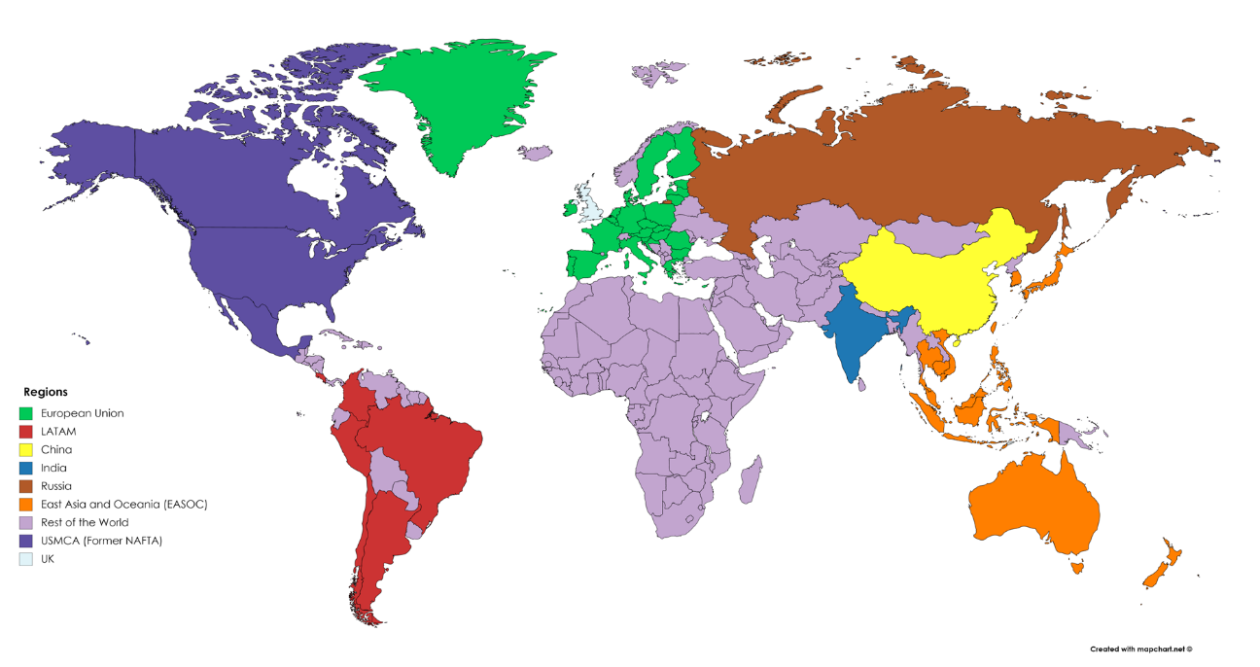

Table S6. Definition of regions in the WILIAM integrated assessment model.
 | LOCOMOTION global regions | LOCOMOTION acronym | Countries | ICIO Code (matches with ALPHA-3 excepting for ROW) | ALPHA-2 code
1 | European Union | EU27 | Austria | AUT | AT
1 | European Union | EU27 | Belgium | BEL | BE
1 | European Union | EU27 | Bulgaria | BGR | BG
1 | European Union | EU27 | Croatia | HRV | HR
1 | European Union | EU27 | Cyprus | CYP | CY
1 | European Union | EU27 | Czech Republic | CZE | CZ
1 | European Union | EU27 | Denmark | DNK | DK
1 | European Union | EU27 | Estonia | EST | EE
1 | European Union | EU27 | Finland | FIN | FI
1 | European Union | EU27 | France | FRA | FR
1 | European Union | EU27 | Germany | DEU | DE
1 | European Union | EU27 | Greece | GRC | GR
1 | European Union | EU27 | Hungary | HUN | HU
1 | European Union | EU27 | Ireland | IRL | IE
1 | European Union | EU27 | Italy | ITA | IT
1 | European Union | EU27 | Latvia | LVA | LV
1 | European Union | EU27 | Lithuania | LTU | LT
1 | European Union | EU27 | Luxembourg | LUX | LU
1 | European Union | EU27 | Malta | MLT | MT
1 | European Union | EU27 | Netherlands | NLD | NL
1 | European Union | EU27 | Poland | POL | PL
1 | European Union | EU27 | Portugal | PRT | PT
1 | European Union | EU27 | Romania | ROU | RO
1 | European Union | EU27 | Slovakia | SVK | SK
1 | European Union | EU27 | Slovenia | SVN | SI
1 | European Union | EU27 | Spain | ESP | ES
1 | European Union | EU27 | Sweden | SWE | SE
2 | United Kingdom | UK | United Kingdom | GBR | GB
3 | China | China | China (People's Republic of) | CHN | CN
3 | China | China | Hong Kong SAR | HKG | HK
4 | East Asia and Oceania | EASOC | Australia | AUS | AU
4 | East Asia and Oceania | EASOC | Brunei Darussalam | BRN | BN
4 | East Asia and Oceania | EASOC | Cambodia | KHM | KH
4 | East Asia and Oceania | EASOC | Chinese Taipei | TWN | TW
4 | East Asia and Oceania | EASOC | Indonesia | IDN | ID
4 | East Asia and Oceania | EASOC | Japan | JPN | JP
4 | East Asia and Oceania | EASOC | Korea | KOR | KR
4 | East Asia and Oceania | EASOC | Malaysia | MYS | MY
4 | East Asia and Oceania | EASOC | New Zealand | NZL | NZ
4 | East Asia and Oceania | EASOC | Philippines | PHL | PH
4 | East Asia and Oceania | EASOC | Singapore | SGP | SG
4 | East Asia and Oceania | EASOC | Thailand | THA | TH
4 | East Asia and Oceania | EASOC | Viet Nam | VNM | VN
5 | India | India | India | IND | IN
6 | Latin America | LATAM | Argentina | ARG | AR
6 | Latin America | LATAM | Brazil | BRA | BR
6 | Latin America | LATAM | Chile | CHL | CL
6 | Latin America | LATAM | Colombia | COL | CO
6 | Latin America | LATAM | Costa Rica | CRI | CR
6 | Latin America | LATAM | Peru | PER | PE
7 | Russia | Russia | Russian Federation | RUS | RU
8 | United States, Mexico and Canada | USMCA | Canada | CAN | CA
8 | United States, Mexico and Canada | USMCA | Mexico | MEX | MX
8 | United States, Mexico and Canada | USMCA | United States | USA | US
9 | Rest of the world | LROW | Rest of the world | ROW | -
9 | Rest of the world | LROW | Switzerland | CHE | CH
9 | Rest of the world | LROW | Iceland | ISL | IS
9 | Rest of the world | LROW | Israel | ISR | IL
9 | Rest of the world | LROW | Kazakhstan | KAZ | KZ
9 | Rest of the world | LROW | Morocco | MAR | MA
9 | Rest of the world | LROW | Norway | NOR | NO
9 | Rest of the world | LROW | Saudi Arabia | SAU | SA
9 | Rest of the world | LROW | Tunisia | TUN | TN
9 | Rest of the world | LROW | Turkey | TUR | TR
9 | Rest of the world | LROW | South Africa | ZAF | ZA

Supplementary Note 5. System-wide dynamics underlying global scenario acceptability in figures 1 and 2.
The acceptability of global and regional scenarios shown in figure 1and 2 is directly linked to the mathematics assumed in the WILIAM integrated assessment model. The Sustainable Development Goals (SDGs) represented in the tool are driven by a complex network of causal relationships.
Regarding global scenarios, we have identified three major “acceptability drivers”, i.e., intertwined causalities (one per row of subplots in the figure) that partially explain the acceptability of global scenarios (figure S4). First, the promotion of economic growth through consumption and investments to re-build climate change damages assumes an increase in government revenues (SDG 1 and 17), the average wage hour (SDG 8), and the labour compensation (SDG 10). As a consequence, economic growth reduces unemployment (SDG 8), but also increases industrial emissions (SDG 9). Freezing durable consumption and reducing private transport, as in the S2-DSR scenario, generates a cascade of trade-offs in employment and wages that reduces its acceptability. Second, the large-scale renewable deployment and efficiency measures (SDG 7 and 12) required to satisfy the energy transition in the short term, boosted by the policy of banning fossil fuels (2025-2030), clashes with high electricity curtailment peaks around 2030 (approach published in Parrado-Hernando et al.²⁰), on the one hand, and the exhaustion of physical land to continue installing renewables, on the other hand, limiting the installed capacity to exploit renewable energy. Moreover, energy efficiency (SDG 7) is improved until a bottom constraint that represents thermodynamic limitations, i.e., decoupling between physical and monetary units beyond that point is not possible in WILIAM. In summary, the energy reduction is finally reached through the promotion of renewables and energy efficiency, clearly reflected by the S1-TLD scenario. Third, the absence of forest protection (S1-TLD vs S3-NCS and S4-MSS) lead to the expansion of wood extraction as energy resource and additional land to place facilities (wind and solar, mainly). This comes at a cost: areas of high carbon sequestration capacity and rich biodiversity are impacted, in line with previous results (see experiment 2 in Mediavilla et al.²¹). In short, achieving SDG 7 (Affordable and Clean Energy) assumes a trade-off with SDG 15 (Life on Land) under the S1-TLD scenario. The policy to drastically reduce fertilizers to achieve SDG 6 (as in S3-NCS) leads to a slight drop of crop yields during the first years of the agricultural transition, after which they recover.

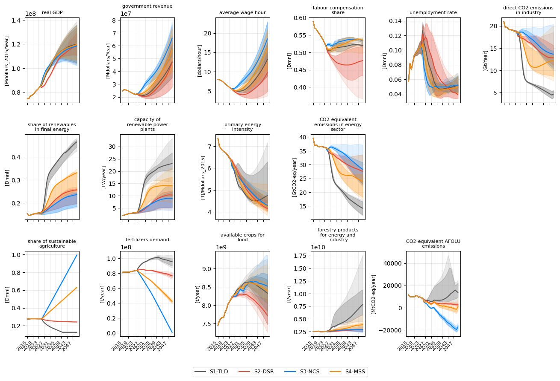
Figure S4. System-wide dynamics underlying global scenario acceptability. Time series of selected global variables illustrating the system-wide dynamics generated by the four mitigation scenarios under sensitivity hypotheses. Lines represent median values across all simulated pathways, with shaded bands indicating the 25–75% and 10–90% quantile ranges. The variables shown capture key economic, energy and land-use processes that mediate trade-offs among Sustainable Development Goals, including economic activity, energy system transformation, agricultural inputs, forest dynamics and sectoral greenhouse gas emissions. These dynamics provide the mechanistic basis for the differences in scenario acceptability reported in the main text, but are presented here for completeness due to their technical nature.

Global acceptability hides the fact that regional preferences can deviate considerably from global ones. Due to data and model limitations, certain indicators are not regionally available. Therefore, the analysis covers nine SDGs hereafter: 1, 2, 3, 6, 7, 9, 11, 15, and 17. Figure 2 showed the regional values of scenario acceptability indices. A slightly preference of S3-NCS over the rest (SAI equal to 3.04), but S1-TLD and S4-MSS reached very similar acceptability values (2.96 and 2.74, respectively). A more robust conclusion was drawn for S2-DSR, which further dropped in the global ranking (on the far left of the figure). The distance between the most preferred scenario and the next one was especially significant in the case of the EU-27 bloc, United Kingdom, Russia, India, China, and the rest of the world bloc; however, figure 2 revealed the absence of clear winners in the USMCA bloc (2.90 for S3-NCS vs 2.82 for S4-MSS), the EASOC bloc (3.07 for S1-TLD vs 3.06 for S3-NCS) and LATAM (3.29 for S3-NCS vs 3.28 for S1-TLD). The S4-DSR showed the highest probability of acceptance in the USMCA. However, overall, the scenario acceptability indices were very similar, and no clear preference emerges.
The WILIAM mechanisms affecting the acceptability of regional scenarios follow the same logics as at the global level. We identify certain acceptability drivers from the multiple interactions present in the model. In the following, we focus on the principal ones, which amplify specific SDGs as shown in figure S5. First, government revenues rely on its capacity to invest, which is expanded as the level of consumption in households and economic sectors increases (SDG 1 and 17). In EU27 and USCMA, the scenario S3-NDS has more positive effect than in India, LATAM or Rest of the World. Second, the capacity to increase renewables in the energy mix (SDGs 7, 9) is different across the world and is constrained by the remaining potential available at the beginning of the simulation (2015) and system’s characteristics to keep renewable energy curtailment at profitable levels. In our simulations, the Global South regions do not reach an upper biophysical constraint on the share of renewables in final energy, whereas Global North regions do, thereby decelerating the energy transition. The scenario S1-TLD implies higher opportunities in the global South to increase the share of renewable energy in the primary energy mix and reduce emissions. Minerals are not modelled at the regional level, which implies that indicators related to large-scale resource extraction and the associated footprint were not considered in the regional SMAA; this would undermine the acceptability of S1-TLD. Third, the agricultural transition benefits S3-NCS scenario as the chemical inputs required for food production decrease through an expansion of cropland area (SDGs 2, 6, 11). In parallel, forest protection policy better preserves biodiversity (SDG 15) than would occur in their absence. Clearly, the higher levels of historical anthropogenic erosion in Europe imply that S3-NCS policies deliver greater positive impact in both the biodiversity habitat index and carbon sequestration than in India or China, which have traditionally higher baseline levels of natural capital. Consequently, the reduction in emissions in Europe, Latin America and Russia is more easily achievable under the promotion of natural carbon sinks than technological solutions. On the contrary, S1-TLD scenario fits better in India or China to reduce emissions.
Consistent with the global analysis, an increase in SDG 7 (Affordable and Clean Energy) entails a trade-off with SDG 15 (Life on Land) in S1-TLD. This is also true regionally, but higher in the Northern regions and lower in the Global South.
Renewable resources are higher in the global South, as better meteorological conditions mean higher full load hours to produce renewable energy. Curtailment arises in all regions due to an initial large increase in the exploitation of intermittent renewable sources until the system reaches a state of equilibrium. However, the remaining potential of solar PV and wind is exhausted after 2030 in some regions, a constraint highly influenced by the EROI hypothesis.
Due to the wider gap in advanced techniques, industrial agriculture has a higher increase in food production per capita in the Global South than in the North (SDG 2). However, under the S1-TLD scenario, the overexploitation of primary forests and replacement by plantations would trigger a net loss of forest biomass and land degradation (SDG 15), which is more pronounced in the global North than in the South, despite both experimenting a decreasing trend by 2050.
Finally, the higher fertility rates and positive pace in life expectancy at birth lead to a higher population expansion (SDG 3) in the Global South. This dynamics produces a contrary urbanization development in the Global North, where urbanization stops with population decreases, and increased urbanization in the Global South with a continued pressure on land needed for urban development.
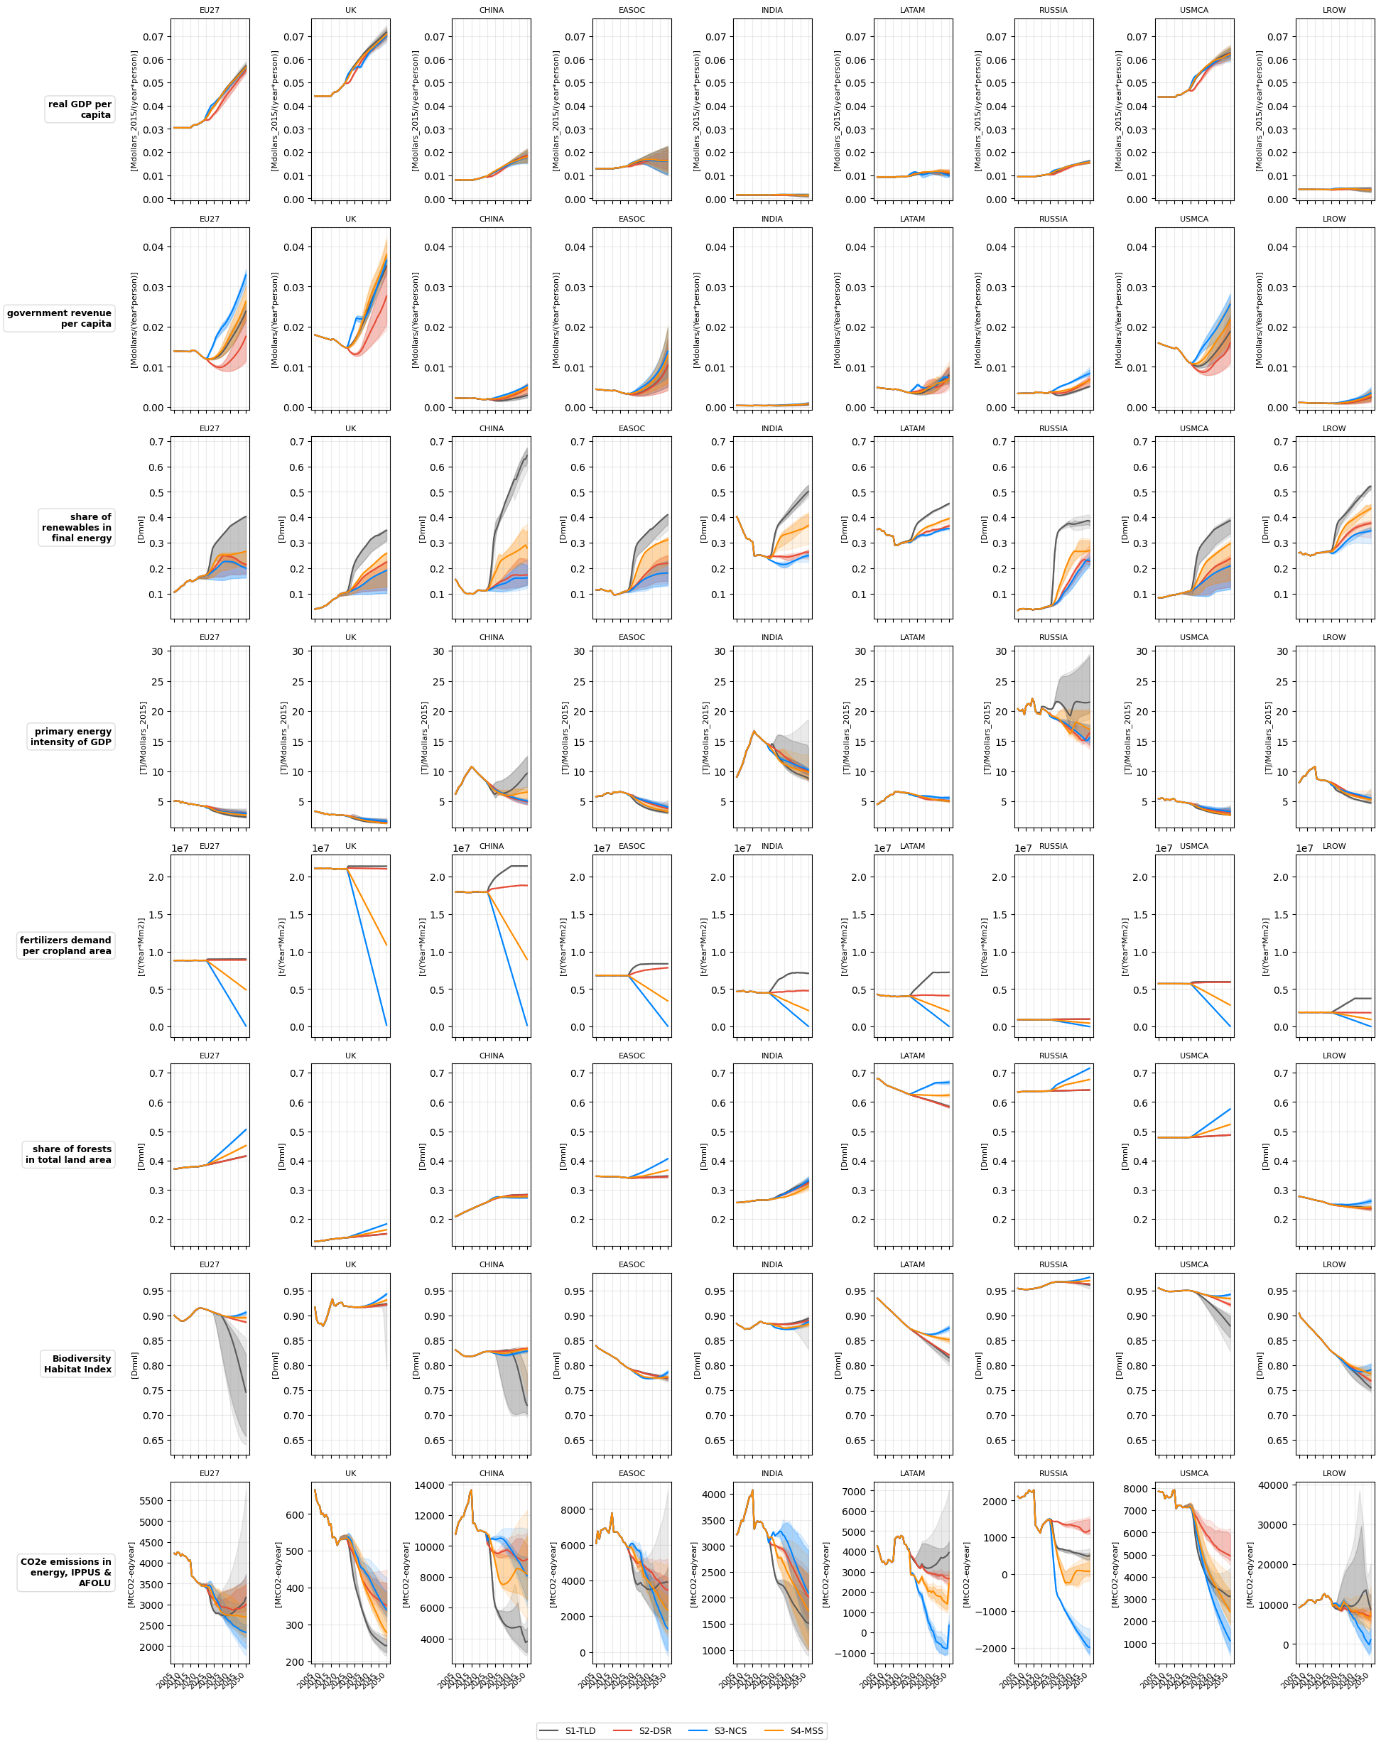
Figure S5. Regional system responses driving differences in scenario acceptability. Regional trajectories of selected economic, energy, land-use and environmental indicators under technology-led decarbonization and natural carbon sink–based mitigation scenarios. Lines represent median values across all simulated pathways, with shaded bands indicating the 25–75% and 10–90% quantile ranges. Results are shown as median values across simulations, with sensitivity ranges reflecting alternative assumptions on population dynamics, technological performance and climate impacts. The figure illustrates how region-specific biophysical constraints and development conditions shape the magnitude and timing of co-benefits and trade-offs across Sustainable Development Goals. These regional system responses underpin the divergent scenario preferences identified in the main text.
Supplementary Figures

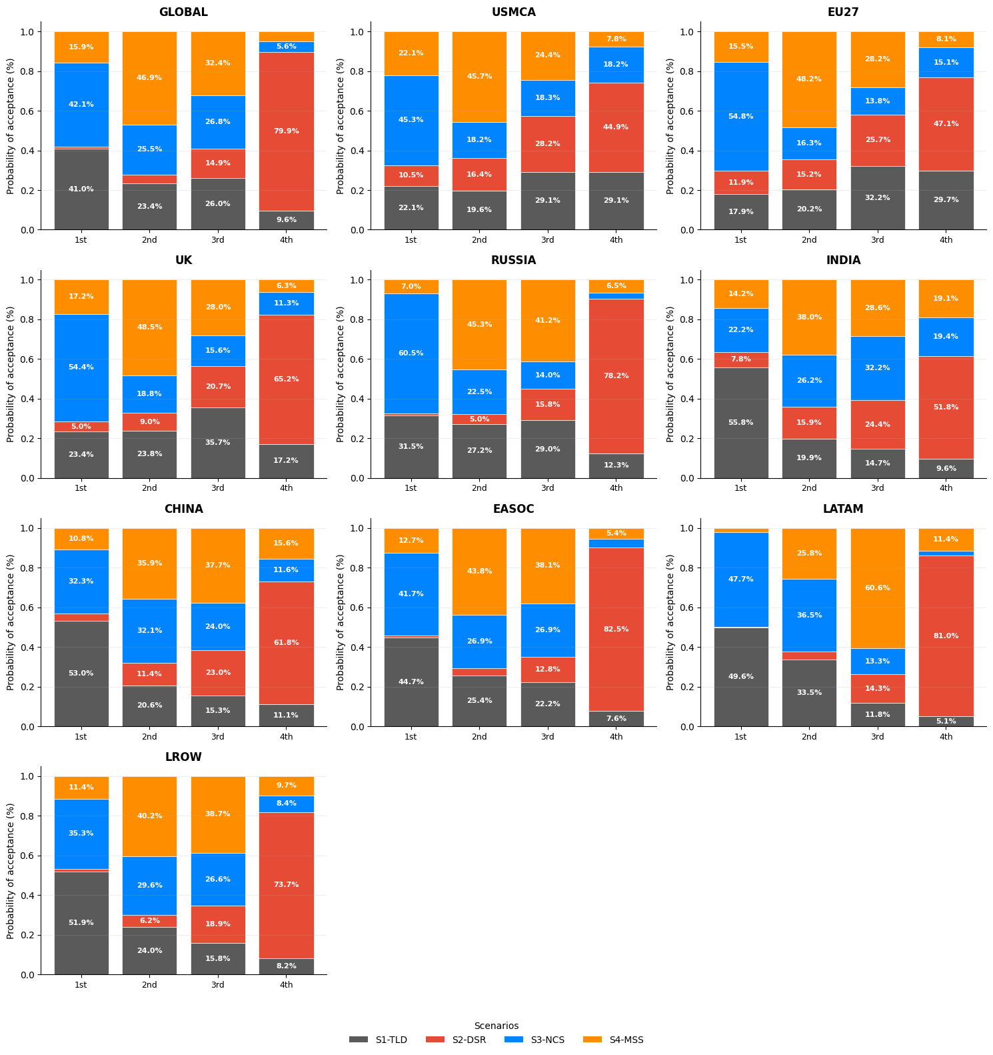
Figure S6. Rank acceptability indices showing the probability that each mitigation scenario occupies a given position in the overall ranking when Sustainable Development Goals (SDGs) are weighted uniformly, by WILIAM region. Rank positions (1st, 2nd, 3rd, 4th) refer to the probability or frequency with which a given alternative (see SMAA information in Methods).

Supplementary References
1. Nakicenovic, N., Kimura, O. & Ajanovic, A. Global Hydrogen and Electricity Storylines. 63 https://pure.iiasa.ac.at/id/eprint/7807/1/IR-05-028.pdf?utm_source=chatgpt.com (2005).
2. Calvin, K. et al. IPCC, 2023: Climate Change 2023: Synthesis Report. Contribution of Working Groups I, II and III to the Sixth Assessment Report of the Intergovernmental Panel on Climate Change [Core Writing Team, H. Lee and J. Romero (Eds.)]. IPCC, Geneva, Switzerland. https://www.ipcc.ch/report/ar6/syr/ (2023) doi:10.59327/IPCC/AR6-9789291691647.
3. Van Vuuren, D. P. et al. A proposal for a new scenario framework to support research and assessment in different climate research communities. Global Environmental Change 22, 21–35 (2012).
4. Riahi, K. et al. The Shared Socioeconomic Pathways and their energy, land use, and greenhouse gas emissions implications: An overview. Global Environmental Change 42, 153–168 (2017).
5. Fizaine, F. & Court, V. Renewable electricity producing technologies and metal depletion: A sensitivity analysis using the EROI. Ecological Economics 110, 106–118 (2015).
6. Lambert, J. G., Hall, C. A. S., Balogh, S., Poisson, A. & Gupta, A. EROI of Global Energy Resources: Preliminary Status and Trends. https://www.inist.org/library/2012-11-02.Lambert%20etal.EROI%20of%20Global%20Energy%20Resources.DFID-59717.pdf (2012).
7. Brandt, A. R. How Does Energy Resource Depletion Affect Prosperity? Mathematics of a Minimum Energy Return on Investment (EROI). Biophys Econ Resour Qual 2, 2 (2017).
8. United Nations Statistics Division (UNSD), Department of Economic and Social Affairs, United Nations. UNdata – United Nations Statistics Database.
9. Soergel, B. et al. A sustainable development pathway for climate action within the UN 2030 Agenda. Nat. Clim. Chang. 11, 656–664 (2021).
10. Allen, C. et al. Indicator-based assessments of progress towards the sustainable development goals (SDGs): a case study from the Arab region. Sustain Sci 12, 975–989 (2017).
11. Tsigaris, P. & Wood, J. The potential impacts of climate change on capital in the 21st century. Ecological Economics 162, 74–86 (2019).
12. Soergel, B. et al. Multiple pathways towards sustainable development goals and climate targets. Environ. Res. Lett. 19, 124009 (2024).
13. Moreno, J. et al. Assessing synergies and trade-offs of diverging Paris-compliant mitigation strategies with long-term SDG objectives. Global Environmental Change 78, 102624 (2023).
14. He, C.-M. et al. Quantification of selected SDGs in the context of China’s climate mitigation pathway. Advances in Climate Change Research 16, 623–635 (2025).
15. Wang, Z., Zhang, H., Li, H. & Zhang, B. Towards sustainable future: Assessing the impact of coal phase-down on the sustainable development goals in China. Journal of Environmental Management 378, 124713 (2025).
16. Forouli, A., Nikas, A., Van De Ven, D.-J., Sampedro, J. & Doukas, H. A multiple-uncertainty analysis framework for integrated assessment modelling of several sustainable development goals. Environmental Modelling & Software 131, 104795 (2020).
17. Wang, Z., Zhang, H., Wang, B. & Ding, Y. Towards a synergistic future: The impact of power sector decarbonization on Sustainable Development Goals in China. Sustainable Production and Consumption 56, 385–395 (2025).
18. Van Vuuren, D. P. et al. Defining a sustainable development target space for 2030 and 2050. One Earth 5, 142–156 (2022).
19. Friedlingstein, P. et al. Global Carbon Budget 2023. Earth Syst. Sci. Data 15, 5301–5369 (2023).
20. Parrado-Hernando, G., Herc, L., Feijoo, F. & Capellán-Pérez, I. Capturing features of hourly-resolution energy models in an integrated assessment model: An application to the EU27 region. Energy 304, 131903 (2024).
21. Mediavilla, M., Lifi, M., Ferreras-Alonso, N., Miguel, L. J. & De Blas, I. Analysis of the competition between land, energy and food using the TERRA module of WILIAM System Dynamics IAM. Renewable and Sustainable Energy Reviews 216, 115651 (2025).

Shared Socioeconomic Pathway 2 (“Middle of the Road”) conceptualized in the IPCC Sixth Assessment Report on climate change in 2021.
ICIO (2018): http://oe.cd/icio

