Supplementary Information
Table of Contents
Supplementary methods 2
MRI acquisition and processing 2
DNA methylation preprocessing and quality control (QC) 3
Reliability checks for all CT- and SA-associated CpGs 3
Measures included in the Phenome-wide association studies (PheWAS) 3
Supplementary results 6
Functional characterisation of CT- and SA-associated CpGs 6
Dataset descriptions 10
Discovery datasets 10
Replication/validation datasets 13
Acknowledgements 18
Supplementary references 24
Supplementary figures 30
Fig. S1. Overview of the analytic plan of the study. 30
Fig. S2. QCEWAS results of average CT and total SA. 31
Fig. S3. Forest plots for significantly associated CpGs in the discovery meta-analysis. 34
Fig. S4. Genomic distribution of CpGs located within differentially methylated regions (DMRs) associated with average CT and total SA. 35
Fig. S5. Tissue-specific expression enrichment (FUMA analyses) of genes annotated to CT- and SA-associated CpGs based on GTEx v8 transcriptomic data across 54 human tissues. 36
Fig. S6. Trait associations of CpGs linked to average CT and total SA, based on previous studies included in the EWAS Catalog. 37
Fig. S7. Correlations between phenotypic variables included in the Phenome-wide association analyses in the IMAGEN cohort. 38

Supplementary methods

MRI acquisition and processing
Cortical surface area (SA) and cortical thickness (CT) were derived from in vivo whole-brain T1-weighted magnetic resonance imaging (MRI) scans using FreeSurfer (v5.3 or later). MRI data were acquired at 1.5 Tesla or 3 Tesla using T1-weighted sequences harmonised across sites. Sequence parameters (TR, TE, flip angle) are summarised in Table S2.

Image processing and quality control (QC) were performed in accordance with the ENIGMA Cortical Quality Control Protocol 2.0 (April 2018), as previously described¹. Site analysts visually inspected the 34 bilateral cortical segmentations defined by the Desikan-Killiany atlas for each participant. Full documentation of ENIGMA imaging protocols is available at https://enigma.ini.usc.edu/protocols/imaging-protocols/ and https://github.com/ENIGMA-git/ENIGMA-FreeSurfer-protocol.

Regional CT and SA measures were extracted according to the Desikan–Killiany atlas (34 regions per hemisphere). Global CT was computed as the mean across all 68 cortical regions, and total SA as the summed surface area across the same regions.

For regional analyses, cortical regions of interest were grouped into anatomically defined lobes. The frontal lobe comprised the superior frontal, rostral and caudal middle frontal, pars opercularis, pars triangularis, pars orbitalis, lateral and medial orbitofrontal, precentral, paracentral, and frontal pole. The temporal lobe included superior, middle, and inferior temporal gyri, banks of the superior temporal sulcus, fusiform, transverse temporal, entorhinal, temporal pole, and parahippocampal regions. The occipital lobe included the lateral occipital, lingual, cuneus, and pericalcarine cortices. The parietal lobe comprised the superior parietal, inferior parietal, supramarginal, postcentral, and precuneus regions. The cingulate cortex included rostral anterior, caudal anterior, posterior, and isthmus cingulate regions, and the insula was analysed separately. Lobe-wise CT, calculated as the mean across constituent regions, and SA, as the summed surface area of those regions, were first computed within each hemisphere and then aggregated bilaterally.

DNA methylation preprocessing and quality control (QC)
DNAm was measured in whole blood using the Illumina Infinium MethylationEPIC array (v1.0 or v2.0) in discovery cohorts and the Illumina HumanMethylation450 BeadChip array in replication cohorts.

EPIC v1.0 and v2.0 interrogate >850,000 CpGs and >900,000 CpGs, respectively, with substantial probe overlap (~77.6%)² and expanded coverage of open chromatin and enhancer elements^{3–5}. The 450K array profiles >480,000 CpGs⁶ and served as the replication platform. High cross-platform reproducibility has been reported previously^{7–9}.

Preprocessing and QC were performed using the minfi R package¹⁰. Red and green channel intensities were mapped to methylated and unmethylated signals, and average intensities were used to assess sample quality. Initial QC was conducted using preprocessIllumina. Principal component analysis (PCA) based on singular value decomposition was applied to identify outliers; samples exceeding three standard deviations from the median on the first four principal components were excluded^{11,12}. Sex was predicted using sex chromosome probe intensities, and samples with discordant predicted and recorded sex were removed.

Samples processed in separate batches were merged prior to normalisation. Stratified quantile normalisation was applied using the preprocessQuantile. PCA on normalised beta-values was used to capture major sources of technical and biological variation. Proportions of six major blood cell types (granulocytes, B cells, CD4⁺ T cells, CD8⁺ T cells, monocytes, and NK cells) were estimated using the estimateCellCounts2 function, based on a reference panel¹³. Full analysis scripts and documentation will be made publicly available upon publication at: https://github.com/XinyangYu918/Meta-analysis-of-cortical-EWAS.

Reliability checks for all CT- and SA-associated CpGs
Reliability of FDR-significant CT- and SA-associated CpGs was assessed using published cross-platform intraclass correlation coefficients (ICCs) for probes shared between the Illumina 450K and EPIC arrays¹⁴, indicating predominantly good-to-excellent reproducibility (14/15 CpGs ICC ≥ 0.40), with one low-reliability CpG interpreted cautiously in downstream analyses (Table S4).

Measures included in the Phenome-wide association studies (PheWAS)
Phenome-wide association analyses (PheWAS) were conducted in the IMAGEN cohort (N = 1,191; mean age = 19.02 ± 0.73 years) to examine associations between CpGs identified in the discovery EWAS of cortical morphology and a broad range of behavioural, clinical, cognitive, and environmental phenotypes. IMAGEN employed a harmonised, structured assessment protocol comprising standardised self-report questionnaires, clinician-administered interviews, and behavioural tasks. Measures were grouped into conceptually related domains, as outlined below.

Anthropometric measures: Height and weight were measured during clinical assessments using standardised protocols. Body mass index (BMI) was calculated as weight (kg) divided by height squared (m²).

Cognitive performance: cognitive function was assessed using selected tasks from the Cambridge Neuropsychological Test Automated Battery (CANTAB), including the Affective Go/No-Go (AGN), Cambridge Gambling Task (CGT), Spatial Working Memory (SWM), and Rapid Visual Processing (RVP). Outcome included latency, response bias, decision quality, risk adjustment, impulsivity, and strategy use.

Eating behaviours: eating behaviours were evaluated using the Eating Disorder Examination Questionnaire (EDE-Q)¹⁵, assessing disordered eating behaviours and related attitudes, and the Three-Factor Eating Questionnaire (TFEQ)^{16,17}, measuring cognitive restraint, uncontrolled eating, and emotional eating.

Environmental and life stressors: Childhood adversity was assessed using the Childhood Trauma Questionnaire (CTQ)¹⁸, capturing emotional abuse, physical abuse, sexual abuse, emotional neglect, and physical neglect. Stressful life events were measured using the Life Events Questionnaire (LEQ), adapted from the Stressful Life Event Questionnaire¹⁹, covering domains such as family conflict, accidents, deviant behaviour, emotional distress, relocation, and sexuality-related events.

Mental health outcomes: Psychiatric symptoms were assessed using the adult self-report Development and Well-Being Assessment (DAWBA)²⁰, the Strengths and Difficulties Questionnaire (SDQ)²¹ and the Community Assessment of Psychic Experience (CAPE-42)²². Depressive symptoms and rumination were measured using the Adolescent Depression Rating Scale (ADRS)²³ and the Ruminative Response Scale (RRS)²⁴, respectively.

Personality traits: Personality was assessed using the revised NEO Five-Factor Personality Inventory (NEO-PI-R)²⁵, capturing neuroticism, extraversion, openness, agreeableness, and conscientiousness. Additional traits were measured using the Temperament and Character Inventory (TCI)²⁶ and its extended version (TCI-3)²⁷, and the Substance Use Risk Profile Scale (SURPS)²⁸, assessing novelty seeking, impulsivity, emotional reactivity, persistence, hopelessness, anxiety sensitivity, and sensation seeking.

Social and interpersonal functioning: social functioning was assessed using the Interpersonal Reactivity Index (IRI)²⁹, and the Perception of Adult Attachment Questionnaire (PAAQ)³⁰. Peer victimisation and perpetration were assessed using items adapted from the Bully Questionnaire³¹.

Somatisation: Frequency of somatic symptoms was measured using the 35-item Children’s Somatisation Inventory (CSI), based on DSM-III-R criteria for somatisation disorders³².

Substance use: Alcohol use and related problems were assessed using the Alcohol Use Disorders Identification Test (AUDIT)³³, the Michigan Alcoholism Screening Test (MAST)³⁴, and the Rutgers Alcohol Problem Index (RAPI)³⁵. Lifetime use of substances including amphetamines, cannabis, cocaine, crack, ecstasy (MDMA), GHB, glue, heroin, ketamine, LSD, mushrooms, synthetic cannabinoids, tranquillisers, and tobacco was recorded.

Urban environment: urbanicity was defined based on early-life (up to age 15) and current residential location, classified by population size to quantify exposure to urban environments.

Accumulating evidence indicates that environmentally responsive DNAm loci exert pleiotropic effects across behavioural, psychiatric, cognitive, and cardiometabolic domains. We therefore implemented a domain-spanning PheWAS framework to characterise the broader phenotypic embedding of cortical morphology–associated CpGs within this multiorgan regulatory landscape. Phenotypes were pre-specified according to the structured IMAGEN assessment protocol and grouped into conceptually defined domains to minimise analytical flexibility (Fig. S7). Multiple testing was conservatively controlled using Bonferroni correction across all CpGs and phenotypes, ensuring that reported associations reflect robust signal rather than residual multiplicity.

Supplementary results

Functional characterisation of CT- and SA-associated CpGs
Genomic annotation: CpGs associated with cortical morphology at FDR-significance were primarily located within gene bodies or intergenic regions, notably in OpenSea contexts (Fig. 4a-b), suggesting that most loci may act through non-promoter regulatory mechanisms.

Regulatory landscape and chromatin state: We next assessed chromatin state and histone mark enrichment for CpGs reaching P < 1×10⁻⁵ (CT: N = 68; SA: N = 52) using NIH Roadmap Epigenomics annotations across 10 brain tissues. CT-associated CpGs showed a distinct regulatory signature, characterised by enrichment in transcription start site-flanking regions (TssAFlnk) and depletion from active core promoters (TssA). Enrichment of flanking TSS states was observed in the anterior caudate, dorsolateral prefrontal cortex, angular gyrus, and hippocampus (all P_{FDR} < 0.05; odds ratios 2.9–3.5; Fig. 4c; Table S8), whereas active promoter states were consistently depleted across multiple cortical and subcortical regions, including the angular gyrus, inferior temporal lobe, cingulate cortex, and foetal brain tissues. Additional enrichment was observed for enhancer elements in the angular gyrus. Histone mark analyses were concordant, showing significant enrichment of H3K4me1, a canonical enhancer-associated modification, in the dorsolateral prefrontal cortex, anterior caudate, and angular gyrus (Table S9). Together, these findings indicate that CT-associated CpGs preferentially localise to enhancer and TSS-flanking regulatory elements, consistent with context-dependent modulation of gene expression rather than constitutive promoter activity.

In contrast, SA-associated CpGs showed no enrichment for active chromatin states but were enriched for the repressive mark H3K27me3 in the brain germinal matrix (P_{FDR} = 0.044), implicating polycomb-mediated repression during early neurodevelopment. These results support distinct epigenetic architectures for CT and SA, with CT reflecting regulatory activity in differentiated cortical regions and SA reflecting earlier developmental programmes.

Tissue-specific gene expression: Tissue-specific expression analyses using FUMA³⁶ revealed marked differences between CT and SA (Fig. S5). Genes mapped to CT-associated CpGs showed strong enrichment in brain tissues, alongside significant enrichment in blood and multiple peripheral tissues, suggesting systemic coordination. Directionality-stratified analyses indicated that CT-associated CpGs preferentially index genes that are relatively downregulated across all brain tissues, heart, blood, liver, colon, kidney, and spleen, whereas enrichment for upregulated genes was limited to adipose, lung, and vagina. This pattern suggests that CT-associated epigenetic variation predominantly reflects repressive or fine-tuning transcriptional programmes, consistent with enhancer-mediated regulation. These expression profiles converge on a multiorgan regulatory network spanning neural, cardiovascular, metabolic, renal, and immune systems, aligning with emerging frameworks linking chronic inflammation, cardiometabolic-renal dysfunction, premature mortality, mental health, and dementia risk^{37,38}. In contrast, genes mapped to SA-associated CpGs showed weaker and more restricted tissue-specific enrichment, with preferential downregulation in blood, heart, liver, and basal ganglia, consistent with a more developmentally constrained transcriptional footprint.

DNAm-gene expression correlations: We further assessed correlations between DNA methylation and gene expression across six tissues using EWAS Toolkit data derived from TCGA cohorts (Table S10). Several replicated CT-associated CpGs showed robust transcriptional coupling. The replicated promoter CpG cg12303084 (ZMYND8), also implicated via DMR analysis, showed consistent inverse correlations with expression across brain, liver, colon, and stomach, with a positive association in testis, indicating tissue-specific regulation. The gene-body CpG cg01015663 (TCEA3) showed a strong inverse correlation with expression in the brain (r = -0.671), alongside positive correlations in liver and testis, while cg03636183 (F2RL3) showed inverse association in the brain and positive associations in testis and kidney.

Several DMR-associated CT CpGs also showed transcriptional coupling, including cg14284211 (FKBP5), cg00024404 (SERINC5) and cg13127741 (COMMD7), with predominantly inverse correlations at promoter-associated loci, consistent with canonical models of methylation-mediated repression. For SA, although no replicated CpGs were identified, DMR-associated loci such as cg10016608 (GAS2L2) and cg19832721 (KANSL1) showed notable tissue-specific associations.

Together, these findings demonstrate that replicated CT-associated CpGs –particularly those mapping to ZMYND8, TCEA3, and F2RL3– exhibit robust, tissue-dependent methylation-expression coupling, supporting their functional relevance. The convergence of chromatin state, tissue-specific expression, and DNAm-expression correlation analyses underscores the biological plausibility of these loci in underlying interindividual variation in cortical structure.

Pathway enrichment analyses: KEGG pathway enrichment analyses of genes annotated to CpGs associated with cortical morphology (P < 1×10⁻⁵; Table S11; Fig. 4d) revealed marked differences between CT and SA. Genes linked to CT-associated CpGs showed broad and robust enrichment across pathways related to environmental sensing and detoxification (e.g. olfactory transduction, drug metabolism, metabolism of xenobiotics by cytochrome P450, glutathione metabolism), alongside cellular signalling and neurobiological processes, including cell adhesion molecules, axon guidance, long-term potentiation, and Wnt and Hedgehog signalling. Additional enrichment was observed for pathways involved in autophagy, transcriptional regulation, protein export, and DNA repair, as well as for multiple neurodegenerative and cancer-related pathways, indicating pleiotropic involvement of CT-linked regulatory loci across brain and systemic disease processes. In contrast, genes annotated to SA-associated CpGs showed a more restricted enrichment profile, primarily involving metabolic and detoxification pathways. Together, these results further support a model in which CT-associated CpGs implicate diverse regulatory programmes integrating environmental, metabolic, and neuroplastic processes, whereas SA-associated CpGs map to a narrower set of broadly acting metabolic pathways, consistent with their distinct epigenetic and developmental architectures.

Trait enrichment analyses: Analysis using the EWAS Atlas showed that CpGs associated with cortical morphology (P < 1×10⁻⁵) were significantly overrepresented among CpGs previously linked to a broad range of behavioural, clinical, and environmental traits (Table S12; Fig. 5a). CT-associated CpGs showed particularly strong enrichment for traits related to environmental exposure and systemic health, including smoking-related phenotypes, lung cancer risk, lung function, air pollution, and IgG glycosylation, highlighting overlap with exposure-sensitive and immune-modulated epigenetic signatures. Robust enrichment was also observed for educational attainment, cognitive function, wellbeing, poverty status, and mortality, in line with the brain- and blood-enriched transcriptional programmes identified in the FUMA analyses. Additional overlap with cardiometabolic traits (e.g. cardiovascular risk, type 2 diabetes, body mass index), immune-mediated disorders (Crohn’s disease, multiple sclerosis, allergic asthma), and neurodegenerative disease (Alzheimer’s disease) further aligns with the multiorgan regulatory networks and metabolic–inflammatory pathways highlighted by KEGG pathway enrichment.

In contrast, SA-associated CpGs showed a more restricted trait enrichment profile, with significant overlap primarily involving psychiatric outcomes (depressive disorder), prenatal maternal conditions (hypertensive disorders in pregnancy), and immune and inflammatory traits (Crohn’s disease, psoriasis, systemic lupus erythematosus, fractional exhaled nitric oxide).

Together, these trait-level enrichments further support a model in which CT-associated CpGs capture environmentally responsive, systemically integrated regulatory processes.

Overlap with previously reported EWAS signals: Across CpGs associated with cortical morphology at P < 1×10⁻⁵, overlap with prior EWAS signals revealed a convergent association with a shared spectrum of traits (Table S13), particularly among CT-associated loci, spanning environmental exposures (smoking, alcohol use), ageing, cardiometabolic-renal dysfunction, inflammatory and immune processes, and mortality-related outcomes. This convergence was evident for replicated CT CpGs, including cg03636183 (F2RL3), cg12303084 (ZMYND8), cg01015663 (TCEA3), and cg13518625 (DUSP4/SARAF), and aligns with the observation that CT-associated CpGs map to a multiorgan regulatory network with predominantly downregulated expression across neural, cardiovascular, metabolic, renal, and immune tissues.

Together, these findings support a model in which replicated CT-associated CpGs capture epigenetic variation operating along a systemic axis of chronic inflammation, cardiometabolic–renal dysfunction, and ageing-related vulnerability, rather than isolated, tissue-specific effects.

Dataset descriptions
Demographics, DNAm and MRI acquisition pipelines for each cohort are summarised in Tables S1-2.

Discovery datasets
ADNI: Data used in the preparation of this article were obtained from the Alzheimer's Disease Neuroimaging Initiative database (adni.loni.usc.edu). The ADNI was launched in 2003 as a 5-year public–private partnership, led by Principal Investigator Michael W. Weiner, MD. The primary goal of ADNI has been to test whether serial magnetic resonance imaging (MRI), positron emission tomography (PET), other biological markers, and clinical and neuropsychological assessment can be combined to measure the progression of mild cognitive impairment (MCI) and early Alzheimer’s disease (AD) and to assess and optimize biomarkers for clinical trials in AD. The initial sample included older adults who were cognitive normal (CN) as well as meeting criteria for MCI and clinical AD.
DBIS: The Dunedin Brain Imaging Study (DBIS) seeks to better understand what factors shape healthy and unhealthy aging of the brain. Neuroimaging data were collected from 2016 to 2019 in Dunedin, New Zealand, in 875 members of the Dunedin Study, a longitudinal investigation of a population-representative birth cohort now in midlife. The cohort is primarily white (93%), and individuals were 45 years old at the time of neuroimaging. The Dunedin Brain Imaging Study is a collaboration between Duke University Professors Terrie Moffitt, Avshalom Caspi, and Ahmad Hariri, and the Dunedin Multidisciplinary Health and Development Research Unit led by Professor Richie Poulton at the University of Otago in Dunedin, New Zealand. The parent Dunedin Study was launched with the enrollment of 1037 individuals born between April 1972 and March 1973 in Dunedin, New Zealand. The individuals enrolled represented the full range of socioeconomic status in the general population of New Zealand's South Island. These individuals have been followed longitudinally with a variety of rigorous health and behavioral assessments conducted at birth and ages 3, 5, 7, 9, 11, 13, 15, 18, 21, 26, 32, 38, and, most recently, 45, when neuroimaging was carried out in 875 individuals.
ESTRA and STRATIFY³⁹: Participants from these datasets were derived from two related and complementary clinical studies, ESTRA and STRATIFY, respectively, led by Prof Sylvane Desrivières and Prof Gunter Schumann. STRATIFY was designed to generate a neurobehavioural framework for the stratification of psychopathology for prevalent mental disorders: major depression (MDD), alcohol use disorder (AUD), and Psychosis, while ESTRA focused on eating disorders (anorexia nervosa, bulimia nervosa, and binge eating disorder). Both studies used protocols harmonised to match the IMAGEN study protocol.
ESTRA: Participants from this study were recruited in London. In addition to age (18–25 years), inclusion criteria were DSM-5-based diagnostic criteria for AN or BN, based on the Eating Disorder Diagnostic Scale (EDDS DSM5 version). All participants from this sample were female. Age-matched healthy controls were also recruited.
STRATIFY: Participants were recruited in the UK (London and Southampton) and Germany (Berlin). In addition to age (18-30 years), inclusion criteria were: current moderate-severe depression, assessed by PHQ-9, with a total score of 15 or above; moderate-severe alcohol use disorder, assessed by AUDIT, with a total score of 15 or above; and schizophrenia, schizotypal and delusional disorders based on ICD-10 diagnosis.
Age-matched healthy controls were also recruited as part of ESTRA and STRATIFY.
Ethical approval was received from the London Westminster Research Ethics Committee and the Charité Ethikkommission (STRATIFY), and the Northwest-Greater Manchester South Research Ethics Committee (ESTRA). Written informed consent was obtained from all participants.
FOR2107: The FOR2107 cohort is a bicentric longitudinal case-control study, aimed at investigating the neurobiological mechanisms underlying mental disorders, including major depression (MDD), bipolar disorder (BD), and schizophrenia (SZ)⁴⁰. Participants include healthy controls as well as patients and are recruited from two different sites in Germany, Marburg and Münster. Data collection included a diagnostic interview, as well as cognitive, psychosocial, genetic and biological measures and an MRI assessment. Participants were assessed at three time points over five years, with the first follow-up occurring about two years after baseline and the third about five years after baseline assessment. Lifetime psychiatric diagnosis was assessed using the semi-structured SCID-I interview according to DSM-IV-TR (Diagnostic and Statistical Manual of Mental Disorders) applied by trained staff. All procedures were approved by the local Ethics Committees of Marburg (AZ:07/14) and Münster (AZ:2014-422-b-S), Germany, according to the Declaration of Helsinki. Participants gave written informed consent prior to study participation and received financial compensation. DNA methylation was profiled using the Infinium MethylationEPIC v1.0 BeadChip (Illumina, San Diego, CA, USA) based on DNA extracted from whole blood samples.
IMAGEN: The longitudinal IMAGEN cohort⁴¹ aims to identify neurobiological correlates of reinforcement-related behaviours in adolescents followed from ages 14 to 23 years. Participants were recruited from eight research centres in the United Kingdom, Germany, France and Ireland. Ethics approval was obtained at each site by the local research ethics committee. Written consent was obtained from each participant. For this study, we analysed data from participants aged 19 years.
MCIC: The Mental Illness and Neuroscience Discovery Institute (MIND) Institute, now the Mind Research Network (MRN, www.mrn.org), formed the MIND Clinical Imaging Consortium (MCIC) in 2003 to conduct a multi-institutional, cross-sectional study of patients with schizophrenia and demographically matched, by sex and age, healthy controls to identify quantitative neuroimaging biomarkers for this devastating disease⁴².
PPMI: The Parkinson’s Progression Markers Initiative (PPMI)⁴³ is an observational study to better define and measure Parkinson’s disease to speed therapeutic development. PPMI makes its data set and biorepository—the most robust in Parkinson’s to date—available to academia and industry to accelerate breakthroughs. PPMI has gathered longitudinal data from more than 1,400 individuals at 33 clinical sites in 11 countries. These data are shared through the University of Southern California’s Neuroimaging Laboratories database (https://ida.loni.usc.edu/).
SHIP-TREND: The SHIP-TREND is a population-based cohort study. Baseline examination was performed between 2008 and 2012⁴⁴. The medical ethics committee of the University of Greifswald approved the study protocol. Oral and written informed consents were obtained. Examinations comprised a health-related interview, an oral health examination, a medical examination and a health- and risk factor-related questionnaire.
SNiP: This cohort was recruited between 2013 and 2018 at the Central Institute of Mental Health (CIMH) in Mannheim, Germany. Ethics approval was given by the medical ethics committee ll of the Medical Faculty Mannheim at Ruprecht-Karls-University in Heidelberg, fulfilling the ethical guidelines for medical research according to the Declaration of Helsinki. All participants signed written informed consent and were free to withdraw from the study at any time. There was no surrogate consent procedure.

Replication/validation datasets
BIP-SYD: Participants were aged 12-30 years and recruited as previously described^{45,46}. Briefly, participants with a personal or family history of bipolar disorder (BD) were recruited from families who had previously participated in family studies of BD, specialised BD research clinics, mental health consumer organisations, or in response to public notices. BD cases (n=17) met DSM-IV criteria for BD type-I (BD-I) or type-II (BD-II). High risk (HR; n=84) participants were the children or siblings of individuals with DSM-IV diagnoses of BD-I, BD-II, or schizoaffective disorder–bipolar-type (SABP), who did not personally have threshold diagnoses of these conditions at baseline, but 64% had some threshold or subthreshold psychopathology (affective, substance, anxiety). Control participants (CON; n=94) were recruited via print/electronic media, and noticeboards in universities and local communities. CON had no personal or familial (first-degree) history of BD-I, BD-II, recurrent unipolar disorder, SABP, schizophrenia, recurrent substance abuse or psychiatric hospitalization, and no second-degree relative with a past mood-disorder hospitalization or history of psychosis.
Written informed consent was obtained from all participants, with additional parental consent for participants aged <16 years. This study was approved by the University of New South Wales Human Research Ethics Committee (HREC Protocol 09/097). A battery of structured clinical interviews, self-report questionnaires and clinician-rated assessments was administered to each participant. The Family Interview for Genetic Studies (FIGS)⁴⁷ was administered to each participant or a family member to determine the family history of mood or psychotic disorder. To determine psychiatric diagnoses, both participants (aged 12-21) and their parent/s completed the Kiddie-Schedule for Affective Disorders and Schizophrenia for School-Aged Children–Present and Lifetime Version (K-SADS-BP; v2, July 2009)^{48,49}. Adult participants (aged 22-30; including BD-probands) completed the Diagnostic Interview for Genetic Studies (DIGS; v4.0/BP, July 2005)⁵⁰. Consensus DSM-IV diagnoses were determined by two clinicians using best-estimate methodology⁵¹, using the K-SADS or DIGS, FIGS, and medical records (where available). The participants in the analysed sample were predominantly European (77%) or mixed-European (11%), while 11% were of Asian ancestry. The analysed cohort was 54% female, had 14.4 ± 3.4 years (mean±sd; range 6-21) of education, and an IQ of 116.8 ± 10.7 (range 83-138). DNA for methylation quantification was derived from peripheral blood extracted from whole blood (n=27), ficol/buffy coat processed (n=113) or separated lymphocytes (n=55), as described previously⁵². Tissue source and cell count estimates were included as covariates.
CTAAC: The purpose of the Cape Town Adolescent Antiretroviral Cohort (CTAAC) is to investigate chronic disease processes in perinatally HIV-infected South African adolescents. The focus is on four key domains: the impact of chronic HIV infection on development; the neuropsychiatric manifestations of HIV in adolescence; the development of chronic lung disease; and early markers of cardiovascular dysfunction. Throughout, the emphasis of this research is on understanding the interactions between chronic disease processes across organ systems. The study enrolled 520 perinatally-infected children ages 9-14 years established on antiretroviral therapy. We followed these children with regular measures (including measures of physical and psychological development, clinical well-being, lung function, cardiovascular status, and emergent risk behaviours) at 6-monthly intervals over 36 months. A CN group of 80 HIV-negative controls was matched on age, gender and socioeconomic status, in order to collect normative data on key parameters.
GenR: The Generation R Study is a prospective population-based cohort that follows children from fetal life onwards. Pregnant women living in the study area of Rotterdam, The Netherlands, with an expected delivery date between April 2002 and January 2006 were invited to participate⁵³. A total of 9,778 mothers were enrolled. These mothers, their children and partners took part in several research waves. The general design, research aims, and specific measurements of The Generation R Study have been approved by the Medical Ethical Committee of Erasmus MC, in accordance with the Declaration of Helsinki of the World Medical Association. Written informed consent was obtained from the parents on behalf of the child. For data collected when the child was 12 years or older, the child also provided written informed consent.
LBC1936: The work was undertaken as part of the Cross Council and University of Edinburgh Centre for Cognitive Ageing and Cognitive Epidemiology (CCACE; http://www.ccace.ed.ac.uk). The image acquisition and analysis were performed at the Brain Research Imaging Centre, University of Edinburgh (http://www.bric.ed.ac.uk).
MPIP: The MPIP Munich Morphometry Sample comprises images acquired as part of the Munich Antidepressant Response Signature (MARS) Study and the Recurrent Unipolar Depression (RUD) Case-Control study performed at the MPIP, and control subjects acquired at the Ludwig-Maximilians-University, Munich, Department of Psychiatry.
NTR: The Netherlands Twin Register is a population-based cohort of over 200,000 people from across the Netherlands. It consists of twin-families, i.e. twins, their parents, spouses and siblings aged between 0 and 99 years at recruitment, and started around 1987 with newborn twins and adolescent and adult twins. Full details have been reported previously⁵⁴. DNA was collected from buccal cells and whole blood as part of multiple projects. For the current paper, we analysed DNA methylation measured in whole blood samples from monozygotic and dizygotic twins collected as part of the NTR Biobank Project⁵⁵. Informed consent was obtained from all participants. The study was approved by the Central Ethics Committee on Research Involving Human Subjects of the VU University Medical Centre, Amsterdam, an Institutional Review Board certified by the U.S. Office of Human Research Protections (IRB number: IRB00002991; Federal-wide Assurance: FWA00017598; IRB/institute codes: NTR 03-180)
OATS: The Older Australian Twins Study (OATS) recruited twins aged 65 and over from the three Eastern mainland states, Victoria, New South Wales and Queensland. The longitudinal OATS study aimed to examine the genetic and environmental factors involved in ageing and ageing-related neurodegenerative disorders. A comprehensive assessment was undertaken and included medical history, a cognitive battery, functional and personality tests. Peripheral blood samples were collected for biochemical tests and DNA extraction for genetic and DNA methylation assays. Neuroimaging was performed on a subsample. Inclusion criteria included the ability to consent, having a consenting co-twin and having at least a low mean IQ. Criteria for exclusion from the study included a life-threatening illness, current acute psychotic disorder and insufficient English to complete the cognitive battery. Written informed consent was provided by all participants, and ethics approval was granted by the ethics committees of the University of New South Wales, the Australian Twin Registry, the University of Melbourne, Queensland Institute of Medical Research and the South-Eastern Sydney and Illawarra Area Health Service. For more details, see⁵⁶.
PAFIP: The data utilized in this study were derived from a substantial epidemiological cohort of patients diagnosed with First Episode Psychosis (FEP), who were part of a longitudinal intervention program known as the Support Programme for Early-stage Psychosis (Programa Asistencial a las Fases Iniciales de Psicosis, or PAFIP) conducted between 2001 and 2011 (Clinical trial identifier NCT02526030). The programme was implemented at both the outpatient and inpatient units of Marqués de Valdecilla University Hospital in Santander, Spain. The PAFIP, which was staffed by a multidisciplinary team of clinical and research personnel, incorporated hospital and outpatient care, offering services in diverse areas such as psychiatric nursing, psychology, psychiatry, and social work, and provided specialized, personalized clinical care from the patient's initial contact until three years thereafter. During this period of time, in addition to the clinical care of the patients, several evaluations were carried out from which the data used for the follow-up analyses were extracted (1-year evaluation and 3-year evaluation). A comprehensive description of PAFIP's methodology is available in previous publications^{57,58}.
SYS: The Saguenay Youth Study (SYS) is a two-generational study of adolescents and their parents (N=1,029 adolescents and 962 parents) aimed at investigating the aetiology, early stages and trans-generational trajectories of common cardiometabolic and brain diseases^{59,60}.
ALSPAC: Pregnant women resident in Avon, UK with expected dates of delivery between 1st April 1991 and 31st December 1992 were invited to take part in the study. 20,248 pregnancies have been identified as being eligible and the initial number of pregnancies enrolled was 14,541. Of the initial pregnancies, there was a total of 14,676 foetuses, resulting in 14,062 live births and 13,988 children who were alive at 1 year of age. When the oldest children were approximately 7 years of age, an attempt was made to bolster the initial sample with eligible cases who had failed to join the study originally. As a result, when considering variables collected from the age of seven onwards (and potentially abstracted from obstetric notes) there are data available for more than the 14,541 pregnancies mentioned above: The number of new pregnancies not in the initial sample (known as Phase I enrolment) that are currently represented in the released data and reflecting enrolment status at the age of 24 is 906, resulting in an additional 913 children being enrolled (456, 262 and 195 recruited during Phases II, III and IV respectively). The phases of enrolment are described in more detail in the cohort profile paper and its update (see footnote 5 below). The total sample size for analyses using any data collected after the age of seven is therefore 15,447 pregnancies, resulting in 15,658 foetuses. Of these 14,901 children were alive at 1 year of age.
Of the original 14,541 initial pregnancies, 338 were from a woman who had already enrolled with a previous pregnancy, meaning 14,203 unique mothers were initially enrolled in the study. As a result of the additional phases of recruitment, a further 630 women who did not enrol originally have provided data since their child was 7 years of age. This provides a total of 14,833 unique women (G0 mothers) enrolled in ALSPAC as of September 2021.
G0 partners were invited to complete questionnaires by the mothers at the start of the study and they were not formally enrolled at that time. 12,113 G0 partners have been in contact with the study by providing data and/or formally enrolling when this started in 2010. 3,807 G0 partners are currently enrolled^{61–63}. The data used in the present study were collected from 571 males and further description of this subset and the variables used in this study are provided in Table S2. Ethical approval for the study was obtained from the ALSPAC Ethics and Law Committee and the Local Research Ethics Committees. The UK Medical Research Council and Wellcome (Grant ref: MR/Z505924/1) and the University of Bristol provide core support for ALSPAC. This publication is the work of the authors and they will serve as guarantors for the contents of this paper. Please note that the study website contains details of all the data that is available through a fully searchable data dictionary and variable search tool" and reference the following webpage: http://www.bristol.ac.uk/alspac/researchers/our-data/.
Ethical approval for the study was obtained from the ALSPAC Ethics and Law Committee and the Local Research Ethics Committees. Informed consent for the use of all data collected was obtained from participants following the recommendations of the ALSPAC Ethics and Law Committee at the time. Participants can contact the study team at any time to retrospectively withdraw consent for their data to be used. Study participation is voluntary and during all data collection sweeps, information was provided on the intended use of data.
Biological samples are collected in accordance with the Human Tissue Act (2004). Specific Research Ethics Committee approval is sought for the consenting process at each collection sweep. Written consent, including permission for future use, is obtained from adult participants or from the parents of children as appropriate. Ethical approval for future use is covered by ALSPAC's Research Tissue Bank approval. All historical consents to hold biological samples have been reviewed as part of the Tissue Bank approval process. Participants can contact the study team at any time to retrospectively withdraw consent for use of their samples.

Acknowledgements
ENIGMA: The study was supported in part by a cross-NIH alliance that funds Big Data to Knowledge Centres of Excellence (grant 5U54EB020403-05) and by NIH grant 1R56AG058854-01 to the ENIGMA World Aging Centre.
ADNI: Data collection and sharing for this project was funded by the Alzheimer's Disease Neuroimaging Initiative (ADNI) (National Institutes of Health Grant U01 AG024904) and DOD ADNI (Department of Defense award number W81XWH-12-2-0012). ADNI is funded by the National Institute on Aging, the National Institute of Biomedical Imaging and Bioengineering, and through generous contributions from the following: AbbVie, Alzheimer's Association; Alzheimer's Drug Discovery Foundation; Araclon Biotech; BioClinica, Inc.; Biogen; Bristol-Myers Squibb Company; CereSpir, Inc.; Cogstate; Eisai Inc.; Elan Pharmaceuticals, Inc.; Eli Lilly and Company; EuroImmun; F. Hoffmann-La Roche Ltd and its affiliated company Genentech, Inc.; Fujirebio; GE Healthcare; IXICO Ltd.;Janssen Alzheimer Immunotherapy Research & Development, LLC.; Johnson & Johnson Pharmaceutical Research & Development LLC.; Lumosity; Lundbeck; Merck & Co., Inc.;Meso Scale Diagnostics, LLC.; NeuroRx Research; Neurotrack Technologies; Novartis Pharmaceuticals Corporation; Pfizer Inc.; Piramal Imaging; Servier; Takeda Pharmaceutical Company; and Transition Therapeutics. The Canadian Institutes of Health Research is providing funds to support ADNI clinical sites in Canada. Private sector contributions are facilitated by the Foundation for the National Institutes of Health (www.fnih.org). The grantee organization is the Northern California Institute for Research and Education, and the study is coordinated by the Alzheimer's Therapeutic Research Institute at the University of Southern California. ADNI data are disseminated by the Laboratory for Neuro Imaging at the University of Southern California. This work was supported by P30 AG010133, P30 AG072976, R01 AG075959, R01 AG082348, R01 AG081951, R01 AG057739, R01 AG070883, U01 AG024904, R01 LM013463, T32 AG071444, U24 AG074855, U01 AG068057, U01 AG072177, U01 AG24904, and U19 AG074879, R01 AG019771, U19 AG024904, R01 AG068193, R01 AG081951, R01 LM012535, U01 AG072177, and U19 AG074879.
ALSPAC: The UK Medical Research Council and Wellcome (Grant ref: MR/Z505924/1) and the University of Bristol provide core support for ALSPAC. This publication is the work of the authors and they will serve as guarantors for the contents of this paper.
BIP-SYD: This work was supported by the Australian National Medical and Health Research Council (NHMRC) Programme grant 1037196 to P.B.M.; NHMRC Project grants 1066177 and 1063960 to J.M.F.; NHMRC Investigator grants 1176716 to P.R.S. and 1177991 to P.B.M.; NHMRC and Medical Research Futures Fund grant 1200428 to J.M.F. Additional philanthropic support was gratefully received from Mrs Betty C. Lynch OAM (deceased), Janette Mary O’Neil, the Lansdowne Foundation, GoodTalk charity, the Gordon Pettigrew Family, the McQuiggin Family, and The Aberdeen Fund directors.
CTAAC: The Cape Town Adolescent Antiretroval Cohort was supported by the Eunice Kennedy Shriver National Institute of Child Health and Human Development (R01HD074051) and the South African Medical Research Council (Zar; Stein). Additional support was provided by the National Institute of Environmental Health Sciences (2T32ES012870; 1F31ES037540 Abrishamcar). Exploration of the Epigenetic and Psychosocial Drivers of NeuroHIV in HIV+ South African Adolescents in CTAAC was funded by NIH R21: R21 MH107327-01A1 (Hoare).
Dunedin study (DBIS): This research received support from the National Institute on Aging (grant no. R01AG049789 to A.R.H. and T.E.M.; grant no. R01AG032282 to A.C. and T.E.M.; grant no. R01AG073207 to A.C. and T.E.M.) and the UK Medical Research Council (grant no. MR/X021149/1 to A.C. and T.E.M.). The Dunedin Multidisciplinary Health and Development Research Unit is supported by the New Zealand Health Research Council (program grant no. 16-604) and the New Zealand Ministry of Business, Innovation and Employment. We thank the Dunedin Study members, Unit research staff, and Study founder P. A. Silva. The Dunedin Unit is located within the Ngāi Tahu tribal area who we acknowledge as first peoples, tangata whenua (people of this land).
ESTRA: The Medical Research Council and Medical Research Foundation (grants MR/R00465X/1 and MRF-058-0004-RG-DESRI: ‘ESTRA: Neurobiological underpinning of eating disorders: integrative biopsychosocial longitudinal analyses in adolescents’; MR/S020306/1 and MRF-058-0009-RG-DESR-C0759: ‘Establishing causal relationships between biopsychosocial predictors and correlates of eating disorders and their mediation by neural pathways’). This paper represents independent research, partly funded by the National Institute for Health and Care Research (NIHR) Maudsley Biomedical Research Centre (BRC). The views expressed are those of the author(s) and not necessarily those of the NIHR or the Department of Health and Social Care.
FOR2107: This study received support from the DFG Collaborative Research Centre/Transregio 393 (CRC/TRR 393, project number 521379614), with contributions to Tilo Kircher, Udo Dannlowski, Igor Nenadić, Nina Alexander, Tim Hahn, Susanne Meinert, Andreas Forstner, and Frederike Stein. Further support was provided by the DFG-funded research unit FOR2107 (project number 240413749), with funding allocated to Tilo Kircher (KI588/14-1, KI588/14-2, KI588/20-1, KI588/22-1), Udo Dannlowski (DA1151/5-1, DA1151/5-2, DA1151/9-1, DA1151/10-1, DA1151/11-1), and Igor Nenadić (NE2254/1-2, NE2254/2-1, NE2254/3-1, NE2254/4-1). Tilo Kircher receives further funds from the Germany’s Excellence Strategy (EXC 3066/1 “The Adaptive Mind”, Project No. 533717223), the DYNAMIC center, funded by the LOEWE program of the Hessian Ministry of Science and Arts (grant number: LOEWE1/16/519/03/09.001(0009)/98) as well as the Wellcome Trust funded DIALOG consortium (Understanding Disorganisation: A Language-Focused Global Initiative in Psychosis; PI: Tilo Kircher; Grant Number 314138/Z/24/Z). Frederike Stein is funded by the DFG through grant STE3301/1-1 (project number 527712970) and by the Von Behring-Röntgen Society (project number 72_0013). Udo Dannlowski received funding from the Interdisciplinary Center for Clinical Research (IZKF) of the Medical Faculty of Münster (grant Dan3/022/22). Biosamples and corresponding data were sampled, processed and stored in the Marburg Biobank CBBMR.
GenR: The work of Charlotte Cecil and Isabel Schuurmans is supported by the European Union’s Horizon Europe Research and Innovation Programme (FAMILY, grant agreement No 101057529; HappyMums, grant agreement No 101057390) and the European Research Council (TEMPO; grant agreement No 101039672). This research was conducted while Charlotte Cecil was a Hevolution/AFAR New Investigator Awardee in Aging Biology and Geroscience Research.
IMAGEN: the European Union-funded FP6 Integrated Project IMAGEN (Reinforcement-related behaviour in normal brain function and psychopathology) (LSHM-CT- 2007-037286), the Horizon 2020 funded ERC Advanced Grant ‘STRATIFY’ (Brain network based stratification of reinforcement-related disorders) (695313), Horizon Europe ‘environMENTAL’, grant no: 101057429, UK Research and Innovation (UKRI) Horizon Europe funding guarantee (10041392 and 10038599), Human Brain Project (HBP SGA 2, 785907, and HBP SGA 3, 945539), the Chinese government via the Ministry of Science and Technology (MOST). The German Center for Mental Health (DZPG), the Bundesministerium für Bildung und Forschung (BMBF grants 01GS08152; 01EV0711; Forschungsnetz AERIAL 01EE1406A, 01EE1406B; Forschungsnetz IMAC-Mind 01GL1745B), the Deutsche Forschungsgemeinschaft (DFG project numbers 458317126 [COPE], 186318919 [FOR 1617], 178833530 [SFB 940], 386691645 [NE 1383/14-1], 402170461 [TRR 265], 454245598 [IRTG 2773]), the Medical Research Foundation and Medical Research Council (grants MR/R00465X/1 and MR/S020306/1), the National Institutes of Health (NIH) funded ENIGMA-grants 5U54EB020403-05, 1R56AG058854-01 and U54 EB020403 as well as NIH R01DA049238, the National Institutes of Health, Science Foundation Ireland (16/ERCD/3797). NSFC grant 82150710554. Further support was provided by grants from: - the ANR (ANR-12-SAMA-0004, AAPG2019 - GeBra), the Eranet Neuron (AF12-NEUR0008-01 - WM2NA; and ANR-18-NEUR00002-01 - ADORe), the Fondation de France (00081242), the Fondation pour la Recherche Médicale (DPA20140629802), the Mission Interministérielle de Lutte-contre-les-Drogues-et-les-Conduites-Addictives (MILDECA), the Assistance-Publique-Hôpitaux-de-Paris and INSERM (interface grant), Paris Sud University IDEX 2012, the Fondation de l’Avenir (grant AP-RM-17-013 ), the Fédération pour la Recherche sur le Cerveau.
Lothian Birth Cohort 1936: joint support from the UK Biotechnology and Biological Sciences Research Council and the UK Economic and Social Research Council (BB/W008793/1), by the Medical Research Council (G0701120, G1001245, MR/M013111/1, MR/R024065/1), Age UK (Disconnected Mind project), the University of Edinburgh and the Milton Damerel Trust. Methylation typing was supported by the Centre for Cognitive Ageing and Cognitive Epidemiology (Pilot Fund award), Age UK, the Wellcome Trust Institutional Strategic Support fund, the University of Edinburgh, and the University of Queensland. S.R.C. is also supported by a Sir Henry Dale Fellowship jointly funded by the Wellcome Trust and the Royal Society (221890/Z/20/Z). The authors are grateful to the participants, radiographer and study researchers.
MCIC: The MIND Clinical Imaging Consortium study was supported by DOE DE-FG02-99ER6274, NIH U24RR021992, and NIH U54EB005149. The authors thank the MCIC members for data collection and support of the scientists and engineers involved in the project.
MPIP: The MPIP cohort represents subsamples of the Munich Antidepressant Response Signature study, an observational study on psychiatric in-patients treated for MDD, and the recurrent unipolar depression study, cross-sectional case/control imaging genetics study⁶⁴. We wish to acknowledge Rosa Schirmer, Elke Schreiter, Reinhold Borschke and Ines Eidner for image acquisition and data preparation, Anna Olynyik for data quality control, and Benno Pütz, Nazanin Karbalai, Darina Czamara, and Bertram Müller-Myhsok for distributed computing support. We thank Dorothee P. Auer and Florian Holsboer for initiation of the RUD study. The MARS study was supported by a grant of the Exzellenz-Stiftung of the Max Planck Society. This work has also been funded by the BMBF in the framework of the National Genome Research Network (NGFN) (FKZ 01GS0481). The funders had no role in study design, data collection and analysis, decision to publish, or preparation of the manuscript.
NTR: The NTR study was supported by the Netherlands Organization for
Scientific Research (NWO), MW904-61-193 (Eco de Geus & Dorret Boomsma),
MaGW-nr: 400-07- 080 (Dennis van ‘t Ent), MagW 480-04-004 (Dorret
Boomsma), NWO/SPI 56-464-14192 (Dorret Boomsma), the European
Research Council, ERC-230374 (Dorret Boomsma), and Amsterdam
Neuroscience. Biobanking and Biomolecular Research Infrastructure (BBMRI-NL, NWO 184.033.111) and the BBRMI-NL-financed BIOS Consortium (NWO 184.021.007).
OATS: We thank the OATS participants and their supporters for their time and generosity in contributing to this research. We acknowledge the contribution of the OATS Research Team (https://cheba.unsw.edu.au/project/older-australian315 twins-study). OATS was supported by an Australian National Health and Medical Research Council (NHMRC)/Australian Research Council Strategic Award (ID401162) and a NHMRC Project Grant (ID1045325). This research was facilitated through Twins Research Australia, a national resource in part supported by a NHMRC Centre for Research Excellence Grant (ID: 1079102).
PAFIP: This work was supported by the Instituto de Salud Carlos III (PI14/00639 and PI14/00918), MINECO (SAF2010-20840-C02-02 and 323 SAF2013-46292-R) and Fundación Instituto de Investigación Marqués de Valdecilla (NCT0235832 and NCT02534363). No pharmaceutical company has financially supported the study.
PPMI: PPMI – a public-private partnership – is funded by the Michael J. Fox Foundation for Parkinson’s Research and funding partners, including 4D Pharma, Abbvie, AcureX, Allergan, Amathus Therapeutics, Aligning Science Across Parkinson's, AskBio, Avid Radiopharmaceuticals, BIAL, BioArctic, Biogen, Biohaven, BioLegend, BlueRock Therapeutics, Bristol-Myers Squibb, Calico Labs, Capsida Biotherapeutics, Celgene, Cerevel Therapeutics, Coave Therapeutics, DaCapo Brainscience, Denali, Edmond J. Safra Foundation, Eli Lilly, Gain Therapeutics, GE HealthCare, Genentech, GSK, Golub Capital, Handl Therapeutics, Insitro, Jazz Pharmaceuticals, Johnson & Johnson Innovative Medicine, Lundbeck, Merck, Meso Scale Discovery, Mission Therapeutics, Neurocrine Biosciences, Neuron23, Neuropore, Pfizer, Piramal, Prevail Therapeutics, Roche, Sanofi, Servier, Sun Pharma Advanced Research Company, Takeda, Teva, UCB, Vanqua Bio, Verily, Voyager Therapeutics, the Weston Family Foundation and Yumanity Therapeutics.
SHIP-TREND: SHIP is part of the Community Medicine Research Net of the University of Medicine Greifswald, Germany, which is funded by the Federal State of Mecklenburg-West Pomerania, and the network ‘Greifswald Approach to Individualized Medicine (GANI_MED)’ funded by the Federal Ministry of Education and Research (grant 03IS2061A). DNA methylation data have been supported by the DZHK (grants 81X3400104, 81X2400157). Whole-body MR imaging was supported by a joint grant from Siemens Healthineers, Erlangen, Germany and the Federal State of Mecklenburg West Pomerania. The University of Greifswald is a member of the Caché Campus program of the InterSystems GmbH. The SHIP authors are grateful to Paul S. DeVries for his support with the EWAS pipeline.
SNiP: This work was supported by the German Research Foundation (SFB 1158 B09 to A.M.-L.); the German Federal Ministry of Education and Research (01ZX1314G, 01GS08147 and 01GQ1003B to A.M.-L.); the Ministry of Science, Research and the Arts of the State of Baden-Württemberg, Germany (42-04HV.MED(16)/16/1 and 42-5400/136/1 to A.M.-L.); the European Union’s Seventh Framework Programme (602450, 602805, 115300 and HEALTH-F2-2010-241909 to A.M.-L.); and the Innovative Medicines Initiative Joint Undertaking (115008 to A.M.-L.).
STRATIFY: the Horizon 2020 funded ERC Advanced Grant ‘STRATIFY’ (Brain network-based stratification of reinforcement-related disorders; 695313), the European Union-funded project environMENTAL (Grant agreement No 101057429 to G.S.), which received complementary funding from the UK Research and Innovation (UKRI) under the UK government’s Horizon Europe funding guarantee (10131373 and 10038599 to S.D.).
SYS: This work was funded by the Canadian Institutes of Health Research, Canadian Foundation for Innovation and Heart and Stroke Foundation of Canada.

Supplementary references
1. Grasby, K. L. et al. The genetic architecture of the human cerebral cortex. Science 367, eaay6690 (2020).
2. Noguera-Castells, A., García-Prieto, C. A., Álvarez-Errico, D. & Esteller, M. Validation of the new EPIC DNA methylation microarray (900K EPIC v2) for high-throughput profiling of the human DNA methylome. Epigenetics 18, 2185742 (2023).
3. ENCODE Project Consortium. An integrated encyclopedia of DNA elements in the human genome. Nature 489, 57–74 (2012).
4. Lizio, M. et al. Gateways to the FANTOM5 promoter level mammalian expression atlas. Genome Biol. 16, 22 (2015).
5. Moore, J. E. et al. Expanded encyclopaedias of DNA elements in the human and mouse genomes. Nature 583, 699–710 (2020).
6. Touleimat, N. & Tost, J. Complete pipeline for Infinium(®) Human Methylation 450K BeadChip data processing using subset quantile normalization for accurate DNA methylation estimation. Epigenomics 4, 325–341 (2012).
7. Fernandez-Jimenez, N. et al. Comparison of Illumina 450K and EPIC arrays in placental DNA methylation. Epigenetics 14, 1177–1182 (2019).
8. Solomon, O. et al. Comparison of DNA methylation measured by Illumina 450K and EPIC BeadChips in blood of newborns and 14-year-old children. Epigenetics 13, 655–664 (2018).
9. Lussier, A. A. et al. Technical variability across the 450K, EPICv1, and EPICv2 DNA methylation arrays: lessons learned for clinical and longitudinal studies. Clin. Epigenetics 16, 166 (2024).
10. Aryee, M. J. et al. Minfi: a flexible and comprehensive Bioconductor package for the analysis of Infinium DNA methylation microarrays. Bioinforma. Oxf. Engl. 30, 1363–1369 (2014).
11. Jia, T. et al. Epigenome-wide meta-analysis of blood DNA methylation and its association with subcortical volumes: findings from the ENIGMA Epigenetics Working Group. Mol. Psychiatry 26, 3884–3895 (2021).
12. Sun, Y. et al. Associations of DNA Methylation With Behavioral Problems, Gray Matter Volumes, and Negative Life Events Across Adolescence: Evidence From the Longitudinal IMAGEN Study. Biol. Psychiatry 93, 342–351 (2023).
13. Gervin, K. et al. Systematic evaluation and validation of reference and library selection methods for deconvolution of cord blood DNA methylation data. Clin. Epigenetics 11, 125 (2019).
14. Sugden, K. et al. Patterns of Reliability: Assessing the Reproducibility and Integrity of DNA Methylation Measurement. Patterns 1, 100014 (2020).
15. Fairburn, C. G. & Beglin, S. J. Assessment of eating disorders: interview or self-report questionnaire? Int. J. Eat. Disord. 16, 363–370 (1994).
16. Karlsson, J., Persson, L.-O., Sjöström, L. & Sullivan, M. Psychometric properties and factor structure of the Three-Factor Eating Questionnaire (TFEQ) in obese men and women. Results from the Swedish Obese Subjects (SOS) study. Int. J. Obes. 24, 1715–1725 (2000).
17. Anglé, S. et al. Three factor eating questionnaire-R18 as a measure of cognitive restraint, uncontrolled eating and emotional eating in a sample of young Finnish females. Int. J. Behav. Nutr. Phys. Act. 6, 41 (2009).
18. Bernstein, D. P., Ahluvalia, T., Pogge, D. & Handelsman, L. Validity of the Childhood Trauma Questionnaire in an adolescent psychiatric population. J. Am. Acad. Child Adolesc. Psychiatry 36, 340–348 (1997).
19. Newcomb, M. D., Huba, G. J. & Bentler, P. M. A multidimensional assessment of stressful life events among adolescents: Derivation and correlates. J. Health Soc. Behav. 22, 400–415 (1981).
20. Goodman, R., Ford, T., Richards, H., Gatward, R. & Meltzer, H. The development and well-being assessment: description and initial validation of an integrated assessment of child and adolescent psychopathology. J. Child Psychol. Psychiatry 41, 645–655 (2000).
21. Goodman, R. The Strengths and Difficulties Questionnaire: A Research Note. J. Child Psychol. Psychiatry 38, 581–586 (1997).
22. Mossaheb, N. et al. The Community Assessment of Psychic Experience (CAPE) questionnaire as a screening-instrument in the detection of individuals at ultra-high risk for psychosis. Schizophr. Res. 141, 210–214 (2012).
23. Revah-Levy, A., Birmaher, B., Gasquet, I. & Falissard, B. The Adolescent Depression Rating Scale (ADRS): a validation study. BMC Psychiatry 7, 2 (2007).
24. Parola, N. et al. Psychometric properties of the Ruminative Response Scale-short form in a clinical sample of patients with major depressive disorder. Patient Prefer. Adherence 11, 929–937 (2017).
25. Costa Jr., P. T. & McCrae, R. R. The Revised NEO Personality Inventory (NEO-PI-R). in The SAGE handbook of personality theory and assessment, Vol 2: Personality measurement and testing 179–198 (Sage Publications, Inc, Thousand Oaks, CA, US, 2008). doi:10.4135/9781849200479.n9.
26. Cloninger, C. R., Svrakic, D. M. & Przybeck, T. R. A psychobiological model of temperament and character. Arch. Gen. Psychiatry 50, 975–990 (1993).
27. Cloninger, C. R. The Temperament and Character Inventory-Revised. (St Louis, MO: Center for Psychobiology of Personality, Washington University, 1999).
28. Woicik, P. A., Stewart, S. H., Pihl, R. O. & Conrod, P. J. The substance use risk profile scale: A scale measuring traits linked to reinforcement-specific substance use profiles. Addict. Behav. 34, 1042–1055 (2009).
29. Davis, M. H. Measuring individual differences in empathy: Evidence for a multidimensional approach. J. Pers. Soc. Psychol. 44, 113–126 (1983).
30. Lichtenstein, J. & Cassidy, J. The Inventory of Adult Attachment: Validation of a new measure. in (Seattle, WA, 1991).
31. Olweus, D. Revised Olweus Bully/Victim Questionnaire. (Research Centre for Health Promotion‚ University of Bergen, Bergen‚ Norway, 1996).
32. American Psychiatric Association. Diagnostic and Statistical Manual of Mental Disorders (3rd Ed., Revised (DSM-III-R)). (Washington DC: American Psychiatric Press., 1987).
33. Saunders, J. B., Aasland, O. G., Babor, T. F., de la Fuente, J. R. & Grant, M. Development of the Alcohol Use Disorders Identification Test (AUDIT): WHO Collaborative Project on Early Detection of Persons with Harmful Alcohol Consumption--II. Addict. Abingdon Engl. 88, 791–804 (1993).
34. Selzer, M. L. The Michigan Alcoholism Screening Test: The quest for a new diagnostic instrument. Am. J. Psychiatry 127, 1653–1658 (1971).
35. White, H. R. & Labouvie, E. W. Towards the assessment of adolescent problem drinking. J. Stud. Alcohol 50, 30–37 (1989).
36. Watanabe, K., Taskesen, E., van Bochoven, A. & Posthuma, D. Functional mapping and annotation of genetic associations with FUMA. Nat. Commun. 8, 1826 (2017).
37. Jiang, X., Bahorik, A. L., Dintica, C. S. & Yaffe, K. Cardiovascular-kidney-metabolic syndrome and incidence of dementia among older adults. J. Prev. Alzheimers Dis. 12, 100112 (2025).
38. Ndumele, C. E. et al. A Synopsis of the Evidence for the Science and Clinical Management of Cardiovascular-Kidney-Metabolic (CKM) Syndrome: A Scientific Statement From the American Heart Association. Circulation 148, 1636–1664 (2023).
39. Zhang, Z. et al. Distinct personality profiles associated with disease risk and diagnostic status in eating disorders. J. Affect. Disord. 360, 146–155 (2024).
40. Kircher, T. et al. Neurobiology of the major psychoses: a translational perspective on brain structure and function-the FOR2107 consortium. Eur. Arch. Psychiatry Clin. Neurosci. 269, 949–962 (2019).
41. Schumann, G. et al. The IMAGEN study: reinforcement-related behaviour in normal brain function and psychopathology. Mol. Psychiatry 15, 1128–1139 (2010).
42. Gollub, R. L. et al. The MCIC collection: a shared repository of multi-modal, multi-site brain image data from a clinical investigation of schizophrenia. Neuroinformatics 11, 367–388 (2013).
43. Parkinson Progression Marker Initiative. The Parkinson Progression Marker Initiative (PPMI). Prog. Neurobiol. 95, 629–635 (2011).
44. Völzke, H. et al. Cohort profile: the study of health in Pomerania. Int. J. Epidemiol. 40, 294–307 (2011).
45. Overs, B. J. et al. Cortical mediation of relationships between dopamine receptor D2 and cognition is absent in youth at risk of bipolar disorder. Psychiatry Res. Neuroimaging 309, 111258 (2021).
46. Roberts, G. et al. Abnormalities in left inferior frontal gyral thickness and parahippocampal gyral volume in young people at high genetic risk for bipolar disorder. Psychol. Med. 46, 2083–2096 (2016).
47. Maxwell, M. E. Family Interview for Genetic Studies (FIGS): A Manual for FIGS. (1992).
48. Kaufman, J. et al. Schedule for Affective Disorders and Schizophrenia for School-Age Children-Present and Lifetime Version (K-SADS-PL): initial reliability and validity data. J. Am. Acad. Child Adolesc. Psychiatry 36, 980–988 (1997).
49. Nurnberger, J. I. et al. A high-risk study of bipolar disorder. Childhood clinical phenotypes as precursors of major mood disorders. Arch. Gen. Psychiatry 68, 1012–1020 (2011).
50. Nurnberger, J. I. et al. Diagnostic interview for genetic studies. Rationale, unique features, and training. NIMH Genetics Initiative. Arch. Gen. Psychiatry 51, 849–859; discussion 863-864 (1994).
51. Leckman, J. F., Sholomskas, D., Thompson, W. D., Belanger, A. & Weissman, M. M. Best estimate of lifetime psychiatric diagnosis: a methodological study. Arch. Gen. Psychiatry 39, 879–883 (1982).
52. Hesam-Shariati, S. et al. Epigenetic signatures relating to disease-associated genotypic burden in familial risk of bipolar disorder. Transl. Psychiatry 12, 310 (2022).
53. Kooijman, M. N. et al. The Generation R Study: design and cohort update 2017. Eur. J. Epidemiol. 31, 1243–1264 (2016).
54. Ligthart, L. et al. The Netherlands Twin Register: Longitudinal Research Based on Twin and Twin-Family Designs. Twin Res. Hum. Genet. Off. J. Int. Soc. Twin Stud. 22, 623–636 (2019).
55. Willemsen, G. et al. The Netherlands Twin Register biobank: a resource for genetic epidemiological studies. Twin Res. Hum. Genet. Off. J. Int. Soc. Twin Stud. 13, 231–245 (2010).
56. Sachdev, P. S. et al. A Comprehensive Neuropsychiatric Study of Elderly Twins: The Older Australian Twins Study. Twin Res. Hum. Genet. 12, 573–582 (2009).
57. Crespo-Facorro, B. et al. Predictors of acute treatment response in patients with a first episode of non-affective psychosis: sociodemographics, premorbid and clinical variables. J. Psychiatr. Res. 41, 659–666 (2007).
58. Pelayo-Terán, J. M. et al. Epidemiological factors associated with treated incidence of first-episode non-affective psychosis in Cantabria: insights from the Clinical Programme on Early Phases of Psychosis. Early Interv. Psychiatry 2, 178–187 (2008).
59. Paus, T. et al. Saguenay Youth Study: a multi-generational approach to studying virtual trajectories of the brain and cardio-metabolic health. Dev. Cogn. Neurosci. 11, 129–144 (2015).
60. Pausova, Z. et al. Cohort Profile: The Saguenay Youth Study (SYS). Int. J. Epidemiol. 46, e19 (2017).
61. Boyd, A. et al. Cohort Profile: the ’children of the 90s’--the index offspring of the Avon Longitudinal Study of Parents and Children. Int. J. Epidemiol. 42, 111–127 (2013).
62. Fraser, A. et al. Cohort Profile: the Avon Longitudinal Study of Parents and Children: ALSPAC mothers cohort. Int. J. Epidemiol. 42, 97–110 (2013).
63. Northstone, K. et al. The Avon Longitudinal Study of Parents and Children (ALSPAC): an update on the enrolled sample of index children in 2019. Wellcome Open Res. 4, 51 (2019).
64. Inkster, B. et al. Association of GSK3beta polymorphisms with brain structural changes in major depressive disorder. Arch. Gen. Psychiatry 66, 721–728 (2009).

Supplementary figures

Fig. S1. Overview of the analytic plan of the study.
EWAS, epigenome-wide association study; DMR, differentially methylated regions; PheWAS, phenome-wide association study.
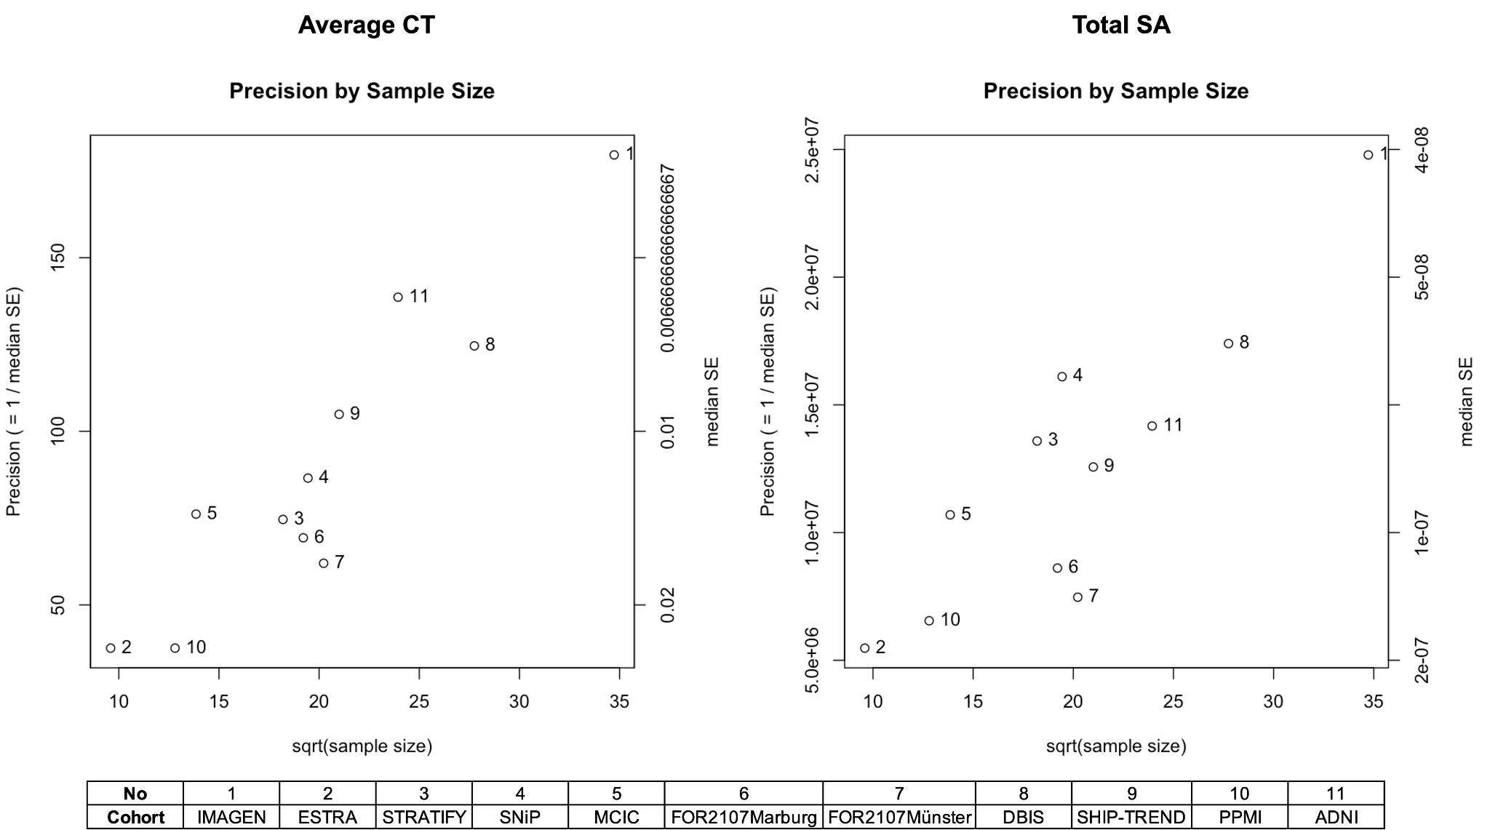

Fig. S2. QCEWAS results of average CT and total SA.
Fig. S2a. The plots show the relationship between sample size and statistical precision for each cohort included in the EWAS meta-analysis. Each point is labelled with its cohort ID, corresponding to the key below the plots. Cohorts are ordered by the mean participant age (cohorts 1 to 11) and displayed sorted by sample size in the figure. Precision was calculated as the inverse of the median standard error (1 / median SE), and plotted against the square root of the cohort sample size. A positive trend – where larger cohorts show higher precision – is generally expected and observed. Both CT and SA analyses demonstrate appropriate clustering along the expected diagonal, indicating good overall precision and no major outliers in cohort-level estimates.

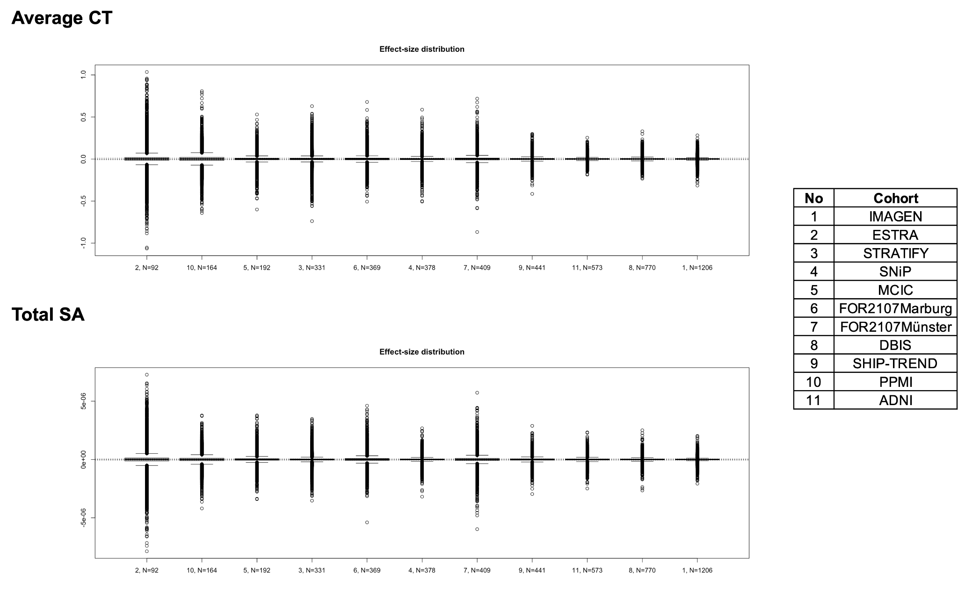
Fig. S2b. Distribution of effect sizes (β values) for average CT and total SA. These plots show the distribution of DNA methylation effect sizes across all CpGs for each cohort included in the EWAS meta-analysis. Each vertical line represents the distribution for one cohort, labelled by number (see cohort legend on the right). Cohorts are ordered by the mean participant age (cohorts 1 to 11) and displayed sorted by sample size in the figure. As expected, effect size distributions become slightly narrower with increasing sample size, reflecting improved precision in larger cohorts. No cohorts displayed markedly deviant distributions, indicating consistency in the scale and dispersion of effect sizes across studies.

a
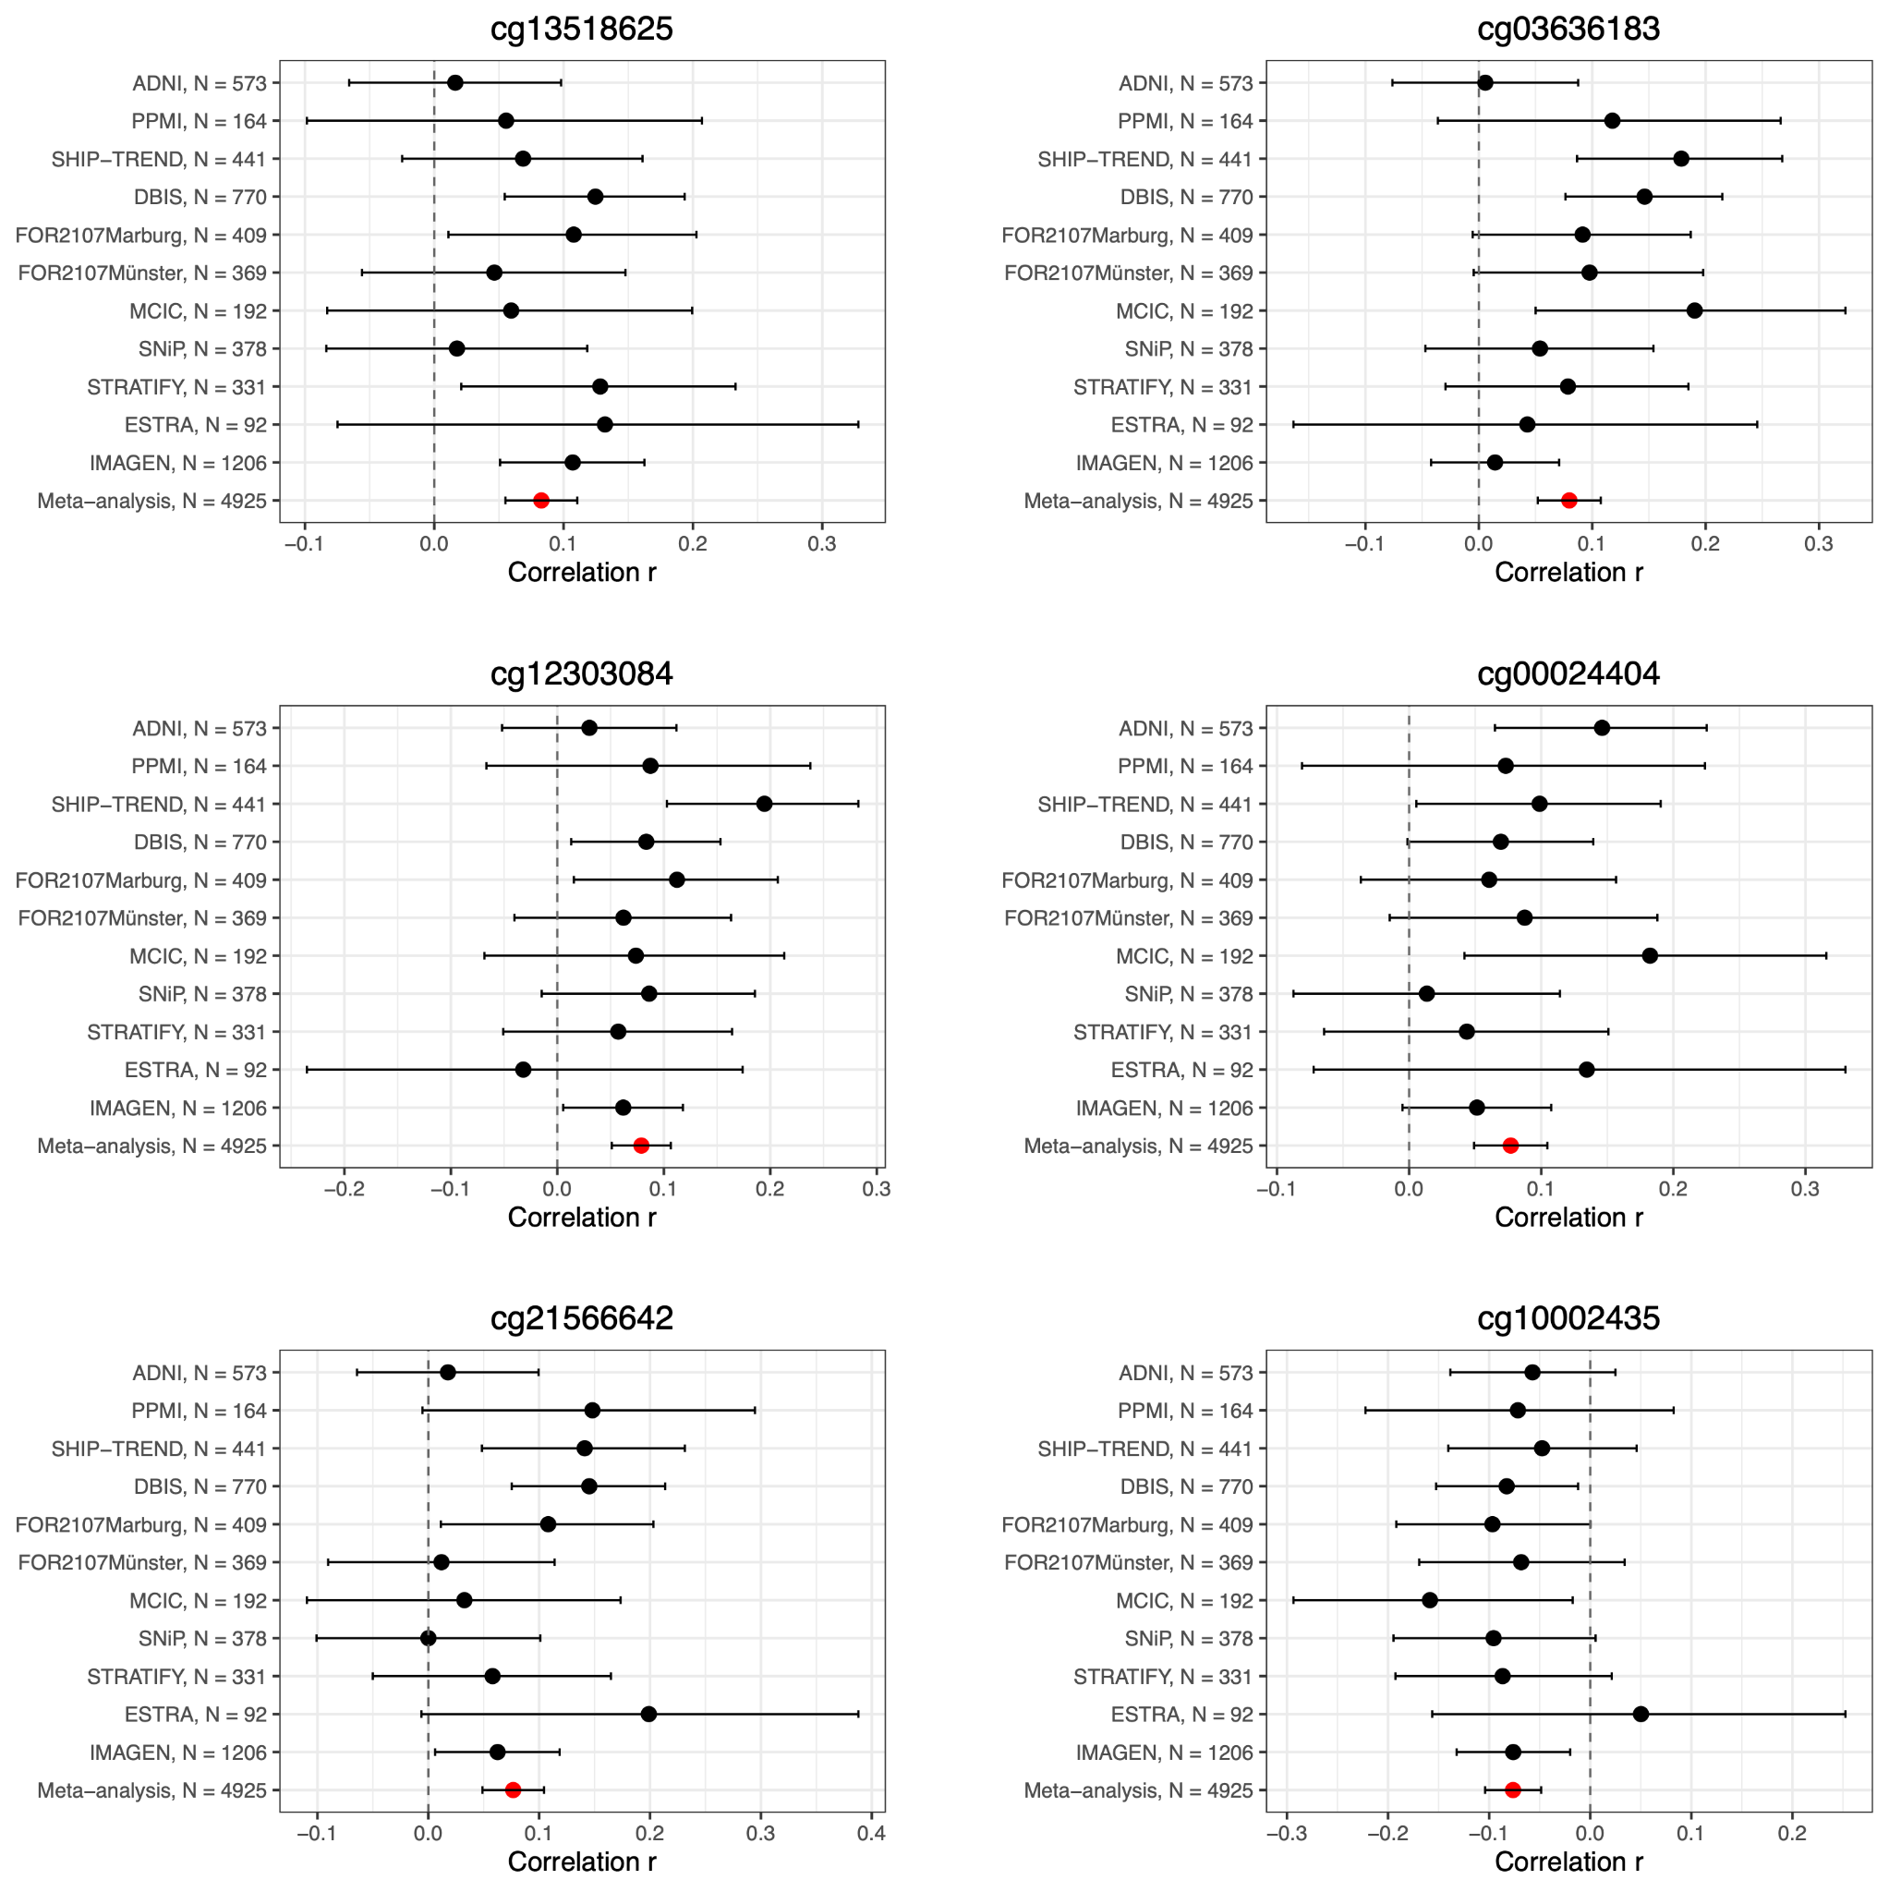

b
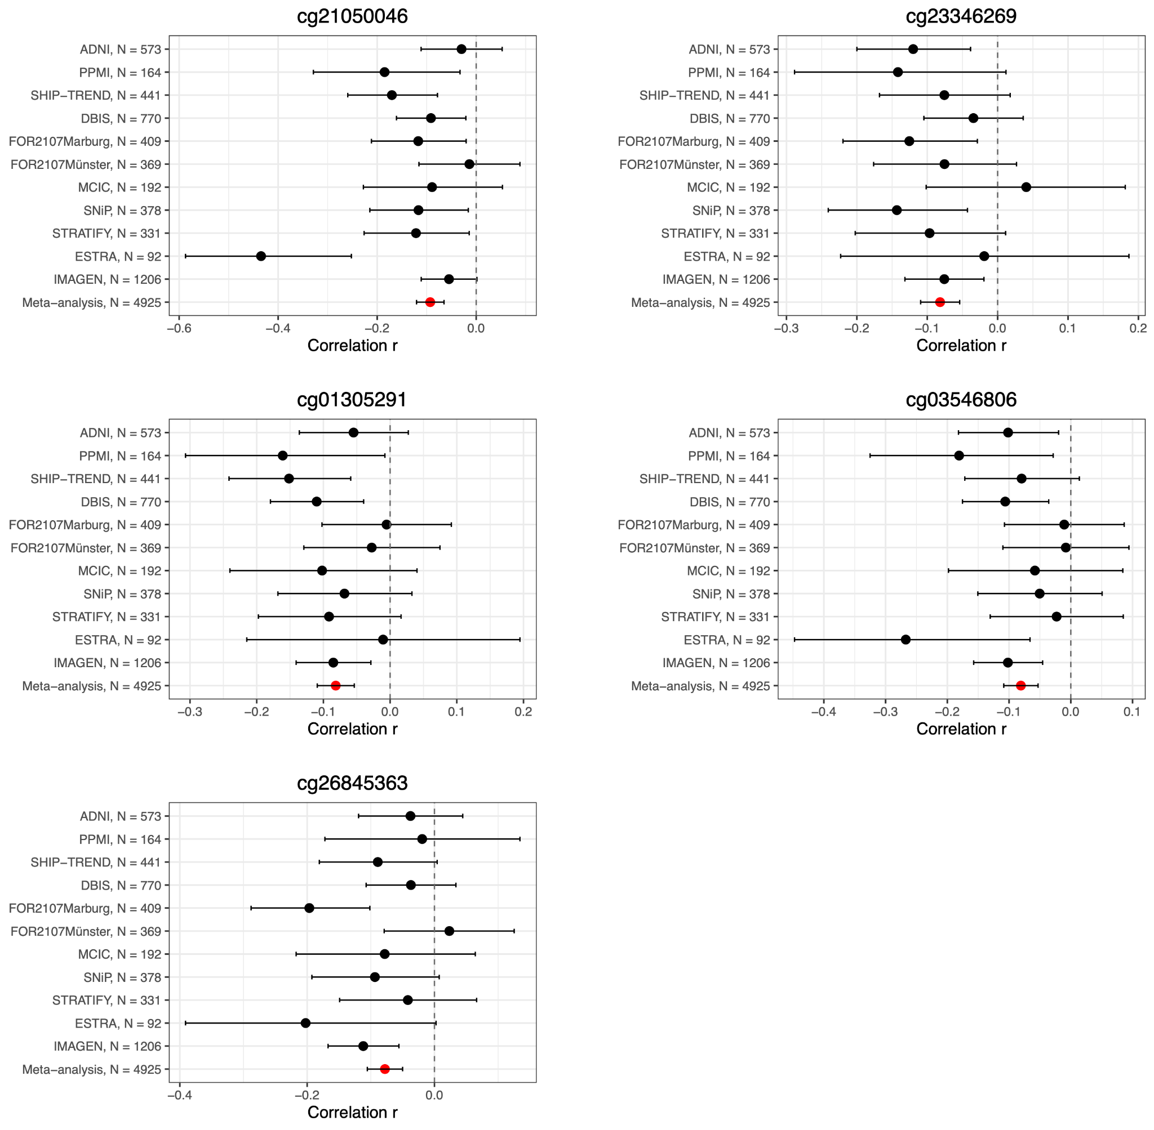

Fig. S3. Forest plots for significantly associated CpGs in the discovery meta-analysis.
Forest plots show the six Bonferroni-significant CpGs associated with average CT (a) and the five CpGs associated with total SA (b). Cohort-specific correlation coefficients and 95% confidence intervals are displayed alongside the combined meta-analysis estimate. Cohorts are ordered by mean age, with IMAGEN being the youngest and ADNI the oldest. The consistent direction and magnitude of effects across cohorts indicate stable associations and minimal cohort-level influence.
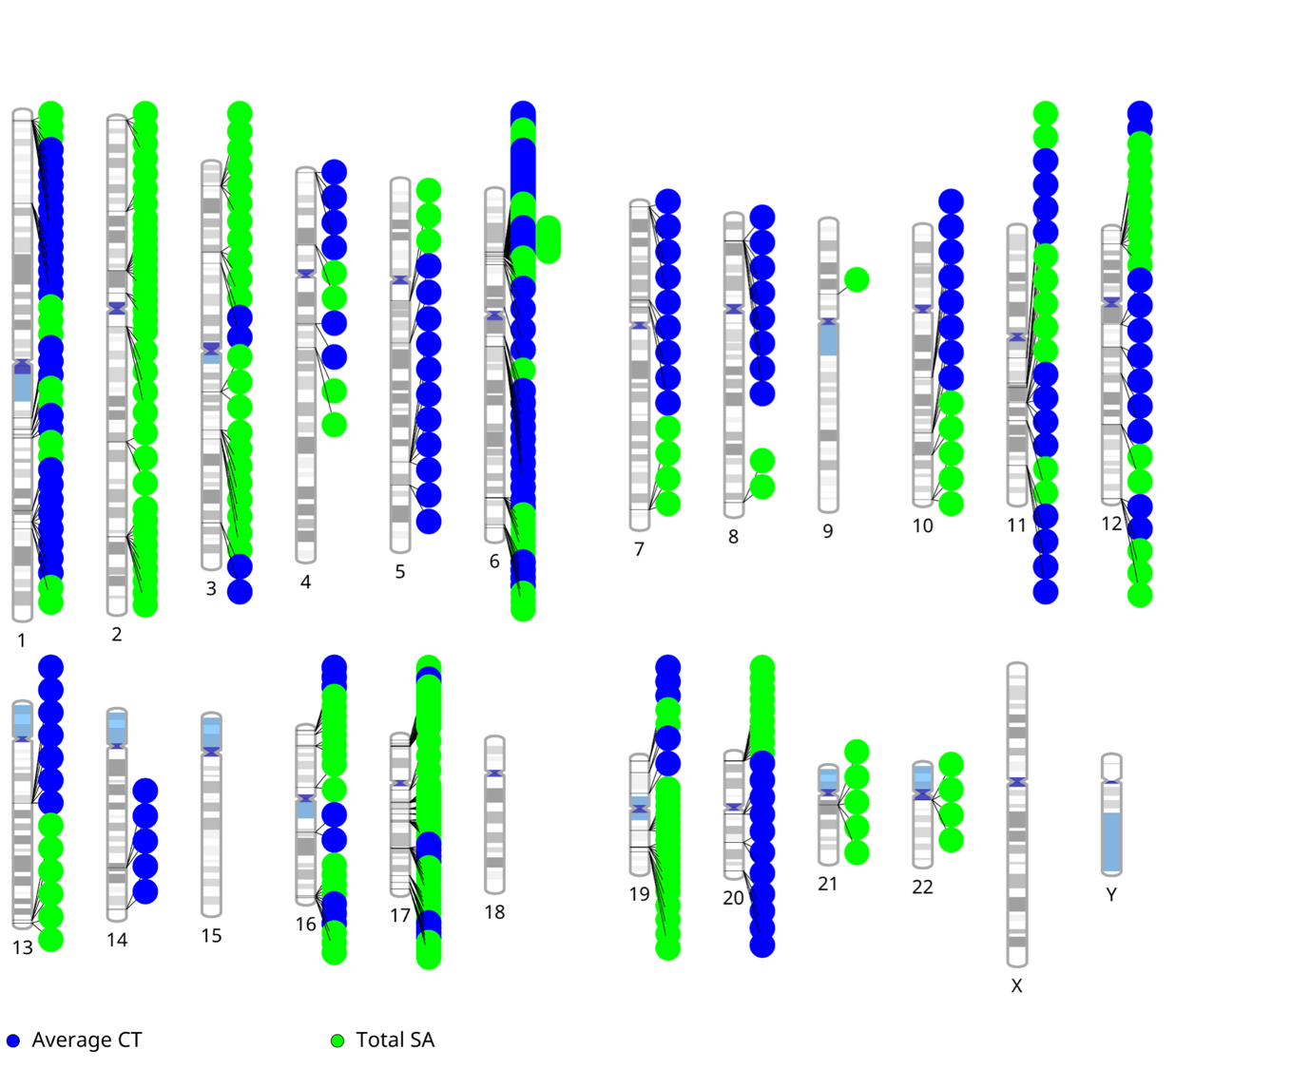

Fig. S4. Genomic distribution of CpGs located within differentially methylated regions (DMRs) associated with average CT and total SA.
Each point represents a CpG site within a significant DMR, plotted according to its chromosomal position (hg19 reference genome). The vertical arrangement of chromosomes follows standard ideogram order (1-22, X, Y).

Fig. S5. Tissue-specific expression enrichment (FUMA analyses) of genes annotated to CT- and SA-associated CpGs based on GTEx v8 transcriptomic data across 54 human tissues.

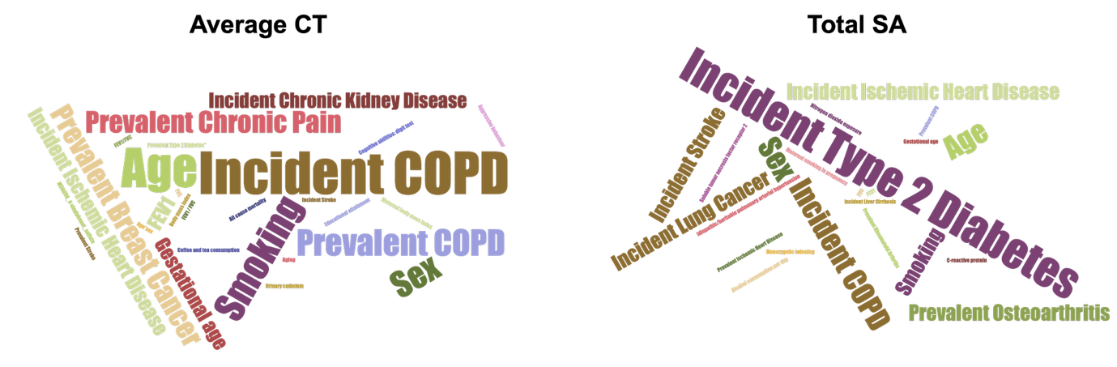

Fig. S6. Trait associations of CpGs linked to average CT and total SA, based on previous studies included in the EWAS Catalog.
Word clouds summarise previously reported trait associations for CpGs significantly associated with average CT (left) and total SA (right). The size of each term reflects the frequency of its appearance in the EWAS Catalog (https://ewascatalog.org/) for the respective CpGs and the lookup was filtered for peer-reviewed journals. Prominent traits include age, smoking, and chronic obstructive pulmonary disease (COPD) for average CT, and type 2 diabetes, osteoarthritis, and ischemic heart disease for total SA.

Fig. S7. Correlations between phenotypic variables included in the Phenome-wide association analyses in the IMAGEN cohort.

