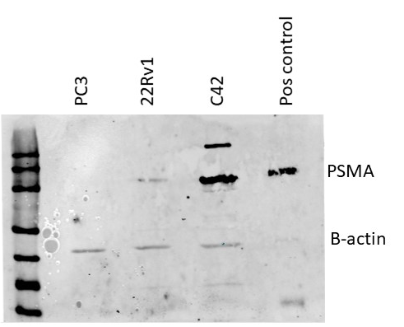
Supplementary Figure 1
Figure 1: Full length blot of PSMA expression levels.

