Supplementary Figures
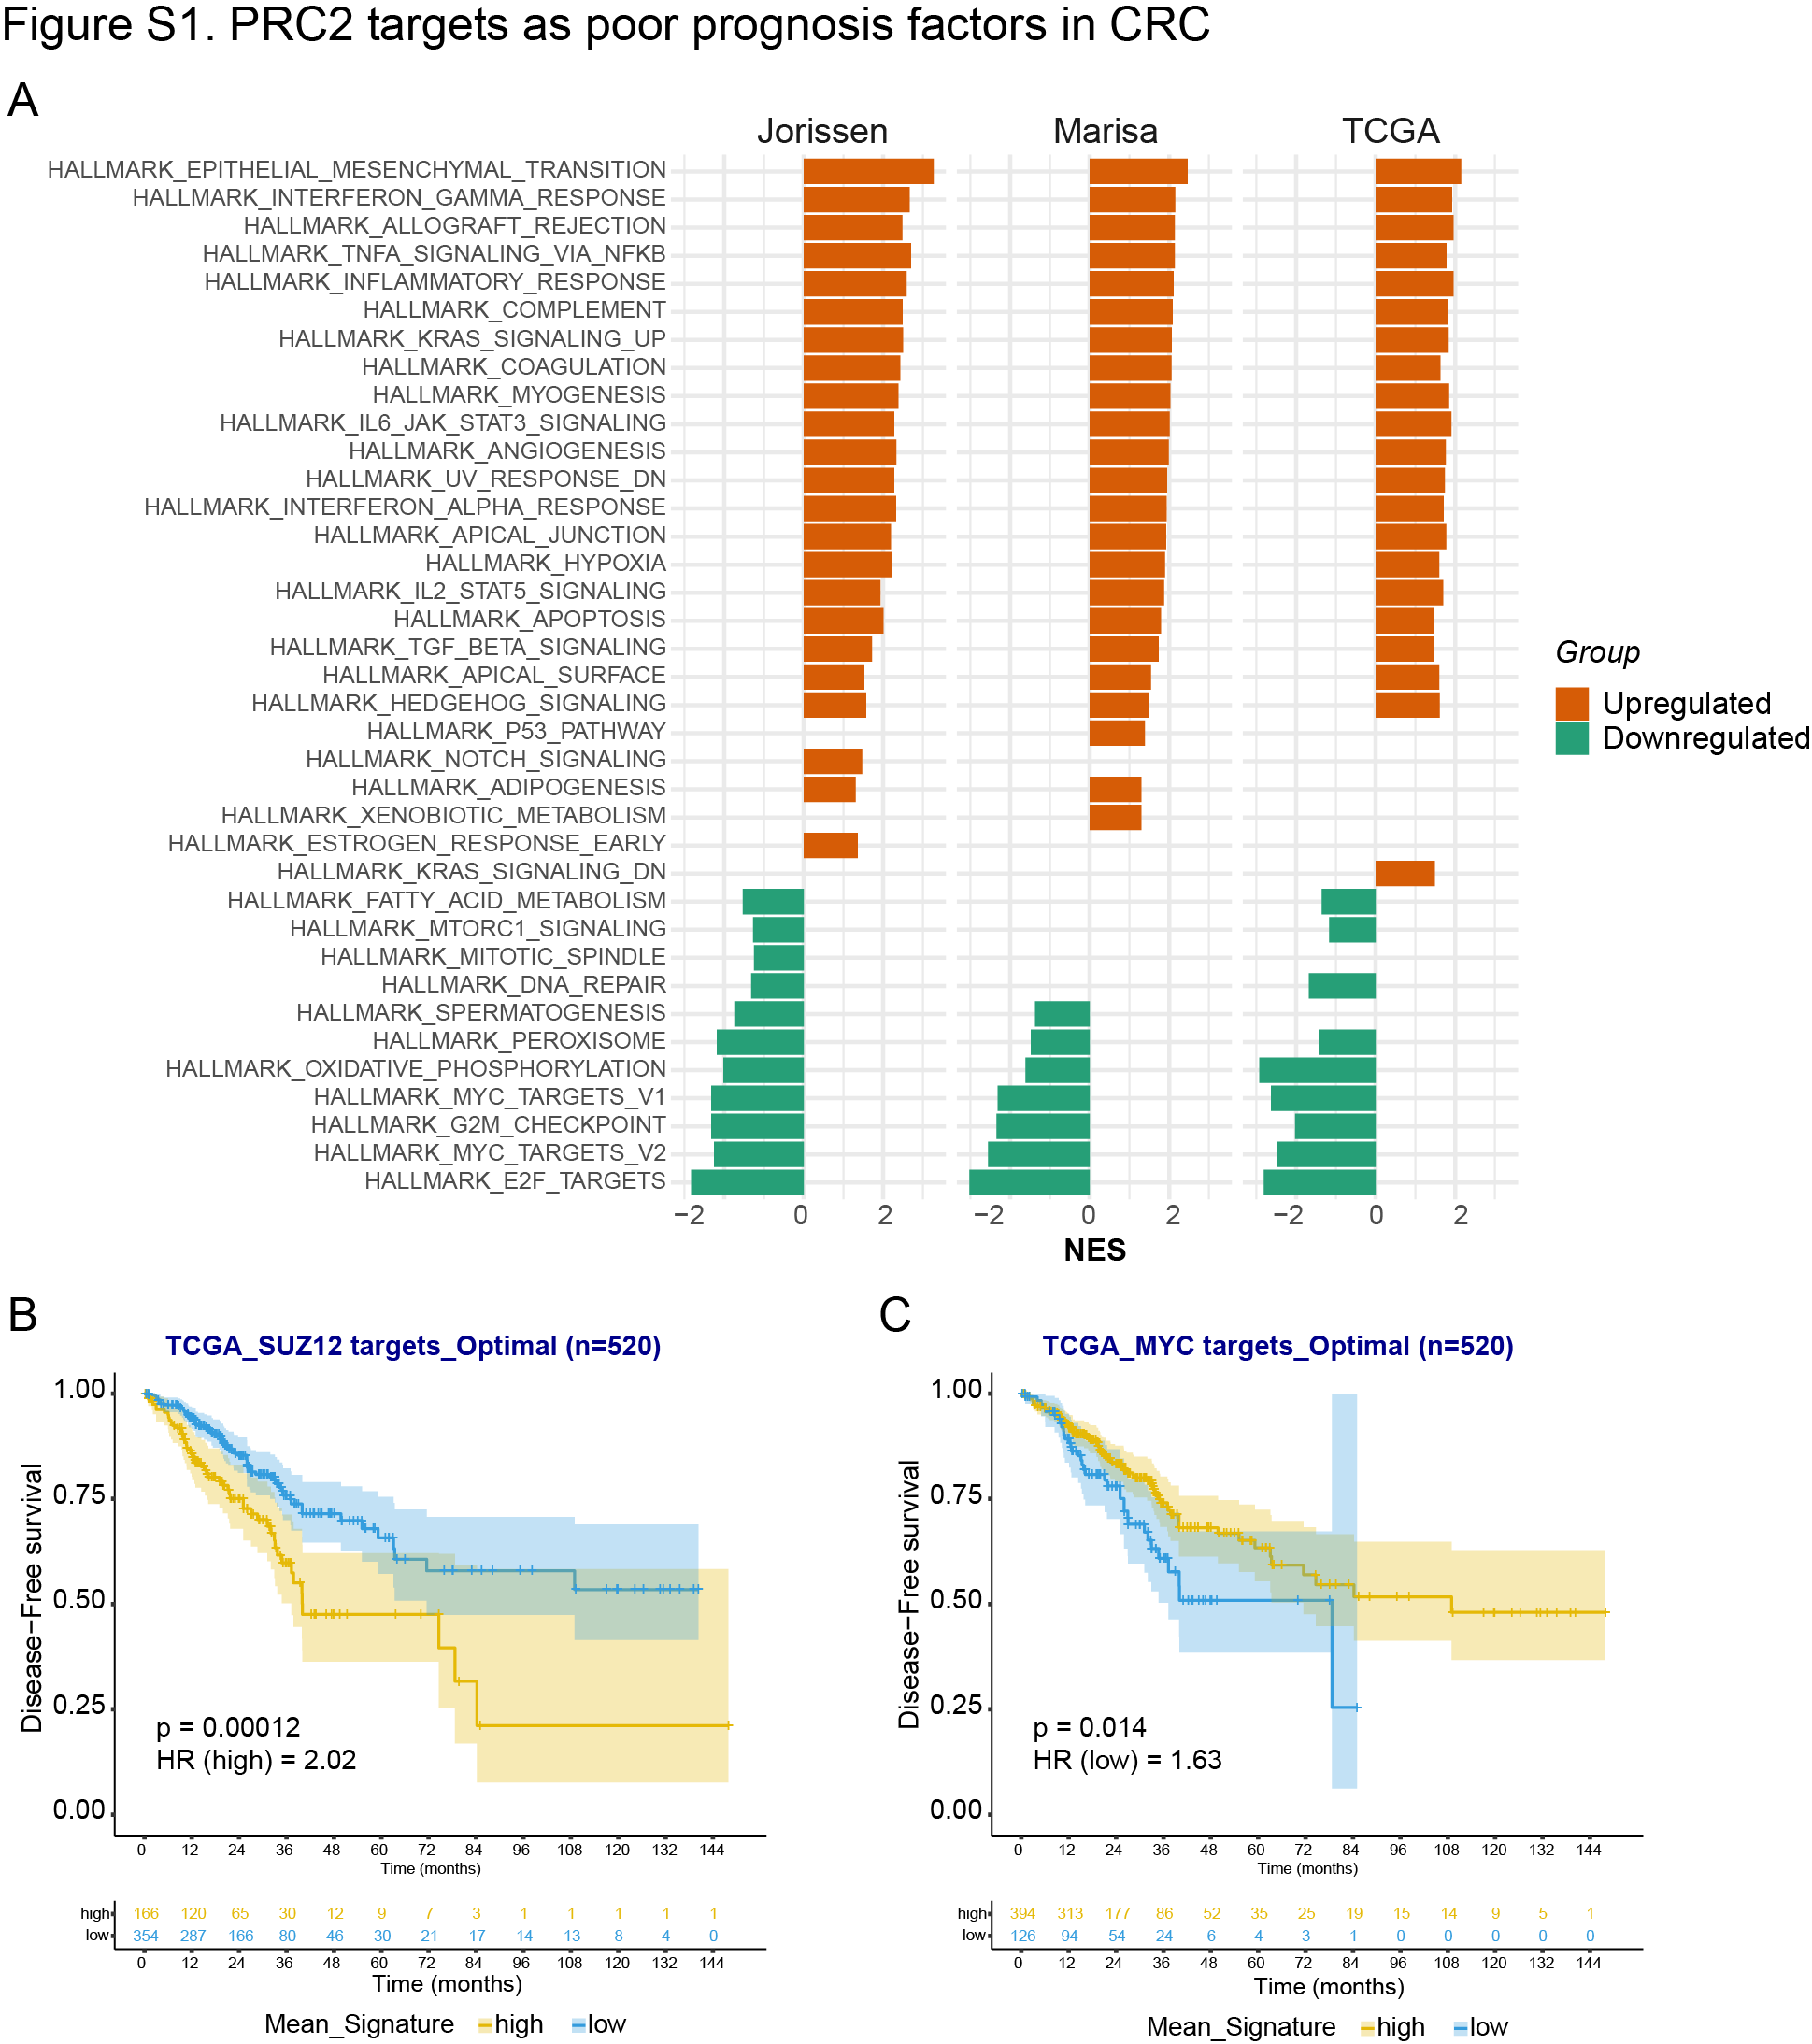
Figure S1. Fetal-type tumors exhibit reduced PRC2 and MYC activities.
(A) GSEA results of fetal-type and non-fetal tumors from the indicated CRC cohorts using the Hallmark gene set collection.
(B, C) Kaplan-Meier plots of DFS over time for CRC patients in the TCGA dataset according to DEGs classified as SUZ12 (B) and MYC targets (C). Kaplan-Meier curve estimates shown with 95% confidence interval.
Source data are provided as a Source Data file.
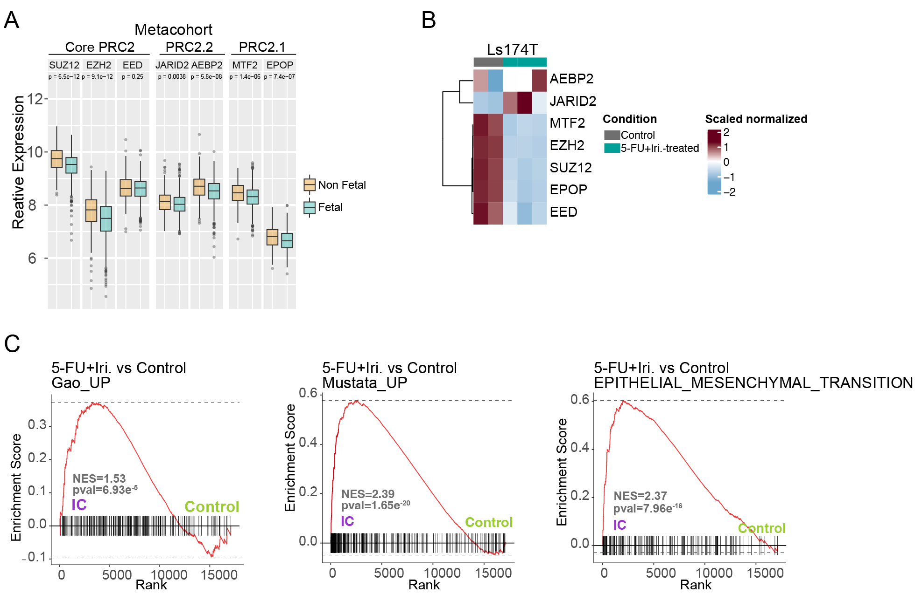
Figure S2. Transcriptional repression of PRC2 in therapy-naïve fetal-type tumors and fetal/EMT upregulation in chemotherapy-treated CRC cells.
(A) Bar plots indicating the mRNA levels of the indicated genes of the PRC2 complex in the metacohort dataset.
(B) Heatmap representation of the ColoStem genes in LS174T cells treated with 5-FU+Iri. (n=3 biological replicates per condition, except for untreated LS174T, n=2).
(C) GSEA results from control and 5-FU+Iri.-treated LS174T cells using the indicated signatures.
Statistical tests; (A) Data are presented as box plots showing the median, the 25th–75th percentiles, and the minimum and maximum values, Wilcoxon test. Source data are provided as a Source Data file.

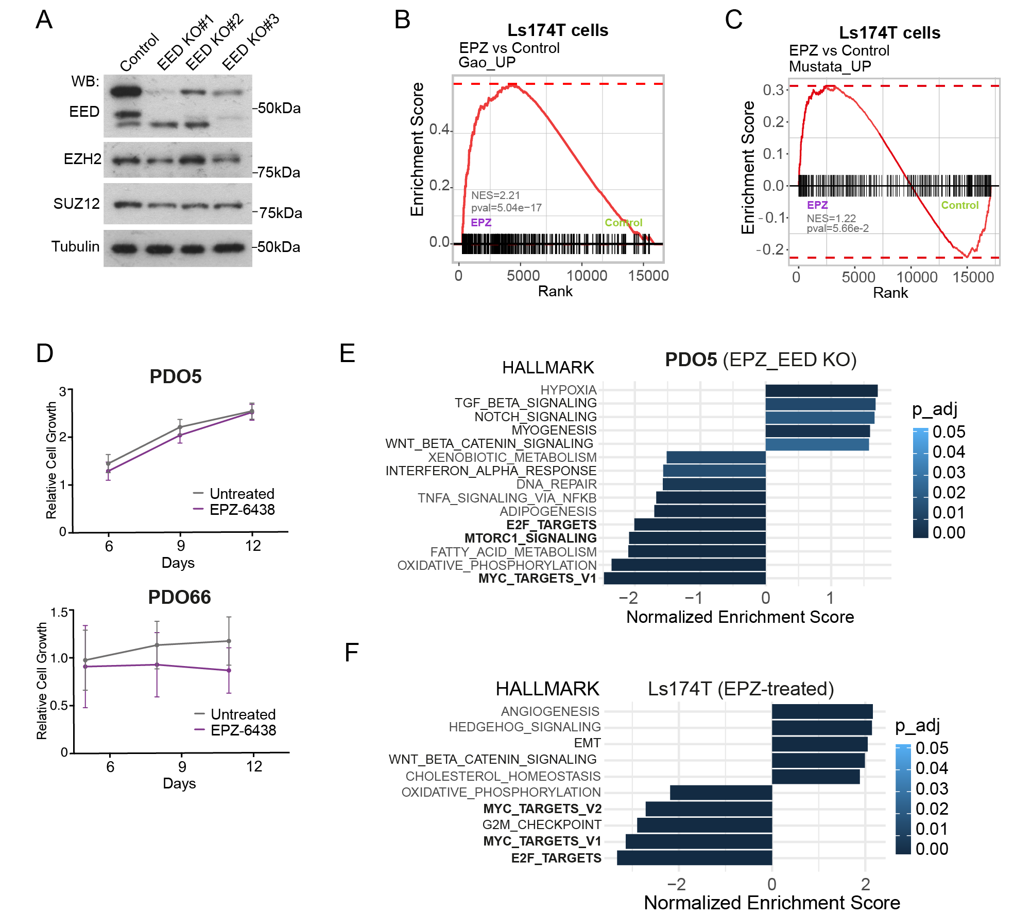
Figure S3. PRC2 inactivation unlocks oncofetal and EMT signatures and is associated with MYC, mTOR and E2F downregulation.
(A) WB analysis (soluble fraction) of the indicated PRC2 elements in EED KO PDO5 pools (from 1 out of 2 experimental replicates).
(B, C) GSEA analysis of LS174T cells treated with EPZ-6438 compared with untreated cells using the indicated signatures.
(D) Relative cell growth of PDO5 and PDO66 untreated or EPZ-6438-treated cells as determined by CellTiter-Glo (n=3 experimental replicates).
(E, F) Bar plot showing GSEA results from PDO5 (E) and LS174T (F) cells under the indicated experimental conditions compared with untreated WT cells, using the MSigDB Hallmark database. MYC, E2F and mTOR signatures are shown in bold.
Statistical tests; (D) Data are presented as mean ± SEM. Source data are provided as a Source Data file.
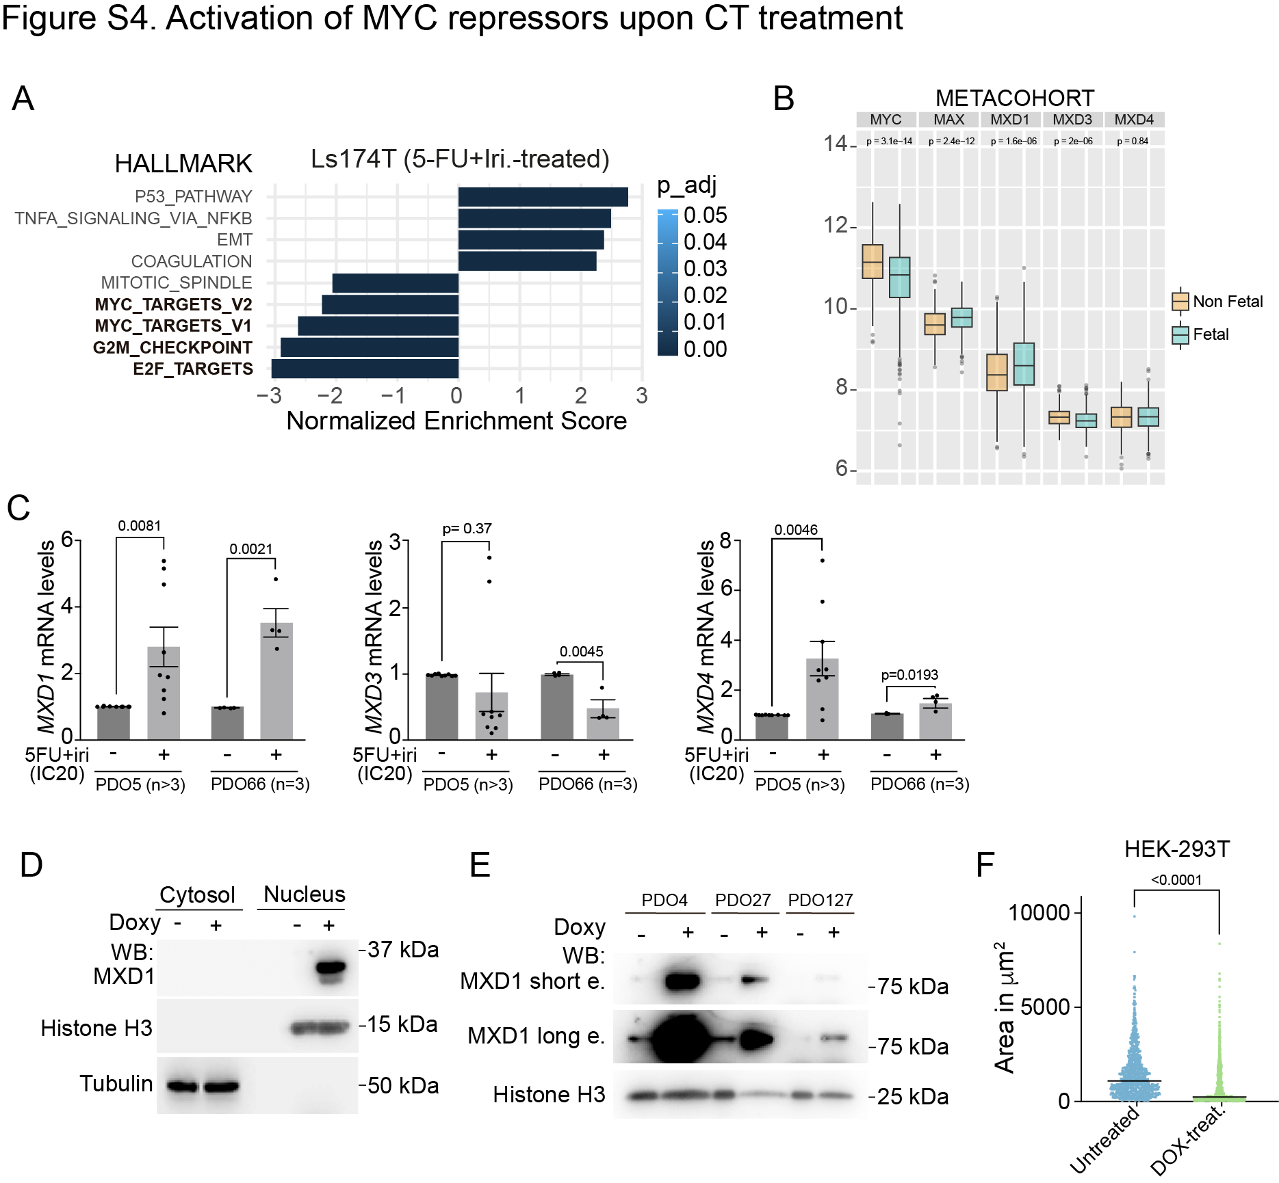
Figure S4. MYC pathway inhibition promotes quiescence entrance.
(A) Bar plot showing GSEA results from LS174T cells treated with 5-FU+Iri. compared with untreated cells, using the MSigDB Hallmark database. MYC, G2M and E2F signatures are shown in bold.
(B) Bar plots indicating the mRNA levels of the indicated genes of the MYC signaling pathway in the metacohort dataset.
(C) qPCR analysis of MXD homologs in PDO5 and PDO66 cells untreated or treated with 5-FU+Iri. (n=9/4 experimental replicates, respectively).
(D, E) WB analysis of HEK-293T (soluble and insoluble fractions) (D) or PDO lines (insoluble fractions) (E) expressing the corresponding doxycycline-inducible constructs (from 1 out of 3 experimental replicates).
(F) Quantification of the area of the spheres generated by untreated or doxycycline-treated MXD1-carrying HEK-293T cells growing in 3D cultures (a minimum of n=700 spheres were examined over 3 biologically independent experiments).
Statistical tests; (B) Data are presented as box plots showing the median, the 25th–75th percentiles, and the minimum and maximum values, Wilcoxon test. (C) Data are presented as mean ± SEM, multiple unpaired t-test. (F) Data are presented as dots showing the median, Mann-Whitney test. Source data are provided as a Source Data file.

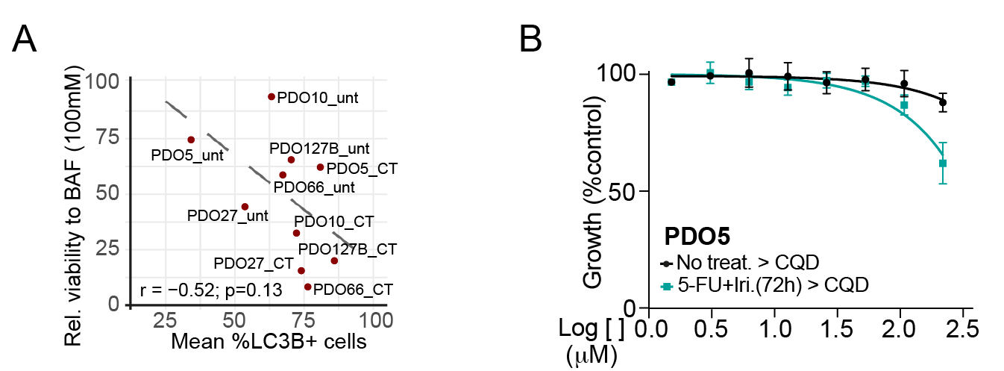
Figure S5. Chemotherapy treatment sensitizes CRC cells to inhibitors of autophagy.
(A) Pearson correlation between mean %LC3B-positive cells and mean cell viability upon bafilomycin A1 treatment (100 nM) across PDOs, showing no significant association. The dashed line indicates the linear regression fit.
(B) Dose-response curves of PDO5 cells treated with the autophagy inhibitor chloroquine (CQD) for 72 hours as single agent or after pretreatment for 72 hours with 5-FU+Iri.
Statistical tests; (B) Data are presented as mean ± SEM. Source data are provided as a Source Data file.

Supplementary Tables
Supplementary Table 1. Patient-derived organoids and CRC cells lines used in this study. The mutations and the corresponding chemotherapy concentrations and effect on cell growth are listed for each PDO and cell line.

Cell line | Mutations | Concentration (μg/mL) | Cell Growth (mean±SEM) | Souce
PDO4 | TP53 I254T (100%)  EGFR S464L (97.21%) | 5-FU 2  Iri. 0.8 | 55.15±8.49  (n=5) | Primary tumor
PDO5 | KRAS G12D (66.43%) | 5-FU 1.67  Iri.] 0.67 | 67.14±7.08  (n=5) | Primary tumor
PDO8 | TP53 Q192stop (98.46%)  KRAS G13C (67.27%) | 5-FU 3.13  Iri. 1.25 | 78.61±6.63  (n=3) | Primary tumor
PDO10 | TP53 R282W (99.82%)  FGFR2 C809W (62.72%)  KRAS A146V (80.25%) | 5-FU 12.5  Iri. 5 | 111.20±7.25  (n=4) | Primary tumor
PDO27 | TP53 R213L (99.8%) | 5-FU 1.67  Iri. 0.67 | 57.96±8.55  (n=4) | Primary tumor
PDO66 | NRAS (G12S) (99.05%)  APC (S1110stop) (99.80%) | 5-FU 2.5  Iri. 1 | 69.13±10.45  (n=4) | Primary tumor
PDO127 | GNAS R201H (65.5%)  KRAS G12D (39.9%)  PIK3CA G1049R (51%) | 5-FU 1.67  Iri. 0.67 | 61.32±6.53  (n=3) | Primary tumor
HCT116 | TP53 WT | 5-FU 0.5  Iri 0.2 | - | Cell line
LS174T | TP53 WT | 5-FU 0.5  Iri 0.2 | - | Cell line

Supplementary Table 2. CRISPR sgRNA.
Target | Specie | Forward | Reverse
CRISPR EED KO1 sgRNA | Human | CACCGGGCGGAGGAATATGTCCGAG | AAACCTCGGACATATTCCTCCGCCC
CRISPR EED KO2 sgRNA | Human | CACCGGGAAGTGTCGACTGCGCCGG | AAACCCGGCGCAGTCGACACTTCCC
CRISPR EED KO3 sgRNA | Human | CACCGGACGCTGTCAGTATAGAAAG | AAACCTTTCTATACTGACAGCGTCC

Supplementary Table 3. IF Antibodies.
Antibody | Company | Reference | Specie | Dilution
LC3B Antibody | Cell Signaling Technology | Cat# 2775, RRID:AB_915950 | Rabbit polyclonal | 1:200
anti-Cleaved Caspase-3 | Cell Signaling Technology | Cat# 9661, RRID:AB_2341188 | Rabbit polyclonal | 1:100
anti-Human mitochondria, clone 113-1 | Merck Millipore | Cat# MAB1273, RRID:AB_94052 | Mouse monoclonal | 1:100
Peroxidase labeled polymer conjugated to goat anti-rabbit IgG | Agilent | Cat# K4003, RRID:AB_2630375 | Secondary antibody | -
anti-rabbit 594 DyLight | ThermoFisher Scientific | Cat# 35510, RRID:AB_1185569 | Secondary antibody | -
anti-mouse 488 DyLight | ThermoFisher Scientific | Cat# 35502, RRID:AB_844397 | Secondary antibody | -

Supplementary Table 4. WB Antibodies.
Antibody | Company | Reference | Specie | Dilution
Anti-EZH2 Antibody, clone BD43 | Merck Millipore | Cat# 05-1319, RRID:AB_1587024 | Mouse monoclonal | 1:1000
Recombinant Anti-KMT6 / EZH2 antibody [EPR20108] - ChIP Grade | Abcam | Cat# ab191250, RRID:AB_2933983 | Rabbit monoclonal | 1:1000
Anti-SUZ12 antibody [SUZ220A] | Abcam | Cat# ab126577, RRID:AB_11159280 | Mouse monoclonal | 1:1000
ICAM1 antibody [EPR4776] | Abcam | Cat# ab109361, RRID:AB_10858467 | Rabbit monoclonal | 1:1000
EED (E4L6E) XP® Rabbit mAb | Cell Signaling Technology | Cat# 85322, RRID:AB_2923355 | Rabbit monoclonal | 1:1000
Recombinant Anti-active YAP1 antibody [EPR19812] | Abcam | Cat# ab205270, RRID:AB_2813833 | Rabbit monoclonal | 1:1000
Anti-p70 S6 Kinase (phospho T389) antibody | Abcam | Cat# ab2571, RRID:AB_303169 | Rabbit polyclonal | 1:1000
MXD1 Polyclonal antibody | Proteintech | Cat# 19547, RRID:AB_10641995 | Rabbit polyclonal | 1:1000
Anti-Histone H3 antibody - Nuclear Loading Control and ChIP Grade | Abcam | Cat# ab1791, RRID:AB_302613 | Rabbit polyclonal | 1:5000
Mouse Anti-alpha-Tubulin Monoclonal Antibody, Unconjugated, Clone B-5-1-2 | Sigma-Aldrich | Cat# T6074, RRID:AB_477582 | Mouse monoclonal | 1:10000
Goat Anti-Rabbit Immunoglobulins/HRP | Agilent | Cat# P0448, RRID:AB_2617138 | Secondary antibody | 1:2000
Rabbit Anti-Mouse Immunoglobulins/HRP | Agilent | Cat# P0260, RRID:AB_2636929 | Secondary antibody | 1:2000

Supplementary Table 5. Primers for RT-qPCR.
Target | Specie | Forward | Reverse
EZH2 | Human | TAAAGAAAGCCGCCCACCTC | AGTTCTTCTGCTGTGCCCTT
SUZ12 | Human | TCTTGATGGGAAGAGGCTGC | GGTCTCTCCTGTCCAACGAA
MXD1 | Human | GCGTGTCTAGTAGCTGGCTA | ATCACCTATTGCACACCCCA
MXD3 | Human | CAGTTGAAGCGGTGCCTG | TCTCCTTGAGCTGTCGGG
MXD4 | Human | CAGGTCTTCACACAACGAGC | GTCCTGCTCCTCCAGTTTCT
HPRT1 | Human | ATAAGCCAGACTTTGTTGG | ATAGGACTCCAGATGTTTCC
GAPDH | Human | GTCATCCCTGAGCTGAACG | CTCCTTGGAGGCCATGTG
ACTB | Human | GCACCACACCTTCTACAATGAGC | TAGCACAGCCTGGATAGCAACG
TBP | Human | ACCCTTCACCAATGACTCCTATG | ATGATGACTGCAGCAAATCGC
B2M | Human | CCCACTGAAAAAGATGAG | CCTCCATGATGCTGCTT

