Supplementary Figures

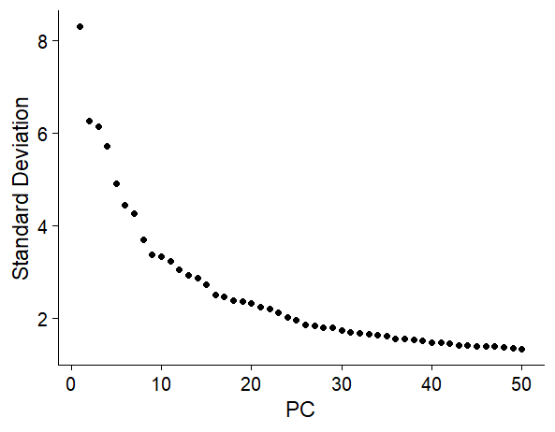

Supplementary Fig. 1: Elbow plot for principal component selection
Principal component (PC)selection of the filtered single-cell dataset for human skin (n=5). The inflection point of the curve (“elbow”) occurs at approximately 15 PCs.

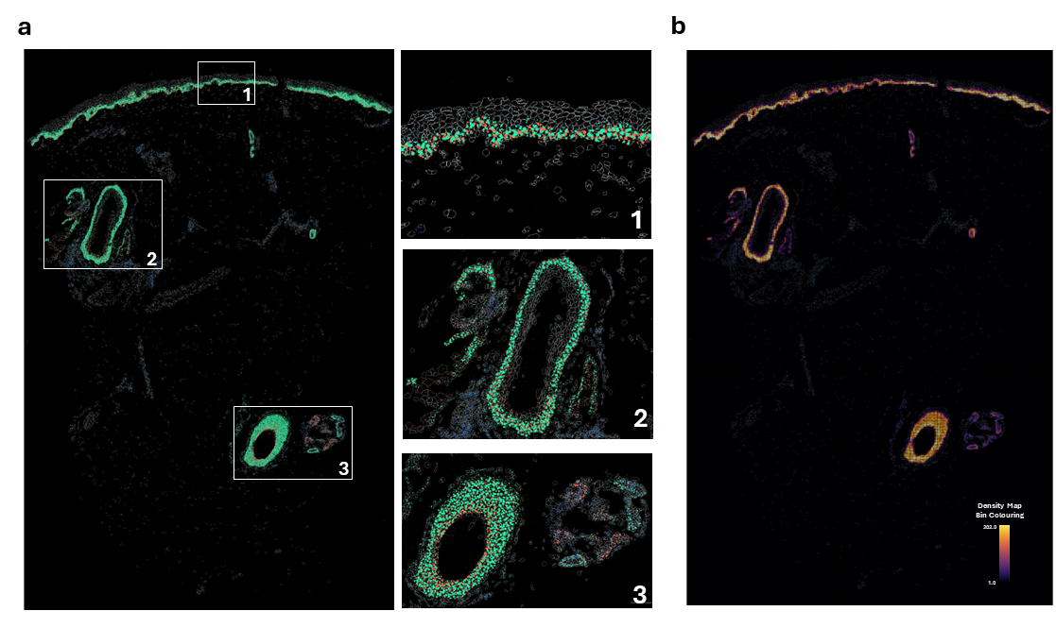

Supplementary Fig. 2: In situ expression of keratins 5 and 15 in forearm skin
a, In situ expression of KRT5 (green) and KRT15 (orange) transcripts seen in the epidermis (1) and dermal appendages (2 & 3). b, In situ density map bin colouring (bin size 10x10µm) showing the number of KRT5 and KRT15 transcripts in each bin.

