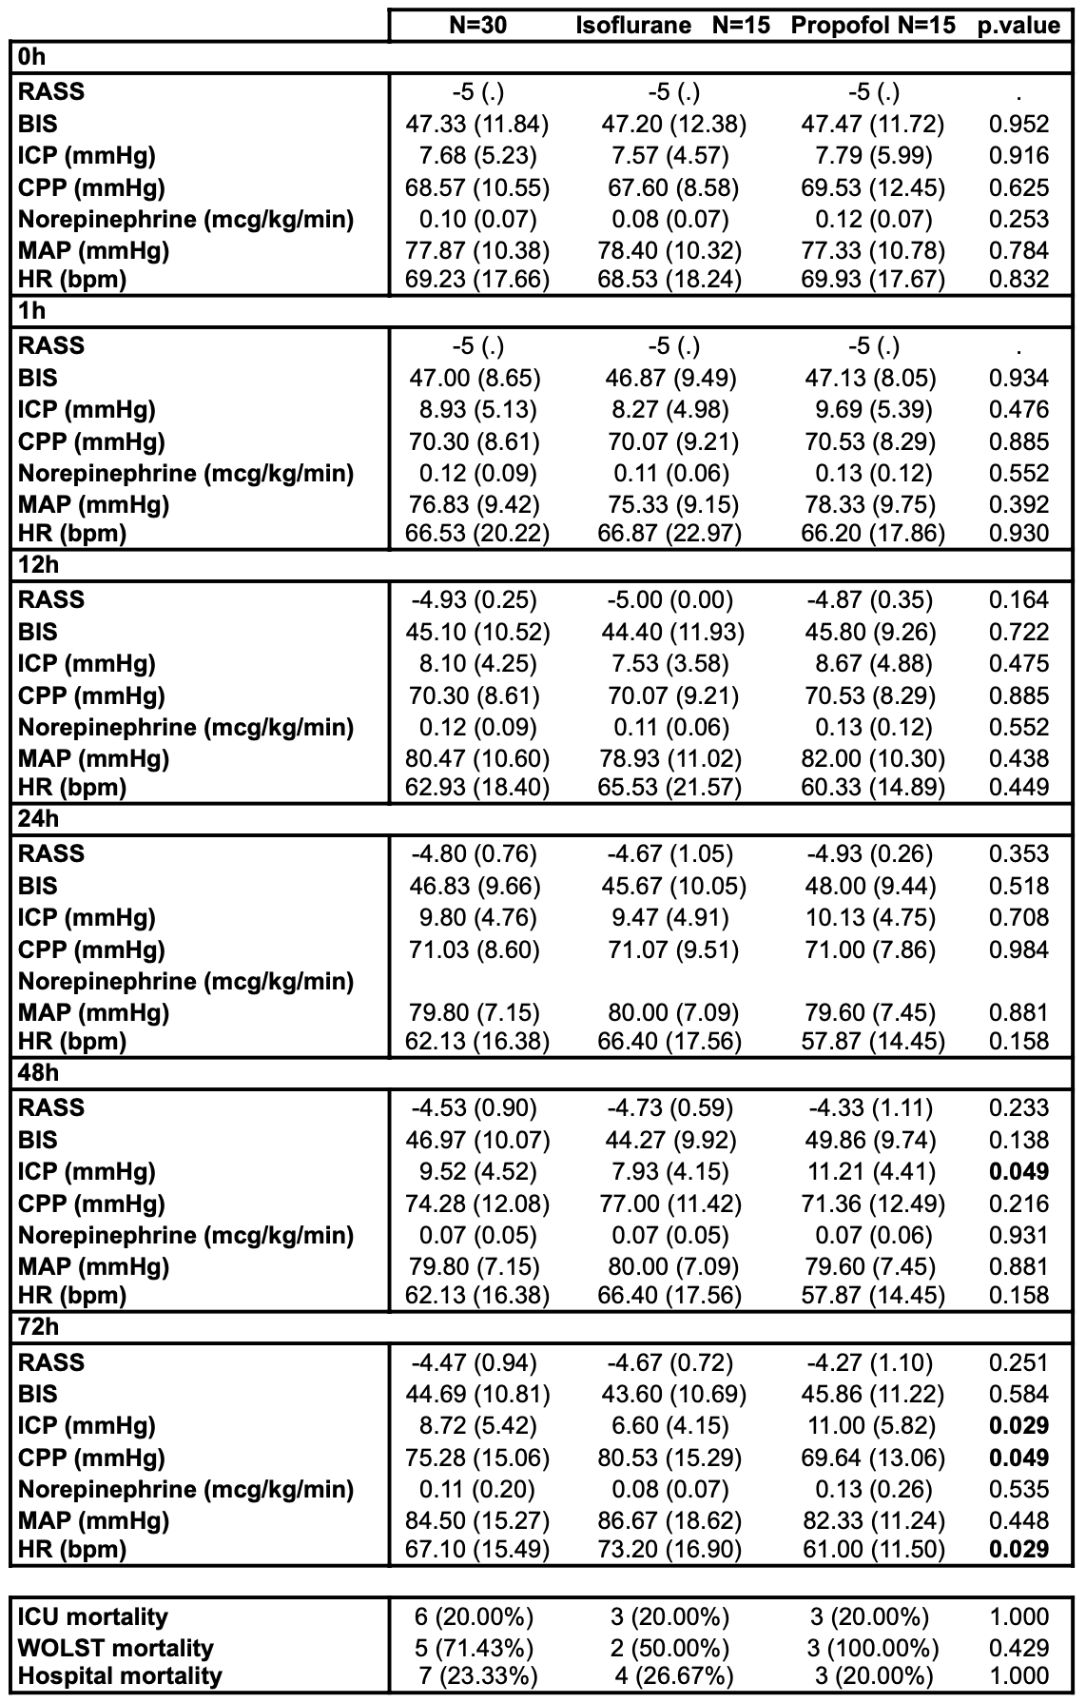Table 2. Sedation efficacy and Safety outcomes. Abbreviations: Richmond Agitation-Sedation Scale (RASS), Bispectral Index System (BIS™). Intracranial pressure (ICP), cerebral perfusion pressure (CPP), mean arterial pressure (MAP), heart rate (HR). Withdrawal of life-sustaining therapies (WOLST).

