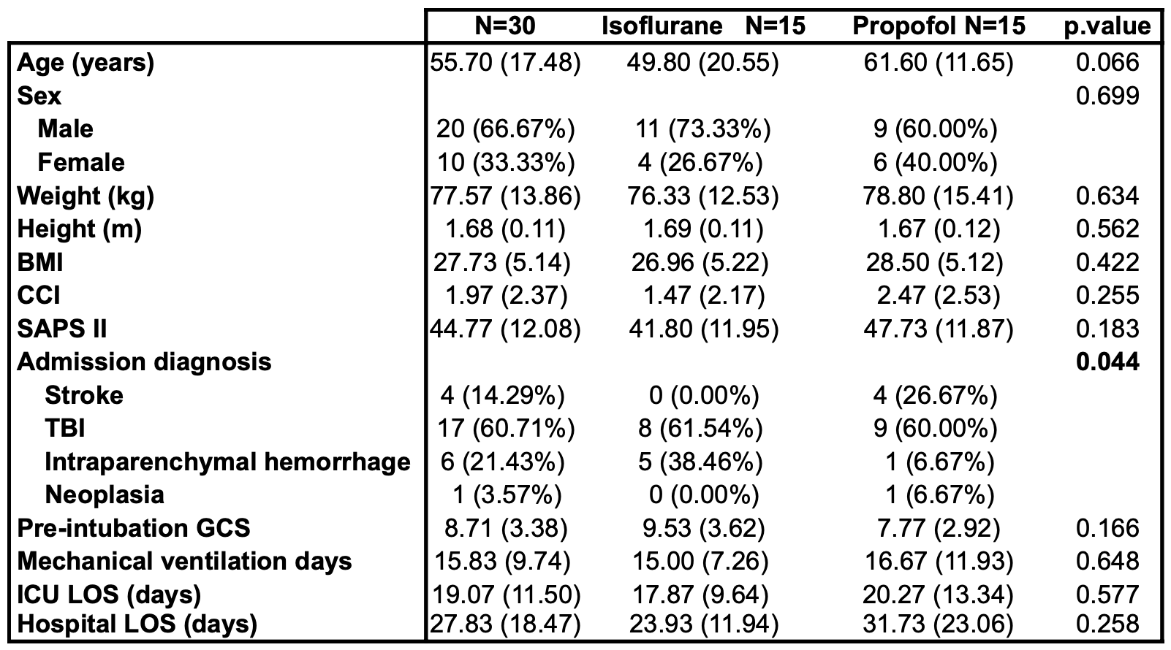Table 1. Baseline demographic, clinical and severity characteristics. Abbreviations: Body mass index (BMI), Charlson Comorbidity Index (CCI), Simplified Acute Physiology Score (SAPS II), Traumatic brain injury (TBI), Glasgow Coma Scale (GCS), Length of stay (LOS), Intensive care unit (ICU), Length of stay (LOS).

