Prognostic Factors Analysis in Breast Cancer Patients with Brain Metastases: Identification of Key Determinants of Survival

Supplementary Material 1
Supplementary Table 1. Results of univariate and multivariate analysis of survival related factors in 505 breast cancer patients with brain metastases.
Variables | Univariate analysis |  |  |  | Multivariate analysis
Variables | P | HR (95%CI) |  | P | HR (95%CI)
Age
＞45
≤45 | 0.879 | 1.02 (0.83 ~ 1.25)
Menopausal conditions
No
Yes | 0.356 | 1.11 (0.89 ~ 1.37)
Histological grade
1 grade
2 grade | 0.207 | 1.77 (0.73 ~ 4.31)
3 grade | 0.780 | 1.04 (0.80 ~ 1.34)
unknow | 0.820 | 0.97 (0.72 ~ 1.30)
T stage
T1
T2 | 0.974 | 1.01 (0.67 ~ 1.50)
T3 | 0.380 | 1.23 (0.78 ~ 1.94)
T4 | 0.891 | 0.97 (0.64 ~ 1.48)
Tx | 0.313 | 1.23 (0.82 ~ 1.83)
N stage
N0
N1 | 0.647 | 1.08 (0.77 ~ 1.52)
N2 | 0.868 | 0.97 (0.67 ~ 1.41)
N3 | 0.218 | 1.25 (0.88 ~ 1.77)
Nx | 0.297 | 1.20 (0.85 ~ 1.69)
M stage
M 0
M1 | 0.229 | 0.86 (0.66 ~ 1.10)
Estrogen receptor
Negative
Positive | 0.671 | 0.95 (0.76 ~ 1.19)
unknown | 0.705 | 0.93 (0.65 ~ 1.34)
HER2
Negative
Positive | 0.102 | 0.81 (0.64 ~ 1.04)
unknown | 0.841 | 1.03 (0.80 ~ 1.33)
Molecular subtyping
Luminal A
Luminal B | 0.082 | 0.72 (0.50 ~ 1.04) |  | 0.078 | 0.71 (0.49 ~ 1.04)
HER2 overexpression type | 0.094 | 0.70 (0.46 ~ 1.06) |  | 0.140 | 0.71 (0.46 ~ 1.12)
Triple negative type | 0.742 | 0.93 (0.62 ~ 1.41) |  | 0.644 | 0.90 (0.59 ~ 1.39)
unknown | 0.173 | 0.76 (0.51 ~ 1.13) |  | 0.066 | 0.69 (0.46 ~ 1.02)
Neoadjuvant chemotherapy
No
Yes | 0.089 | 0.83 (0.68 ~ 1.03) |  | 0.584 | 0.94 (0.74 ~ 1.18)
Breast Surgery
No
Radical surgery | 0.666 | 1.06 (0.82 ~ 1.37)
Breast-conserving surgery | 0.609 | 0.88 (0.54 ~ 1.44)
unknown | 0.666 | 1.12 (0.68 ~ 1.85)
Adjuvant chemotherapy
No
Yes | 0.075 | 1.22 (0.98 ~ 1.51) |  | 0.068 | 1.24 (0.98 ~ 1.57)
Radiotherapy for the Breast
No
Yes | 0.276 | 0.89 (0.72 ~ 1.10)
Maintenance treatment
No
Endocrine Therapy | 0.746 | 1.04 (0.81 ~ 1.34)
Targeted Therapy | 0.237 | 0.79 (0.53 ~ 1.17)
Endocrine and targeted therapy | 0.136 | 0.68 (0.41 ~ 1.13)
Chemotherapy | 0.455 | 1.13 (0.82 ~ 1.56)
Size of brain metastases
＞1cm
≤1cm | 0.903 | 0.98 (0.76 ~ 1.28)
Number of brain metastases
＞4
≤4 | 0.002 | 1.40 (1.13 ~ 1.74) |  | <.001 | 1.55 (1.23 ~ 1.95)
Leptomeningeal metastases
No
Yes | 0.009 | 1.54 (1.11 ~ 2.14) |  | 0.084 | 1.35 (0.96 ~ 1.89)
Location of brain metastases
Supratentorial transfer
Subtentorial transfer | 0.023 | 1.28 (1.03 ~ 1.58) |  | 0.166 | 1.17 (0.94 ~ 1.46)
unknown | 0.629 | 1.16 (0.64 ~ 2.08) |  | 0.167 | 1.54 (0.84 ~ 2.82)
Clinical symptoms
No
Yes | 0.919 | 1.01 (0.82 ~ 1.24)
Craniocerebral surgery
No
Yes | 0.032 | 0.65 (0.44 ~ 0.96) |  | 0.100 | 0.71 (0.48 ~ 1.07)
Endocrine Therapy
No
Yes | 0.064 | 0.79 (0.62 ~ 1.01) |  | 0.259 | 0.86 (0.66 ~ 1.12)
Chemotherapy
No
Yes | 0.045 | 0.80 (0.65 ~ 0.99) |  | 0.661 | 0.95 (0.74 ~ 1.21)
Targeted Therapy
No
Yes | 0.085 | 0.80 (0.63 ~ 1.03) |  | 0.904 | 1.02 (0.75 ~ 1.39)
Craniocerebral radiotherapy
No
Yes | <.001 | 0.52 (0.42 ~ 0.64) |  | <.001 | 0.47 (0.38 ~ 0.60)

Supplementary Table2. Univariate and Multivariate Analysis of Intracranial PFS in 293 BCBM Patients Treated with RT. HER2: Human Epidermal Growth Factor Receptor 2; SRS: Stereotactic Radiosurgery; WBRT: Whole Brain Radiation Therapy

Variables | Univariate analysis |  |  |  |  |  | Multivariate analysis
Variables | P | HR (95%CI) |  |  | P | HR (95%CI)
Age
＞45 |  | 1.00 (Reference)
≤ 45 | 0.311 | 0.85 (0.63 ~ 1.16)
Pathological pattern
Invasive carcinoma |  | 1.00 (Reference)
Other | 0.343 | 1.35 (0.73 ~ 2.51)
Estrogen receptor
Unknow |  | 1.00 (Reference)
Positive | 0.771 | 1.12 (0.52 ~ 2.43)
Negative | 0.704 | 1.16 (0.53 ~ 2.53)
HER2
Unknow |  | 1.00 (Reference)
Positive | 0.577 | 1.14 (0.72 ~ 1.79)
Negative | 0.120 | 1.43 (0.91 ~ 2.24)
Ki67
＜14% |  | 1.00 (Reference)
≥14% | 0.903 | 1.03 (0.69 ~ 1.53)
Unknow | 0.613 | 0.85 (0.46 ~ 1.57)
Size of brain metastases
＞1cm |  | 1.00 (Reference)
≤1cm | 0.853 | 0.96 (0.66 ~ 1.42)
Unknow | 0.921 | 1.04 (0.48 ~ 2.26)
Number of brain metastases
＞4 |  | 1.00 (Reference)
≤4 | 0.551 | 1.12 (0.77 ~ 1.63)
Unknow | 0.499 | 1.18 (0.73 ~ 1.92)
Leptomeningeal metastases
No |  | 1.00 (Reference) |  |  |  | 1.00 (Reference)
Yes | <.001 | 3.43 (1.94 ~ 6.06) |  |  | <.001 | 3.07 (1.73 ~ 5.45)
Location of brain metastases
Unknow |  | 1.00 (Reference)
Supratentorial transfer | 0.658 | 0.86 (0.44 ~ 1.67)
Subtentorial transfer | 0.701 | 0.88 (0.45 ~ 1.70)
Clinical symptoms
No |  | 1.00 (Reference)
Yes | 0.291 | 0.85 (0.62 ~ 1.15)
Craniocerebral surgery
No |  | 1.00 (Reference) |  |  |  | 1.00 (Reference)
Yes | 0.081 | 0.55 (0.28 ~ 1.08) |  |  | 0.077 | 0.54 (0.27 ~ 1.07)
Endocrine Therapy
No |  | 1.00 (Reference) |  |  |  | 1.00 (Reference)
Yes | 0.094 | 0.73 (0.51 ~ 1.05) |  |  | 0.079 | 0.72 (0.50 ~ 1.04)
Chemotherapy
No |  | 1.00 (Reference) |  |  |  | 1.00 (Reference)
Yes | 0.063 | 0.74 (0.54 ~ 1.02) |  |  | 0.070 | 0.75 (0.54 ~ 1.02)
Targeted Therapy
No |  | 1.00 (Reference)
Yes | 0.978 | 1.01 (0.70 ~ 1.45)
Methods of radiotherapy
SRS |  | 1.00 (Reference)
WBRT | 0.744 | 1.06 (0.76 ~ 1.46)
Concomitant medications for radiotherapy
No |  | 1.00 (Reference)
Yes | 0.339 | 0.86 (0.63 ~ 1.17)
Extracranial metastasis
No |  | 1.00 (Reference)
Yes | 0.154 | 1.31 (0.90 ~ 1.90)

（A）
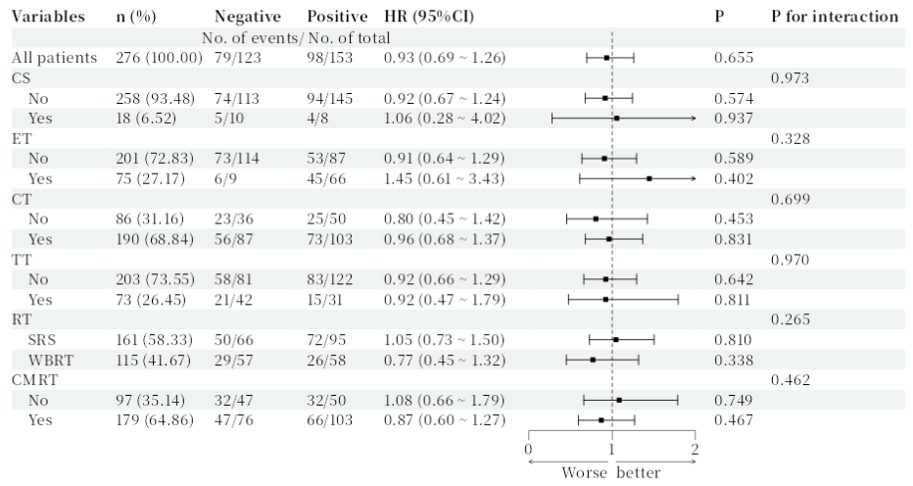
（B）
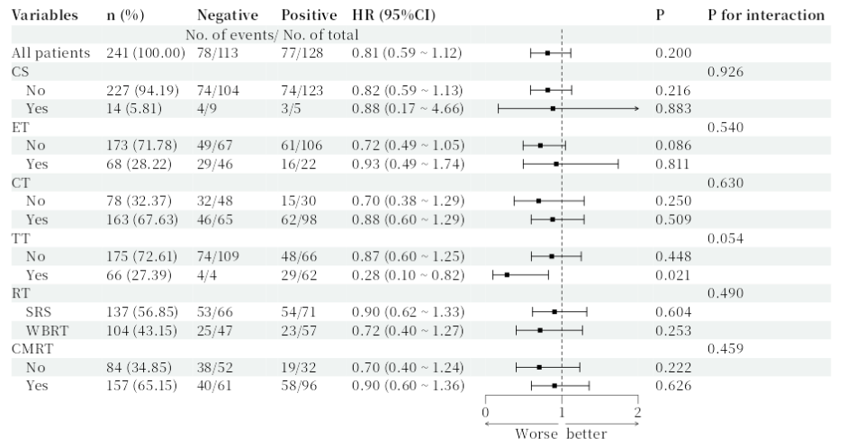
Supplementary Figure 1. Forest Plot of Subgroup Analysis for BCBM Patients Treated with RT. (A) Association between different treatment strategies after BM and RT-OS, stratified by ER expression status. (B) Association between different treatment strategies after BM and RT-OS, stratified by HER2 expression status. CS: Craniocerebral surgery; ET: Endocrine Therapy; CT: Chemotherapy; TT: Targeted Therapy; RT: Radiation therapy; CMRT: Concomitant medications for radiotherapy.

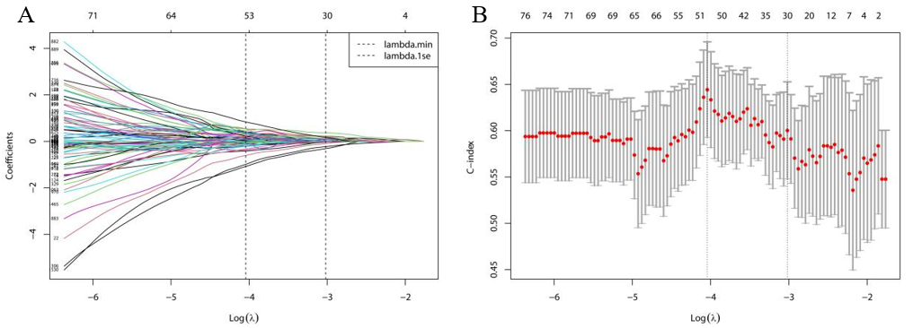
Supplementary Figure 2. Feature Selection Using LASSO-Cox Regression for Survival-Associated Predictors. (A) Trajectory of LASSO regression coefficients across different values of log(λ). (B) Relationship between log(λ) and the corresponding model deviance (error).

Supplementary Material 2

Predictive model related code
library(Matrix)
library(glmnet) # Core package for LASSO regression
library(survival) # Survival analysis package
install.packages("survminer")
library(ggpubr)
library(survminer) # Survival analysis visualization
library(ggplot2)

surv_data <- X149AA ### Imported Excel name

# Data Preprocessing
y <- Surv(surv_data$OS, surv_data$live) # Create survival object
x <- as.matrix(surv_data[, 3:ncol(surv_data)]) # Predictor variable matrix

# Check and handle missing values (adjust based on actual situation)
if(sum(is.na(x)) > 0) {
x <- na.omit(x) # Simply delete rows with missing values (or use imputation)
y <- y[rownames(x), ]
warning("Deleted samples containing missing values")}

# Standardize predictor variables (LASSO requires standardization)
x_scaled <- scale(x) # Mean = 0, Standard deviation = 1

#### LASSO Cox Regression
# Set up cross-validation
install.packages("doParallel")
library(foreach)
library(iterators)
library(parallel)
library(doParallel)

cv_fit <- cv.glmnet(
x = x_scaled,
y = y,
family = "cox", # Cox proportional hazards model
type.measure = "C", # Evaluate model using C-index
alpha = 1, # 1 = LASSO (0 = Ridge regression)
nfolds = 10, # 10-fold cross-validation
parallel = TRUE # Enable parallel processing if doParallel is installed
)

# Visualize cross-validation results
plot(cv_fit) # Show C-index and error at different lambda values
title("LASSO Cox Regression Cross-Validation Results", line = 2.5)

# Select optimal lambda values
lambda_min <- cv_fit$lambda.min # Lambda giving best C-index
lambda_1se <- cv_fit$lambda.1se # Most simplified model within 1 standard error

cat("Optimal lambda (min):", lambda_min, "\n")
cat("Simplified model lambda (1se):", lambda_1se, "\n")

# Extract final model
## Use lambda.min (prioritizes prediction accuracy) or lambda.1se (prioritizes simplicity)
final_model <- glmnet(
x = x_scaled,
y = y,
family = "cox",
alpha = 1)

# Get non-zero coefficient features
coef_min <- coef(final_model, s = lambda_min)
coef_1se <- coef(final_model, s = lambda_1se)

selected_min <- which(as.vector(coef_min) != 0)
selected_1se <- which(as.vector(coef_1se) != 0)

cat("\nNumber of features selected using lambda.min:", length(selected_min), "\n")
cat("Feature names:", colnames(x)[selected_min], "\n")

cat("\nNumber of features selected using lambda.1se:", length(selected_1se), "\n")
cat("Feature names:", colnames(x)[selected_1se], "\n")

# Visualize coefficient path
plot(final_model, xvar = "lambda", label = TRUE)
abline(v = log(c(lambda_min, lambda_1se)), lty = 2)
title("LASSO Coefficient Path Plot", line = 2.5)
legend("topright", legend = c("lambda.min", "lambda.1se"), lty = 2, col = 1)

# Model Evaluation
# Calculate predicted risk scores
risk_scores <- predict(final_model, newx = x_scaled, s = lambda_1se, type = "response")

# Save important results
# Output selected features and their coefficients
final_coef <- coef(final_model, s = lambda_1se)
selected_features <- final_coef[which(final_coef != 0), ]
cat("\nFinal model features and coefficients:\n")
print(selected_features)

### Multivariate COX Regression Analysis
install.packages("survival")
library(survival)
model <- coxph(Surv(OS, live) ~ ART+Size+Location+CT+KPS+YXLLHWFK+YXLLHWFmedian+
YXLHLWGLALGLE+YXLHLWNS+YXHLLWFmedian+YXHLLWGDV+YXHLHWFmean+
YXHLHWGLRLGLE+YXHHLWFmean+YXHHLWGSAE+YXHHHWGZE+JLOF10P+JLOGLGLE+
JLLLHWGSZNUN+JLLHLWFSn+JLLHHWGSE+JLLHHWGSAE+JLHLLWFSn+JLHLLWGMCC+
JLHLHWGDeE+JLHHLWGLGLZE+JLHHLWGSZNUN+JLHHHWFSn+JLLLLWGCl+
JLLLLWGLGLZE ,data = surv_data)
summary(model)

## Dynamic Nomogram
library(Hmisc)
library(rms)
install.packages("regplot")
library(regplot)
f <- cph(Surv(OS_years, live) ~ Location+CT+KPS+YXLLHWFK+
YXLHLWGLALGLE+YXLHLWNS+JLLHHWGSAE+JLHHLWGLGLZE+JLLLLWGLGLZE, data = da, maxit=15, x=T, y=T, surv=T)
regplot(f, observation = Idw_exper[4,], # Specify a specific patient, 85 means selecting the 85th patient in the dataset
interval = "confidence", title = "Nomogram",
plots = c("violin", "boxes"), clickable = T,
failtime = c(3, 2, 1)) # Set follow-up times: 1 year, 2 years, 3 years

# Time-dependent ROC for Nomogram: 1-year, 2-year, 3-year ROC
install.packages("survivalROC")
library(survivalROC)
da1 <- data.frame(Idw_exper)
cutoff <- 3
newdata <- predict(f, type = "lp") # Calculate combined prediction probability
write.csv(newdata, file = "C:/Users/Administrator/Desktop/final_prediction_probability_lp.csv")

# Set prediction time points (Year 1, 2, 3)
times <- c(1, 2, 3)

# Calculate ROC curves for each time point
roc_data <- lapply(times, function(t) {
survivalROC(
Stime = Idw_exper$OS_years, # Survival time
status = Idw_exper$live, # Event status
marker = Idw_exper$x, # Prediction values
predict.time = t, # Prediction time point
method = "NNE", # Non-parametric kernel estimation method
span = 0.25 * nrow(Idw_exper)^(-0.20) # Smoothing parameter
)
})

# Set plot colors
colors <- c("#E41A1C", "#377EB8", "#4DAF4A")

# Plot combined ROC curves
plot(roc_data[[1]]$FP, roc_data[[1]]$TP,
type = "l", col = colors[1], lwd = 2,
xlim = c(0, 1), ylim = c(0, 1),
xlab = "1 - Specificity (False Positive Rate)",
ylab = "Sensitivity (True Positive Rate)",
main = "Time-Dependent ROC Curves for COX Model")
abline(0, 1, lty = 2, col = "gray") # Add reference line

# Add curves for other time points
for (i in 2:length(times)) {
lines(roc_data[[i]]$FP, roc_data[[i]]$TP,
col = colors[i], lwd = 2)
}

# Add legend and AUC values
legend_text <- paste0("Year ", times, " (AUC = ",
sapply(roc_data, function(x) round(x$AUC, 3)), ")")
legend("bottomright",
legend = legend_text,
col = colors,
lty = 1,
lwd = 2,
title = "Time Points",
bty = "n")

# Add grid lines
grid(col = "lightgray", lty = "dotted")
box()

################## Calculate various statistical metrics
roc <- survivalROC(
Stime = Idw_exper$OS_years, # Survival time
status = Idw_exper$live, # Event status
marker = Idw_exper$x, # Prediction values
predict.time = 3, # Prediction time point
method = "KM", # Kaplan-Meier method
)

#### Optimal threshold
youden_index <- roc$TP - roc$FP
best_idx <- which.max(youden_index)
best_threshold <- roc$cut.values[best_idx]

# Calculate confusion matrix
predicted_class <- ifelse(Idw_exper$x >= best_threshold, 1, 0)
actual_class <- ifelse(Idw_exper$OS_years <= 3 & Idw_exper$live == 1, 1, 0)

# Calculate metrics
TP <- sum(predicted_class == 1 & actual_class == 1)
TN <- sum(predicted_class == 0 & actual_class == 0)
FP <- sum(predicted_class == 1 & actual_class == 0)
FN <- sum(predicted_class == 0 & actual_class == 1)
sensitivity <- TP / (TP + FN)
specificity <- TN / (TN + FP)
accuracy <- (TP + TN) / (TP + TN + FP + FN)

# Output results
cat("Threshold =", best_threshold, "\n",
"Sensitivity =", round(sensitivity, 3), "\n",
"Specificity =", round(specificity, 3), "\n",
"Accuracy =", round(accuracy, 3))

# Nomogram Calibration Curve
da <- data.frame(Idw_exper)
dc <- datadist(da)
options(datadist = "dc")
ff0.5 <- cph(Surv(OS_days, live) ~ Location+CT+KPS+YXLLHWFK+
YXLHLWGLALGLE+YXLHLWNS+JLLHHWGSAE+JLHHLWGLGLZE+JLLLLWGLGLZE, data = da, x=T, y=T, surv=T, time.inc=360)
cal_0.5 <- calibrate(ff0.5, cmethod='KM', method='boot', u=360, m=40, B=1000)
par(mar=c(7,4,4,3), cex=1.0)
plot(cal_0.5, lwd=2, lty=1, errbar.col=c(rgb(0,118,192,maxColorValue=255)), xlab='Nomogram 1-year OS Calibration Curve', ylab='1-year OS', col=c(rgb(192,98,83,maxColorValue=255)),
xlim=c(0,1), ylim=c(0,1))

## DCA (Decision Curve Analysis)
library(dcurves)
library(foreign)
library(survival)
library(dplyr)
str(Idw_exper)
f1 <- coxph(Surv(OS, live) ~ Location+CT+KPS+YXLLHWFK+
YXLHLWGLALGLE+YXLHLWNS+JLLHHWGSAE+JLHHLWGLGLZE+JLLLLWGLGLZE, data = Idw_exper)

Idw_exper$pr_failure1 = c(1-(summary(survfit(f1, newdata=Idw_exper), times=36)$surv))
dca(Surv(OS, live) ~ pr_failure1, data = Idw_exper, time=36, thresholds=1:50/100) %>%
plot(smooth=T)

