Table S1 Calibration of joint angle
Joint Angle | Side 1 | Vertex | Side 2
Neck | Line connecting the greater trochanter of the femur and the spinous process of the seventh cervical vertebra | Spinous process of the seventh cervical vertebra | Line connecting the spinous processes from the first cervical vertebra to the seventh cervical vertebra
Trunk | Vertical line from the greater trochanter of the femur to the ground plane | The greater trochanter of the femur | Line connecting the greater trochanter of the femur and the spinous process of the seventh cervical vertebra
Upper Arm | Parallel line to the line connecting the greater trochanter of the femur and the spinous process of the seventh cervical vertebra | Acromion | Line connecting the acromion and the elbow point
Lower Arm | Line connecting the acromion and the elbow point | The elbow point | Line connecting the elbow point and the styloid process of the ulna/radius
Hand/Wrist | Line connecting the elbow point and the styloid process of the ulna/radius | The styloid process of the ulna/radius | Palmar Line
Knee | Line connecting the greater trochanter of the femur and the patella | The patella | Line connecting the patella and the lateral malleolus

Table S2 The prevalence of WMSDs among various construction workers [Number (Prevalence, %)]
Job type | Number | Overall | Neck | Shoulder | Upper back | Elbow | Lower back | Hand/Wrist | Thigh/Leg | Knee | Angle/  Foot
General Laborer | 3014 | 817  (27.1) | 301  (10.0) | 363  (12.0) | 200  (6.6) | 120  (4.0) | 297  (9.9) | 276  (9.2) | 276  (9.2) | 195  (6.5) | 375  (12.4)
Rebar Worker | 1749 | 481  (27.5) | 151  (8.6) | 179  (10.2) | 123  (7.0) | 80  (4.6) | 160  (9.1) | 188  (10.7) | 161  (9.2) | 104  (5.9) | 165  (9.4)
Carpenter | 1591 | 453  (28.5) | 154  (9.7) | 152  (9.6) | 93  (5.8) | 68  (4.3) | 165  (10.4) | 157  (9.9) | 160  (10.1) | 124  (7.8) | 140  (8.8)
Scaffolder | 898 | 201  (22.4) | 71  (7.9) | 69  (7.7) | 42  (4.7) | 28  (3.1) | 68  (7.6) | 80  (8.9) | 54  (6.0) | 27  (3.0) | 74  (8.2)
Roofer | 795 | 266  (33.5) | 107  (13.5) | 94  (11.8) | 55  (6.9) | 35  (4.4) | 107  (13.5) | 80  (10.1) | 92  (11.6) | 65  (8.2) | 96  (12.1)
Welder | 776 | 271  (34.9) | 123  (15.9) | 107  (13.8) | 68  (8.8) | 31  (4.0) | 119  (15.3) | 66  (8.5) | 72  (9.3) | 66  (8.5) | 96  (12.4)
Crane Operator | 511 | 107  (20.9) | 47  (9.2) | 41  (8.0) | 24  (4.7) | 10  (2.0) | 46  (9.0) | 25  (4.9) | 40  (7.8) | 34  (6.7) | 42  (8.2)
Concrete Worker | 397 | 98  (24.7) | 42  (10.6) | 45  (11.3) | 29  (7.3) | 21  (5.3) | 39  (9.8) | 35  (8.8) | 46  (11.6) | 24  (6.0) | 37  (9.3)
Installer | 241 | 64  (26.6) | 23  (9.5) | 27  (11.2) | 18  (7.5) | 10  (4.1) | 30  (12.4) | 15  (6.2) | 25  (10.4) | 20  (8.3) | 24  (10.0)
Painter | 149 | 38  (25.5) | 20  (13.4) | 12  (8.1) | 10  (6.7) | 6  (4.0) | 13  (8.7) | 12  (8.1) | 12  (8.1) | 5  (3.4) | 7  (4.7)
Construction Vehicle Driver | 144 | 35  (24.3) | 28  (19.4) | 16  (11.1) | 12  (8.3) | 2  (1.4) | 22  (15.3) | 9  (6.3) | 13  (9.0) | 7  (4.9) | 5  (3.5)
Other | 516 | 121  (23.4) | 45  (8.7) | 40  (7.8) | 33  (6.4) | 16  (3.1) | 56  (10.9) | 33  (6.4) | 37  (7.2) | 32  (6.2) | 27  (5.2)

Continued Table S2 The prevalence of WMSDs among various construction workers [Number (Prevalence, %)]
Job type | Number | Overall | Neck | Shoulder | Upper back | Elbow | Lower back | Hand/Wrist | Thigh/Leg | Knee | Angle/  Foot
Total | 10781 | 2952  (27.4) | 1112  (10.3) | 1145  (10.6) | 707  (6.6) | 427  (4.0) | 1122  (10.4) | 976  (9.1) | 988  (9.2) | 703  (6.5) | 1088  (10.1)
χ² |  | 66.486 | 63.045 | 35.665 | 17.846 | 14.999 | 46.386 | 27.819 | 24.792 | 36.567 | 60.793
P |  | <0.001 | <0.001 | <0.001 | 0.085 | 0.183 | <0.001 | 0.003 | 0.010 | <0.001 | <0.001

Table S3 The key postural angles of different body parts in different tasks [M (P₂₅ ~ P₇₅)]
Posture | Rebar Tying | Wood Processing | Welding | Grinding
Neck Flexion/Extension | 18.4  (11.0-24.2) | 18.9  (13.3-27.7) | 22.1  (15.3-27.2) | 24.0  (17.5-29.1)
Trunk Flexion/Extension | 28.0  (6.0-40.6) | 32.2  (19.5-52.4) | 38.1  (24.2-50.0) | 32.3  (19.8-46.7)
Upper Arm Forward Flexion/Extension | 60.0  (36.9-79.5) | 41.9  (24.0-65.4) | 45.0  (24.8-58.2) | 43.2  (25.1-58.4)
Forearm Flexion | 50.9  (32.3-75.7) | 37.1  (22.9-57.9) | 75.4  (54.1-104.4) | 70.2  (39.5-86.0)
Knee Flexion | 101.1 (21.9-148.4) | 23.9  (13.6-90.1) | 109.8  (32.9-136.0) | 110.1  (20.3-133.7)

Table S4 The distribution of posture risk scores for different tasks in RULA
Group | Score | Rebar Tying | Wood Processing | Welding | Grinding | H | P
Upper arm | 1 | 3(5.0%) | 6(10.0%) | 3(6.0%) | 7(14.0%) | 3.771 | 0.287
Upper arm | 2 | 12(20.0%) | 17(28.3%) | 12(24.0%) | 13(26.0%) | 3.771 | 0.287
Upper arm | 3 | 25(41.7%) | 25(41.7%) | 21(42.0%) | 17(34.0%) | 3.771 | 0.287
Upper arm | 4 | 20(33.3%) | 10(16.7%) | 12(24.0%) | 13(26.0%) | 3.771 | 0.287
Upper arm | 5 | - | 2(3.3%) | 2(4.0%) | - | 3.771 | 0.287
Lower arm | 1 | 13(21.7%) | 2(3.3%) | 9(18.0%) | 10(20.0%) | 20.733 | <0.001
Lower arm | 2 | 27(45.0%) | 31(51.7%) | 33(66.0%) | 35(70.0%) | 20.733 | <0.001
Lower arm | 3 | 20(33.3%) | 27(45.0%) | 8(16.0%) | 5(10.0%) | 20.733 | <0.001
Wrist bend | 1 | - | - | - | - | 66.220 | <0.001
Wrist bend | 2 | 9(15.0%) | 45(75.0%) | 38(76.0%) | 35(68.6%) | 66.220 | <0.001
Wrist bend | 3 | 45(75.0%) | 15(25.0%) | 12(24.0%) | 15(31.4%) | 66.220 | <0.001
Wrist bend | 4 | 6(10.0%) | 0(0%) | 0(0.0%) | 3(6.0%) | 66.220 | <0.001
Wrist twist | 1 | 32(53.3%) | 52(86.7%) | 41(82.0%) | 45(90.0%) | 27.716 | <0.001
Wrist twist | 2 | 28(46.7%) | 8(13.3%) | 9(18.0%) | 5(10.0%) | 27.716 | <0.001
Muscle use | 1 | 2(3.3%) | 41(68.3%) | - | - | 124.573 | <0.001
Muscle use | 2 | 58(96.7%) | 19(31.7%) | 50(100.0%) | 50(100.0%) | 124.573 | <0.001
Add force/load | 0 | - | 23(38.3%) | - | - | 174.817 | <0.001
Add force/load | 1 | 60(100.0%) | 31(51.7%) | 50(100.0%) | 2(4.0%) | 174.817 | <0.001
Add force/load | 2 | - | 6(10.0%) | - | 48(96.0%) | 174.817 | <0.001
Wrist & Arm Score | 1 | - | - | - | -
Wrist & Arm Score | 2 | - | - | - | -
Wrist & Arm Score | 3 | - | 11(18.3) | - | -
Wrist & Arm Score | 4 | - | 14(23.3) | 2(4.0%) | -

Continued Table S4 The distribution of posture risk scores for different tasks in RULA
Group | Score | Rebar Tying | Wood Processing | Welding | Grinding | H | P
Wrist & Arm Score | 5 | - | 13(21.6) | 10(20.0%) | 7(14.0%) | 120.559 | <0.001
Wrist & Arm Score | 6 | 7(11.7) | 19(31.6) | 35(70.0%) | 14(28.0%) | 120.559 | <0.001
Wrist & Arm Score | 7 | 18(63.3) | 3(5.0) | 1(2.0%) | 27(54.0%) | 120.559 | <0.001
Wrist & Arm Score | 8 | 35(25.0) | - | 1(2.0%) | 2(4.0%) | 120.559 | <0.001
Wrist & Arm Score | 9 | - | - | 1(2.0%) | - | 120.559 | <0.001
Neck | 1 | 2(3.3%) | 1(1.7%) | 1(2.0%) | 3(6.0%) | 0.985 | 0.805
Neck | 2 | 11(18.3%) | 12(20.0%) | 7(14.0%) | 6(12.0%) | 0.985 | 0.805
Neck | 3 | 27(45.0%) | 29(48.3%) | 24(48.0%) | 20(40.0%) | 0.985 | 0.805
Neck | 4 | 16(26.7%) | 16(26.7%) | 18(36.0%) | 21(42.0%) | 0.985 | 0.805
Neck | 5 | 4(6.7%) | 2(3.3%) | - | - | 0.985 | 0.805
Trunk | 1 | - | - | - | - | 0.943 | 0.815
Trunk | 2 | 16(26.7%) | 14(23.3%) | 7(14.0%) | 11(22.0%) | 0.943 | 0.815
Trunk | 3 | 26(43.3%) | 26(43.3%) | 31(62.0%) | 21(42.0%) | 0.943 | 0.815
Trunk | 4 | 18(30.0%) | 18(30.0%) | 10(20.0%) | 17(34.0%) | 0.943 | 0.815
Trunk | 5 | - | 2(3.3%) | 2(4.0%) | 1(2.0%) | 0.943 | 0.815
Leg | 1 | 56(93.3%) | 60(100.0%) | 50(100.0%) | 50(100.0%) | 10.815 | 0.013
Leg | 2 | 4(6.7%) | - | - | - | 10.815 | 0.013
Muscle use | 0 | 2(3.3%) | 22(36.7%) | - | 3(6.0%) | 49.103 | <0.001
Muscle use | 1 | 58(96.7%) | 38(63.3%) | 50(100.0%) | 47(94.0%) | 49.103 | <0.001
Add force/load | 0 | 60(100.0%) | 60(100.0%) | 50(100.0%) | 50(100.0%) | <0.001 | 1.000
Add force/load | 1 | - | - | - | - | <0.001 | 1.000
Neck, trunk, leg score | 1 | - | - | - | -
Neck, trunk, leg score | 2 | - | 1(1.6%) | - | -
Neck, trunk, leg score | 3 | 4(6.6%) | 3(5.0%) | 2(4.0%) | 5(10.0%)

Continued Table S4 The distribution of posture risk scores for different tasks in RULA
Group | Score | Rebar Tying | Wood Processing | Welding | Grinding | H | P
Neck, trunk, leg score | 4 | 7(11.6%) | 12(20.0%) | 1(2.0%) | 3(6.0%) | 5.500 | 0.139
Neck, trunk, leg score | 5 | 20(33.3%) | 22(36.6%) | 23(46.0%) | 13(26.0%) | 5.500 | 0.139
Neck, trunk, leg score | 6 | 11(18.3%) | 7(11.6%) | 9(18.0%) | 9(18.0%) | 5.500 | 0.139
Neck, trunk, leg score | 7 | 8(13.3%) | 11(18.3%) | 9(18.0%) | 11(22.0%) | 5.500 | 0.139
Neck, trunk, leg score | 8 | 9(15.0%) | 4(6.6%) | 6(12.0%) | 9(18.0%) | 5.500 | 0.139
Neck, trunk, leg score | 9 | 1(1.6%) | - | - | -
RULA score | 1 | - | - | - | - | 49.299 | <0.001
RULA score | 2 | - | 12(20.0%) | 2(4.0%) | 2(4.0%) | 49.299 | <0.001
RULA score | 3 | 13(21.7%) | 33(55.0%) | 24(48.0%) | 9(18.0%) | 49.299 | <0.001
RULA score | 4 | 47(78.3%) | 15(25.0%) | 24(48.0%) | 39(78.0%) | 49.299 | <0.001

Table S5 The distribution of posture risk scores for different tasks in REBA
Group | Score | Rebar Tying | Wood Processing | Welding | Grinding | H | P
Neck | 1 | 5(8.3%) | 13(21.7%) | 7(14.0%) | 7(14.0%) | 7.496 | 0.058
Neck | 2 | 39(65.0%) | 35(58.3%) | 22(44.0%) | 23(46.0%) | 7.496 | 0.058
Neck | 3 | 16(26.7%) | 12(20.0%) | 21(42.0%) | 20(40.0%) | 7.496 | 0.058
Trunk | 1 | - | - | - | - | 0.943 | 0.815
Trunk | 2 | 16(26.7%) | 14(23.3%) | 7(14.0%) | 10(20.0%) | 0.943 | 0.815
Trunk | 3 | 27(45.0%) | 26(43.3%) | 30(60.0%) | 23(46.0%) | 0.943 | 0.815
Trunk | 4 | 17(28.3%) | 18(30.0%) | 11(22.0%) | 16(32.0%) | 0.943 | 0.815
Trunk | 5 | - | 2(3.3%) | 2(4.0%) | 1(2.0%) | 0.943 | 0.815
Leg | 1 | 20(33.3%) | 38(63.3%) | 22(44.0%) | 30(60.0%) | 15.701 | 0.001
Leg | 2 | 9(15.0%) | 8(13.3%) | 5(10.0%) | 4(8.0%) | 15.701 | 0.001
Leg | 3 | 30(50.0%) | 14(23.3%) | 23(46.0%) | 16(32.0%) | 15.701 | 0.001
Leg | 4 | 1(1.7%) | - | - | - | 15.701 | 0.001
Force/Load | 0 | 60(100.0%) | 60(100.0%) | 50(100.0%) | 50(100.0%) | <0.001 | 1.000
Force/Load | 1 | - | - | - | - | <0.001 | 1.000
Score A | 1 | - | - | - | - | 10.087 | 0.018
Score A | 2 | 2(3.3%) | 3(5.0%) | 3(6.0%) | 3(6.0%) | 10.087 | 0.018
Score A | 3 | 4(6.6%) | 11(18.3%) | 2(4.0%) | 2(4.0%) | 10.087 | 0.018
Score A | 4 | 10(16.6%) | 13(21.6%) | 7(14.0%) | 7(14.0%) | 10.087 | 0.018
Score A | 5 | 12(20.0%) | 9(15.0%) | 10(20.0%) | 10(20.0%) | 10.087 | 0.018
Score A | 6 | 19(31.6%) | 8(13.3%) | 18(36.0%) | 18(36.0%) | 10.087 | 0.018
Score A | 7 | 9(15.0%) | 8(13.3%) | 7(14.0%) | 7(14.0%) | 10.087 | 0.018
Score A | 8 | 4(6.6%) | 5(8.3%) | 1(2.0%) | 1(2.0%) | 10.087 | 0.018
Score A | 9 | 0(4.0%) | 3(5.0%) | 2(4.0%) | 2(4.0%) | 10.087 | 0.018

Continued Table S5 The distribution of posture risk scores for different tasks in REBA
Group | Score | Rebar Tying | Wood Processing | Welding | Grinding | H | P
Upper Arm | 1 | 3(5.0%) | 6(10.0%) | 3(6.0%) | 7(14.0%) | 2.415 | 0.491
Upper Arm | 2 | 12(20.0%) | 17(28.3%) | 12(24.0%) | 15(30.0%) | 2.415 | 0.491
Upper Arm | 3 | 31(51.7%) | 26(43.3%) | 23(46.0%) | 15(30.0%) | 2.415 | 0.491
Upper Arm | 4 | 14(23.3%) | 10(16.7%) | 12(24.0%) | 13(26.0%) | 2.415 | 0.491
Upper Arm | 5 | - | 1(1.7%) | - | - | 2.415 | 0.491
Lower Arm | 1 | 16(26.7%) | 14(23.3%) | 16(32.0%) | 24(48.0%) | 4.685 | 0.196
Lower Arm | 2 | 44(73.3%) | 46(76.7%) | 34(68.0%) | 26(52.0%) | 4.685 | 0.196
Wrist | 1 | - | 17(28.3%) | 7(14.0%) | 8(16.0%) | 35.505 | <0.001
Wrist | 2 | 52(86.7%) | 38(63.3%) | 37(74.0%) | 31(62.0%) | 35.505 | <0.001
Wrist | 3 | 8(13.3%) | 5(8.3%) | 6(12.0%) | 11(22.0%) | 35.505 | <0.001
Coupling | 0 | 60(100.0%) | 20(33.3%) | 42(84.0%) | - | 121.597 | <0.001
Coupling | 1 | - | 33(55.0%) | 8(16.0%) | 50(100.0%) | 121.597 | <0.001
Coupling | 2 | - | 7(11.7%) | - | - | 121.597 | <0.001
Score B | 1 | - | - | - | - | 5.796 | 0.122
Score B | 2 | 1(1.6%) | 1(1.6%) | 1(2.0%) | 1(2.0%) | 5.796 | 0.122
Score B | 3 | 7(11.6%) | 9(15.0%) | 6(12.0%) | 6(12.0%) | 5.796 | 0.122
Score B | 4 | 7(11.6%) | 10(16.6%) | 9(18.0%) | 9(18.0%) | 5.796 | 0.122
Score B | 5 | 35(58.3%) | 14(23.3%) | 21(42.0%) | 21(42.0%) | 5.796 | 0.122
Score B | 6 | - | 11(18.3%) | 5(6.0%) | 5(10.0%) | 5.796 | 0.122
Score B | 7 | 10(16.6%) | 10(16.6%) | 8(16.0%) | 8(16.0%) | 5.796 | 0.122
Score B | 8 | - | 4(6.6%) | - | - | 5.796 | 0.122
Score B | 9 | - | 1(1.6%) | - | - | 5.796 | 0.122

Continued Table S5 The distribution of posture risk scores for different tasks in REBA
Group |  | Score | Rebar Tying | Wood Processing | Welding | Grinding | H | P
 | Activity | 0 | - | 14(23.3%) | - | - | 102.460 | <0.001
 | Activity | 1 | 4(6.7%) | 32(53.3%) | - | 2(4.0%) | 102.460
 | Activity | 2 | 56(93.3%) | 10(16.7%) | 50(100.0%) | 48(96.0%) | 102.460
 | Activity | 3 | - | 4(6.7%) | - | - | 102.460
 | REBA Score | 1 | - | - | - | - | 21.595 | <0.001
 | REBA Score | 2 | 17(28.3%) | 32(53.3%) | 12(24.0%) | 11(22.0%) | 21.595
 | REBA Score | 3 | 33(55.0%) | 19(31.7%) | 27(54.0%) | 19(38.0%) | 21.595
 | REBA Score | 4 | 10(16.7%) | 9(15.0%) | 11(22.0%) | 20(40.0%) | 21.595

Table S6 The distribution of posture risk scores for different tasks in OWAS
Group | Score | Rebar Tying | Wood Processing | Welding | Grinding | H | P
Trunk | 1 | 21(35.0%) | 14(23.3%) | 10(20.0%) | 12(24.0%) | 1.237 | 0.744
Trunk | 2 | 33(55.0%) | 42(70.0%) | 38(76.0%) | 35(70.0%) | 1.237 | 0.744
Trunk | 3 | 3(5.0%) | 1(1.7%) | 2(4.0%) | 1(2.0%) | 1.237 | 0.744
Trunk | 4 | 3(5.0%) | 3(5.0%) | - | 2(4.0%) | 1.237 | 0.744
Arm | 1 | 51(85.0%) | 58(96.7%) | 47(94.0%) | 46(92.0%) | 7.573 | 0.056
Arm | 2 | 9(15.0%) | 2(3.3%) | 3(6.0%) | 4(8.0%) | 7.573 | 0.056
Arm | 3 | - | - | - | - | 7.573 | 0.056
Leg | 1 | 1(1.7%) | 4(6.7%) | 12(24.0%) | 16(32.0%) | 16.552 | 0.001
Leg | 2 | 24(40.0%) | 27(45.0%) | 14(28.0%) | 19(38.0%) | 16.552 | 0.001
Leg | 3 | 4(6.7%) | 1(1.7%) | - | - | 16.552 | 0.001
Leg | 4 | 20(33.3%) | 9(15.0%) | 16(32.0%) | 13(26.0%) | 16.552 | 0.001
Leg | 5 | 11(18.3%) | 4(6.7%) | 8(16.0%) | 2(4.0%) | 16.552 | 0.001
Leg | 6 | - | - | - | - | 16.552 | 0.001
Leg | 7 | - | 15(25.0%) | - | - | 16.552 | 0.001
Lifting heavy objects with hands | 1 | 60(100.0%) | 54(90.0%) | 50(100.0%) | 50(100.0%) | 16.374 | 0.001
Lifting heavy objects with hands | 2 | - | 6(10.0%) | - | - | 16.374 | 0.001
Lifting heavy objects with hands | 3 | - | - | - | - | 16.374 | 0.001
OWAS Score | 1 | 19(31.7%) | 15(25.0%) | 8(16.0%) | 12(24.0%) | 15.179 | 0.002
OWAS Score | 2 | 15(25.0%) | 28(46.7%) | 20(40.0%) | 23(46.0%) | 15.179 | 0.002
OWAS Score | 3 | 24(40.0%) | 17(28.3%) | 20(40.0%) | 15(30.0%) | 15.179 | 0.002
OWAS Score | 4 | 2(3.3%) | - | 2(4.0%) | - | 15.179 | 0.002

Table S7 Differences in overall risk level for each task between different methods
 | Risk level difference | Total | Rebar Tying | Wood Processing | Welding | Grinding
RULA-REBA | -1 | 6(2.7%) | - | 4(6.7%) | 2(4.0%) | -
RULA-REBA | 0 | 103(46.8%) | 17(28.3%) | 29(48.3%) | 29(57.9%) | 28(56.0%)
RULA-REBA | 1 | 96(43.6%) | 35(58.4%) | 26(43.3%) | 14(28.0%) | 21(42.0%)
RULA-REBA | 2 | 15(6.8%) | 8(13.3%) | 1(1.7%) | 5(10.0%) | 1(2.0%)
RULA-REBA | 3 | - | - | - | - | -
RULA-OWAS | -1 | - | - | - | - | -
RULA-OWAS | 0 | 32(14.5%) | 4(6.7%) | 12(20.0%) | 16(32.0%) | -
RULA-OWAS | 1 | 95(43.2%) | 24(40.0%) | 35(58.3%) | 16(32.0%) | 20(40.0%)
RULA-OWAS | 2 | 75(34.1%) | 22(36.6%) | 13(21.7%) | 14(28.0%) | 26(52.0%)
RULA-OWAS | 3 | 18(8.2%) | 10(16.7%) | - | 4(8.0%) | 4(8.0%)
REBA-OWAS | -1 | 2(0.9%) | 1(1.6%) | 1(1.7%) | - | -
REBA-OWAS | 0 | 62(28.2%) | 15(25.0%) | 23(38.3%) | 22(44.0%) | 2(4.0%)
REBA-OWAS | 1 | 132(60.0%) | 40(66.7%) | 34(56.7%) | 22(44.0%) | 36(72.0%)
REBA-OWAS | 2 | 23(10.4%) | 4(6.7%) | 2(3.3%) | 6(12.0%) | 11(22.0%)
REBA-OWAS | 3 | 1(0.5%) | - | - | - | 1(2.0%)
Note: The term "risk level difference" for RULA-REBA, RULA-OWAS, and REBA-OWAS comparisons refers to the numerical value obtained by subtracting the risk level assigned by the latter method from that assigned by the former method.
Table S8 Results of consistency tests on overall risk levels for each task between different methods
Task | Comparison group | Kappa (κ) | Standard error | Z | P | 95% CI
Total | RULA-REBA | 0.318 | 0.040 | 7.827 | <0.001 | 0.240 ~ 0.396
Total | RULA-OWAS | 0.044 | 0.012 | 3.171 | 0.002 | 0.021 ~ 0.068
Total | REBA-OWAS | 0.229 | 0.026 | 7.648 | <0.001 | 0.177 ~ 0.280
Rebar Tying | RULA-REBA | 0.099 | 0.033 | 2.143 | 0.032 | 0.035 ~ 0.164
Rebar Tying | RULA-OWAS | 0.009 | 0.006 | 0.756 | 0.449 | -0.004 ~ 0.021
Rebar Tying | REBA-OWAS | 0.245 | 0.050 | 4.266 | <0.001 | 0.146 ~ 0.343
Wood Processing | RULA-REBA | 0.373 | 0.077 | 4.497 | <0.001 | 0.221 ~ 0.524
Wood Processing | RULA-OWAS | 0.320 | 0.060 | 5.344 | <0.001 | 0.202 ~ 0.437
Wood Processing | REBA-OWAS | 0.297 | 0.055 | 4.541 | <0.001 | 0.189 ~ 0.405
Welding | RULA-REBA | 0.324 | 0.095 | 3.664 | <0.001 | 0.138 ~ 0.511
Welding | RULA-OWAS | 0.064 | 0.033 | 1.925 | 0.054 | -0.001 ~ 0.130
Welding | REBA-OWAS | 0.298 | 0.068 | 4.234 | <0.001 | 0.165 ~ 0.430
Grinding | RULA-REBA | 0.374 | 0.084 | 4.150 | <0.001 | 0.211 ~ 0.538
Grinding | RULA-OWAS | 0.014 | 0.010 | 0.945 | 0.345 | -0.006 ~ 0.034
Grinding | REBA-OWAS | 0.090 | 0.027 | 2.315 | 0.021 | 0.036 ~ 0.143

Table S9 Comparison of overall risk levels for each task between different methods
 | Total | Rebar Tying | Wood Processing | Welding | Grinding
Mean Rank of RULA | 457.17^{a, b} | 135.53^{a, b} | 118.48^{a, b} | 101.12^{a, b} | 106.17^{a, b}
Mean Rank of REBA | 341.49^{b, c} | 84.95^{b, c} | 92.56^{b, c} | 78.52^{b, c} | 84.72^{b, c}
Mean Rank of OWAS | 192.85^{a, c} | 51.03^{a, c} | 60.07^{a, c} | 47.36^{a, c} | 35.61^{a, c}
χ² | 226.031 | 88.720 | 42.991 | 36.343 | 77.560
P | <0.001 | <0.001 | <0.001 | <0.001 | <0.001
Note: Within the same column, post hoc pairwise comparisons were performed using Dunn's test.
- Significantly different compared to REBA mean rank (P < 0.017);
- Significantly different compared to OWAS mean rank (P < 0.017);
- Significantly different compared to RULA mean rank (P < 0.017).

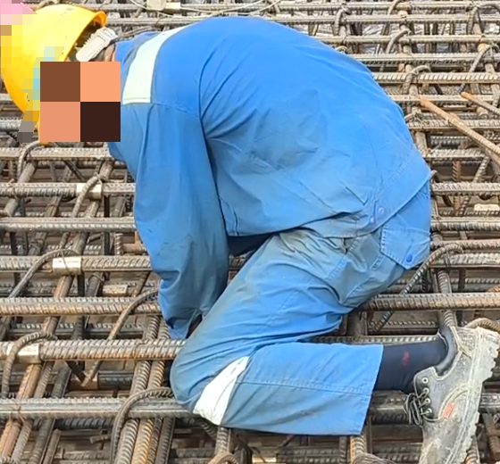
Figure S1 Diagram of rebar tying operations

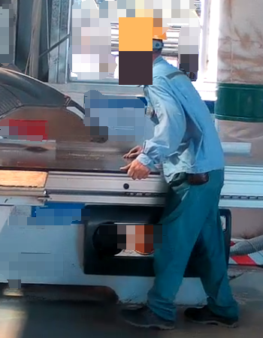
Figure S2 Diagram of wood processing operations

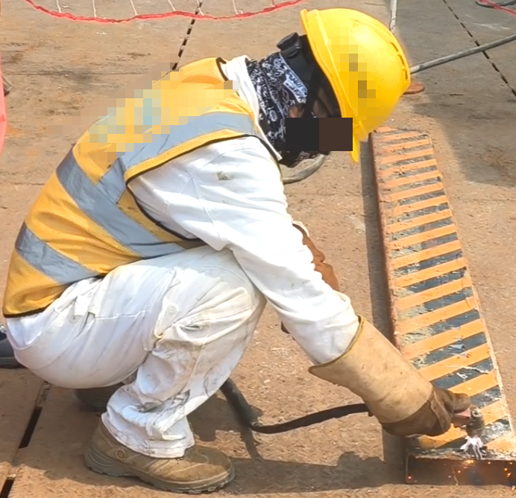
Figure S3 Diagram of welding operations

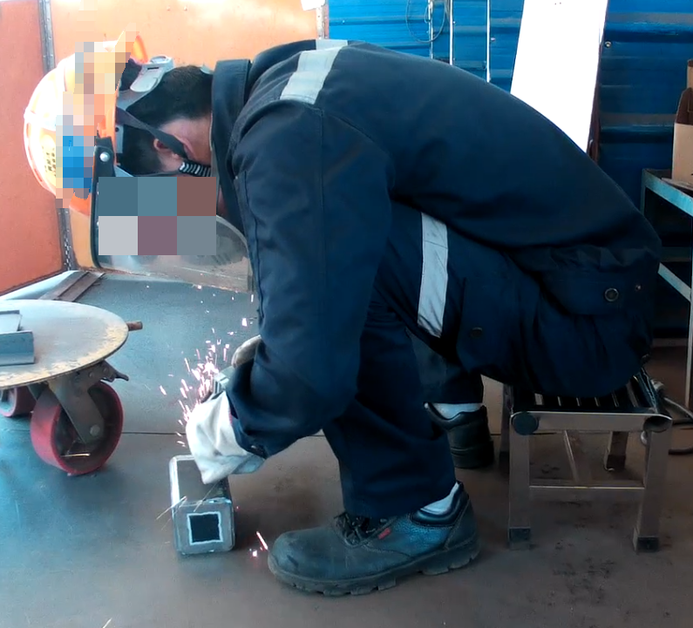
Figure S4 Diagram of grinding operations

