Supplementary Figure and Table Legend
Figure S1. Inclusion and exclusion criteria to select eligible CRC patients treated by endoscopic electrocautery and segmental resection.

Figure S2. The standardized mean differences of included variables before and after PSM.

Table S1. No. of patients treated by different therapies.

Table S2. Characteristics of CRC patients treated with endoscopic electrocautery from 2000 to 2017 after PSM matching.

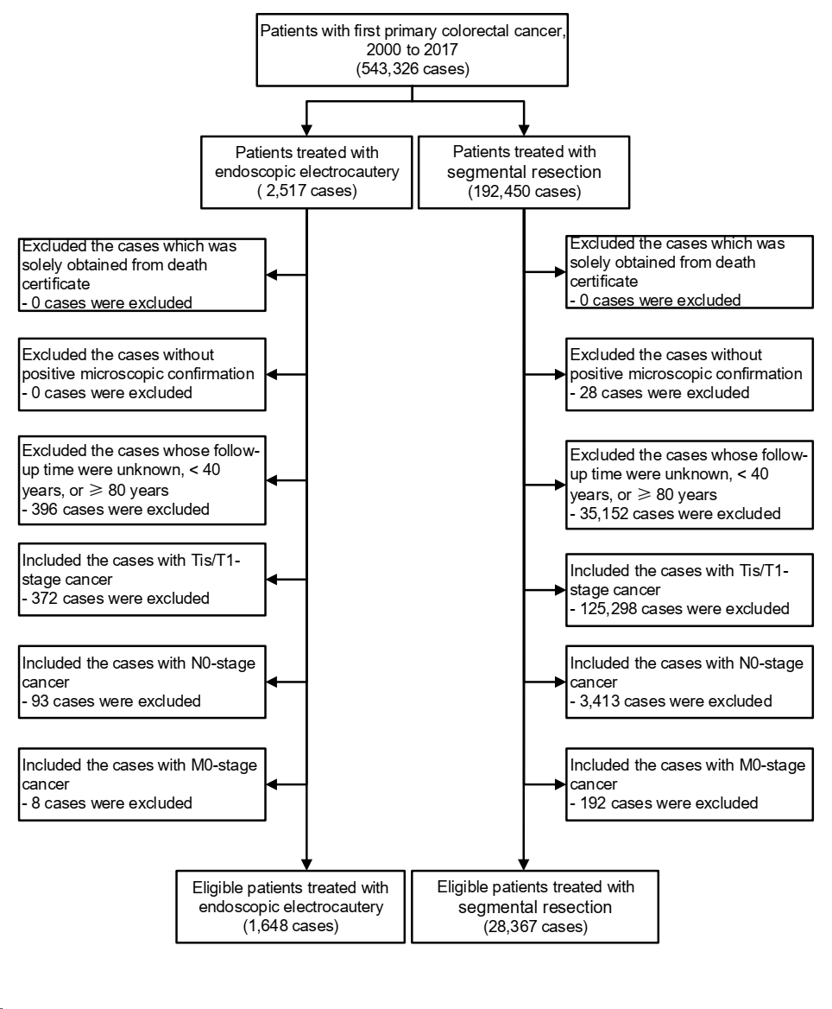
Figure S1. Inclusion and exclusion criteria to select eligible CRC patients treated by endoscopic electrocautery and segmental resection.

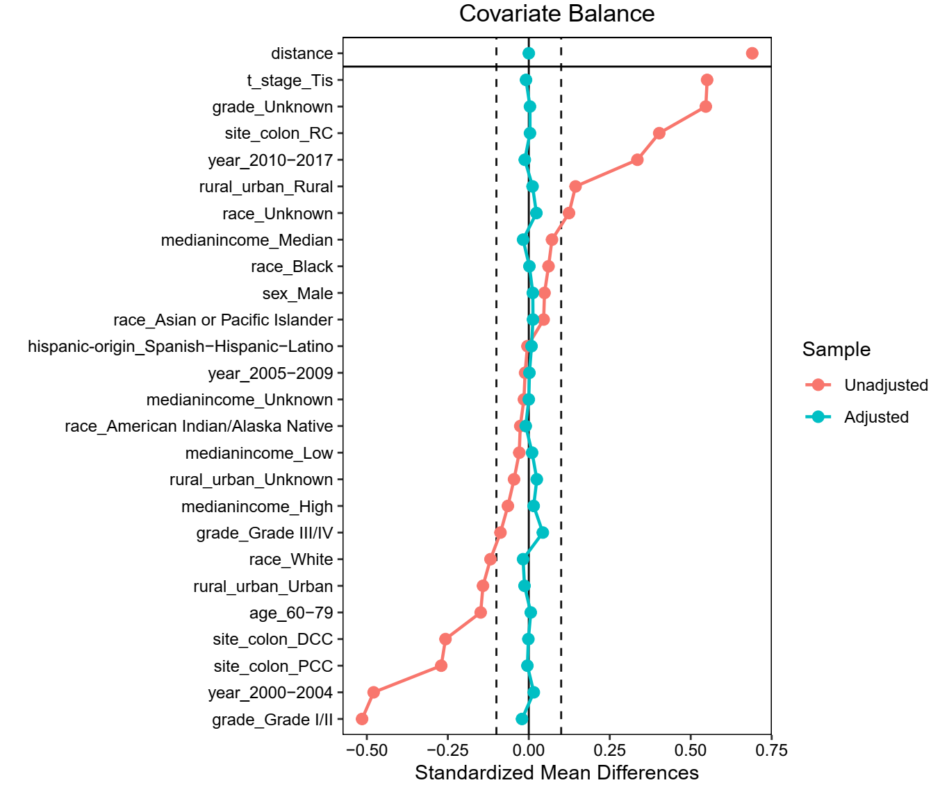
Figure S2. The standardized mean differences of included variables before and after PSM.

Table S1. No. of patients treated by different therapies.
Interventions | No. of patients¹ | %
None | 5,404 | 9.7%
Local destruction | 67 | 0.1%
Electrocautery | 1,648 | 3.0%
Segmental resection | 28,367 | 50.8%
Radical surgery | 20,348 | 36.4%
Total | 55,834 | 100%
¹ Included all Tis/T1-stage CRC patients in the SEER program.

Table S2. Characteristics of CRC patients treated with endoscopic electrocautery from 2000 to 2017 after PSM matching.
Characteristics | All patients (%) | Endoscopic electrocautery (%) | Segmental resection (%) | p¹
Total | 4,847 (100%) | 1,635 (100%) | 3,212 (100%)
Age at diagnosis |  |  |  | 0.9
40-59 | 2,299 (47.4%) | 774 (47.3%) | 1,525 (47.5%)
60-79 | 2,548 (52.6%) | 861 (52.7%) | 1,687 (52.5%)
Sex |  |  |  | 0.6
Female | 2,063 (42.6%) | 687 (42%) | 1,376 (42.8%)
Male | 2,784 (57.4%) | 948 (58%) | 1,836 (57.2%)
Race |  |  |  | 0.9
White | 3,679 (75.9%) | 1,232 (75.4%) | 2,447 (76.2%)
Black | 564 (11.6%) | 191 (11.7%) | 373 (11.6%)
American Indian/Alaska Native | 21 (0.4%) | 7 (0.4%) | 14 (0.4%)
Asian or Pacific Islander | 492 (10.2%) | 170 (10.4%) | 322 (10%)
Unknown | 91 (1.9%) | 35 (2.1%) | 56 (1.7%)
Hispanic origin |  |  |  | 0.8
Non-Hispanic | 4,403 (90.8%) | 1,483 (90.7%) | 2,920 (90.9%)
Hispanic | 444 (9.2%) | 152 (9.3%) | 292 (9.1%)
Year of diagnosis |  |  |  | 1
2000-2004 | 622 (12.8%) | 213 (13%) | 409 (12.7%)
2005-2009 | 1,457 (30.1%) | 489 (29.9%) | 968 (30.1%)
2010-2017 | 2,768 (57.1%) | 933 (57.1%) | 1,835 (57.1%)
Rural/Urban status |  |  |  | 0.2
Rural | 868 (17.9%) | 305 (18.7%) | 563 (17.5%)
Urban | 3,978 (82.1%) | 1,329 (81.3%) | 2,649 (82.5%)
Unknown | 1 (0%) | 1 (0.1%) | 0 (0%)
Median household income |  |  |  | 0.9
Low | 68 (1.4%) | 24 (1.5%) | 44 (1.4%)
Median | 3,475 (71.7%) | 1,165 (71.3%) | 2,310 (71.9%)
High | 1,304 (26.9%) | 446 (27.3%) | 858 (26.7%)
Unknown |  |  |  | 0.8
AJCC T stage | 2,365 (48.8%) | 803 (49.1%) | 1,562 (48.6%)
Tis | 2,482 (51.2%) | 832 (50.9%) | 1,650 (51.4%)
T1 |  |  |  | 0.2
Grade | 2,251 (46.4%) | 739 (45.2%) | 1,512 (47.1%)
Grade I/II | 173 (3.6%) | 67 (4.1%) | 106 (3.3%)
Grade III/IV | 2,423 (50%) | 829 (50.7%) | 1,594 (49.6%)
Ungraded |  |  |  | 0.9
Anatomic sites | 448 (9.2%) | 148 (9.1%) | 300 (9.3%)
PCC | 144 (3%) | 33 (2%) | 111 (3.5%)
Cecum | 145 (3%) | 58 (3.5%) | 87 (2.7%)
Ascending Colon | 36 (0.7%) | 18 (1.1%) | 18 (0.6%)
Hepatic Flexure | 123 (2.5%) | 39 (2.4%) | 84 (2.6%)
Transverse Colon | 1,725 (35.6%) | 576 (35.2%) | 1,149 (35.8%)
DCC | 68 (1.4%) | 11 (0.7%) | 57 (1.8%)
Splenic Flexure | 169 (3.5%) | 69 (4.2%) | 100 (3.1%)
Descending Colon | 1,488 (30.7%) | 496 (30.3%) | 992 (30.9%)
Sigmoid Colon | 2,674 (55.2%) | 911 (55.7%) | 1,763 (54.9%)
RC | 740 (15.3%) | 96 (5.9%) | 644 (20%)
Rectosigmoid Junction | 1,934 (39.9%) | 815 (49.8%) | 1,119 (34.8%)
Rectum | 4,847 (100%) | 1,635 (100%) | 3,212 (100%)
Notes:
¹ The p-values were calculated by Fisher exact test or Person chi2 test. The p-values were 2-sides.

