Supplementary Figures

Interpretable machine learning enables de novo mapping of cell type-specific RNA splicing regulation from scRNA-seq data

Xianke Xiang^{1,2}, Xuerui Yang^{2*}

¹ Institute of Hepatopancreatobiliary Surgery, Chongqing General Hospital, School of Medicine, Chongqing University, Chongqing, 401147, China
² MOE Key Laboratory of Bioinformatics, Center for Synthetic & Systems Biology, School of Life Sciences, Tsinghua University, Beijing, China

*Correspondence: Xuerui Yang, School of Life Sciences, Tsinghua University, Beijing 100084, China. Tel: 86-10-62783943. Email: yangxuerui@tsinghua.edu.cn
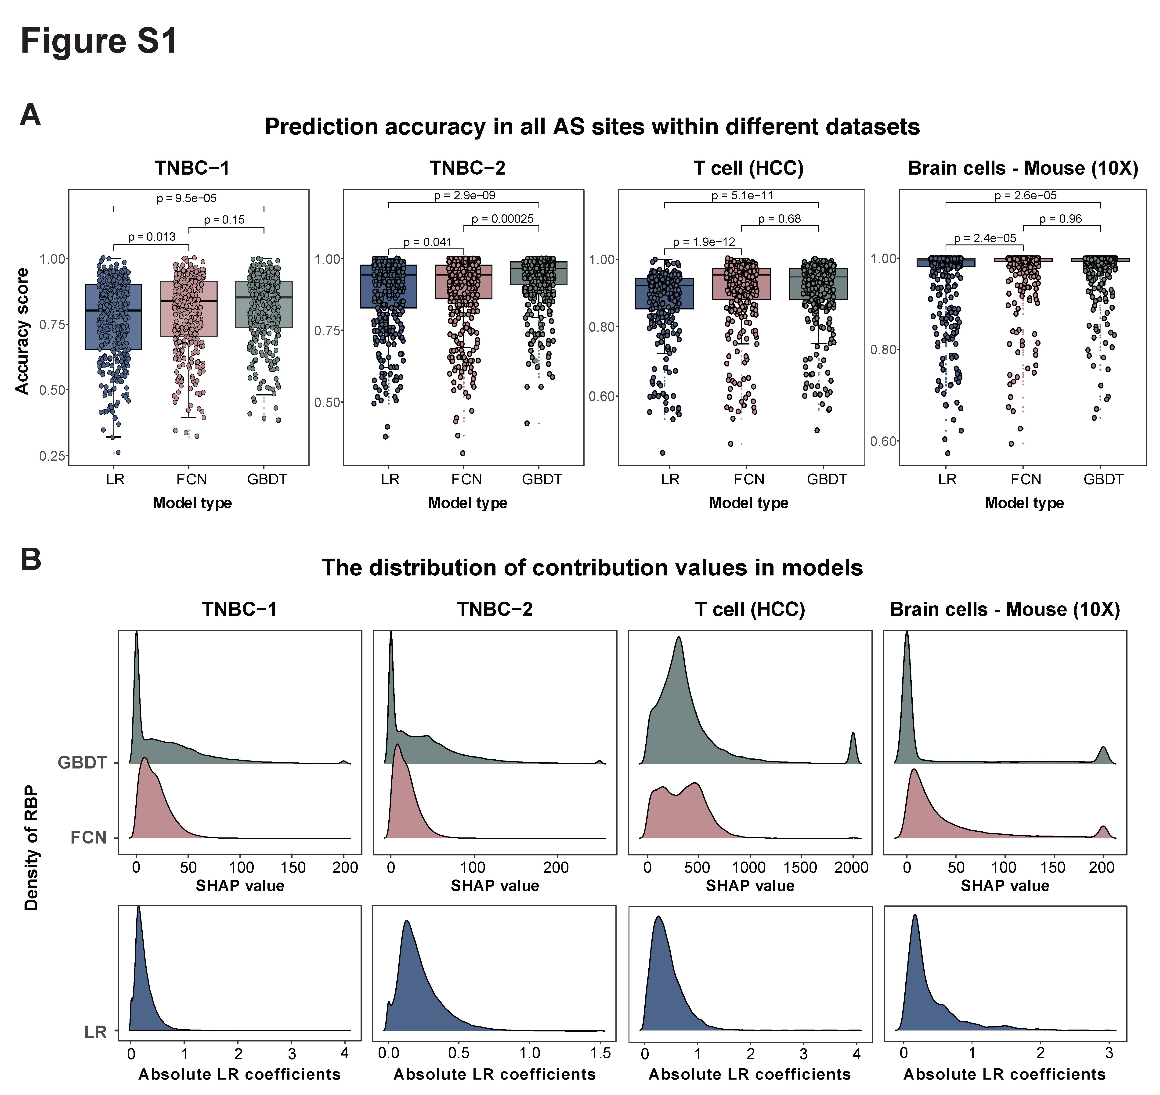Figure S1. Benchmarking of CASREL based on 3 models.
(A) Box plots showing accuracy of AS profile prediction by CASREL based on 3 models (GBDT, FCN, LR) applied on four datasets. Each point represents the prediction accuracy of an individual splicing event. Statistical significance was assessed using two-sided Wilcoxon rank-sum tests.
(B) Distributions of quantitative assessments of RBPs in shaping AS landscapes, as revealed by CASREL based on 3 models applied on four datasets. For complex models (GBDT and FCN), contributions of RBPs were quantified using SHAP values, while absolute values of LR coefficients were used in the LR model.

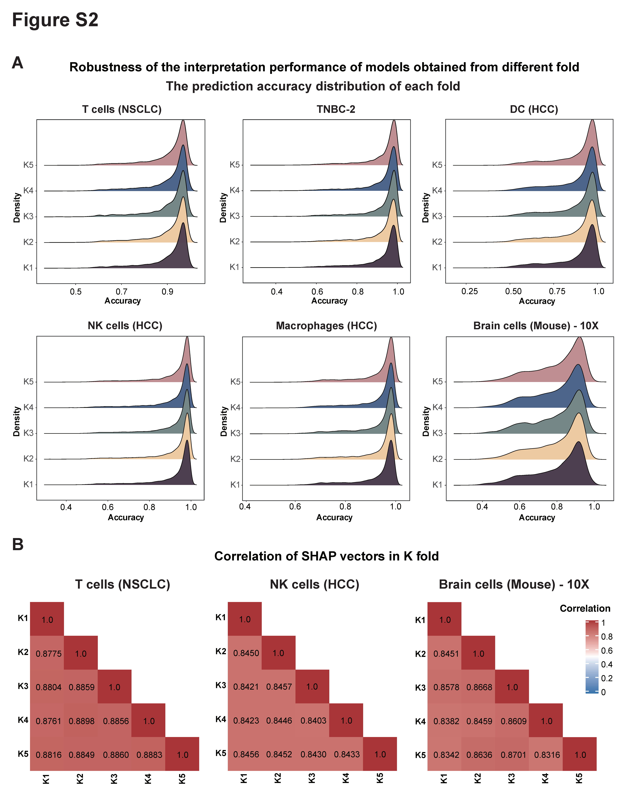
Figure S2. Consistency of AS prediction and SHAP analysis across k-fold models.
(A) Prediction accuracy distributions of AS events across six datasets. Density plots represent accuracy within individual cross-validation folds.
(B) Pearson correlation of the SHAP values across k folds in three datasets: NSCLC T cells, NSCLC NK cells, and mouse brain cells (10x Genomics).
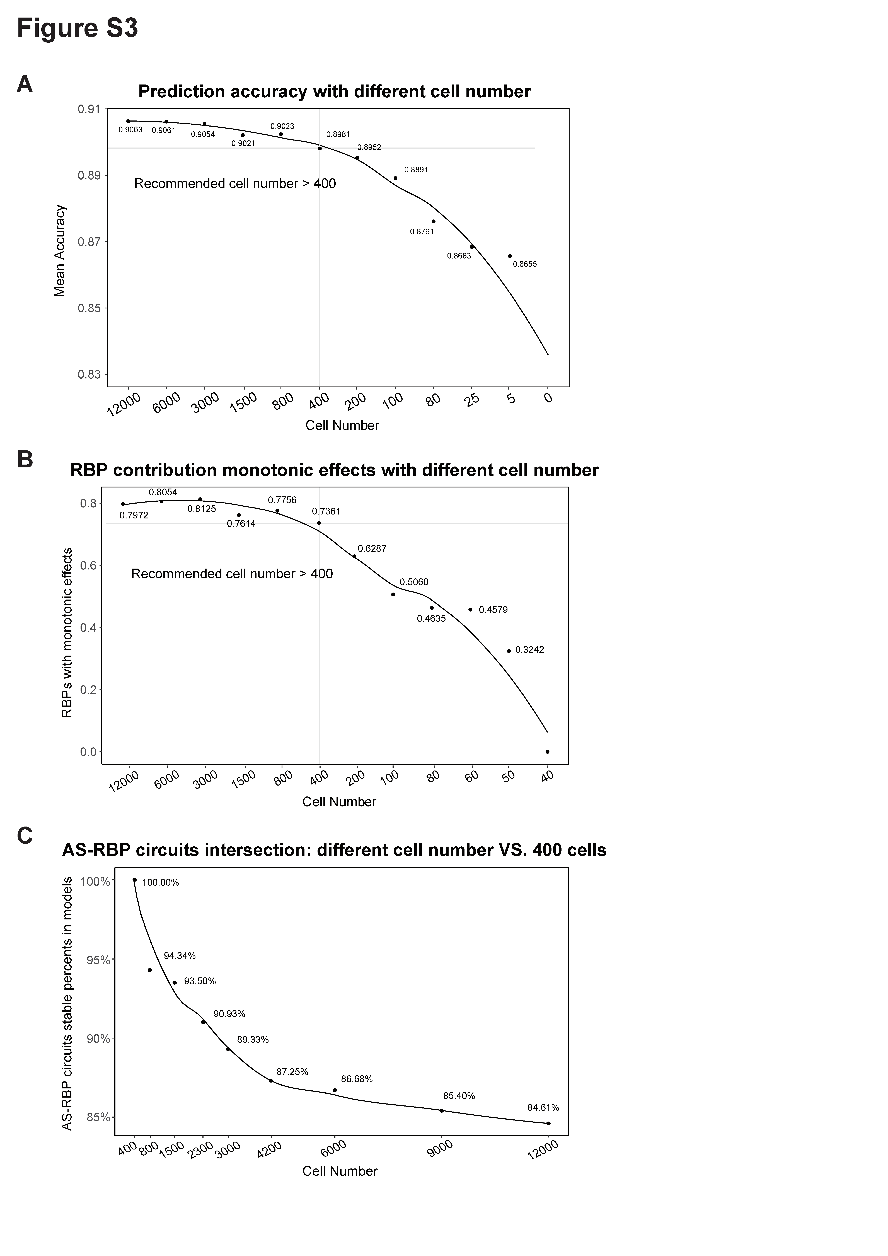
Figure S3. Performances of CASREL with different volumes of single-cell input data.
(A-C) Subsampling analysis of the NSCLC T cell dataset (12,022 cells). (A) Mean prediction accuracy for AS profiles across subsampled cell numbers. (B) Proportion of RBPs with monotonic effects at varying numbers of cells as input data. (C) Retention rates of predicted RBP-AS circuits when training on different cell numbers, relative to the circuits identified using the minimum training set (400 cells).

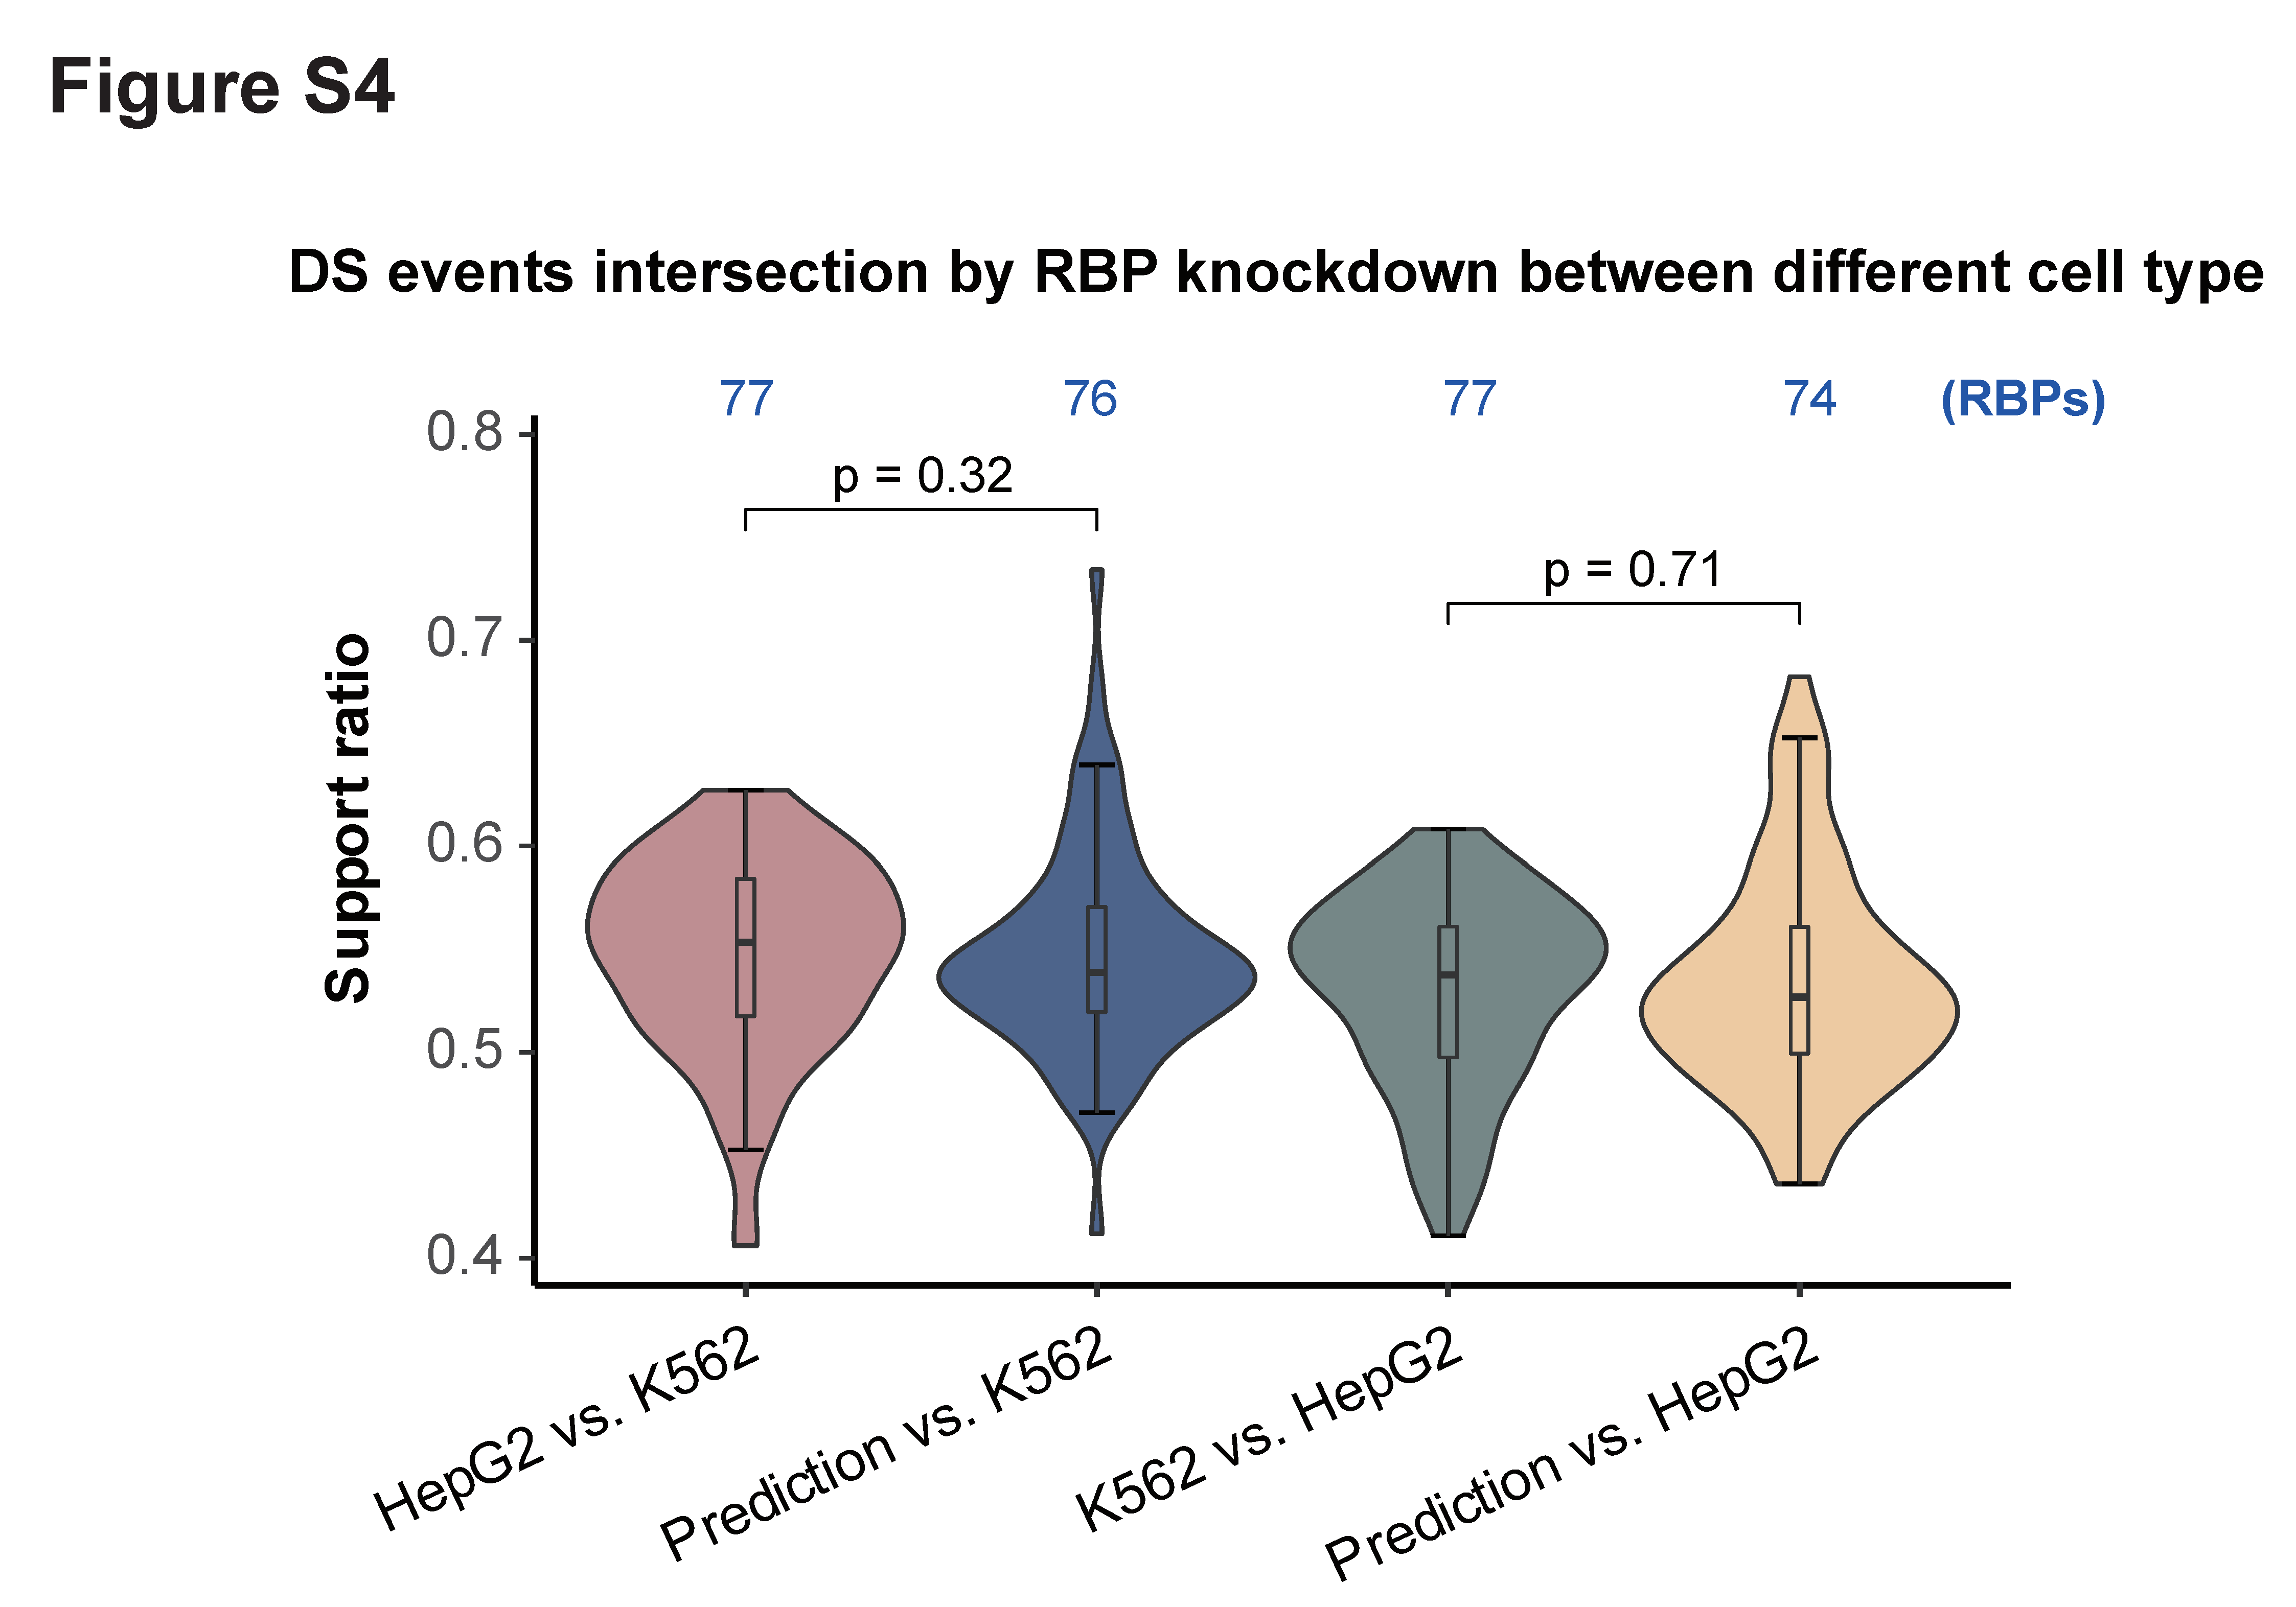
Figure S4. Supporting rates of RBP-AS regulations from knockdown experiments and CASREL predictions across cell types.
RBP-AS regulations derived from RBP knockdown experiments and CASREL predictions are compared against each other. Y-axis: overlap ratio of differential splicing events across experimental conditions (RBP knockdowns in 2 cell lines, or CASREL predictions versus RBP knockdown experiments). For CASREL, values represent mean support ratios across 9 datasets in Fig. 3A. Numbers above indicate total RBP intersections per comparison. Statistical testing used two-sided Wilcoxon rank-sum tests.

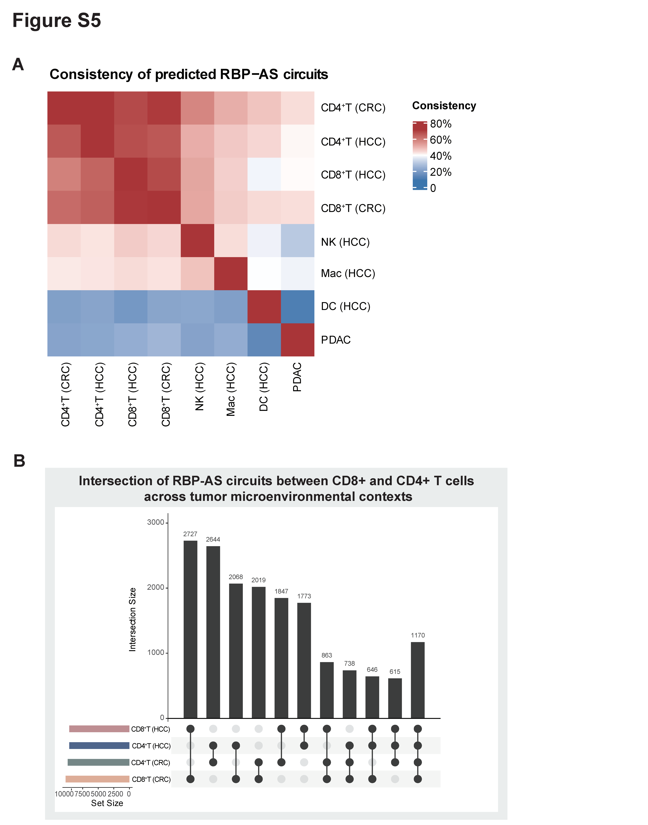
Figure S5. Consistency of predicted RBP-AS circuits across cell types.
(A) Heatmap showing consistency of CASREL-predicted RBP-AS circuit across cell types. Color intensity reflects the proportion of shared circuits normalized to the reference cell type (horizontal axis).
(B) Bar chart showing intersections of RBP-AS circuits in CD8⁺ and CD4⁺ T cells across tumor microenvironment datasets. Left inset: total number of circuits per cell type.
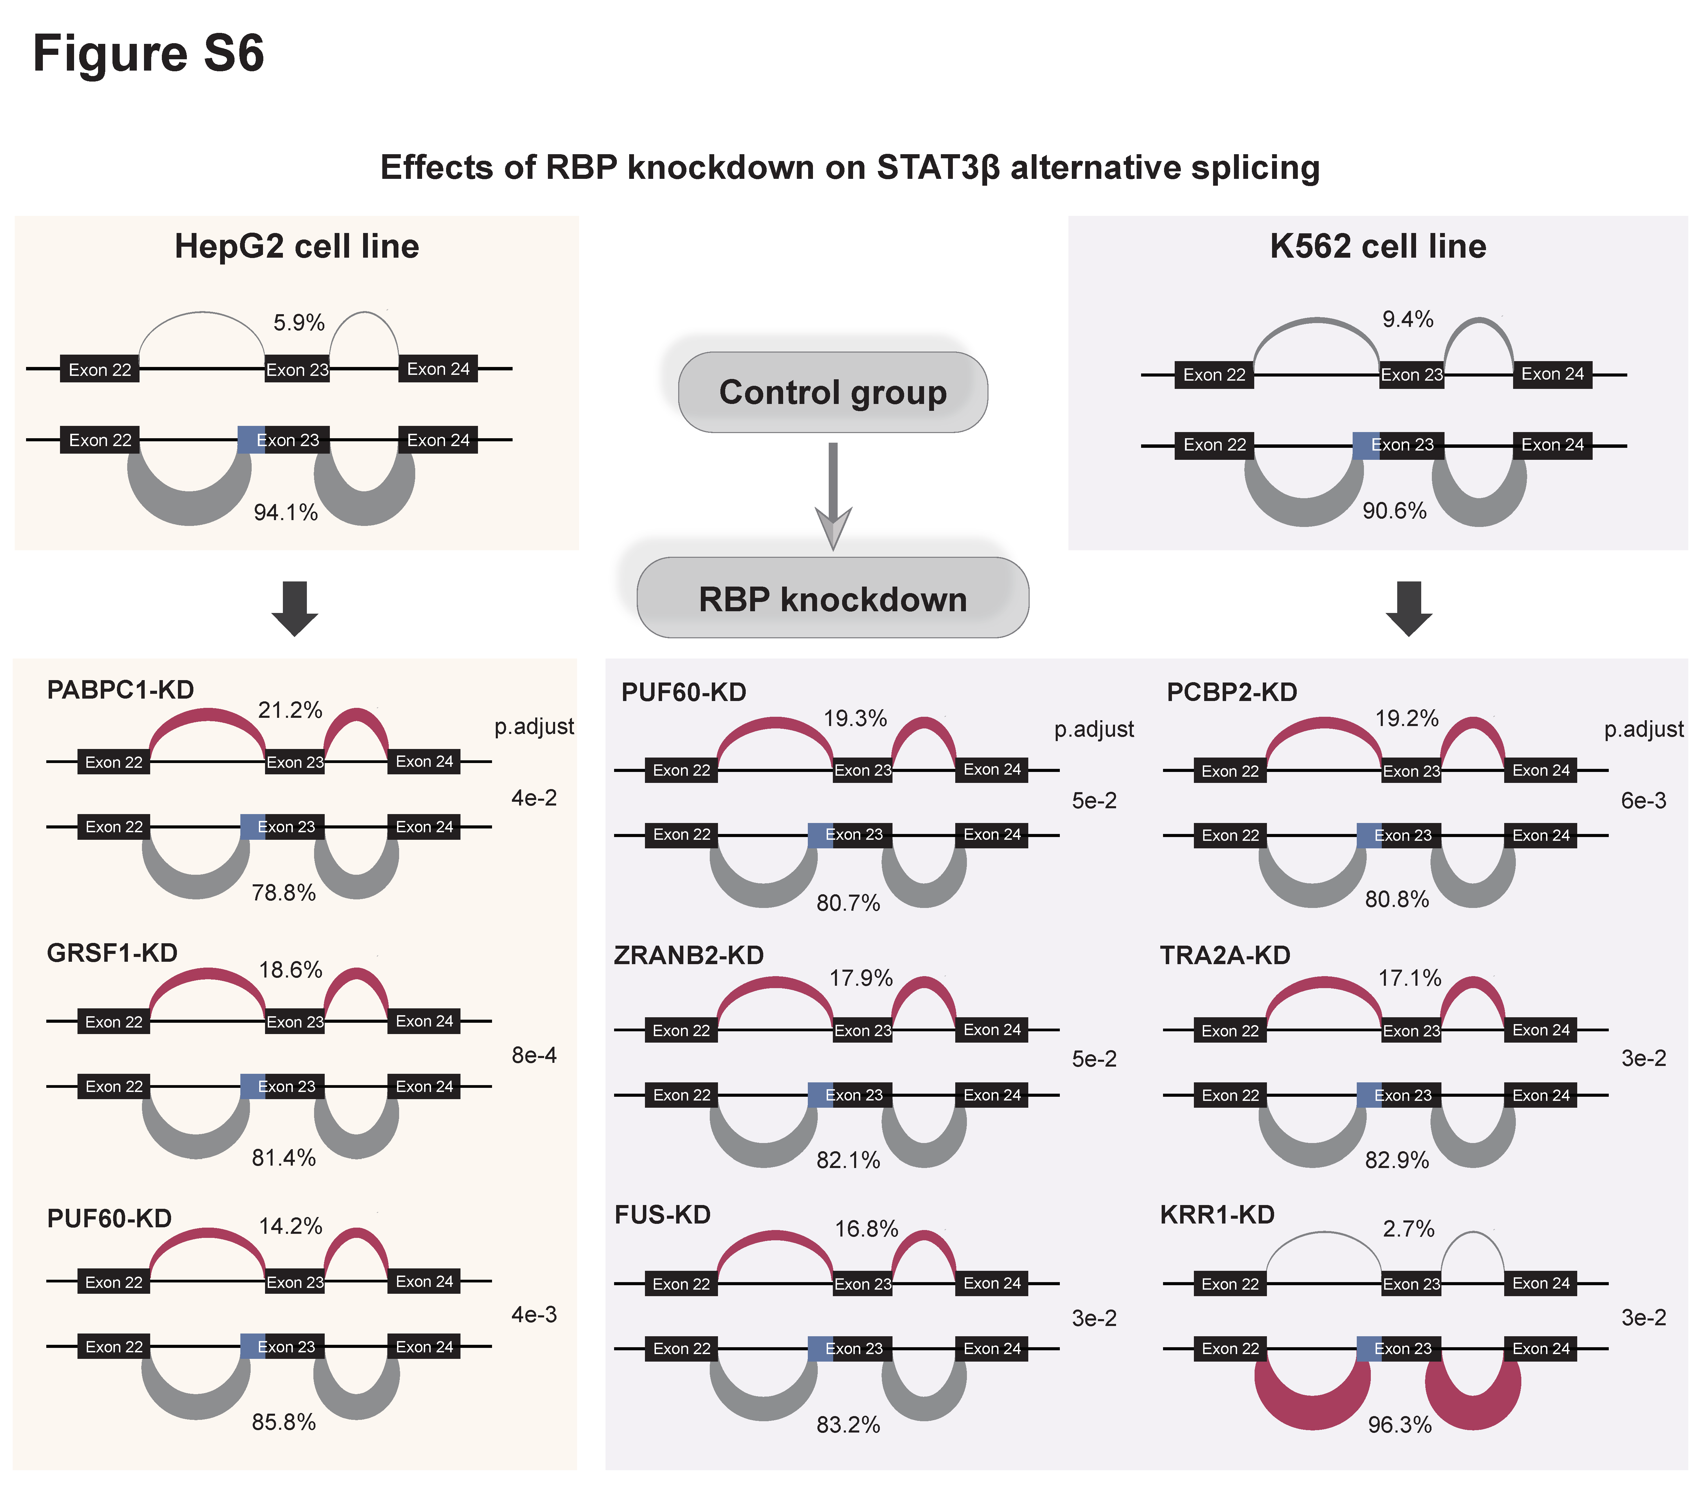
Figure S6. Experimental validation of CASREL-predicted STAT3β regulators (Supplementary to Fig. 4C–F).
STAT3β splicing patterns upon RBP knockdown in HepG2 (yellow) and K562 (purple) cells. Upper panels show control; lower panels, knockdown. Differentially spliced exons are highlighted in blue. Junction width reflects splicing probability, with numerical values shown. Significance was assessed by two-sided Wilcoxon rank-sum tests and adjusted p-values are shown to the right.

