Supplementary Material

Table S1. Classification of locations based-on time-use diary. p. 2
Table S2. Proportion of spatial discrepancies between the P-GPS and A-GPS by decimal precision p. 3
Figure S1. Statistical distribution and outlier cutoffs for GPS accuracy p. 4
Figure S2. Temporal variability in distances between consecutive GPS positions p. 5
Figure S3. GPS correction effects of indoor-house scenario p. 6
Figure S4 GPS correction effects of indoor-other scenario p. 7
Figure S5 GPS correction effects of outdoor-walk scenario p. 8
Figure S6 GPS correction effects of outdoor-transportation scenario p. 9

Supplementary Table S1 Classification of locations based-on time-use diary.
Category | Sub-category | Location | Sub-location
Indoor | House | House | -
Indoor | Other | Workplace | Offices, Middle/High schools, University lecture halls
Indoor | Other | Restaurant | Cafeteria, Korean BBQ restaurant
Indoor | Other | Others | Café, Pub, Bookstore, Senior center, Market
Outdoor | Walk | Walk | -
Outdoor | Transportation | Transportation | Car, Taxi, Bus, Subway

Supplementary Table S2 Proportion of spatial discrepancies between the P-GPS and A-GPS by decimal precision.
The decimal place indicates the first occurrence of geographic coordinate differences between the two GPS devices, representing the corresponding geometric scale in meters. The values in each time-activity scenario are the number of discrepant GPS records and their percentage relative to the total records. The highlighted value implies a substantial data loss in the “Transport” scenario when applying the same threshold as the others.
Decimal places | Approx. distance (m) | Indoor | Walk | Transport
1 | 11000 | 0 (0.0 %) | 0 (0.0 %) | 0 (0.0 %)
2 | 1100 | 215 (1.6 %) | 7 (0.4 %) | 52 (2.2 %)
3 | 110 | 2,754 (20.0 %) | 215 (12.4 %) | 1,277 (53.6%)
4 | 11 | 11,360 (82.6 %) | 1,608 (93.0 %) | 2,311 (97.1 %)
5 | 1.1 | 13,247 (96.3 %) | 1,728 (99.9 %) | 2,378 (99.9 %)
6 | 0.1 | 13,608 (98.9 %) | 1,729 (100.0 %) | 2,380 (100.0%)

Supplementary Figure S1 Statistical distribution and outlier cutoffs for GPS accuracy.
Boxplots show horizontal, vertical, and speed accuracy, respectively, with horizontal and vertical values presented on a log scale. The solid black line represents the median, and the red dashed line indicates the upper whisker cutoff ($Q_{3}+1.5×IQR$) used for outlier filtering.
(A) Indoor, (B) Outdoor-walk, (C) Outdoor-transport
(A) | (B)
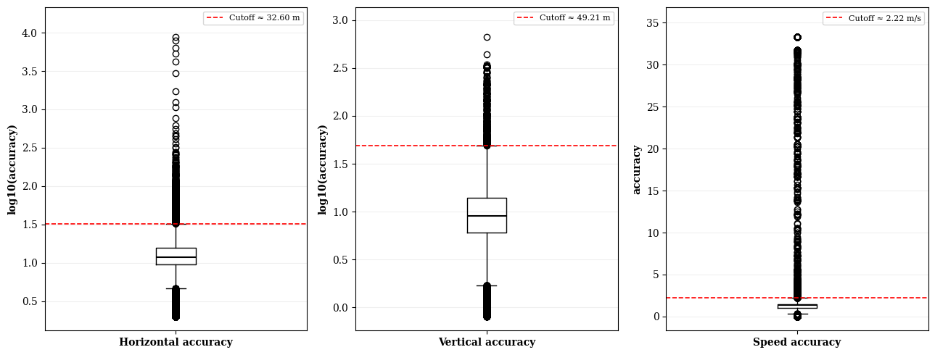 | 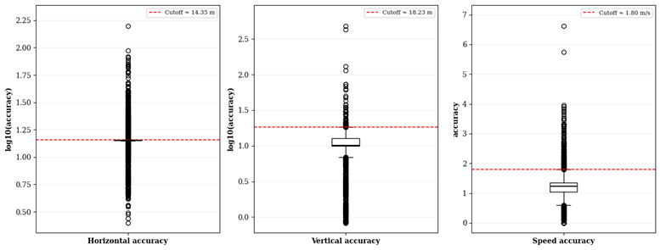
(C)
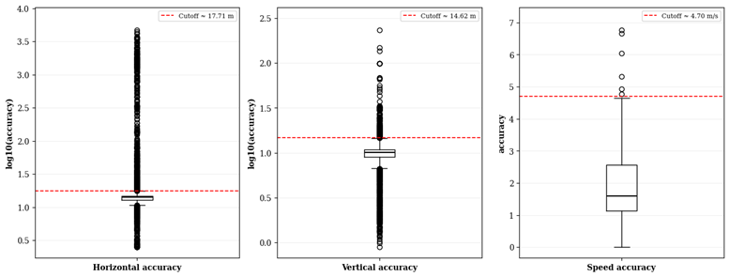

Supplementary Figure S2 Temporal variability in distances between consecutive GPS positions.
The solid lines represent the mean distance at each time step across all trajectories and the shaded areas are 95th percentile bands. The time steps are limited to the timepoint where at least ten valid trajectories remained within a given scenario.
(A) Indoor-house, (B) Indoor-other, (C) Outdoor-walk, (D) Outdoor-transport
(A) | (B)
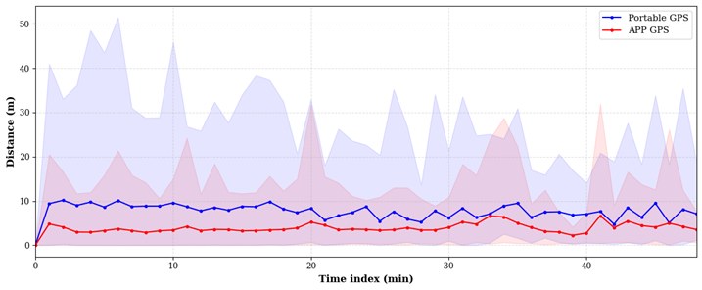 | 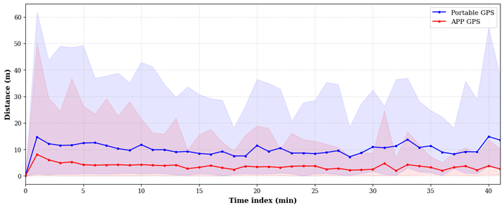
(C) | (D)
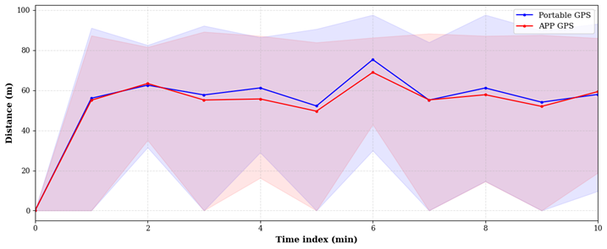 | 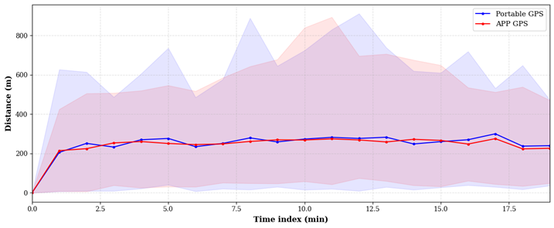

Supplementary Figure S3 GPS correction effects of indoor-house scenario.
The MAE of GPS coordinates indicates the mean absolute differences in longitude and latitude between each model and the reference GPS. ΔAUC indicates the difference of area under the curve between the sum of positive regions (blue) and negative regions (red). The shaded area represents each trajectory in chronological order.
(A) Kalman Filter; (B) LSTM; (C) LSTM-AE; (D) GAN
(A) | (B)
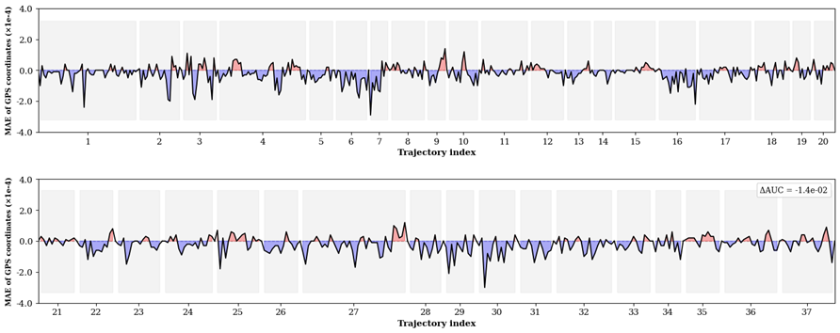 | 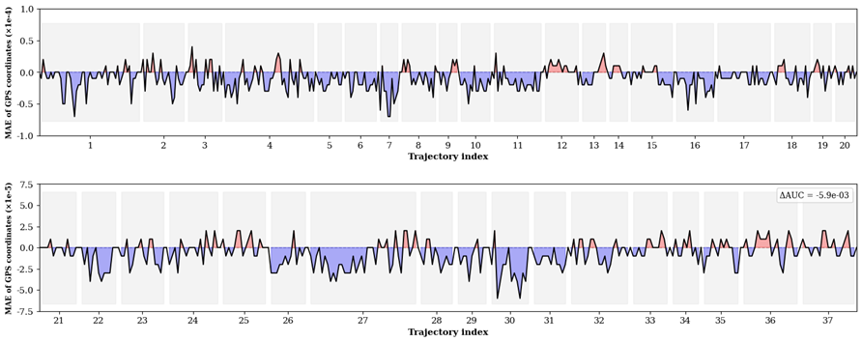
(C) | (D)
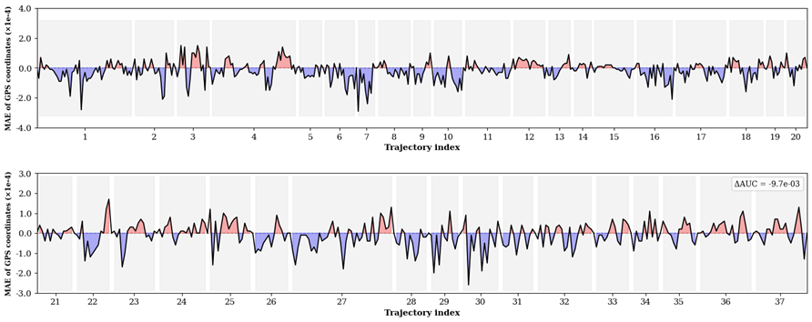 | 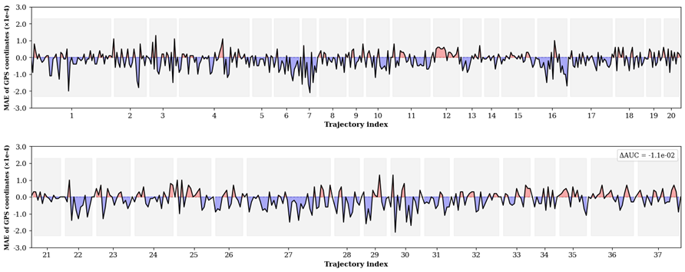

Supplementary Figure S4 GPS correction effects of indoor-other scenario.
(A) Kalman Filter; (B) LSTM; (C) LSTM-AE; (D) GAN
(A) | (B)
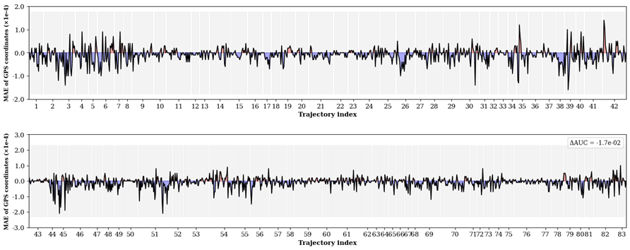 | 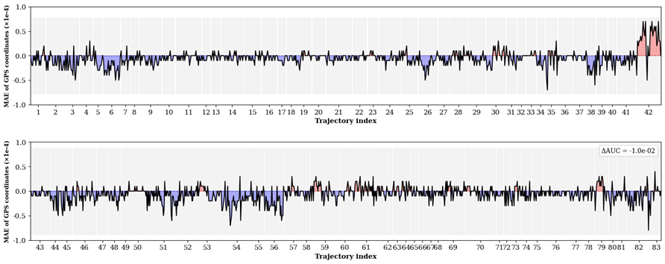
(C) | (D)
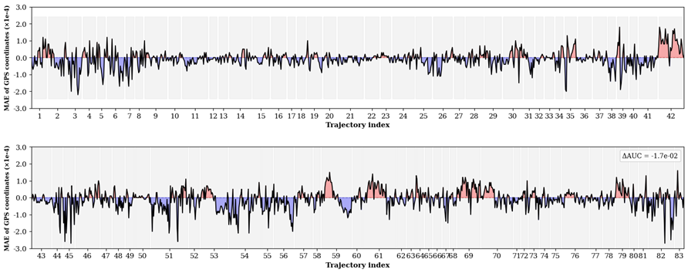 | 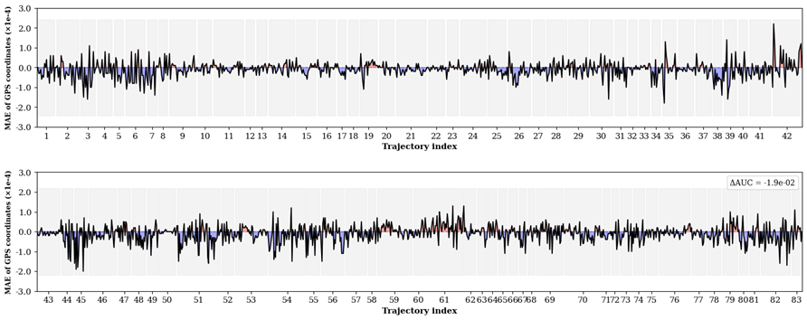

Supplementary Figure S5 GPS correction effects of outdoor-walk scenario.
(A) Kalman Filter; (B) LSTM; (C) LSTM-AE; (D) GAN
(A) | (B)
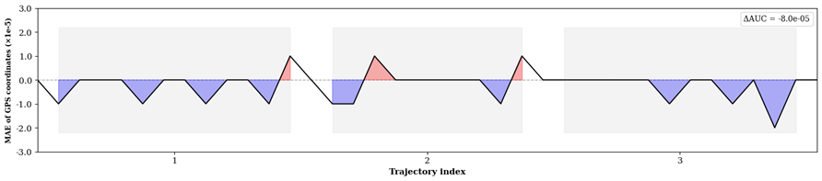 | 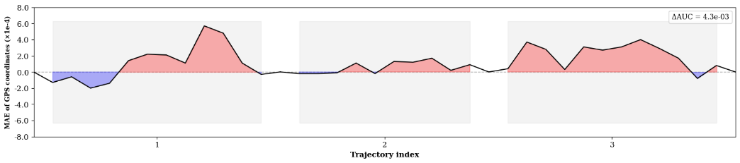
(C) | (D)
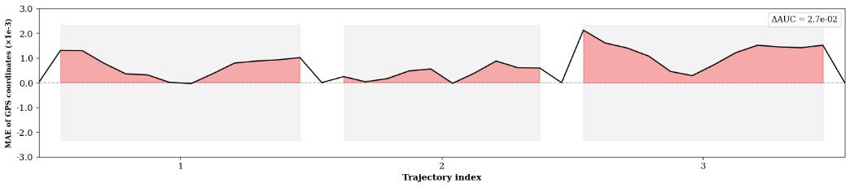 | 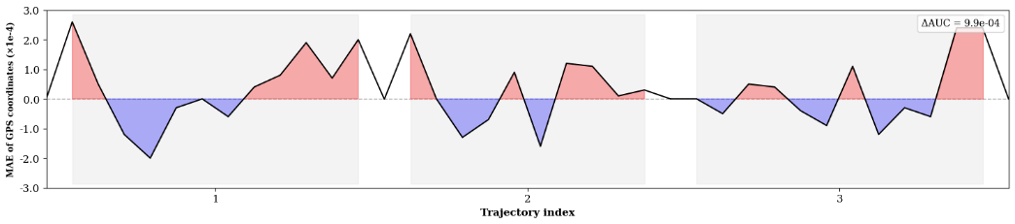

Supplementary Figure S6 GPS correction effects of outdoor-transportation scenario.
(A) Kalman Filter; (B) LSTM; (C) LSTM-AE; (D) GAN
(A) | (B)
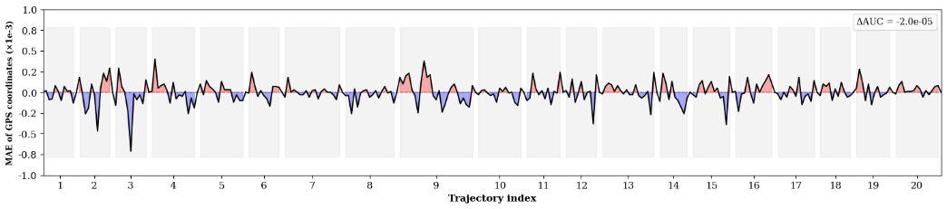 | 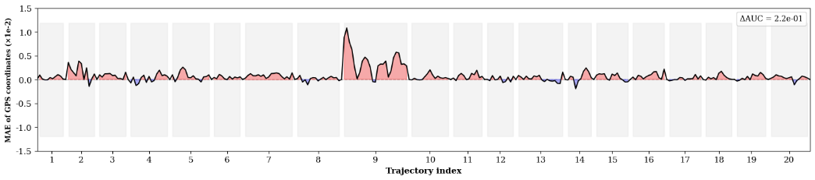
(C) | (D)
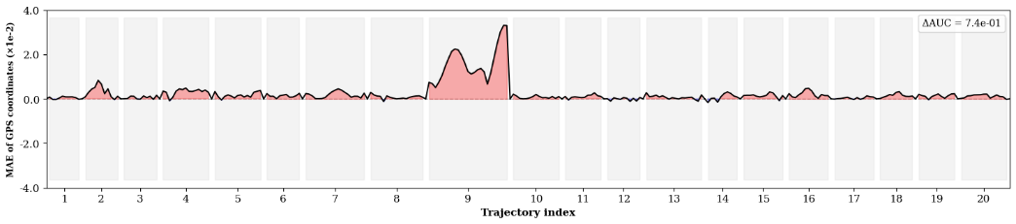 | 