SUPPLEMENTARY MATERIALS for

Proteome-wide evolutionary rate covariation reveals the mitonuclear coevolutionary landscape in Squamata

Note: all the additional networks and gene enrichments in this study are stored in the FigShare repository (https://doi.org/10.6084/m9.figshare.31455355).

Table S1. List of squamate species used in this study, including taxonomic information, NCBI taxonomy ID (txid), presence of mitochondrial OXPHOS proteins (mtOXPHOS), mitochondrial genome identifier (mtDNA ID; accession number or source paper), nuclear genome assembly ID, assembly level, and release date. Mitochondrial genomes were obtained from public databases or identified from genomic/transcriptomic data, as described in Methods. L. sacra and P. przwalskii mitogenomes were downloaded from the National Genomics Data Center (CGDC). In the mtDNA ID column, when mtDNA annotated mitogenomes were unavailable in NCBI, we replaced the accession ID with the citation of the study reporting the assembly. When “Wallnoefer et al. 2025” is indicated, it indicates that mtOXPHOS sequences were already available to the authors.

Group | Family | Species | txid | mtOXPHOS | mtDNA ID | Assembly ID | Assembly Level | Release Date
Acrodonta | Agamidae | Pogona vitticeps | 103695 | yes | AB166795.1 | GCF_900067755.1 | Scaffold | 28/02/17
Acrodonta | Agamidae | Phrynocephalus forsythii | 171643 | yes | KP232959.1 | GCA_029282475.1 | Scaffold | 20/03/23
Acrodonta | Agamidae | Intellagama lesueurii | 103694 | no | \ | GCA_037013535.1 | Scaffold | 11/12/23
Acrodonta | Agamidae | Laudakia sacra | 52204 | yes | MK411596.1 | GWHBKHB00000000 | Contig | 03/09/22
Acrodonta | Agamidae | Phrynocephalus przewalskii | 171649 | yes | NC_022719.1 | GWHAAFD00000000 | Scaffold | 07/12/18
Pleurodonta | Dactyloidae | Anolis carolinensis | 28377 | yes | EU747728.2 | GCF_035594765.1 | Chromosome | 12/01/24
Pleurodonta | Dactyloidae | Anolis sagrei | 38937 | yes | Geneva et al., 2021 | GCF_037176765.1 | Chromosome | 15/03/24
Pleurodonta | Dactyloidae | Anolis homolechis | 235309 | no | \ | Kanamori et al. 2022 | Scaffold | 04/11/22
Pleurodonta | Phrynosomatidae | Sceloporus undulatus | 8520 | yes | Westfall et al., 2021 | GCF_019175285.1 | Chromosome | 08/07/21
Pleurodonta | Phrynosomatidae | Phrynosoma platyrhinos | 52577 | yes | Wallnoefer et al., 2025 | GCA_020142125.1 | Chromosome | 27/09/21
Serpentes | Colubridae | Thamnophis elegans | 35005 | yes | Wallnoefer et al., 2025 | GCF_009769535.1 | Chromosome | 23/12/19
Serpentes | Colubridae | Ahaetulla prasina | 499056 | yes | Identified using Miniprot | GCF_028640845.1 | Chromosome | 22/02/23
Serpentes | Colubridae | Pituophis catenifer | 94852 | yes | KU833245.2 | GCF_029215685.1 | Scaffold | 14/03/23
Serpentes | Colubridae | Pantherophis guttatus | 94885 | yes | Wallnoefer et al., 2025 | GCF_029531705.1 | Scaffold | 31/03/23
Serpentes | Elapidae | Naja naja | 35670 | yes | NC_010225.1 | GCA_009733165.1 | Chromosome | 11/12/19
Serpentes | Elapidae | Notechis scutatus | 8663 | yes | Identified from Transcriptome | GCF_900518725.1 | Scaffold | 24/09/18
Serpentes | Elapidae | Pseudonaja textilis | 8673 | yes | Identified using Miniprot | GCF_900518735.1 | Scaffold | 24/09/18
Serpentes | Elapidae | Ophiophagus hannah | 8665 | yes | NC_011394.1 | GCA_000516915.1 | Scaffold | 11/12/13
Serpentes | Viperidae | Protobothrops mucrosquamatus | 103944 | yes | NC_021412.1 | GCF_001527695.2 | Scaffold | 22/01/16
Serpentes | Viperidae | Crotalus adamanteus | 8729 | yes | NC_041524.1 | GCA_039797435.1 | Chromosome | 24/05/24
Serpentes | Boidae | Candoia aspera | 51853 | yes | CM069494.1 | GCF_035149785.1 | Chromosome | 18/01/24
Serpentes | Dipsadidae | Erythrolamprus reginae | 121349 | yes | Identified using Miniprot | GCF_031021105.1 | Chromosome | 31/08/23
Serpentes | Pythonidae | Python bivittatus | 176946 | yes | NC_021479.1 | GCF_000186305.1 | Scaffold | 15/09/13
Gekkota | Eublepharidae | Eublepharis macularius | 481883 | yes | NC_033383.1 | GCF_028583425.1 | Chromosome | 10/02/23
Gekkota | Sphaerodactylidae | Euleptes europaea | 460621 | no | \ | GCF_029931775.1 | Chromosome | 15/05/23
Gekkota | Sphaerodactylidae | Sphaerodactylus townsendi | 933632 | yes | Wallnoefer et al., 2025 | GCF_021028975.2 | Chromosome | 08/04/22
Gekkota | Gekkonidae | Heteronotia binoei | 13085 | yes | NC_010292.1 | GCF_032191835.1 | Chromosome | 29/09/23
Gekkota | Gekkonidae | Gekko japonicus | 146911 | yes | NC_028035.1 | GCF_001447785.1 | Scaffold | 25/11/15
Laterata | Lacertidae | Podarcis raffonei | 65483 | yes | NC_011607.1 | GCF_027172205.1 | Chromosome | 27/12/22
Laterata | Lacertidae | Zootoca vivipara | 8524 | yes | NC_026867.1 | GCF_963506605.1 | Chromosome | 20/09/23
Laterata | Lacertidae | Lacerta agilis | 80427 | yes | NC_021766.1 | GCF_009819535.1 | Chromosome | 31/12/19
Anguimorpha | Varanidae | Varanus komodoensis | 61221 | yes | Wallnoefer et al., 2025 | GCF_004798865.1 | Scaffold | 17/04/19
Scincomorpha | Scincidae | Tiliqua scincoides | 71010 | no | \ | GCF_035046505.1 | Chromosome | 04/01/24
Scincomorpha | Scincidae | Lerista edwardsae | 470340 | yes | Wallnoefer et al., 2025 | GCA_029204185.1 | Scaffold | 14/03/23
Rhynchocephalia | Sphenodontidae | Sphenodon punctatus (outgroup) | 8508 | yes | NC_004815.1 | GCA_003113815.1 | Scaffold | 10/05/18

Figure S1. Mitochondrial OXPHOS gene dataset. The presence is indicated by a blue square. The genes NADH3, NADH4L, and ATP8 were not used in the ERC analysis due to length filters.

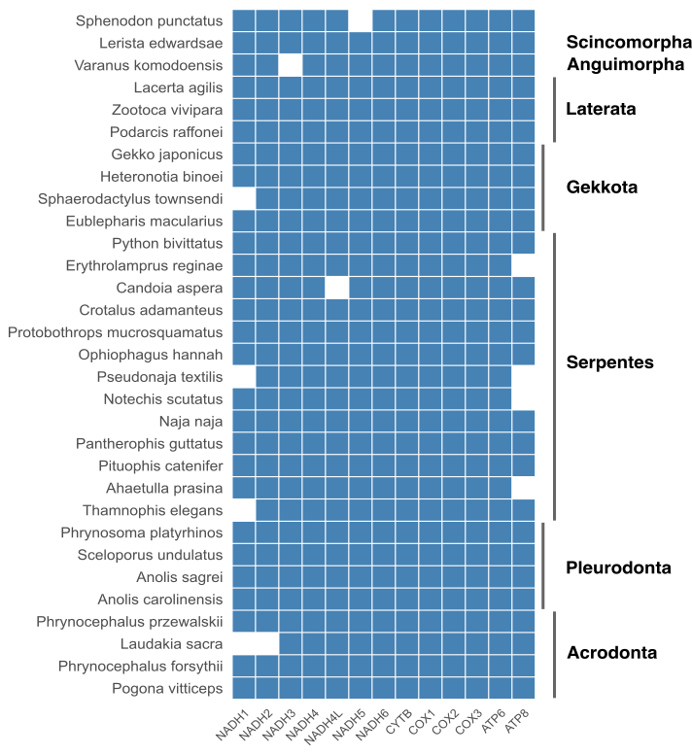

Table S2. Comparison of node metrics for mtOXPHOS and nuclear orthogroups in the network filtered by Spearman’s ρ > 0.4 and p-value < 0.05. Medians of mitochondrial nodes were compared to null distributions obtained from 10,000 random samples of non-mitochondrial nodes of the same size; p-values indicate the proportion of permutations with medians ≥ observed. Degree is the number of direct connections per node, betweenness measures how often a node lies on shortest paths, closeness reflects how close a node is to all others, and eigenvector indicates a node’s influence based on its connections and their importance (Newman 2010).

metric | mit_median | nuc_mean | sd_nuc | p-value
degree | 0.03717 | 0.01540 | 0.00738 | 0.0143
betweenness | 0.00225 | 0.00045 | 0.00025 | 1e-04
closeness | 0.36372 | 0.32862 | 0.01250 | 9e-04
eigenvector | 0.00922 | 0.00149 | 0.00245 | 0.0189

Table S3. ERC results: number of nuclear first-neighbors of mitochondrial OXPHOS proteins, under different filtering conditions (p-value < 0.05, < 0.01, < 0.001; Spearman’s ρ > 0.4, 0.5, 0.6, 0.7, 0.8). Green intensity refers to the number of first-neighbors.

Threshold  p-value | 0.05 |  |  |  |  | 0.01 |  |  |  |  | 0.001
Threshold Spearman’s ρ | 0.4 | 0.5 | 0.6 | 0.7 | 0.8 | 0.4 | 0.5 | 0.6 | 0.7 | 0.8 | 0.4 | 0.5 | 0.6 | 0.7 | 0.8
NADH1 | 83 | 46 | 20 | 7 | 1 | 74 | 44 | 20 | 7 | 1 | 25 | 25 | 18 | 7 | 1
NADH2 | 112 | 58 | 22 | 8 | 1 | 105 | 54 | 22 | 8 | 1 | 40 | 40 | 21 | 7 | 1
NADH3 | 0 | 0 | 0 | 0 | 0 | 0 | 0 | 0 | 0 | 0 | 0 | 0 | 0 | 0 | 0
NADH4 | 48 | 23 | 6 | 4 | 0 | 44 | 21 | 6 | 4 | 0 | 15 | 15 | 5 | 4 | 0
NADH4L | 0 | 0 | 0 | 0 | 0 | 0 | 0 | 0 | 0 | 0 | 0 | 0 | 0 | 0 | 0
NADH5 | 64 | 30 | 17 | 5 | 1 | 57 | 29 | 17 | 5 | 1 | 24 | 24 | 15 | 4 | 1
NADH6 | 287 | 159 | 70 | 18 | 4 | 277 | 157 | 70 | 18 | 4 | 138 | 137 | 68 | 18 | 4
CYTB | 174 | 70 | 24 | 6 | 0 | 165 | 69 | 24 | 6 | 2 | 56 | 56 | 22 | 5 | 2
COX1 | 68 | 31 | 15 | 7 | 5 | 63 | 30 | 15 | 7 | 5 | 31 | 29 | 15 | 7 | 5
COX2 | 95 | 45 | 18 | 8 | 4 | 88 | 44 | 18 | 8 | 4 | 40 | 40 | 18 | 8 | 4
COX3 | 56 | 25 | 7 | 3 | 0 | 53 | 24 | 7 | 3 | 0 | 18 | 18 | 5 | 2 | 0
ATP6 | 128 | 61 | 24 | 5 | 0 | 127 | 61 | 24 | 5 | 0 | 60 | 53 | 23 | 5 | 0
ATP8 | 0 | 0 | 0 | 0 | 0 | 0 | 0 | 0 | 0 | 0 | 0 | 0 | 0 | 0 | 0
Sum | 1,115 | 548 | 223 | 71 | 16 | 1,053 | 533 | 223 | 71 | 18 | 447 | 437 | 210 | 67 | 18

S4. Tree inference

1. Description: Mitochondrial tree inferred from 13 mtOXPHOS proteins (3,426 sites; 31 species) using IQTREE.
Command line: iqtree3 -s concatenated.out -p partitions.txt -m MFP+MERGE -b 100 -T 16
Statistics: Alignment has 31 sequences with 3,426 columns, 2,475 distinct patterns, 2,051 parsimony-informative, 291 singleton sites, 1,084 constant sites
Newick:
(Acar:0.1110792033,((((((((((((Apra:0.1207301548,(Pcat:0.0312858058,Pgut:0.0292156434)100:0.0580225415)100:0.0319638501,(Ereg:0.2148643764,Tele:0.1043936751)57:0.0145127585)92:0.0187729635,((Nnaj:0.0768944272,Ohan:0.0709299097)81:0.0134841129,(Nscu:0.0526027804,Ptex:0.0567704755)100:0.0432049474)100:0.0597713289)100:0.0337532438,(Cada:0.0814398019,Pmuc:0.0509893550)100:0.0959788745)100:0.0812092168,(Casp:0.1179622453,Pbiv:0.0850221370)59:0.0272885661)100:0.6109868618,((Lsac:0.1405570099,(Pfor:0.0509549408,Pprz:0.0383968875)100:0.1177838114)100:0.2287048147,Pvit:0.4414965294)100:0.3760074681)100:0.1094751523,Vkom:0.4165474527)63:0.0206004435,Spun:0.5650290296)39:0.0198196134,(Emac:0.3291829608,((Gjap:0.1857805681,Hbin:0.2389632451)100:0.0871932723,Stow:0.2765458313)100:0.0559754564)100:0.0957914715)65:0.0332034507,(Lagi:0.0879695386,(Praf:0.0729431630,Zviv:0.1086671728)80:0.0177578309)100:0.2141346398)58:0.0321766124,Ledw:0.1729942576)100:0.0659533301,(Ppla:0.0686727557,Sund:0.0924856857)100:0.0583708696)100:0.0846801921,Asag:0.1021493835);

2. Description: Species tree inferred from 681 nuclear proteins (401,430 sites; 31 species) using IQTREE.
Command line: iqtree3 -s concatenated.out -p partitions.txt -m MFP+MERGE -B 1000 -T 20
Statistics: Alignment has 31 sequences with 401,430 columns, 154,794 distinct patterns, 109,659 parsimony-informative, 66,470 singleton sites, 225,301 constant sites
Newick:
(Acar:0.0180157183,(((((((((Apra:0.0143279862,(Pcat:0.0026296806,Pgut:0.0031978311)100:0.0086219710)100:0.0037057051,(Ereg:0.0369360756,Tele:0.0254028755)100:0.0022339684)100:0.0033170080,((Nnaj:0.0220502344,Ohan:0.0207852827)100:0.0048501108,(Nscu:0.0074729819,Ptex:0.0066111556)100:0.0078368605)100:0.0109701175)100:0.0086982050,(Cada:0.0177709591,Pmuc:0.0095961176)100:0.0177350322)100:0.0249081422,(Casp:0.0240323988,Pbiv:0.0225803963)100:0.0038095903)100:0.0765974364,Vkom:0.0747326790)100:0.0056328557,((((Emac:0.0388980764,((Gjap:0.0298937978,Hbin:0.0296538226)100:0.0117394435,Stow:0.0559863896)100:0.0099458133)100:0.0384369816,Spun:0.1849867199)100:0.0084031002,Ledw:0.0898300341)100:0.0124865472,((Lagi:0.0101425245,Zviv:0.0128207276)97:0.0017639858,Praf:0.0094148834)100:0.0590701964)100:0.0065315569)100:0.0125777600,((Lsac:0.0160925265,(Pfor:0.0150921645,Pprz:0.0166515736)100:0.0170567451)100:0.0191929547,Pvit:0.0336841434)100:0.0431932823)100:0.0288134839,(Ppla:0.0458489019,Sund:0.0264539207)100:0.0189761943)100:0.0434287866,Asag:0.0172434027);

3. Description: Coalescent-based species tree inferred from 2,332 gene trees, using ASTRAL-IV.
Command line: astral4 -in input.treefile -out output.treefile
Newick:
((Cada:0.122727,(((((Pgut:0.002921,Pcat:0.000556)1.000000:0.008202,Apra:0.017147)1.000000:0.005984,(Ereg:0.044835,Tele:0.028995)1.000000:0.000703)1.000000:0.003672,((Nscu:0.004708,Ptex:0.004096)1.000000:0.009943,(Nnaj:0.024065,Ohan:0.022264)1.000000:0.015356)1.000000:0.013206)1.000000:0.008335,((Casp:0.029813,Pbiv:0.031869)1.000000:0.006435,(Vkom:0.078702,(((((Pfor:0.013648,Pprz:0.011542)1.000000:0.020221,Lsac:0.012637)1.000000:0.024935,Pvit:0.029404)1.000000:0.053782,((Asag:0.006916,Acar:0.009025)1.000000:0.059210,(Ppla:0.050182,Sund:0.030250)1.000000:0.023986)1.000000:0.036831)1.000000:0.016382,((((((Gjap:0.036337,Hbin:0.034434)1.000000:0.015472,Stow:0.073116)1.000000:0.011549,Emac:0.028767)1.000000:0.057207,Spun:0.288577)1.000000:0.008349,Ledw:0.117190)1.000000:0.016990,(Praf:0.005050,(Zviv:0.015049,Lagi:0.014092)1.000000:0.000718)1.000000:0.074370)1.000000:0.007157)1.000000:0.003050)1.000000:0.093528)1.000000:0.032937)1.000000:0.017257):0.008286,Pmuc:0.008286);

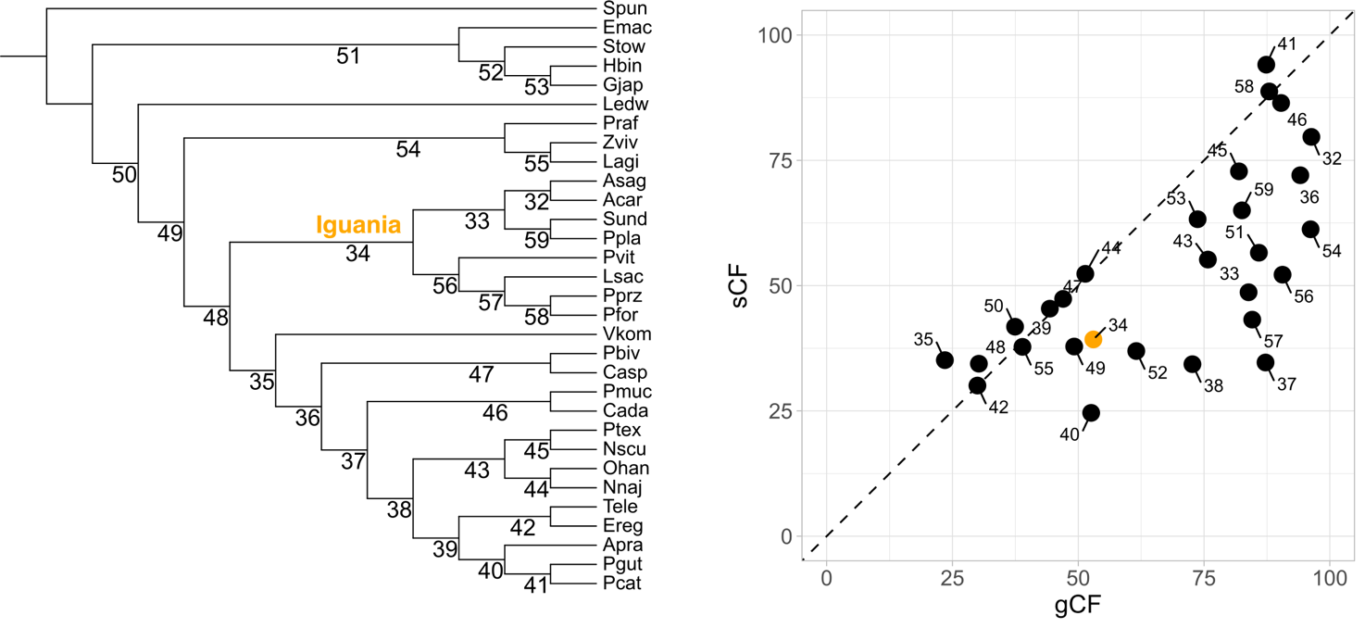

Figure S2. Relationship between genes (gCF) and sites (sCF) concordance factors, calculated on 681 orthologues used as input for the species tree. The node leading to Iguania (34) is highlighted in yellow.

Supplementary references

Geneva, A.J., Park, S., Bock, D., de Mello, P., Sarigol, F., Tollis, M., Donihue, C., Reynolds, R.G., Feiner, N., Rasys, A.M., Lauderdale, J.D., Minchey, S.G., Alcala, A.J., Infante, C., Kolbe, J.J., Schluter, D., Menke, D.B., Losos, J.B., 2021. Anolis sagrei genome assembly and annotation. Harvard Dataverse, V2, https://doi.org/10.7910/DVN/TTKBFU

Newman, M.E., 2010. Networks: an introduction.

Kanamori, S., M. Díaz L., Cádiz A., Yamaguchi K., Shigenobu S., Kawata M. 2022. Anolis sagrei gene annotation. figshare. Dataset. https://doi.org/10.6084/m9.figshare.19613922.v2

Wallnoefer, O., Formaggioni, A., Plazzi, F. and Passamonti, M., 2025. Convergent evolution in nuclear and mitochondrial OXPHOS subunits underlies the phylogenetic discordance in deep lineages of Squamata. Molecular Phylogenetics and Evolution, 208, pp.1-11.
Westfall A.K., Telemeco R.S., Grizante M.B., Waits D.S., Clark A.D., Simpson D.Y., Klabacka R.L., Sullivan A.P., Perry G.H., Sears M.W., Cox C.L., Cox R.M., Gifford M.E., John-Alder H.B., Langkilde T., Angilletta Jr. M.J., Leaché A.D., Tollis M., Kusumi K., Schwartz T.S. 2021. Supporting data for "A chromosome-level genome assembly for the Eastern fence lizard (Sceloporus undulatus), a reptile model for physiological and evolutionary ecology" GigaScience Database. https://doi.org/10.5524/100913

