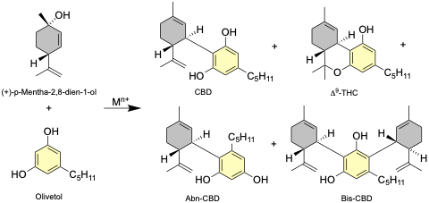
Scheme 1. Synthetic strategy for CBD via aryl coupling of olivetol and (+)-p-mentha-2,8-dien-1-ol.

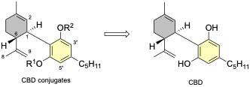
Scheme 2. CBD conjugates from CBD.

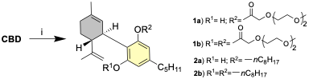

Scheme 3. Synthesis CBD conjugates. For 1a,b, i) 2-[2-(2-methoxyethoxy)ethoxy]acetic acid (1.1 or 2.2 eq.), DCC, DMAP, CH₂Cl₂, 12 h, rt. For 2a,b, i) CBD, 1-bromooctane (1.5 or 3.0 eq.), K₂CO₃, acetone, 12 h, rt.

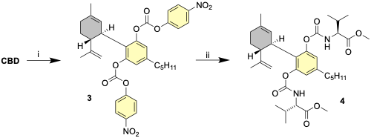

Scheme 4. Synthesis of compound 4. i) 4-Nitrophenyl chloroformate (4 eq.), Et₃N, CH₂Cl₂, 1 h, rt; ii) L-valine methyl ester (4 eq.), DMAP, CH₂Cl₂, 12 h, reflux.

