- Data was collected to estimate emissions in the case study.

The first data sheet in Table A1 presents the data for the entire lifecycle, from cradle to grave. It includes the raw materials for each step, production steps for the LVL and SS, the individual energy consumption, the packaging involved, the transportation (in kilometers), the assumed uselife of SS, EoL scenarios, and the outputs. The carbon stored in the beech wood, which is 91% of LVL, during the year of cutting down the tree, is calculated by the formula in Appendix C and stored further for the next 1 or 2 lives based on the selected EoL scenario. Then, according to the equation shown in Table A2. Additionally, Figure A1 shows a tentative simulation based image of developed seat shell from the LVL material. The simulation was performed by design experts and stay out of context for this study.

Table A1: (a) Raw-materials considered in the LCA study for 1 kg of LVL production scenario; (b) Production process 1, considered in the LCA study for 1 kg of LVL production scenario; (c) Production process 2, considered in the LCA study for 1 kg of LVL production scenario; (d) Production process 3, considered in the LCA study for 1 kg of LVL production scenario; (e) Transportation considered in the LCA study for 1 kg of LVL production scenario; (f) Production phase data considered in the LCA automotive seat shell scenario study; (g) Use, Assumption 20 years (200,000 km) of life span for 1080 kg vehicle with 4.7 kg SS, [Wil09]; and (h) EoL Scenarios and energy recovered from incineration.
Category | Input (material and energy) | Supporting Processes (operations and logistics) | Output | Amount | Units | Transferred to | Type
(a) Stage:Raw Material Input | Inorganic nitrogen fertilizer, as N/ Cutoff, S- CN |  |  | 1.28E-03 | kg | Forestry Operations
(a) Stage:Raw Material Input | Inorganic phosphorus fertilizer, as P2O5/ Cutoff, S- TR |  |  | 3.65E-04 | kg | Forestry Operations
(a) Stage:Raw Material Input | Inorganic potassium fertilizer, as K2O/ Cutoff, S- LK |  |  | 1.82E-07 | kg | Forestry Operations
(a) Stage:Raw Material Input | Seeds and Lubricants |  |  | 1.82E-03 | kg | Forestry Operations
(a) Stage:Raw Material Input | Poly-Urethane Resin |  |  | 0.165 | kg | LVL Manufacturing at plant
(a) Stage:Raw Material Input | De-Carbonized Water |  |  | 0.96 | kg | Dry Veneer Production
(a) Stage:Raw Material Input | De-Carbonized Water |  |  | 0.17 | kg | LVL Manufacturing at plant
(b) STAGE: PRODUCTION PROCESS- Forestry Operations | Electricity |  |  | 9.12E-04 | kWh |  | high voltage, production mix/ Cutoff, S- DE
(b) STAGE: PRODUCTION PROCESS- Forestry Operations | Diesel |  |  | 6.20E-03 | liter
(b) STAGE: PRODUCTION PROCESS- Forestry Operations |  |  | Log Veneer (Debarked Block) | 1.9 | kg | Veneer Production
(b) STAGE: PRODUCTION PROCESS- Forestry Operations |  |  | Waste wood bark (Co-product) | 0.06 | kg | Veneer Production
(b) STAGE: PRODUCTION PROCESS- Forestry Operations |  |  | Waste wood chips (Co-product) | 0.01 | kg | Veneer Production
(c) STAGE: PRODUCTION PROCESS- Dry Veneer Production | Electricity |  |  | 0.14 | kWh |  | high voltage, production mix/ Cutoff, S- DE
(c) STAGE: PRODUCTION PROCESS- Dry Veneer Production | Diesel |  |  | 7.30E-04 | liter
(c) STAGE: PRODUCTION PROCESS- Dry Veneer Production | Natural Gas LPG |  |  | 7.66E-03 | m3
(c) STAGE: PRODUCTION PROCESS- Dry Veneer Production |  |  |  | 2.37E-03 | liter
(c) STAGE: PRODUCTION PROCESS- Dry Veneer Production |  |  | Dry Veneer Sheets | 1.1 | kg | LVL Production
(c) STAGE: PRODUCTION PROCESS- Dry Veneer Production |  |  | Waste Saw Dust (Co-product) | 0.0004 | kg | LVL Production
(d) STAGE: PRODUCTION PROCESS- LVL Production at plant | Electricity |  |  | 0.11 | kWh |  | high voltage, production mix/ Cutoff, S- DE
(d) STAGE: PRODUCTION PROCESS- LVL Production at plant | Diesel |  |  | 7.30E-04 | liter
(d) STAGE: PRODUCTION PROCESS- LVL Production at plant | Natural Gas |  |  | 6.38E-03 | m3
(d) STAGE: PRODUCTION PROCESS- LVL Production at plant | LPG |  |  | 9.12E-04 | liter
(d) STAGE: PRODUCTION PROCESS- LVL Production at plant |  |  | 1 m³3DLVL | 1 | kg | Component Production
(d) STAGE: PRODUCTION PROCESS- LVL Production at plant |  |  | Waste Trim and Saw Dust (Co-product) | 0.045 | kg
(e) STAGE: Transport |  | PU Resin-LVL Manufacturing at the plant |  | 80 | km |  | Transport, freight,  lorry 16-32 metric ton, EURO5 — Cutoff, S
(e) STAGE: Transport |  | Seeds and Lubricant-Forestry operations |  | 85 | km |  | Transport, freight,  lorry 16-32 metric ton, EURO5 — Cutoff, S
(e) STAGE: Transport |  | Veneer-Production plant |  | 155 | km |  | Transport, freight,  lorry 16-32 metric ton, EURO5 — Cutoff, S
(f) STAGE: Production of the Seat shell | LVL (from Sub-system 1) |  |  | 4.94 | kg
(f) STAGE: Production of the Seat shell | Energy |  |  | 0.4 | kWh |  | Deutschland grid (internal)
(f) STAGE: Production of the Seat shell |  | Transport |  | 10 | km |  | Transport, freight,  lorry 16-32 metric ton, EURO5 — Cutoff, S
(f) STAGE: Production of the Seat shell |  |  | Seat shell | 4.7 | kg | Final Seat
(f) STAGE: Production of the Seat shell |  |  | Waste LVL with resin | 0.24 | kg | Final Seat
(g) STAGE: Use |  | Fuel Consumption |  | 5.87 | kg/100km |  | [Wil09]
(g) STAGE: Use |  | Fuel Consumption increase (per year) |  | 2 | % |  | [Wil09]
(g) STAGE: Use |  | Fuel Consumption by Component |  | 30.65 | kg/life span |  | [Wil09]
(h) STAGE: EoL | Burning wood (3.95 kg) | Incineration | Energy (28.61 kWh) | 7.18-1.05* | kgCO₂ |  | * Negative value represents energy recovered through incineration
(h) STAGE: EoL | Burning PU resin (0.75 kg) | Incineration | Energy (7.7 kWh) | 1.65-0.29* | kgCO₂ |  | * Negative value represents energy recovered through incineration
(h) STAGE: EoL |  | Landfill | Combustion and disposal | 9% C emitted | Per 100 years
(h) STAGE: EoL |  | Recycle (Downcycle- Open loop) | CLT (Construction industry) | 0.26 | kgCO₂/kg
(h) STAGE: EoL |  | Recycle (Upcycle Closed-loop) | Other automotive components | 4.09 | kgCO₂/kg component

Table A2: Stored carbon, considered in the LCA study for 1 kg of LVL production scenario.
STAGE: STORED CARBON
Carbon storage | Amount per kg LVL | Unit | Time of Capture
Bio-generic Carbon Stored | -1.82 | kgCO₂e | based on EoL choice

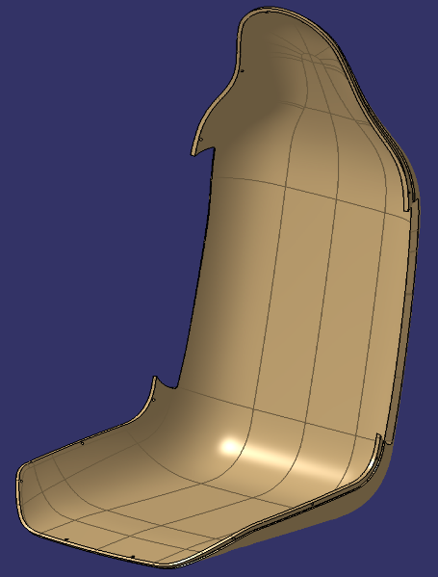
Figure A1: Simulation image of Seat shell using LVL material

Supplementary Sheet: B
- Literature Review
This literature review examines sustainable material development in the automotive industry, with a particular focus on CO2 footprint assessment, material lifespan extension, and end-of-life (EoL) strategies. Through a literature (narrative) review, relevant studies were selected, screened, and analyzed to explore the intersection of life cycle assessment (LCA) methodologies, renewable materials, and automotive sustainability efforts. A clear gap was identified in the integration of early-stage material selection and multi-lifecycle approaches, underscoring the need for more comprehensive decision-support tools.
The methodology was employed to identify, screen, and analyze relevant research studies and reports. The review process consisted of four main stages: defining research scope and objectives, conducting a structured database search, applying inclusion and exclusion criteria, and synthesizing and categorizing the selected literature. The article selection procedure is broadly described in Fig. 1 in the main text. The authors aimed to focus on peer-reviewed publications from 2015 onwards that discussed as per the string ‘("Decision-Making Tools" OR "Material Selection Tools") AND ("Sustainability Assessment" OR "Environmental Assessment") AND ("Automotive Industry" OR "Vehicle Development")’ resulting in 56 filtered papers. The following strings were elaborated to ensure a comprehensive and focused exploration of the relevant literature. The exact search strings used for the study are described in Table B1.
Table B1: Search strings used for the literature review.
Search String 1 | ("Environmental assessment" OR "CO2 Emissions" OR " GHG emission") AND ("Life Cycle Assessment" OR "LCA" OR "Early-stage LCA" ) AND ( "Multi-life" OR "Cradle to Grave" OR "Cradle to Cradle)
Search String 2 | ("End-of-Life" OR "EoL") AND ("Closed-loop" OR “Open-loop” OR "Recycling Strategies") AND ("Material Reuse" OR "Second-life")
Search String 3 | ("Bio-Based Materials" OR “Biocomposites" ) AND ("Carbon Footprint" OR "GHG emissions") AND (“Sustainable Product” OR “Biodegradable”)
Search String 4 | ("Decision-Making Tools" OR "Material Selection Tools") AND ("Sustainability Assessment" OR "Environmental Evaluation") AND ("Automotive Industry" OR "Vehicle Development")

These search strings were designed using Boolean operators (AND, OR) to ensure a comprehensive yet focused search. The 'AND' operator was used to combine essential topics (e.g., 'Life Cycle Assessment' AND 'Carbon Footprint'). In contrast, the 'OR' operator broadened the search to include alternative terminology (e.g., 'End-of-Life' OR 'Recycling Strategies'). This approach ensured that the search captured relevant studies related to life cycle assessment (LCA), sustainability, and environmental impact assessments in the context of automotive materials and their end-of-life considerations.
Literature Search Planning
The planning process involved defining the research scope, developing search strategies, outlining the review protocol, confirming inclusion and exclusion criteria, specifying the data collection plan, ensuring quality assurance, addressing ethical concerns, and estimating the timeline and resources. The literature search was conducted in the following databases: Scopus, Web of Science, ScienceDirect, and Google Scholar. These databases were chosen for their comprehensive coverage of peer-reviewed articles, industry reports, and environmental impact studies. The strings from Table B1 helped to refine results and ensure the inclusion of papers specifically relevant to environmental assessment in the automotive sector.
Studies included in the review were based on three main criteria:
- Published in peer-reviewed journals in English or reputable industry reports in English from 2015 onwards.
- Focused on environmental assessment, LCA methodologies, evaluation tools, or biobased materials in the automotive sector.
- Provided theoretical frameworks, case studies, or empirical data for assessments that were directly applicable to material selection, recyclability, or carbon footprint reduction in automotive applications.
Whereas the exclusion criteria were as follows:
- Studies lacking methodological transparency or empirical validation.
- Articles that discussed general sustainability topics without specific relevance to environmental assessments.
- Articles that focus solely on policy implications without providing technical or empirical assessments.

B.1 Steps in the Literature Review
B.1.1 Literature Selection: The first step in the review involved a comprehensive literature search using databases relevant to the fields of Life Cycle Assessment (LCA), automotive, and bio-based materials, adhering to the key search strings defined during the planning of the literature search. The following databases were used due to their wide journal coverage and relevance to the study: Scopus (124 papers), Web of Science (69 papers), and ScienceDirect (371 papers). A total of 564 papers were initially identified based on their titles and abstracts, which contained one or more of the key search strings, such as "LCA," "automotive," "bio-based materials," and "GHG emissions."
Rejection of Duplicates and Outdated Documents: Upon initial review, duplicates were removed, and a temporal cut-off was applied to ensure the relevance of the papers. Documents published before 2015 were excluded, as they were deemed outdated for model development in the context of the rapidly evolving automotive and sustainability sectors. This step resulted in the rejection of more than half of the initial papers, leaving a more manageable subset for the next stages of selection.
B.1.2 Identification: In this step, abstracts of the remaining papers were read to assess their relevance to the study’s objectives. This process revealed that, despite using broad search keywords (LCA, GHG emissions, automotive), many papers were irrelevant to the study. Specifically, 348 papers were identified as not aligned with the scope, as they discussed industries outside the automotive sector. Some papers also focused on irrelevant contexts or were duplicates of papers already removed. The filtering process resulted in the retention of 112 papers for further analysis.
B.1.3 Intensive Screening: At this stage, a more in-depth evaluation of the papers was conducted to classify them based on their content and relevance to the study's core objectives. The 112 remaining papers were grouped into four categories:
- Method-based papers – those that focused on the development of methodologies or frameworks for LCA.
- Tool-based papers – those discussing the use of specific tools or software (e.g., GaBi, SimaPro) in LCA assessments.
- Review-based papers – comprehensive reviews on LCA applications across various industries.
- Case study-based papers – studies focused on real-world applications and case studies, primarily from industries like construction, with limited relevance to automotive LCA.
Through this process, it became clear that many of the tool- and case study-based papers were heavily focused on sectors outside the automotive industry. Thus, only papers addressing methodologies in non-automotive industries were included, with an emphasis on exploring open-loop possibilities that may be relevant for automotive Life Cycle Assessment (LCA). This screening process reduced the total number of papers to 78.
Further eliminations occurred based on repetitive content, studies focusing on outdated technologies, or papers that were deemed out of scope for the study’s goals. Ultimately, 56 papers remained for evaluation.
B.1.4 Evaluation: The final step in the selection process involved a thorough evaluation of the 56 selected papers, with each paper being read in full and analyzed to extract the most relevant information. The papers were evaluated based on the system boundary defined for the study (LCA in the automotive industry, with a focus on carbon emissions, renewable materials, and lifecycle stages). The evaluation categorized the papers as follows:
- 24 papers focused on greenhouse gas (GHG) emissions in automotive industry with focus to variety of topics, with three papers examining closed-loop models and case studies in non-automotive industries.
- 13 papers explicitly focused on LCA in the automotive industry, covering various system boundaries, from cradle-to-gate to full lifecycle assessments. Of these, only three included analyses of the use-phase and end-of-life stages.
- 9 papers dealt with the discussion of the environmental impact of bio-based materials, with only a few directly linked to automotive applications.
- 7 papers discussed intensive decision support systems used for LCA, such as GaBi and SimaPro, providing detailed material flow analysis.
- 3 papers examined the need for early-stage CO2 analysis, primarily conceptual models for factory-level CO2 assessments.
The papers were categorized, and the data extracted accordingly to build a comprehensive understanding of the existing body of literature related to LCA in automotive industries, with a focus on open-loop recycling and CO2 footprint assessment
B.2 Results
B.2.1 Publication Trends
Figure B1-(a) presents the annual trends in the publication of research articles in the studied area. Since the research focused on a new area, finding papers that combined all the keywords proved to be challenging. Therefore, trends were identified for three relevant research areas: LCA and the automotive industry (or other industries), LCA and bio-based products, and bio-based products and the automotive industry.
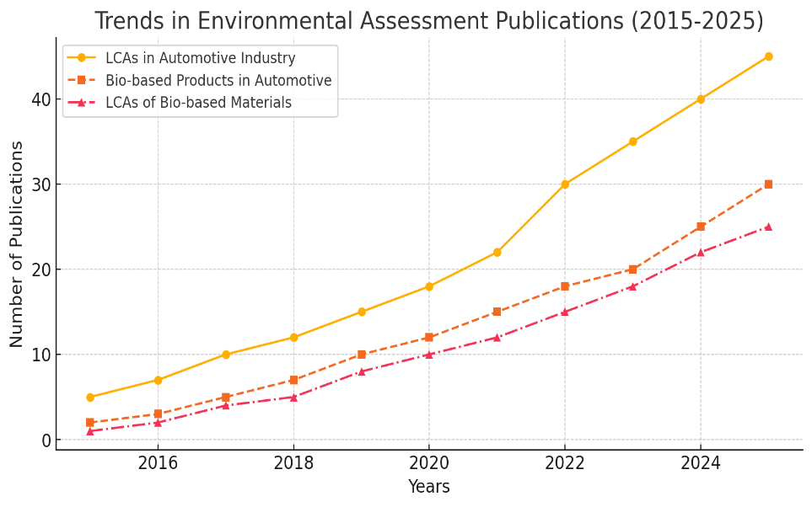
Figure B1-(a): The annual publication trends of research articles in the studied area.
Between 2015 and 2024, articles applying Life Cycle Assessment (LCA) across various industries exhibited an exponential upward trend. The number of publications annually also shows a consistent upward trend, representing the growing realization and acceptance of sustainability concepts among product-based industries [Liu24]. The literature on bio-based products and the automotive industry dates back many years. The oldest paper dates back to the 1940s; however, research progressed slowly until 2010, then accelerated in both the automotive and non-automotive industries due to sustainability requirements. Most papers discussed the transition from conventional materials to biocomposites, focusing on their mechanical properties, manufacturing technologies, and potential lightweightness [AkaO15]. Figure B1-(b) presents the most common biocomposites used in the automotive industry today. No literature was found in the third area, ‘LCA and bio-based products,’ for the automotive industry; however, around eight papers were found using wood as a structural material in the construction industry. Most of them revolved around the implementation of case studies. The combination of the above keywords barely mentioned any paper, hence, depicted a gap regarding the usability of bio-based material in the automotive industry, considering their environmental potential and not focusing only on structural aspects.
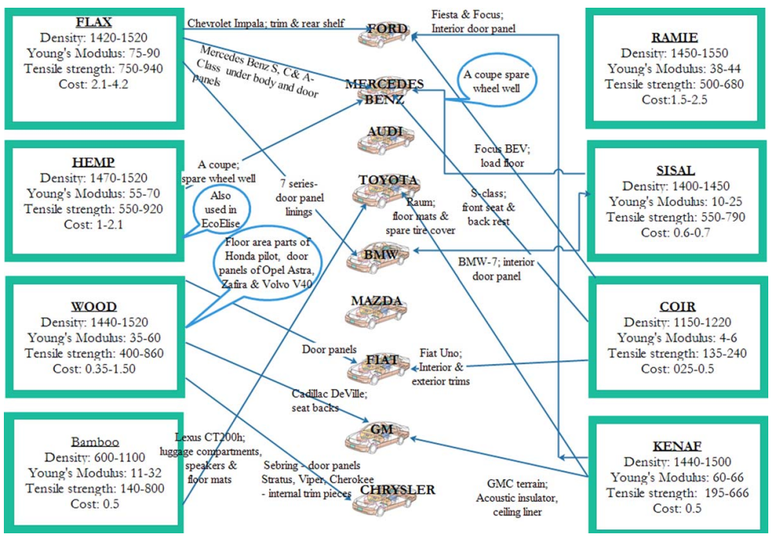
Figure B1-(b): Biocomposites used in the automotive industry today [AkaO15].

B.2.2 Journal Trends
A drastic increase in LCA and bio-based publications is observed each year, as shown in Table B2, which lists the most influential journals between 2015 and 2024. The Journals with consistently increasing publication counts in these fields are the Journal of Cleaner Production (JCP)-16.5%, International Journal of Life Cycle Assessment (IJLCA)-6.7%, Science of the Total Environment (JSTE)-6.3%, Resources, Conservation, and Recycling (RCR)-4.55%, Sustainability (Switzerland)-7.44%, Environmental Science Technology (EST)-2.07%, and Journal of Industrial Ecology-2.05%. The collected papers were categorized according to the three areas discussed above. The collection represented a trend concerning the subject areas where environmental science made the highest contribution (28%), followed by engineering (20%), business and management (7%), energy (16%), and the remainder from multidisciplinary fields.
Table B2: List of Journals Published in the Field of Research between 2015 and 2024.
Journal | Contribution (in %) | Publisher
Journal of Cleaner Production | 16.5 | Elsevier
International Journal of Life Cycle Assessment | 6.7 | Springer
Science of the Total Environment | 6.3 | Elsevier
Resources, Conservation, and Recycling | 4.55 | Elsevier
Sustainability | 7.5 | MDPI
Journal of Industrial Ecology | 2.05 | Wiley
Environmental Science Technology | 2.07 | ACS Publication

B.3 Gaps in Current Research
The analyzed literature primarily consists of life cycle assessment (LCA) studies, case studies, and review papers, with a strong focus on cradle-to-gate assessment methodologies. From 2016 to 2020, there was an increasing focus on the intersection of LCA with industrial processes and the circular economy, which continued to grow exponentially after 2020. Many concentrated on enhancing assessment methods from cradle to gate during this period. A few studies examined cradle-to-grave assessments, but none suggested multi-lifecycle approaches, especially in the automotive industry. Additionally, while bio-based materials have been tested in the past, their use as structural materials has often required improvement through the use of chemicals, which compromises their environmental performance. Furthermore, there was a lack of studies developing methods or tools to support early-stage assessments and multi-lifecycle potential analysis. These challenges were primarily anticipated and validated by industrial product developers through interviews, leading to the recognition of the need for a decision support system that can analyze materials early and assist in selection and improvement while considering multiple lifecycles during the assessment. The gaps identified during the review are discussed in detail in the main text in Section 2, followed by an examination of the interrelations among these gaps and the conclusions drawn, which led to the development of the DSS.
References:
[Sha22] Shadman, S., Khalid, P. A., Hanafiah, M., Koyande, A. K. & others. (2022). The carbon sequestration potential of urban public parks of densely populated cities to improve environmental sustainability. Sustainable Energy Technologies and Assessments , 52(5864): 102064.
[AkaO15] Akampumuza, A., Wambua, P. , Ahmed, A., & others. (2015). A review of the applications of biocomposites in the automotive industry. Polymer Composites,10.1002/pc.23847.
[CK19] Kim, H. C., Wallington, J. L., & Sullivan, G. A. (2019). Commentary on “Correction to: On the calculation of fuel savings through lightweight design in automotive life cycle assessments” by Koffler and Rohde-Brandeburger-2018. International Journal of Life Cycle Assessment, 24(12), 2201–2203.

[Liu24] Liu, M., Zhu, G., Tian, Y. (2024). The historical evolution and research trends of life cycle assessment. Green Carbon (2), 425-437.
[Wil09] Wilson, J. B. (2009). Resins: A life-cycle inventory of manufacturing resins used in the wood composites industry. Oregon State University, Corvallis.
[QZL⁺17] Qiao, Qinyu & Zhao, Fuquan & Liu, Zongwei & Jiang, Shuhua & Hao, Han. (2017). Comparative Study on Life Cycle CO2 Emissions from the Production of Electric and Conventional Vehicles in China. Energy Procedia, 105, 3584-3595.
[EUC98] EUCAR. (1998). Eucar-automotive LCA guidelines- phase 2 (982185). Lynne Ridge, Rover Group Ltd. (Coordinator).
[WBKB20] Wojnowska-Baryła, I., Kulikowska, D., & Bernat, K. (2020). Effect of Bio-Based Products on Waste Management. Sustainability, 12(5), 2088.

Definitions
- When a high-quality recycling process is used, the quality of metals is barely diminished. However, it may be noted that some dissipation during the life cycle and EoL management cannot be avoided. Hence, it has been mentioned that most of the metal recovered is of excellent quality.

- In a typical automotive component, the monomeric materials are mixed at the polymerization stage to reach a specific performance requirement. On the other hand, a single component may comprise various parts assembled. Such a combination of polymers is formidable to separate due to their chemical bonding or strong gluing structure. Hence, shredding the combination comes as the solution.

- Biopolymers (bioplastics) can be produced from renewable materials, including sugar, corn, soy, hemp, and methane from waste [WBKB20].

- A Functional Unit (FU) is a quantified description of the function of a product that serves as the reference basis for all calculations regarding impact assessment.

- The year when the overall CO₂ emitted and sequestrated balances out and drops to zero.

- When trees are grown for a specific purpose, the sequestered carbon associated with the wood can be transferred to the product.

- FRV estimates the total energy needed to move a certain weight over a defined distance in a distinct way and expresses this energy in liters of gasoline or diesel [CK19].

- Environmental burden points here refer to inputs (raw materials, energy sources, transport, etc.) with a high carbon footprint that is central to increasing the total footprint.

