Supplement
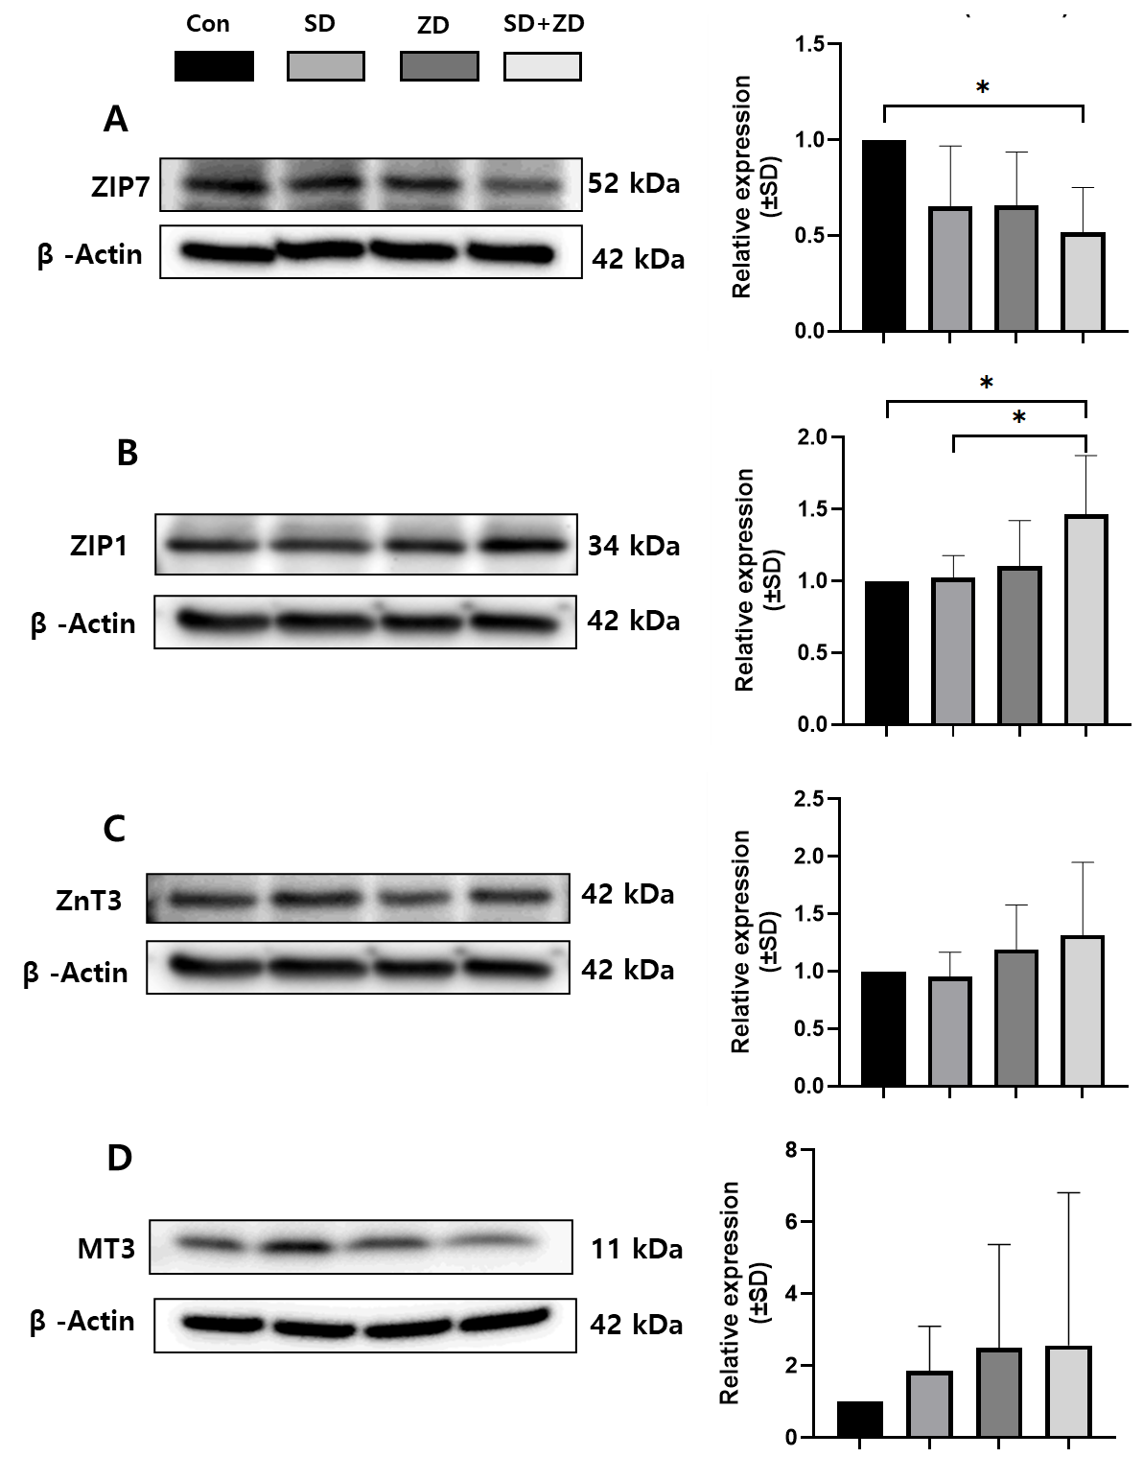
Supplement 1. Zinc transporter proteins and MT3 in brain parenchyma (BP). Expression of ZIP1, ZIP7, ZnT3, and MT3 in brain parenchyma (BP) fractions. ZIP7 was significantly decreased in SD+ZD mice compared to control (*p <0.05).

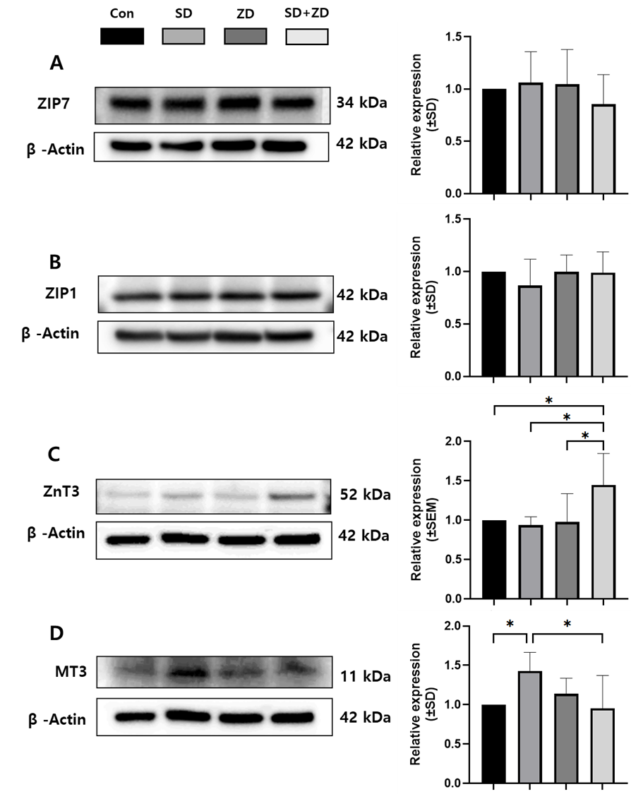
Supplement 2. Zinc transporter proteins in brain capillary endothelium (BCE). Expression of ZIP1, ZIP7, ZnT3, and MT3 in brain capillary endothelial (BCE) fractions. MT3 was significantly increased in the SD group and ZnT3 in the SD+ZD group (*p <0.05).

