A comparative study on the accuracy of different machine learning methods for lung cancer prediction

Jiayi Zhaoª, Yao Tongª, Yunchao Huang^{b}, Chao Zhang^{c}, Hongjiang Zhang^{d}, Zhenghong Yang^{b}, Fang Li^{f}, Yang Luo^{e}, Dinglin Zhangª.

a Department of Chemistry, College of Basic Medicine, Army Medical University (Third Military Medical University), Chongqing, 400038, China
b Department of Thoracic Surgery I, Yunnan Cancer Hospital, the Third Affiliated Hospital of Kunming Medical University, Peking University Cancer Hospital Yunnan, Kunming, Yunnan, 650118, China.
c Department of Oncology, Qujing Central Hospital of Yunnan Province / Kunming Medical University Affiliated Qujing Hospital, Qujing, Yunnan, 655000, China.
d Anning First People’s Hospital Affiliated to Kunming University of Science and Technology, Anning, Yunnan, 650300, China.
e Department of Laboratory Medicine, Chongqing Center for Clinical Laboratory, Chongqing Academy of Medical Sciences, Chongqing General Hospital, School of Medicine, Chongqing University, Chongqing, 401147, China
f Department of Health Statistics, College of Preventive Medicine, Army Medical University, Chongqing 400038, China

*Corresponding authors:
Dinglin Zhang, PhD, Prof.
Department of Chemistry
College of Basic Medicine
Army Medical University, (Third Military Medical University), Chongqing 400038, China
E-mail: zh18108@163.com, zh18108@tmmu.edu.cn
ORCID: 0000-0003-4400-919X

Yang Luo, PhD, Prof.
Department of Laboratory Medicine, Chongqing Center for Clinical Laboratory
Chongqing Academy of Medical Sciences, Chongqing General Hospital, School of Medicine
Chongqing University, Chongqing, 401147, China
E-mail: luoy@cqu.edu.cn
ORCID: 0000-0002-0166-9027

Tables
- Supplementary Table 1, Characteristics of non-LC and LC patients in internal validation set.
- Supplementary Table 2, Characteristics of non-LC and LC patients in test set.
- Supplementary Table 3, Ten-fold cross-validation of ten machine learning models.
- Supplementary Table 4, Ten-fold cross-validation of ten machine learning models for each fold result.
- Supplementary Table 5, DeLong test results of 10 ML models.
- Supplementary Table 6, The overall performance of 31 model stacking ensemble models.
- Supplementary Table 7, Performance ranking of 31 ML models.
- Supplementary Table 8, Top 5 stacking models.
- Supplementary Table 9, DeLong test results of 31 ML models.
- Supplementary Table 10, The value of single and combined detection of five serum tumor markers in the early diagnosis of LC.
- Supplementary Table 11, Performance ranking of single and combined detection of 5 serum tumor markers.
- Supplementary Table 12, Top 5 combinations of serum tumor markers.
Figures
- Supplementary Figure 1, Variable selection using Boruta, Least Absolute Shrinkage and Selection Operator (LASSO), Recursive Feature Elimination Based On Random Forest (RF-RFE).
- Supplementary Figure 2, Correlation Heatmap
- Supplementary Figure 3, Comparison of the performance of nine Class-balancing methods
- Supplementary Figure 4, Performance of test set
- Supplementary Figure 5, Scatter plot of 10 after.
- Supplementary Figure 6, Clinical prediction tool.

Supplementary Table 1, Characteristics of non-LC and LC patients in internal validation set.
 |  | Overall | non-LC | LC | P-Value | Statistic
n |  | 780 | 92 | 688
Gender, n (%) | Female | 505 (64.7) | 46 (50.0) | 459 (66.7) | 0.002 | 9.21
Gender, n (%) | Male | 275 (35.3) | 46 (50.0) | 229 (33.3)
Age, M [Q1,Q3] |  | 56.0 [48.0,63.0] | 55.0 [49.0,63.0] | 56.0 [48.0,63.0] | 0.946 | 0.07
Smoking history, n (%) | No | 647 (82.9) | 65 (70.7) | 582 (84.6) | 0.001 | 10.19
Smoking history, n (%) | Yes | 133 (17.1) | 27 (29.3) | 106 (15.4)
Family history, n (%) | No | 759 (97.3) | 88 (95.7) | 671 (97.5) | 0.297 | 0.56
Family history, n (%) | Yes | 21 (2.7) | 4 (4.3) | 17 (2.5)
work, n (%) | No | 779 (99.9) | 92 (100.0) | 687 (99.9) | 1.000 | inf
work, n (%) | Yes | 1 (0.1) | 0 (0.0) | 1 (0.1)
COPD, n (%) | No | 772 (99.0) | 91 (98.9) | 681 (99.0) | 1.000 | 0.94
COPD, n (%) | Yes | 8 (1.0) | 1 (1.1) | 7 (1.0)
WBC, M [Q1,Q3] |  | 5.9 [4.8,7.3] | 5.6 [4.8,7.2] | 6.0 [4.8,7.3] | 0.206 | 1.26
RBC, M [Q1,Q3] |  | 4.8 [4.4,5.2] | 4.7 [4.5,5.1] | 4.8 [4.4,5.2] | 0.930 | 0.09
Hb, M [Q1,Q3] |  | 143.0 [132.0,154.0] | 147.0 [134.8,160.2] | 143.0 [132.0,154.0] | 0.033 | 2.13
PLT, M [Q1,Q3] |  | 223.0 [183.0,266.2] | 213.5 [183.5,249.2] | 225.0 [183.0,268.0] | 0.190 | 1.31
ALP, M [Q1,Q3] |  | 74.0 [61.0,94.0] | 71.0 [60.8,88.2] | 74.0 [61.0,95.0] | 0.343 | 0.95
LDH, M [Q1,Q3] |  | 170.0 [149.0,193.2] | 168.0 [147.8,190.2] | 170.0 [150.0,194.0] | 0.365 | 0.91
AST/ALT, M [Q1,Q3] |  | 1.1 [0.9,1.4] | 1.0 [0.8,1.3] | 1.1 [0.9,1.4] | 0.037 | 2.09
GGT, M [Q1,Q3] |  | 24.0 [16.0,41.0] | 20.0 [15.0,37.2] | 24.0 [16.0,42.0] | 0.174 | 1.36
Dbil, M [Q1,Q3] |  | 3.6 [2.4,5.2] | 3.2 [2.1,4.2] | 3.7 [2.5,5.3] | 0.008 | 2.67
Albumin, M [Q1,Q3] |  | 44.5 [40.1,47.6] | 43.0 [39.0,47.0] | 44.9 [40.4,47.7] | 0.212 | 1.25
TB, M [Q1,Q3] |  | 11.4 [8.2,15.3] | 10.8 [8.2,14.9] | 11.6 [8.2,15.3] | 0.633 | 0.48
PT, M [Q1,Q3] |  | 11.9 [11.0,12.6] | 11.4 [10.6,12.3] | 12.0 [11.1,12.6] | 0.005 | 2.79
Creatinine, M [Q1,Q3] |  | 67.0 [58.0,78.0] | 69.5 [60.9,77.3] | 67.0 [58.0,78.0] | 0.256 | 1.14
BUN, M [Q1,Q3] |  | 5.9 [4.3,11.2] | 11.3 [5.5,15.4] | 5.6 [4.3,9.5] | <0.001 | 4.84
D-dimer, M [Q1,Q3] |  | 0.3 [0.2,0.5] | 0.2 [0.1,0.4] | 0.3 [0.2,0.5] | 0.042 | 2.03
CEA, M [Q1,Q3] |  | 2.0 [1.3,2.9] | 2.0 [1.4,2.7] | 2.0 [1.3,2.9] | 0.988 | 0.02
NSE, M [Q1,Q3] |  | 12.2 [10.4,14.1] | 12.0 [10.1,13.9] | 12.2 [10.4,14.2] | 0.414 | 0.82
CYFRA21-1, M [Q1,Q3] |  | 2.2 [1.6,3.0] | 2.0 [1.7,2.6] | 2.2 [1.6,3.0] | 0.244 | 1.16
SCCAg, M [Q1,Q3] |  | 0.7 [0.5,1.0] | 0.7 [0.5,0.9] | 0.7 [0.5,1.0] | 0.271 | 1.1
CA-125, M [Q1,Q3] |  | 11.9 [9.0,16.4] | 11.7 [9.7,15.1] | 12.0 [9.0,16.6] | 0.871 | 0.16

Supplementary Table 2, Characteristics of non-LC and LC patients in test set.

 |  | Overall | non-LC | LC | P-Value | Statistic
n |  | 781 | 91 | 690
Gender, n (%) | Female | 481 (61.6) | 45 (49.5) | 436 (63.2) | 0.016 | 5.85
Gender, n (%) | Male | 300 (38.4) | 46 (50.5) | 254 (36.8)
Age, M [Q1,Q3] |  | 57.0 [49.0,63.0] | 56.0 [49.0,61.0] | 57.0 [49.0,64.0] | 0.076 | 1.77
Smoking history, n (%) | No | 620 (79.4) | 67 (73.6) | 553 (80.1) | 0.191 | 1.71
Smoking history, n (%) | Yes | 161 (20.6) | 24 (26.4) | 137 (19.9)
Family history, n (%) | No | 756 (96.8) | 82 (90.1) | 674 (97.7) | 0.001 | 0.22
Family history, n (%) | Yes | 25 (3.2) | 9 (9.9) | 16 (2.3)
work, n (%) | No | 780 (99.9) | 91 (100.0) | 689 (99.9) | 1.000 | inf
work, n (%) | Yes | 1 (0.1) | 0 (0.0) | 1 (0.1)
COPD, n (%) | No | 771 (98.7) | 87 (95.6) | 684 (99.1) | 0.021 | 0.19
COPD, n (%) | Yes | 10 (1.3) | 4 (4.4) | 6 (0.9)
WBC, M [Q1,Q3] |  | 6.0 [5.0,7.4] | 6.0 [4.7,6.9] | 6.0 [5.0,7.4] | 0.252 | 1.14
RBC, M [Q1,Q3] |  | 4.8 [4.5,5.2] | 4.7 [4.5,5.1] | 4.8 [4.5,5.2] | 0.350 | 0.93
Hb, M [Q1,Q3] |  | 145.0 [135.0,155.0] | 146.0 [137.5,157.5] | 145.0 [135.0,155.0] | 0.281 | 1.08
PLT, M [Q1,Q3] |  | 226.0 [187.0,268.0] | 214.0 [186.0,254.5] | 228.0 [187.0,269.0] | 0.171 | 1.37
ALP, M [Q1,Q3] |  | 77.0 [61.0,92.0] | 74.0 [61.0,87.0] | 77.0 [61.2,94.0] | 0.238 | 1.18
LDH, M [Q1,Q3] |  | 172.0 [153.0,194.0] | 176.0 [154.5,194.0] | 172.0 [152.5,193.0] | 0.579 | 0.56
AST/ALT, M [Q1,Q3] |  | 1.1 [0.9,1.4] | 1.0 [0.8,1.2] | 1.1 [0.9,1.4] | 0.060 | 1.88
GGT, M [Q1,Q3] |  | 24.0 [16.0,41.0] | 26.0 [18.0,52.5] | 23.5 [16.0,40.4] | 0.047 | 1.99
Dbil, M [Q1,Q3] |  | 3.7 [2.6,5.3] | 3.0 [2.1,4.5] | 3.8 [2.7,5.3] | <0.001 | 4.05
Albumin, M [Q1,Q3] |  | 44.5 [41.0,47.5] | 43.4 [40.5,47.0] | 44.8 [41.0,47.6] | 0.374 | 0.89
TB, M [Q1,Q3] |  | 11.1 [8.3,15.5] | 10.3 [7.9,14.6] | 11.2 [8.3,15.6] | 0.247 | 1.16
PT, M [Q1,Q3] |  | 12.0 [11.1,12.6] | 11.5 [10.9,12.1] | 12.1 [11.2,12.7] | <0.001 | 3.73
Creatinine, M [Q1,Q3] |  | 68.0 [59.0,79.0] | 68.1 [61.5,81.0] | 68.0 [58.7,79.0] | 0.500 | 0.68
BUN, M [Q1,Q3] |  | 5.8 [4.2,9.7] | 7.0 [5.0,13.6] | 5.6 [4.2,9.0] | <0.001 | 3.47
D-dimer, M [Q1,Q3] |  | 0.3 [0.2,0.5] | 0.2 [0.1,0.3] | 0.3 [0.2,0.5] | <0.001 | 3.61
CEA, M [Q1,Q3] |  | 2.0 [1.3,3.0] | 2.0 [1.3,3.1] | 2.0 [1.3,3.0] | 0.862 | 0.17
NSE, M [Q1,Q3] |  | 12.3 [10.4,14.4] | 12.3 [10.6,14.5] | 12.2 [10.3,14.4] | 0.435 | 0.78
CYFRA21-1, M [Q1,Q3] |  | 2.2 [1.5,3.0] | 2.1 [1.6,2.9] | 2.2 [1.5,3.1] | 0.774 | 0.29
SCCAg, M [Q1,Q3] |  | 0.7 [0.5,0.9] | 0.7 [0.5,0.9] | 0.7 [0.5,1.0] | 0.710 | 0.37
CA-125, M [Q1,Q3] |  | 11.9 [8.5,16.9] | 11.5 [8.6,18.3] | 11.9 [8.5,16.8] | 0.671 | 0.42

Supplementary Table 3, Ten-fold cross-validation of ten machine learning models.

Model | Accuracy | Precision | Recall | F1 | AUC | Brier | MCC
LR | 0.6466±0.0214 | 0.9237 ± 0.0185 | 0.6423 ± 0.016 | 0.7576 ± 0.0152 | 0.6578 ± 0.0442 | 0.3534 ± 0.0214 | 0.2231 ± 0.0622
GNB | 0.4±0.0285 | 0.9179 ± 0.0191 | 0.3323 ± 0.0357 | 0.4868 ± 0.039 | 0.5742 ± 0.0259 | 0.6 ± 0.0285 | 0.1113 ± 0.0387
BNB | 0.6722 ± 0.0197 | 0.9212 ± 0.015 | 0.6771 ± 0.0209 | 0.7803 ± 0.015 | 0.6599 ± 0.0359 | 0.3278 ± 0.0197 | 0.23 ± 0.0507
SVM | 0.6842 ± 0.0269 | 0.9122 ± 0.0217 | 0.7004 ± 0.0204 | 0.7923 ± 0.0184 | 0.6427 ± 0.0574 | 0.3158 ± 0.0269 | 0.2086 ± 0.0831
RF | 0.7372 ± 0.0387 | 0.9012 ± 0.023 | 0.7799 ± 0.0319 | 0.836 ± 0.0257 | 0.6275 ± 0.0686 | 0.2628 ± 0.0387 | 0.2031 ± 0.1083
KNN | 0.5521 ± 0.025 | 0.8964 ± 0.0151 | 0.5419 ± 0.0267 | 0.6752 ± 0.0231 | 0.5785 ± 0.0317 | 0.4479 ± 0.025 | 0.1089 ± 0.0437
XGB | 0.7043 ± 0.034 | 0.9154 ± 0.0252 | 0.7233 ± 0.0271 | 0.8078 ± 0.0231 | 0.6555 ± 0.0677 | 0.2957 ± 0.034 | 0.2311 ± 0.0994
DT | 0.6585 ± 0.0272 | 0.9194 ± 0.0173 | 0.6612 ± 0.0295 | 0.7688 ± 0.0218 | 0.6519 ± 0.0416 | 0.3415 ± 0.0272 | 0.2171 ± 0.0582
AdaBoost | 0.7004 ± 0.026 | 0.9117 ± 0.0178 | 0.7218 ± 0.0231 | 0.8055 ± 0.0182 | 0.6455 ± 0.0492 | 0.2996 ± 0.026 | 0.2165 ± 0.073
LightGBM | 0.7479 ± 0.0239 | 0.8999 ± 0.0126 | 0.7953 ± 0.0219 | 0.8443 ± 0.0162 | 0.6257 ± 0.037 | 0.2521 ± 0.0239 | 0.2046 ± 0.0591

Supplementary Table 4, Ten-fold cross-validation of ten machine learning models for each fold result.

Model | Fold | Accuracy | Precision | Recall | F1 | AUC | Brier | MCC
LR | 1 | 0.6496 | 0.9412 | 0.6337 | 0.7574 | 0.7246 | 0.2161 | 0.2672
LR | 2 | 0.6667 | 0.9429 | 0.6535 | 0.7719 | 0.7483 | 0.2104 | 0.2828
LR | 3 | 0.6667 | 0.9493 | 0.6485 | 0.7706 | 0.7497 | 0.21 | 0.3002
LR | 4 | 0.688 | 0.9507 | 0.6716 | 0.7872 | 0.8069 | 0.1916 | 0.3274
LR | 5 | 0.6709 | 0.9306 | 0.6667 | 0.7768 | 0.7408 | 0.1976 | 0.2601
LR | 6 | 0.6453 | 0.9214 | 0.6418 | 0.7566 | 0.6911 | 0.2246 | 0.219
LR | 7 | 0.6154 | 0.8993 | 0.6219 | 0.7353 | 0.6231 | 0.2322 | 0.1401
LR | 8 | 0.6496 | 0.922 | 0.6468 | 0.7602 | 0.6777 | 0.2191 | 0.2229
LR | 9 | 0.6368 | 0.9265 | 0.6269 | 0.7478 | 0.7253 | 0.2107 | 0.2285
LR | 10 | 0.6496 | 0.922 | 0.6468 | 0.7602 | 0.757 | 0.2137 | 0.2229
GNB | 1 | 0.4145 | 0.9221 | 0.3515 | 0.509 | 0.6043 | 0.5266 | 0.1199
GNB | 2 | 0.4274 | 0.9146 | 0.3713 | 0.5282 | 0.6048 | 0.5223 | 0.1098
GNB | 3 | 0.4231 | 0.9241 | 0.3614 | 0.5196 | 0.6588 | 0.5315 | 0.1263
GNB | 4 | 0.453 | 0.9506 | 0.3831 | 0.5461 | 0.6671 | 0.494 | 0.1916
GNB | 5 | 0.3675 | 0.8955 | 0.2985 | 0.4478 | 0.6612 | 0.5619 | 0.0665
GNB | 6 | 0.4359 | 0.9481 | 0.3632 | 0.5252 | 0.6279 | 0.4982 | 0.1792
GNB | 7 | 0.4103 | 0.9315 | 0.3383 | 0.4964 | 0.5678 | 0.5527 | 0.1403
GNB | 8 | 0.3675 | 0.8955 | 0.2985 | 0.4478 | 0.5352 | 0.6078 | 0.0665
GNB | 9 | 0.4274 | 0.9241 | 0.3632 | 0.5214 | 0.6202 | 0.5314 | 0.1335
GNB | 10 | 0.3675 | 0.9344 | 0.2836 | 0.4351 | 0.6306 | 0.5975 | 0.1287
BNB | 1 | 0.6838 | 0.9384 | 0.6782 | 0.7874 | 0.7751 | 0.2164 | 0.2816
BNB | 2 | 0.6453 | 0.9281 | 0.6386 | 0.7566 | 0.7096 | 0.2418 | 0.2282
BNB | 3 | 0.6667 | 0.9306 | 0.6634 | 0.7746 | 0.7542 | 0.2197 | 0.2478
BNB | 4 | 0.6752 | 0.9139 | 0.6866 | 0.7841 | 0.7451 | 0.2127 | 0.2129
BNB | 5 | 0.688 | 0.9267 | 0.6915 | 0.792 | 0.6967 | 0.2191 | 0.2599
BNB | 6 | 0.6752 | 0.9252 | 0.6766 | 0.7816 | 0.7164 | 0.2241 | 0.2472
BNB | 7 | 0.6581 | 0.9116 | 0.6667 | 0.7701 | 0.6296 | 0.2561 | 0.1964
BNB | 8 | 0.6581 | 0.8903 | 0.6866 | 0.7753 | 0.628 | 0.2462 | 0.1262
BNB | 9 | 0.7009 | 0.9172 | 0.7164 | 0.8045 | 0.6757 | 0.2202 | 0.2389
BNB | 10 | 0.6667 | 0.9362 | 0.6567 | 0.7719 | 0.7466 | 0.2326 | 0.2731
SVM | 1 | 0.7393 | 0.9434 | 0.7426 | 0.831 | 0.7463 | 0.1706 | 0.3396
SVM | 2 | 0.6667 | 0.9306 | 0.6634 | 0.7746 | 0.7313 | 0.1936 | 0.2478
SVM | 3 | 0.6923 | 0.9276 | 0.698 | 0.7966 | 0.7412 | 0.1822 | 0.2551
SVM | 4 | 0.7137 | 0.9351 | 0.7164 | 0.8113 | 0.7586 | 0.1615 | 0.3033
SVM | 5 | 0.6624 | 0.8961 | 0.6866 | 0.7775 | 0.6676 | 0.1912 | 0.148
SVM | 6 | 0.6752 | 0.8882 | 0.7114 | 0.7901 | 0.6659 | 0.1982 | 0.1247
SVM | 7 | 0.641 | 0.8774 | 0.6766 | 0.764 | 0.6109 | 0.2111 | 0.0742
SVM | 8 | 0.688 | 0.9156 | 0.7015 | 0.7944 | 0.6708 | 0.1855 | 0.2257
SVM | 9 | 0.7009 | 0.9281 | 0.7065 | 0.8023 | 0.7009 | 0.1794 | 0.273
SVM | 10 | 0.6538 | 0.8896 | 0.6816 | 0.7718 | 0.6831 | 0.2019 | 0.1221
RF | 1 | 0.7821 | 0.9218 | 0.8168 | 0.8661 | 0.7715 | 0.1543 | 0.3074
RF | 2 | 0.7308 | 0.9112 | 0.7624 | 0.8302 | 0.7503 | 0.1647 | 0.2252
RF | 3 | 0.7521 | 0.9235 | 0.7772 | 0.8441 | 0.75 | 0.1625 | 0.2859
RF | 4 | 0.7991 | 0.9231 | 0.8358 | 0.8773 | 0.8082 | 0.1448 | 0.3446
RF | 5 | 0.7692 | 0.8848 | 0.8408 | 0.8622 | 0.6973 | 0.1537 | 0.1565
RF | 6 | 0.735 | 0.8883 | 0.791 | 0.8368 | 0.6968 | 0.1673 | 0.1518
RF | 7 | 0.6624 | 0.8631 | 0.7214 | 0.7859 | 0.6272 | 0.1859 | 0.0189
RF | 8 | 0.7137 | 0.8807 | 0.7711 | 0.8223 | 0.66 | 0.1676 | 0.1086
RF | 9 | 0.7479 | 0.8901 | 0.806 | 0.846 | 0.7009 | 0.1582 | 0.1674
RF | 10 | 0.6923 | 0.8862 | 0.7363 | 0.8043 | 0.7215 | 0.1686 | 0.1236
KNN | 1 | 0.594 | 0.9147 | 0.5842 | 0.713 | 0.6626 | 0.2801 | 0.1661
KNN | 2 | 0.5769 | 0.9055 | 0.5693 | 0.6991 | 0.6549 | 0.2873 | 0.134
KNN | 3 | 0.5598 | 0.9024 | 0.5495 | 0.6831 | 0.6259 | 0.2902 | 0.1201
KNN | 4 | 0.547 | 0.906 | 0.5274 | 0.6667 | 0.6733 | 0.2789 | 0.1351
KNN | 5 | 0.5256 | 0.8879 | 0.5124 | 0.6498 | 0.6149 | 0.3064 | 0.0825
KNN | 6 | 0.547 | 0.874 | 0.5522 | 0.6768 | 0.5522 | 0.2995 | 0.0471
KNN | 7 | 0.5855 | 0.8881 | 0.592 | 0.7104 | 0.6327 | 0.2719 | 0.0967
KNN | 8 | 0.5897 | 0.9134 | 0.5771 | 0.7073 | 0.6928 | 0.2628 | 0.1703
KNN | 9 | 0.594 | 0.9015 | 0.592 | 0.7147 | 0.6279 | 0.2804 | 0.139
KNN | 10 | 0.5256 | 0.8879 | 0.5124 | 0.6498 | 0.5516 | 0.3481 | 0.0825
XGB | 1 | 0.7564 | 0.9503 | 0.7574 | 0.843 | 0.7794 | 0.1716 | 0.3763
XGB | 2 | 0.7137 | 0.9355 | 0.7178 | 0.8123 | 0.7641 | 0.1841 | 0.2945
XGB | 3 | 0.7179 | 0.925 | 0.7327 | 0.8177 | 0.7421 | 0.1778 | 0.2643
XGB | 4 | 0.7521 | 0.9387 | 0.7612 | 0.8407 | 0.8318 | 0.1573 | 0.3469
XGB | 5 | 0.7222 | 0.9096 | 0.7512 | 0.8229 | 0.6906 | 0.1705 | 0.2274
XGB | 6 | 0.6923 | 0.9006 | 0.7214 | 0.8011 | 0.7148 | 0.1855 | 0.1777
XGB | 7 | 0.6325 | 0.871 | 0.6716 | 0.7584 | 0.6216 | 0.2068 | 0.0483
XGB | 8 | 0.6752 | 0.8981 | 0.7015 | 0.7877 | 0.6579 | 0.1892 | 0.1605
XGB | 9 | 0.7222 | 0.9096 | 0.7512 | 0.8229 | 0.7339 | 0.1724 | 0.2274
XGB | 10 | 0.7009 | 0.9281 | 0.7065 | 0.8023 | 0.7583 | 0.1826 | 0.273
DT | 1 | 0.6154 | 0.9058 | 0.6188 | 0.7353 | 0.6469 | 0.2366 | 0.1485
DT | 2 | 0.6838 | 0.9103 | 0.703 | 0.7933 | 0.6904 | 0.2173 | 0.1935
DT | 3 | 0.6795 | 0.9379 | 0.6733 | 0.7839 | 0.7101 | 0.1978 | 0.2774
DT | 4 | 0.6368 | 0.9203 | 0.6318 | 0.7493 | 0.7061 | 0.2088 | 0.2112
DT | 5 | 0.6795 | 0.8889 | 0.7164 | 0.7934 | 0.6232 | 0.2138 | 0.1289
DT | 6 | 0.6752 | 0.9085 | 0.6915 | 0.7853 | 0.5729 | 0.2336 | 0.1956
DT | 7 | 0.5983 | 0.9147 | 0.5871 | 0.7152 | 0.6815 | 0.238 | 0.1776
DT | 8 | 0.6453 | 0.9097 | 0.6517 | 0.7594 | 0.6354 | 0.2291 | 0.1844
DT | 9 | 0.6795 | 0.9091 | 0.6965 | 0.7887 | 0.6848 | 0.2078 | 0.1998
DT | 10 | 0.6496 | 0.9343 | 0.6368 | 0.7574 | 0.7008 | 0.2194 | 0.2572
AdaBoost | 1 | 0.7179 | 0.9359 | 0.7228 | 0.8156 | 0.7737 | 0.232 | 0.299
AdaBoost | 2 | 0.6709 | 0.9252 | 0.6733 | 0.7794 | 0.7404 | 0.2332 | 0.2343
AdaBoost | 3 | 0.6752 | 0.9091 | 0.6931 | 0.7865 | 0.6779 | 0.2309 | 0.1851
AdaBoost | 4 | 0.735 | 0.9371 | 0.7413 | 0.8278 | 0.8186 | 0.2323 | 0.3269
AdaBoost | 5 | 0.6923 | 0.8957 | 0.7264 | 0.8022 | 0.7001 | 0.2316 | 0.1599
AdaBoost | 6 | 0.688 | 0.9051 | 0.7114 | 0.7967 | 0.7123 | 0.2365 | 0.1909
AdaBoost | 7 | 0.6453 | 0.8782 | 0.6816 | 0.7675 | 0.6134 | 0.2311 | 0.0781
AdaBoost | 8 | 0.7051 | 0.9024 | 0.7363 | 0.811 | 0.689 | 0.2348 | 0.1911
AdaBoost | 9 | 0.7009 | 0.9018 | 0.7313 | 0.8077 | 0.7134 | 0.2313 | 0.1866
AdaBoost | 10 | 0.6667 | 0.9073 | 0.6816 | 0.7784 | 0.6834 | 0.239 | 0.1872
LightGBM | 1 | 0.7778 | 0.931 | 0.802 | 0.8617 | 0.7706 | 0.1556 | 0.336
LightGBM | 2 | 0.735 | 0.9118 | 0.7673 | 0.8333 | 0.7489 | 0.1639 | 0.2301
LightGBM | 3 | 0.7308 | 0.9112 | 0.7624 | 0.8302 | 0.7395 | 0.1618 | 0.2252
LightGBM | 4 | 0.7821 | 0.9213 | 0.8159 | 0.8654 | 0.7814 | 0.1536 | 0.3195
LightGBM | 5 | 0.7778 | 0.886 | 0.8507 | 0.868 | 0.7019 | 0.149 | 0.1685
LightGBM | 6 | 0.7479 | 0.8944 | 0.801 | 0.8451 | 0.7344 | 0.1635 | 0.1861
LightGBM | 7 | 0.7051 | 0.8837 | 0.7562 | 0.815 | 0.6513 | 0.1869 | 0.1184
LightGBM | 8 | 0.7479 | 0.8989 | 0.796 | 0.8443 | 0.6828 | 0.1614 | 0.2044
LightGBM | 9 | 0.7735 | 0.9066 | 0.8209 | 0.8616 | 0.7116 | 0.1549 | 0.256
LightGBM | 10 | 0.7222 | 0.8864 | 0.7761 | 0.8276 | 0.7217 | 0.1696 | 0.1371
LR_Mean | Mean | 0.6539 | 0.9306 | 0.6458 | 0.7624 | 0.7244 | 0.2126 | 0.2471
GNB_Mean | Mean | 0.4094 | 0.924 | 0.3413 | 0.4977 | 0.6178 | 0.5424 | 0.1262
BNB_Mean | Mean | 0.6718 | 0.9218 | 0.6761 | 0.7798 | 0.7077 | 0.2289 | 0.2312
SVM_Mean | Mean | 0.6833 | 0.9132 | 0.6985 | 0.7914 | 0.6977 | 0.1875 | 0.2114
RF_Mean | Mean | 0.7385 | 0.8973 | 0.7859 | 0.8375 | 0.7184 | 0.1628 | 0.189
KNN_Mean | Mean | 0.5645 | 0.8981 | 0.5569 | 0.6871 | 0.6289 | 0.2906 | 0.1173
XGB_Mean | Mean | 0.7085 | 0.9166 | 0.7272 | 0.8109 | 0.7294 | 0.1798 | 0.2396
DT_Mean | Mean | 0.6543 | 0.914 | 0.6607 | 0.7661 | 0.6652 | 0.2202 | 0.1974
AdaBoost_Mean | Mean | 0.6897 | 0.9098 | 0.7099 | 0.7973 | 0.7122 | 0.2333 | 0.2039
LightGBM_Mean | Mean | 0.75 | 0.9031 | 0.7948 | 0.8452 | 0.7244 | 0.162 | 0.2181

Supplementary Table 5, DeLong test results of 10 ML models.

Method 1 | Method 2 | AUC of Method 1 | AUC of Method 2 | Z | p
AdaBoost | LightGBM | 0.6912 | 0.6831 | -1.1487 | 0.2507
XGB | AdaBoost | 0.6885 | 0.6912 | 1.0685 | 0.2853
GNB | AdaBoost | 0.6083 | 0.6912 | 0.8859 | 0.3756
SVM | LightGBM | 0.7005 | 0.6831 | -0.8677 | 0.3856
RF | LightGBM | 0.7058 | 0.6831 | -0.777 | 0.4371
RF | AdaBoost | 0.7058 | 0.6912 | 0.7752 | 0.4382
GNB | SVM | 0.6083 | 0.7005 | 0.7244 | 0.4688
LR | GNB | 0.6579 | 0.6083 | -0.7057 | 0.4804
KNN | AdaBoost | 0.6207 | 0.6912 | 0.6828 | 0.4947
SVM | XGB | 0.7005 | 0.6885 | -0.6735 | 0.5006
LR | LightGBM | 0.6579 | 0.6831 | -0.6476 | 0.5172
SVM | KNN | 0.7005 | 0.6207 | -0.5986 | 0.5494
BNB | AdaBoost | 0.6849 | 0.6912 | 0.5013 | 0.6161
LR | KNN | 0.6579 | 0.6207 | -0.4658 | 0.6414
SVM | RF | 0.7005 | 0.7058 | -0.4581 | 0.6469
DT | LightGBM | 0.637 | 0.6831 | -0.4389 | 0.6608
BNB | LightGBM | 0.6849 | 0.6831 | -0.4335 | 0.6647
GNB | RF | 0.6083 | 0.7058 | 0.4136 | 0.6792
LR | XGB | 0.6579 | 0.6885 | -0.4071 | 0.6839
GNB | BNB | 0.6083 | 0.6849 | 0.404 | 0.6862
GNB | DT | 0.6083 | 0.637 | 0.403 | 0.687
XGB | LightGBM | 0.6885 | 0.6831 | -0.397 | 0.6914
BNB | SVM | 0.6849 | 0.7005 | 0.3541 | 0.7233
DT | AdaBoost | 0.637 | 0.6912 | 0.3477 | 0.7281
RF | XGB | 0.7058 | 0.6885 | -0.3463 | 0.7291
LR | AdaBoost | 0.6579 | 0.6912 | 0.3096 | 0.7568
KNN | DT | 0.6207 | 0.637 | 0.2829 | 0.7773
LR | RF | 0.6579 | 0.7058 | -0.277 | 0.7818
RF | KNN | 0.7058 | 0.6207 | -0.2733 | 0.7846
GNB | XGB | 0.6083 | 0.6885 | 0.2632 | 0.7924
BNB | KNN | 0.6849 | 0.6207 | -0.2527 | 0.8005
LR | BNB | 0.6579 | 0.6849 | -0.2344 | 0.8147
SVM | AdaBoost | 0.7005 | 0.6912 | 0.2251 | 0.8219
XGB | DT | 0.6885 | 0.637 | 0.2056 | 0.8371
SVM | DT | 0.7005 | 0.637 | -0.2033 | 0.8389
BNB | XGB | 0.6849 | 0.6885 | -0.2029 | 0.8392
KNN | XGB | 0.6207 | 0.6885 | 0.1367 | 0.8913
LR | SVM | 0.6579 | 0.7005 | 0.1355 | 0.8922
LR | DT | 0.6579 | 0.637 | -0.124 | 0.9013
GNB | KNN | 0.6083 | 0.6207 | 0.1052 | 0.9162
GNB | LightGBM | 0.6083 | 0.6831 | 0.0807 | 0.9357
RF | DT | 0.7058 | 0.637 | 0.0725 | 0.9422
BNB | DT | 0.6849 | 0.637 | 0.0537 | 0.9571
KNN | LightGBM | 0.6207 | 0.6831 | -0.0268 | 0.9786
BNB | RF | 0.6849 | 0.7058 | -0.021 | 0.9833

Supplementary Table 6, The overall performance of 31 model stacking ensemble models.
Stacking_Combo | Num_Base_Models | Accuracy | Precision | Recall | F1 | AUC | Brier | MCC
SVM | 1 | 0.882051 | 0.882051 | 1 | 0.93733 | 0.668494 | 0.103414 | 0
RF | 1 | 0.882051 | 0.885013 | 0.99564 | 0.937073 | 0.708876 | 0.100603 | 0.104288
XGB | 1 | 0.880769 | 0.884864 | 0.994186 | 0.936345 | 0.72266 | 0.100281 | 0.091643
AdaBoost | 1 | 0.882051 | 0.882051 | 1 | 0.93733 | 0.710693 | 0.103012 | 0
LightGBM | 1 | 0.880769 | 0.8819 | 0.998547 | 0.936605 | 0.692066 | 0.103591 | -0.0131
SVM + RF | 2 | 0.882051 | 0.885013 | 0.99564 | 0.937073 | 0.709097 | 0.100605 | 0.104288
SVM + XGB | 2 | 0.883333 | 0.885161 | 0.997093 | 0.937799 | 0.726096 | 0.10013 | 0.120042
SVM + AdaBoost | 2 | 0.882051 | 0.882051 | 1 | 0.93733 | 0.733553 | 0.101989 | 0
SVM + LightGBM | 2 | 0.880769 | 0.8819 | 0.998547 | 0.936605 | 0.697406 | 0.102987 | -0.0131
RF + XGB | 2 | 0.882051 | 0.88601 | 0.994186 | 0.936986 | 0.718671 | 0.100719 | 0.120577
RF + AdaBoost | 2 | 0.883333 | 0.885161 | 0.997093 | 0.937799 | 0.714706 | 0.099995 | 0.120042
RF + LightGBM | 2 | 0.883333 | 0.885161 | 0.997093 | 0.937799 | 0.708923 | 0.100901 | 0.120042
XGB + AdaBoost | 2 | 0.880769 | 0.884864 | 0.994186 | 0.936345 | 0.724833 | 0.09994 | 0.091643
XGB + LightGBM | 2 | 0.882051 | 0.885013 | 0.99564 | 0.937073 | 0.721641 | 0.100555 | 0.104288
AdaBoost + LightGBM | 2 | 0.880769 | 0.8819 | 0.998547 | 0.936605 | 0.70698 | 0.102711 | -0.0131
SVM + RF + XGB | 3 | 0.882051 | 0.88601 | 0.994186 | 0.936986 | 0.718276 | 0.100754 | 0.120577
SVM + RF + AdaBoost | 3 | 0.883333 | 0.885161 | 0.997093 | 0.937799 | 0.715195 | 0.099994 | 0.120042
SVM + RF + LightGBM | 3 | 0.883333 | 0.885161 | 0.997093 | 0.937799 | 0.708639 | 0.100902 | 0.120042
SVM + XGB + AdaBoost | 3 | 0.883333 | 0.885161 | 0.997093 | 0.937799 | 0.728593 | 0.099777 | 0.120042
SVM + XGB + LightGBM | 3 | 0.883333 | 0.885161 | 0.997093 | 0.937799 | 0.724706 | 0.100411 | 0.120042
SVM + AdaBoost + LightGBM | 3 | 0.880769 | 0.8819 | 0.998547 | 0.936605 | 0.717928 | 0.102107 | -0.0131
RF + XGB + AdaBoost | 3 | 0.882051 | 0.88601 | 0.994186 | 0.936986 | 0.723095 | 0.100348 | 0.120577
RF + XGB + LightGBM | 3 | 0.882051 | 0.88601 | 0.994186 | 0.936986 | 0.718845 | 0.100672 | 0.120577
RF + AdaBoost + LightGBM | 3 | 0.883333 | 0.885161 | 0.997093 | 0.937799 | 0.714863 | 0.100323 | 0.120042
XGB + AdaBoost + LightGBM | 3 | 0.882051 | 0.885013 | 0.99564 | 0.937073 | 0.723948 | 0.100219 | 0.104288
SVM + RF + XGB + AdaBoost | 4 | 0.882051 | 0.88601 | 0.994186 | 0.936986 | 0.722052 | 0.100382 | 0.120577
SVM + RF + XGB + LightGBM | 4 | 0.882051 | 0.88601 | 0.994186 | 0.936986 | 0.718323 | 0.10071 | 0.120577
SVM + RF + AdaBoost + LightGBM | 4 | 0.883333 | 0.885161 | 0.997093 | 0.937799 | 0.714721 | 0.100325 | 0.120042
SVM + XGB + AdaBoost + LightGBM | 4 | 0.883333 | 0.885161 | 0.997093 | 0.937799 | 0.727329 | 0.100062 | 0.120042
RF + XGB + AdaBoost + LightGBM | 4 | 0.882051 | 0.88601 | 0.994186 | 0.936986 | 0.723253 | 0.100295 | 0.120577
SVM + RF + XGB + AdaBoost + LightGBM | 5 | 0.882051 | 0.88601 | 0.994186 | 0.936986 | 0.72251 | 0.10033 | 0.120577

Supplementary Table 7, Performance ranking of 31 ML models.

Stacking_Combo | N | Accuracy_rank | Precision_rank | Recall_rank | F1_rank | AUC_rank | MCC_rank | Brier_rank | Total score
SVM | 1 | 11 | 25 | 1 | 11 | 31 | 25 | 30 | 134
RF | 1 | 11 | 19 | 18 | 14 | 26 | 19 | 17 | 124
XGB | 1 | 26 | 23 | 22 | 30 | 10 | 23 | 8 | 142
AdaBoost | 1 | 11 | 25 | 1 | 11 | 23 | 25 | 29 | 125
LightGBM | 1 | 26 | 28 | 4 | 26 | 30 | 28 | 31 | 173
SVM + RF | 2 | 11 | 19 | 18 | 14 | 24 | 19 | 18 | 123
SVM + XGB | 2 | 1 | 9 | 8 | 1 | 4 | 9 | 6 | 38
SVM + AdaBoost | 2 | 11 | 25 | 1 | 11 | 1 | 25 | 25 | 99
SVM + LightGBM | 2 | 26 | 28 | 4 | 26 | 29 | 28 | 28 | 169
RF + XGB | 2 | 11 | 1 | 22 | 18 | 15 | 1 | 21 | 89
RF + AdaBoost | 2 | 1 | 9 | 8 | 1 | 22 | 9 | 4 | 54
RF + LightGBM | 2 | 1 | 9 | 8 | 1 | 25 | 9 | 23 | 76
XGB + AdaBoost | 2 | 26 | 23 | 22 | 30 | 5 | 23 | 2 | 131
XGB + LightGBM | 2 | 11 | 19 | 18 | 14 | 13 | 19 | 16 | 110
AdaBoost + LightGBM | 2 | 26 | 28 | 4 | 26 | 28 | 28 | 27 | 167
SVM + RF + XGB | 3 | 11 | 1 | 22 | 18 | 17 | 1 | 22 | 92
SVM + RF + AdaBoost | 3 | 1 | 9 | 8 | 1 | 19 | 9 | 3 | 50
SVM + RF + LightGBM | 3 | 1 | 9 | 8 | 1 | 27 | 9 | 24 | 79
SVM + XGB + AdaBoost | 3 | 1 | 9 | 8 | 1 | 2 | 9 | 1 | 31
SVM + XGB + LightGBM | 3 | 1 | 9 | 8 | 1 | 6 | 9 | 15 | 49
SVM + AdaBoost + LightGBM | 3 | 26 | 28 | 4 | 26 | 18 | 28 | 26 | 156
RF + XGB + AdaBoost | 3 | 11 | 1 | 22 | 18 | 9 | 1 | 13 | 75
RF + XGB + LightGBM | 3 | 11 | 1 | 22 | 18 | 14 | 1 | 19 | 86
RF + AdaBoost + LightGBM | 3 | 1 | 9 | 8 | 1 | 20 | 9 | 10 | 58
XGB + AdaBoost + LightGBM | 3 | 11 | 19 | 18 | 14 | 7 | 19 | 7 | 95
SVM + RF + XGB + AdaBoost | 4 | 11 | 1 | 22 | 18 | 12 | 1 | 14 | 79
SVM + RF + XGB + LightGBM | 4 | 11 | 1 | 22 | 18 | 16 | 1 | 20 | 89
SVM + RF + AdaBoost + LightGBM | 4 | 1 | 9 | 8 | 1 | 21 | 9 | 11 | 60
SVM + XGB + AdaBoost + LightGBM | 4 | 1 | 9 | 8 | 1 | 3 | 9 | 5 | 36
RF + XGB + AdaBoost + LightGBM | 4 | 11 | 1 | 22 | 18 | 8 | 1 | 9 | 70
SVM + RF + XGB + AdaBoost + LightGBM | 5 | 11 | 1 | 22 | 18 | 11 | 1 | 12 | 76

Supplementary Table 8, Top 5 stacking models.
Stacking_Combo | Accuracy_rank | Precision_rank | Recall_rank | F1_rank |  | AUC_rank | MCC_rank | Brier_rank | Total score
SVM + XGB + AdaBoost | 1 | 9 | 8 | 1 |  | 2 | 9 | 1 | 31
SVM + XGB + AdaBoost + LightGBM | 1 | 9 | 8 | 1 |  | 3 | 9 | 5 | 36
SVM + XGB | 1 | 9 | 8 | 1 |  | 4 | 9 | 6 | 38
SVM + XGB + LightGBM | 1 | 9 | 8 | 1 |  | 6 | 9 | 15 | 49
SVM + RF + AdaBoost | 1 | 9 | 8 | 1 |  | 19 | 9 | 3 | 50

Supplementary Table 9, DeLong test results of 31 ML models.

Method 1 | Method 2 | AUC of Method 1 | AUC of Method 2 | Z | p
SVM + XGB + AdaBoost | SVM + RF + AdaBoost | 0.7286 | 0.7152 | -0.9443 | 0.345
SVM + XGB + AdaBoost + LightGBM | SVM + RF + AdaBoost | 0.7273 | 0.7152 | -0.9236 | 0.3557
SVM + XGB | SVM + XGB + LightGBM | 0.7261 | 0.7247 | -0.8586 | 0.3906
SVM + XGB + AdaBoost | SVM + XGB + LightGBM | 0.7286 | 0.7247 | -0.7948 | 0.4268
SVM + XGB + AdaBoost + LightGBM | SVM + XGB + LightGBM | 0.7273 | 0.7247 | -0.7114 | 0.4768
SVM + XGB | SVM + RF + AdaBoost | 0.7261 | 0.7152 | -0.6327 | 0.5269
SVM + XGB + AdaBoost | SVM + XGB | 0.7286 | 0.7261 | -0.6326 | 0.527
SVM + XGB + LightGBM | SVM + RF + AdaBoost | 0.7247 | 0.7152 | -0.5772 | 0.5638
SVM + XGB + AdaBoost + LightGBM | SVM + XGB | 0.7273 | 0.7261 | -0.5421 | 0.5878
SVM + XGB + AdaBoost | SVM + XGB + AdaBoost + LightGBM | 0.7286 | 0.7273 | -0.3079 | 0.7582

Supplementary Table 10, The value of single and combined detection of five serum tumor markers in the early diagnosis of LC.

 | Accuracy | Precision | Recall | F1 Score | AUC | Brier Score | MCC
NSE+SCCAg+CEA+CA-125 | 0.7298 | 0.9284 | 0.7522 | 0.8311 | 0.7507 | 0.1718 | 0.2224
CEA | 0.7209 | 0.9354 | 0.7348 | 0.8231 | 0.7473 | 0.1751 | 0.2438
SCCAg+CEA+CA-125 | 0.7298 | 0.9362 | 0.7449 | 0.8297 | 0.7455 | 0.174 | 0.253
NSE+CYFRA21-1+SCCAg+CA-125 | 0.7196 | 0.9321 | 0.7362 | 0.8227 | 0.7452 | 0.1738 | 0.2303
NSE+SCCAg+CA-125 | 0.7234 | 0.9325 | 0.7406 | 0.8255 | 0.7438 | 0.1737 | 0.2342
NSE+SCCAg | 0.7183 | 0.932 | 0.7348 | 0.8217 | 0.7433 | 0.1745 | 0.229
CA-125 | 0.726 | 0.9327 | 0.7435 | 0.8274 | 0.7429 | 0.1759 | 0.2368
CYFRA21-1+SCCAg+CA-125 | 0.7157 | 0.9286 | 0.7348 | 0.8204 | 0.7413 | 0.1782 | 0.2142
NSE+CA-125 | 0.7222 | 0.9355 | 0.7362 | 0.824 | 0.7406 | 0.1761 | 0.2451
NSE+CEA+CA-125 | 0.735 | 0.932 | 0.7551 | 0.8343 | 0.7405 | 0.1727 | 0.2401
NSE+CYFRA21-1 | 0.7196 | 0.929 | 0.7391 | 0.8232 | 0.7405 | 0.1775 | 0.2181
CYFRA21-1+SCCAg+CEA+CA-125 | 0.7145 | 0.9238 | 0.7377 | 0.8203 | 0.7405 | 0.1749 | 0.1944
NSE | 0.7093 | 0.9295 | 0.7261 | 0.8153 | 0.7374 | 0.1766 | 0.214
CYFRA21-1+CA-125 | 0.7286 | 0.9299 | 0.7493 | 0.8299 | 0.7373 | 0.176 | 0.2272
CEA+CA-125 | 0.7273 | 0.9282 | 0.7493 | 0.8292 | 0.737 | 0.1732 | 0.2197
SCCAg+CA-125 | 0.7196 | 0.9305 | 0.7377 | 0.823 | 0.7368 | 0.1776 | 0.2242
NSE+CEA | 0.7375 | 0.9307 | 0.7594 | 0.8364 | 0.7367 | 0.1734 | 0.2366
NSE+CYFRA21-1+CEA+CA-125 | 0.726 | 0.9281 | 0.7478 | 0.8283 | 0.7362 | 0.1748 | 0.2184
NSE+CYFRA21-1+SCCAg+CEA+CA-125 | 0.7119 | 0.9282 | 0.7304 | 0.8175 | 0.7362 | 0.176 | 0.2104
SCCAg | 0.7055 | 0.934 | 0.7174 | 0.8115 | 0.7356 | 0.1793 | 0.2286
CYFRA21-1 | 0.726 | 0.9312 | 0.7449 | 0.8277 | 0.7346 | 0.178 | 0.2307
CYFRA21-1+CEA | 0.7132 | 0.9283 | 0.7319 | 0.8185 | 0.7342 | 0.1777 | 0.2117
SCCAg+CEA | 0.7145 | 0.9253 | 0.7362 | 0.82 | 0.7332 | 0.1784 | 0.2006
CYFRA21-1+CEA+CA-125 | 0.7247 | 0.9249 | 0.7493 | 0.8279 | 0.7329 | 0.1753 | 0.2047
NSE+CYFRA21-1+CA-125 | 0.717 | 0.9241 | 0.7406 | 0.8222 | 0.7316 | 0.1763 | 0.1969
NSE+SCCAg+CEA | 0.7132 | 0.9252 | 0.7348 | 0.8191 | 0.7294 | 0.1764 | 0.1993
NSE+CYFRA21-1+SCCAg | 0.7132 | 0.9236 | 0.7362 | 0.8194 | 0.7293 | 0.1787 | 0.1931
NSE+CYFRA21-1+CEA | 0.7209 | 0.9229 | 0.7464 | 0.8253 | 0.7287 | 0.1757 | 0.1945
CYFRA21-1+SCCAg+CEA | 0.7157 | 0.9239 | 0.7391 | 0.8213 | 0.7273 | 0.1783 | 0.1956
NSE+CYFRA21-1+SCCAg+CEA | 0.7222 | 0.9231 | 0.7478 | 0.8263 | 0.7269 | 0.1753 | 0.1958
CYFRA21-1+SCCAg | 0.7157 | 0.9255 | 0.7377 | 0.821 | 0.7211 | 0.1799 | 0.2019

Supplementary Table 11, Performance ranking of single and combined detection of 5 serum tumor markers.

 | Accuracy_rank | Precision_rank | Recall_rank | F1 Score_rank | AUC_rank | MCC_rank | Brier Score_rank | Total score
NSE+SCCAg+CEA+CA-125 | 3 | 17 | 3 | 3 | 1 | 14 | 1 | 42
CEA | 14 | 3 | 24 | 16 | 2 | 3 | 11 | 73
SCCAg+CEA+CA-125 | 3 | 1 | 10 | 5 | 3 | 1 | 7 | 30
NSE+CYFRA21-1+SCCAg+CA-125 | 16 | 7 | 20 | 18 | 4 | 9 | 6 | 80
NSE+SCCAg+CA-125 | 11 | 6 | 13 | 12 | 5 | 7 | 5 | 59
NSE+SCCAg | 19 | 8 | 24 | 20 | 6 | 10 | 8 | 95
CA-125 | 7 | 5 | 12 | 10 | 7 | 5 | 15 | 61
CYFRA21-1+SCCAg+CA-125 | 21 | 16 | 24 | 23 | 8 | 18 | 26 | 136
NSE+CA-125 | 12 | 2 | 20 | 14 | 9 | 2 | 18 | 77
NSE+CEA+CA-125 | 2 | 8 | 2 | 2 | 10 | 4 | 2 | 30
NSE+CYFRA21-1 | 16 | 15 | 15 | 15 | 10 | 17 | 22 | 110
CYFRA21-1+SCCAg+CEA+CA-125 | 24 | 28 | 17 | 24 | 10 | 30 | 10 | 143
NSE | 30 | 14 | 30 | 30 | 13 | 19 | 21 | 157
CYFRA21-1+CA-125 | 5 | 13 | 4 | 4 | 14 | 12 | 16 | 68
CEA+CA-125 | 6 | 19 | 4 | 6 | 15 | 15 | 3 | 68
SCCAg+CA-125 | 16 | 12 | 17 | 17 | 16 | 13 | 23 | 114
NSE+CEA | 1 | 11 | 1 | 1 | 17 | 6 | 4 | 41
NSE+CYFRA21-1+CEA+CA-125 | 7 | 21 | 7 | 7 | 18 | 16 | 9 | 85
NSE+CYFRA21-1+SCCAg+CEA+CA-125 | 29 | 19 | 29 | 29 | 18 | 21 | 16 | 161
SCCAg | 31 | 4 | 31 | 31 | 20 | 11 | 30 | 158
CYFRA21-1 | 7 | 10 | 10 | 9 | 21 | 8 | 25 | 90
CYFRA21-1+CEA | 26 | 18 | 28 | 28 | 22 | 20 | 24 | 166
SCCAg+CEA | 24 | 23 | 20 | 25 | 23 | 24 | 28 | 167
CYFRA21-1+CEA+CA-125 | 10 | 25 | 4 | 8 | 24 | 22 | 12 | 105
NSE+CYFRA21-1+CA-125 | 20 | 26 | 13 | 19 | 25 | 26 | 19 | 148
NSE+SCCAg+CEA | 26 | 24 | 24 | 27 | 26 | 25 | 20 | 172
NSE+CYFRA21-1+SCCAg | 26 | 29 | 20 | 26 | 27 | 31 | 29 | 188
NSE+CYFRA21-1+CEA | 14 | 31 | 9 | 13 | 28 | 29 | 14 | 138
CYFRA21-1+SCCAg+CEA | 21 | 27 | 15 | 21 | 29 | 28 | 27 | 168
NSE+CYFRA21-1+SCCAg+CEA | 12 | 30 | 7 | 11 | 30 | 27 | 12 | 129
CYFRA21-1+SCCAg | 21 | 22 | 17 | 22 | 31 | 23 | 31 | 167

Supplementary Table 12, Top 5 combinations of serum tumor markers.

 | Accuracy_rank | Precision_rank | Recall_rank | F1 Score_rank | AUC_rank | MCC_rank | Brier Score_rank | Total score
SCCAg+CEA+CA-125 | 3 | 1 | 10 | 5 | 3 | 1 | 7 | 30
NSE+CEA+CA-125 | 2 | 8 | 2 | 2 | 10 | 4 | 2 | 30
NSE+CEA | 1 | 11 | 1 | 1 | 17 | 6 | 4 | 41
NSE+SCCAg+CEA+CA-125 | 3 | 17 | 3 | 3 | 1 | 14 | 1 | 42
NSE+SCCAg+CA-125 | 11 | 6 | 13 | 12 | 5 | 7 | 5 | 59

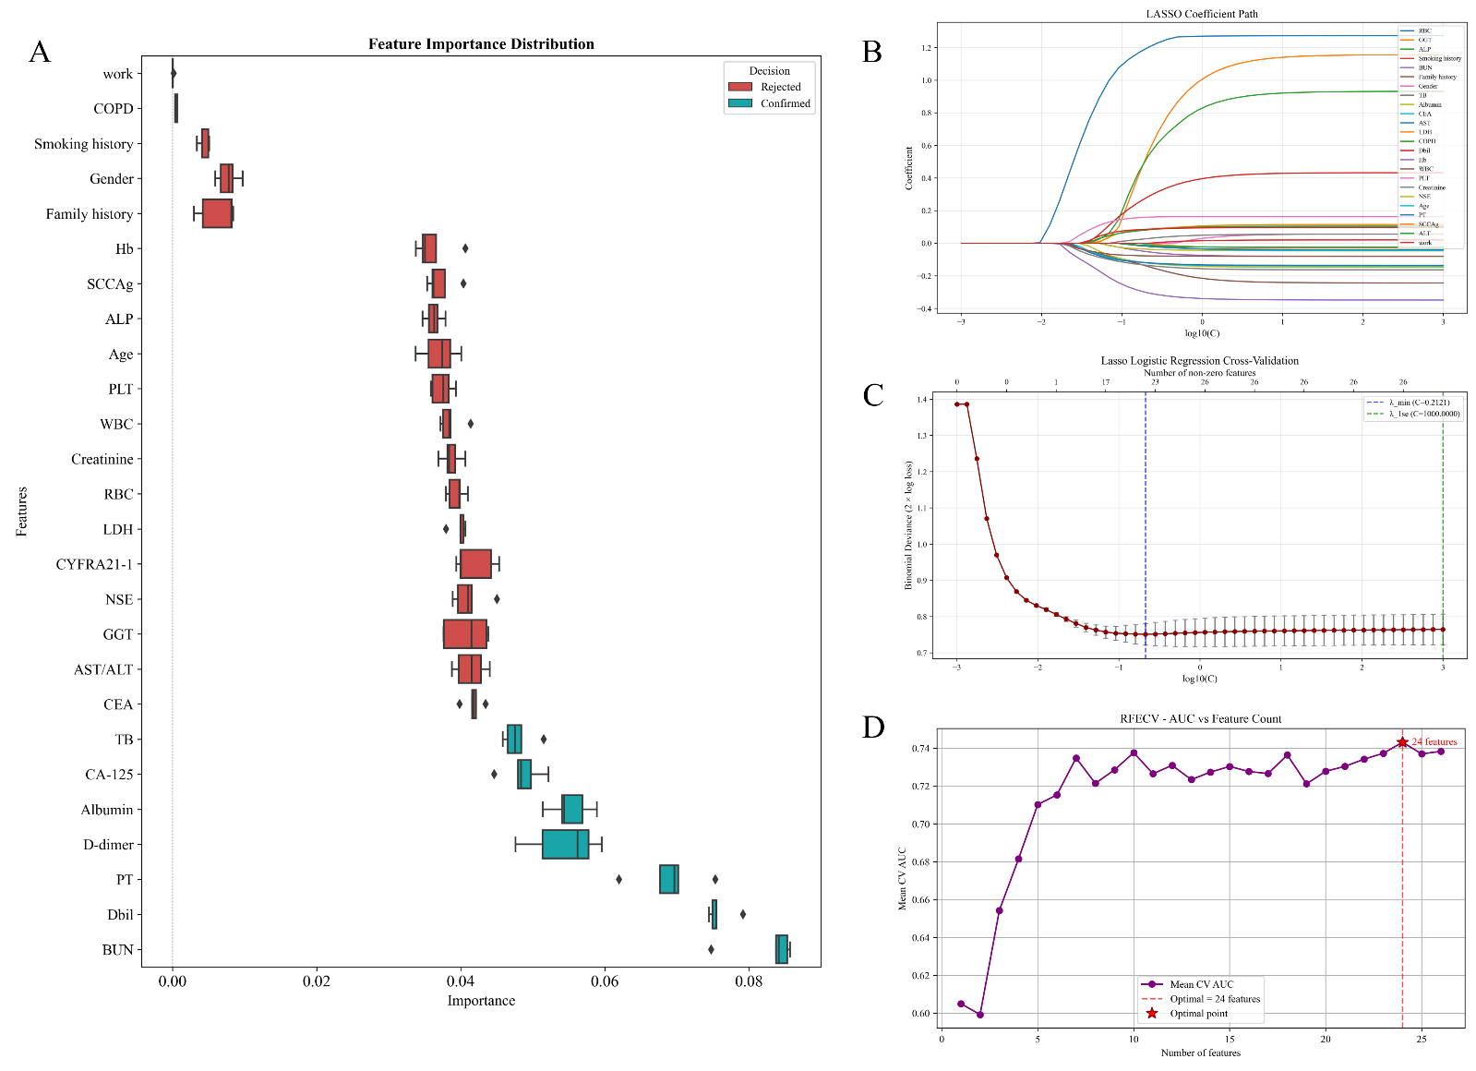
Supplementary Figure 1, Variable selection using Boruta, Least Absolute Shrinkage and Selection Operator (LASSO), Recursive Feature Elimination Based On Random Forest (RF-RFE). (A) Boruta;(B) Coefficient path plot for LASSO. The optimal λ (𝜆𝑚𝑖𝑛) determined via 10-fold cross-validation; (C) Cross-validation error plot for LASSO; (D) Illustration of Recursive Feature Elimination (RFE) for variable selection. A Random Forest model was trained to evaluate feature importance, and the optimal subset was selected via 10-fold crossvalidation.

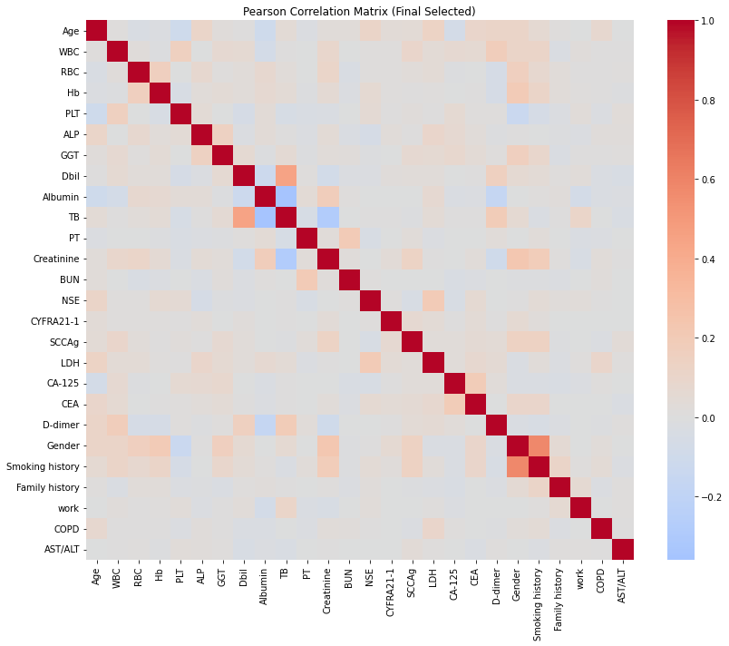
Supplementary Figure 2, Correlation Heatmap.

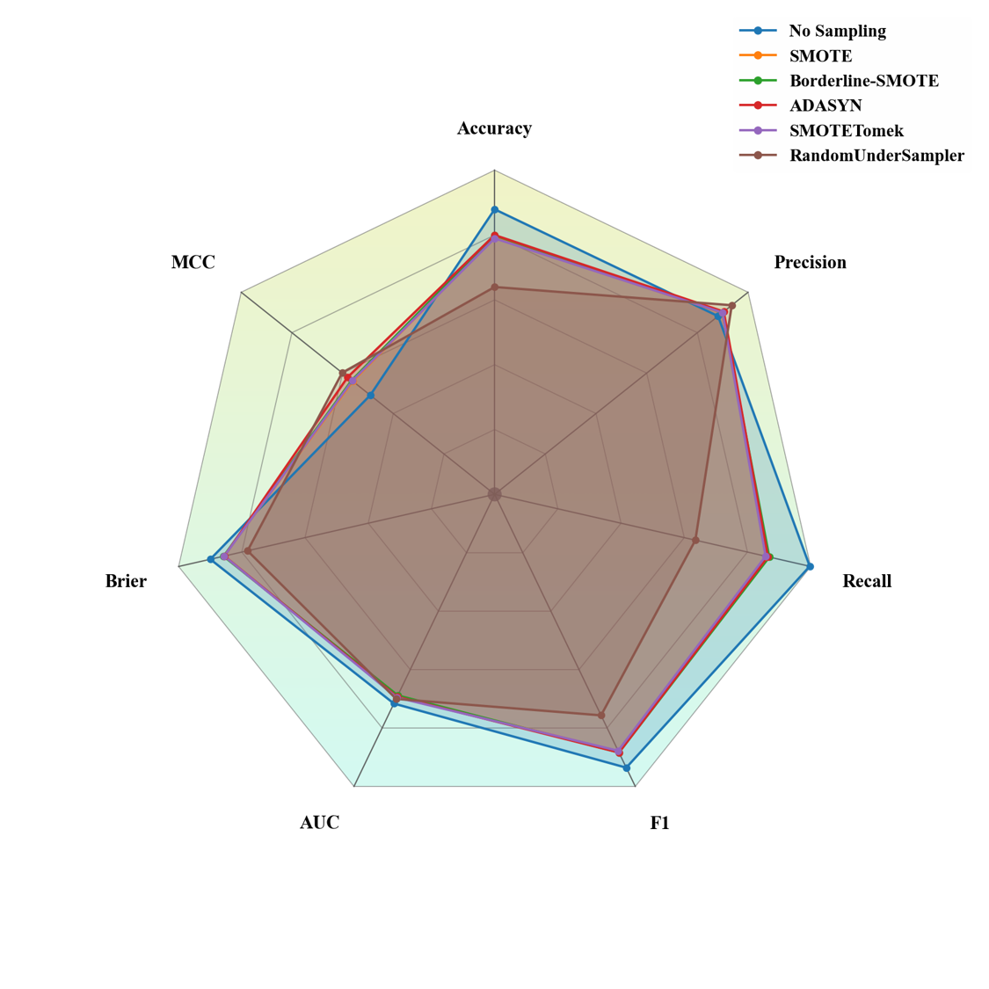
Supplementary Figure 3, Comparison of the performance of nine Class-balancing methods.

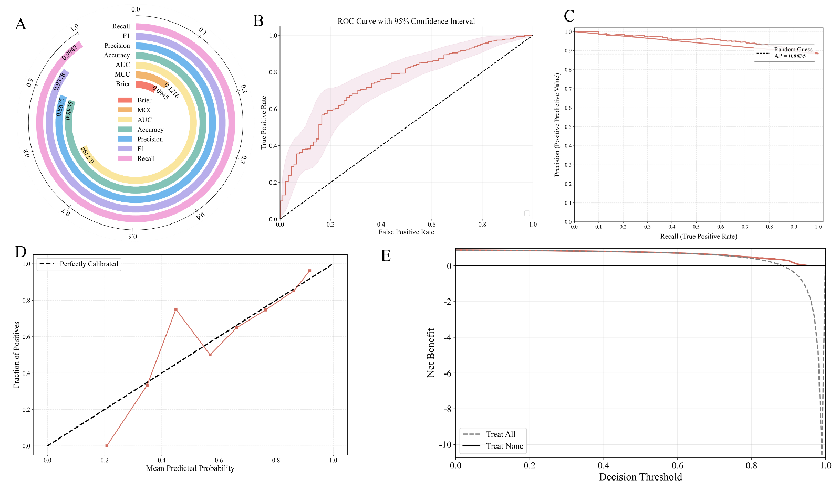
Supplementary Figure 4, Performance of test set. (A) Model evaluation metrics; (B) ROC curve of the test set; (C) The PR curve of the test set; (D) Calibration curve of the test set; (E) The DCA curve of the test set.

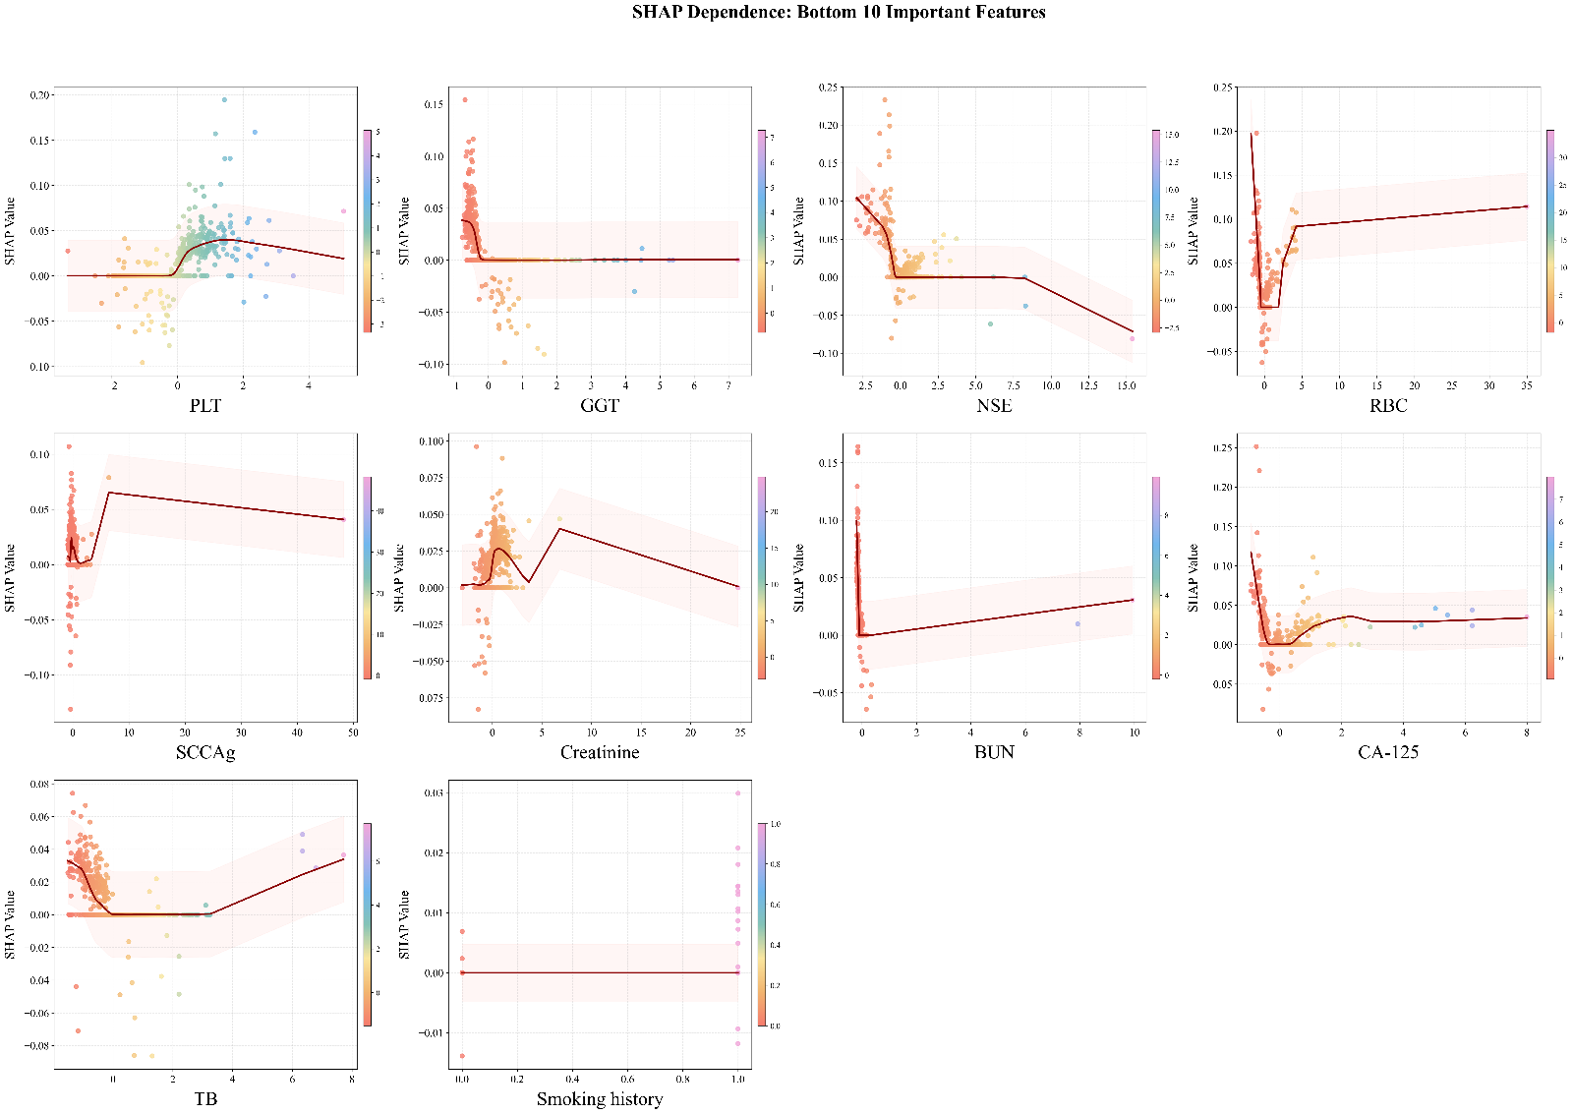
Supplementary Figure 5, Scatter plot of 10 after.

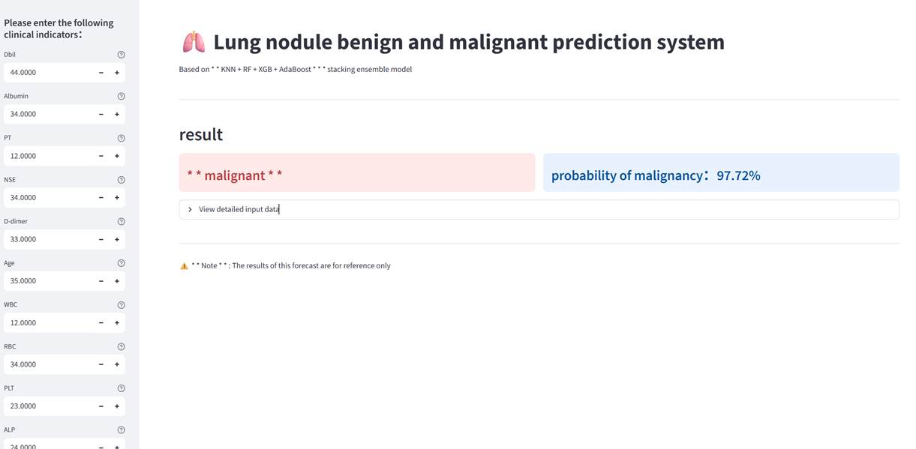
Supplementary Figure 6, Clinical prediction tool.

