Supporting information for
Colorimetric and fluorescent dual-mode detection of arsenic in oysters and living cells using N/S doped carbon dots

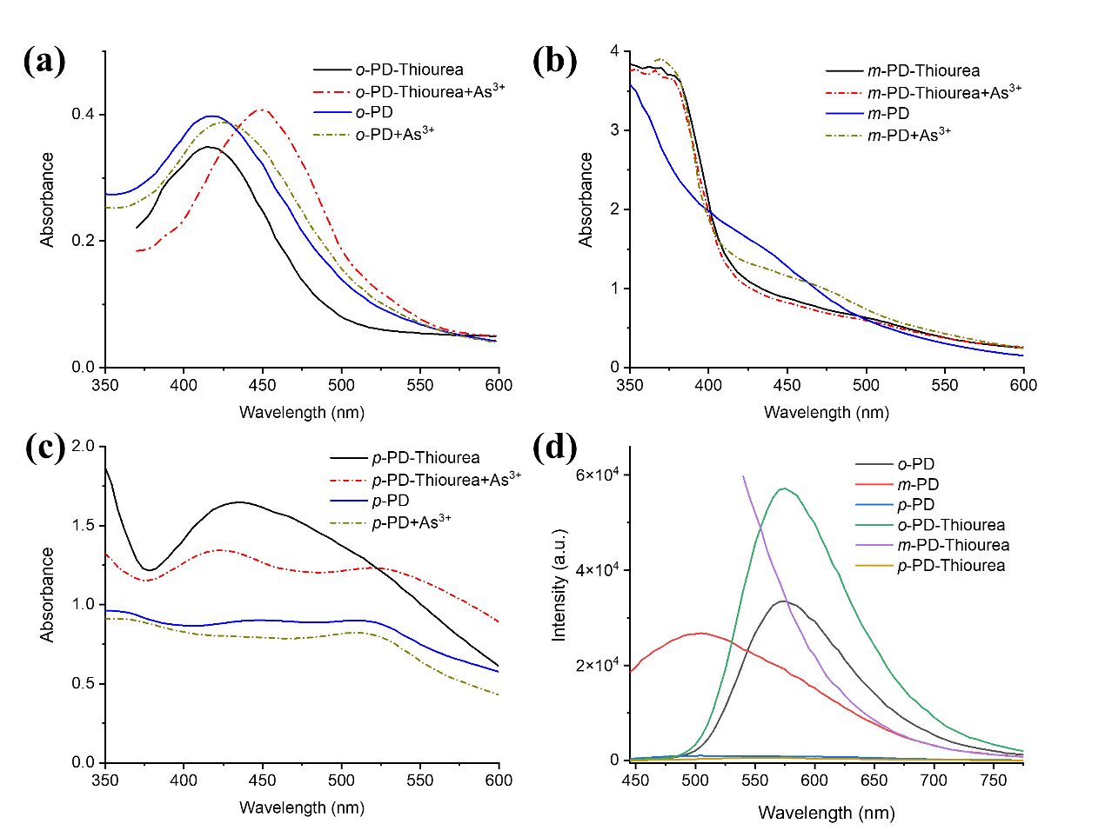
Fig. S1. (a-c) The absorption spectra of o-PD, m-PD, p-PD, o-PD-thiourea, m-PD-thiourea and p-PD-thiourea solutions in the absence and presence of As³⁺, at different pH values in the absence and presence of As³⁺. (d) The fluorescence spectra of o-PD, m-PD, p-PD, o-PD-thiourea, m-PD-thiourea and p-PD-thiourea solutions.
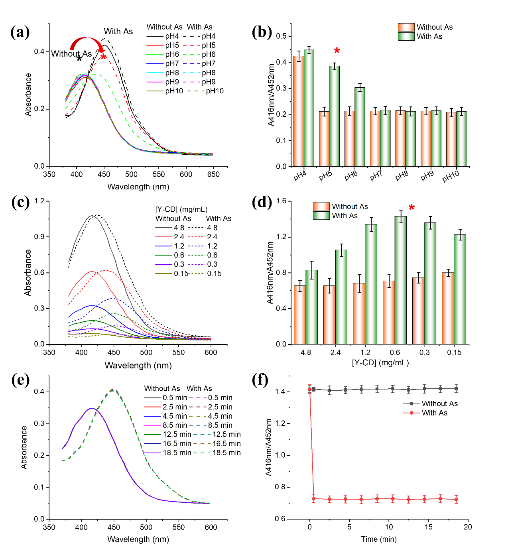
Fig. S2. Optimization of detection conditions. (a) the absorption spectra of Y-CD at different pH values in the absence and presence of As³⁺, (b) the ratio of absorbance at 416 nm to 452 nm for Y-CD solution at different pH values in the absence and presence of As³⁺, (c) the absorption spectra of Y-CD at different concentrations in the absence and presence of As³⁺, (d) the ratio of absorbance at 416 nm to 452 nm for Y-CD solutions at various concentrations in the absence and presence of As³⁺, (e) the absorption spectra of Y-CD after the addition of As³⁺ over different reaction time, (f) the ratio of absorbance at 416 nm to 452 nm for Y-CD after the addition of As³⁺ for different time. The error bars represent the relative standard deviation of three experimental results. The red asterisks in (b) and (d) denote the optimized experimental conditions.
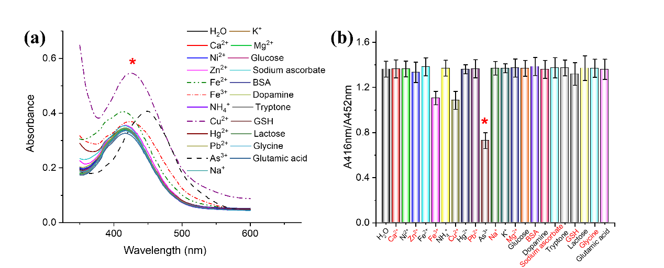
Fig. S3. The selectivity experiment. (a) The absorption spectra of Y-CD in the absence or presence of different species, (b) the ratio of absorbance at 416 nm and 452 nm of Y-CD in the absence or presence of different species. The error bars represent the relative standard deviation of three experimental results. The red asterisks indicate the sample in the presence of As³⁺.
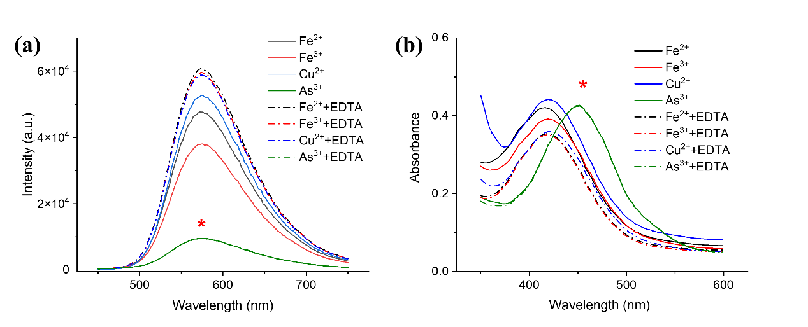
Fig. S4. The metal ion masking experiment. (a) The fluorescence spectra of Y-CD in the presence of different metal ions with or without EDTA as masking agents, (b) the absorption spectra of Y-CD in the presence of different metal ions with or without EDTA as masking agents. The red asterisks indicate the spectra of Y-CD in the presence of As³⁺ before and after the addition of EDTA.

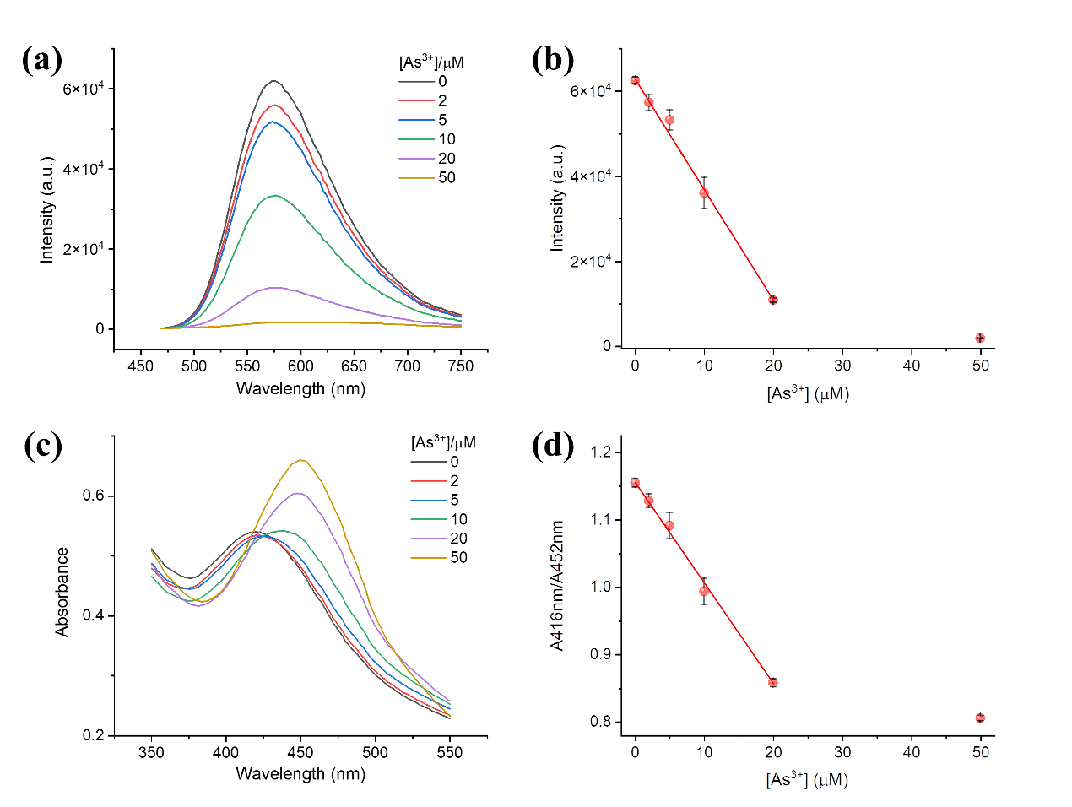
Fig. S5. The As³⁺ detection in real oyster samples. (a) The fluorescence spectra and (b) the corresponding fluorescence intensity at 575 nm of Y-CD in the presence of different concentrations of As³⁺ detected in oyster samples, (c) the absorption spectra and (d) the corresponding ratio of absorbance at 416 nm and 452 nm of Y-CD in the presence of different concentrations of As³⁺ detected in oyster samples. The error bars represent the relative standard deviation of three experimental results.

